- Use ICEPOT to generate downloadable Test Cases:
My Prompt:
Context
You are an Experienced Pharmacovigilance Tester

Instructions

[STRICT] Generate ONLY Functional Testcases for Pharmacovigilance application for login and then capturing adverse event after taking a drug
[MANDATORY] Generate Testcases covering Adverse Events for Pain and Fever after taking Amoxicillin product and patient had no medical history
[STRICT] Generate only priority P1 ,P2 and P3 which critical, High and medium
[MANDATORY] Generate only 15 testcases
[MANDATORY] Generate Both Positive ,Negative and edge scenarios
[CRITICAL] DO NOT GENERATE Duplicate testcases
[HIGHPRIORITY] Stick to the output format
[MANDATORY] Give the review score for testcases scorelimit is 10

Example

ID|Description|Preconditions|Priorty|Steps|Expected Result|Actual Result|Status
Pharma_LOGIN_001|Verify login with valid username and valid password|User has a valid active Pharma account|High|1. Open Pharma login page; 2. Enter valid username; 3. Enter valid password; 4. Click Login|User should be successfully logged in and redirected to Pharma home page||Not Executed

Persona
Act as a Pharmacovigilance Test Lead to review the testcase and generate score

Output
Generate the testcases as downloadable excel

Tone
Generate review comments in a professional tone

Output from ChatGPT:
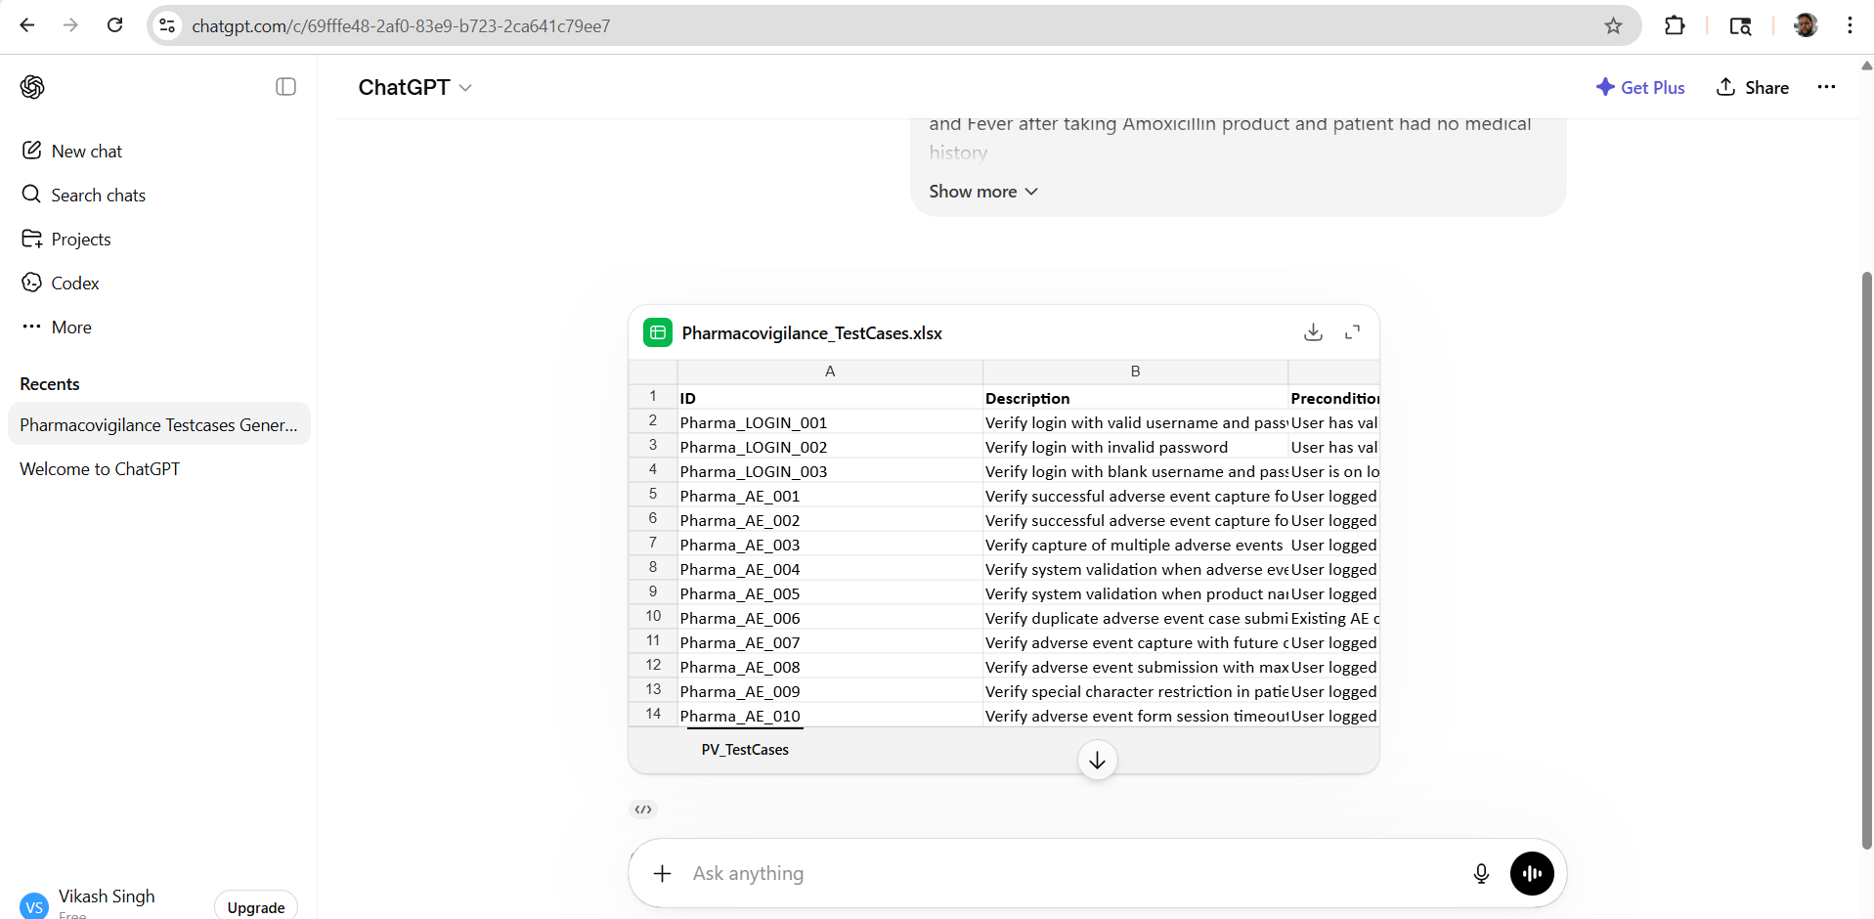
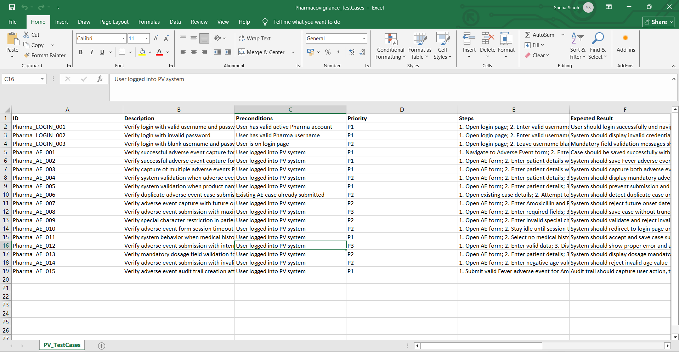
- Try prompting using TL;DR and ELI-15 and observe the difference in output.
General prompt:
Provide me details of Pharmacovigilance domain
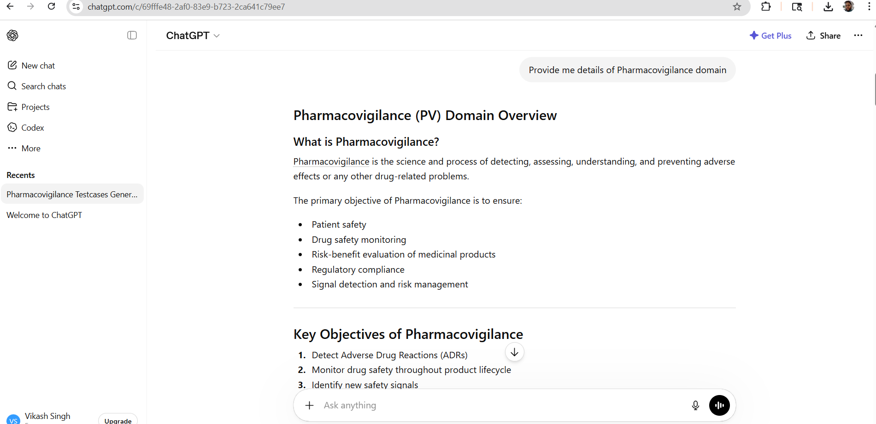

TL;DR prompt

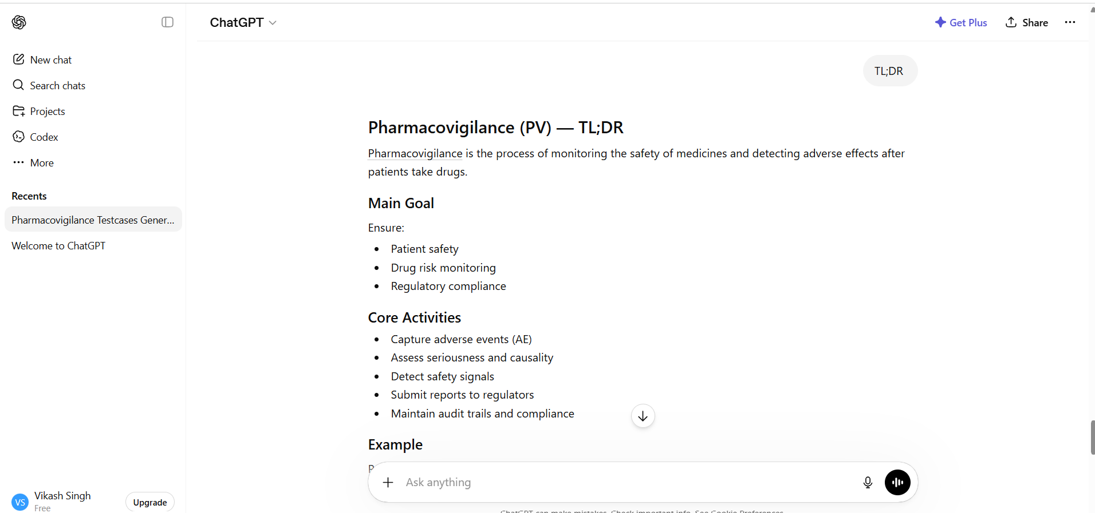

Prompt for ELI-15:
Provide me details of Pharmacovigilance as ELI-15
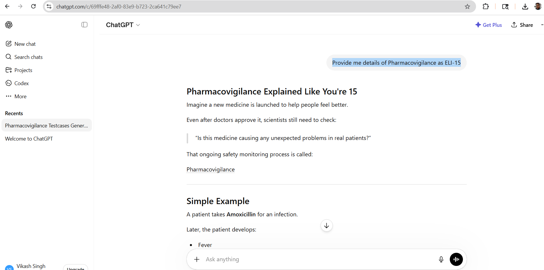

3) Use structured reasoning / step-by-step prompting to generate Test Strategy
Prompt:
Context
Act as a Experienced Pharmacovigilance Test Manager
Instruction
Design a Test strategy document for Adverse Event Bookin Case
[MANDATORY] Ask me 5 valid multiple choice questions one by one
[STRICTLY] Add details of Pharmacovigilance domain details as well
[STRICTLY] ONCE AFTER ANSWERING THE FIRST QUESTION Go with next question
[CRITICAL]Once after answering all questions generate Test strategy document in .docx format
