Assignment: - With vibe coding implement the playwright/typescript

- 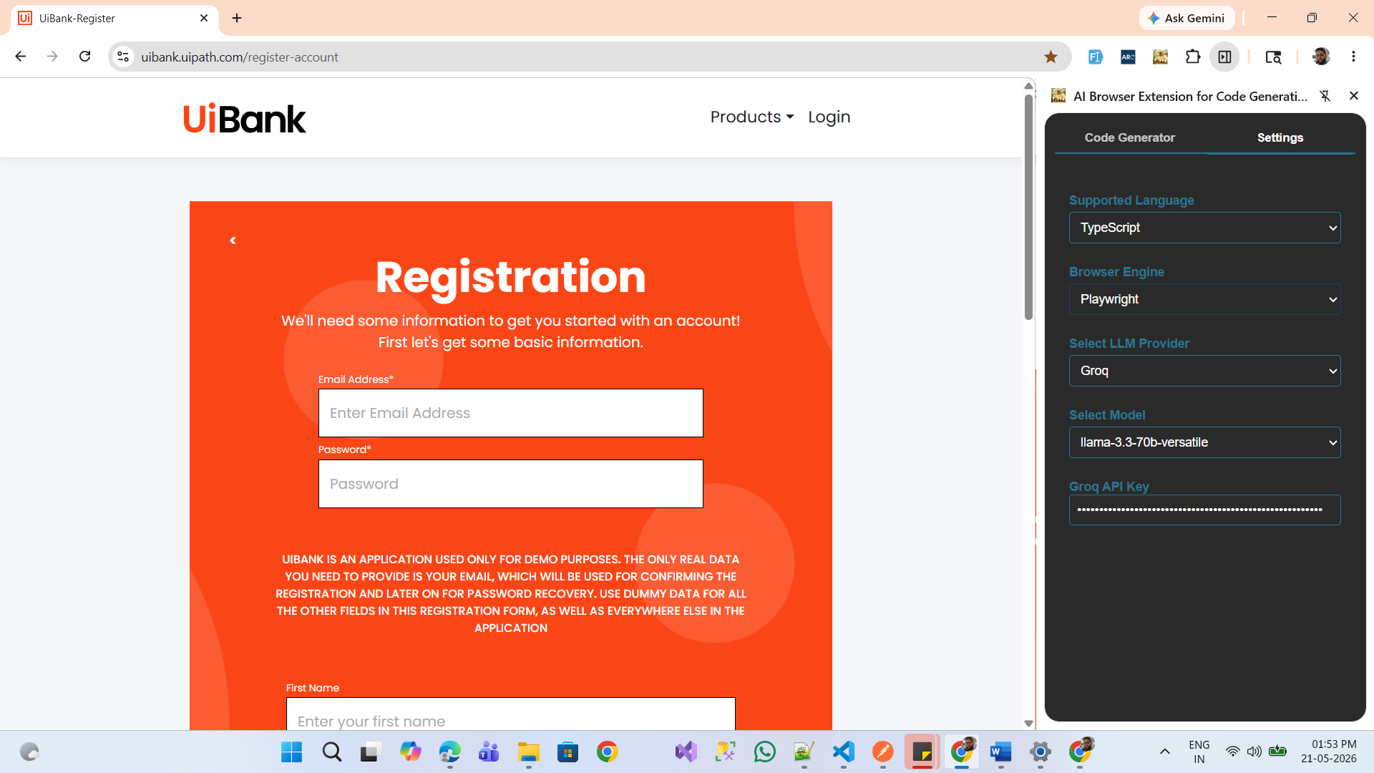
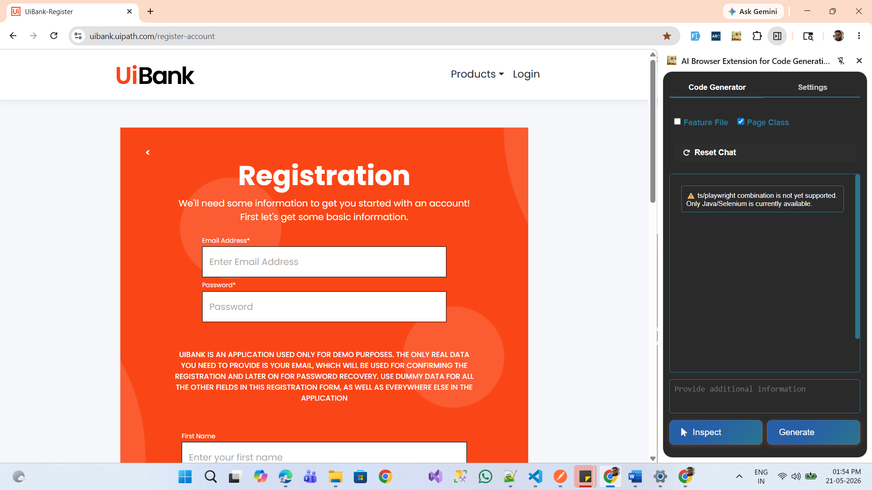
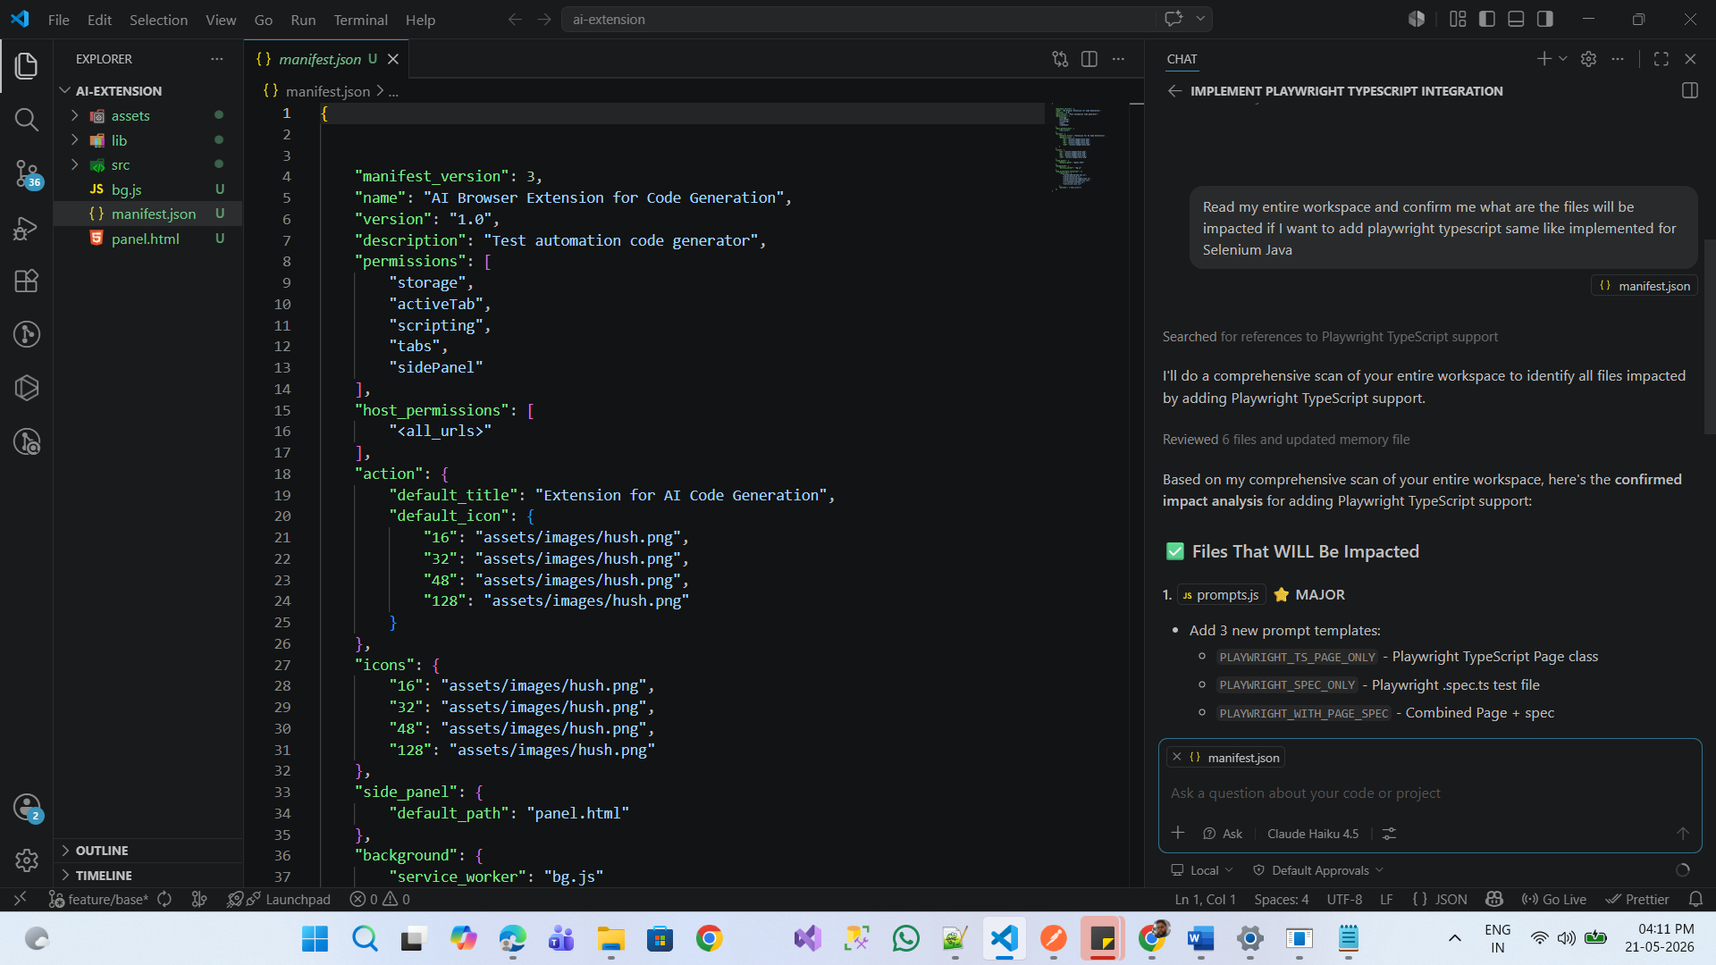
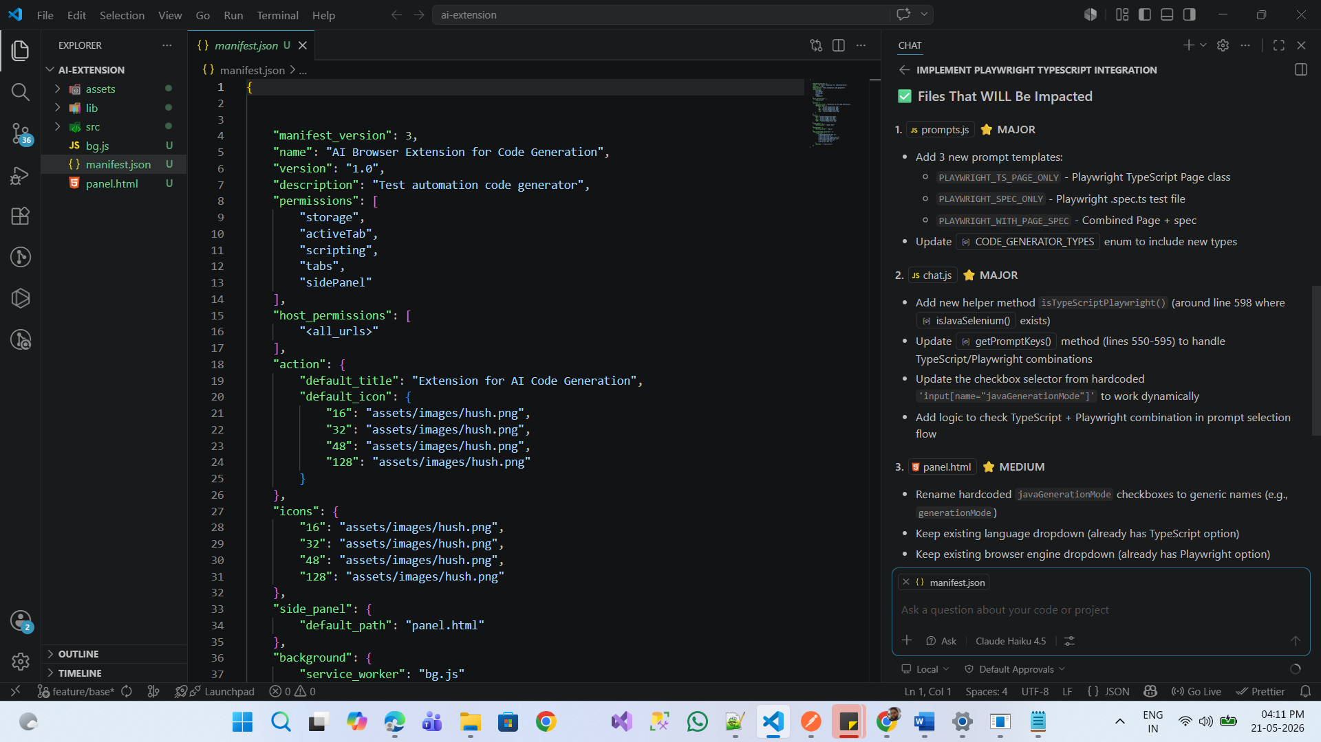
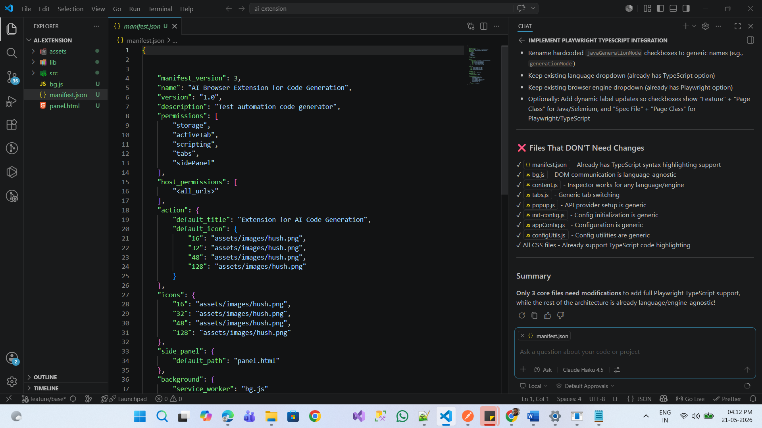

Read the Entire workspace and understand how I implemented the selenium Java

I want to add the playwright typescript

Go to prompts.js and add 3 new prompt templates for Playwright TypeScript
Take selenium Java as reference

PLAYWRIGHT_TS_PAGE_ONLY - Playwright TypeScript Page class
PLAYWRIGHT_SPEC_ONLY - Playwright .spec.ts test file
PLAYWRIGHT_WITH_PAGE_SPEC - Combined Page + spec

And, Update CODE_GENERATOR_TYPES enum to include new types
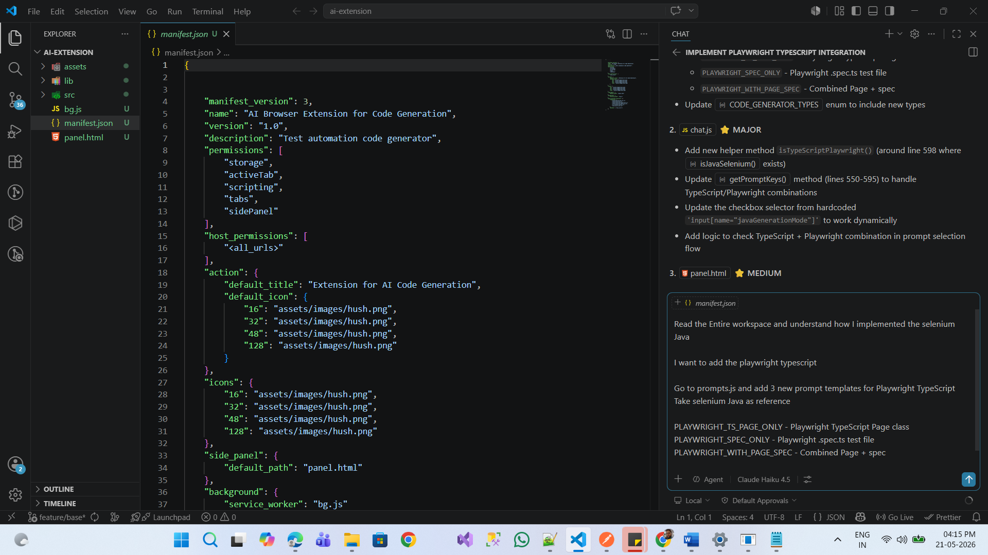
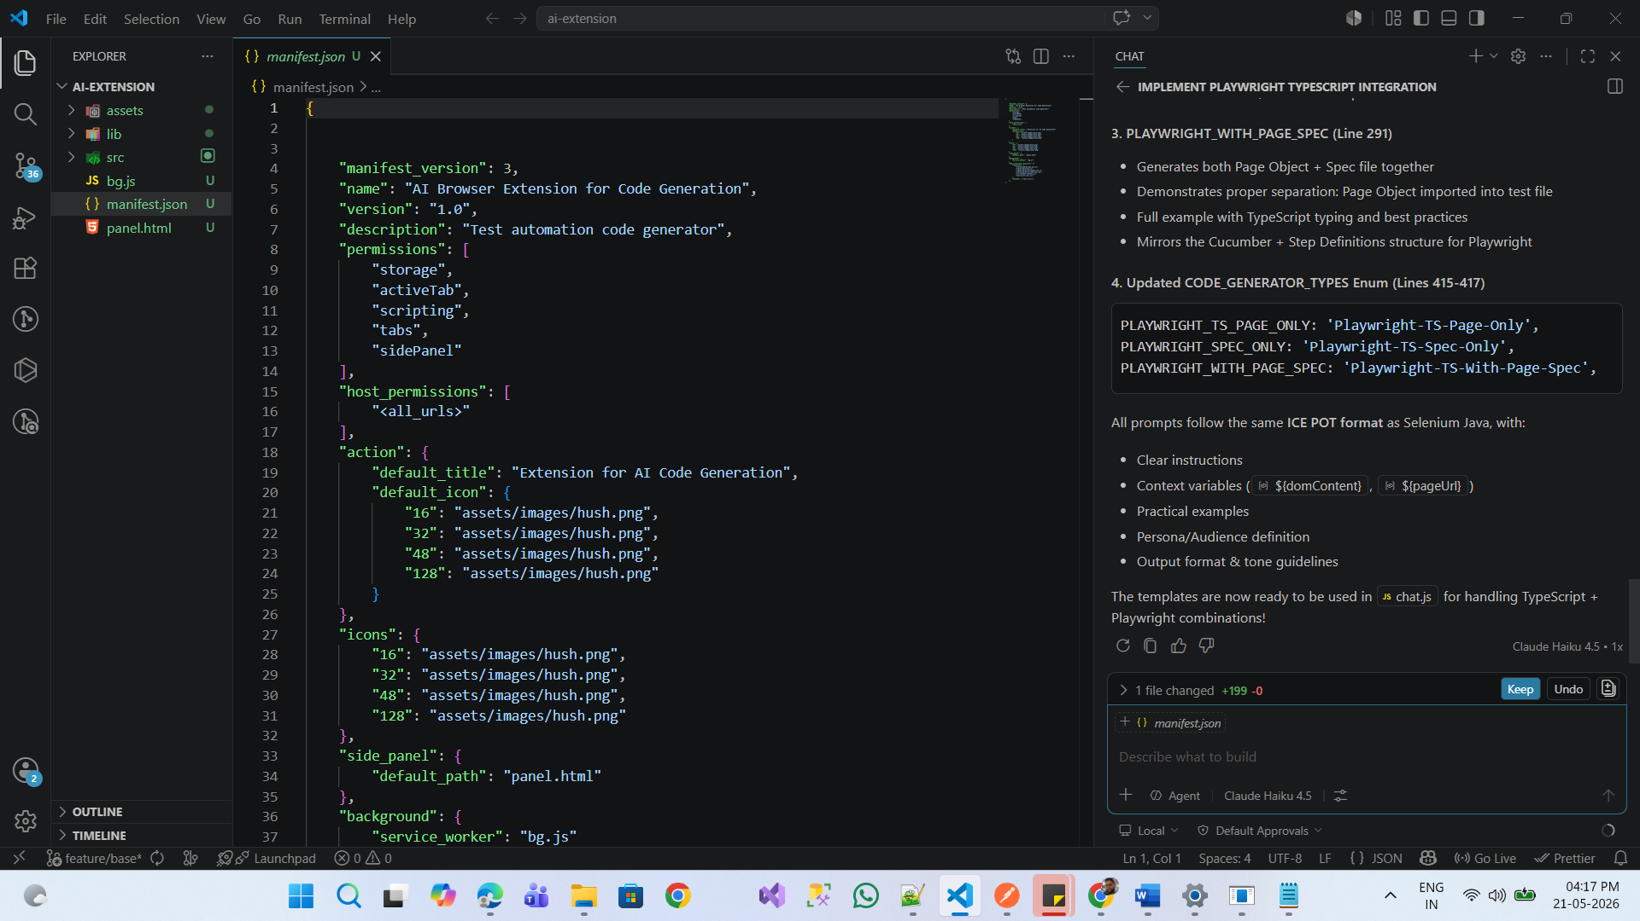
Read the Entire workspace and understand how I implemented the selenium Java

I want to add the playwright typescript
Go to chat.js and add new helper method isTypeScriptPlaywright() (around line 598 where isJavaSelenium() exists)
and, update getPromptKeys() method (lines 550-595) to handle TypeScript/Playwright combinations
and, Update the checkbox selector from hardcoded 'input[name="javaGenerationMode"]' to work dynamically
and, then Add logic to check TypeScript + Playwright combination in prompt selection flow
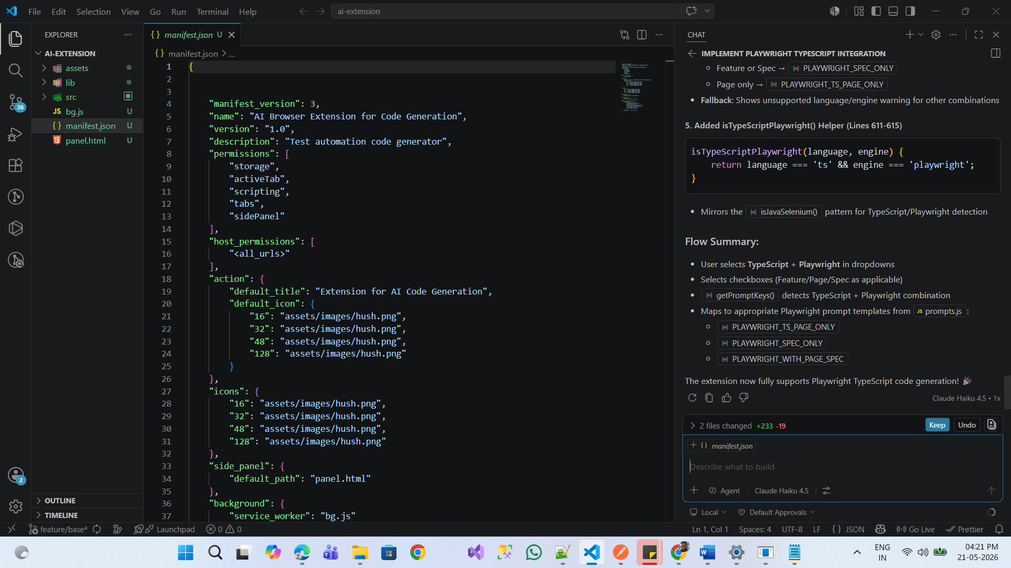
Go to panel.html
Rename hardcoded javaGenerationMode checkboxes to generic names (e.g., generationMode)
Keep existing language dropdown (already has TypeScript option)
Keep existing browser engine dropdown (already has Playwright option)
and, Add dynamic label updates so checkboxes show "Feature" + "Page Class" for Java/Selenium, and "Spec File" + "Page Class" for Playwright/TypeScript

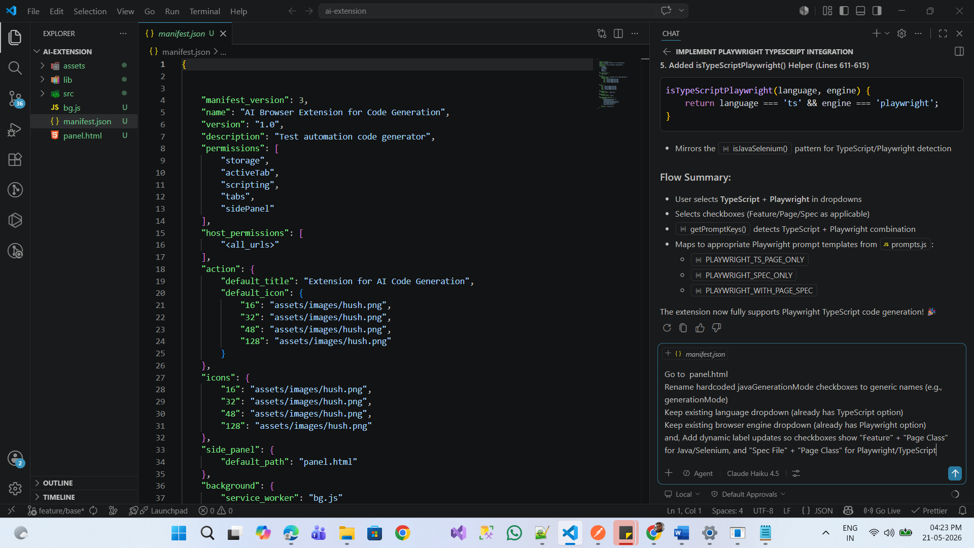
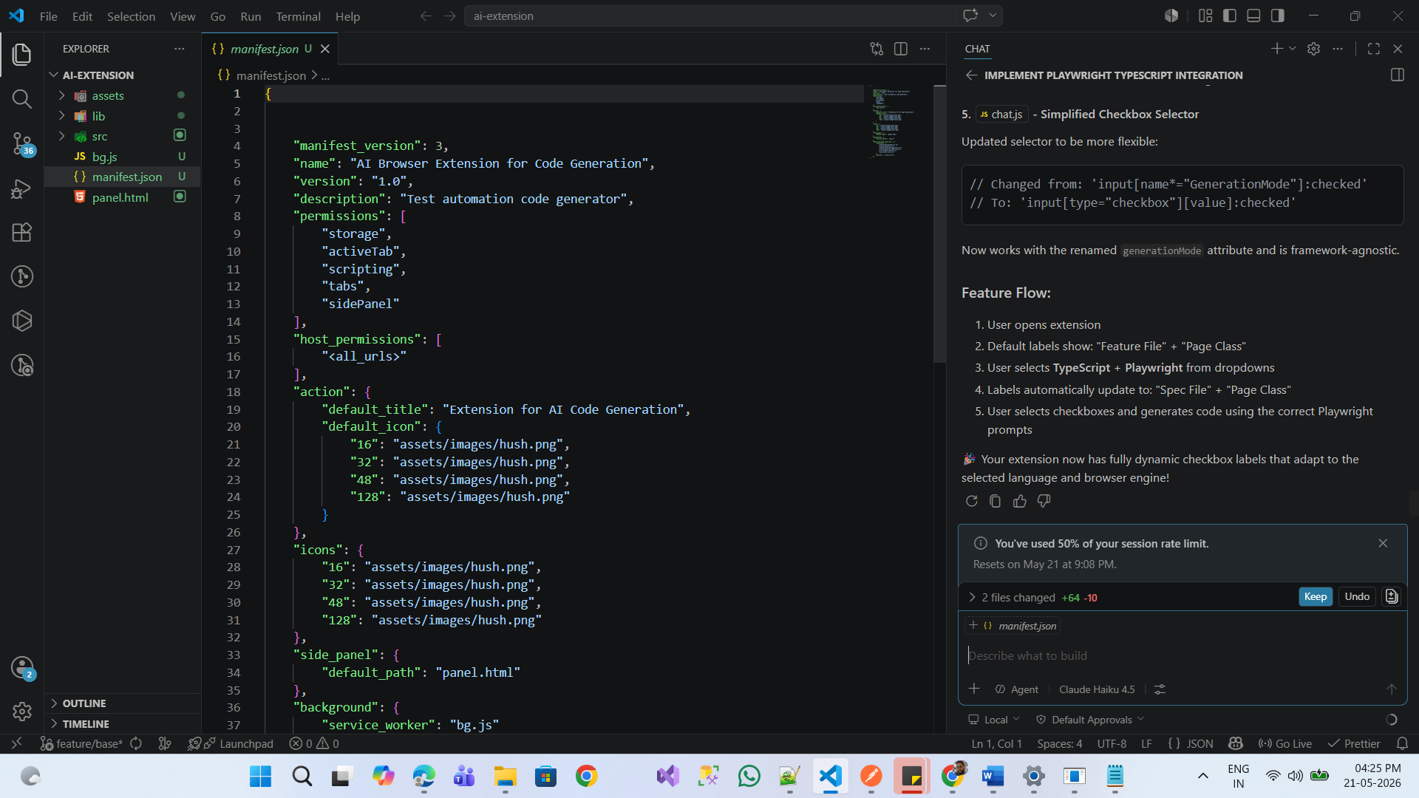
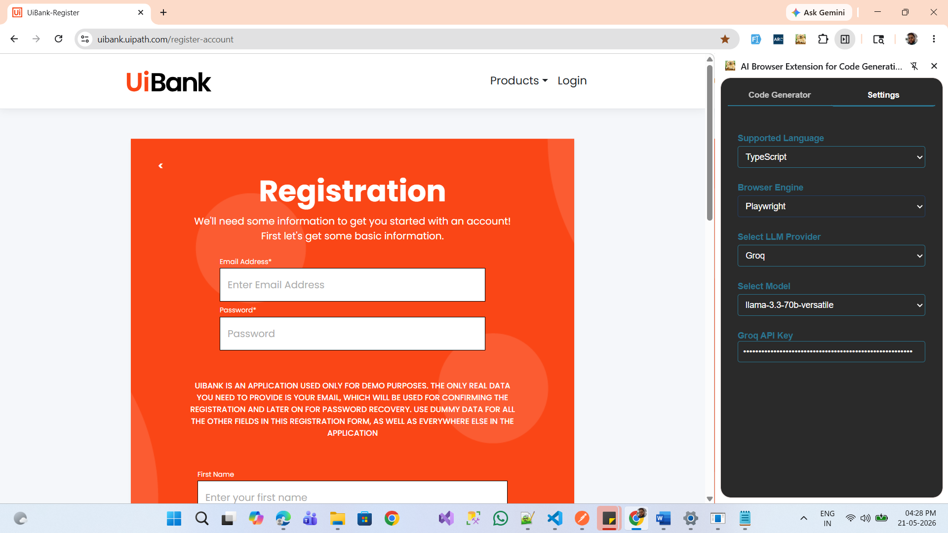
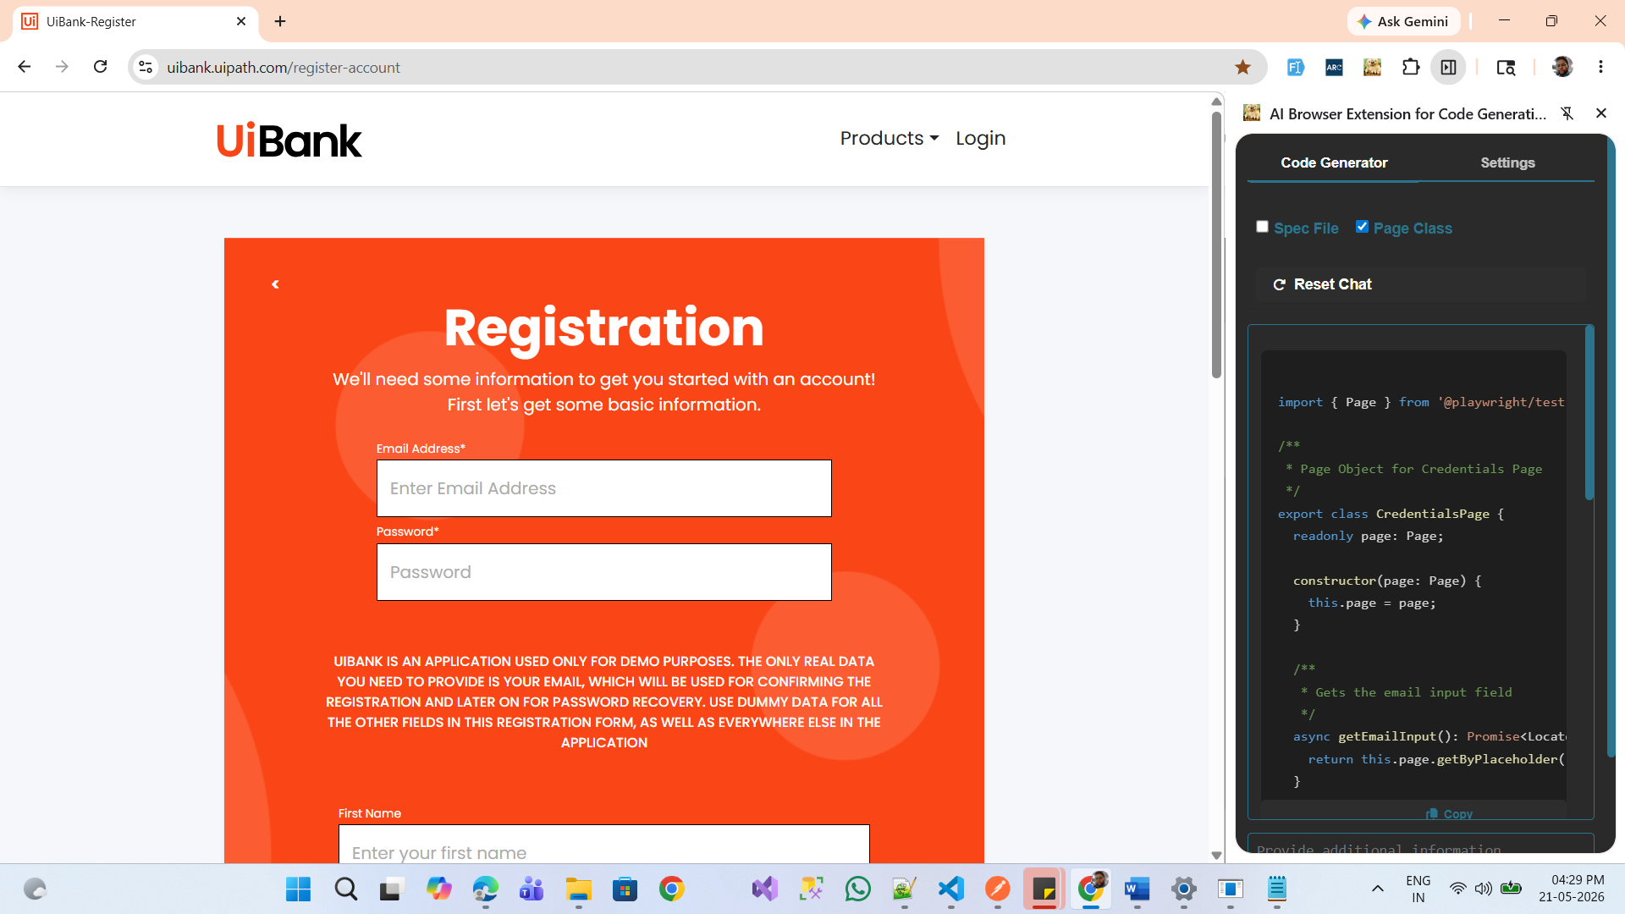
Playwright Typescript Automation Script generated from AI extension browser:
import { Page } from '@playwright/test';

/**
* Page Object for Credentials Page
*/
export class CredentialsPage {
readonly page: Page;

constructor(page: Page) {
this.page = page;
}

/**
* Gets the email input field
*/
async getEmailInput(): Promise<Locator> {
return this.page.getByPlaceholder('Enter Email Address');
}

/**
* Gets the password input field
*/
async getPasswordInput(): Promise<Locator> {
return this.page.getByPlaceholder('Password');
}

/**
* Enters the email address
* @param email - The email address to enter
*/
async enterEmail(email: string): Promise<void> {
const emailInput = await this.getEmailInput();
await emailInput.fill(email);
}

/**
* Enters the password
* @param password - The password to enter
*/
async enterPassword(password: string): Promise<void> {
const passwordInput = await this.getPasswordInput();
await passwordInput.fill(password);
}

/**
* Gets the email address label
*/
async getEmailLabel(): Promise<Locator> {
return this.page.getByText('Email Address*');
}

/**
* Gets the password label
*/
async getPasswordLabel(): Promise<Locator> {
return this.page.getByText('Password*');
}
}

