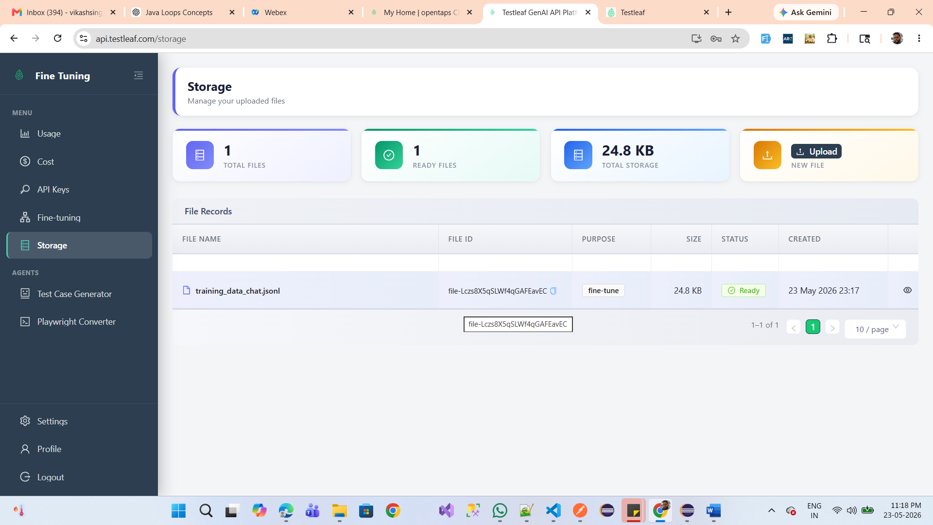
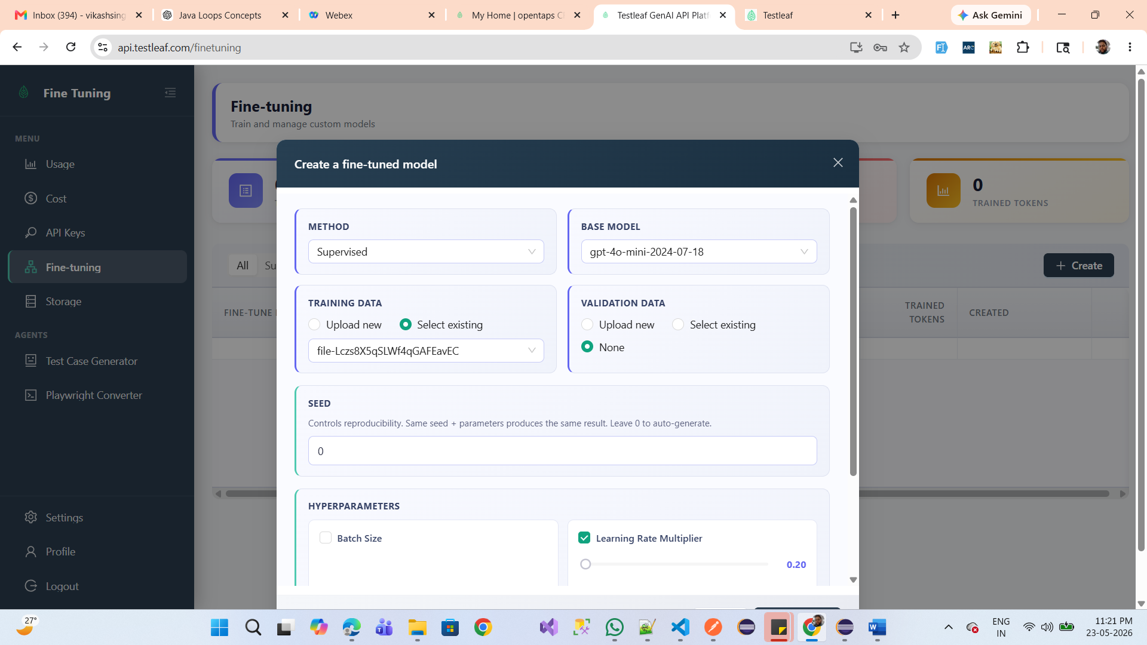
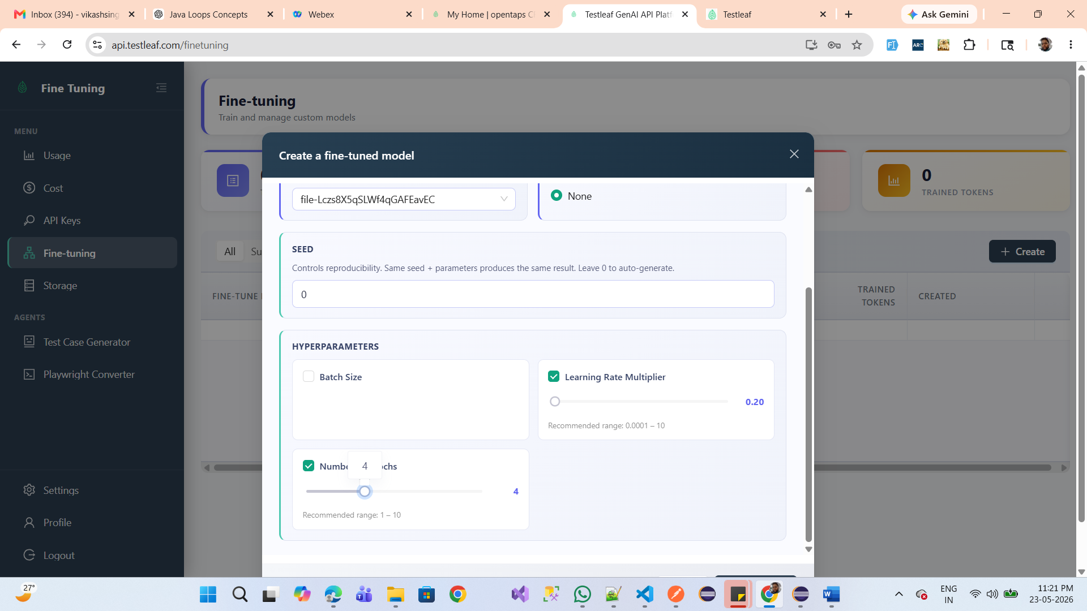
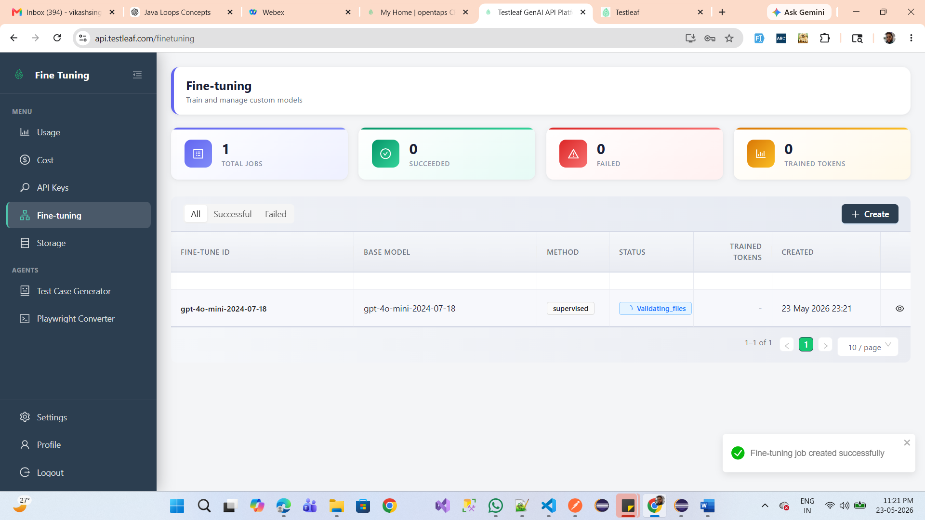

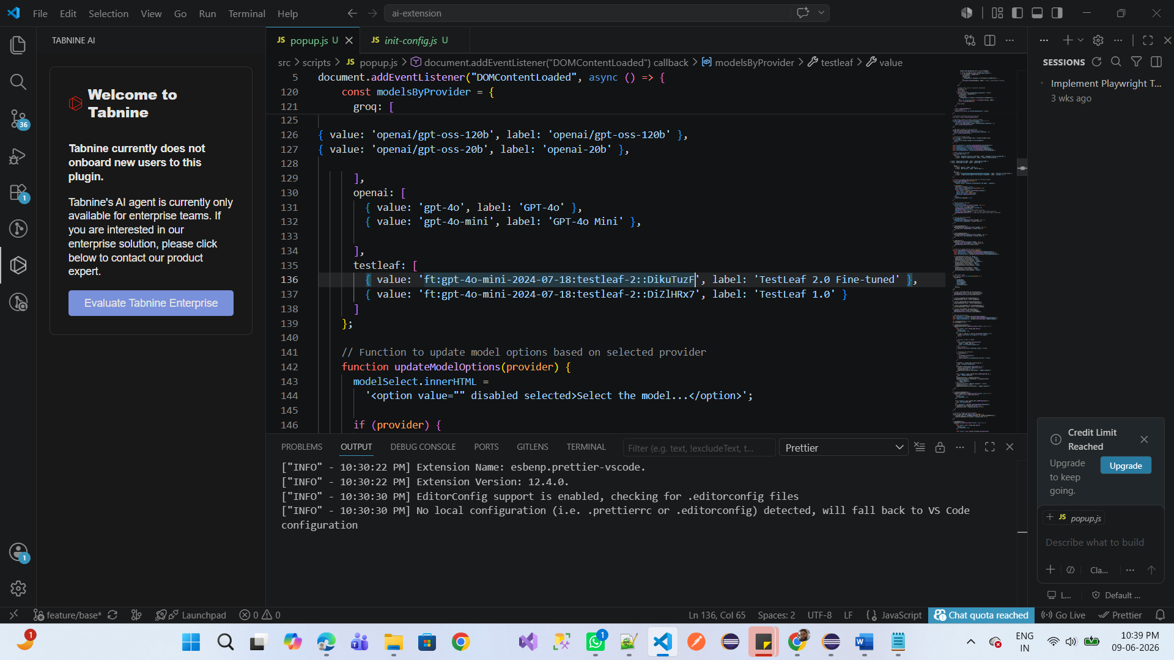
Selenium-Java Automation Test Script for Registration:
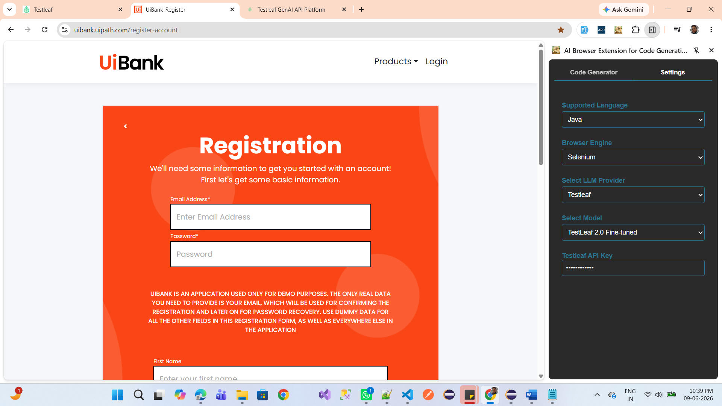
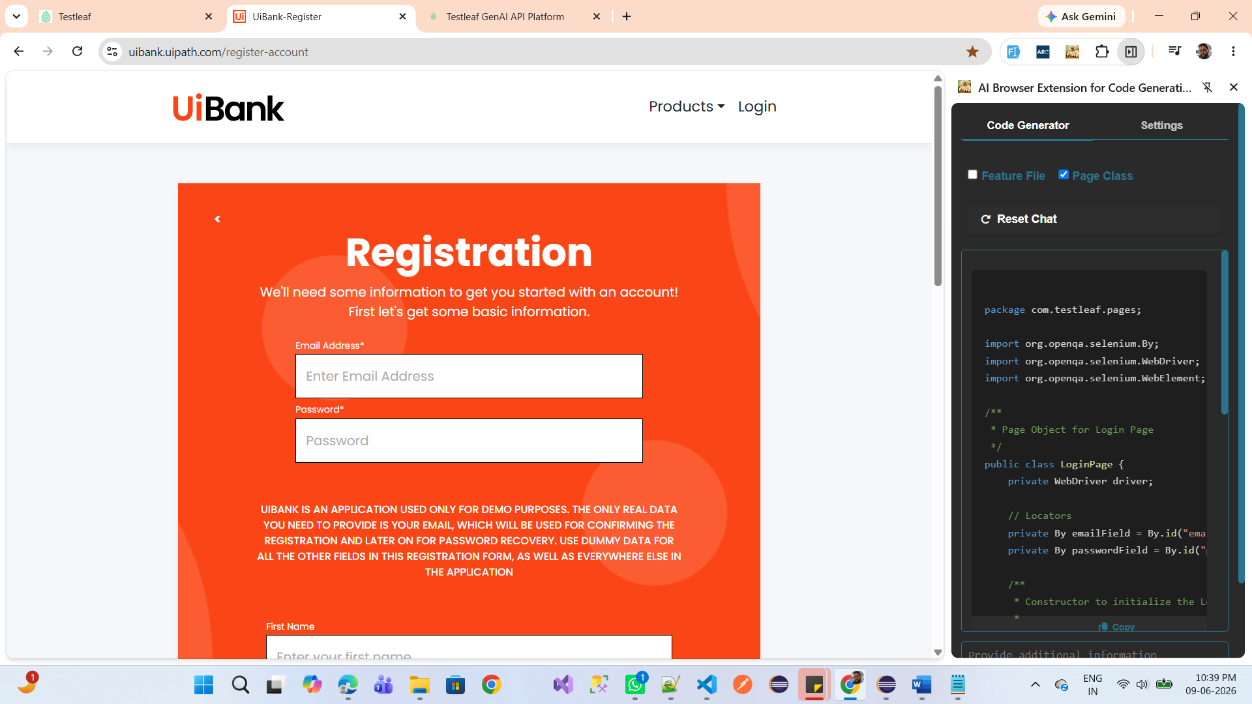
package com.testleaf.pages;

import org.openqa.selenium.By;
import org.openqa.selenium.WebDriver;
import org.openqa.selenium.WebElement;

/**
* Page Object for Login Page
*/
public class LoginPage {
private WebDriver driver;

// Locators
private By emailField = By.id("email");
private By passwordField = By.id("password");

/**
* Constructor to initialize the LoginPage with WebDriver
*
* @param driver WebDriver instance
*/
public LoginPage(WebDriver driver) {
this.driver = driver;
}

/**
* Method to enter email address
*
* @param email Email address to be entered
*/
public void enterEmail(String email) {
WebElement emailElement = driver.findElement(emailField);
emailElement.clear();
emailElement.sendKeys(email);
}

/**
* Method to enter password
*
* @param password Password to be entered
*/
public void enterPassword(String password) {
WebElement passwordElement = driver.findElement(passwordField);
passwordElement.clear();
passwordElement.sendKeys(password);
}
}
Playwright-TypeScript Automation Test Script for Registration:
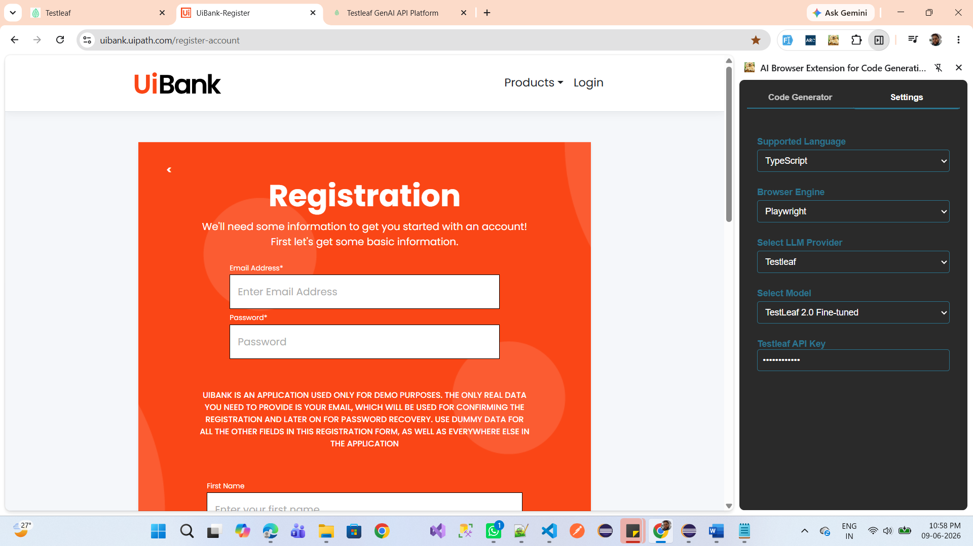
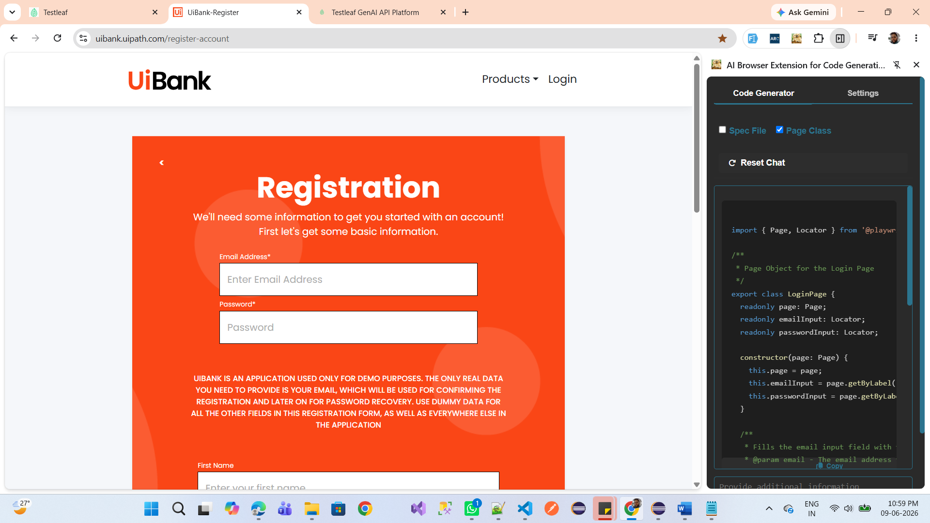
import { Page, Locator } from '@playwright/test';

/**
* Page Object for the Login Page
*/
export class LoginPage {
readonly page: Page;
readonly emailInput: Locator;
readonly passwordInput: Locator;

constructor(page: Page) {
this.page = page;
this.emailInput = page.getByLabel('Email Address*');
this.passwordInput = page.getByLabel('Password*');
}

/**
* Fills the email input field with the provided email.
* @param email - The email address to enter.
*/
async fillEmail(email: string): Promise<void> {
await this.emailInput.fill(email);
}

/**
* Fills the password input field with the provided password.
* @param password - The password to enter.
*/
async fillPassword(password: string): Promise<void> {
await this.passwordInput.fill(password);
}

/**
* Retrieves the value of the email input field.
* @returns The email address entered in the input field.
*/
async getEmailValue(): Promise<string> {
return await this.emailInput.inputValue();
}

/**
* Retrieves the value of the password input field.
* @returns The password entered in the input field.
*/
async getPasswordValue(): Promise<string> {
return await this.passwordInput.inputValue();
}
}

