Assignment sheet for IAM

**Assignment 1 :- Create an IAM user with username of your own wish and grant administrator policy.**

Answer : Created an IAM user with the name of “admin” and assigned him the administrator permissions

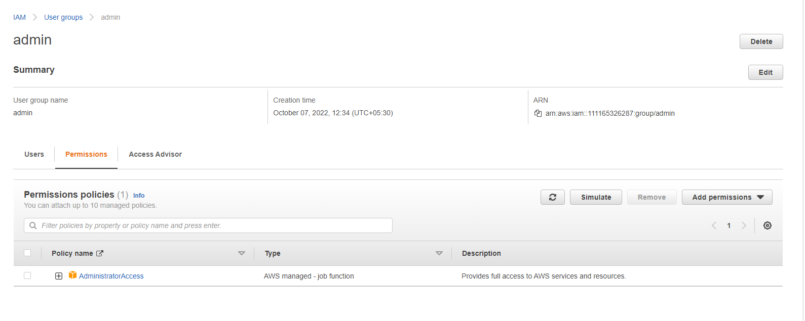

**Assignment 2 :- Hello students, in this assignment you need to prepare a developers team of avengers.**

**- Create 3 IAM users of avengers and assign them in developer’s groups with IAM policy.**

Created three new users test_user1, test_user2 and test_user3 and assingned them in the Avengers group

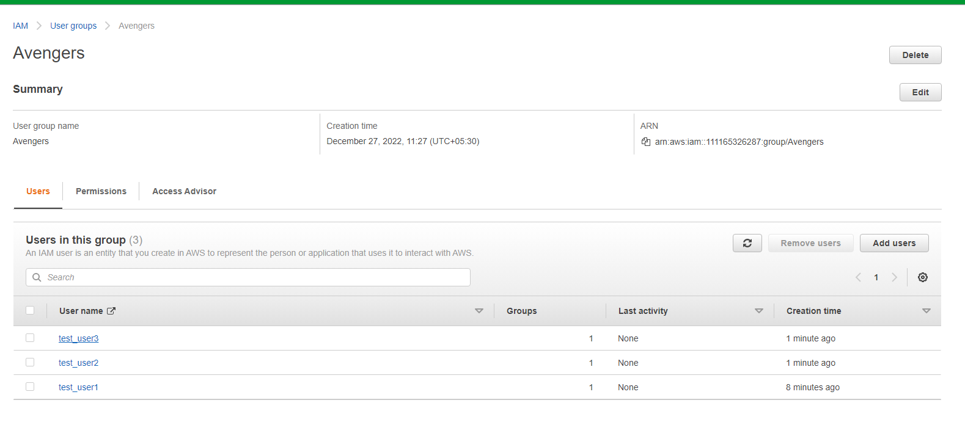

**Permissions of the Avengers Group :**

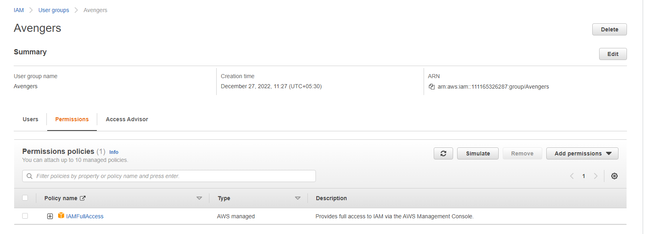

**Assignment 3 :- Define a condition in policy for expiration like**

"DateGreaterThan": {"aws:CurrentTime":

"2020-04-01T00:00:00Z"},

"DateLessThan": {"aws:CurrentTime": "2020-06-30T23:59:59Z"}

Define the span of 4 months as per your wish

Answer : Created a policy and added the expiration conditions

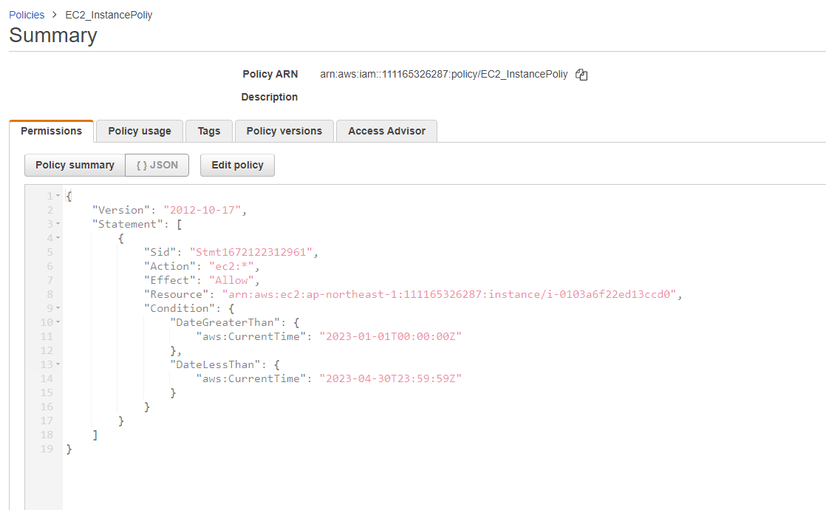

**Assignment 4 :- Prepare 15 authentic MCQ questions related to IAM.**

1. Which statement is true regarding IAM?
2. It allows you to deploy and manage applications in the AWS Cloud.
3. IAM allows you to manage users, groups, roles, and their corresponding level of access to the AWS Platform.
4. IAM allows you to manage users' passwords only and can be done via raising a ticket
5. IAM allows you to manage permissions for AWS resources only

Answer : B

1. Which of these is a part of IAM (Choose two)

a) MFA.

b) Billing

c) Instance

d) Policy

Answer : a and d

3. In which language IAM policies ae being written

a) html

b) xml

c) json

d) java

Answer : c

4. Can a user belong to multiple groups?

a) true

b) false

Answer : a

5. By default an IAM user created will have

a) Partial permission

b) No permission

c) Full permission

Answer : b

6. Which of the following is not a part of Policy structure

a) version

b) id

c) statement

d) Access

Answer : d

7. Which of the following is true about principal

a) account/user/role to which this policy applied to

b) an identifier for the statement

c) list of actions this policy allows or denies

d) list of resources to which the actions applied to

Answer : a

8. An user cannot inherit the permissions assigned in the group

a) true

b) false

Answer : b

9. What is an additional way to secure the AWS accounts of both the root account and new users alike?

a) Implement Multi-Factor Authentication for all accounts.

b) Store the access key id and secret access key of all users in a publicly accessible plain text document on S3 of which only you and members of your organization know the address to.

c) Configure the AWS Console so that you can only log in to it from your internal network IP address range.

d) Configure the AWS Console so that you can only log in to it from a specific IP Address range

Answer : a

10. What is the optional element in IAM policy document

a) Version

b) Action

c) Effect

d) Condition

Answer : d

11. A __________ is a document that provides a formal statement of one or more permissions.  
  
 a) Group  
 b) Policy  
 c) Role  
 d) User

Answer : b

12. Can we revoke a policy assigned to a user?

a) true

b) false

Answer : a

13. Which of these is Identity in IAM?

a) roles

b) groups

c) users

d) all of these

Answer : b

14. Which of the following can be used along multiple identities?

a) roles

b) policies

c) users

d) password

Answer : b

15. Which of these is IAM principal?

a) roles

b) application

c) users

d) all of these

Answer : d

|  |  |
| --- | --- |
|  |  |
|  |  |
|  |  |

**Assignment 5 :- Launch your linux instance in IAM and update your machine**

Answer : Created an ubuntu instance and updated the machine

