1. Microsoft TrOCR

Output

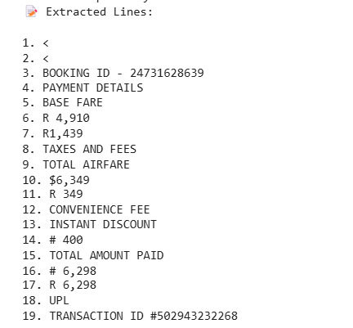

2. Donut

Output

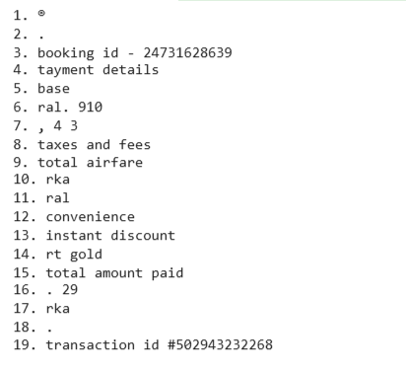

3.EasyOcr

Output

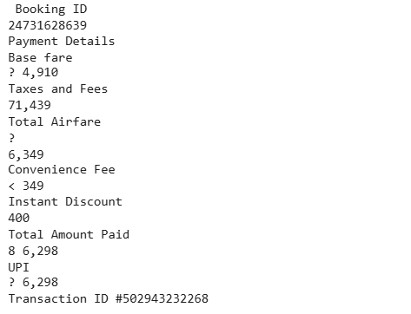

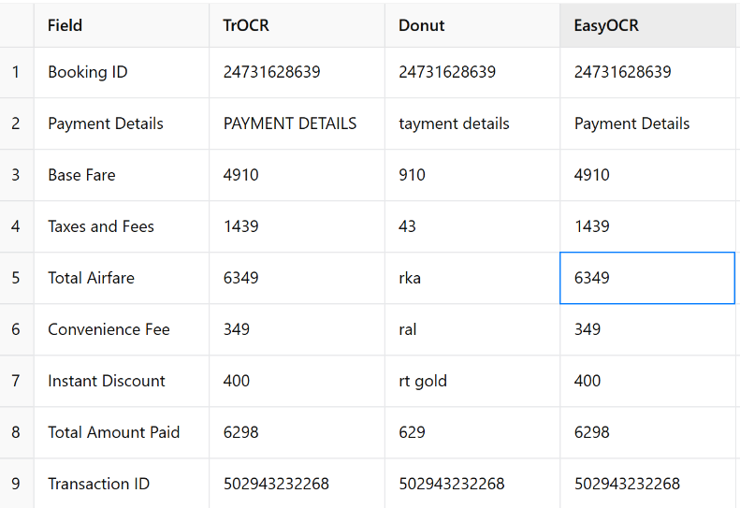

|  |  |  |
| --- | --- | --- |
| **Model** | **Common Errors** | **Observed In Fields** |
| TrOCR | Occasional prefix symbol confusion (R, #) | Handled well here, minor |
| Donut | Truncation, missed digits, spacing issues | All amount fields |
| EasyOCR | Slight symbol confusion (₹ as ?, <) | But numeric data correct |

|  |  |  |
| --- | --- | --- |
|  | **Model** | **Verdict** |
|  | **EasyOCR** | Best all-rounder for printed invoices |
|  | **TrOCR** | Strong and accurate; best for line-based OCR |
|  | **Donut** | Underperforms on cropped lines — better for full-doc extraction with fine-tuning |