WAZUH-PROJECT (Vikas Kumar)
Custom Field , Decoder & Rule

System – Remnux ,Ubuntu Linux
Setup - Manager (Combined) ,no Agent

- Wazuh-Template -
File - /etc/filebeat/wazuh-template.json
Location – data.------
Fields – data.process.name , data.process.command_line
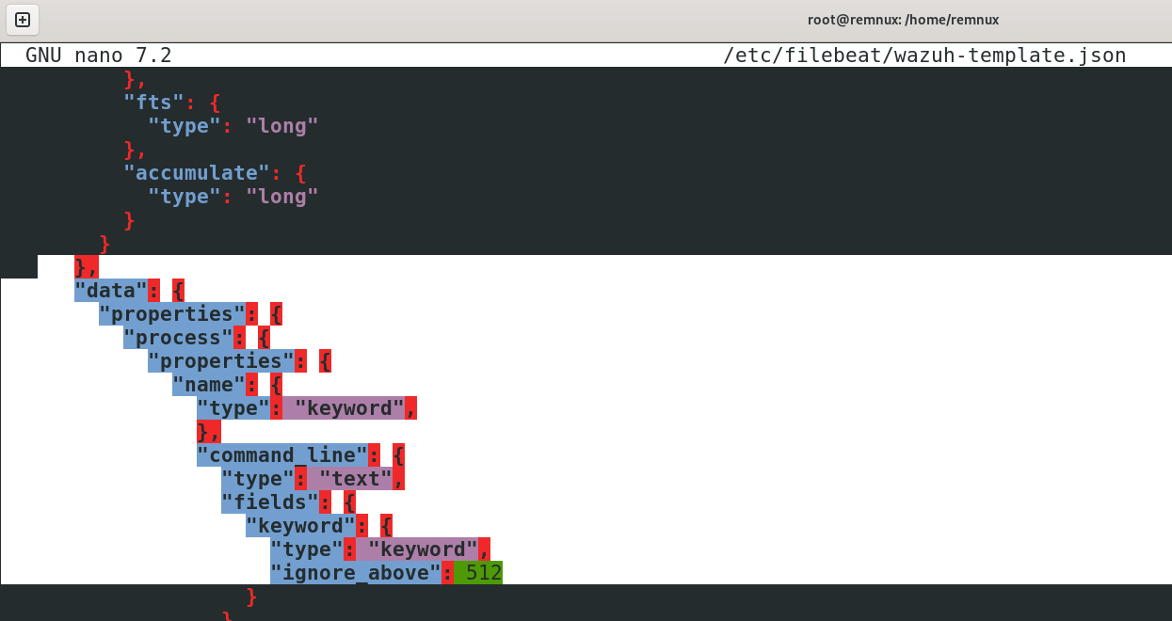
- Custom Decoder -
File - /var/ossec/etc/decoders/local-decoder.xml
Name – update-alternatives(Parent)
Prematch - <prematch>^update-alternatives \d\d\d\d-\d\d-\d\d \d\d:\d\d:\d\d:</prematch>

Name – update-alternatives-child
Regex- <regex>^(\S+) \d\d\d\d-\d\d-\d\d \d\d:\d\d:\d\d: run with (\.+)|\S+ \d\d\d\d-\d\d-\d\d \d\d:\d\d:\d\d: (.+)</regex>

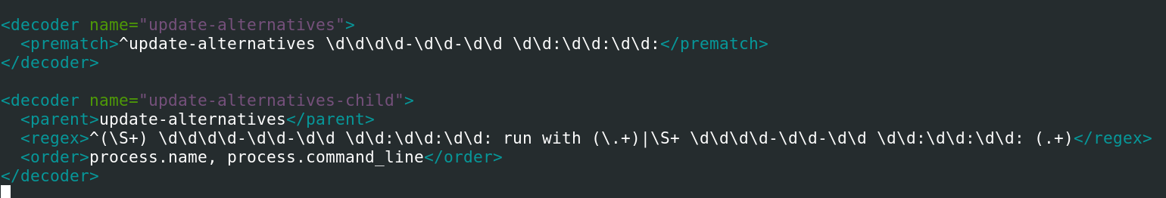

- Custom Rule-
File - /var/ossec/etc/rules/local-rules.xml
Rule Id – 100005
Decoded-As – Update-alternatives

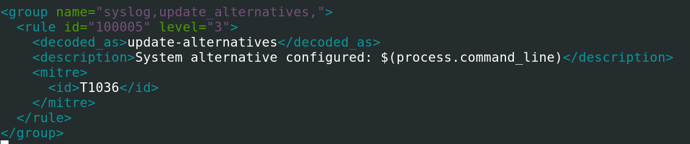

- Config to Ossec.conf –
File - /var/ossec/etc/ossec.conf
Location - <Localfile>
Adding Desired log monitoring files at localfile

- LogTest –

Adding log in the desired testing log file
Test log - update-alternatives 2026-04-10 10:53:06: run with --install /usr/bin/x-www-browser x-www-browser /usr/bin/firefox 40

Result
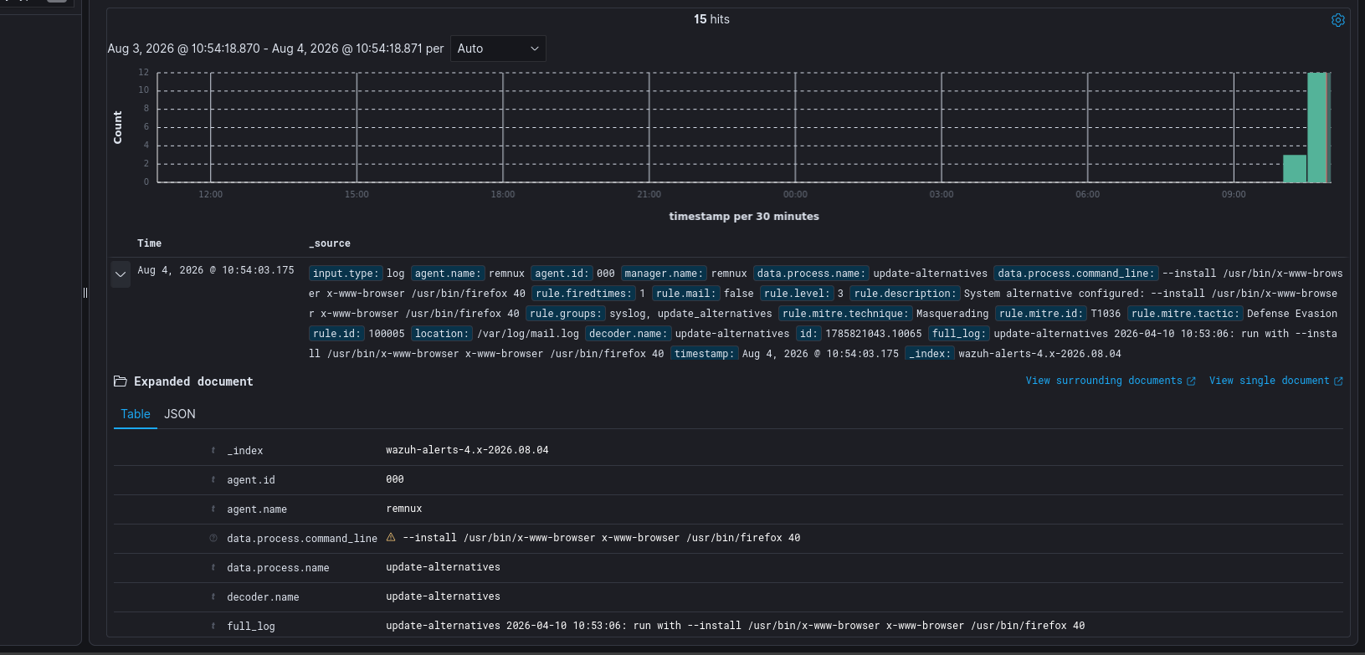
The Alert Made in the wazuh-alerts*

