Wazuh

Topic : FIM and Active Response

Date : 17th April 2026
OS: Ubuntu 24.04.4 LTS
Architecture : Server, Indexer and Dashboard Integrated , No agent
Wazuh version : 4.14.4

Activity : A file is created , will be modified and FIM alert should generat . Active response should trigger to save a backup file from original file location to /tmp by the wazuh .

Subject : mkdir honeydirectory
Directory :
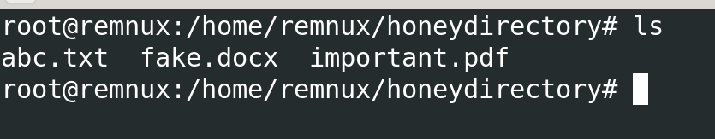

Dummy files have been added in subject directory /honeydirectory

Configuration : At server /var/ossec/etc/ossec.conf
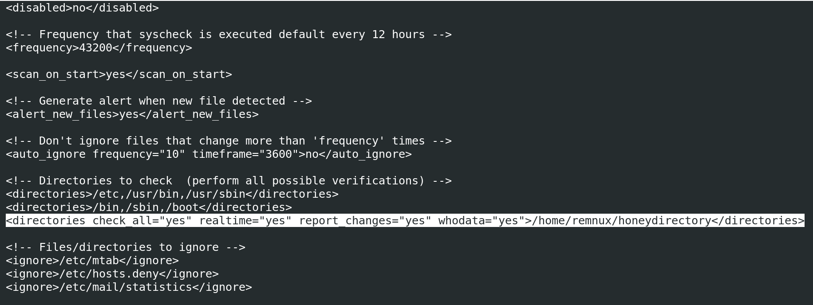
Important options added in the directories tag for extra information in the alerts that will be generated .
- Who data : user name
- Realtime : bypass 12h scanning interval
- Check_all : all file attributes
- Report changes : the difference in the file content

Active Response Configuration : in the same ossec.conf file

The script name is Backup-file.sh to make the backup file.
The command block adds the script and active response block binds where to execute and when .

The Script Bin : /var/ossec/active-response/bin/..

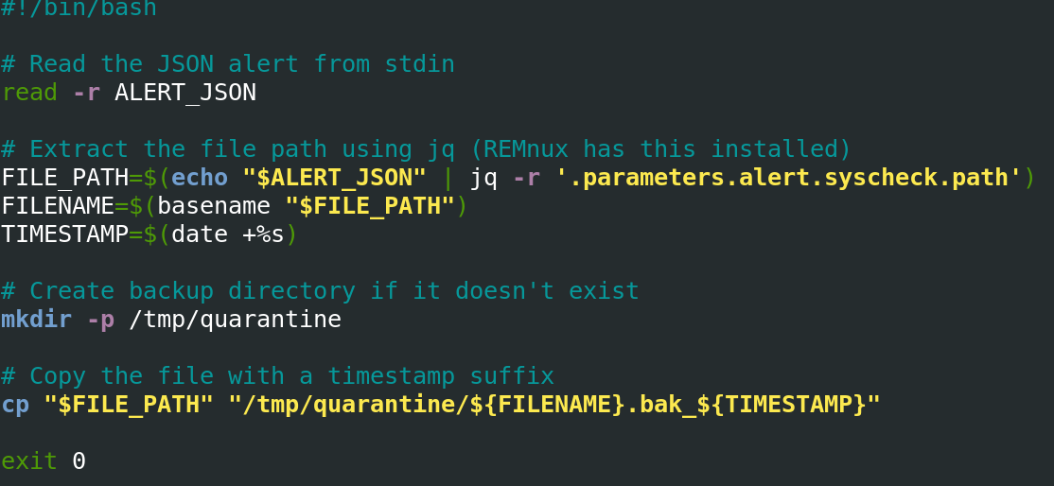
The backup file path is /tmp/quarantine

Change in the subject file :
/honeydirectory/abc.tx

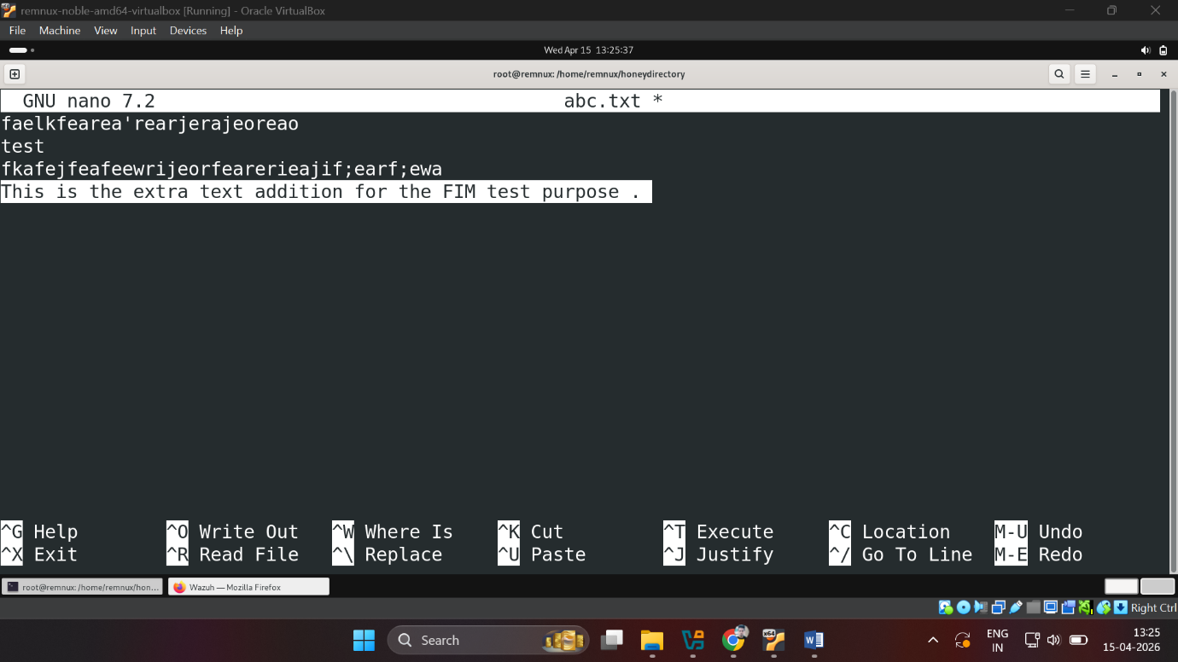

The extra text has been added to file and saved the changes .

Wazuh-Dashboard : overview/file_integrity_monitoring/events
The json content of the alerts is copied here ;
{
"_index": "wazuh-alerts-4.x-2026.04.15",
"_id": "ZhMjkJ0BbJ089S1LtYSQ",
"_score": null,
"_source": {
"syscheck": {
"size_before": "74",
"uname_after": "root",
"mtime_after": "2026-04-15T13:25:47",
"size_after": "133",
"gid_after": "0",
"md5_before": "f9da064a4220edc85d6a940543336df8",
"diff": "3a4\n> This is the extra text addition for the FIM test purpose .\n",
"sha256_before": "c35946cde5363bb54bb0cf907d7682fc651bf9fb1747d10bf0a525a1b6321b77",
"mtime_before": "2026-04-14T13:23:24",
"mode": "whodata",
"path": "/home/remnux/honeydirectory/abc.txt",
"sha1_after": "d6423211cdeaa6cfdb9e101e72e39c4ccb800266",
"changed_attributes": [
"size",
"mtime",
"md5",
"sha1",
"sha256"
],
"gname_after": "root",
"audit": {
"process": {
"parent_name": "/usr/bin/bash",
"cwd": "/home/remnux/honeydirectory",
"parent_cwd": "/home/remnux/honeydirectory",
"name": "/usr/bin/nano",
"id": "8734",
"ppid": "2968"
},
"login_user": {
"name": "remnux",
"id": "1000"
},
"effective_user": {
"name": "root",
"id": "0"
},
"user": {
"name": "root",
"id": "0"
},
"group": {
"name": "root",
"id": "0"
}
},
"uid_after": "0",
"perm_after": "rw-r--r--",
"event": "modified",
"md5_after": "4e3f44151374a543305dcd033675b76a",
"sha1_before": "ec1ce7aae6622b47f0203ed5c66d05d8a818bd69",
"sha256_after": "995c6f8596b52f3c72db695275feb103d62d24ceefddf0715c2bc7b1b354560c",
"inode_after": 3145730
},
"input": {
"type": "log"
},
"agent": {
"name": "remnux",
"id": "000"
},
"manager": {
"name": "remnux"
},
"rule": {
"firedtimes": 1,
"mail": true,
"level": 10,
"description": "Critical file modified/deleted/ransom/corrrupted",
"groups": [
"syscheck",
"custom_fim"
],
"mitre": {
"technique": [
"Data Manipulation"
],
"id": [
"T1565"
],
"tactic": [
"Impact"
]
},
"id": "100002"
},
"location": "syscheck",
"decoder": {
"name": "syscheck_integrity_changed"
},
"id": "1776239747.1857",
"full_log": "File '/home/remnux/honeydirectory/abc.txt' modified\nMode: whodata\nChanged attributes: size,mtime,md5,sha1,sha256\nSize changed from '74' to '133'\nOld modification time was: '1776153204', now it is '1776239747'\nOld md5sum was: 'f9da064a4220edc85d6a940543336df8'\nNew md5sum is : '4e3f44151374a543305dcd033675b76a'\nOld sha1sum was: 'ec1ce7aae6622b47f0203ed5c66d05d8a818bd69'\nNew sha1sum is : 'd6423211cdeaa6cfdb9e101e72e39c4ccb800266'\nOld sha256sum was: 'c35946cde5363bb54bb0cf907d7682fc651bf9fb1747d10bf0a525a1b6321b77'\nNew sha256sum is : '995c6f8596b52f3c72db695275feb103d62d24ceefddf0715c2bc7b1b354560c'\n",
"timestamp": "2026-04-15T13:25:47.262+0530"
},
"fields": {
"syscheck.mtime_after": [
"2026-04-15T13:25:47.000Z"
],
"syscheck.mtime_before": [
"2026-04-14T13:23:24.000Z"
],
"timestamp": [
"2026-04-15T07:55:47.262Z"
]
},
"sort": [
1776239747262
]
}
The actual content diff. change is highlighted in bold in above alert data.

Backupfile : at /tmp/quarantine
