Wazuh -Project

Topic - SCA Checks And Reports

Subject – Ubuntu Machine 24.04 , VMbox

Architecture – Server, Indexer , Dashboard Integrated . No Agent

Date – 25.04.2026

Wazuh Version – 4.14 Latest

Preparation : Configuration in the /var/ossec/etc/ossec.conf file and activate the SCA checks .

Some Changes in the interval from the Default time interval .

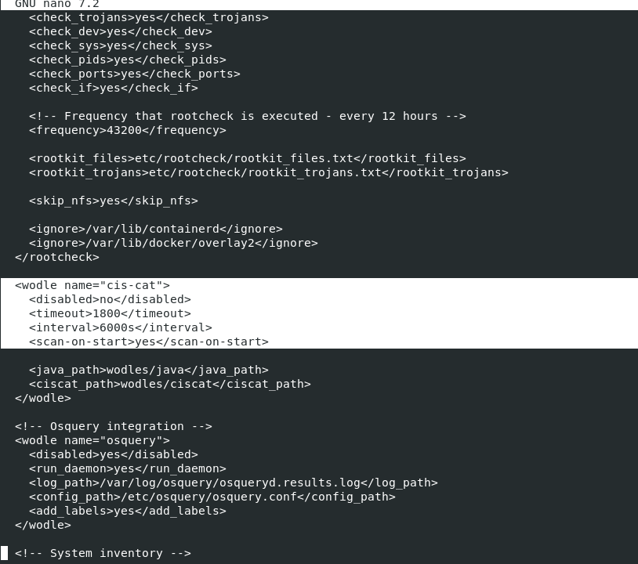

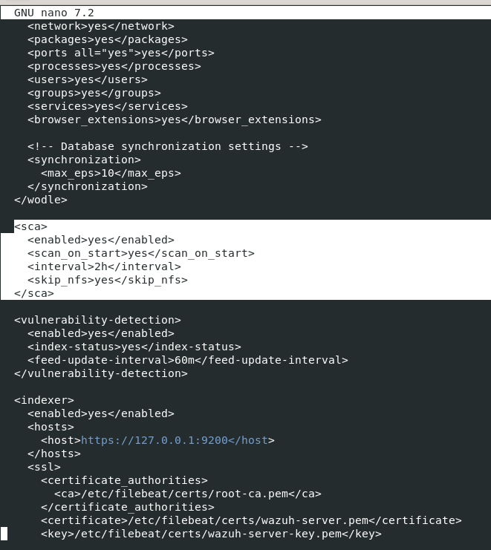

Visualization Creation :
- Top 10 SCA Checks With Remediations
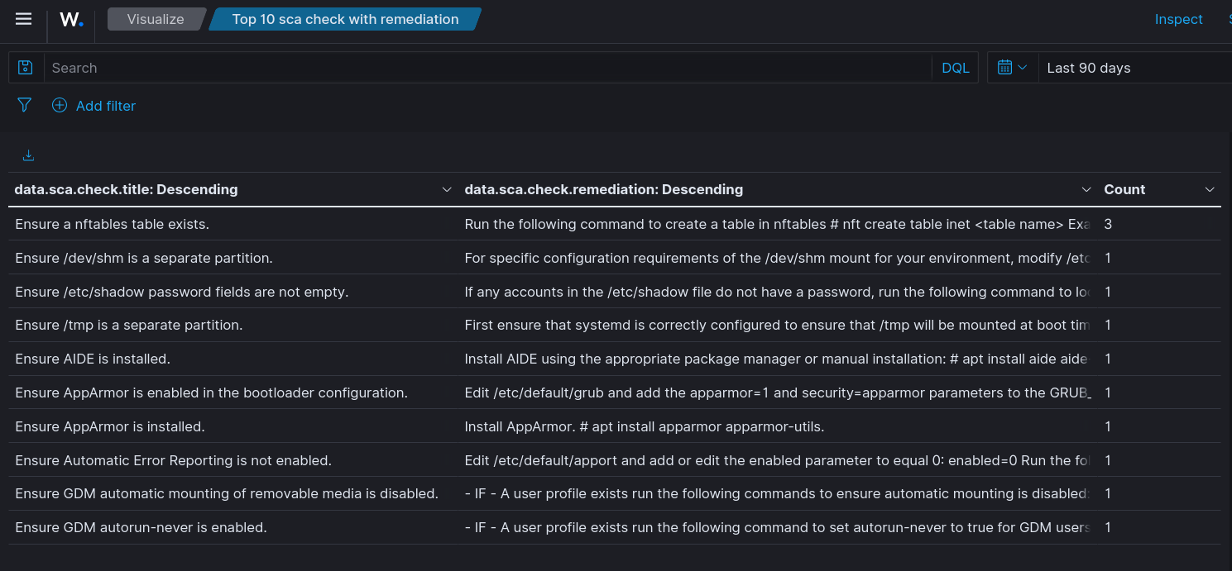

- ISO 27000 Compliance
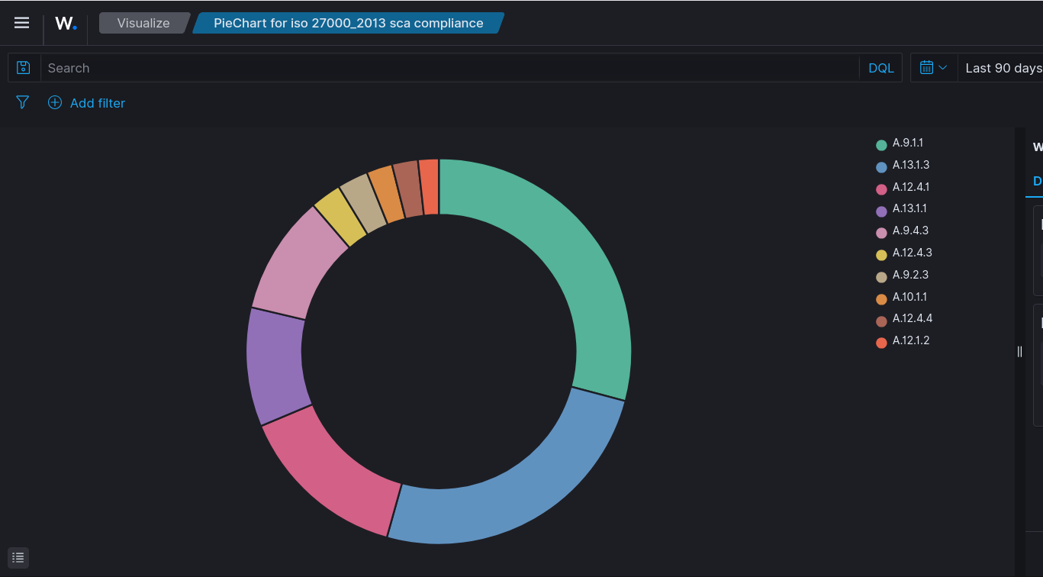

- CIS Compliance
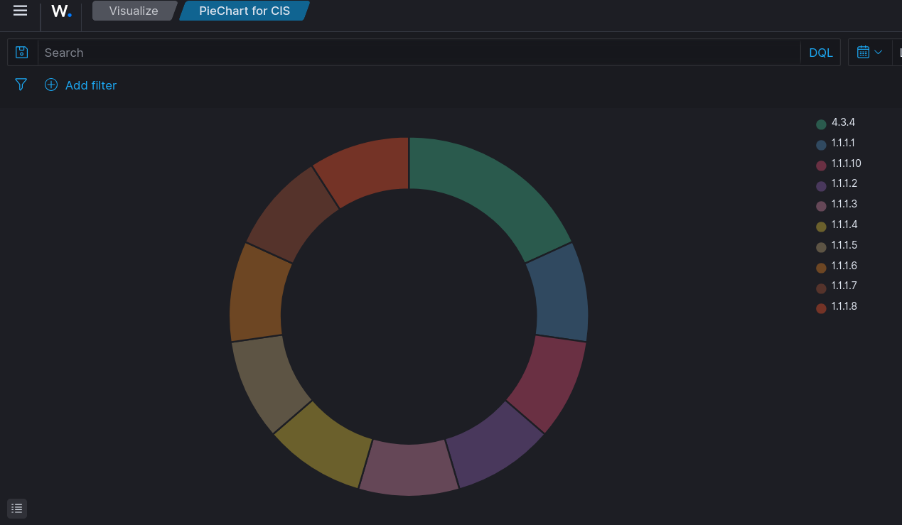

- HIPAA Compliance
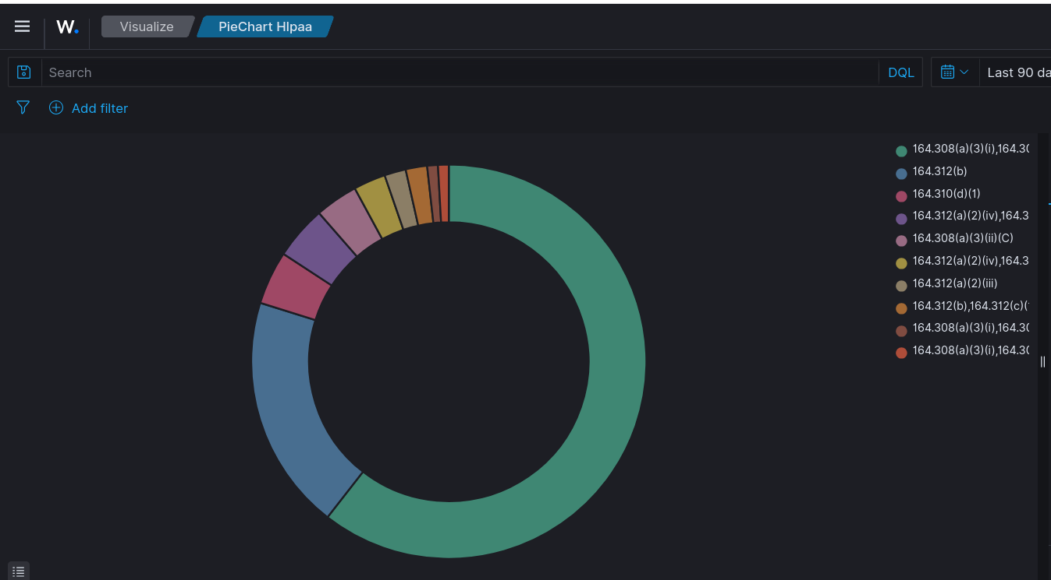

- SCO.2 Compilance
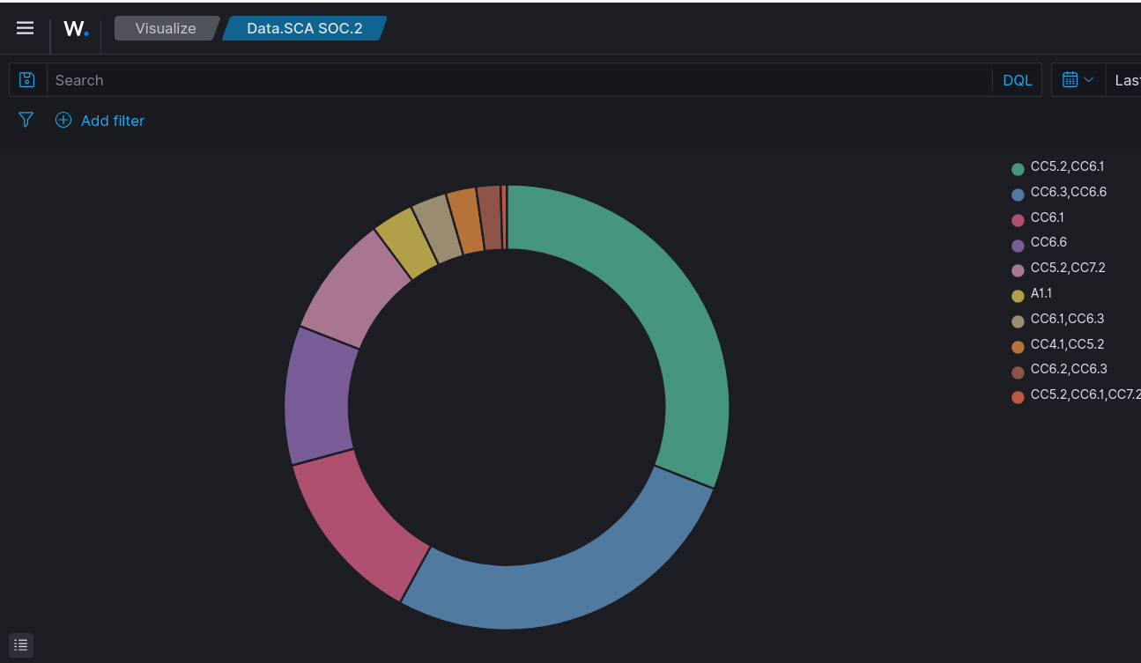

- SCA Checks Results
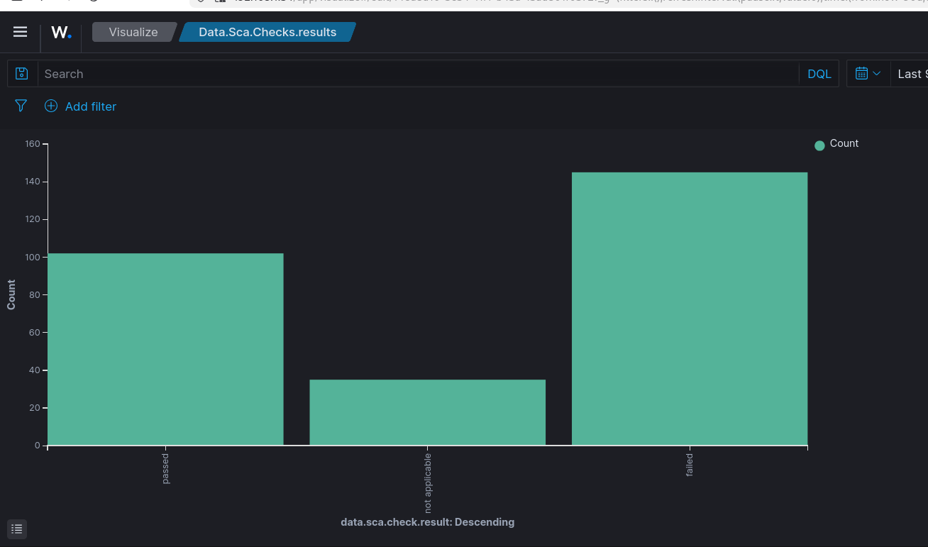

- Remediation Status
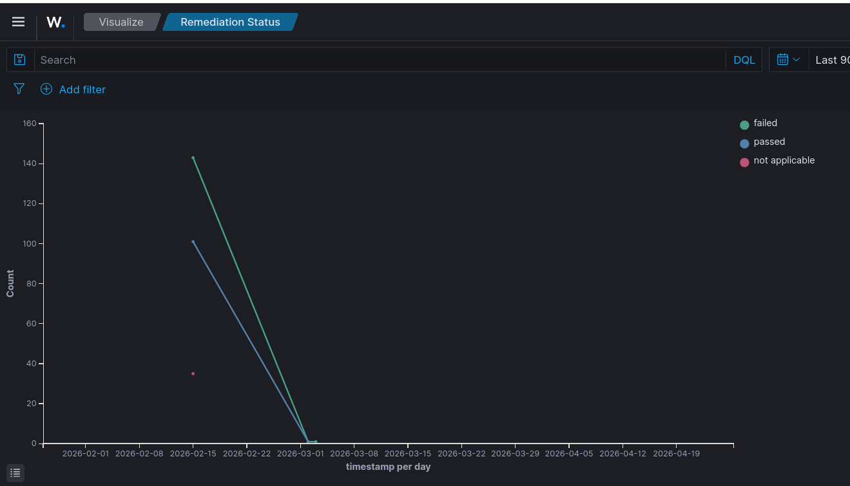

Dashboard Creation : By adding all the Visualization in the panel .

Reporting : Creation of report
Visualization pick is Remediation Status
Period , Last 4 month to date
On Demand , PDF
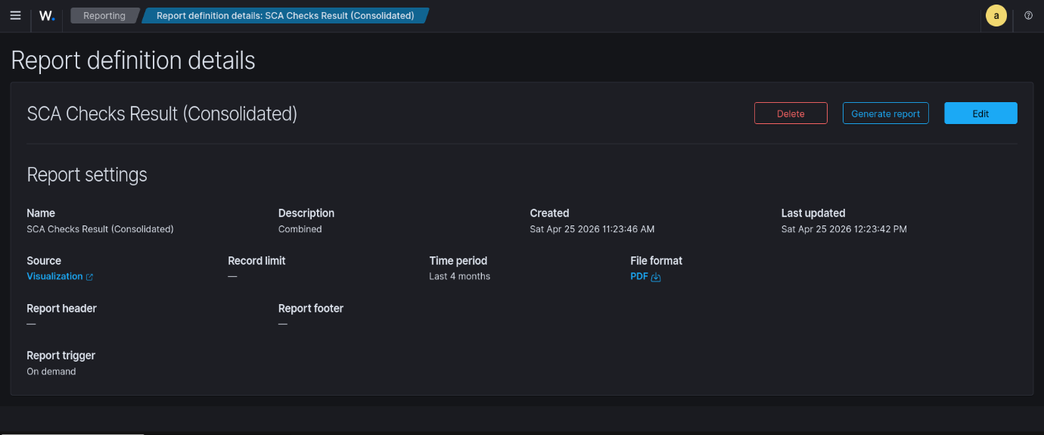

Sample of The Report :
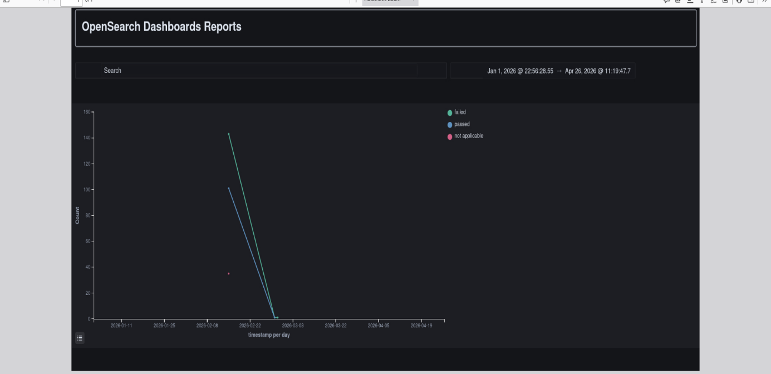

Status of Decline in failed over time if the correct remediation has been taken , will be shown in the reflected the Report .

