LINUX FUNDAMENTALS

QUESTION: How to check if linux is installed in your windows?

METHOD:

PS C:\Users\akujvika> wsl --version

WSL version: 2.5.7.0

Kernel version: 6.6.87.1-1

WSLg version: 1.0.66

MSRDC version: 1.2.6074

Direct3D version: 1.611.1-81528511

DXCore version: 10.0.26100.1-240331-1435.ge-release

Windows version: 10.0.22631.5335

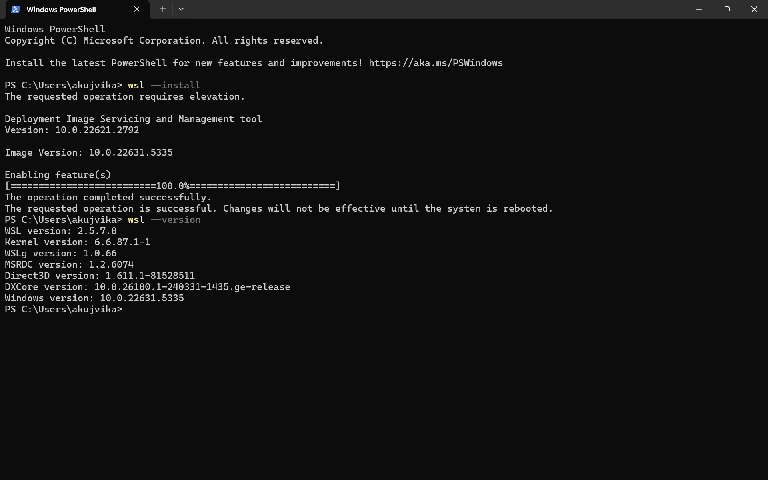

TASK 1: Create a Directory with the Name Linux

SOLUTION:



TASK 2: Change to the directory

SOLUTION :



TASK 3: Create a file name TestFile1.txt and add the content to it.

SOLUTION:

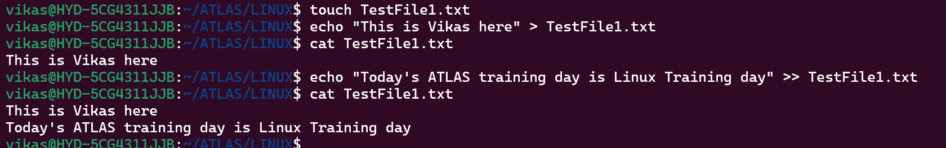

TASK 4: Create a Folder named Dummy and try to delete it.

SOLUTION:

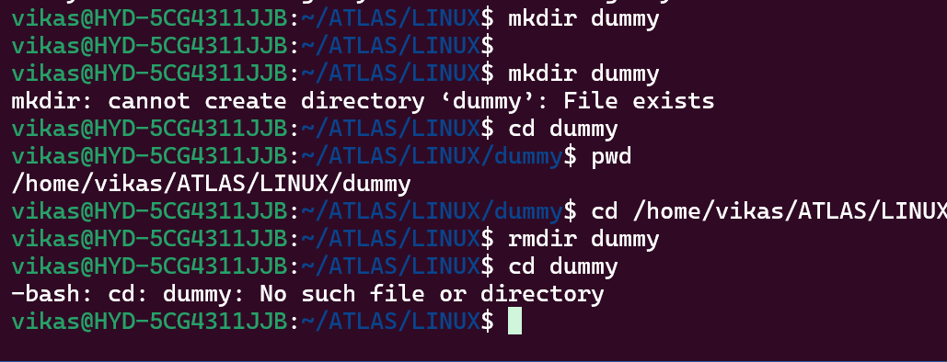

Task 5: check the working directory (Hint : pwd)

SOLUTION:

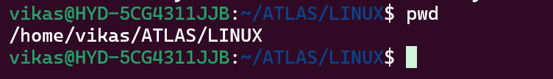

Task 6: How do you check all the files and directories in the directory you are in?

SOLUTION:

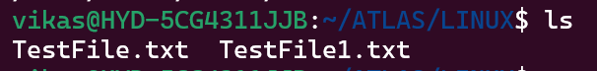

Task 7: Create five files named TestFile2.txt.. TestFile3.txt… and so on till TestFile6.txt

SOLUTION:

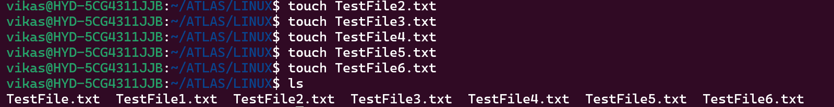

Task 8: Copy all files from Dir 1 to Dir 2

SOLUTION:

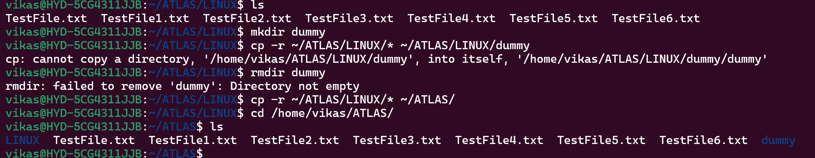

Task 9: Move all files from Dir 2 to Dir 3

SOLUTION:

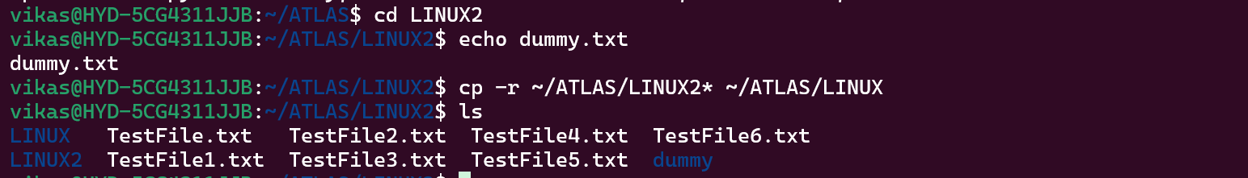

Task 10: Can you plz show me the diff between **rm** and **rmdir** commands with screenshots?

SOLUTION :

1. `rm` (remove) command:The `rm` command is used to remove files. It can be used to delete both files and directories

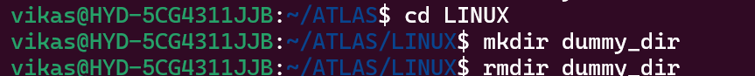

2. `rmdir` command: The `rmdir` command is used to remove empty directories. It can only remove directories that are completely empty (i.e., they do not contain any files or subdirectories).

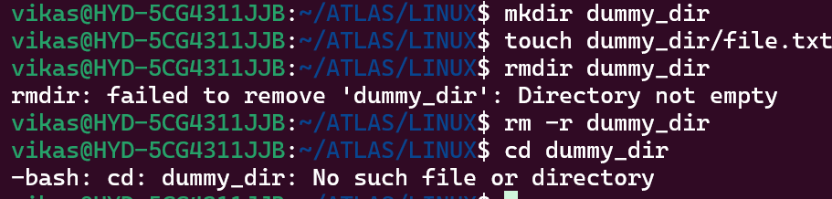

Task 11: Now use specifically use cat command to create a file and add the dummy text from the above link Lorem Ipsum.

SOLUTION:

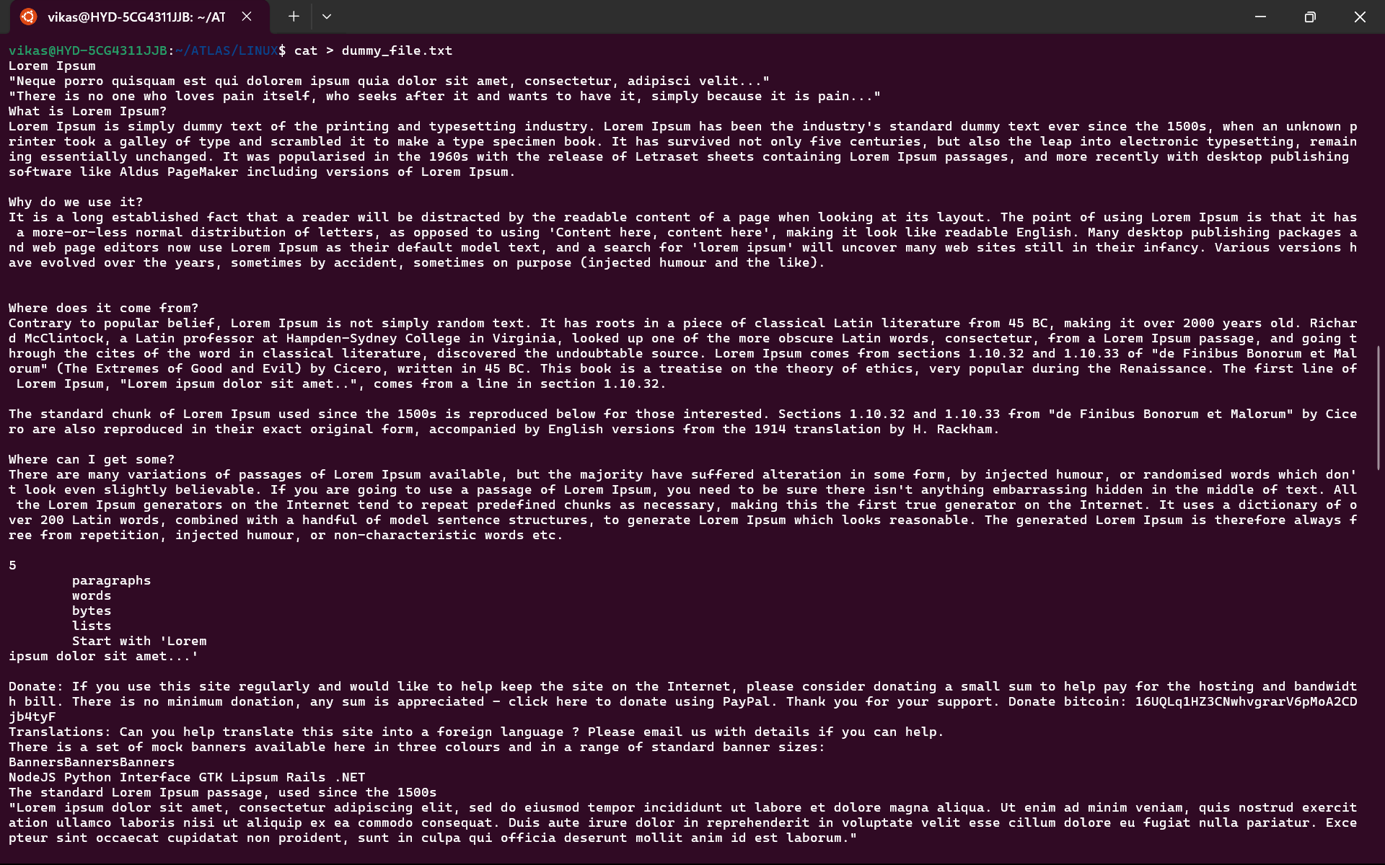 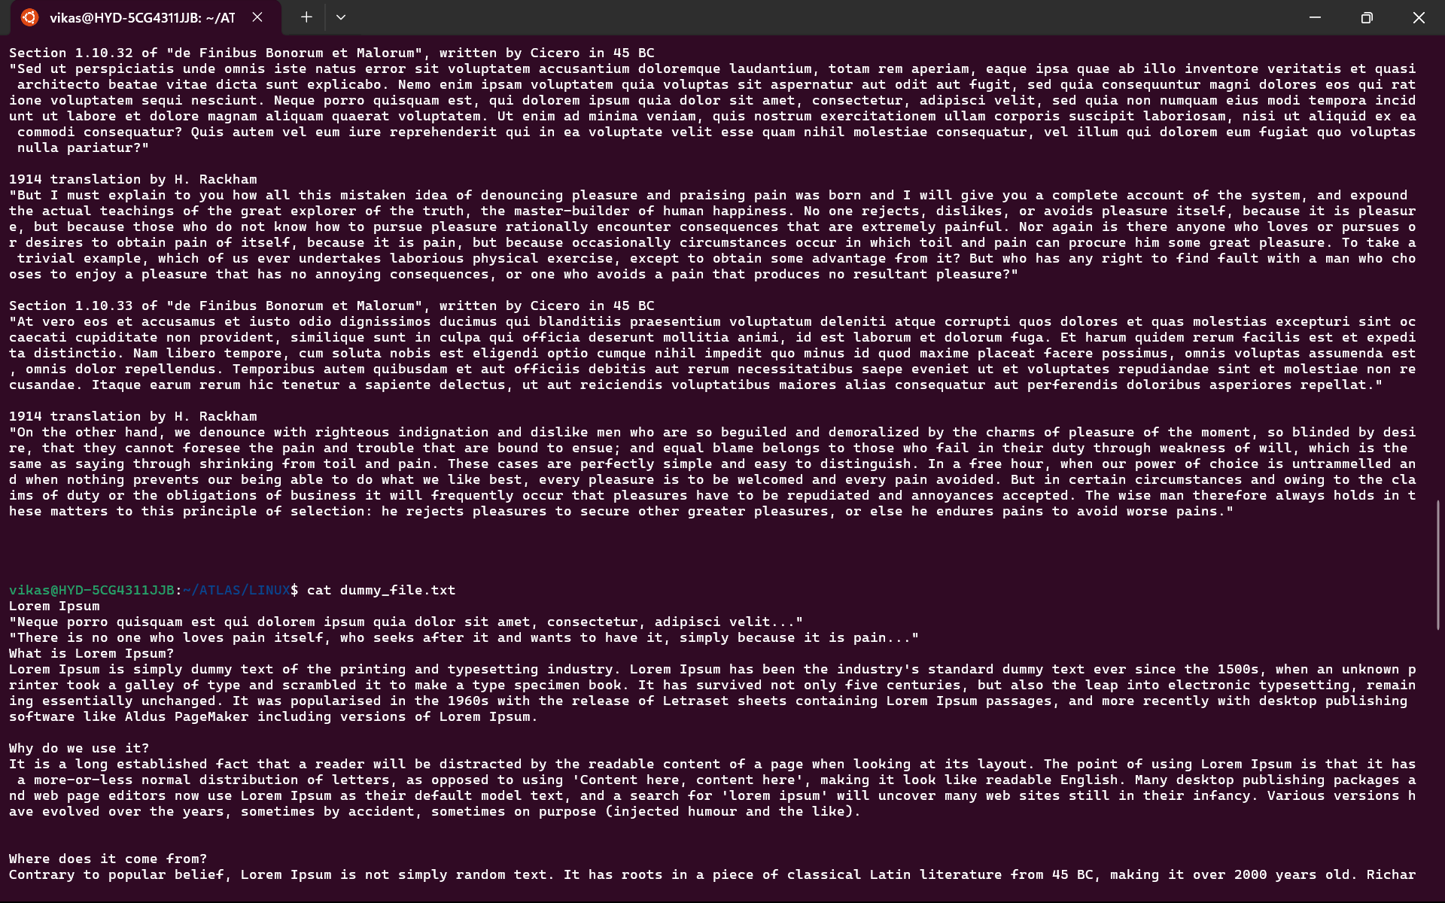

Task 12: How to get only the top part of your file. (Hint: use head)

SOLUTION:

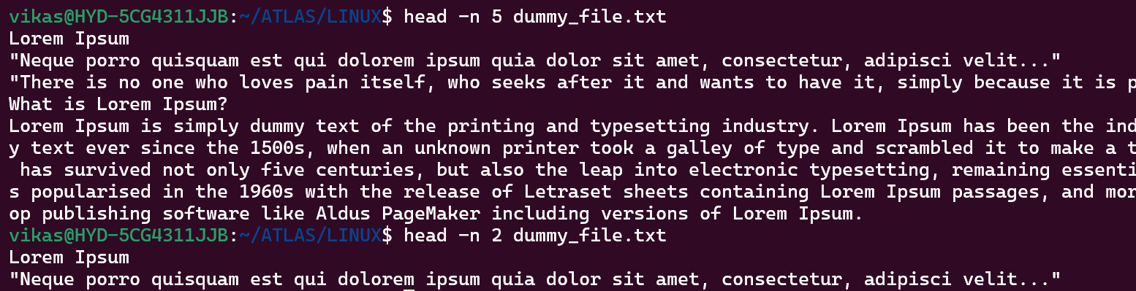

Task 13: How to get only the last part of your file (Hint: use tail)

SOLUTION:

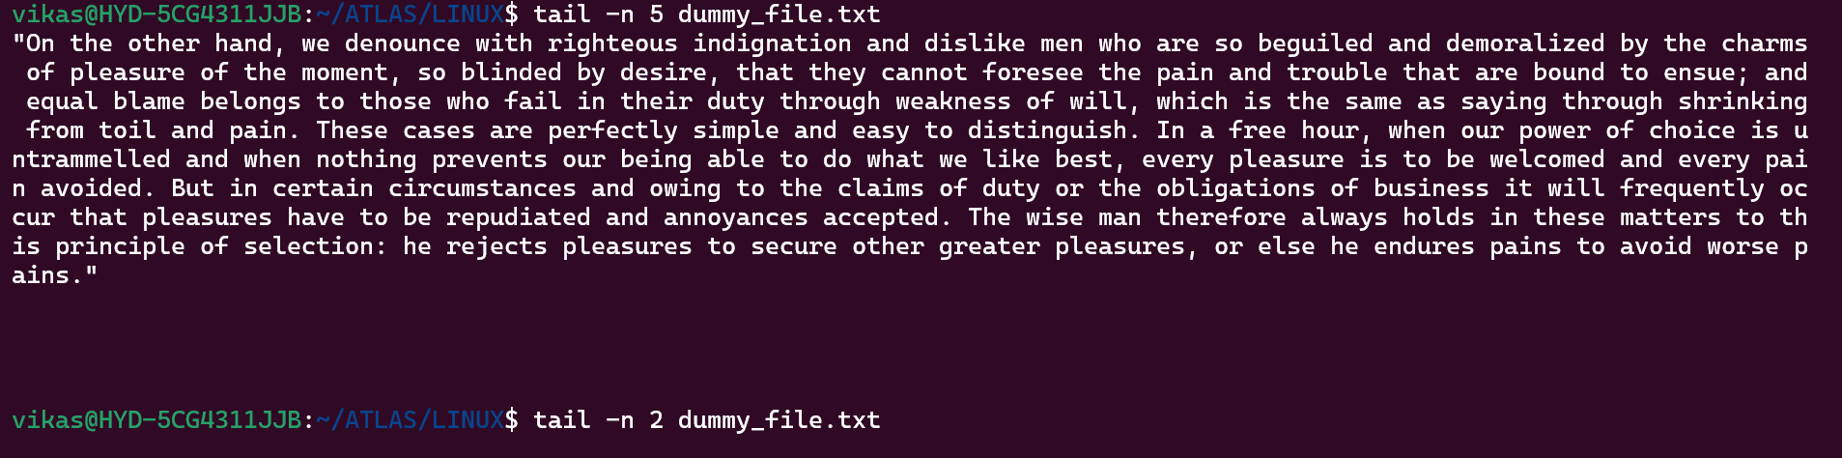

Task 14: Please add dummy text of 5 to 6 pages in to the same file and Now show the file in page by page (Hint: use less command)

SOLUTION: 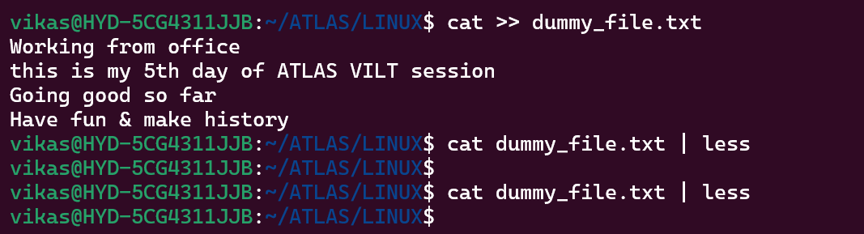 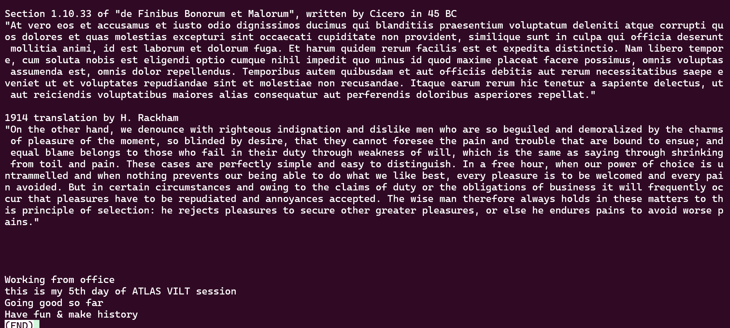

Task 15: Use more command on the above file and find out the diff between less command and more command.

SOLUTION: less is more feature-rich and provides more control over navigating and searching through the file contents, while more is a simpler and faster option for basic page-by-page viewing.



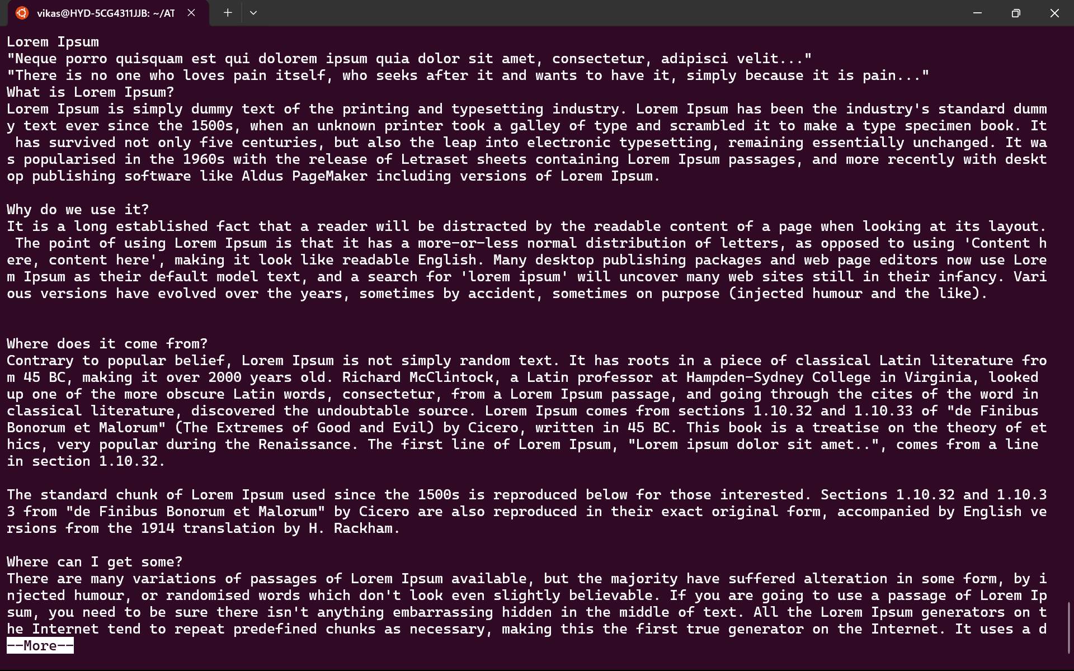

Task 16: Can you use echo command with -e and see the difference

SOLUTION: The main difference is that the -e option allows the echo command to interpret and display special characters and escape sequences, while without the -e option, these sequences are displayed literally.

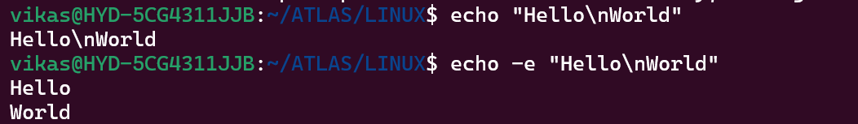

Task 17: What is diff between ls and ls -l command?

SOLUTION: ls provides a simple, concise listing of files and directories, while ls -l offers a more detailed, comprehensive view of the directory contents, which can be useful for various administrative and troubleshooting tasks

Ls :

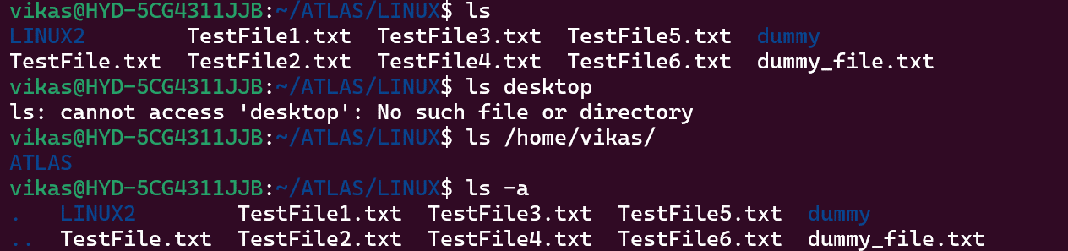

Ls-l :

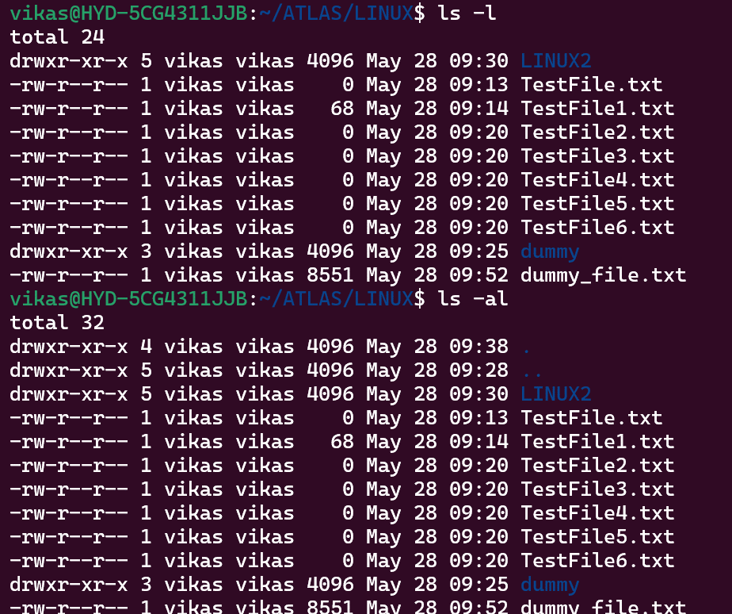

Task 18: Create a file using **touch** command, **cat** command and **echo** command. Also write the difference between touch, cat and echo commands.

SOLUTION: The key differences are:

- `touch` creates or updates file timestamps, `cat` displays file contents, `echo` outputs a given string.

- `touch` does not display any output, `cat` displays the file contents, `echo` displays the provided text.

- `touch` does not create file content, `cat` can be used to create new files, `echo` can be used to create or modify file contents.

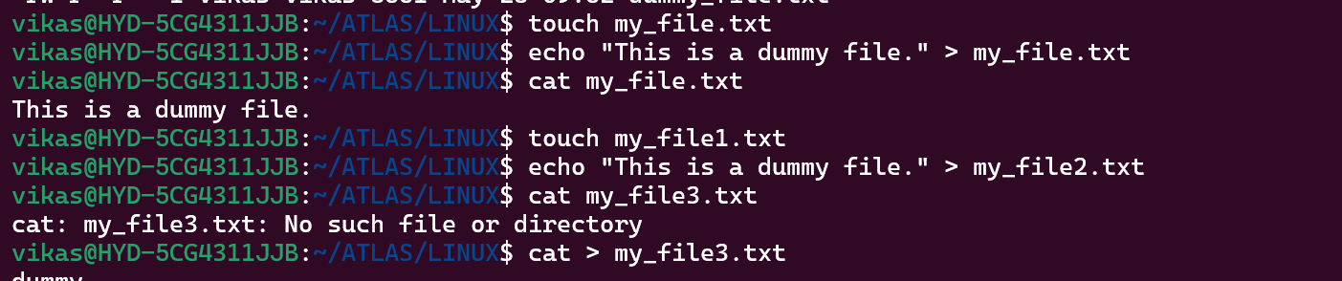

Task 19: Can you guys try to display the calendar by using a command. (Hint: use Cal)

SOLUTION: 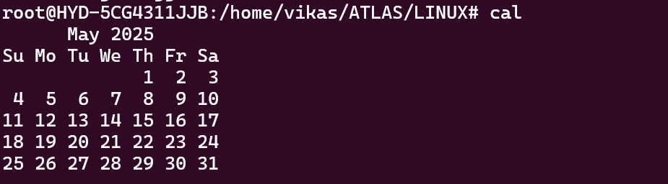

Task 20: Can you go back to 1 directory. at a time, what’s the command?

SOLUTION: 

Task 21: How to know whose user u are working on? (Hint: use whoami command)

SOLUTION: 

Task 22: Try to find out who is peeping into your system. (Use users, who and w commands)

SOLUTION: 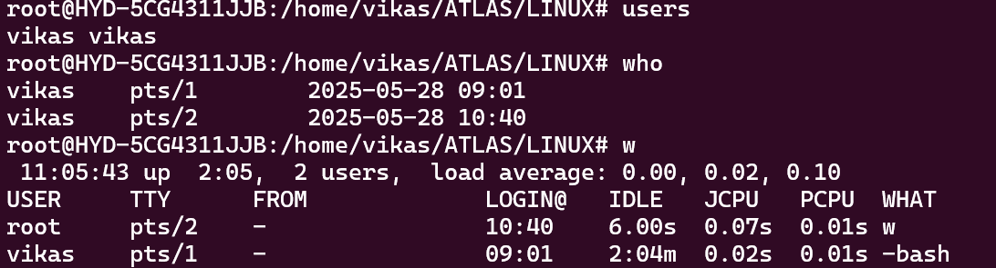

Task 23: Can you guys try to check how much disk space is consumed. (Hint: use df -h)

SOLUTION: 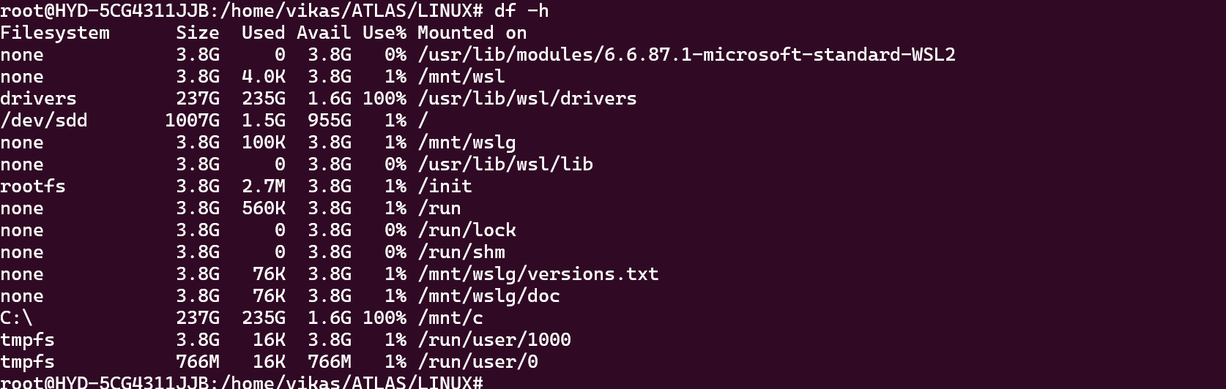

Task 24: Can you plz try using the below commands?

|  |  |
| --- | --- |
| **Prefix** | **Description** |
| **-** | **Regular file**, such as an ASCII text file, binary executable, or hard link. |
| **b** | **Block special file**. Block input/output device file such as a physical hard drive. |
| **c** | **Character special file**. Raw input/output device file such as a physical hard drive. |
| **d** | **Directory** which contains a listing of other files and directories. |
| **l** | **Symbolic link file**. Links on any regular file. |
| **p** | **Named pipe**. A mechanism for interprocess communications. |
| **s** | **Socket** which is used for interprocess communication. |

SOLUTION:

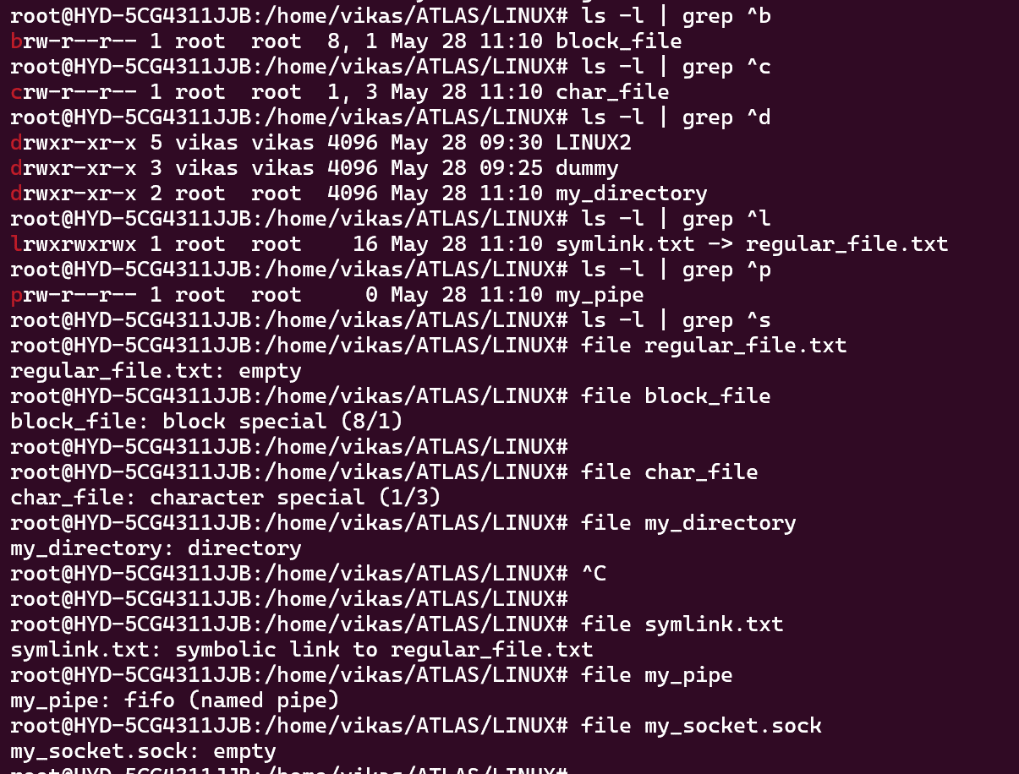

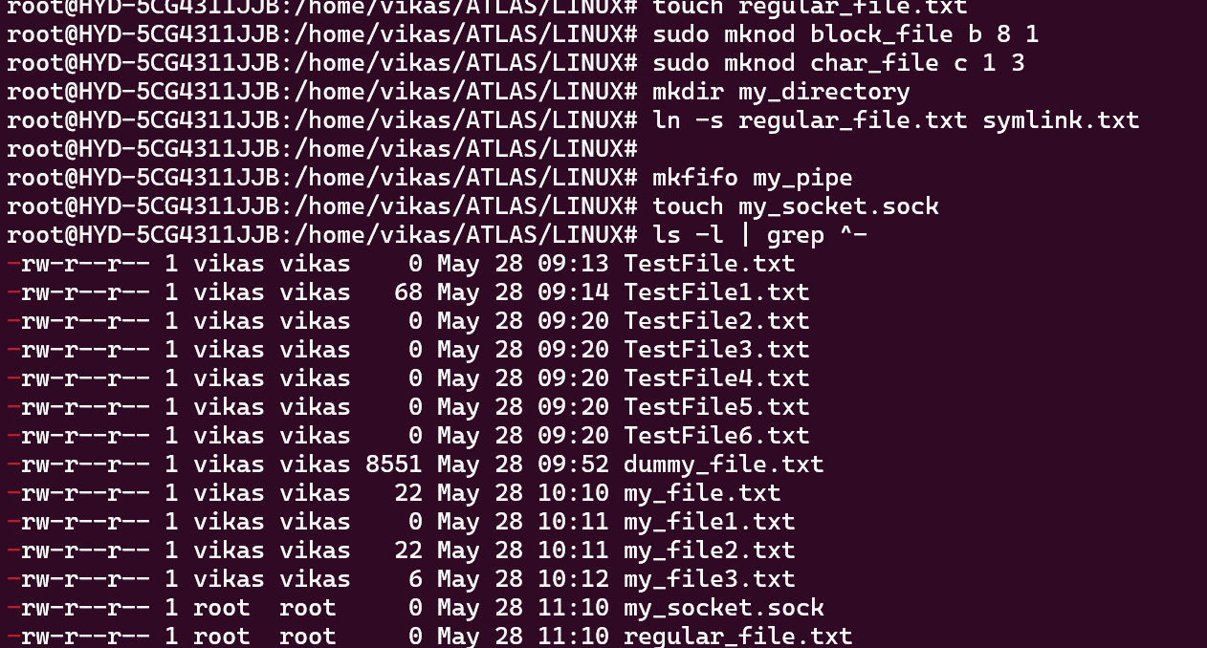

Task 25: Find the list pf all files ending with .txt (Hint: use * in ls)

SOLUTION: 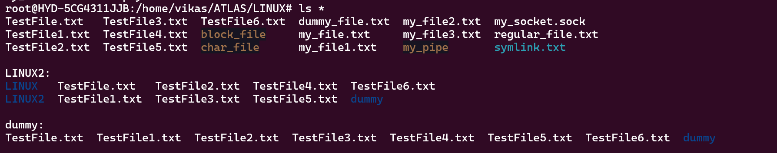

Task 26: In Linux all the hidden files start with. (period) How to check all the hidden files in Linux. (Hint: use ls -a)

SOLUTION:

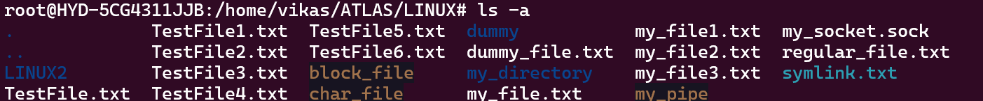

Task 27: What is the difference between (.) and (..) in Linux?

SOLUTION: Both the (.) and (..) are considered "special" directories in Linux and are present in every directory. They are essential for navigating the file system and performing various operations relative to the current working directory.

Task 28: Can you create a file using vi editor (Hint: Esc is for come out of the edit mode & press two keys Shift &plus; ZZ together to come out of the file completely)

* I - to insert /To move inside the file
* **l** key to move to the right side.
* **h** key to move to the left side.
* **k** key to move upside in the file.
* **j** key to move downside in the file.

SOLUTION: 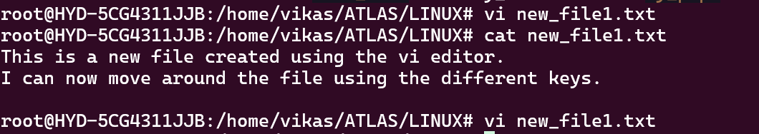

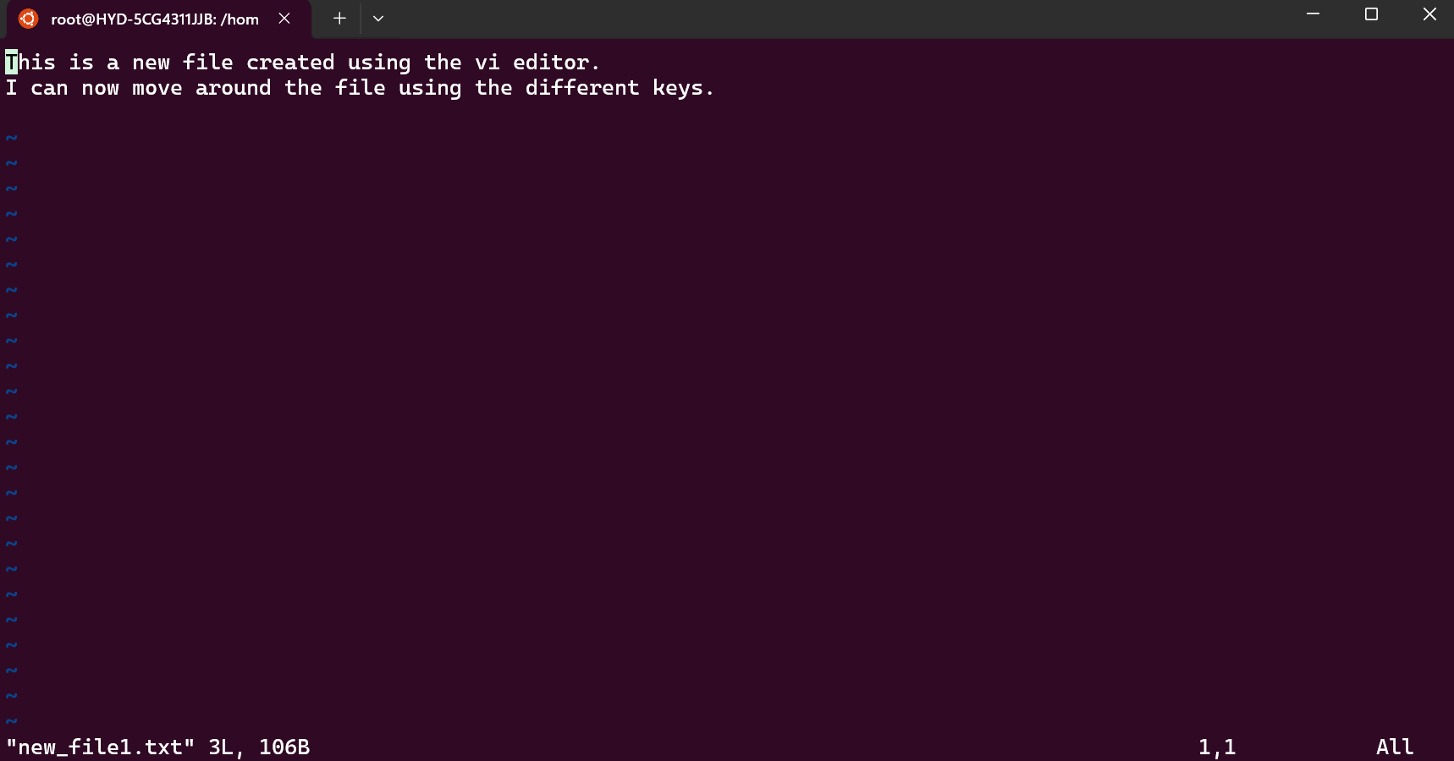

Task 29: How to find the no of words in the file? (Hint: use wc)

Here is the detail of all the four columns of wc command −

* **First Column** − Represents the total number of lines in the file.
* **Second Column** − Represents the total number of words in the file.
* **Third Column** − Represents the total number of bytes in the file. This is the actual size of the file.
* **Fourth Column** − Represents the file name.

SOLUTION: The wc command with the -w option, we can quickly and easily get the word count of a file in Linux.

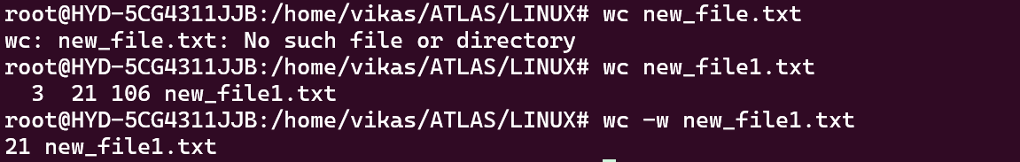

Task 30: What is the use of cat -b myfilename.txt command?

SOLUTION: The cat -b command is a useful tool for displaying the contents of a file with line numbers for non-empty lines, which can be helpful in various situations

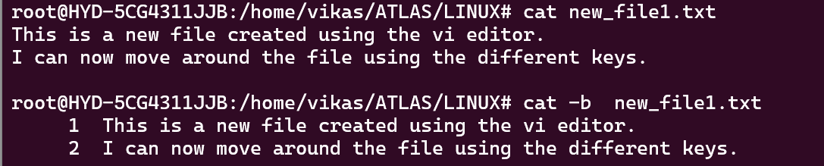

Task 31: Can I use the wc with 2 or more files (Ex: Wc file1 file2 file3)

SOLUTION: 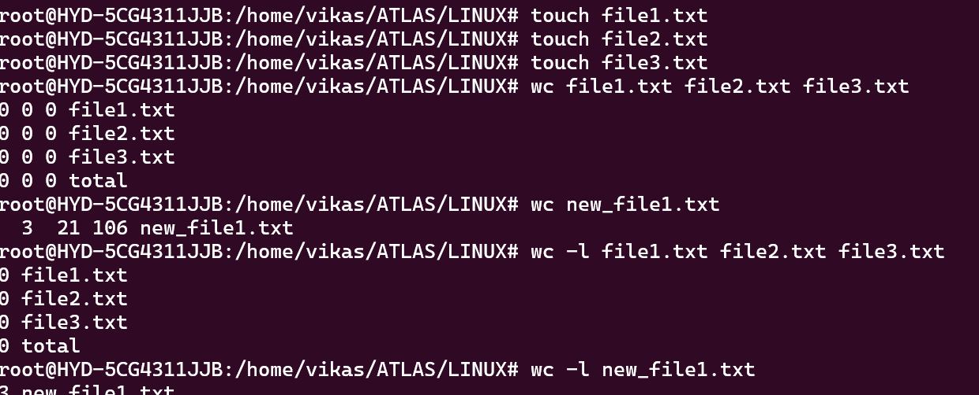

Task 32: How to copy content of one file to another file. Hint: (use cp)

SOLUTION: The cp command creates a new file with the specified name, and the content of the new file will be a copy of the source file.

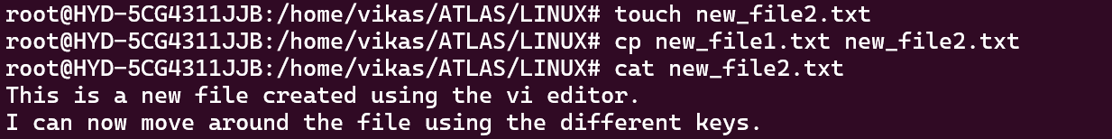

Task 33: Now I want to rename my file with MYFILENEW. How to do it? (Hint use: mv)

SOLUTION: 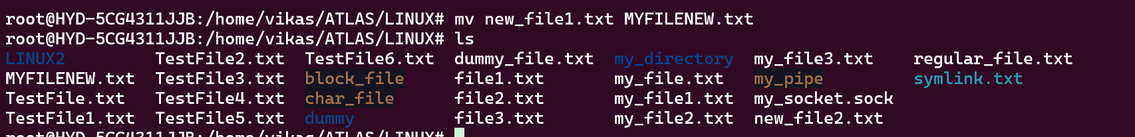

Task 34: Can I remove or delete multiple files in Linux? How?

SOLUTION: Okay, let's dive deeper into the removal or deletion of multiple files in Linux. Here are some additional points and examples:

1. **Deleting multiple files with a single command**:

- You can delete multiple files at once by listing them all in the `rm` command:

rm file1.txt file2.txt file3.txt

- This will delete the three files `file1.txt`, `file2.txt`, and `file3.txt`.

2. **Deleting files using wildcards**:

- You can use wildcards (`*`) to delete files that match a certain pattern:

rm *.txt

- This will delete all files with the `.txt` extension in the current directory.

3. **Deleting files recursively (including subdirectories)**:

- To delete a directory and all its contents (files and subdirectories), use the `-r` (recursive) option:

rm -r directory1

- This will delete the `directory1` directory and all its contents.

4. **Deleting files interactively**:

- The `-i` option will prompt you before deleting each file, allowing you to confirm or skip the deletion:

rm -i *.txt

- This will prompt you before deleting each `.txt` file in the current directory.

5. **Deleting files without confirmation**:

- The `-f` (force) option will delete the files without prompting for confirmation:

rm -f *.txt

- This will delete all `.txt` files in the current directory without any prompts.

6. **Deleting empty directories**:

- To delete an empty directory, you can use the `rmdir` command:

rmdir empty_directory

- This will delete the `empty_directory` directory if it is empty.

7. **Deleting non-empty directories**:

- If you want to delete a directory that is not empty, you can use the recursive (`-r`) option with `rm`:

rm -r non_empty_directory

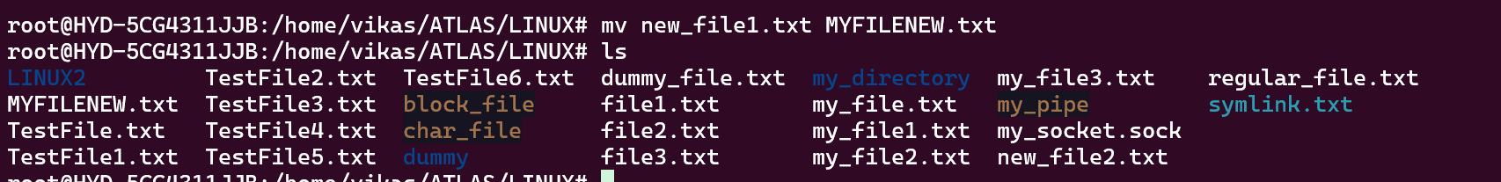

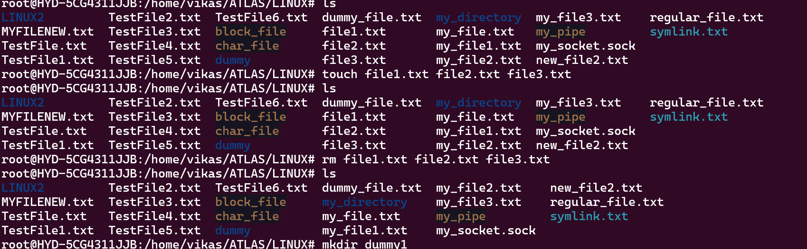

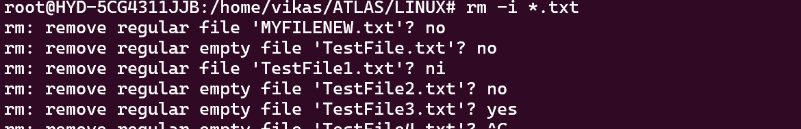

Task 35: In directory / slash is root, can you try cd / what is it doing? (Linux directory structure below)

|  |  |
| --- | --- |
| **Directory** | **Description** |
| **/bin** | important binary applications |
| **/boot** | boot configuration files, kernels, and other files needed at boot time. |
| **/dev** | System device files. |
| **/etc** | configuration files, startup scripts, etc. |
| **/home** | List of home directories for different users |
| **/lib** | system libraries, shared libraries |
| **/lost+found** | a lost+found system for files that exist under the root (/) directory |
| **/media** | automatically mounted (loaded) partitions on your hard drive and removable media such as CDs, digital cameras, etc. |
| **/mnt** | manually mounted filesystems on your hard drive |
| **/opt** | 3rd part applications to be installed |
| **/proc** | Maintains information about the state of the system, including currently running processes. |
| **/root** | root user's home directory. |
| **/sbin** | important system binaries |
| **/srv** | contain files that are served to other systems |
| **/sys** | system files |
| **/tmp** | temporary files |
| **/usr** | applications and files that are mostly available for all users to access |
| **/var** | variable files such as logs and databases |

SOLUTION: Okay, let's explore what happens when you use the `cd /` command in the Linux directory structure.

The `/` (forward slash) represents the root directory, which is the top-level directory in the Linux file system hierarchy. When you execute the `cd /` command, it will change your current working directory to the root directory.

Breakdown of the Linux directory structure and what the root directory (`/`) represents:

- `/`: This is the root directory, the top-level directory in the file system. It contains all the other directories and files in the system.

- `/bin`: This directory contains important binary applications, such as essential command-line tools like `ls`, `cp`, `mv`, and `rm`.

- `/boot`: This directory contains the boot configuration files, kernels, and other files needed during the boot process.

- `/dev`: This directory contains system device files, which represent hardware devices connected to the system.

- `/etc`: This directory contains system-wide configuration files, startup scripts, and other essential system files.

- `/home`: This directory contains the home directories for different users on the system.

- `/lib`: This directory contains system libraries, including shared libraries required by various applications.

- `/mnt`: This directory is used to manually mount filesystems, such as external storage devices or network-attached storage.

- `/opt`: This directory is used to install third-party applications and software.

- `/proc`: This directory provides information about the current state of the system, including running processes.

- `/root`: This is the home directory for the root user, the superuser with the highest level of privileges.

- `/sbin`: This directory contains important system binaries, typically used by the system administrator.

- `/tmp`: This directory is used to store temporary files that can be safely deleted.

- `/usr`: This directory contains applications and files that are mostly available for all users to access.

- `/var`: This directory is used to store variable files, such as logs and databases.

By using the `cd /` command, you will change your current working directory to the root directory, allowing you to navigate and interact with the various subdirectories and files within the Linux file system.

Task 36: What is the way to go to home directory? (Hint: use cd ~)

SOLUTION: The tilde (~) is a shorthand notation that represents the current user's home directory. It's a convenient way to quickly navigate to your home directory, regardless of your current working directory.

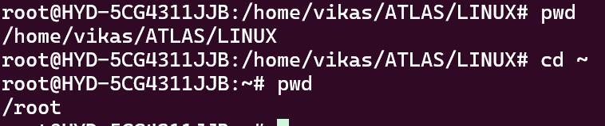

Alternatively, you can simply use the cd command without any arguments to achieve the same result:

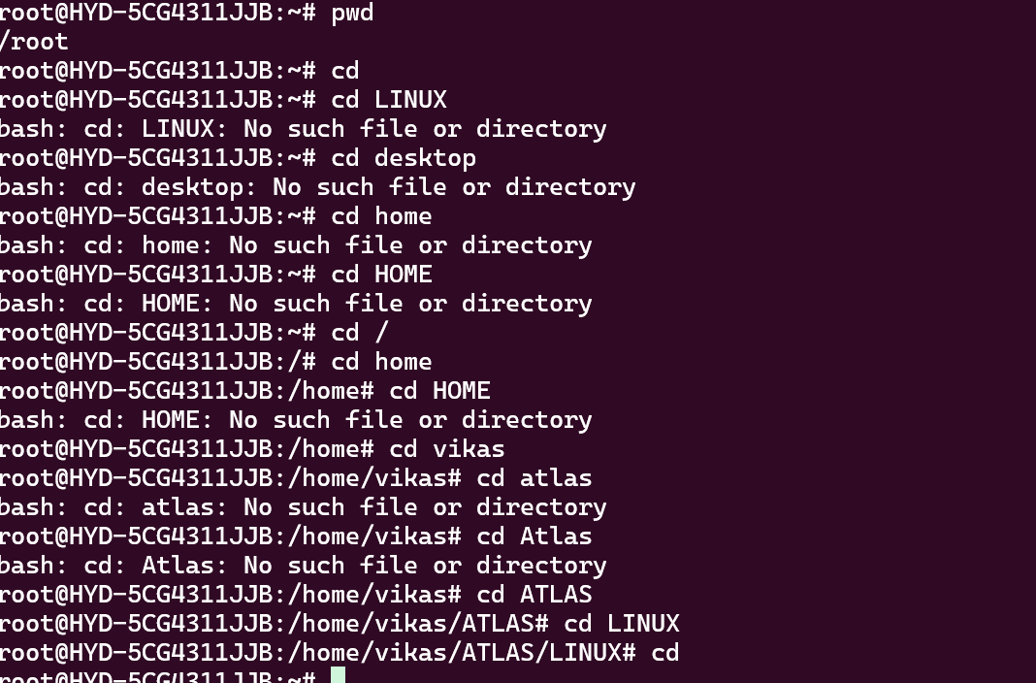

Task 37: If i want to move to different user’s home directory (Hint: use ~username)

SOLUTION: Using the ~username syntax is a convenient way to quickly navigate to other users' home directories in Linux, without having to remember or type the full path.

