Output:
2. Implement vaccum-cleaner Agent using reflex and goal based agent:
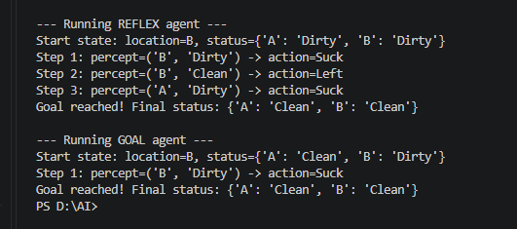

- Implement TIC-TAC-TOE game:

