USN-1BM24CS315 LAB-2 (BANK DATABASE)

1. Find all customers who have atleast two deposits at same branch

select d.customer_name,count(*) as accountcount

from depositor d

group by d.customer_name

having count(*)>=2;

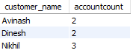

1. Create a view which gives each branch sum of amounts of all loans at the branch.

create view total as

select branch_name, sum(amount)

from loan

group by branch_name;

select * from total;

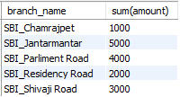

1. Display branchname, assests in lakhs

select branch_name,assets as assests_in_lakhs from branch ;

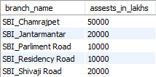

Additional Queries:

1. Find all the customers who have an account all the branches located in a specific city.

select d.customer_name

from depositor d,bankaccount b

where d.accno=b.accno and branch_name in (select branch_name from branch where branch_city='Delhi')

group by d.customer_name;

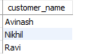

1. Find all the customers who have a loan at the bank but do not have an account

None

1. Customer who have both an account and a loan at the banglore branch

None

1. Branches with assests greater than all the branches located in banglore.

select branch_name from branch where assets >all(select assets from branch where branch_city='Banglore');

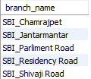

1. Delete all account types at branches in Bombay

delete from bankaccount where branch_name in(select branch_name from branch where branch_city='Bombay');

0 rows affected.

1. Update balance of all accounts by 5%

update bankaccount

set balance=balance*1.05;

select * from bankaccount;

