WEEK-5-EMPOLYEE DATABASE ADDITONAL QUERIS
(7-11-2025)

- List employees with their department name & location

select e.e_name,d.d_name,d.d_loc
from employee e, dept d
where e.dept_no=d.dept_no;

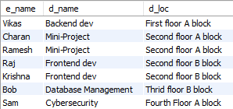

- Employees who are not assigned to any project ,Project-wise headcount

SELECT E.e_no, E.e_name
FROM employee E
LEFT JOIN assigned_to A ON E.e_no = A.e_no
WHERE A.p_no IS NULL;

NONE: Every employee is assigned to some project.

SELECT P.p_name, COUNT(A.e_no) as total
FROM project P
LEFT JOIN assigned_to A ON P.p_no = A.p_no
GROUP BY P.p_name;

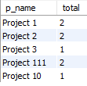

- Department-wise average & max salary

SELECT D.d_name, AVG(E.sal) AS AVG_SALARY, MAX(E.SAL) AS MAX_SALARY
FROM employee E
JOIN dept D ON E.dept_no = D.dept_no
GROUP BY D.d_name;

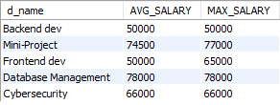
- Total incentives earned by each employee (lifetime)
SELECT E.e_no, E.e_name, SUM(I.incentive_amount) AS TOTAL_INCENTIVES
FROM employee E
JOIN Incentives I ON E.e_no = I.e_no
GROUP BY E.e_no, E.e_name;

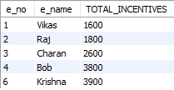

- Employees working on a given project (project name :Alpha Project)
SELECT E.e_no, E.e_name, P.p_name
FROM employee E
JOIN assigned_to A ON E.e_no = A.e_no
JOIN project P ON A.p_no = P.p_no
WHERE P.p_name = 'Project 1';

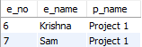

- Departments with no employees
SELECT D.dept_no, D.d_name
FROM dept D
LEFT JOIN employee E ON D.dept_no = E.dept_no
WHERE E.e_no IS NULL;
None: Each department has empolyees.

- Managers and their direct report counts (MGR_NO references EMPNO)
SELECT
M.e_no AS MANAGER_ID,
M.e_name AS MANAGER_NAME,
COUNT(E.e_no) AS REPORT_COUNT
FROM Employee M
LEFT JOIN Employee E ON E.MGR_no = M.e_no
GROUP BY M.e_no, M.e_name;

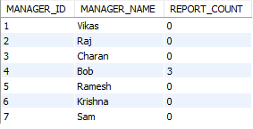

- Employees assigned to more than one project.
SELECT e_no, COUNT(p_no) AS PROJECT_COUNT
FROM assigned_to
GROUP BY e_no
HAVING COUNT(p_no) > 1;

