**MSc. (Computer Science) Semester-I**

**NAME:-VIKAS YADAV ROLL NO: 507**

**Paper III (Bioinformatics)**

|  |  |  |  |  |
| --- | --- | --- | --- | --- |
|  |  | **INDEX** |  |  |
| **NO** | **DATE** | **TITLE** | **PAGE NO** | **SIGN** |
|  |  |  |  |  |
| 1 | 08-08-22 | Complementary DNA Sequence | 2 |  |
| 2 | 08-08-22 | Identity of Two protein sequence | 4 |  |
| 3 | 26-08-22 | Pairwise Sequence Alignment | 6 |  |
| 4 | 18-08-22 | Similarity between two protein sequence | 8 |  |
| 5 | 21-08-22 | Multiple Sequence Alignment | 10 |  |
| 6 |  | Motif Finding | 15 |  |
| 7 |  | Perform a BLAST search on any genes sequence and write a code to count the no of repetition of each nucleotide in the sequence | 16 |  |
| 8 | 29-09-22 | Regular Expression | 17 |  |
| 9 | 22-09-22 | Fingerprint | 18 |  |
| 10 |  | Retrieving 3D structure from PDB |  |  |

**Practical No: 1**

**Aim**: Write a Python/Java code to find the Complementary DNA Sequence.

**Code:**

def complementary_strand_find(dna_strand):

complementary_strand = ""

for base in dna_strand:

if base == "A" :

complementary_strand += "T"

elif base == "T" :

complementary_strand += "A"

elif base == "U" :

complementary_strand += "A"

elif base == "G" :

complementary_strand += "C"

elif base == "C" :

complementary_strand += "G"

elif base == "Y" :

complementary_strand += "R"

elif base == "R" :

complementary_strand += "Y"

else :

print("Wrong input")

complementary_strand = None

break

return complementary_strand

if __name__ == "__main__":

dna_strand = "GGTACTTGCCAT"

print("DNA strand is:",

dna_strand)

print("complementary strand is:",

complementary_strand_find(dna_strand))

**Output:**

DNA strand is: GGTACTTGCCAT

complementary strand is: CCATGAACGGTA

**Practical No: 2**

**Aim:** Write a Python/Java code to find the identity value of a given sequences. Take the sequence from user.

**Code:**

se1=input("Enter the first sequence::")

se2=input("Enter the second sequence::")

seq1=list(se1)

seq2=list(se2)

def find_identity(a,b):

gap(a,b)

print(a)

print(b)

score=0

length=len(a)

total_elements=len(a)*len(b)

for i in range(0,length):

for j in range(0,length):

if(a[i]==b[j]):

score=score+1

identity=(score/total_elements)*100

print("Matching Score::",score)

print("Identity of the sequences::",identity)

def gap(a,b):

if(len(a)==len(b)):

print()

else:

k=int(input("enter the position to insert gap ::"))

if (len(a)<len(b)):

a.insert(k,'-')

else:

b.insert(k,'-')

return(a,b)

find_identity(seq1,seq2)

**Output:**

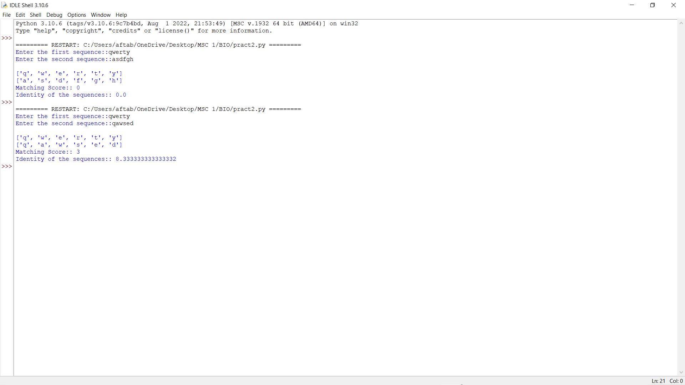

**Practical No: 3**

**Aim:** Write a Python/Java code to perform pairwise alignment. Take 2 sequences from user and calculate the score.

**Code:**

se1=input("Enter the first sequence::")

se2=input("Enter the second sequence::")

seq1=list(se1)

seq2=list(se2)

score=[]

def Pairwise_alignment(a,b):

gap(a,b)

print(a)

print(b)

value=0

length=len(a)

for i in range(0,length):

if(a[i]==b[i]):

score.append('1')

value=value+1

else:

score.append('0')

print(score)

print(value)

def gap(a,b):

if(len(a)==len(b)):

print()

else:

k=int(input("enter the position to insert::"))

if (len(a)<len(b)):

a.insert(k,'-')

else:

b.insert(k,'-')

return(a,b)

Pairwise_alignment(seq1,seq2)

**Output:**

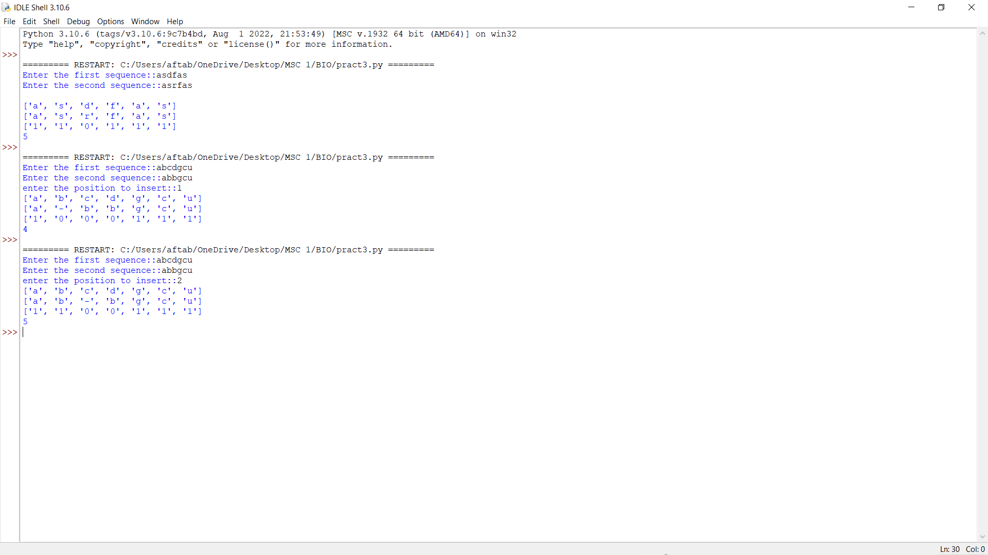

**Practical No: 4**

**Aim:** Write a Python/Java code to find the Similarity value of a given sequences. Take the sequence from user.

**Code:**

sequence_one=input("Enter the first sequence: ")

sequence_two=input("Enter the second sequence: ")

how_many=int(input("How many elements for similarity condition?"))

similarities=[]

for i in range(0,how_many):

a=input("Enter an element: ")

c=int(input("How many elements is it similar to? "))

similarities.append([])

similarities[i].append(a)

for j in range(0,c):

b=input("What is it similar to? ")

similarities[i].append(b)

def compare(o,t,s):

print(o)

print(t)

print(s)

#checking if similar

score=0

for i in range(len(o)):

for j in range(len(s)):

if o[i] in s[j] and t[i] in s[j] and o[i] != t[j]:

score+=1

#calculating similarity

similarity= (score*100)/len(o)

return similarity

print(compare(list(sequence_one),list(sequence_two),similarities),"%")

**Output:**

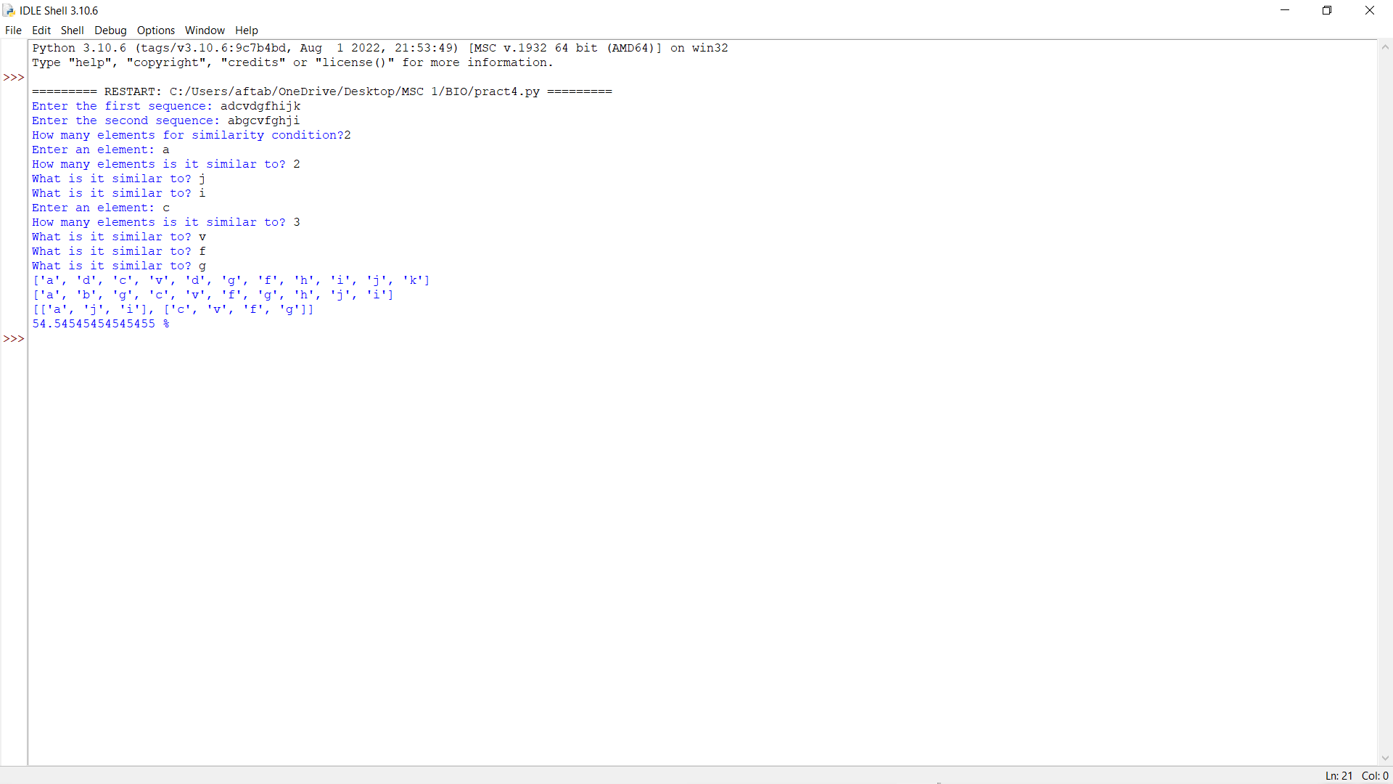

**Practical No: 5**

**Aim:** Enter genome of five different organism and write a python/java program to find consensus sequence using Multiple Sequence Alignment (MSA) technique.

**Code:**

import java.io.*; import java.util.*; public class Consensus

{

public static void main(String str[]) throws IOException

{

int n, i,j,k,count; String seq[],cons[];

ArrayList<Integer> a = new ArrayList<Integer>(); ArrayList s = new ArrayList();

BufferedReader br=new BufferedReader(new InputStreamReader(System.in)); System.out.println("Enter the no of Sequences"); n=Integer.parseInt(br.readLine());

seq=new String[n]; System.out.println("Enter sequences"); for(i=0;i<n;i++)

seq[i]=br.readLine();

cons=new String[seq[0].length()]; for(j=0;j<seq[0].length();j++) cons[j]=" "; for(j=0;j<seq[0].length();j++)

{

a.clear();

s.clear(); for(i=0;i<n;i++)

{

count=1; for(k=i+1;k<n;k++)

{

if(seq[i].charAt(j)==seq[k].charAt(j)) count++;

}

System.out.println("count="+count); a.add(count); s.add(seq[i].charAt(j));

}

/**Updated Snippet 1**/ Set<String> set = new HashSet<>(s);

ArrayList setlist = new ArrayList(set); Collections.sort(setlist);

if (setlist.contains('-') &&setlist.size()==2){ cons[j]+="-"+setlist.get(1);

}

else if (setlist.size()==1){ cons[j]+="-"+setlist.get(0);

}

else{

int m = Collections.max(a);

int index=a.indexOf(m); System.out.println("Max="+m); cons[j]+=s.get(index); System.out.println("index="+index); for(i=index+1;i<a.size();i++)

{

if(a.get(i)==m) cons[j]+="/"+s.get(i);

}

}

}

System.out.println("Consensus="); for(j=0;j<seq[0].length();j++){

/**Updated Snippet 2**/ if(cons[j].length()==2) System.out.print(cons[j].toLowerCase()); else if(cons[j].length()==3) System.out.print(cons[j].replace("-","")); else

System.out.print(cons[j]);

}

}

**Output**:

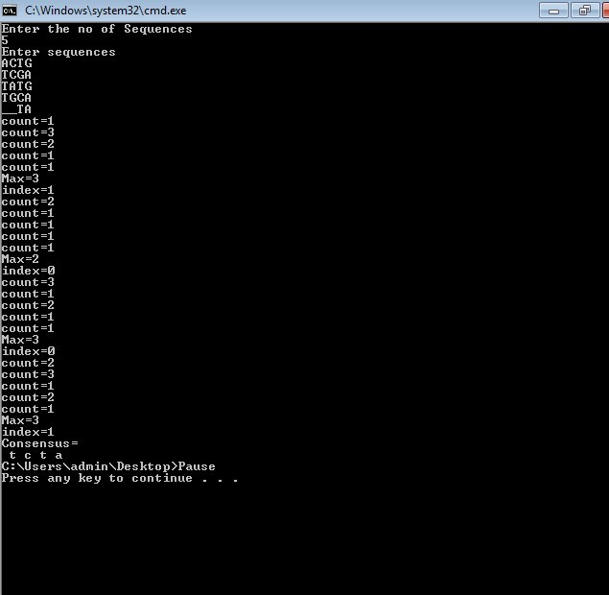

**Practical No: 6**

**Aim:** Write a Python/Java code to find motif in a given sequence

**Code:**

import random

l=int(input("Enter the length of motif"))

file=open("mot.txt","r")

r=file.read()

print("Sequence",r)

size=len(r)

print("Size of the sequence",size)

pos=random.randint(0,len(r)-5)

#pos=1

print("Position",pos)

motif=r[pos:pos+l]

print("Motif",motif)

i=pos+1

while(i<=size-1):

if(motif==r[i:i+1]):

str1=r[i:i+1]

print("Match motif",str1)

file1=open("motoutput.txt","a")

file1.write(str1+" ")

i+=1

**Output**:

Enter the length of motif4

Sequence AGAAGTTCGAGAAGCCGTAGT

Size of the sequence 21 Position 0

Motif AGAA

**Practical No: 7**

**Aim**: Perform a BLAST search on any genes sequence and writer a java/python code to count the no of repetition of each nucleotide in the sequence.

**Code**:

file=open("genes.txt","r")

r=file.read()

size=len(r)

score_A=0

score_C=0

score_T=0

score_G=0

for i in range(size):

if(r[i]=='A'):

score_A+=1

elif (r[i]=='C'):

score_C+=1

elif(r[i]=='T'):

score_T+=1

elif(r[i]=='G'):

score_G+=1

print("score of A is ",score_A)

print("score of C is ",score_C)

print("score of T is ",score_T)

print("score of G is ",score_G)

**Output:**

score of A is 6

score of C is 4

score of T is 7

score of G is 6

**Practical No: 8**

**Aim:** Generate a regular expression enter three protein sequence of three different organism. Write Python/Java code to find regular expression for this sequences.

**Code:**

def gen_reg_exp(seq_list, no_of_col):

final_list=[]

for colnum in range(no_of_col):

collist=[]

for colseq in seq_list:

collist.append(colseq[colnum])

if len(set(collist))==len(collist):

#print(final_list)

final_list.append('x')

else:

if len(set(collist))==1:

final_list.append(collist[0])

else:

final_list.append(''.join(set(collist)))

display_output(final_list)

def display_output(final_list):

print(*final_list, sep='-')

no_of_seq=int(input("Enter the number of sequence: "))

print("Enter all the sequences")

seq_list=[]

for _ in range(no_of_seq):

seq_list.append(list(map(str, input("").split())))

gen_reg_exp(seq_list, len(seq_list[0]))

**Output:**

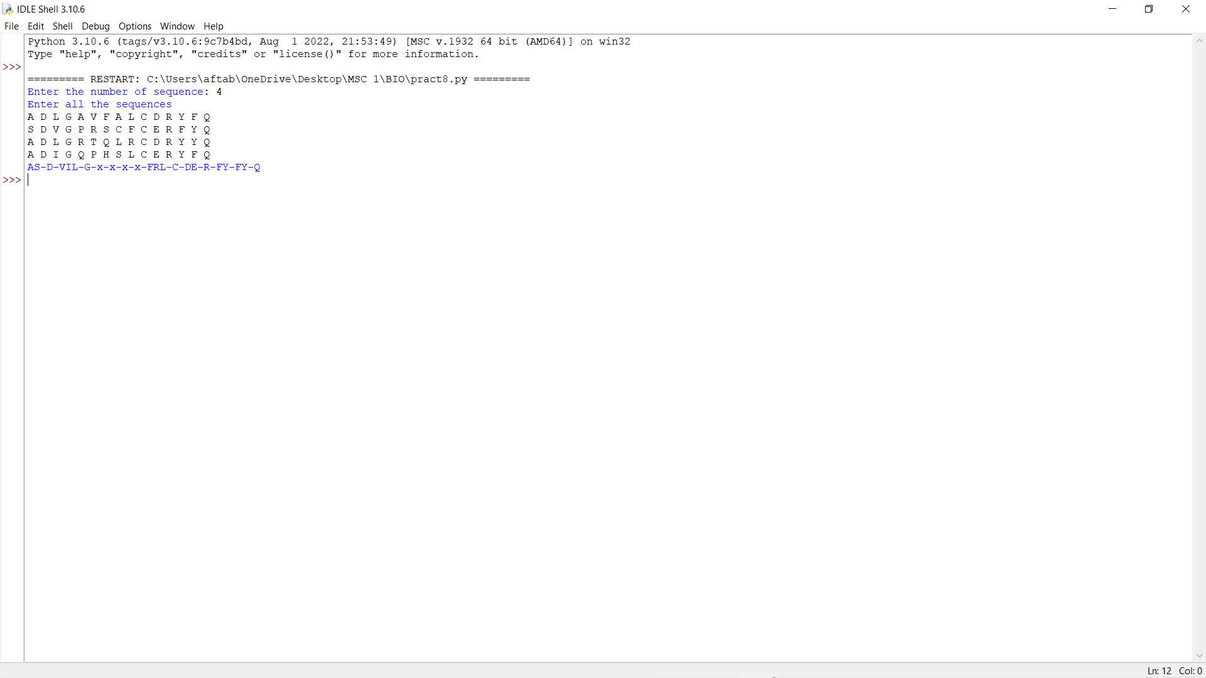

**Practical No: 9**

**Aim:** Enter six protein sequence of different organism and write a program to find a fingerprint of sequence.

**Code:**

def solve_fingerprint(seq_list, no_of_col):

seq_dict=dict()

for colnum in range(no_of_col):

counta,countc,countt,countg=0,0,0,0

for colseq in seq_list:

if colseq[colnum]=='A':

counta+=1

elif colseq[colnum]=='T':

countt+=1

elif colseq[colnum]=='C':

countc+=1

elif colseq[colnum]=='G':

countg+=1

seq_dict[colnum]=[counta,countc,countt,countg]

display_results(seq_dict)

def display_results(seq_dict):

print("\tA \tC \tT \tG")

for key in seq_dict:

print("\n",*seq_dict[key],sep="\t")

no_of_seq=int(input("Enter the number of sequence: "))

print("Enter all the sequences")

seq_list=[]

for _ in range(no_of_seq):

seq_list.append(list(map(str, input("").split())))

solve_fingerprint(seq_list,len(seq_list[0]))

**Output:**

