Landing page to connect with strava
https://strava-year-end-summary-production.up.railway.app/
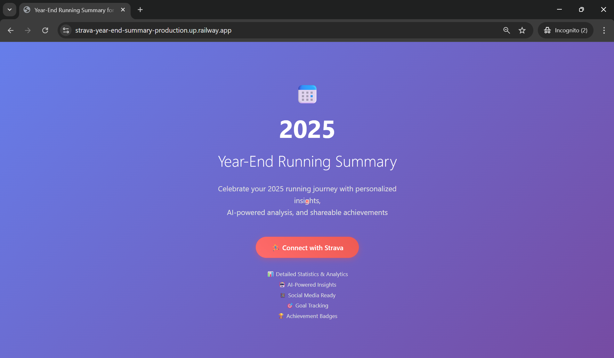

Requesting Authorization consent from the user to fetch the data
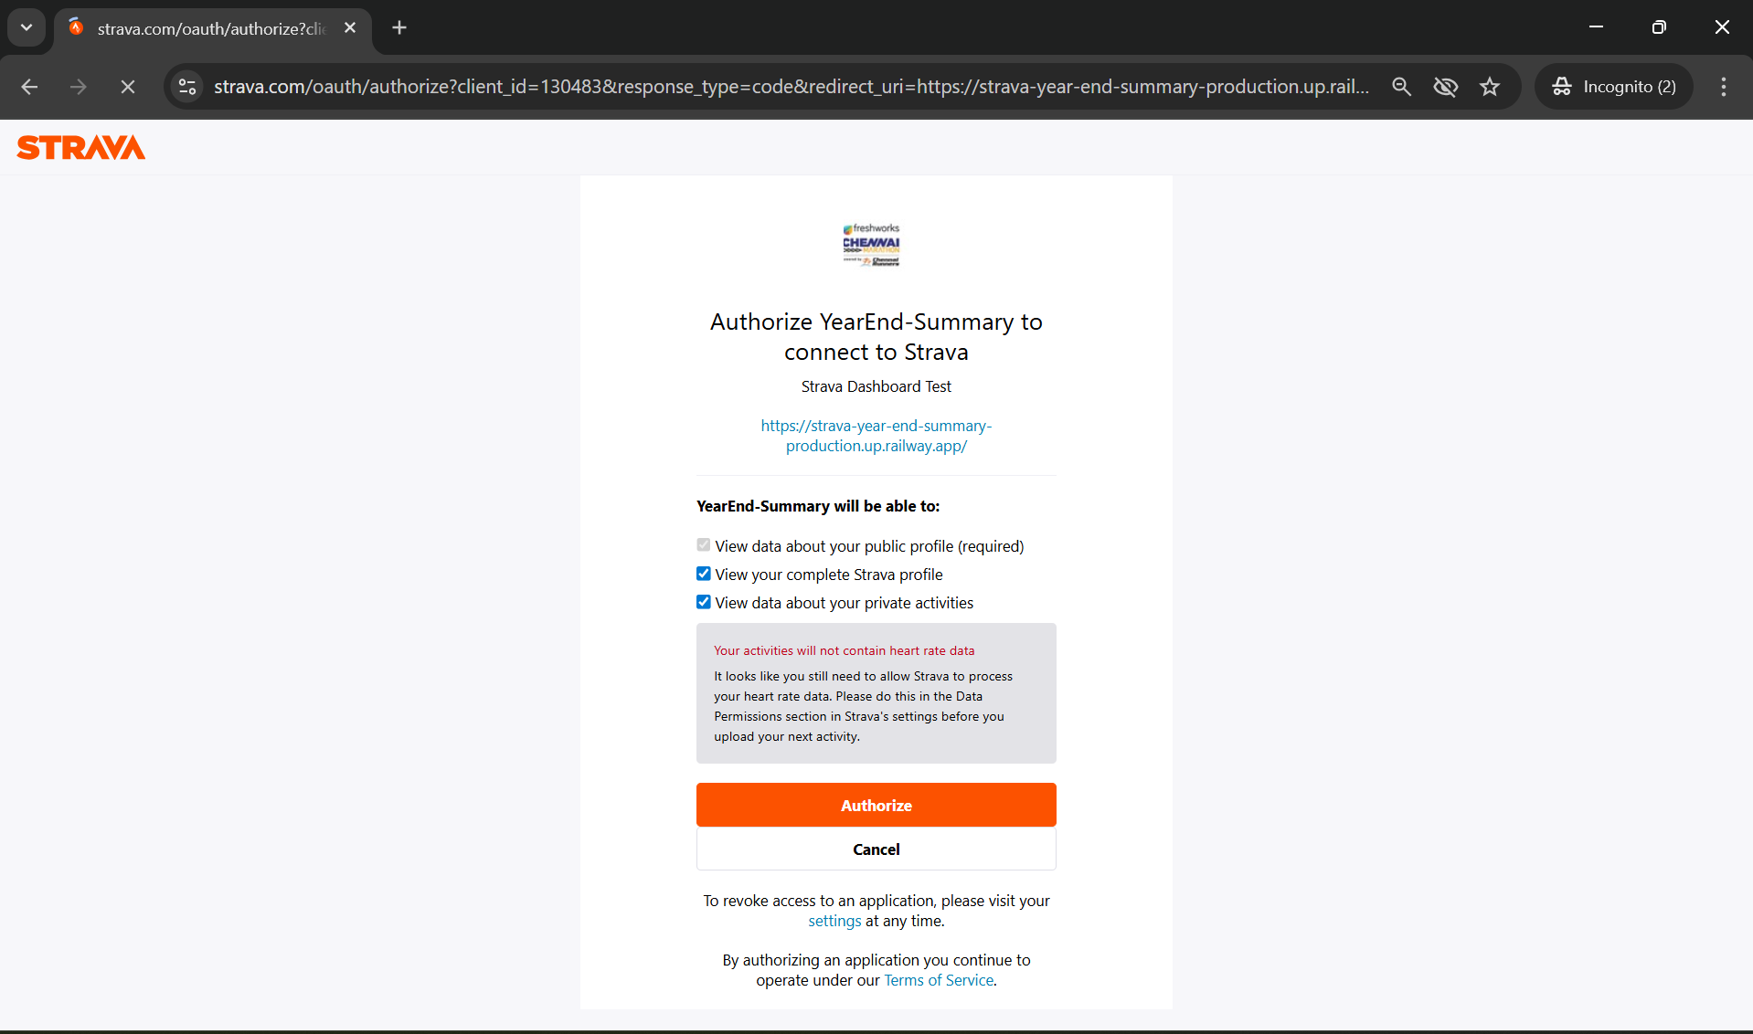
Final dashboard view after authorize is successful to pull the data for creating prompts which can be copied and pasted to chatgpt prompt for poster creation.

