**Pre-Deployment Steps:**

1. Set up a domain name for your org. You need to have a domain before you create the below connected app, auth. Provider and Named credentials for smooth authentication.

Ignore if the domain is already present.

1. Create Connected app

**Name: CallSameOrgApi_app**

This connected app will be used for authenticating the request when calling the REST api service of same Salesforce org. As part of framework this will be used to insert webservice log records via REST callout but it can be extended for making callouts to other REST services of same org.

Below is the screenshot for reference:

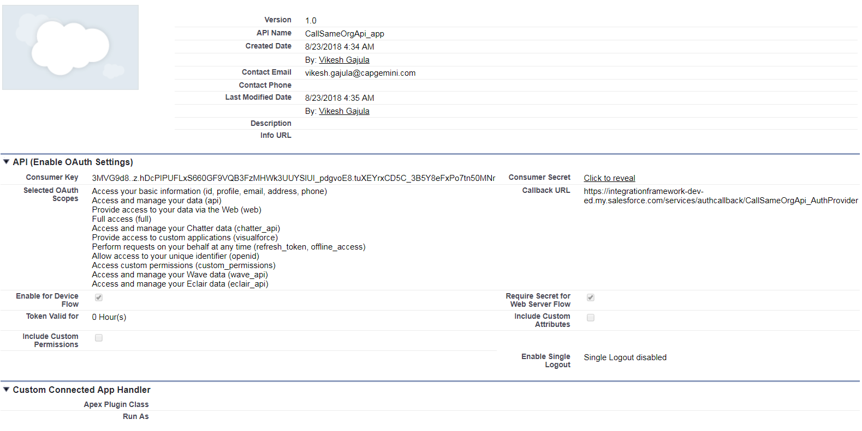

While creating the app keep the callback URL value as ‘TEMP:VALUE’. Once the Auth. Provider is created then replace the callback URL value with the callback URL from Auth. Provider.

1. Create Auth. Provider

**Name:** **CallSameOrgApi_AuthProvider**

This authentication provider will be used for authenticating the request when calling the REST api service of same Salesforce org. As part of framework this will be used to insert webservice log records via REST callout but it can be extended for making callouts to other REST services of same org.

Below is the screenshot for reference:

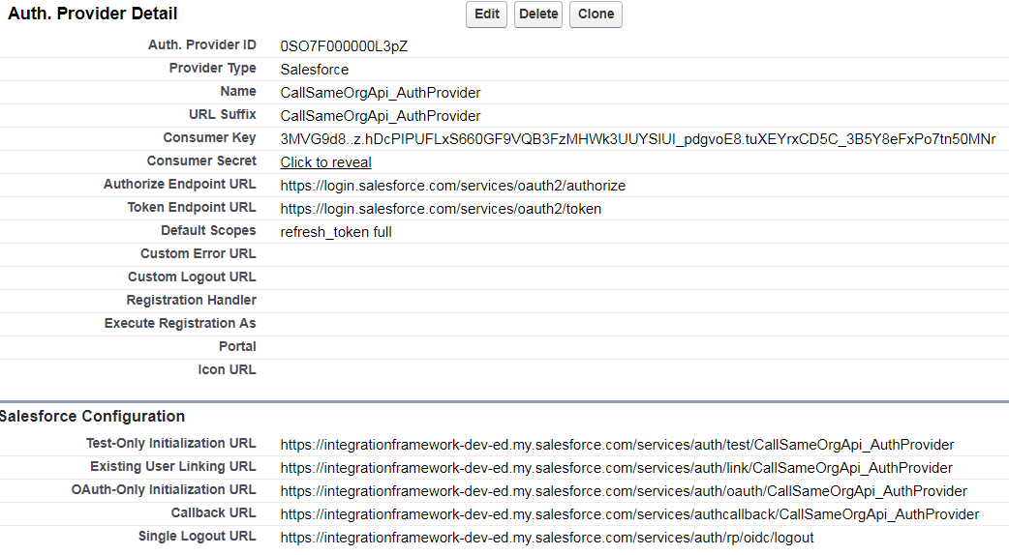

Copy the consumer key and secret from Connected App. Also copy the auto-generated callback URL and paste in Connected app. So, this would link the connected app and auth. Provider together.

1. Create Named Credential

**Name: CallSameOrgApi**

This named credential will be used for authenticating the request when calling the REST api service of same Salesforce org. As part of framework this will be used to insert webservice log records via REST callout but it can be extended for making callouts to other REST services of same org.

Below is the screenshot for reference:

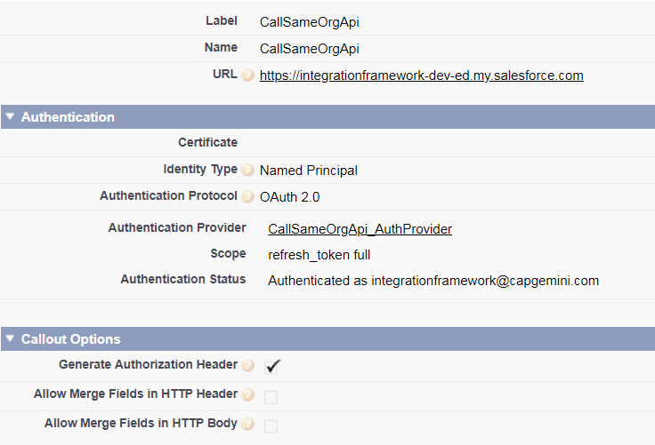

For the URL, enter the URL for your ORG but make sure it’s **\*\*\*. my.salesforce.com** i.e. domain name. Then clear the checkbox “Start Authentication Flow on Save” and click save.

Click Edit, make sure the checkbox is checked and save again.

The reason for not setting the checkbox the first time is that if you make some mistakes saving this you’ll have to restart the form.

**Post-Deployment Steps:**

1. Update value of custom label ‘Org_Name’ e.g. Dev, UAT, PROD.
2. Update Recipients list in email alert ‘Send_email_on_error’.
3. Activate workflow rule ‘Status Log Alert’.
4. Insert data in below custom settings as shown in screenshots.

