

2024 – 25 – EVEN – EVENT DAY – 2
TECH-SOCIETY
MACHINE LEARNING COMMUNITY

EVENT TITLE: Getting Started with Financial Machine Learning: From Building to Deploying Macroeconomic Forecasting Apps

DATE : 16.05.2025
SESSION : 10:00 PM TO 12:00 PM

RESOURCE PERSON
VIKHRAM S – IIIrd Year – B.E. – ECE
EVENT COORDINATOR
ROHITH JAIN
IIIrd Year - B.Tech – AI & DS

EVENT POSTER
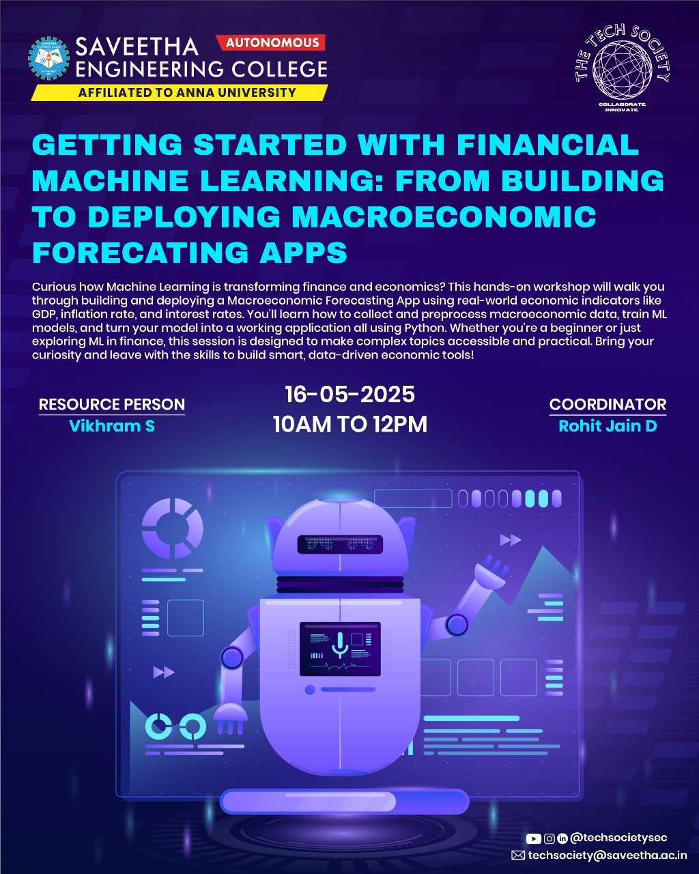

REPORT CONTENT

S. No | Content
1 | Event Objective & Outcomes
2 | Resource Person Profile
3 | Problem statement and Leader-board
4 | Gallery
5 | Participants
6 | Feedback
7 | Summary

OBJECTIVES
The objective of this workshop is to provide practical, hands-on experience in Financial Machine Learning (FML) using Python-based tools and frameworks. The focus is on building, training, and deploying machine learning models tailored for macroeconomic forecasting applications. Participants will explore financial datasets, develop predictive models, and create end-to-end forecasting solutions that can be integrated into real-world decision-making systems.

OUTCOMES
- G Gained practical experience in implementing financial machine learning algorithms using Python and libraries such as scikit-learn, XGBoost, and pandas.
- Successfully developed and deployed macroeconomic forecasting models for key indicators such as GDP, inflation, and growth rate.
- Acquired foundational knowledge of financial data sources, feature engineering techniques, and economic indicators.
- Utilized the Wbdata Python API to fetch real-time country-level economic data from the World Bank for model training and prediction.
- Built an end-to-end FML prototype that demonstrates data ingestion, model development, visualization, and interactive deployment using tools like Streamlit or Gradio.
- Strengthened skills in time series analysis, model evaluation, and interpretability for financial decision-making applications.

RESOURCE PERSON PROFILE

Problem statement
Dataset Descriptions :
- Training & Testing Datasets:
Real-world macroeconomic indicators were sourced using the wbdata Python API, pulling historical and up-to-date data directly from the World Bank database for selected countries.
- Features:
Key financial and economic indicators such as GDP (current US$), inflation rate (consumer prices), and annual growth rate were used as input features for forecasting models.
- Feature Scaling:
Continuous variables were normalized using Min-Max or Standard Scaler techniques to enhance model convergence and performance.
- Target Variables:
Predictive models were designed to forecast macroeconomic targets such as future GDP growth, inflation trends, or economic slowdown indicators.
- Data Preprocessing:
Missing values were handled using interpolation or forward-fill methods. Time series alignment and stationarity checks were performed for temporal modeling tasks.

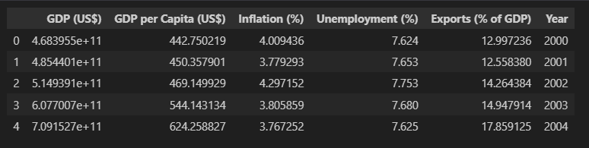
Agenda of the Hands-on Quantum Machine Learning Workshop
This workshop aims to provide practical experience with building and deploying machine learning models for macroeconomic forecasting using real-time data accessed via the wbdata Python API.
1. Problem Understanding & Objective Setting
- Recognize the challenges in forecasting macroeconomic indicators like GDP, inflation, and growth rate.
- Define workshop goals: build forecasting models using historical economic data, evaluate accuracy, and deploy an interactive forecasting app.
- Select technologies: Python, wbdata, scikit-learn, pandas, matplotlib, Gradio or Streamlit.

2. Data Collection and Understanding
- Use the wbdata Python API to retrieve historical economic data from the World Bank for selected countries.
- Choose indicators (e.g., NY.GDP.MKTP.CD for GDP, FP.CPI.TOTL.ZG for inflation).
- Visualize trends and understand economic indicator relationships.
- Discuss economic significance of each feature.

3. Data Preprocessing
- Clean and preprocess time series data (handle missing values, align time indices).
- Perform feature scaling using MinMaxScaler or StandardScaler.
- Engineer time-based features (lags, moving averages) to capture trends.
- Split data into training and testing sets with chronological integrity.

4. Building Forecasting Models
- Implement regression models using scikit-learn (e.g., Linear Regression, Random Forest, XGBoost).
- Train and evaluate models on historical macroeconomic data.
- Use metrics like RMSE, MAE, and R² to assess model performance.
- Perform hyperparameter tuning and cross-validation if applicable.

5. Visualization and Interpretation
- Plot actual vs predicted values to assess forecast accuracy visually.
- Create correlation heatmaps, trend charts, and feature importance plots.
- Interpret economic implications of model predictions.

6. Model Deployment
- Build an interactive forecasting interface using Gradio or Streamlit.
- Enable users to select a country and view predicted values for GDP, inflation, or growth.
- Discuss deployment options and hosting platforms (e.g., Hugging Face Spaces, GitHub Pages).

7. Real-World Applications and Discussion
- Explore real-life use cases of macroeconomic forecasting (e.g., policy planning, investment analysis).
- Discuss model limitations, data bias, and the importance of interpretability in financial contexts.
- Introduce advanced topics such as time series forecasting (ARIMA, LSTM) or AutoML.

8. Final Presentation and Summary
- Recap workshop goals and the end-to-end forecasting pipeline.
- Demonstrate the deployed application and its capabilities.
- Summarize key learnings on financial ML, model building, and API-based data sourcing.
- Open Q&A, feedback session, and suggestions for further learning or projects.

GALLERY
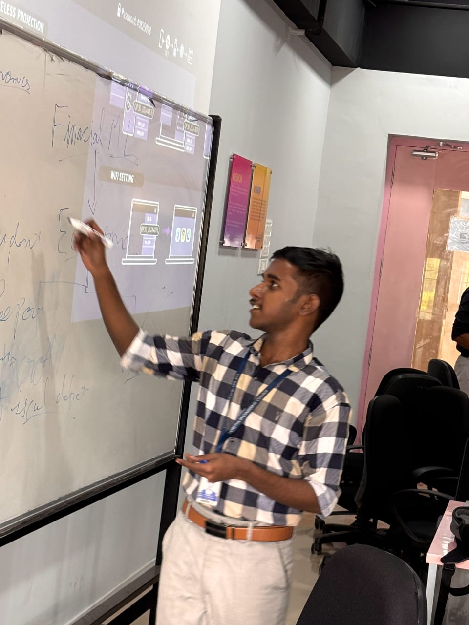
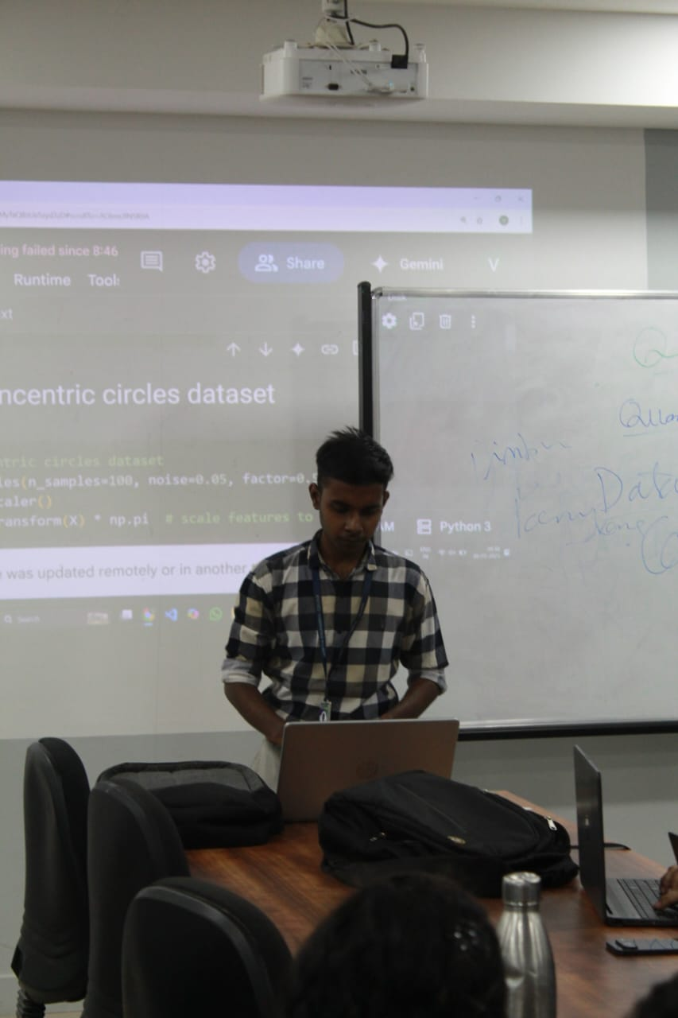
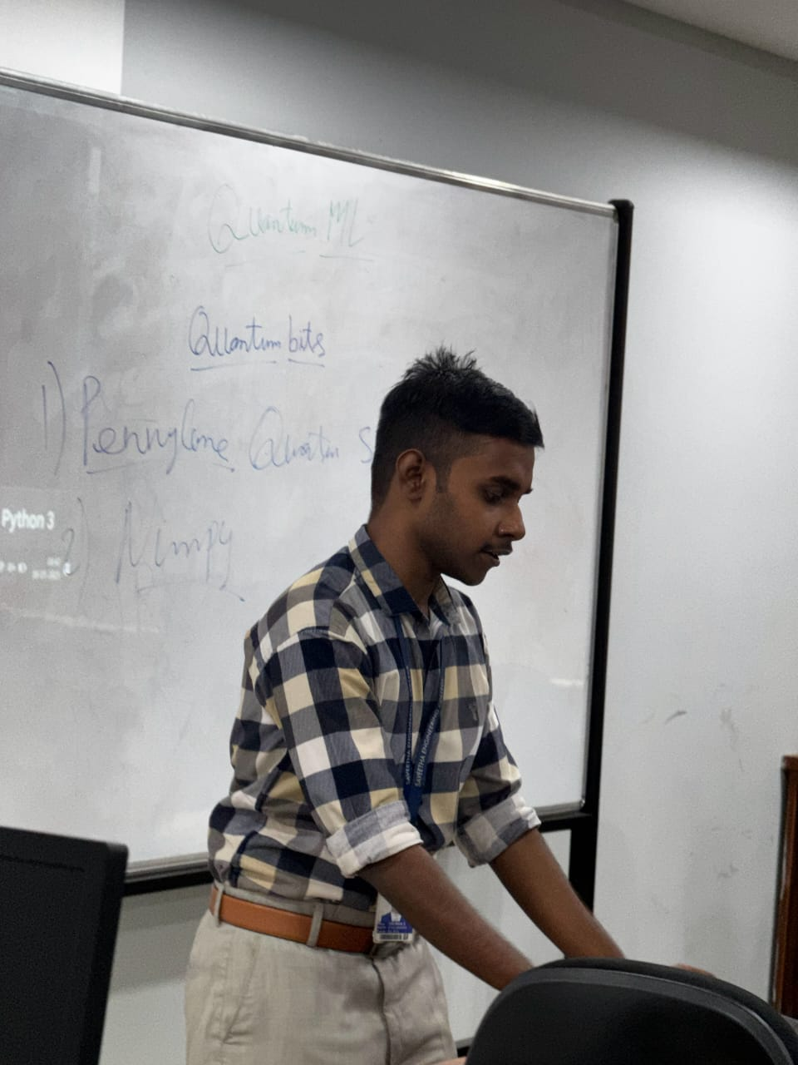
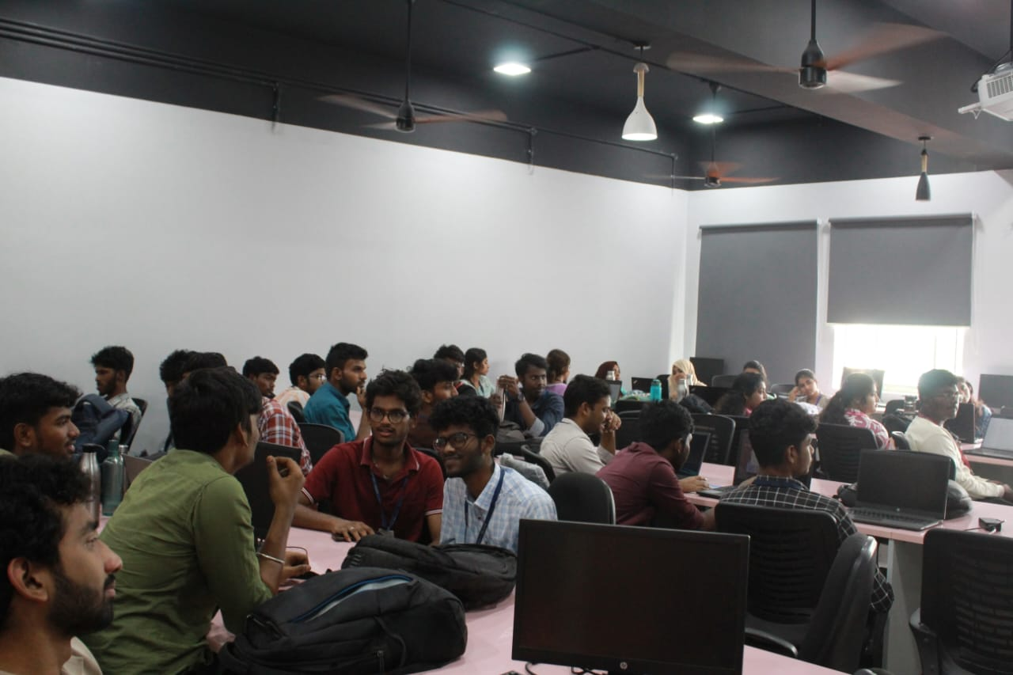

Summary
This project focuses on building an interactive and educational Financial Machine Learning (FML) application using Python and real-time economic data from the World Bank via the wbdata API. The main goal is to demonstrate how machine learning models can be applied to forecast macroeconomic indicators such as GDP, inflation, and growth rates for different countries.
The forecasting models are developed using scikit-learn, employing regression techniques like Linear Regression, Random Forest, and XGBoost to analyze historical economic trends. Real-world financial data is retrieved and preprocessed for modeling, including scaling, feature engineering, and time series preparation to ensure accurate and meaningful predictions.
This hands-on project not only provides practical experience with building and evaluating forecasting models but also reinforces key concepts in financial data analysis, machine learning workflows, and deployment. By integrating Gradio or Streamlit, the project culminates in an interactive application that allows users to select countries and view predicted macroeconomic trends, making complex forecasting tools accessible and interpretable. It serves as a strong foundation for learners interested in applying ML to economic analysis and policy planning.

FEEDBACK SUMMARY

