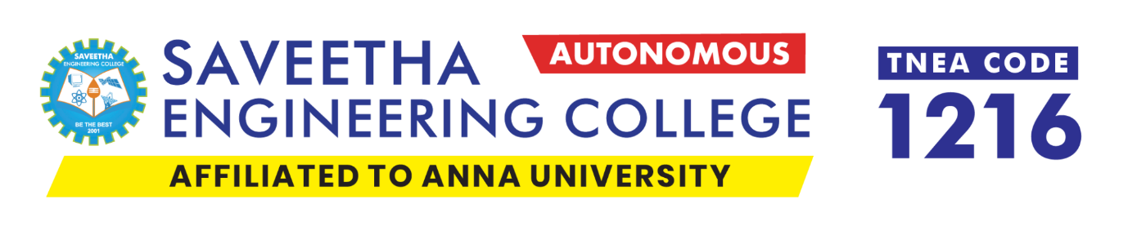

2024 – 25 – EVEN – EVENT DAY – 2
TECH-SOCIETY
MACHINE LEARNING COMMUNITY

EVENT TITLE: Quantum Machine Learning in Practice: Building with Qubits

DATE : 16.05.2025
SESSION : 08:00 PM TO 10:00 PM

RESOURCE PERSON
VIKHRAM S – IIIrd Year – B.E. – ECE
EVENT COORDINATOR
ROHITH JAIN
IIIrd Year - B.Tech – AI & DS

EVENT POSTER
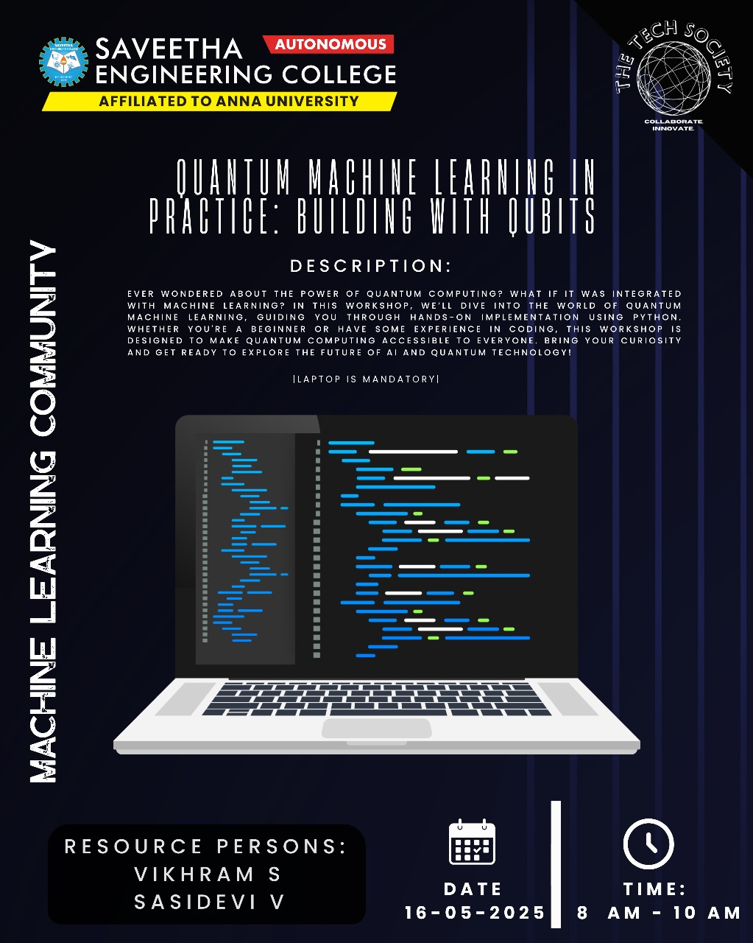

REPORT CONTENT

S. No | Content
1 | Event Objective & Outcomes
2 | Resource Person Profile
3 | Problem statement and Leader-board
4 | Gallery
5 | Participants
6 | Feedback
7 | Summary

OBJECTIVES
The objective of this workshop is to provide practical, hands-on experience in Quantum Machine Learning (QML) using Python-based frameworks such as Qiskit or PennyLane. The focus is on building an understanding of quantum computing principles and applying them to machine learning tasks. Participants will explore quantum algorithms, design hybrid quantum-classical models, and develop prototype QML solutions for real-world problems.
OUTCOMES
Gained practical experience in implementing quantum machine learning algorithms using Python and QML libraries like IBM Qiskit and PennyLane.
• Successfully developed and tested hybrid quantum-classical models for classification and regression tasks.
• Acquired foundational knowledge of quantum computing concepts such as qubits, superposition, entanglement, and quantum gates.
• Built a working prototype of a QML application demonstrating the integration of quantum circuits within a classical ML pipeline.
• Strengthened skills in quantum circuit design, model training, data encoding techniques, and performance evaluation in QML workflows.

RESOURCE PERSON PROFILE

Problem statement
Dataset Descriptions :
- Training & Testing Datasets:
Synthetic datasets (e.g., concentric circles) are used to classify non-linearly separable data points, demonstrating classical and quantum model performance.
- Feature Scaler:
Feature values are normalized (e.g., to [0, π]) for compatibility with quantum gate encodings.
- Label Encoding:
Class labels (0, 1) represent the binary classification target.
- Quantum Feature Encoding:
Maps classical inputs into quantum states using angle encoding (e.g., RX, RY rotations).

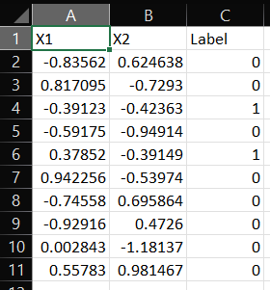
Agenda of the Hands-on Quantum Machine Learning Workshop
This workshop aims to provide hands-on experience with building and comparing classical and quantum logistic regression models using PennyLane on the concentric circles dataset.

1. Problem Understanding & Objective Setting
- Recognize the challenge of classifying non-linearly separable data using classical models.
- Define workshop goals: implement logistic regression (classical & quantum), visualize results, and understand quantum advantage.
- Select technologies: Python, PennyLane, Scikit-learn, Matplotlib.

2. Dataset Generation and Understanding
- Generate the concentric circles dataset using sklearn.datasets.make_circles().
- Visualize data to observe the non-linear decision boundary.
- Understand why this dataset is suitable for testing quantum machine learning models.

3. Data Preprocessing
- Normalize input features for quantum encoding (typically [0, π]).
- Split into training and testing sets.
- (Optional) Perform dimensionality analysis or feature scaling visualization.

4. Classical Logistic Regression
- Implement logistic regression using Scikit-learn.
- Fit the model and evaluate accuracy.
- Plot decision boundaries.
- Analyze limitations in separating non-linear patterns.

5. Quantum Logistic Regression with PennyLane
- Encode classical data into quantum circuits using angle encoding.
- Create a variational quantum circuit using parameterized gates (e.g., RX, RY, ZZ interactions).
- Define a cost function (e.g., cross-entropy loss).
- Train using gradient descent and qml.grad.
- Compare performance against the classical model.

6. Result Visualization and Comparison
- Plot decision boundaries for both classical and quantum models.
- Compare accuracy, decision region sharpness, and training efficiency.
- Discuss cases where QML might provide an edge (e.g., high-dimensional feature spaces).

7. QML Application Potential Discussion
- Discuss real-world applications where QML could outperform classical ML.
- Introduce other quantum models (e.g., QNNs, variational classifiers) and the role of hybrid quantum-classical models.
8. Final Presentation and Summary
- Recap workshop goals and results.
- Present classical vs quantum performance comparison.
- Summarize key learnings about QML, PennyLane, and encoding strategies.
- Open Q&A and project continuation ideas.

GALLERY
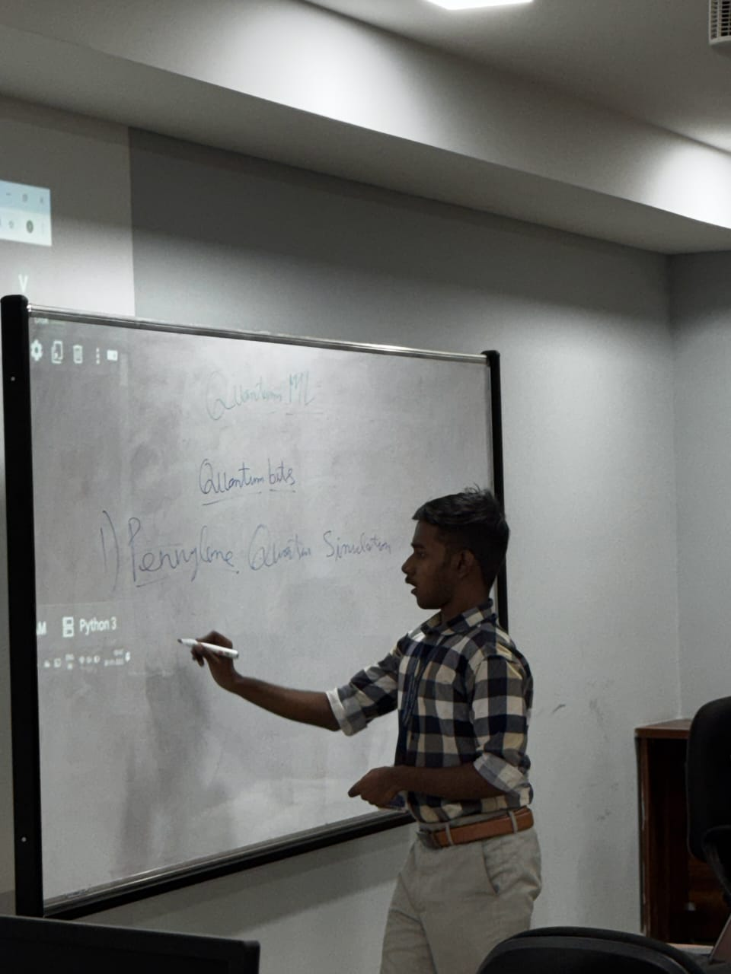
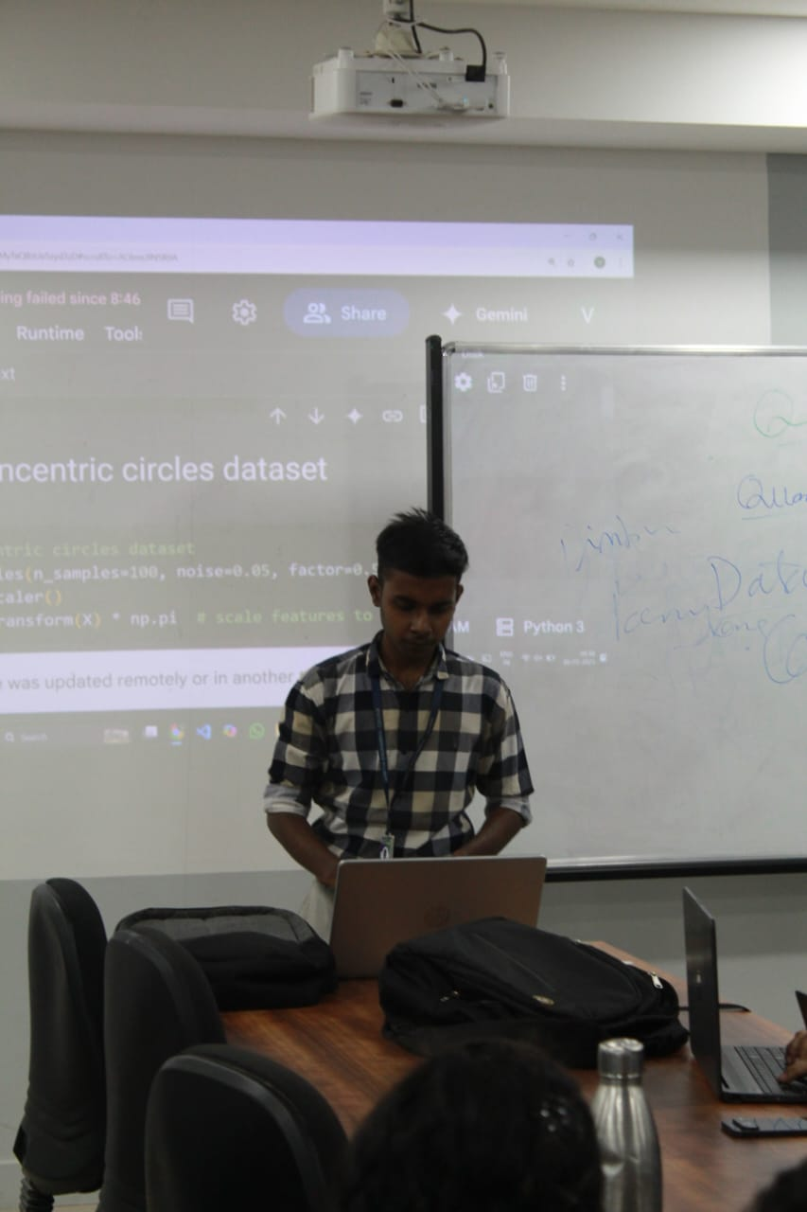
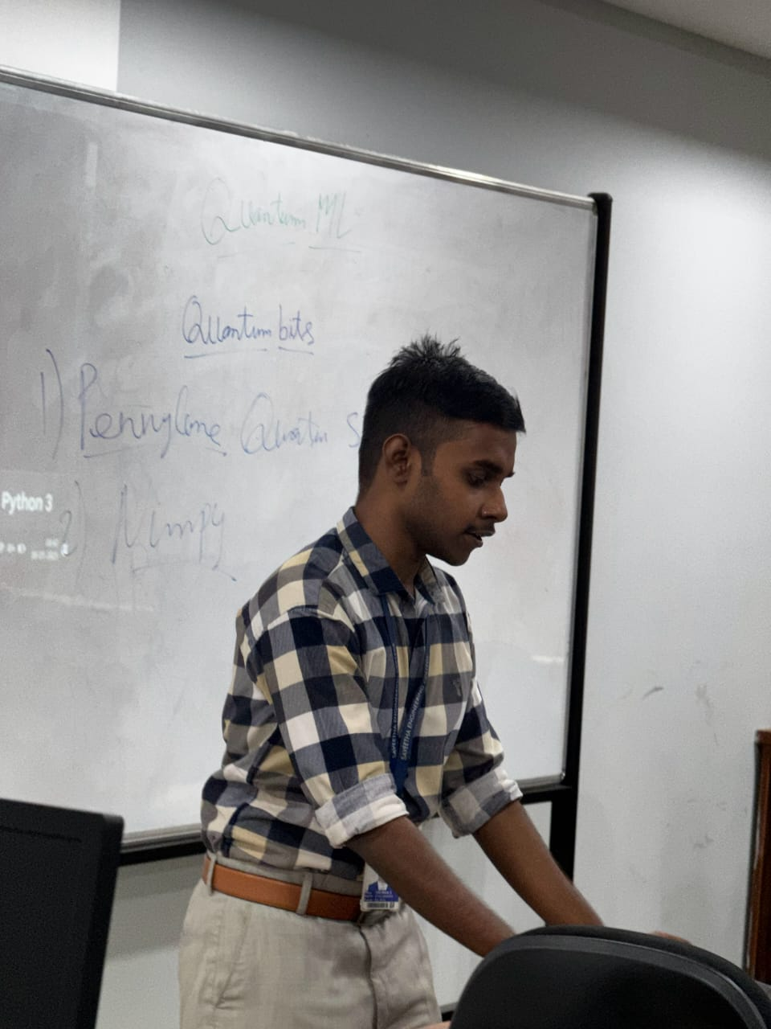
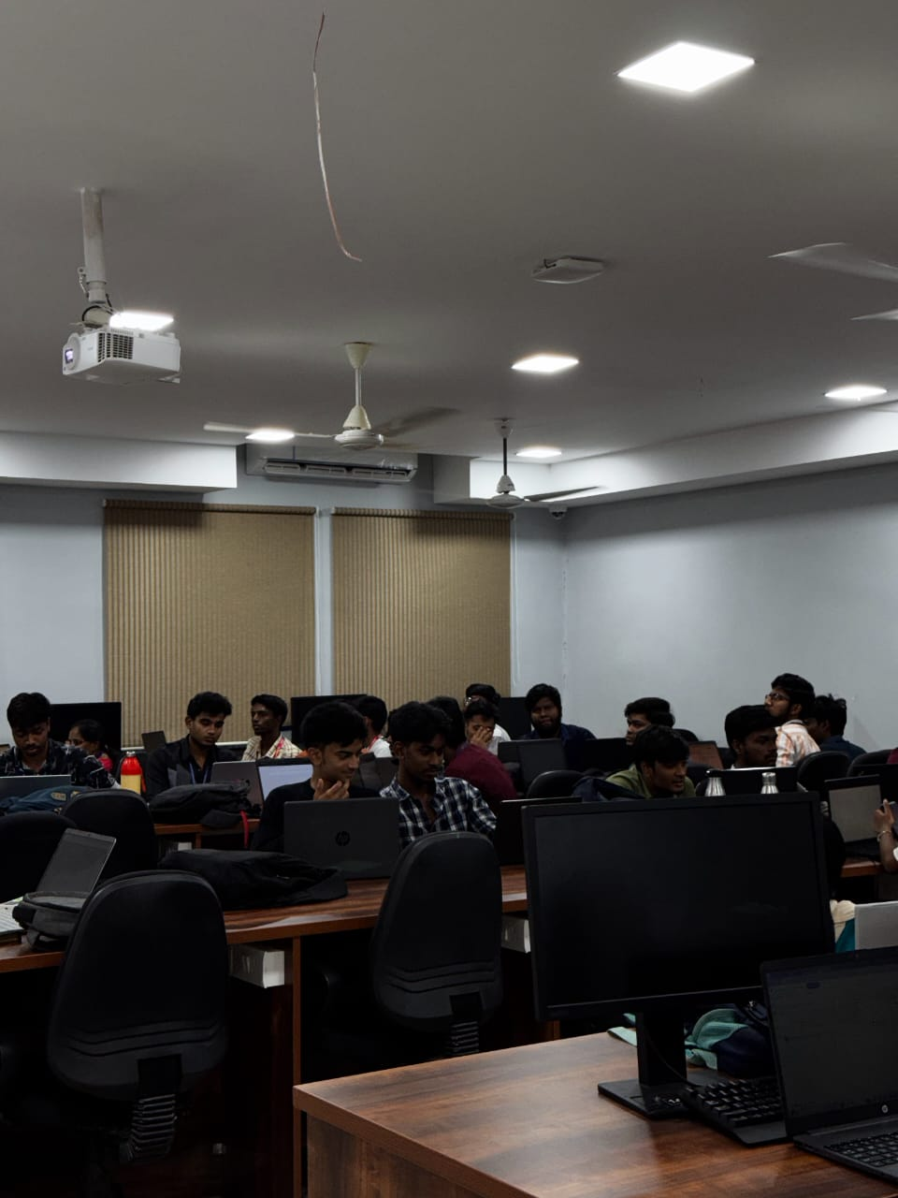

Summary
This project focuses on building an interactive and educational Quantum Machine Learning (QML) application using PennyLane and IBM Qiskit. The main goal is to demonstrate the differences between classical and quantum approaches to binary classification, using the concentric circles dataset. By applying both classical logistic regression and quantum logistic regression, the project highlights the potential advantages of quantum models in handling non-linearly separable data.
The quantum models are developed using PennyLane, leveraging quantum circuits with parameterized gates to encode classical data and perform variational optimization. The classical counterpart is built using Scikit-learn for direct performance comparison. Input features are preprocessed and scaled appropriately to fit quantum encoding requirements, such as angle encoding with RX and RY gates.
This hands-on project not only provides practical experience with QML but also reinforces fundamental concepts in quantum computing, model training, and data visualization. It serves as an accessible starting point for learners exploring the growing field of quantum-enhanced machine learning and illustrates how hybrid quantum-classical models can be applied to real-world data classification tasks.

FEEDBACK SUMMARY

