**LAB-1🡪 Create Elastic Load Balancer::**

1. **We will create a S3 bucket named as elbloadbalance as below**

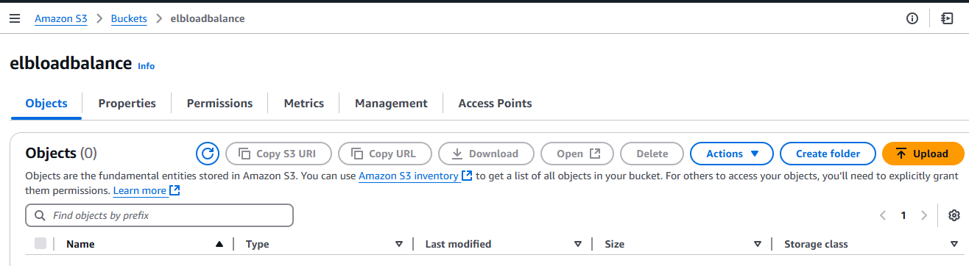

**2.we will upload two object in S3 Bucket(index.html and healthchecks.html in bucket)**

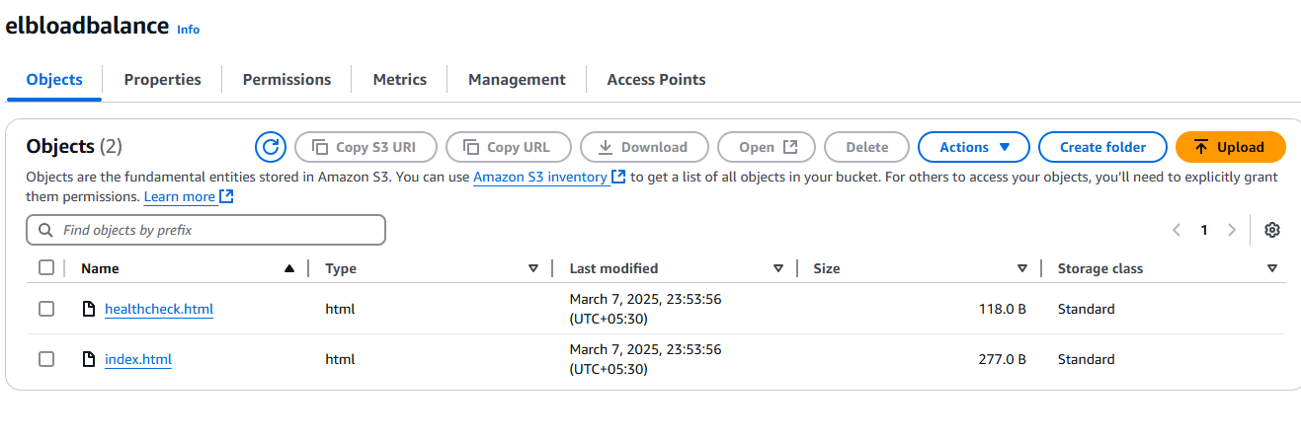

**3.Create a Iam Role having S3 full access as below**

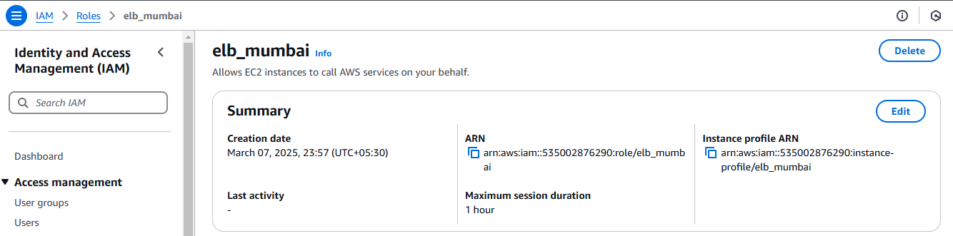

**4.Create security group and also add inbound rules ( http/https/ssh/DNS) as below**

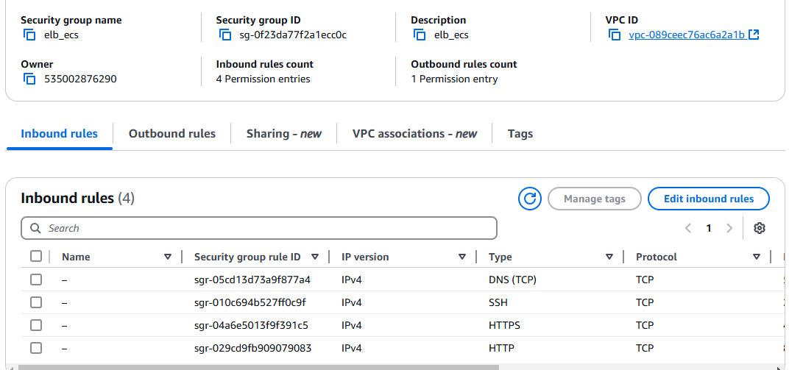

**5.Now create two instances one in 1a and in 1b and assign IAM role , security group and below bootstrap command as well**

**#!/bin/bash**

**yum install -y httpd**

**aws s3 cp s3://elbloadbalance/index.html /var/www/html/**

**aws s3 cp s3:// elbloadbalance /healthcheck.html /var/www/html/**

**service httpd start**

**chkconfig httpd on**

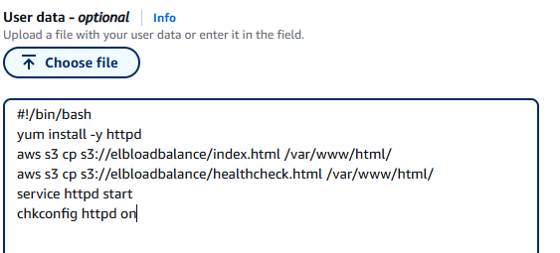

**Instances created as below**

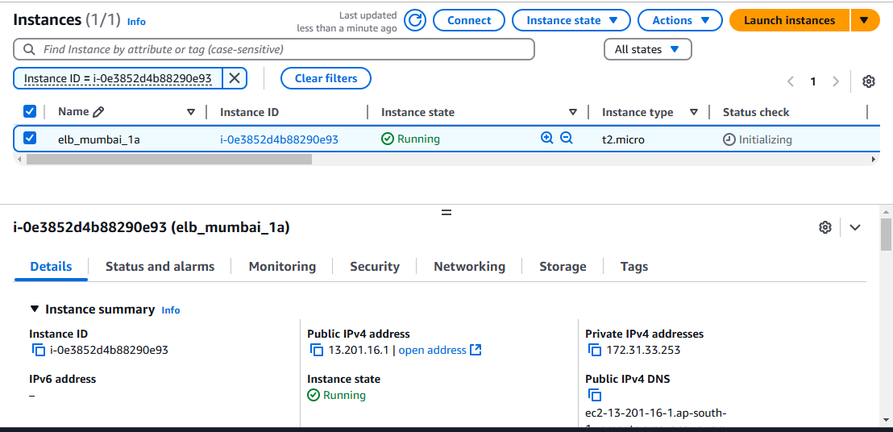

**In Mumbai_ap_south_1b**

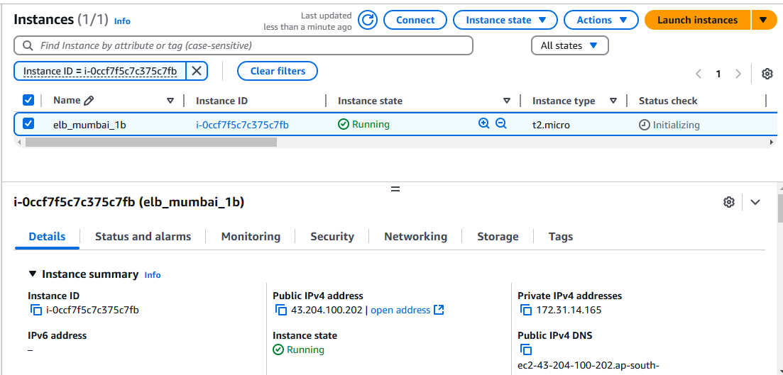

**6. Now create ELB -🡪 go in EC2 load balancer tab and create load balancer**

**First we will create classic load balancer-🡪 under classic load balancer tab click Create LB**

* **Under section click on internet-facing and add security group as well**
* **Under Listeners and routing tab click http protocol and port 80**

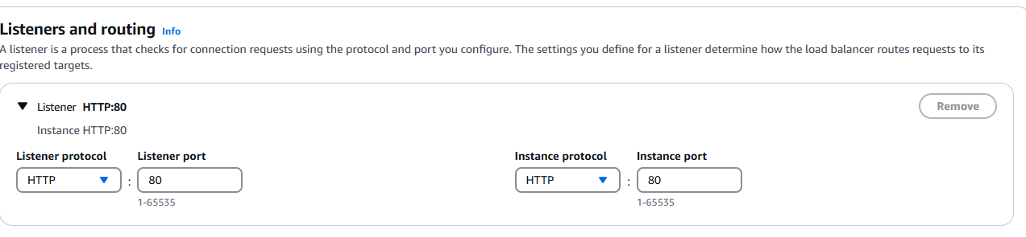

**7.Under health checks tab load balancer will automatically check for health of instances by pinging /index.html as mention below**

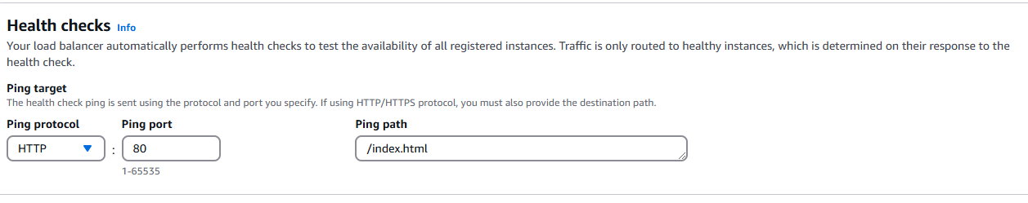

**8.Created load balancer as below**

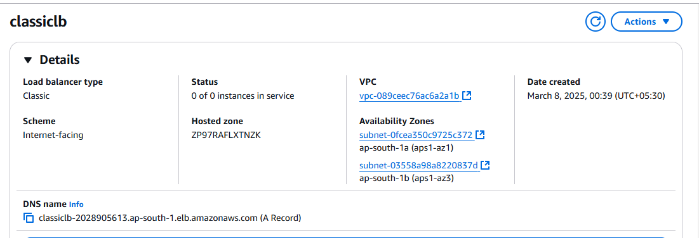

**9.Load balances registered instances and instances are in running condition as below**

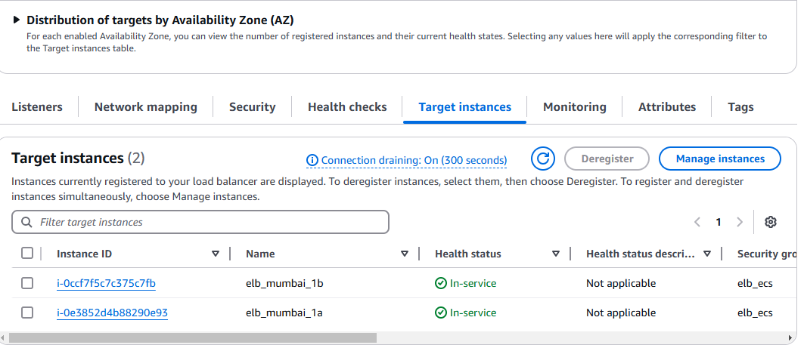

**10. Below html files can be accessible as below**



**11. Now we will stop one instance and see the status of application**

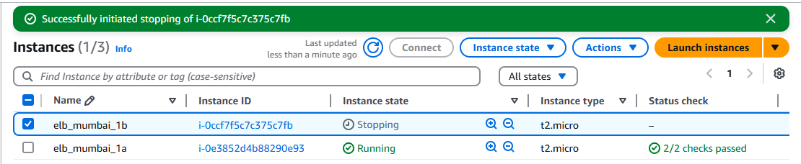

**We observed my application is still running post to stopped one instance as well**



**LAB2-🡪Create Application Load balancer by using above created Instances**

1. **Create application Balancer named as applicationlb**

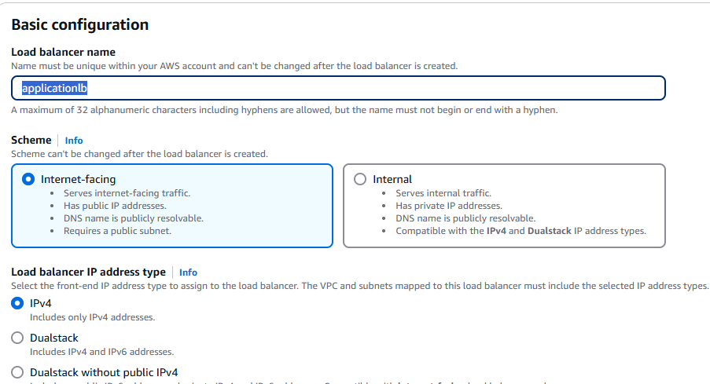

**2.We will select availability zones 1a and 1b and attach our security group as well**

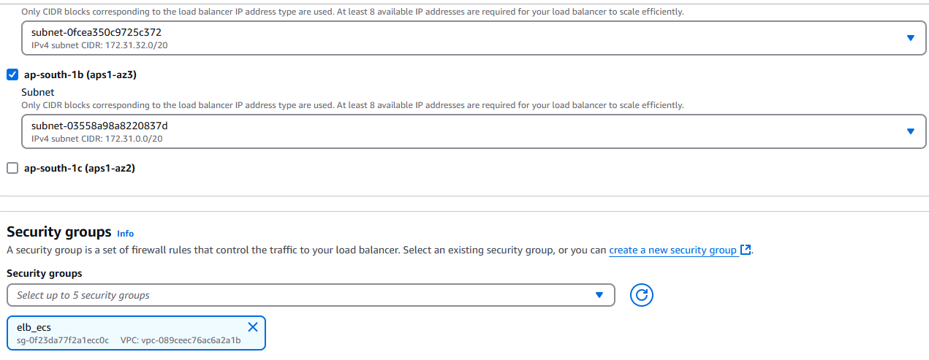

**3.Now we have to create a target group**

* **Name target group as targetgroup and also choose target type as instances**
* **Select Protocol version as http1 or http2 or gRPC**
* **Add health checks path as below**

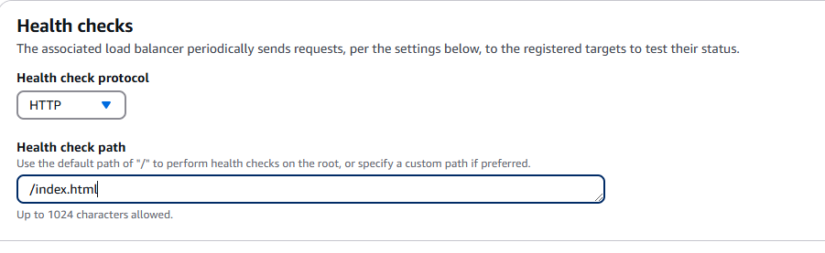

* **Under advance health check settings click below settings**

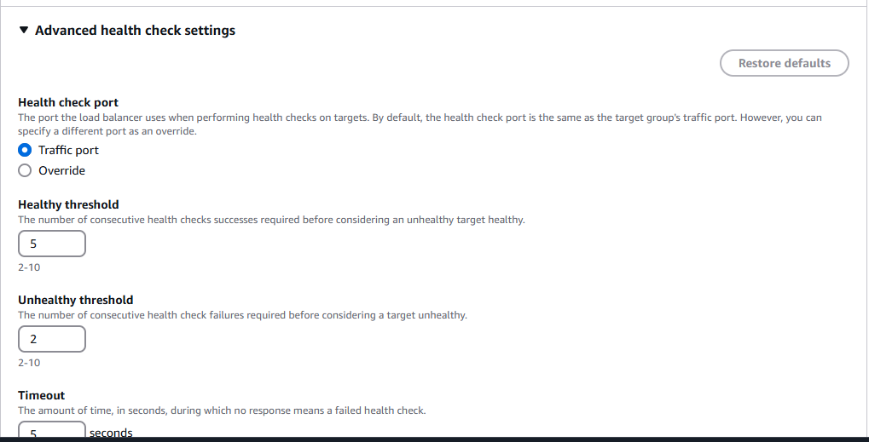

* **Include Target Group as below and click create target group**

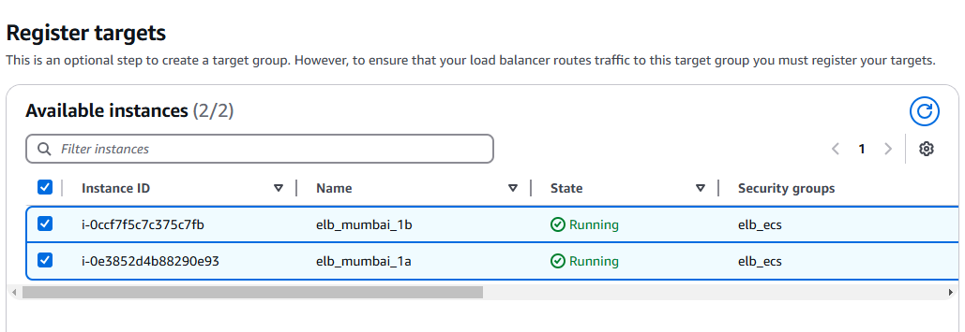

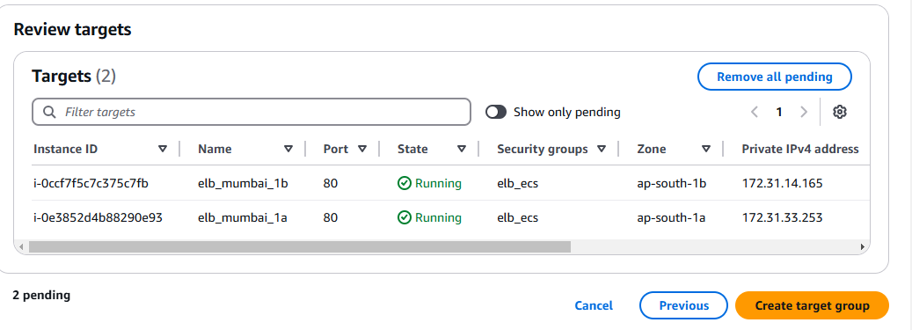

* **Target group has been created as below**

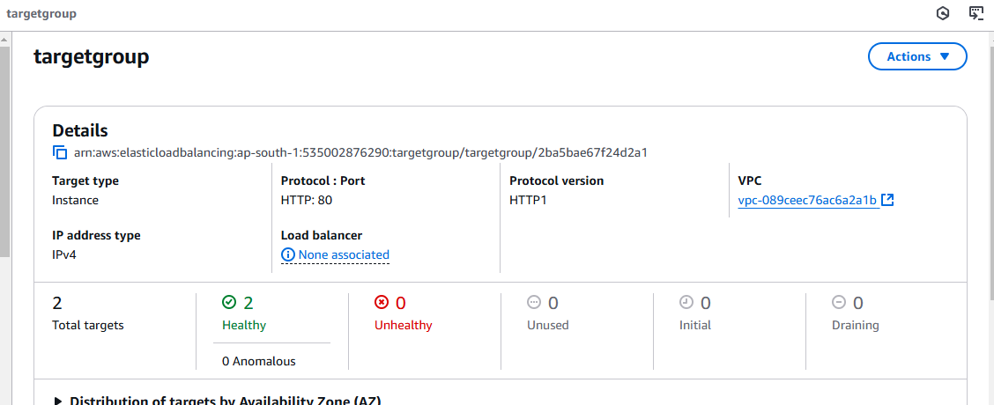

**4.Select created target group as below**

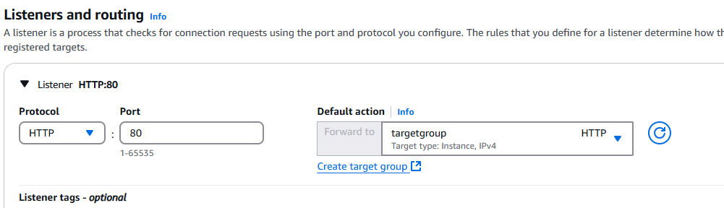

**5.We will not click on cloud front+WAF+Global accelerator for security/performance/availibility as these are chargeable**

**6. We will click on Create Load balancer as below**

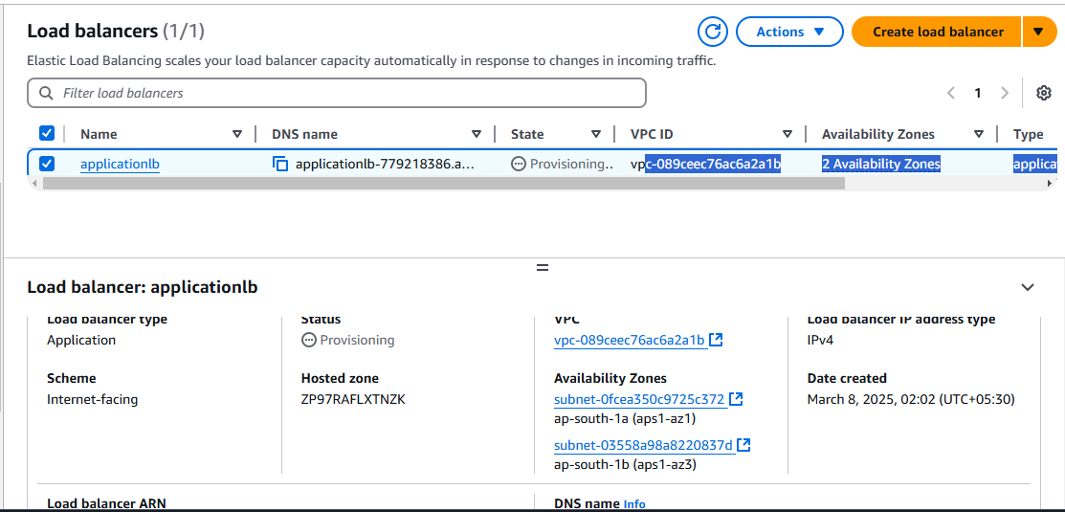

**7.We can access the application via LB**



**8.we stopped one instance and still we can see our applications is running**

