
THE JARVIS MANIFESTO: Engineering a Conversational Android
IMAGINE THE UNIMAGINABLE

February 25, 2026
Vikhyat gupta

THE JARVIS MANIFESTO: Engineering a Conversational Android
Developed by: Vikhyat Gupta
Fabrication: The Architect Division: Aayush Agarwal, Shresth Adukia, Adhyansh Kumar, Rudraksh Sharma
Location: St. Anthony’s School
Target Deployment: September 16th

FOREWORD: The Philosophy of Optimization
Most humanoid robots fail because they prioritize acrobatics over intelligence. They waste computational power trying to balance on two wheels. Project Jarvis operates on a different engineering philosophy: "Bio-Inspired but Engineered." By utilizing a geometrically perfect mechanical base, we free up 100% of our CPU power for true Artificial Intelligence, computer vision, and social interaction.
This book outlines the anatomy, neural pathways, and cognitive architecture of a 4-board, edge-computing android.

CHAPTER 1: The Mechanical Anatomy (The Skeleton)
Jarvis is designed to look like a bipedal humanoid while secretly utilizing a hyper-stable, zero-turn chassis.
1.1 The Stance: The 6-Point Bipedal Tripod
Instead of a standard 4-wheel car base, Jarvis uses a custom "Foot" design to simulate human legs without the risk of falling.
- The Ankles (Main Drive): 2 central BO Motors placed precisely in the middle of the base. These provide all forward, backward, and 360-degree rotational movement.
- The Invisible Toes & Heels: 4 miniature ball casters (2 in the front, 2 in the back).
- The Zero-Wobble Secret: The main drive wheels sit exactly 1-2 millimeters lower than the casters. Jarvis rests entirely on his motorized wheels for maximum grip. The casters only engage to "catch" the robot if it leans forward or backward.
1.2 The Spine & The “Palla” Tray
- The Spine: A central, vertical pillar rising from the exact center of the wheel axle.
- The “Palla” Tray: Mounted at waist height. Because the 6-point base eliminates all rocking and tilting, the tray remains perfectly level. It is strictly for stationary, social holding (e.g., holding exhibit brochures or items).
- The Head: The uppermost mount housing the AV (Audio/Visual) Hub.

CHAPTER 2: The Nervous System (Power & Wiring)
A multi-core robot will crash if its power supply is "dirty." Jarvis uses an industrial dual-power isolation strategy.
2.1 Dual-Juice Architecture
- The Muscle Juice (Dirty Power): A 12V Li-ion battery mounted at the absolute lowest point of the chassis (for a low Center of Gravity). This is wired only to the L298N Motor Driver.
- The Brain Juice (Clean Power): A 20,000mAh 5V Power Bank. This powers the microcontrollers. It guarantees perfectly smooth voltage, ensuring the AI never reboots during a voltage sag.
2.2 The Electrical Bridge
Even though the power sources are separate, the Ground (GND) of the 12V battery and the 5V power bank must be connected. This creates a "Common Ground," allowing the 5V brain to send movement signals to the 12V muscles without frying the circuitry.
2.3 Data Routing (Star Topology)
Instead of a messy web of jumper wires, Jarvis uses a centralized USB Bus. The Master CPU connects to the Sub-Processors via short, shielded USB cables. This prevents electromagnetic interference (EMI) and keeps the internal cavity looking like a professional server rack.

CHAPTER 3: The Multi-Core Brain (Compute Hubs)
Jarvis distributes tasks across four specific logic boards. No single chip is bottlenecked.

Logic Board | Designation | Primary Directive
Raspberry Pi 3B+ | The Master | The Jetson brain. Runs the Linux OS, handles OpenCV vision, processes the Gemini AI API, and routes audio.
Arduino Uno | The Bouncer | Ultra-low power guard. Stays awake 24/7. Watches the perimeter and wakes the Master.
Arduino Mega | The Muscle | Takes USB movement commands from the Pi. Directly controls the motors and enforces hardware safety rules.
Raspberry Pi Pico | The Artist | Dedicated parallel processor solely for calculating and running smooth NeoPixel LED animations.

CHAPTER 4: Senses & AI (The Software Stack)
Jarvis does not use pre-recorded lines. He is a generative, contextual android.
4.1 The AV Hub (USB Webcam & Speaker)
To eliminate ribbon-cable failures, Jarvis uses a single, unified plug-and-play USB Webcam.
- The Eyes (Vision): The camera lens feeds high-definition frames to OpenCV on the Pi. It actively tracks faces. If the Lead Architect walks left, the Pi commands the Mega to pivot the base left.
- The Ears (STT): The webcam's built-in microphone acts as the Speech-to-Text receiver, capturing the user's voice clearly.
- The Voice (TTS): The Pi sends the Gemini AI's generated response to a dedicated external speaker in the Head unit.
4.2 The "Vibe" System
Controlled by the Pico, a NeoPixel LED ring in the chest acts as Jarvis's emotional indicator:
- Pulsing Blue: Scanning/Listening.
- Solid Gold: Gemini AI is processing logic.
- Flickering White: Synced to the TTS audio output (speaking).

CHAPTER 5: Safety Protocols & Silent Optimizations
These features separate a school project from an industrial machine.
5.1 The Dual-Ping Architecture (Ultrasonic Security)
Jarvis uses two separate ultrasonic sensors for two entirely different safety systems.
- System 1: The 1-Meter Wake-Up (Uno Protocol)
  - The Pi rests in a thermal-saving "Idle" state.
  - Ultrasonic Sensor 1 is wired to the Arduino Uno.
  - If a human enters a 1-meter radius, the Uno fires a 5V interrupt signal to the Pi, instantly launching the Gemini AI script.
- System 2: The 30 cm Kill-Zone (Mega Protocol)
  - Ultrasonic Sensor 2 is wired directly to the Arduino Mega.
  - If an object breaches a 30 cm diameter, the Mega triggers a hardware override.
  - It cuts power to the wheels instantly. It ignores all commands from the Pi. If the AI hallucinates and says "Move forward into that wall," the Mega refuses.
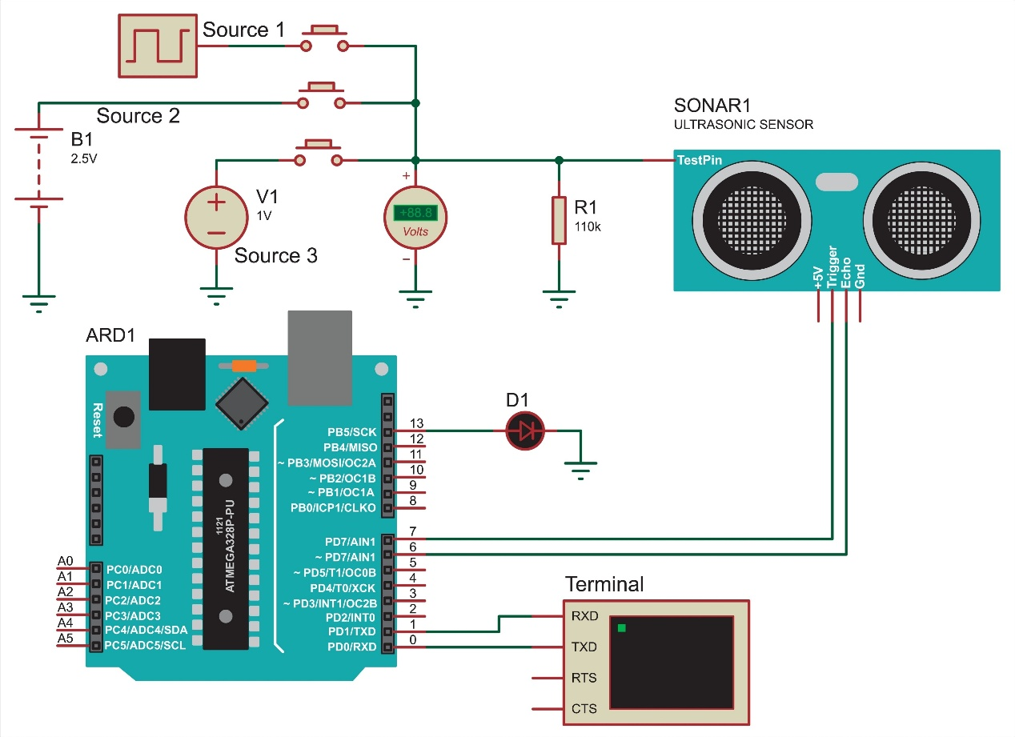
5.2 Fail-Safes
- Brownout Protection: A $1000\mu F$ capacitor across the motor driver absorbs electrical spikes.
- Diagnostics Announcer: If the 12V battery dies, the 5V brain stays alive to verbally announce: "Lead Architect, my drive systems have lost power."
- The Kill Switch: A physical, master red button that severs the Common Ground, shutting down all mechanical operations immediately.

CHAPTER 6: The Fabrication Roadmap
- Phase 1 (March-April): The Skeleton. Assemble the 6-point base, PVC spine, and 12V motor wiring.
- Phase 2 (May-June): The Network. Establish USB serial communication. Program the Mega to respect the 30 cm kill-zone.
- Phase 3 (July): The Senses. Calibrate the USB Webcam. Wire the Uno 1-meter wake-up trigger.
- Phase 4 (August): The Soul. Finalize Gemini AI API integration, STT, and TTS looping.
- Phase 5 (Sept 1-15): The Polish. Cable sleeves, chassis painting, and Exhibit day rehearsals.

Complete guide
PROJECT JARVIS: THE COMPLETE SOFTWARE & CODING GUIDE

Prepared by: Lead Systems Architect
For: The Fabrication Team
Deadline: September 16th

TEAM BRIEFING:
This document contains the complete software for our 4-board robot.
Do not mix these up. Each board has a specific job. Read the
"What this does" section before you upload the code so you understand
the logic of the machine.

====================================================================
BOARD 1: THE BOUNCER (ARDUINO UNO)
====================================================================
WHAT THIS DOES:
This is our security guard. It never sleeps. It uses Ultrasonic Sensor 1
to watch the room. If a human steps within 1 meter (100 cm), it sends a
5-volt signal through a trigger wire to wake up the main Raspberry Pi.

HOW TO UPLOAD:
1. Open the Arduino IDE software on your laptop.
2. Plug the Arduino Uno into the laptop via USB.
3. Paste the code below and click the "Upload" arrow.

--- CODE START ---

int trigPin = 9; // The pin that shouts the soundwave
int echoPin = 10; // The pin that listens for the echo
int wakePin = 2; // The wire connecting to the Raspberry Pi

void setup() {
pinMode(trigPin, OUTPUT);
pinMode(echoPin, INPUT);
pinMode(wakePin, OUTPUT);
}

void loop() {
long duration, distance;

// Fire the ultrasonic pulse
digitalWrite(trigPin, LOW); delayMicroseconds(2);
digitalWrite(trigPin, HIGH); delayMicroseconds(10);
digitalWrite(trigPin, LOW);

// Calculate the distance in centimeters
duration = pulseIn(echoPin, HIGH);
distance = (duration / 2) / 29.1;

// THE WAKE-UP RULE: If person is closer than 100cm...
if (distance < 100 && distance > 0) {
digitalWrite(wakePin, HIGH); // Send 5V to WAKE UP the Pi!
} else {
digitalWrite(wakePin, LOW); // Send 0V to let the Pi sleep.
}

delay(500); // Check the room twice a second
}

--- CODE END ---

====================================================================
BOARD 2: THE MUSCLE (ARDUINO MEGA)
====================================================================
WHAT THIS DOES:
This controls the 12V motors. It takes orders from the Raspberry Pi.
HOWEVER, it is wired to Ultrasonic Sensor 2. If any object gets closer
than 30 cm, this board triggers a HARDWARE OVERRIDE. It cuts the motors
instantly to prevent a crash, ignoring the Pi completely.

HOW TO UPLOAD:
1. Open the Arduino IDE software.
2. Plug the Arduino Mega into the laptop.
3. Paste the code below and click "Upload".

--- CODE START ---

int trigPin = 9; // Kill-zone sensor shout
int echoPin = 10; // Kill-zone sensor ear

// Wires going to the L298N Motor Driver
int leftMotorForward = 4;
int leftMotorBackward = 5;
int rightMotorForward = 6;
int rightMotorBackward = 7;
int motorSpeedLeft = 3;
int motorSpeedRight = 8;

void setup() {
Serial.begin(9600); // Open communication with Pi via USB

pinMode(trigPin, OUTPUT);
pinMode(echoPin, INPUT);

pinMode(leftMotorForward, OUTPUT); pinMode(leftMotorBackward, OUTPUT);
pinMode(rightMotorForward, OUTPUT); pinMode(rightMotorBackward, OUTPUT);
}

void loop() {
// 1. CHECK THE KILL-ZONE SENSOR FIRST
long duration, distance;
digitalWrite(trigPin, LOW); delayMicroseconds(2);
digitalWrite(trigPin, HIGH); delayMicroseconds(10);
digitalWrite(trigPin, LOW);

duration = pulseIn(echoPin, HIGH, 30000);
distance = (duration / 2) / 29.1;

// 2. THE HARDWARE OVERRIDE (Safety First)
if (distance < 30 && distance > 0) {
// STOP ALL MOTORS INSTANTLY
digitalWrite(leftMotorForward, LOW); digitalWrite(rightMotorForward, LOW);
digitalWrite(leftMotorBackward, LOW); digitalWrite(rightMotorBackward, LOW);
analogWrite(motorSpeedLeft, 0); analogWrite(motorSpeedRight, 0);
delay(100);
return; // Skip the rest of the code. Do not listen to Pi.
}

// 3. LISTEN TO THE PI (If path is clear)
if (Serial.available() > 0) {
char command = Serial.read();

if (command == 'F') { // Move Forward
digitalWrite(leftMotorForward, HIGH); digitalWrite(leftMotorBackward, LOW);
digitalWrite(rightMotorForward, HIGH); digitalWrite(rightMotorBackward, LOW);
analogWrite(motorSpeedLeft, 150); analogWrite(motorSpeedRight, 150);
}
else if (command == 'S') { // Stop
digitalWrite(leftMotorForward, LOW); digitalWrite(rightMotorForward, LOW);
analogWrite(motorSpeedLeft, 0); analogWrite(motorSpeedRight, 0);
}
}
}

--- CODE END ---

====================================================================
BOARD 3: THE ARTIST (RASPBERRY PI PICO)
====================================================================
WHAT THIS DOES:
Controls the NeoPixel LED chest lights. It waits for a single letter
from the Pi: 'B' makes it Blue (listening), 'G' makes it Gold (thinking),
'W' makes it White (speaking), and 'X' turns them off.

HOW TO UPLOAD:
1. Open Thonny IDE on your laptop.
2. Hold the tiny "BOOTSEL" button on the Pico while plugging it in.
3. Paste the code, click "Save As" -> "Raspberry Pi Pico" -> Name it main.py

--- CODE START ---

import machine, neopixel, sys

# We have 12 LEDs connected to Pin 28
led_strip = neopixel.NeoPixel(machine.Pin(28), 12)

def change_color(red, green, blue):
for i in range(12):
led_strip[i] = (red, green, blue)
led_strip.write()

while True:
letter = sys.stdin.read(1) # Read letter from Pi via USB

if letter == 'B':
change_color(0, 0, 255) # Blue (Listening)
elif letter == 'G':
change_color(255, 200, 0) # Gold (Thinking)
elif letter == 'W':
change_color(255, 255, 255) # White (Speaking)
elif letter == 'X':
change_color(0, 0, 0) # OFF (Idle)

--- CODE END ---

====================================================================
BOARD 4: THE MASTER BRAIN (RASPBERRY PI 3B+)
====================================================================
WHAT THIS DOES:
The CEO. It stays asleep to save battery. When the Uno pokes it, it wakes up,
turns on the webcam mic, talks to Gemini AI, speaks the answer out loud,
and commands the Mega and Pico via USB cables.

HOW TO PREPARE:
Open the black Terminal window on the Pi and type this exactly, hit enter:
pip install google-generativeai speechrecognition pyttsx3 pyserial

HOW TO UPLOAD:
Open a text editor (like Thonny) on the Pi. Paste the code. Put your actual
Gemini API key in the quotes at the top. Save as jarvis.py and click Run.

--- CODE START ---

import RPi.GPIO as GPIO
import serial, time
import speech_recognition as sr
import google.generativeai as genai
import pyttsx3

# 1. SETUP THE AI (Jetson Pro: Insert API key here)
genai.configure(api_key="YOUR_GEMINI_API_KEY_HERE")
brain = genai.GenerativeModel('gemini-2.5-flash')

# 2. SETUP THE WAKE-UP WIRE (Listen to Uno)
uno_wire = 17
GPIO.setmode(GPIO.BCM)
GPIO.setup(uno_wire, GPIO.IN, pull_up_down=GPIO.PUD_DOWN)

# 3. CONNECT TO THE WORKER BOARDS (via USB)
mega = serial.Serial('/dev/ttyACM0', 9600)
pico = serial.Serial('/dev/ttyACM1', 9600)

# 4. SETUP MOUTH AND EARS
ears = sr.Recognizer()
mouth = pyttsx3.init()

def jarvis_routine():
with sr.Microphone() as source:
pico.write(b'B') # Tell Pico: Turn Blue
print("Listening to Boss...")
audio = ears.listen(source, timeout=5)

try:
words = ears.recognize_google(audio)
print("You said: " + words)

pico.write(b'G') # Tell Pico: Turn Gold

# Ask Gemini AI
answer = brain.generate_content("You are Jarvis. Keep answers short. Boss says: " + words)

pico.write(b'W') # Tell Pico: Turn White

# Speak the answer
mouth.say(answer.text)
mouth.runAndWait()

except:
pass # Ignore silence

# 5. THE MAIN LOOP
print("Jarvis System Ready. Waiting for human to approach...")
while True:

# Did the Bouncer (Uno) see someone?
if GPIO.input(uno_wire) == GPIO.HIGH:

mega.write(b'F') # Tell Mega: Move forward to greet
time.sleep(1)
mega.write(b'S') # Tell Mega: Stop moving

jarvis_routine() # Listen and talk

else:
# Room is empty. Sleep.
pico.write(b'X') # Tell Pico: Turn lights off
time.sleep(1)

--- CODE END ---

MASTER GUIDE

====================================================================
PROJECT JARVIS: INTEGRATION & CALIBRATION MANUAL
====================================================================
Prepared by: Lead Architect
For: The Fabrication Team

TEAM BRIEFING:
Building the body and uploading the code is only 80% of the work.
The final 20% is wiring it correctly, turning it on safely, and tuning
the sensors so the robot actually feels "alive" instead of glitchy.

====================================================================
SECTION 1: THE MASTER WIRING CHEAT SHEET (For Mason 1)
====================================================================
Do not guess where wires go. Follow this exact pinout map, which
perfectly matches the code we uploaded to the boards.

1. THE BOUNCER (ARDUINO UNO) WIRING:
* 5V Pin -> VCC on Ultrasonic Sensor 1
* GND Pin -> GND on Ultrasonic Sensor 1
* Pin 9 -> TRIG on Ultrasonic Sensor 1
* Pin 10 -> ECHO on Ultrasonic Sensor 1
* Pin 2 -> Connects to Raspberry Pi GPIO Pin 17 (The Wake-Up Wire)

2. THE MUSCLE (ARDUINO MEGA) WIRING:
* 5V & GND -> VCC & GND on Ultrasonic Sensor 2 (Kill-Zone)
* Pin 9 -> TRIG on Ultrasonic Sensor 2
* Pin 10 -> ECHO on Ultrasonic Sensor 2
* Pin 3 -> ENA on L298N Motor Driver (Left Motor Speed)
* Pin 4 -> IN1 on L298N (Left Motor Forward)
* Pin 5 -> IN2 on L298N (Left Motor Backward)
* Pin 6 -> IN3 on L298N (Right Motor Forward)
* Pin 7 -> IN4 on L298N (Right Motor Backward)
* Pin 8 -> ENB on L298N (Right Motor Speed)
* CRITICAL: Mega GND MUST connect to L298N GND.

3. THE ARTIST (RASPBERRY PI PICO) WIRING:
* VBUS (5V) -> 5V/VCC on NeoPixel LED Ring
* GND -> GND on NeoPixel LED Ring
* Pin 28 (GP28) -> DIN (Data In) on NeoPixel LED Ring

====================================================================
SECTION 2: THE STARTUP & SHUTDOWN PROTOCOL
====================================================================
Never just "pull the plug" on a Raspberry Pi, or you will corrupt
the SD card and lose the AI brain forever.

THE BOOT SEQUENCE (Turning it ON):
1. Plug the 20,000mAh Power Bank into the Raspberry Pi.
(Because of USB Star Topology, this automatically turns on the
Uno, Mega, and Pico).
2. Wait 60 seconds. Let the Pi's hidden Linux operating system boot up.
3. Connect the 12V Battery to the L298N Motor Driver.
(The muscles are now live).
4. Walk in front of the Uno to trigger the 1-meter wake-up sequence.

THE SLEEP SEQUENCE (Turning it OFF):
1. Unplug the heavy 12V battery from the L298N Motor Driver first.
(Deactivates the muscles).
2. Plug a keyboard/mouse into the Pi (or use your laptop via SSH)
and type: sudo shutdown -h now
3. Wait 15 seconds until the green light on the Pi stops blinking.
4. Unplug the 5V Power Bank.

====================================================================
SECTION 3: REAL-WORLD CALIBRATION (The "Jetson" Tuning)
====================================================================
The code is a template. You will need to change these three things
during your testing phase to make Jarvis perfect.

1. THE "DRIVING STRAIGHT" PROBLEM (Mega Code):
No two motors are perfectly identical. If you tell Jarvis to move
forward, he might drift slightly to the left.
* Fix: In the Mega code, find the line:
analogWrite(motorSpeedLeft, 150); analogWrite(motorSpeedRight, 150);
* If he drifts left, it means the right motor is too fast. Change it to:
analogWrite(motorSpeedLeft, 150); analogWrite(motorSpeedRight, 140);

2. THE "GHOST ECHO" PROBLEM (Uno & Mega Code):
If Jarvis randomly stops or wakes up when no one is there, your
ultrasonic sensors are picking up "ghost echoes" from the floor.
* Fix: Point the sensors slightly upward (about 5 to 10 degrees).
Do not mount them perfectly parallel to the ground.

3. THE "DEAF AI" PROBLEM (Raspberry Pi Code):
Exhibit halls are loud. The USB webcam might pick up background chatter
and constantly send garbage text to the Gemini AI.
* Fix: Inside the jarvis_routine() function, adjust the microphone
ambient noise threshold. Add this line right before listening:
ears.adjust_for_ambient_noise(source, duration=1)

=====================================================================================
END OF DOCUMENTATION. COMMENCE FABRICATION
=====================================================================================

