Practice Problem

21_AIE_211

Big Data Analysis– SEM-IV

Professor – SanjanaSri Mam

Submitted By: Vikhyat Bansal [CB.EN.U4AIE21076]



Practice Problem - 1

Q1. to check if the value of the first or last element of a given array(length more than 5) are same or not.

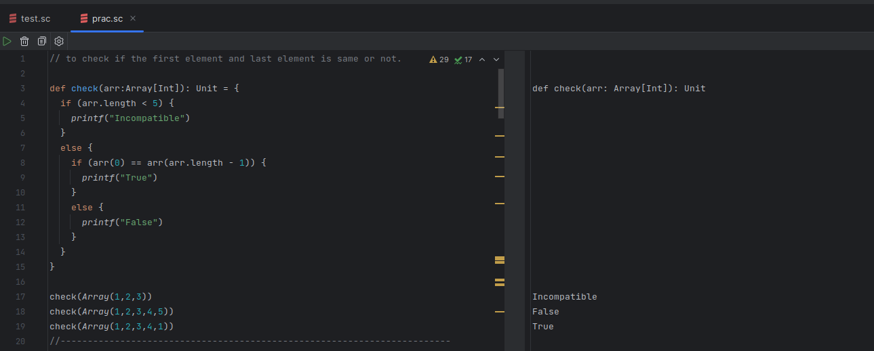 Code & Output:

Q2. Reverse the array (do not use APIs)

Code & Output:

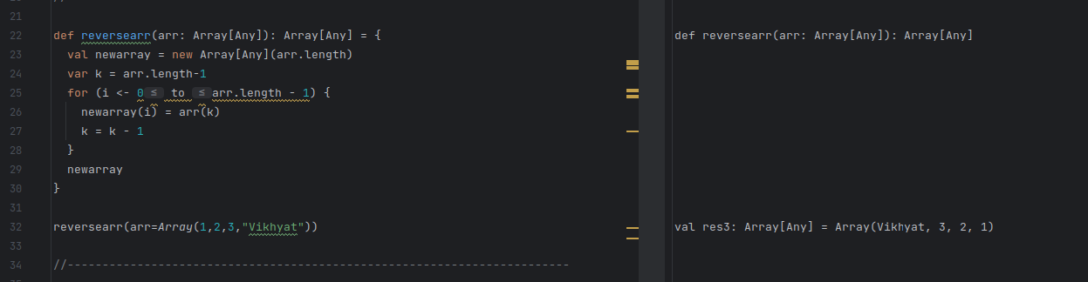

Q3. Get the sum of prime numbers and even numbers in array

Code & Output:

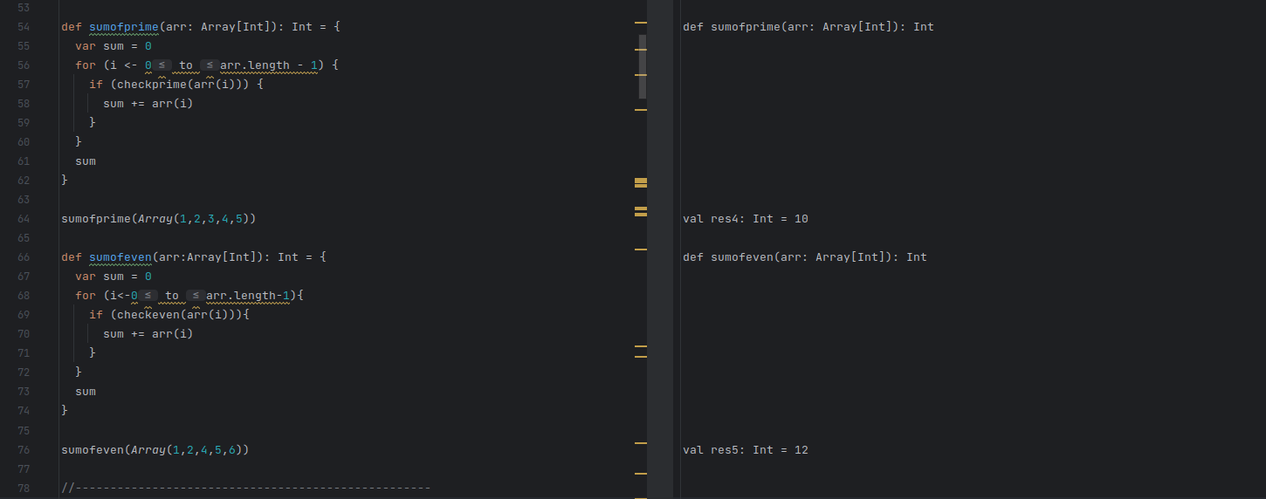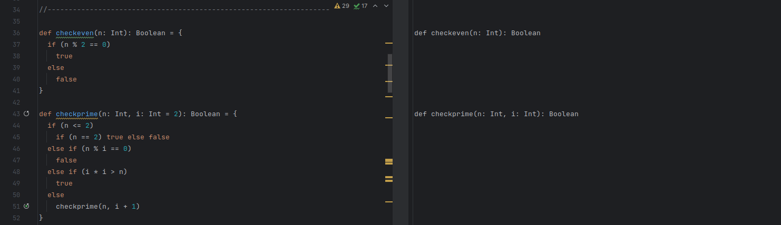

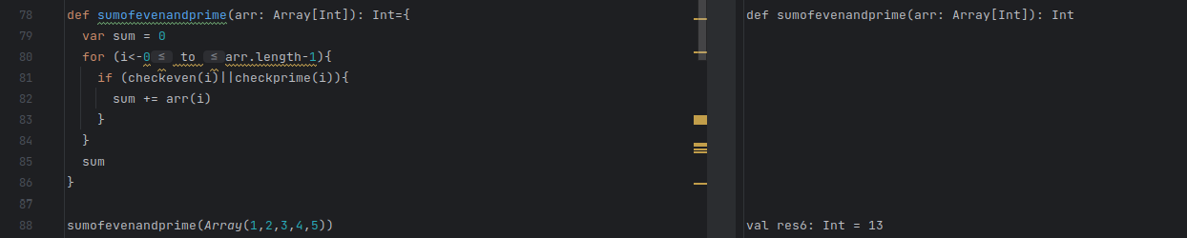

Q4. Find first three smallest elements in the array

Code & Output:

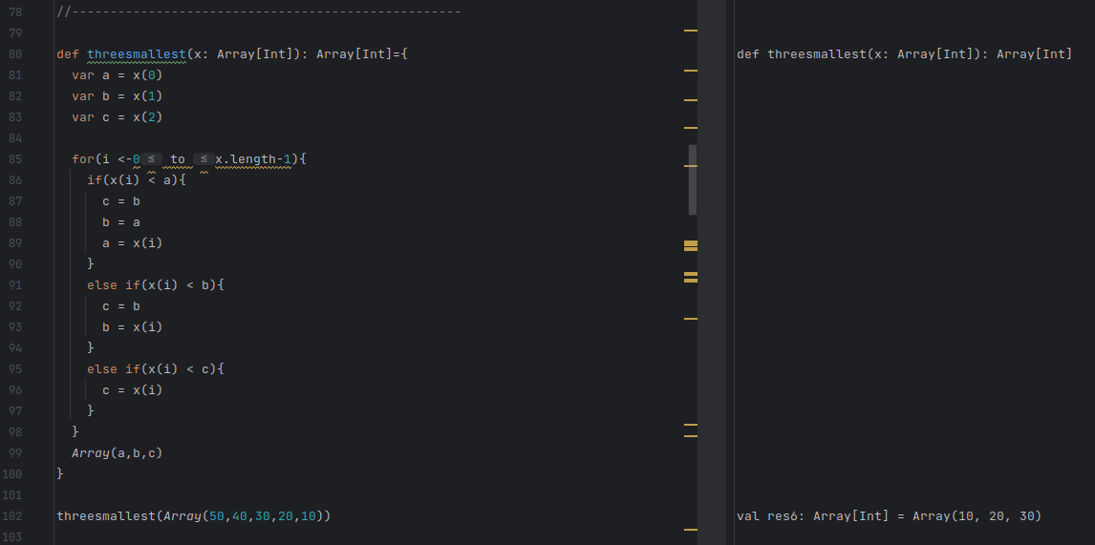

Q5. Print the characters that are repeated more than twice from the given string.

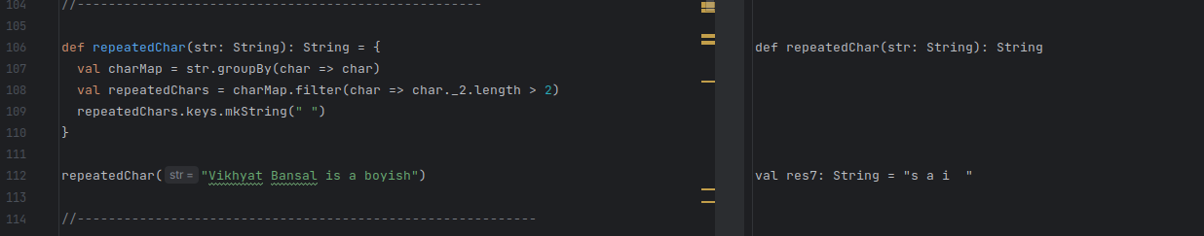 Code & Output:

Q6. Transpose the given matrix and find the diagonal sum

Code & Output: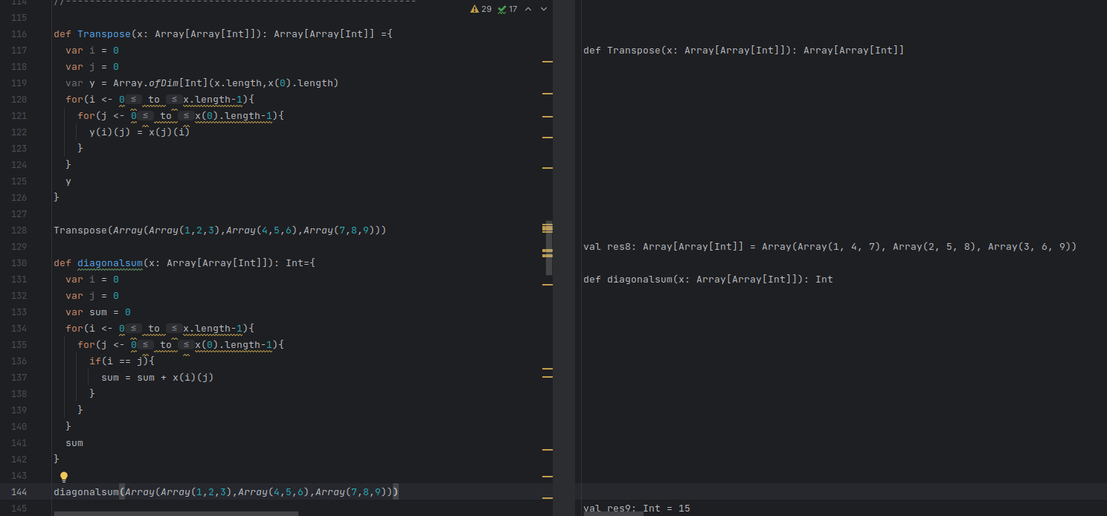

Practice Problem 2 and 3

Q1. A function that takes list of Any Type and check if the list is empty, if not check whether the given list is palindrome.

Code & Output: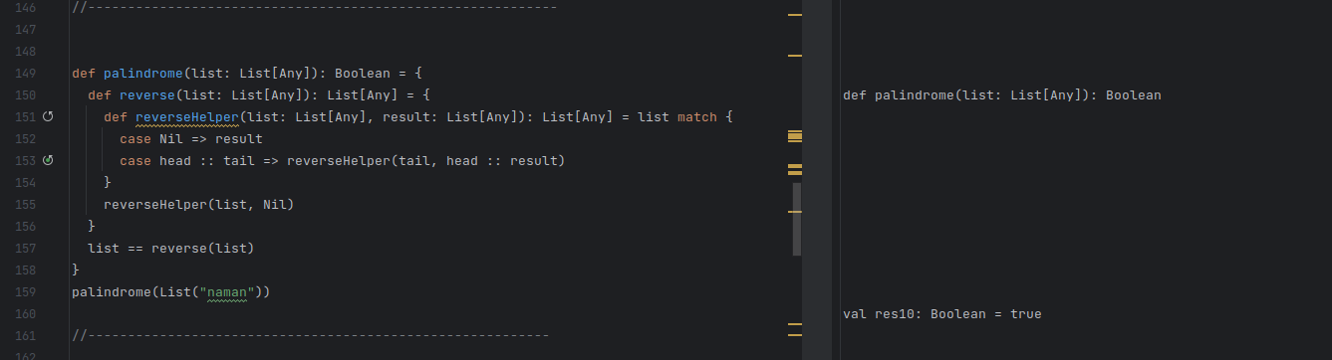

Q2. A function to calculate the sum of even numbers in fibonacci series

Code & Output: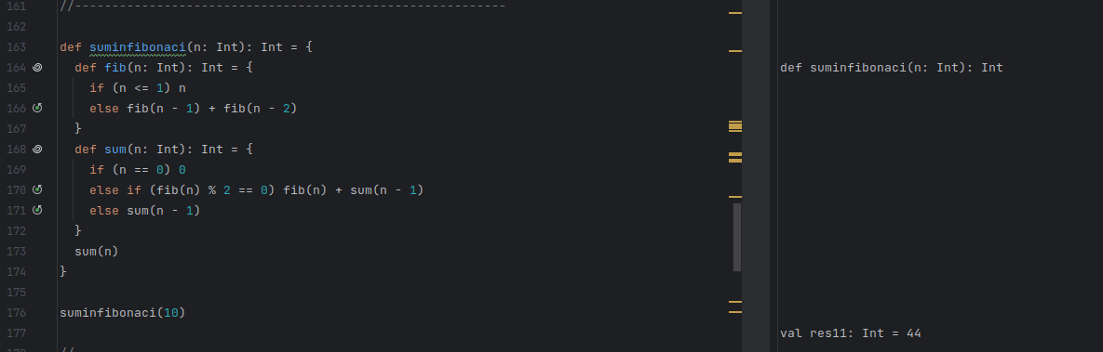

Q3. A function to check valid email addresses [ex: eg: xxxxx@cb.amrita.edu or xxxx@am.amrita.edu or xxxx@blr.amrita.edu, where x can be alphanumeric characters and includes underscore “_”) .

Code & Output:

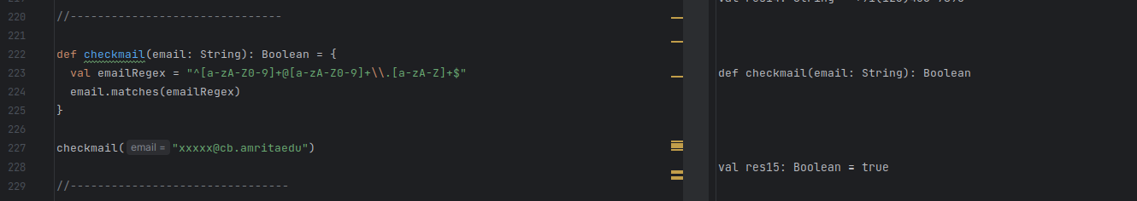

Q4. A function to determine the number of bits you would need to flip to convert integer A to integer B.

Code & Output:

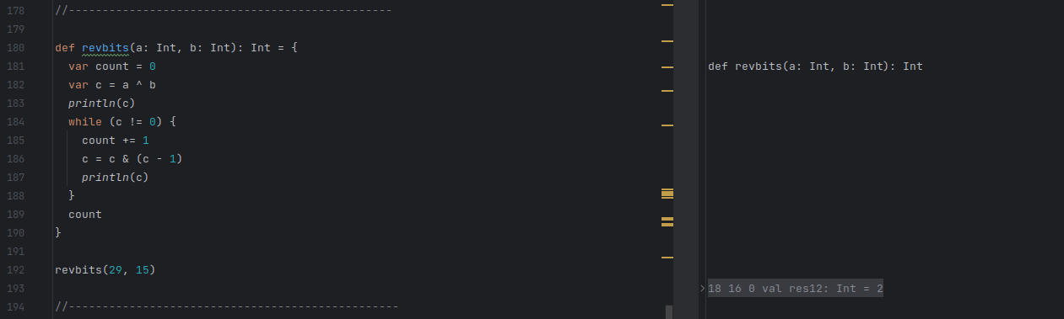

Q5. A function to group characters that are repeated same number of times from sentence.

Code:

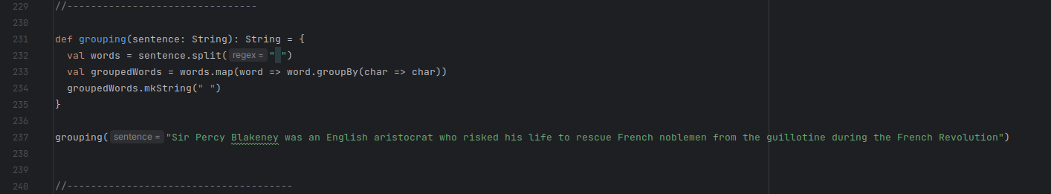

Output:

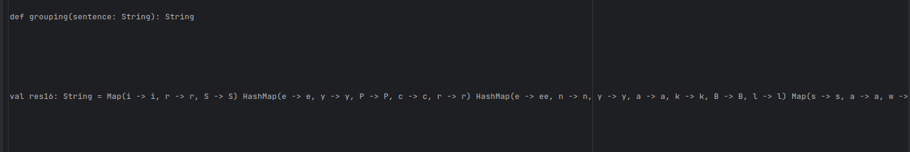

Q6. A function that can accept either array or list can return the sum of elements in the even position.

Code & Output:

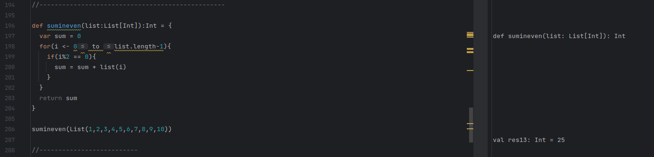

Q7. A function that takes in a ten-digit number as string and prints as proper phone number with area code, exchange, and station (ex: If input is “9445687596 -> +91 (944) 568-7596) .

Code & Output:

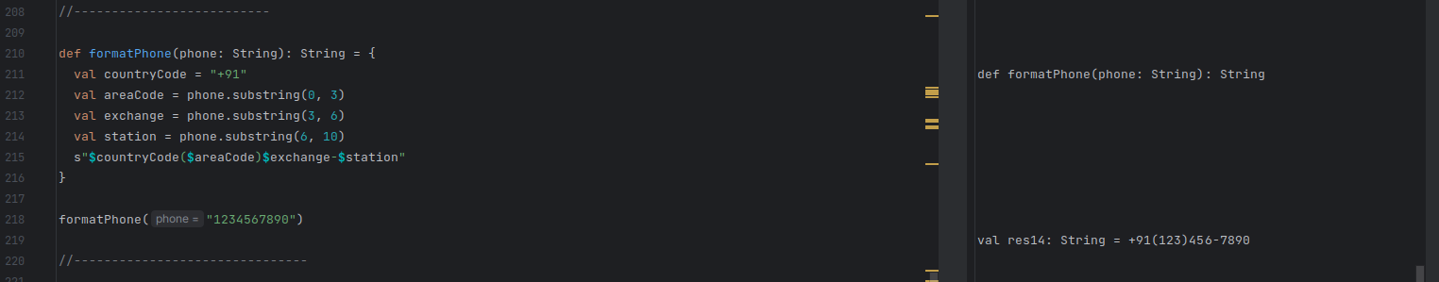

Q8. Perform XOR operation on array of numbers.

Code & Output:

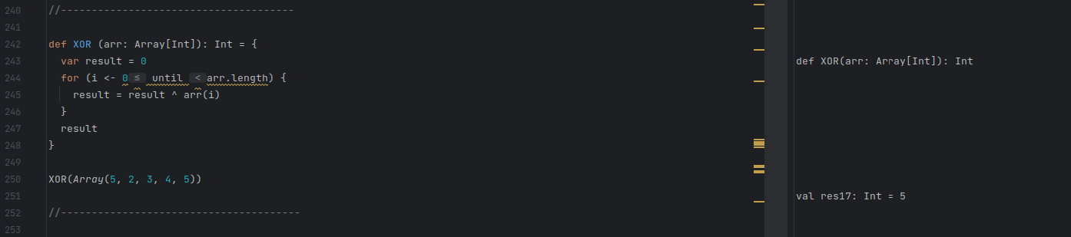

Q9. A function that takes a string as input and group the characters in the even and odd positions respectively and also get the third entity from each group.

Code & Output:

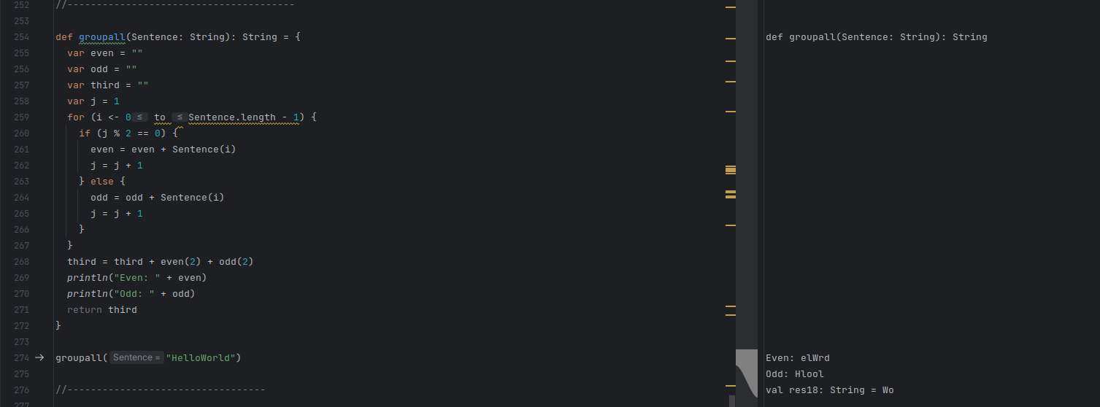

Q10. A function that takes plane shape as input and calculates t the corresponding area (ex: (“rectangle”) when called, it should take the input required from user to calculate the area; in the given case, it is length and breadth). Calculate for rectangle, square, circle, Parallelogram, trapezoid.

Code & Output:

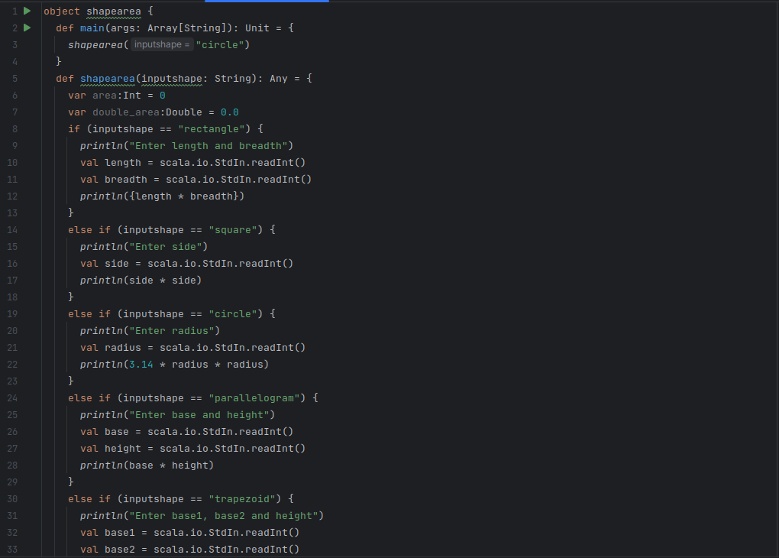

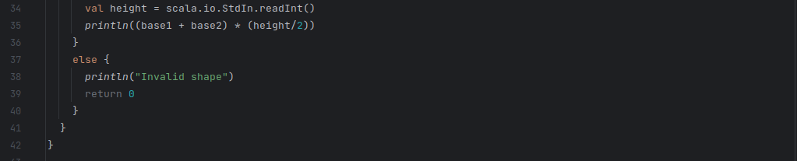

Output:

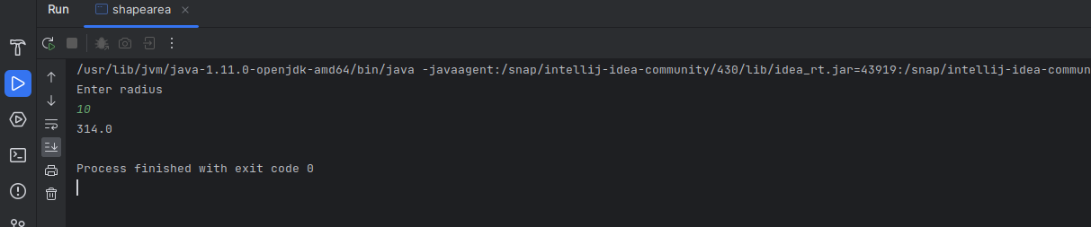

Q11. A function that reads from a file and perform following actions

* 1. Check whether all residents have unique id

Group the residents who does not have unique id

Group residents who are Neighbours

Get the group who has maximum number of neighbours.

Ans.

Code:

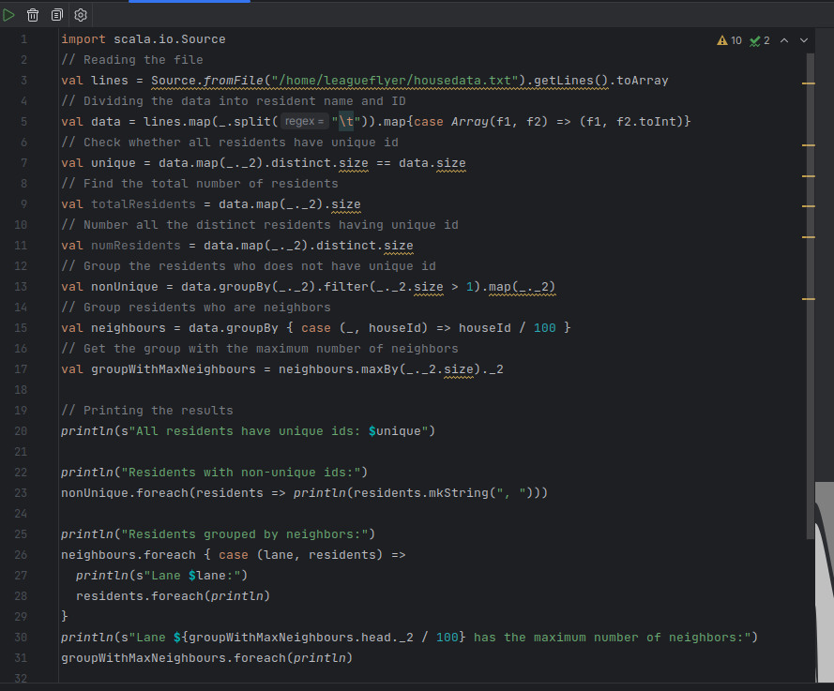

Output:

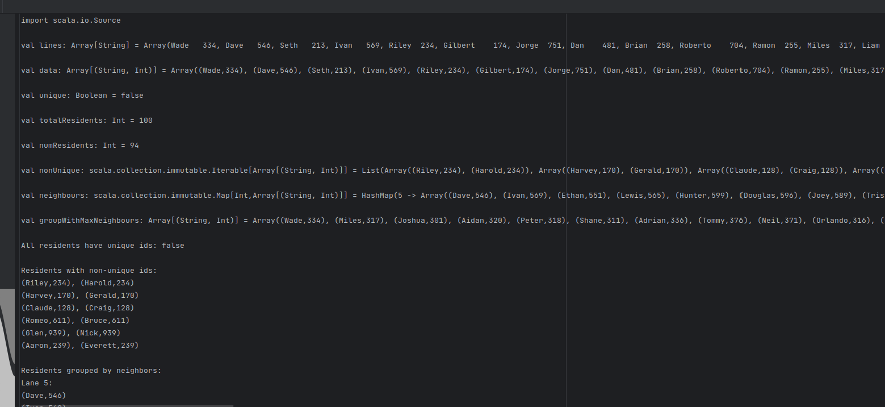

Lab-Test Question

Given a list of words, write a SCALA function that returns a new list with each word converted to TITLECASE.

Code & Output:

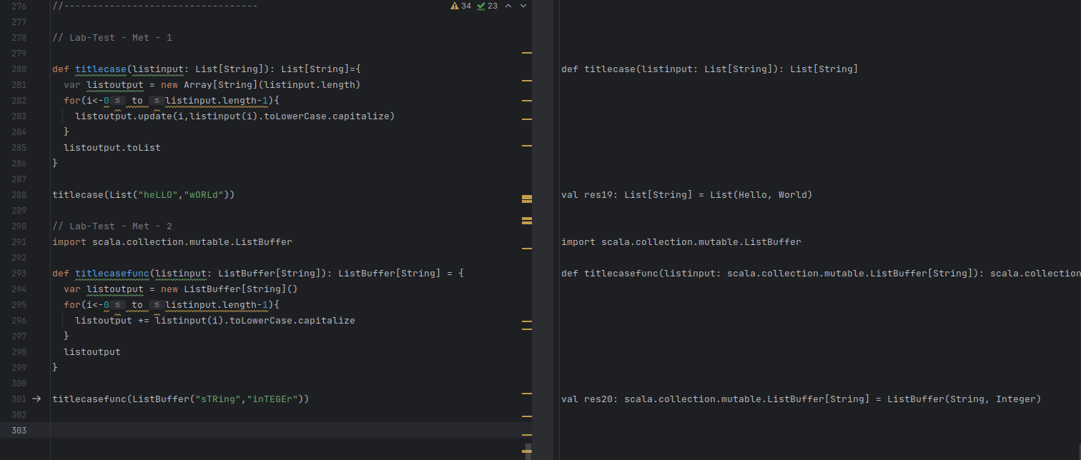

Practice Problem – 4

Q1 a) Sierpenski triangle

Code and Output:

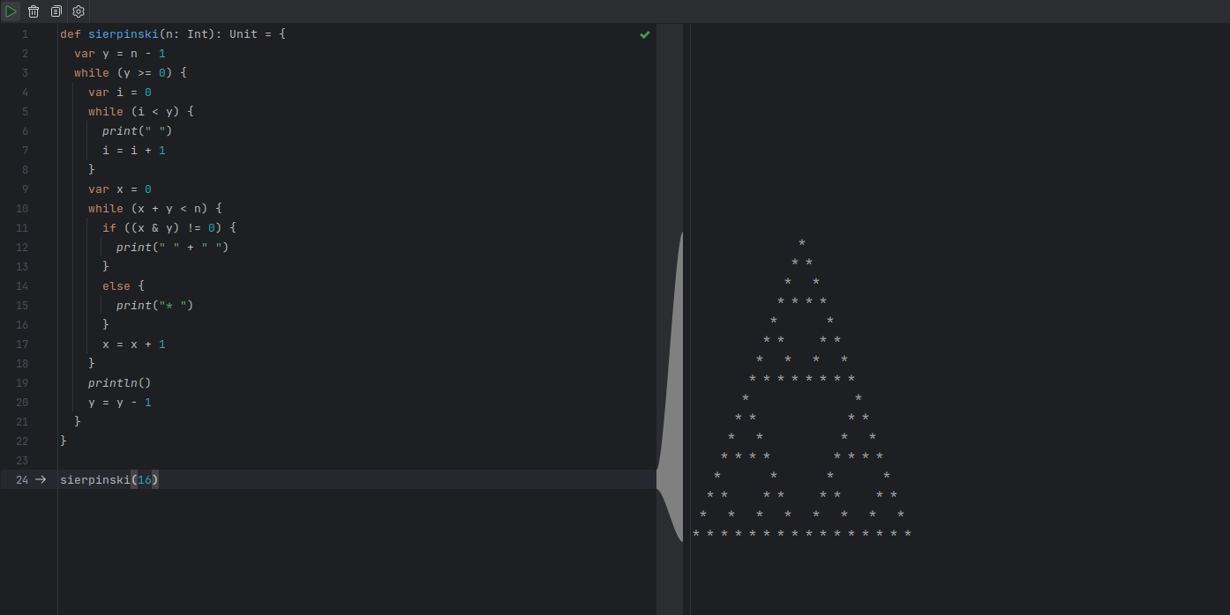

b) Suppose we have a list of 1000 coin flips, and we want to calculate the probability of getting heads or tails on each flip, as well as the overall frequency of heads and tails.

Code and Output:

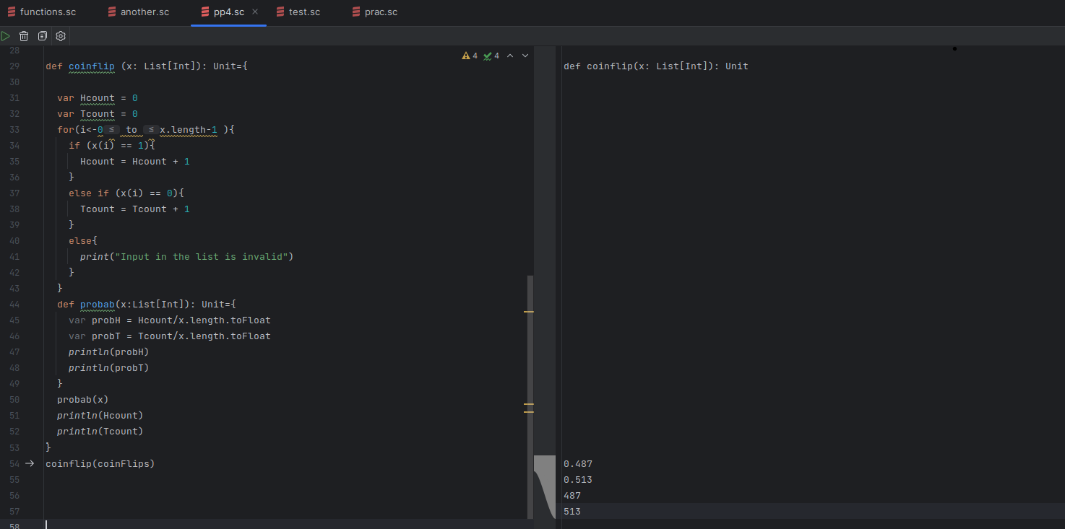

c) A function that takes an integer input and returns the sum of its digits. (Solve through nested function).

Code and Output:

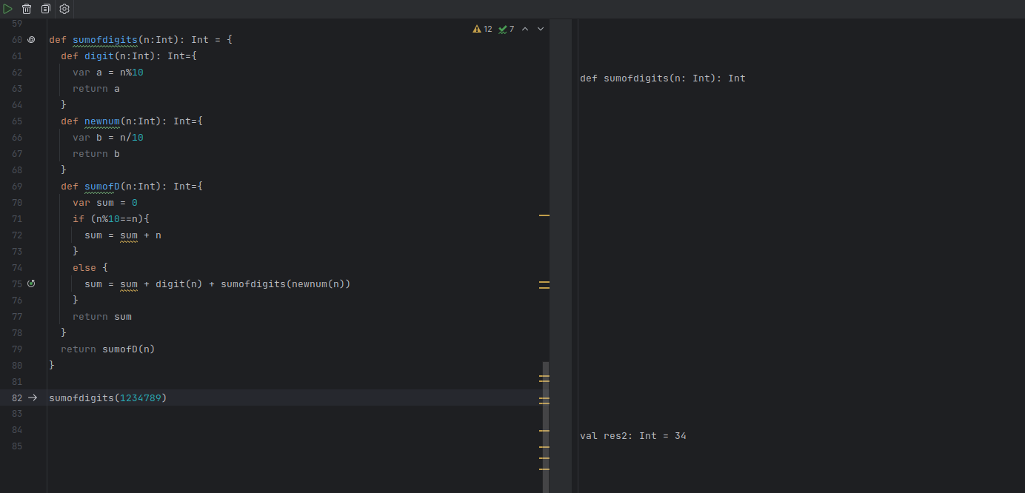

d) Write a Scala function that takes a list of strings and returns a new list containing the lengths of the strings in the input list. (Solve using ConsList)

Code and Output: Using Cons Operator

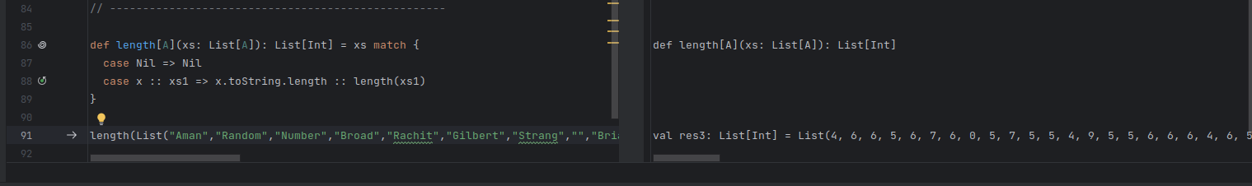

e) Given a list of words, write a Scala function that returns a new list with each word converted to title case. Title case means that the first letter of each word should be capitalized, and the remaining letters should be in lowercase. (Solve using ConsList)

Code and Output: Using Cons Operator

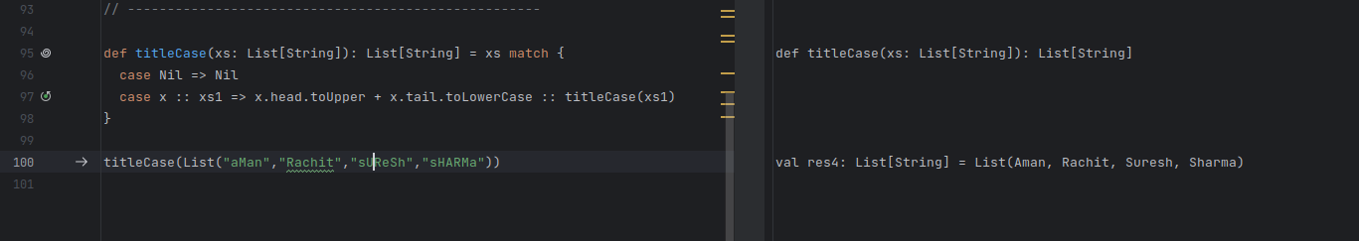

f). You are given a list of temperatures in Celsius. You need to write a function that calculates the corresponding temperatures in Fahrenheit using the formula: Fahrenheit = (Celsius * 9/5) + 32. However, the conversion should be done lazily only when the Fahrenheit temperature is accessed, and not eagerly when the function is called.

Code and Output:

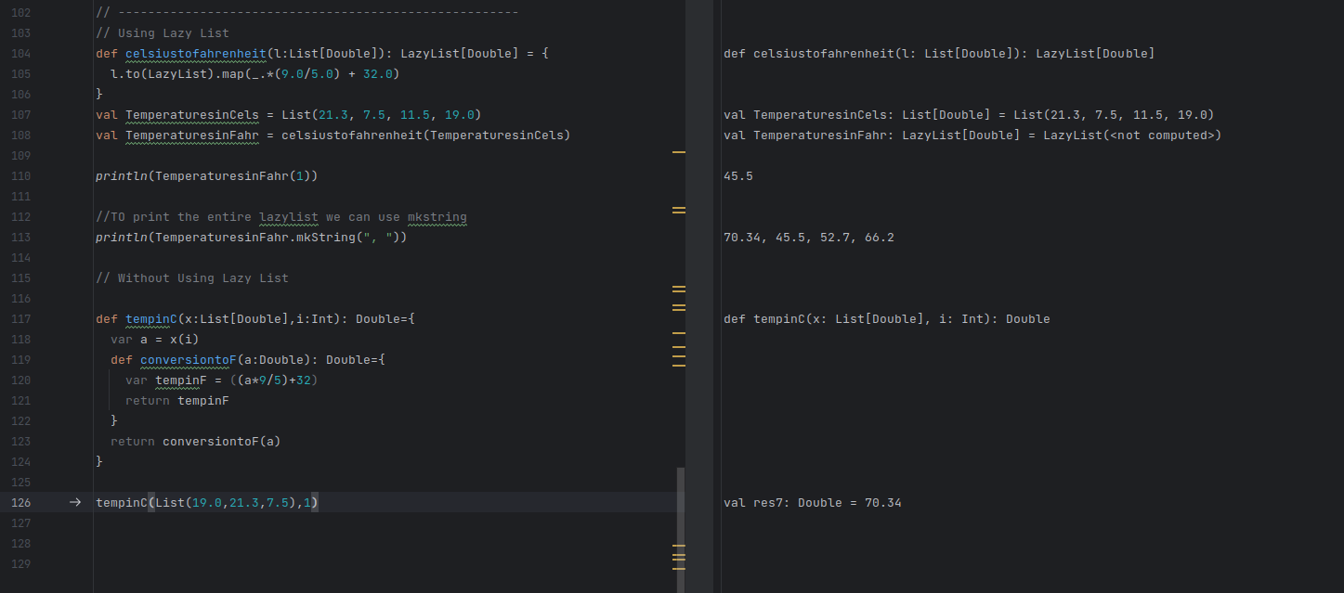

g). Suppose there are 5 candidates running for a position and you need to select a team of 3 for a project. How many different teams can you select if one of the candidates must be on the team?

Code and Output:

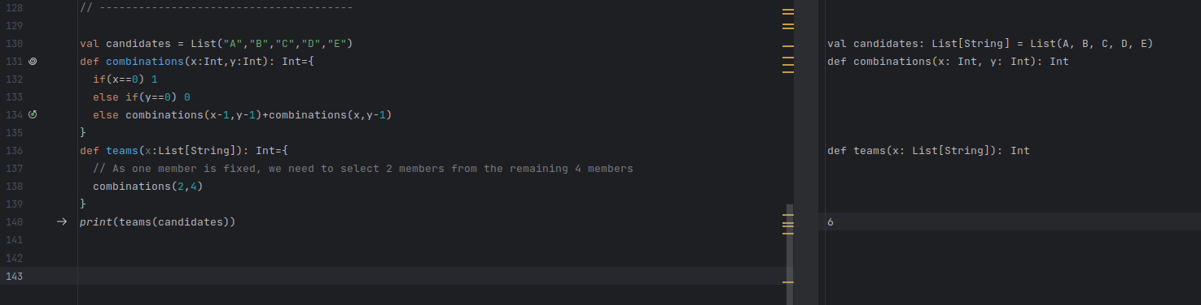

h). Suppose you are given a file system directory containing a hierarchy of files and directories. Each directory may contain other directories and files. Your task is to write a Scala program that traverses the directory hierarchy recursively and counts the total number of files contained in the directory tree.

Code and Output:

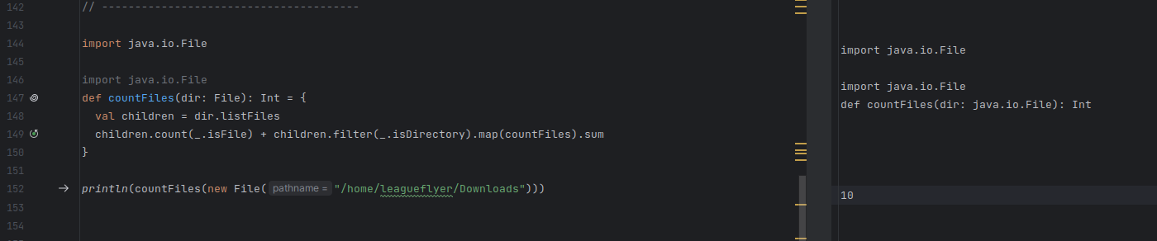

i). Recursive Insertion Sort

Code and Output:

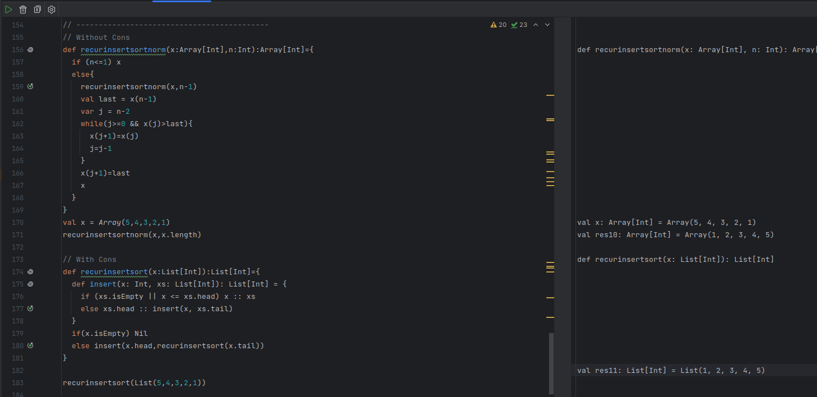

j). Recursive Bubble Sort

Code and Output:

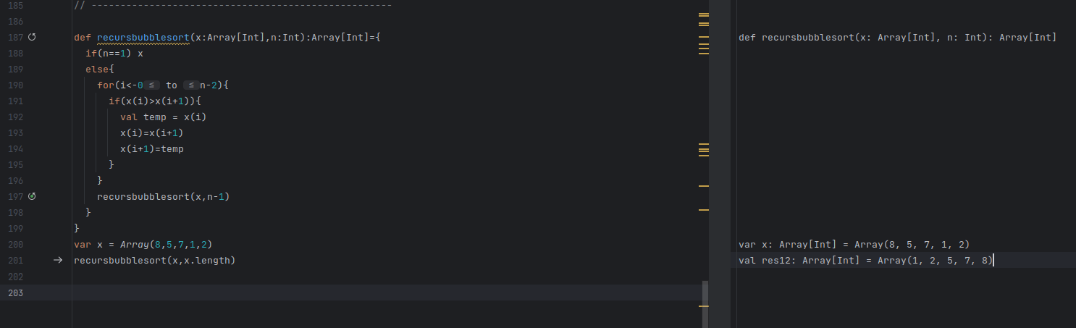

k). Tail recursion Insertion Sort  
Code and Output:

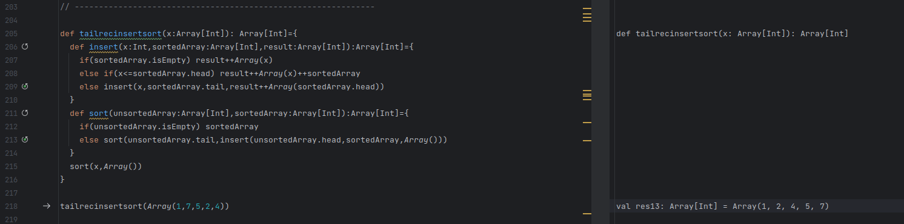

l). Tail recursion bubble sort

Code and Output:

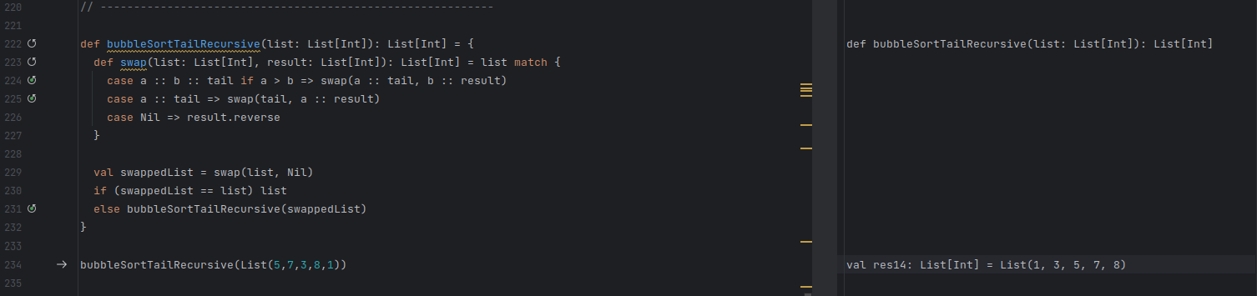

m.) Given a string find its first uppercase letter scala code

Code and Output:

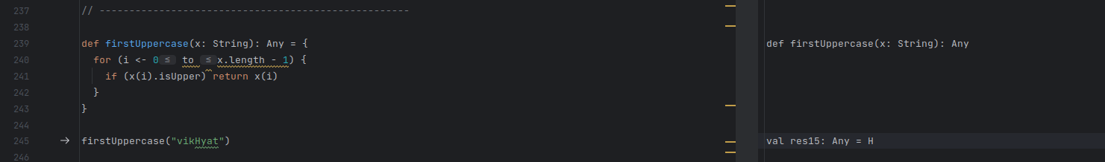

n.) A function to generate the power set of as given string in lexicographic order using recursion:

Code and Output:

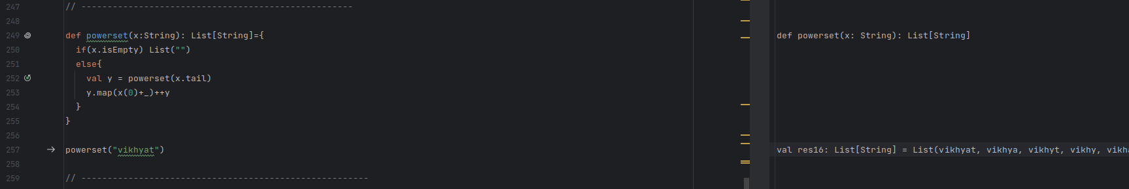

o.) A function to count the total number of consonants in a given string using recursion:

Code and Output:

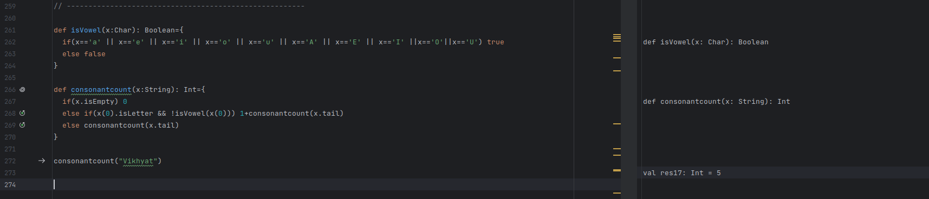

THANK YOU!!