**Introduction to Computer Networks**

In-class Assignment-1

11/03/2023

Submitted by:

Vikhyat Bansal [CB.EN.U4AIE21076]

Sejal Singh [CB.EN.U4AIE21061]

IP of the server: 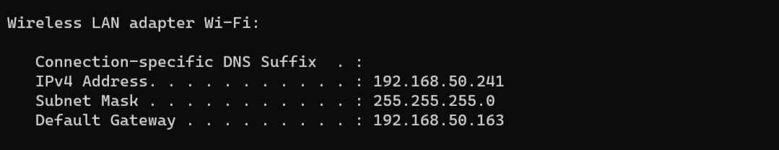

IP of the client: 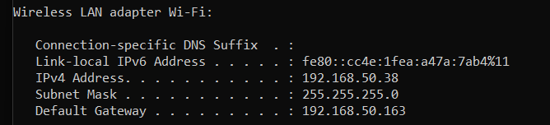

Case1)

Reversing the string:

Code: 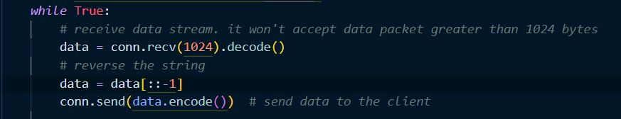

Input from client for reversing and output:

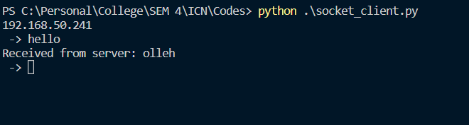

Response from server:

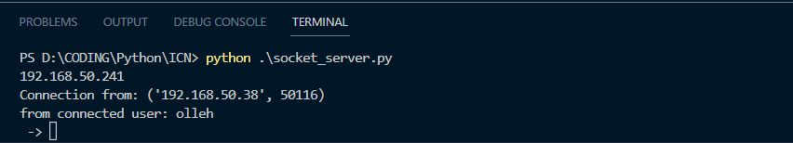

Case2) Change the case:

Code: 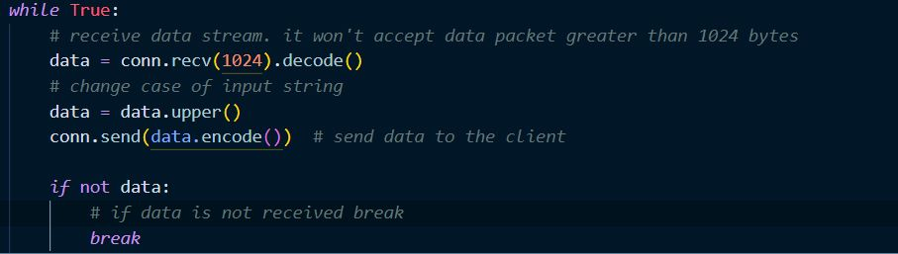

Input from the client and the output:

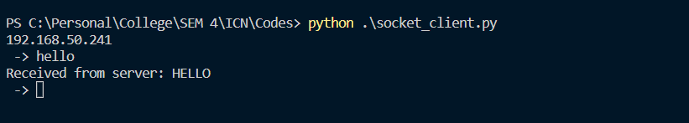

Response of server:

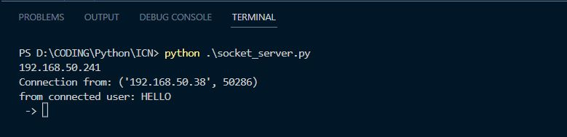

Case3) Swapping the Case:

Code:

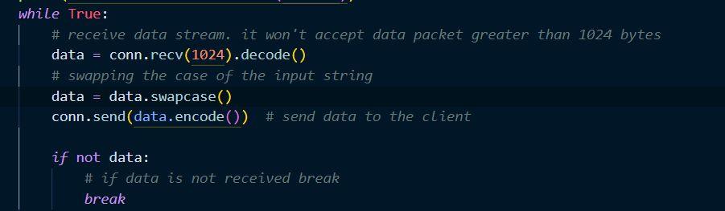

Input from client and output: 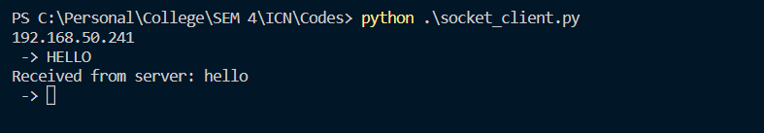

Response from server:

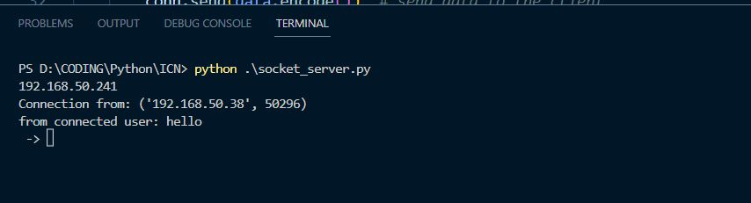

Case4) Vowel count:

Code:

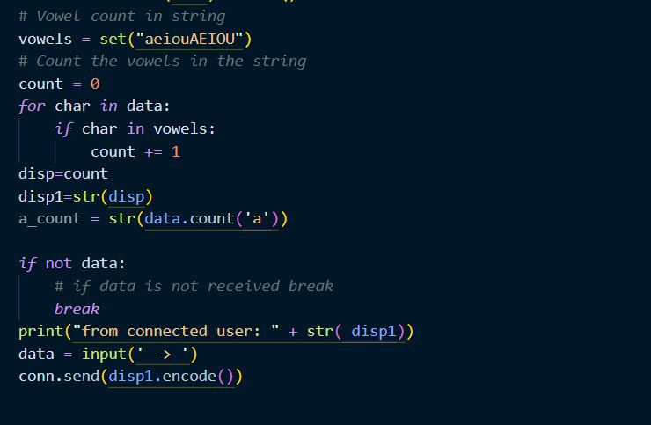

Input from client and output: 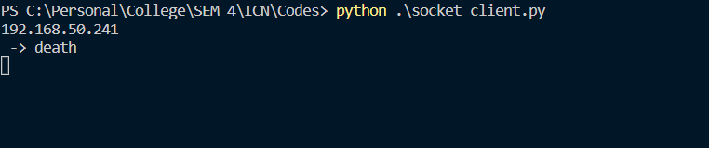

Response from server:

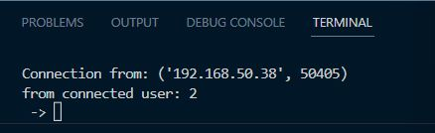

Case5) Occurrence of ‘a’ in a string

Code: 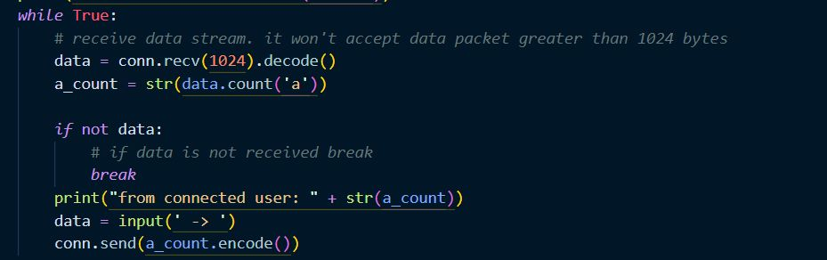

Input from client and output: 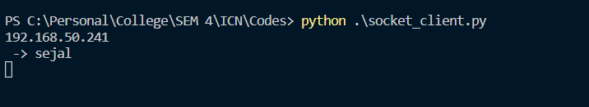

Response form server:

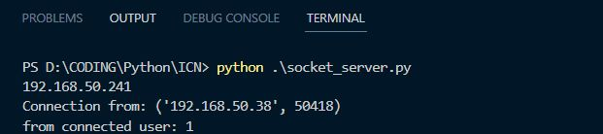

Thank you