Tutorial – 1

21_AIE_211

Introduction to Computer Networks– SEM-IV

Professor – Ganga Gowri

Submitted By: Vikhyat Bansal [CB.EN.U4AIE21076]



NETWORK

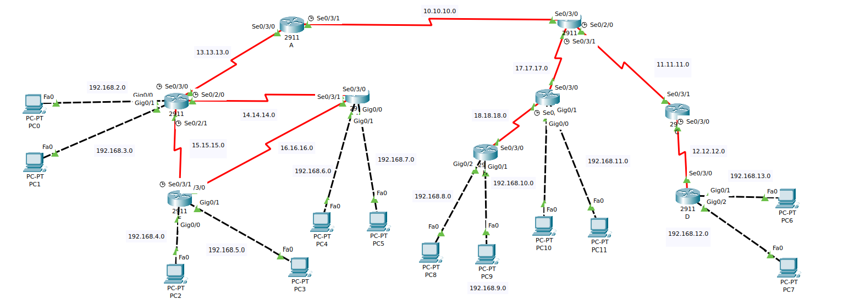

Device Configuration Table

|  |  |  |  |  |
| --- | --- | --- | --- | --- |
| Device | Interface | IP Address | Subnet Mask | Default Gateway |
| Router A | Se 0/3/0 | 13.13.13.1 | 255.0.0.0 | N.A |
| Se 0/3/1 | 10.10.10.1 | 255.0.0.0 | N.A |
| Router B | Se 0/3/0 | 10.10.10.2 | 255.0.0.0 | N.A |
| Se 0/2/0 | 11.11.11.1 | 255.0.0.0 | N.A |
| Se 0/3/1 | 17.17.17.1 | 255.0.0.0 | N.A |
| Router C | Se 0/3/0 | 12.12.12.1 | 255.0.0.0 | N.A |
| Se 0/3/1 | 11.11.11.2 | 255.0.0.0 | N.A |
| Router D | GigabitEthernet0/1 | 192.168.13.1 | 255.255.255.0 | N.A |
| GigabitEthernet0/2 | 192.168.12.1 | 255.255.255.0 | N.A |
| Se 0/3/0 | 12.12.12.2 | 255.0.0.0 | N.A |
| Router G | GigabitEthernet0/0 | 192.168.10.1 | 255.255.255.0 | N.A |
| GigabitEthernet0/1 | 192.168.11.1 | 255.255.255.0 | N.A |
| Se 0/3/0 | 17.17.17.2 | 255.0.0.0 | N.A |
| Se 0/3/1 | 18.18.18.1 | 255.0.0.0 | N.A |
| Router H | GigabitEthernet0/1 | 192.168.9.1 | 255.255.255.0 | N.A |
| GigabitEthernet0/2 | 192.168.8.1 | 255.255.255.0 | N.A |
| Se 0/3/0 | 18.18.18.2 | 255.0.0.0 | N.A |
| Router F | GigabitEthernet0/0 | 192.168.2.1 | 255.255.255.0 | N.A |
| GigabitEthernet0/1 | 192.168.3.1 | 255.255.255.0 | N.A |
| Se 0/2/0 | 14.14.14.1 | 255.0.0.0 | N.A |
| Se 0/2/1 | 15.15.15.1 | 255.0.0.0 | N.A |
| Se 0/3/0 | 13.13.13.2 | 255.0.0.0 | N.A |
| Router I | GigabitEthernet0/0 | 192.168.7.1 | 255.255.255.0 | N.A |
| GigabitEthernet0/1 | 192.168.6.1 | 255.255.255.0 | N.A |
| Se 0/3/0 | 14.14.14.2 | 255.0.0.0 | N.A |
| Se 0/3/1 | 16.16.16.2 | 255.0.0.0 | N.A |
| Router E | GigabitEthernet0/0 | 192.168.4.1 | 255.255.255.0 | N.A |
| GigabitEthernet0/1 | 192.168.5.1 | 255.255.255.0 | N.A |
| Se 0/3/0 | 16.16.16.1 | 255.0.0.0 | N.A |
| Se 0/3/1 | 15.15.15.2 | 255.0.0.0 | N.A |
| PC 0 | FastEhernet0 | 192.168.2.2 | 255.255.255.0 | 192.168.2.1 |
| PC 1 | FastEhernet0 | 192.168.3.2 | 255.255.255.0 | 192.168.3.1 |
| PC 2 | FastEhernet0 | 192.168.4.2 | 255.255.255.0 | 192.168.4.1 |
| PC 3 | FastEhernet0 | 192.168.5.2 | 255.255.255.0 | 192.168.5.1 |
| PC 4 | FastEhernet0 | 192.168.6.2 | 255.255.255.0 | 192.168.6.1 |
| PC 5 | FastEhernet0 | 192.168.7.2 | 255.255.255.0 | 192.168.7.1 |
| PC 6 | FastEhernet0 | 192.168.13.2 | 255.255.255.0 | 192.168.13.1 |
| PC 7 | FastEhernet0 | 192.168.12.2 | 255.255.255.0 | 192.168.12.1 |
| PC 8 | FastEhernet0 | 192.168.8.2 | 255.255.255.0 | 192.168.8.1 |
| PC 9 | FastEhernet0 | 192.168.9.2 | 255.255.255.0 | 192.168.9.1 |
| PC 10 | FastEhernet0 | 192.168.10.2 | 255.255.255.0 | 192.168.10.1 |
| PC 11 | FastEhernet0 | 192.168.12.2 | 255.255.255.0 | 192.168.11.1 |

Routing Implementation in CLI : OSPF Routing

|  |  |  |
| --- | --- | --- |
| Device | Configuration Step | CLI Command |
| Router A | OSPF | Enable  Configure terminal  Router ospf 1  Network 13.13.13.0 0.0.0.255 area 10  Network 10.10.10.0 0.0.0.255 area 0 |
| Router B | OSPF | Enable  Configure terminal  Router ospf 1  Network 17.17.17.0 0.0.0.255 area 20  Network 10.10.10.0 0.0.0.255 area 0  Network 11.11.11.0 0.0.0.255 area 0 |
| Router C | OSPF | Enable  Configure terminal  Router ospf 1  Network 12.12.12.0 0.0.0.255 area 30  Network 11.11.11.0 0.0.0.255 area 0 |
| Router D | OSPF | Enable  Configure terminal  Router ospf 1  Network 12.12.12.0 0.0.0.255 area 30  Network 192.168.12.0 0.0.0.255 area 30  Network 192.168.13.0 0.0.0.255 area 30 |
| Router G | OSPF | Enable  Configure terminal  Router ospf 1  Network 17.17.17.0 0.0.0.255 area 20 Network 18.18.18.0 0.0.0.255 area 20  Network 192.168.10.0 0.0.0.255 area 20  Network 192.168.11.0 0.0.0.255 area 20 |
| Router H | OSPF | Enable  Configure terminal  Router ospf 1  Network 18.18.18.0 0.0.0.255 area 20  Network 192.168.8.0 0.0.0.255 area 20  Network 192.168.9.0 0.0.0.255 area 20 |
| Router F | OSPF | Enable  Configure terminal  Router ospf 1  Network 13.13.13.0 0.0.0.255 area 10 Network 14.14.14.0 0.0.0.255 area 10  Network 15.15.15.0 0.0.0.255 area 10  Network 192.168.2.0 0.0.0.255 area 10  Network 192.168.3.0 0.0.0.255 area 10 |
| Router I | OSPF | Enable  Configure terminal  Router ospf 1  Network 14.14.14.0 0.0.0.255 area 10  Network 15.15.15.0 0.0.0.255 area 10  Network 192.168.6.0 0.0.0.255 area 10  Network 192.168.7.0 0.0.0.255 area 10 |
| Router E | OSPF | Enable  Configure terminal  Router ospf 1  Network 15.15.15.0 0.0.0.255 area 10  Network 16.16.16.0 0.0.0.255 area 10  Network 192.168.4.0 0.0.0.255 area 10  Network 192.168.5.0 0.0.0.255 area 10 |

Ping Results Screenshot

From Area 10 to Area 20 (ping 192.168.8.2 using 192.168.3.2 (PC 1))

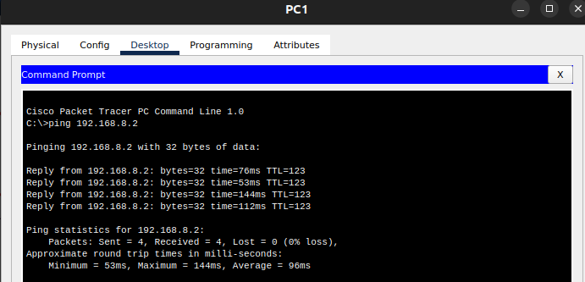

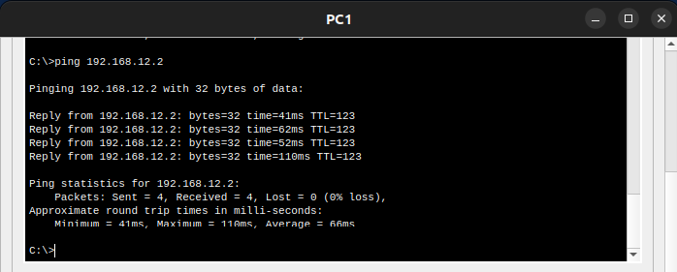From Area 10 to Area 30 (ping 192.168.12.2 using 192.168.3.2 (PC 1))

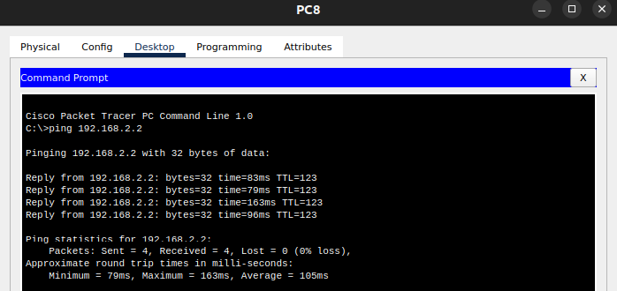From Area 20 to Area 10 (ping 192.168.2.2 using 192.168.8.2 (PC 8))

From Area 20 to Area 30 (ping 192.168.12.2 using 192.168.10.2 (PC 10))

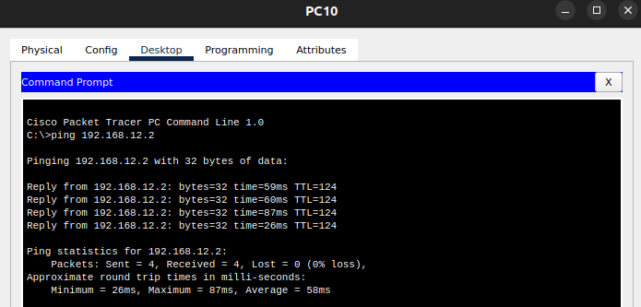

From Area 30 to Area 10 (ping 192.168.2.2 using 192.168.12.2 (PC 7))

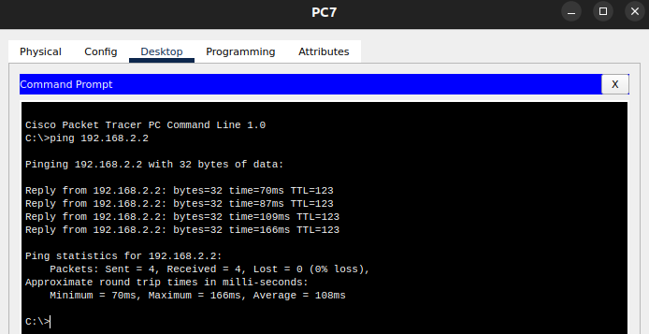

From Area 30 to Area 20 (ping 192.168.8.2 using 192.168.13.2 (PC 6))

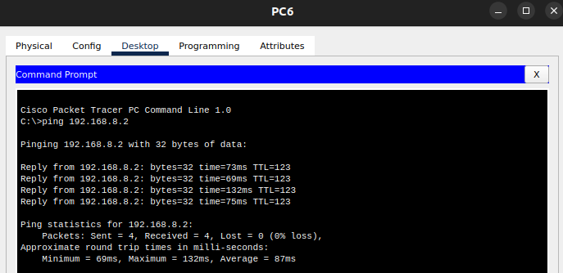

[Link of the CPT-OSPF(Routing) FILE](https://amritavishwavidyapeetham-my.sharepoint.com/:u:/g/personal/cb_en_u4aie21076_cb_students_amrita_edu/EcP2v64cFUtDnuNDShhEjxUBp_N4cPMaSmSWF34ay8vhpQ?e=XKvZlg)

THANK YOU!!