ASSIGNMENT-1  
SUBJECT CODE-19AIE105

Q1. Write matlab/octave code to compute the following

Q2. Explain the difference between the commands ‘format short’ and ‘format long’ with examples

A2. Using code help we can know and understand the difference between subtypes of each data type.  
To understand see below:-

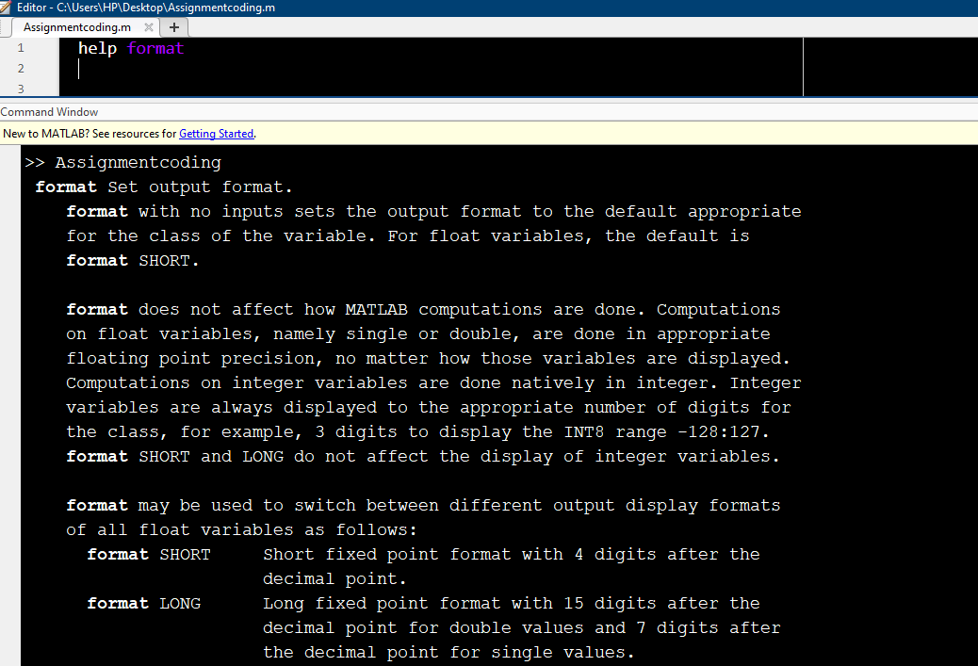

Examples of same are:-

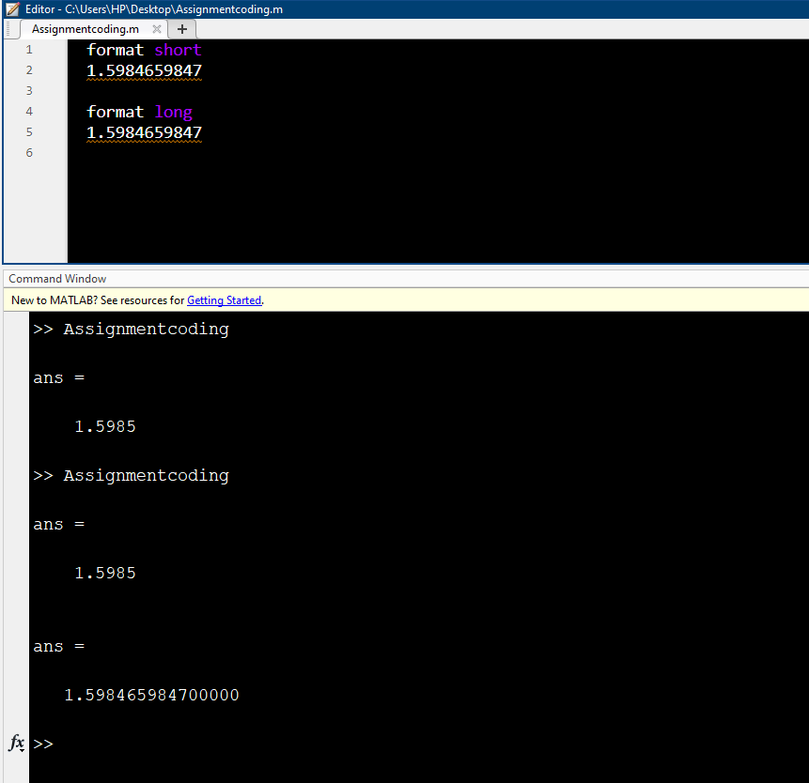

Q3. Write matlab/octave code to compute the following. Choose a value for variables ‘a’, ‘x’, ‘y’

A3. Using the code given below we can get above expression and dedicating some values to the variable will give us new value of Y each time

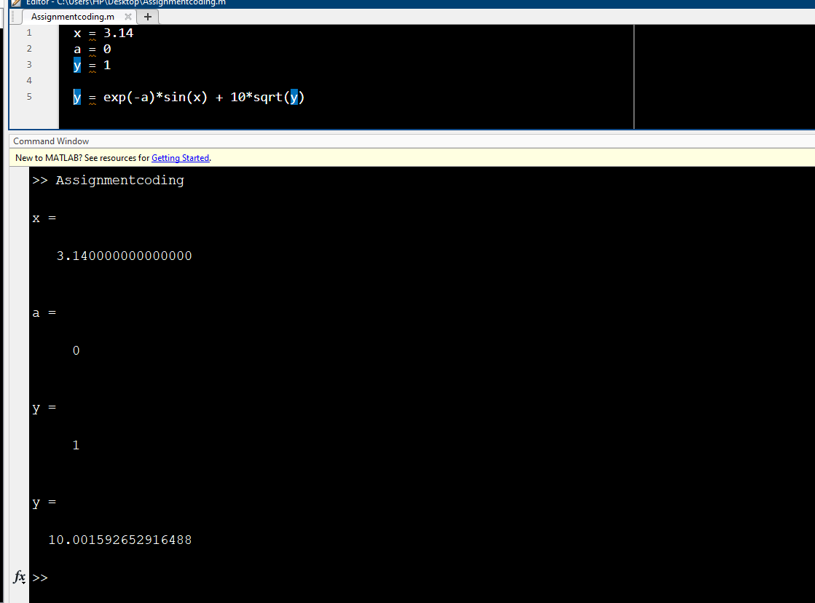

Q4. Write a MATLAB /octave code to create a ‘column vector’. Perform ‘transpose’ operation and display the vector.

A4. Using the code given below

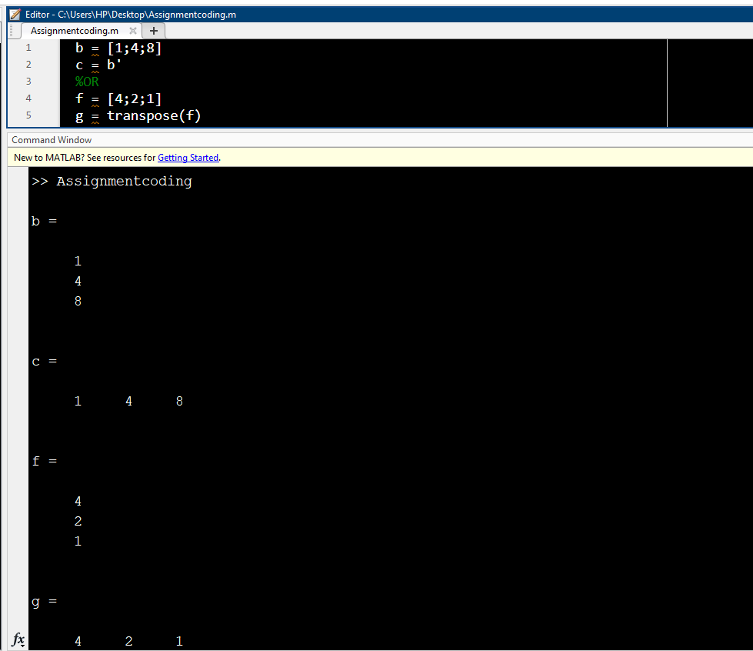

Q5. Write a matlab/octave code to create a 3x3 matrix. Display the 2nd and 3rd column of the matrix.

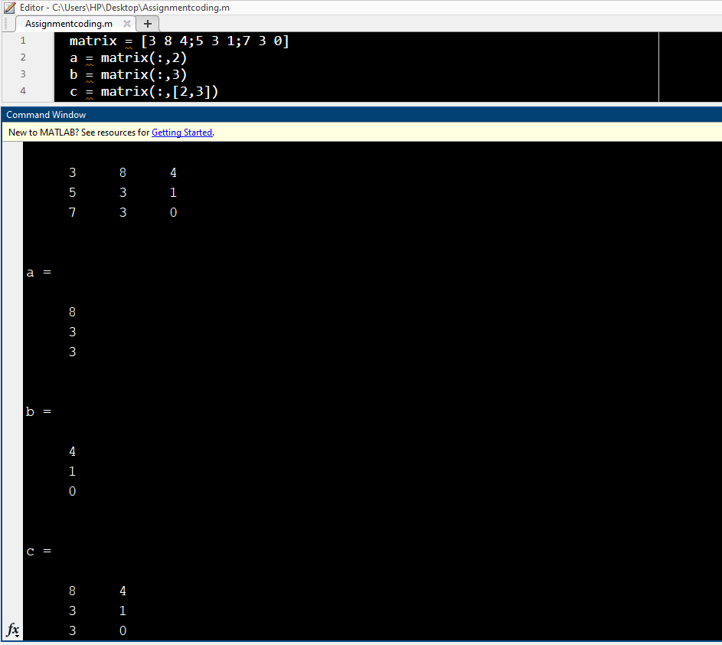

Q6. Write a MATLAB/octave code to generate the following number sequence

0.0, 0.1, 0.2, 0.3, 0.4, 0.5, 0.6, 0.7, 0.8, 0.9, 1.0

A6. Using code given below:-

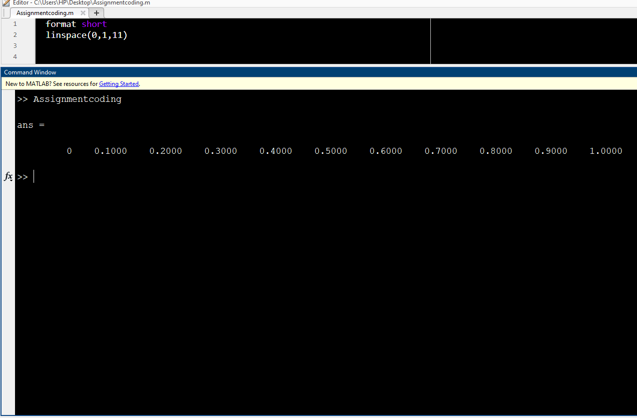

SUBMITTED BY:-  
VIKHYAT BANSAL