**Assignment – 2**

1. Write a MATLAB code to display the following patterns

a)

* * * * *

 * * * *

  * * *

   * *

    *

THE MATLAB CODE FOR THE SAME IS:

for i=1:5

for j=1:5

if (j>=i)

fprintf('* ');

else

fprintf(' ');

end

end

disp (' ')

end

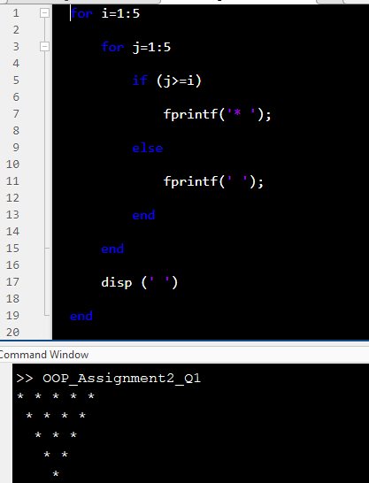

b)

*

**

***

****

*****

****

***

**

*

THE MATLAB CODE FOR THE SAME IS:

for i=1:5

for j=1:i

fprintf('*')

end

fprintf('\n')

end

for i=5-1:-1:1

for j=i:-1:1

fprintf('*')

end

fprintf('\n')

end

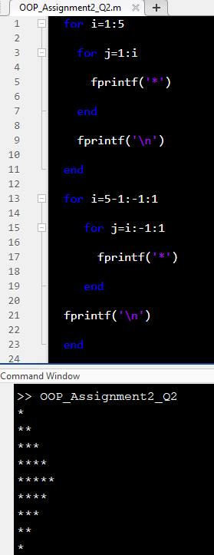

c)

*

**

***

****

*****

******

*****

****

***

**

*

THE MATLAB CODE FOR THE SAME IS:

for i=1:1:6

for l=i:1:6

fprintf(' ')

end

for j=i:-1:1

fprintf(" *")

end

fprintf('\n')

fprintf('\n')

end

for i=5:-1:1

for l=i:1:7

fprintf(" ")

end

for j=i:-1:1

fprintf('* ')

end

fprintf('\n')

fprintf('\n')

end

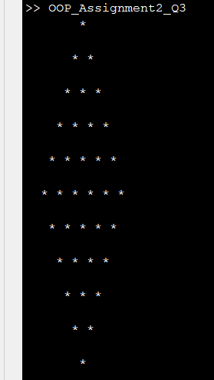

d)

*

* *

* *

* *

* *

THE MATLAB CODE FOR THE SAME IS:

y= [];

for i=1:5

for j=i:(2*5-1)

if(i==j || i+j==2*5)

y(i,j)='*';

end

end

end

z=char(y);

w=flip(z);

disp(w);

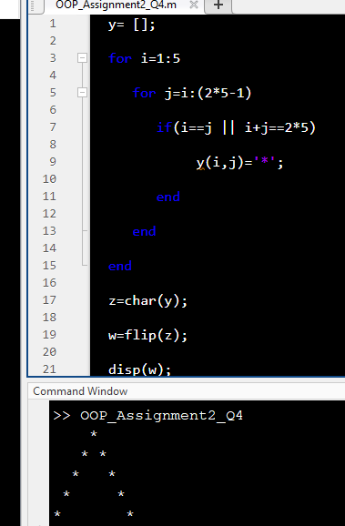

e)

* *

* *

* *

* *

*

THE MATLAB CODE FOR THE SAME IS:

for i=1:5

for j=1:9

if abs(5-j)==5-i

fprintf('*');

else

fprintf(' ');

end

end

disp(' ');

end

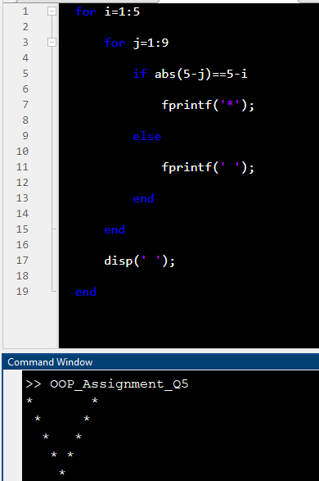

**Link to upload:**

<https://amritavishwavidyapeetham-my.sharepoint.com/:f:/g/personal/s_sachinkumar_cb_amrita_edu/EvirZagdrHZIln_77A3V3zkBIaL7f1ms2PO4d4wFPunrdg?e=Faa3CT>

Copy the code to a word document and following the below mentioned format to name the document.

**Naming format for the document:**

Batch ‘A’ students - ‘A_name.docx’

Batch ‘B’ students - ‘B_name.docx’