**Assignment 3**

1. Given an array, {3,1,5,6,8}, find a subsequence or subarray which adds to a total of 12. Write a MATLAB code for the problem.

THE MATLAB CODE FOR THE SAME IS:

x = [3,1,5,6,8];

i = 1;

while i <=5

j = i + 1;

while j <= 5

k = j + 1;

while k <=5

if x(1, i) + x(1, j) + x(1, k) == 12

sum = [x(1, i) x(1, j) x(1, k)]

end

k = k + 1;

end

j = j + 1;

end

i = i + 1;

end

OUTPUT:

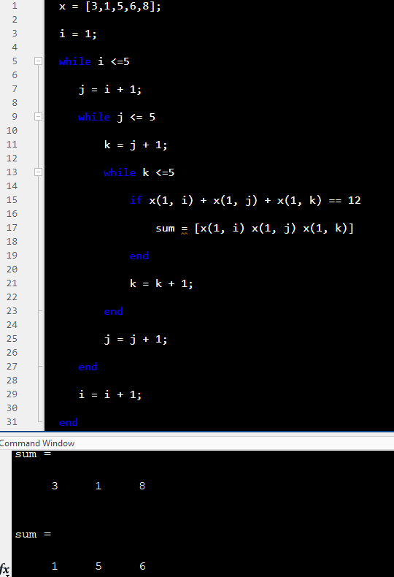

2. Given an array, {3,1,5,6,8}, find a triplet (subsequence or subarray with 3 elements) in which adding first two elements equals to third element. Write a MATLAB code for the problem.

THE MATLAB CODE IS:

x = [3 1 5 6 8];

i = 1;

while i <=5

j = i + 1;

while j <= 5

k = j + 1;

while k <=5

if x(1, i) + x(1, j) == x(1, k)

sum_of_first_two_element_is_third = [x(1, i) x(1, j) x(1, k)]

end

k = k + 1;

end

j = j + 1;

end

i = i + 1;

end

OUTPUT:

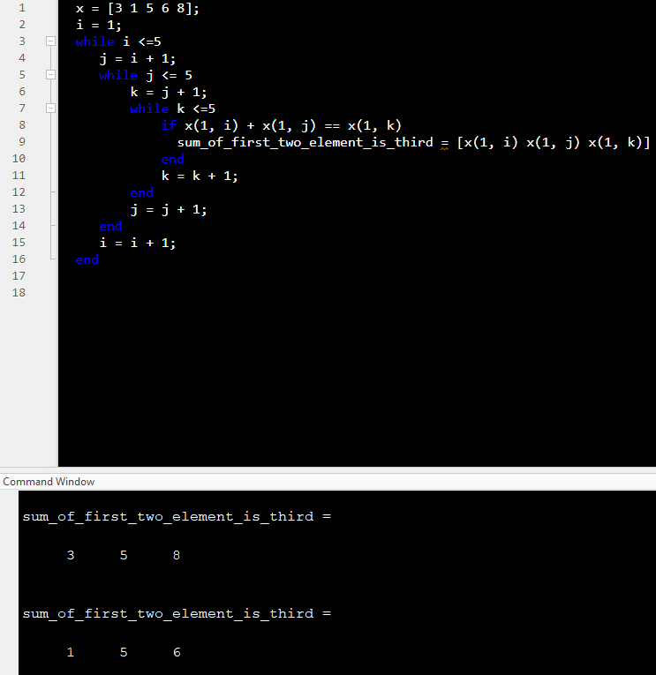

3. Given an array, {0,1,3,0,1}, rearrange it in ascending order. Write a MATLAB code for the problem.

THE MATLAB CODE IS:

a = [0 1 3 0 1];

sort(a,'ascend')

OUTPUT:

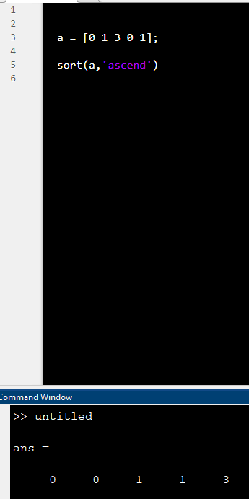

4. Given an array, {3,1,4,0,4,6,8}, rearrange it in ascending order and find the 5th largest element. Write a MATLAB code for the problem.

THE MATLAB CODE IS:

a= [3,1, 4, 0, 4, 6, 8];

b=sort(a, 'ascend');

disp ('Ascending order of the array is:')

disp(b)

disp('The 5th largest number is:') %As 5th largest number is asked

x=b(3);

disp(x)

OUTPUT:

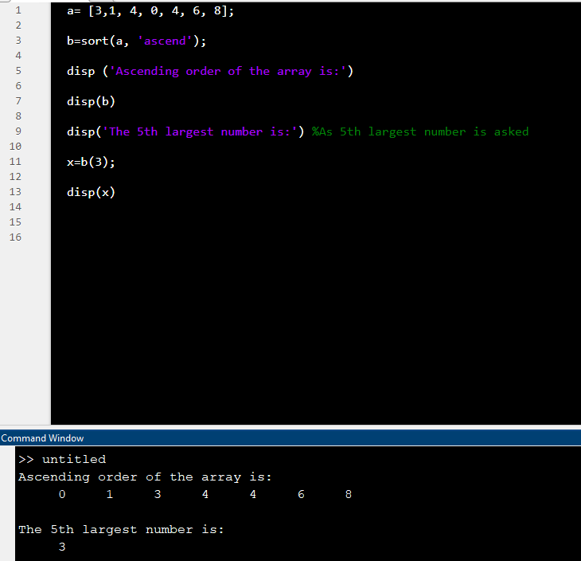

Link to upload:

<https://amritavishwavidyapeetham-my.sharepoint.com/:f:/g/personal/s_sachinkumar_cb_amrita_edu/Ei7JNLqyWwBMgd1d_c-TmioBhA82mdJ9yu2_B06Y9wHkOQ?e=VqrzRg>

Copy the code to a word document and following the below mentioned format to name the document.

**Naming format for the document:**

Batch ‘A’ students - ‘A_name.docx’

Batch ‘B’ students - ‘B_name.docx’