GROUP ASSIGNMENT-1

21AIE113

INTRODUCTION TO ELECTRONICS

Professor-Dr. Neethu Mohan



Contributed by: -

|  |  |
| --- | --- |
| BATCH-A | TEAM-7 |
| GAJULA SRI VATSANKA | CB.EN.U4AIE.21010 |
| GUNNAM HIMAMSH | CB.EN.U4AIE.21014 |
| M.PRASANNA TEJA | CB.EN.U4AIE.21035 |
| VIKHYAT BANSAL | CB.EN.U4AIE.21076 |

QUESTION-1

Perform the experiment of Forward Bias and Reverse Bias of a PN junction silicon diode in Falstad circuit simulator.

a) Explain the theory behind the experiment.

b) Draw the circuit diagrams, mention the components used, and state the procedure of the experiment.

c) Plot the V-I characteristics, mark the cut-in voltage, and calculate the static and dynamic resistance in the case of forward bias. Write down the inference from the VI characteristics.

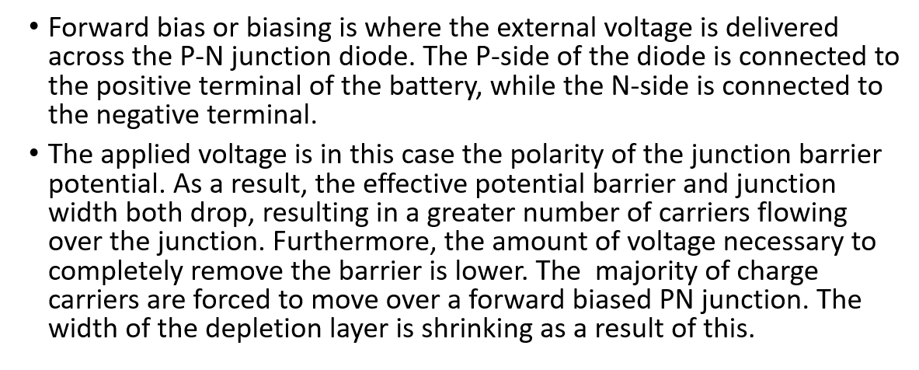

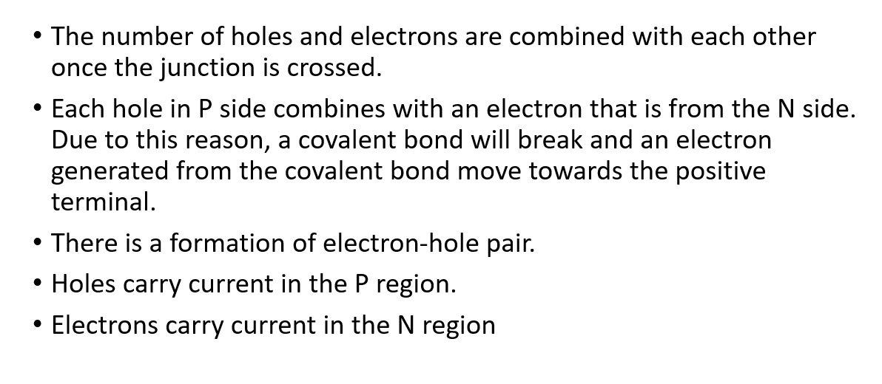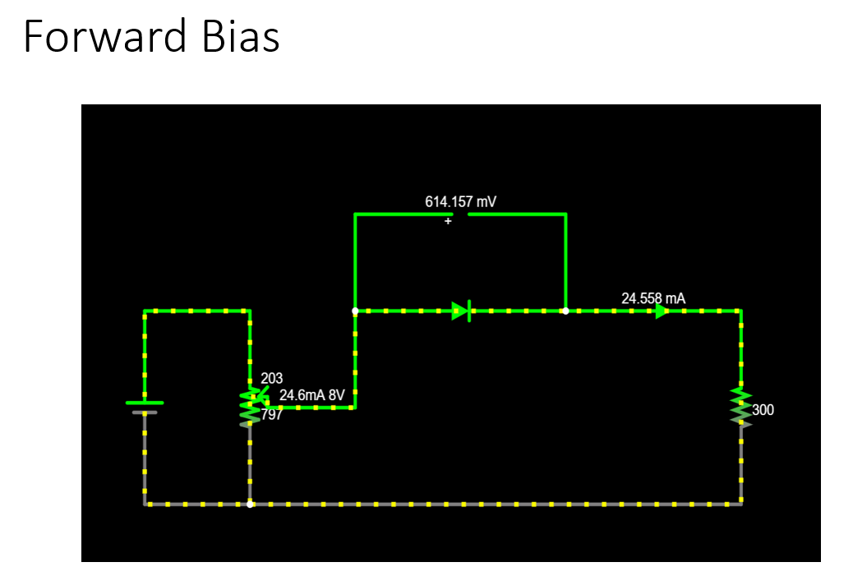

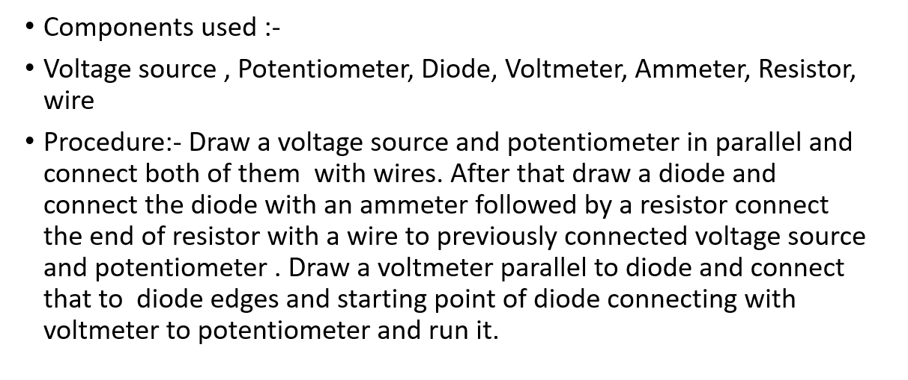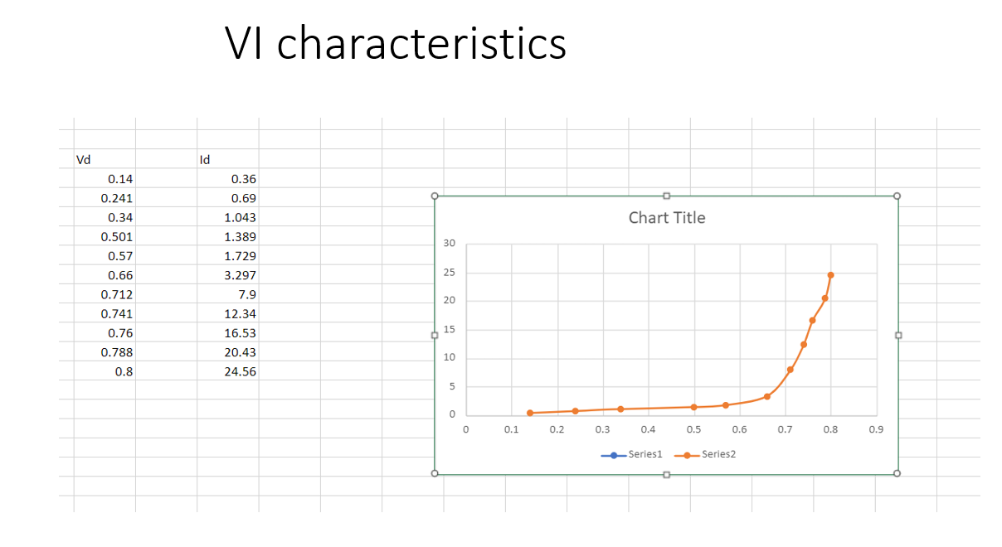

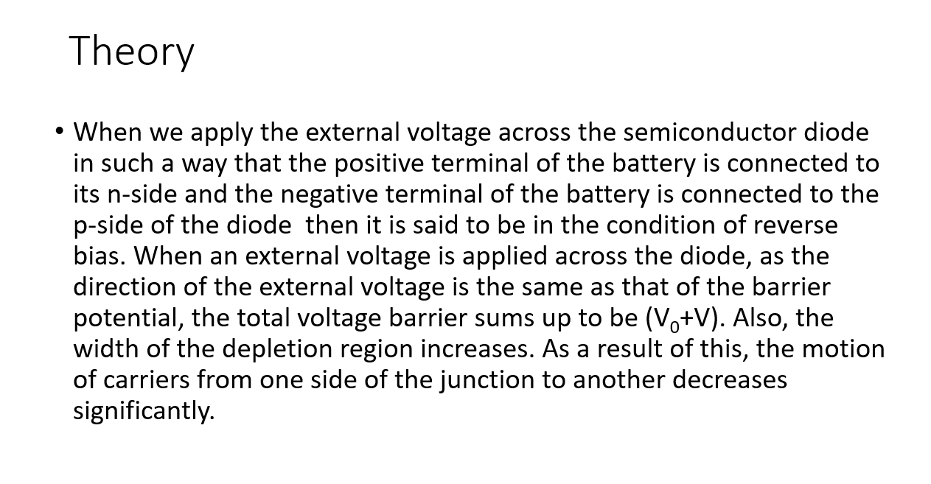

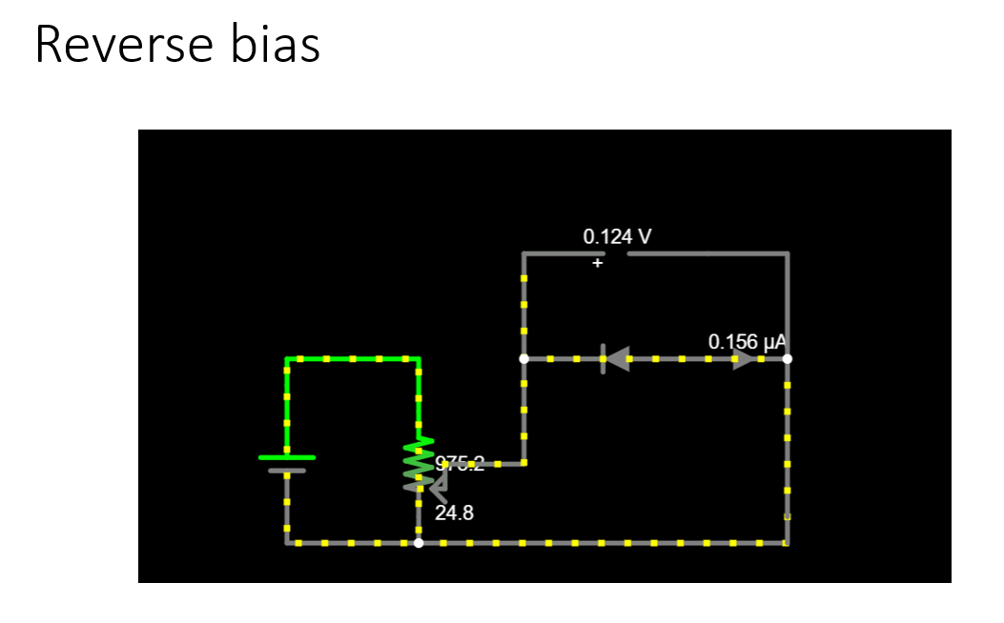

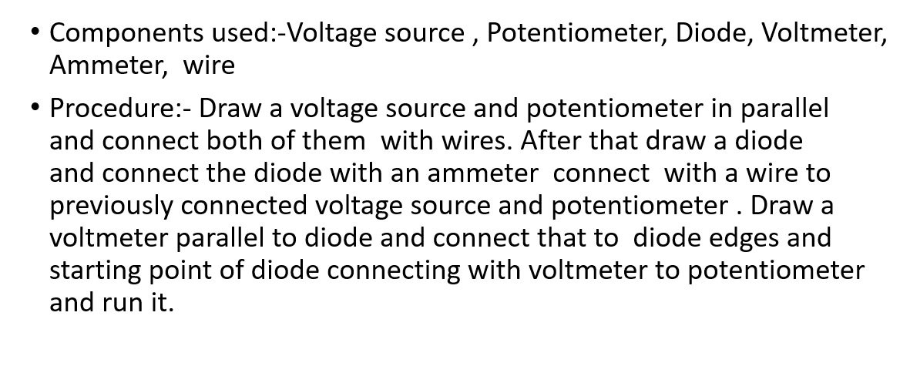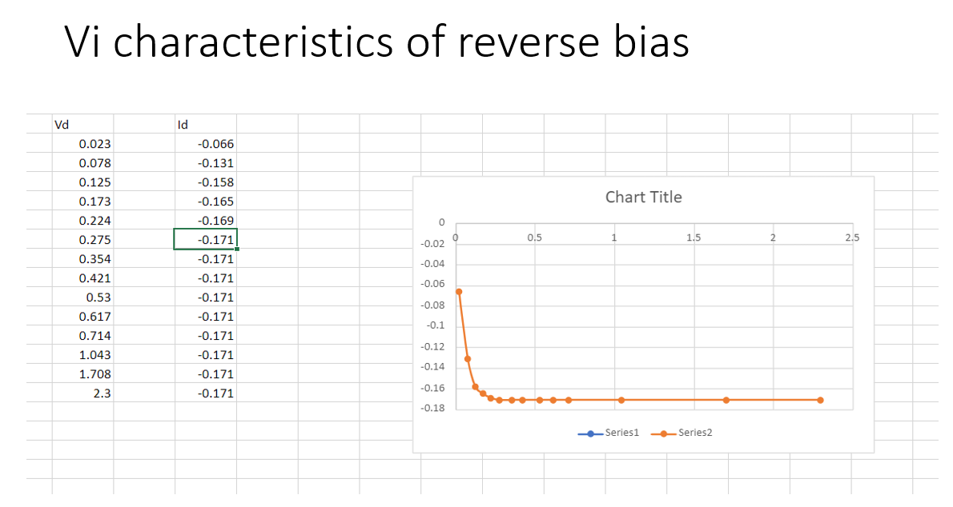

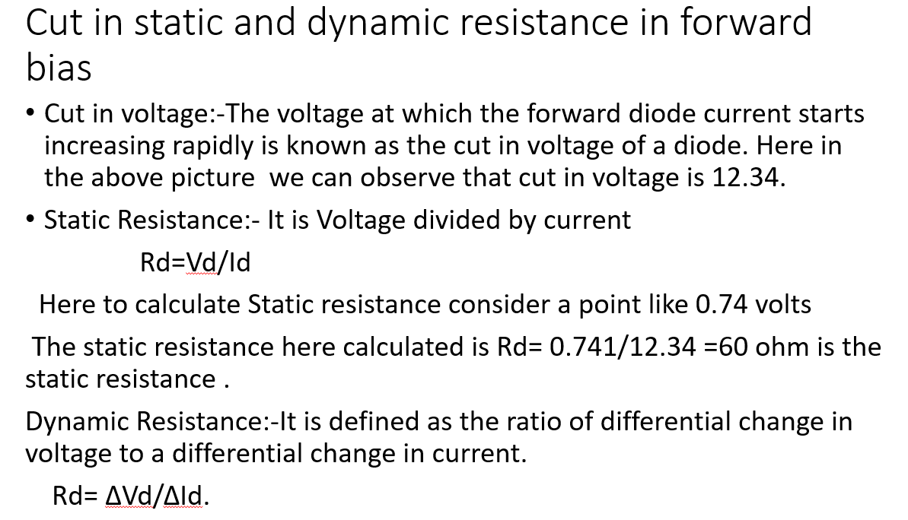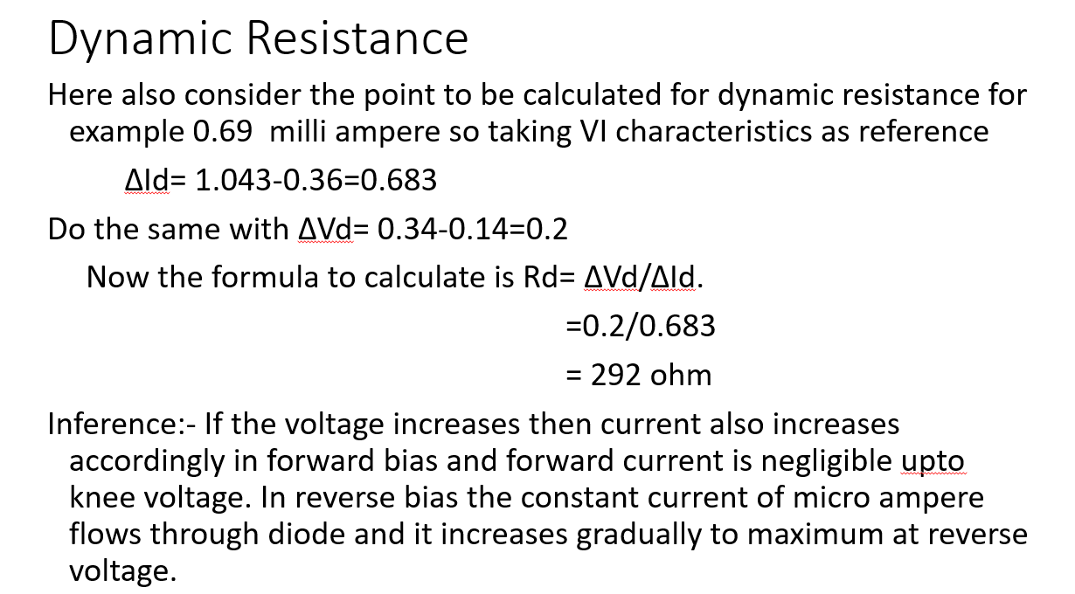

QUESTION-2

Write a Matlab program to calculate the current flowing through a diode during forward bias. (Hint: Shockley’s equation and consider n as 1).

Shockley's Equation: - Id = Is (eVd / n*VT – 1)

Here we are required to find the current flowing through a diode during forward bias

So, by Using Shockley's Equation, we can calculate the current flowing through out a diode during forward bias experiment.

In Shockley's Equation:

Id = Current flowing through the diode.

Is = Reverse saturation current.

Vd = Applied forward-bias voltage across the diode:

n = Ideality factor (given n = 1)

Vt= Thermal Voltage

Here,

Thermal Voltage, VT = (k*Tk )/q

Here, in the above Equation

• k = Boltzmann's constant (1.38 x 10-23 J/K)

• T₁ = Absolute temperature in Kelvins = 273 + temperature in "C

•q=Magnitude of electronic charge (1.6 x 10-19 C)

We can consider Tk as 27c, as 27 C as it is the common temperature for components in an enclosed in the operating system

Here, Tk= 273 +C=273+27= 300 K

MATLAB to calculate the current flowing through a diode during forward bias.

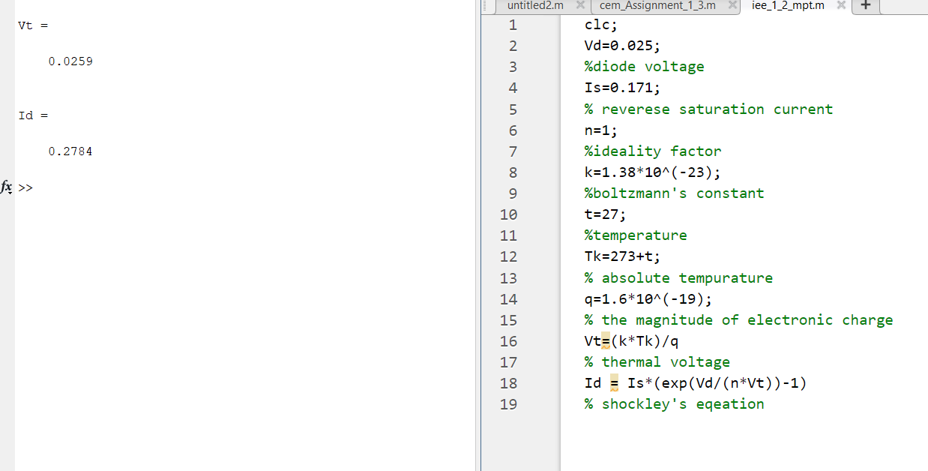

QUESTION-3

The reverse saturation current of a diode at 25 deg. Celsius is 10pA. Plot the forward characteristic of the diode at the 0 degree Celsius and 100 degrees Celsius. Write down the inference from the plot.

Hint: The expression for the reverse saturation current is as a function of temperature is



where ks = 0.072 / degree Celsius. T1 and T2 are two different temperatures.

The **saturation current** (or **scale current**), more accurately the **reverse saturation current**, is that part of the reverse current in a semiconductor diode caused by diffusion of minority carriers from the neutral regions to the depletion region. Increase in reverse bias does not allow the majority charge carriers to diffuse across the junction. However, this potential helps some minority charge carriers in crossing the junction. Since the minority charge carriers in the n-region and p-region are produced by thermally generated electron-hole pairs, these minority charge carriers are extremely temperature dependent and independent of the applied bias voltage. The applied bias voltage acts as a forward bias voltage for these minority charge carriers and a current of small magnitude flows in the external circuit in the direction opposite to that of the conventional current due to the moment of majority charge carriers.  
***I*S**, the reverse bias saturation current for an ideal p–n diode.

**Calculating reverse saturation using MATLAB**

Formulae for calculating reverse saturation current at different temperature is given in question and using that formulae we calculate reverse saturation current at 0 and 100 degrees Celsius.



CODE:  
  
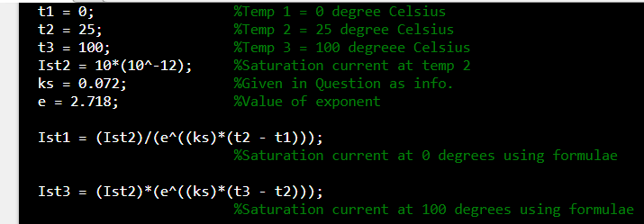

OUTPUT:

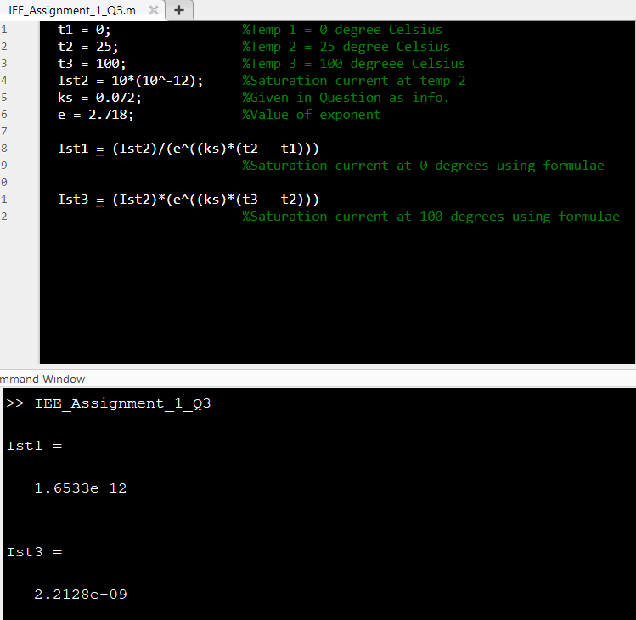

Now, to plot the forward characteristic of diode at 0 degrees and 100 degrees Celsius we will need current flowing across the diode (ID) at both the temperatures respectively and for calculating that we use **SHOCKLEY’S EQUATION.**

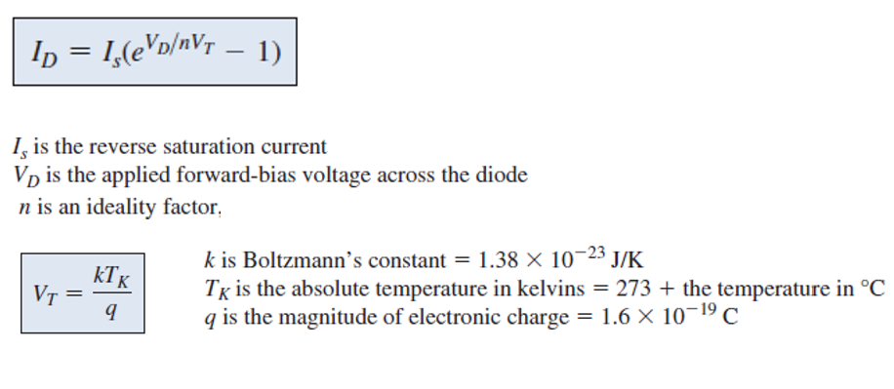

VD will be varying from 0V to 0.8V with step size of 0.01.

VT here is thermal voltage, voltage produced within P-N junction due to action of temperature.

**Calculating diode current (ID)using MATLAB**

Code:

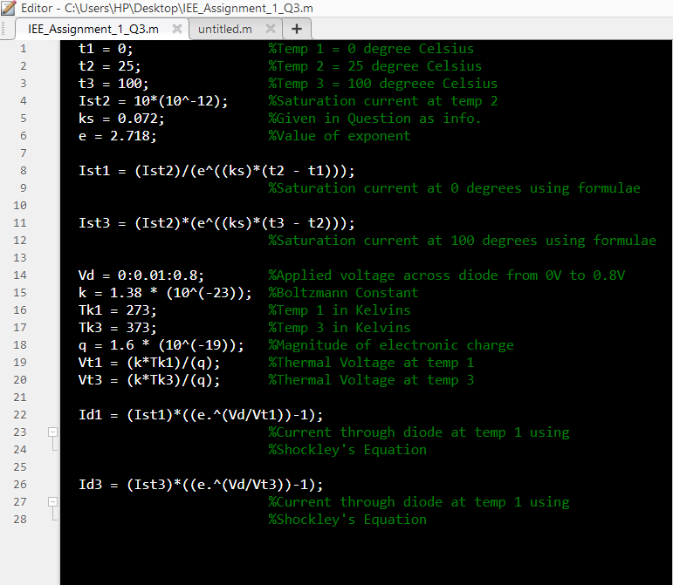

OUTPUT:

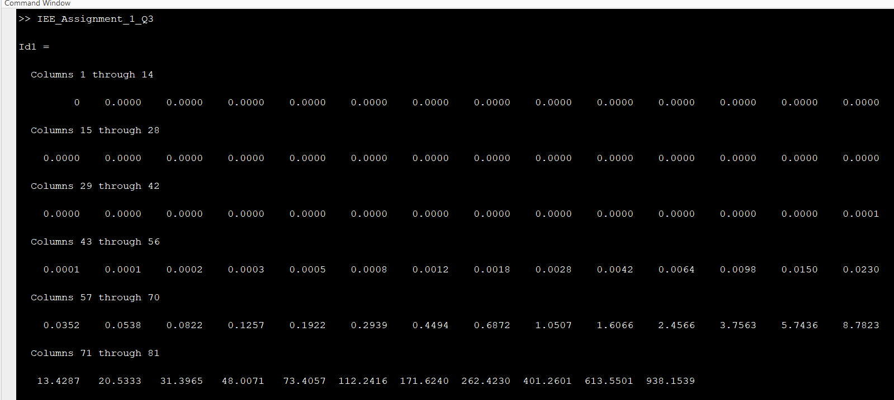 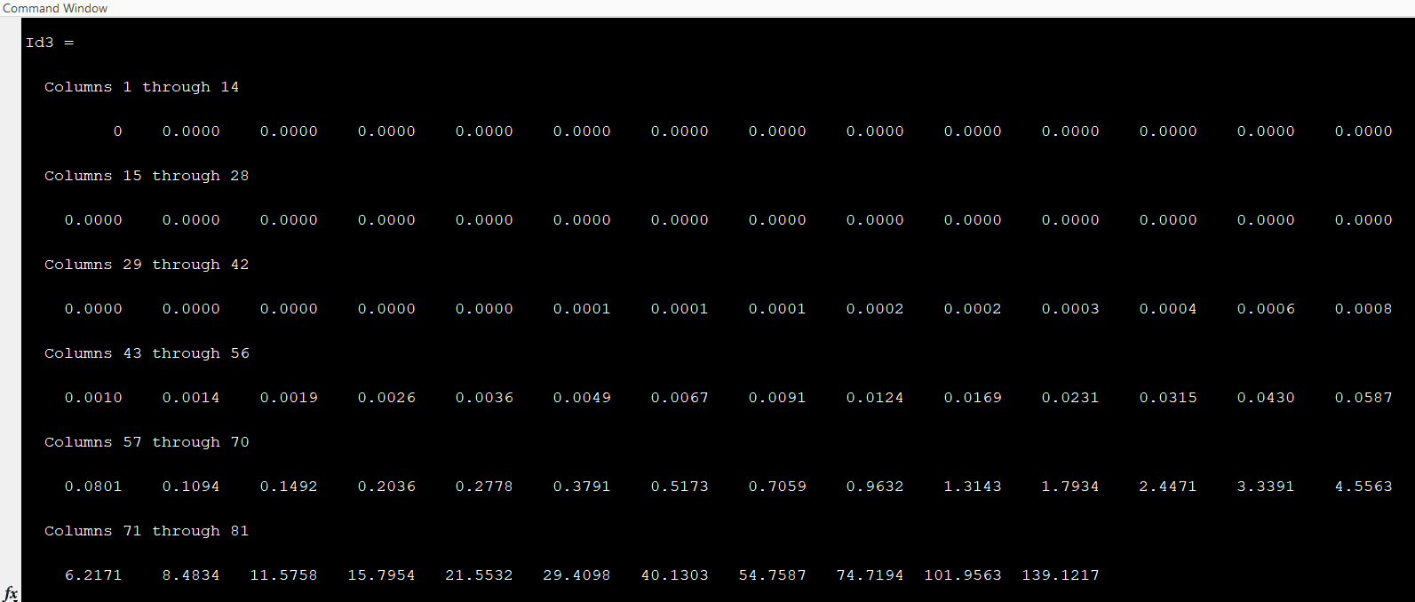

(Note : To zoom the images, keep pressing CTRL + MOUSE SCROLL UP)

**Plot of forward characteristic at 0 degree Celsius**

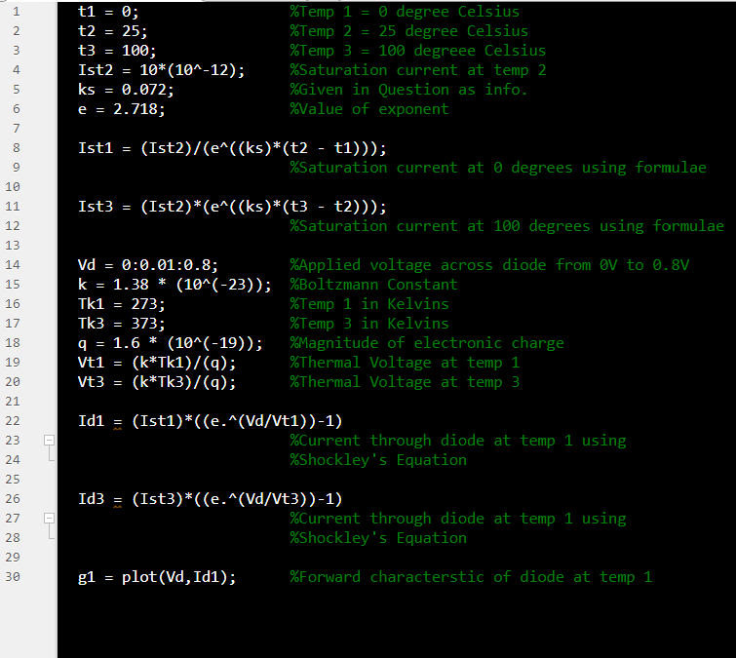

**Plot of forward characteristic at 100 degree Celsius**

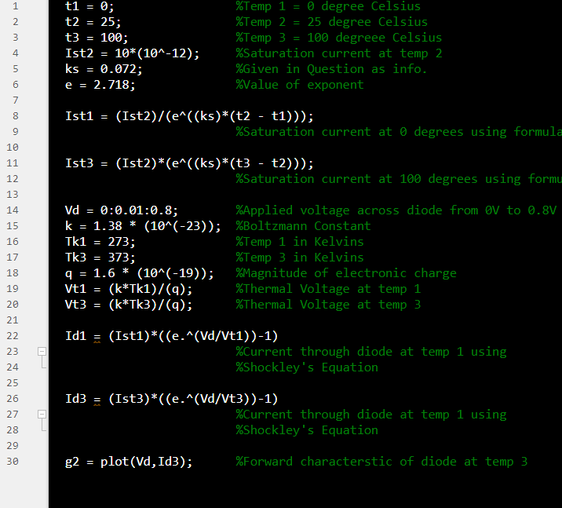

Graph:

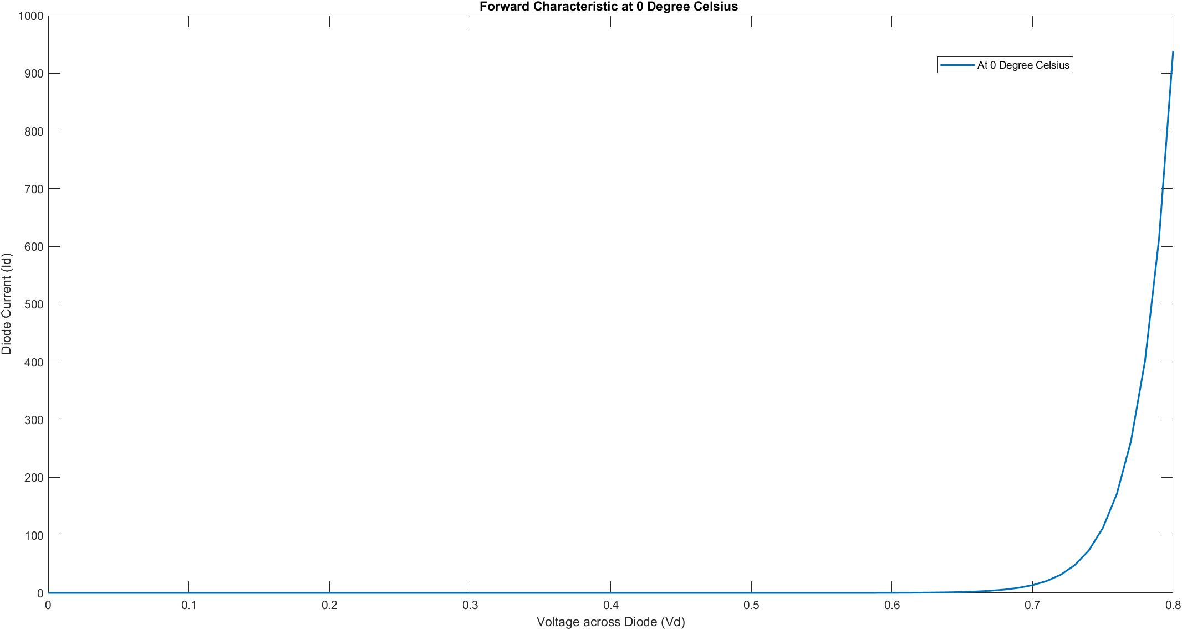

(Note : To zoom the images, keep pressing CTRL + MOUSE SCROLL UP)

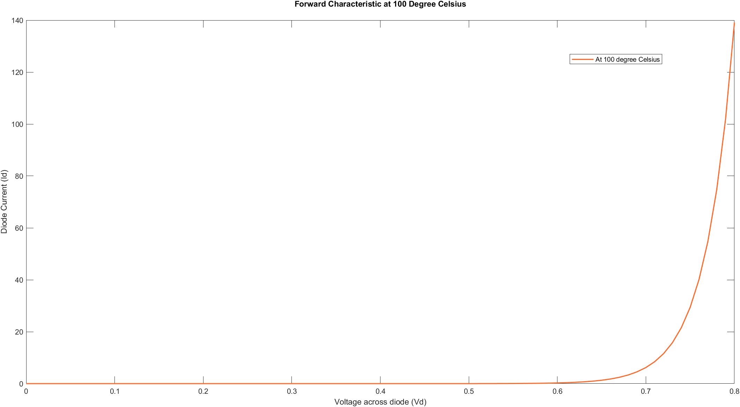

(Note : To zoom the images, keep pressing CTRL + MOUSE SCROLL UP)

Comparison b/w diode current at both temperature

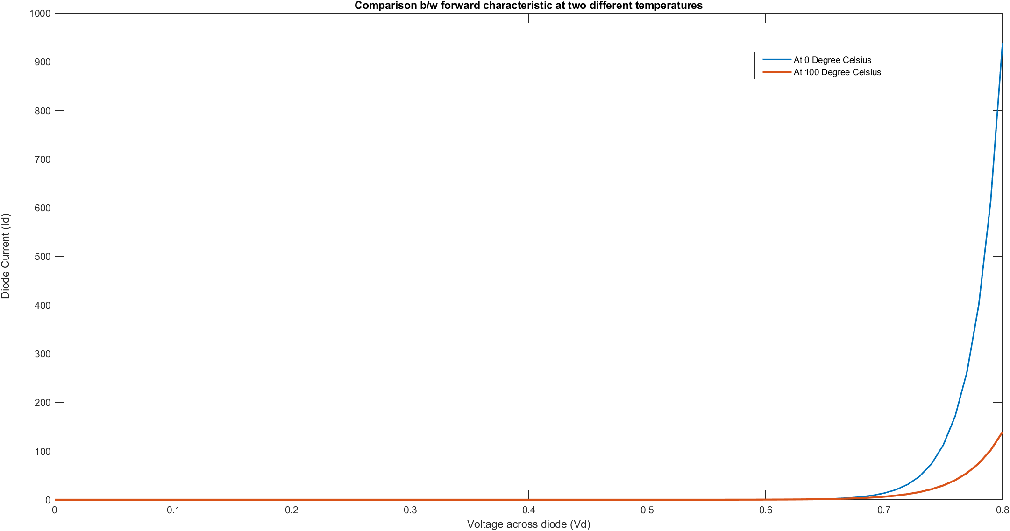

Inference:

For forward characteristic of diode, as voltage increases the diode current increases. The amount of increase in diode current depends on temperature.

THANK YOU