ASSIGNMENT-2

INTRODUCTION TO ELCTRICAL ENGINEERING

Professor-Dr. Neethu Mohan



Contributed By: -

|  |  |
| --- | --- |
| BATCH-A | TEAM-7 |
| GAJULA SRI VATSANKA | CB.EN.U4AIE.21010 |
| GUNNAM HIMAMSH | CB.EN.U4AIE.21014 |
| M.PRASANNA TEJA | CB.EN.U4AIE.21032 |
| VIKHYAT BANSAL | CB.EN.U4AIE.21076 |

QUESTION-1

**Perform the experiment for investigating Zener diode characteristics in Falstad circuit simulator.**

**a) Explain the theory behind the experiment.**

**Ans.**

Definition  
A Zener Diode, also known as a breakdown diode, is a heavily doped semiconductor device that is designed to operate in the reverse direction. When the voltage across the terminals of a Zener diode is reversed and the potential reaches the Zener Voltage (knee voltage), the junction breaks down and the current flows in the reverse direction. This effect is known as the Zener Effect.

There are two type of diodes:  
 i) Semiconductor Diode

ii) Zener Diode   
Difference between both the diodes is that, Zener diode allow flow of current in 2 directions i.e., forward direction as well as reverser direction, reverse direction when zener voltage (knee voltage) is reached whereas in semiconductor diode current flows in one direction (positive direction) when voltage is applied forward biased.

A Zener diode operates just like a normal diode when it is  
forward-biased. However, when connected in reverse biased mode, a small leakage current flows through the diode. As the reverse voltage increases to the predetermined breakdown voltage (Vz), current starts flowing through the diode. The current increases to a maximum, which is determined by the series resistor, after which it stabilizes and remains constant over a wide range of applied voltage.

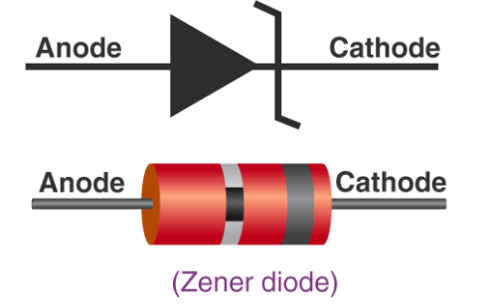

**There are two types of breakdowns for a Zener Diode:**

* Avalanche Breakdown
* Zener Breakdown

Avalanche Breakdown in Zener Diode

Avalanche breakdown occurs both in normal diode and Zener Diode at high reverse voltage. When a high value of reverse voltage is applied to the PN junction, the free electrons gain sufficient energy and accelerate at high velocities. These free electrons moving at high velocity collides other atoms and knocks off more electrons. Due to this continuous collision, a large number of free electrons are generated as a result of [electric current](https://byjus.com/physics/electric-current/) in the diode rapidly increases. This sudden increase in electric current may permanently destroy the normal diode, however, a Zener diode is designed to operate under avalanche breakdown and can sustain the sudden spike of current. Avalanche breakdown occurs in Zener diodes with Zener voltage (Vz) greater than 6V.

Zener Breakdown in Zener Diode

When the applied reverse bias voltage reaches closer to the Zener voltage, the electric field in the depletion region gets strong enough to pull electrons from their valence band. The valence electrons that gain sufficient energy from the strong electric field of the depletion region break free from the parent atom. At the Zener breakdown region, a small increase in the voltage results in the rapid increase of the electric current.

b) Draw the circuit diagrams, mention the components used, and state the procedure of the experiment.

Forward Bias

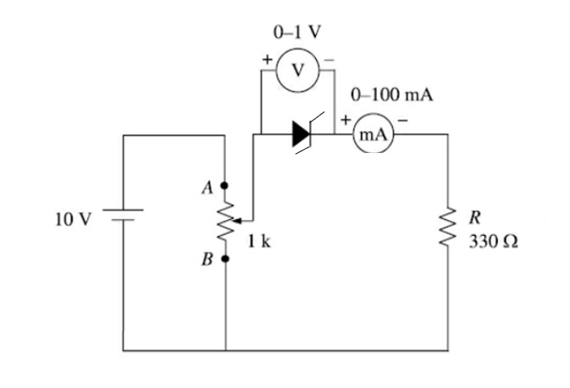

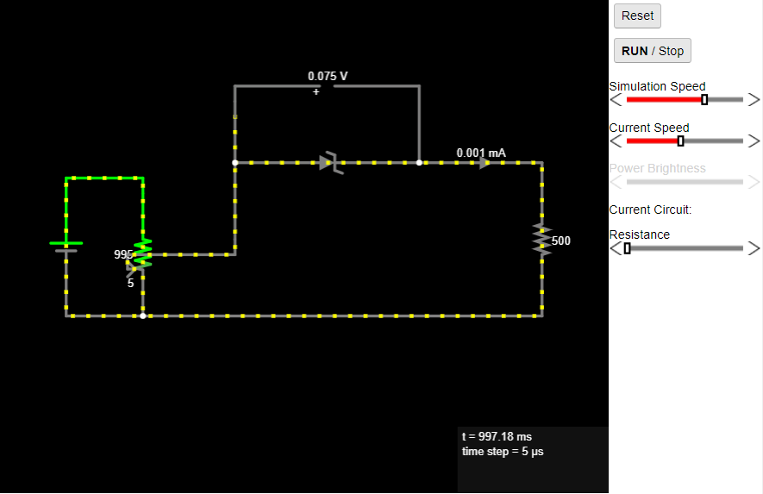

Reverse Bias

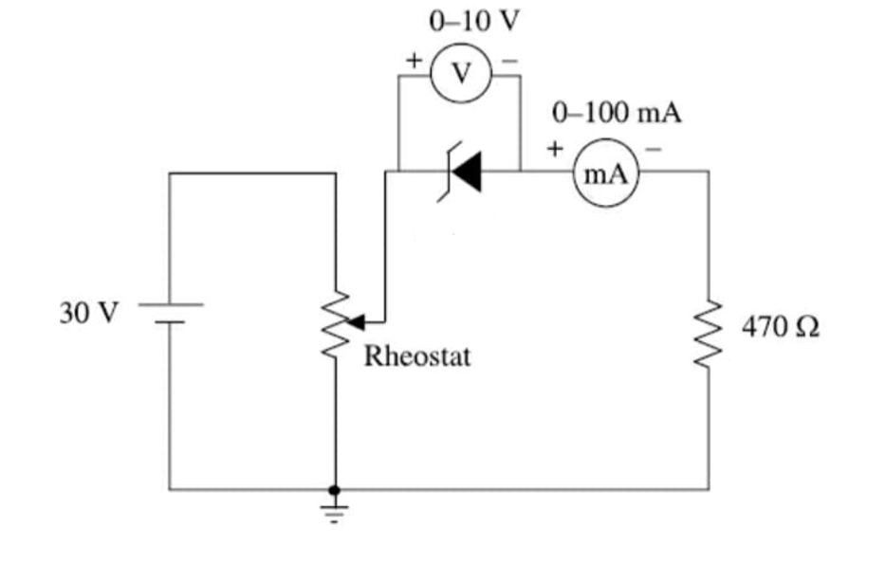

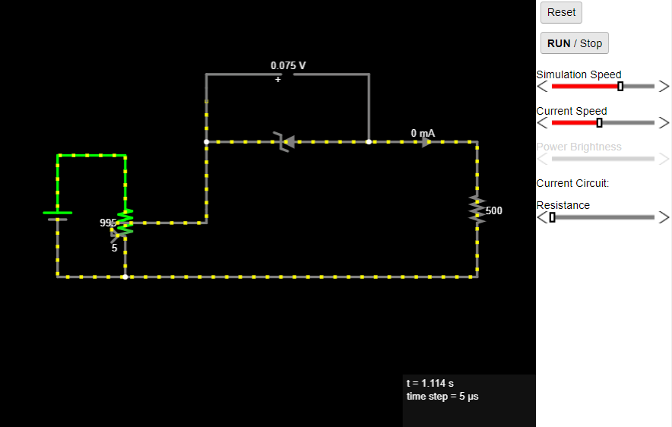

Components Used:

* Power Supply
* Microammeter
* Voltmeter
* Resistor
* Rheostat (**A potentiometer can be used as a rheostat but a rheostat cannot be used as a potentiometer**.)
* zener diode
* connecting wires

Procedure of Experiment

Make the connections as shown in circuit diagram for forward bias. Switch on the power supply. The voltage is set at 0 V and the current through the zener diode shown by  
micro-ammeter is recorded. With the help of slider of rheostat, the voltage is increased in steps. For each setting of the voltage, corresponding current shown by the  
micro-ammeter is noted. The observations are recorded in table.

Then the connections are made as shown in the circuit diagram for reverse bias. The reverse voltage is set at 0 V and the current shown by the micro-ammeter is recorded. Then the voltage is increased in steps till the current suddenly tend to rise. All these readings are recorded in table.

c) Plot the V-I characteristics for both forward bias and reverse bias.

Simulator Circuit for Zener diode in forward bias

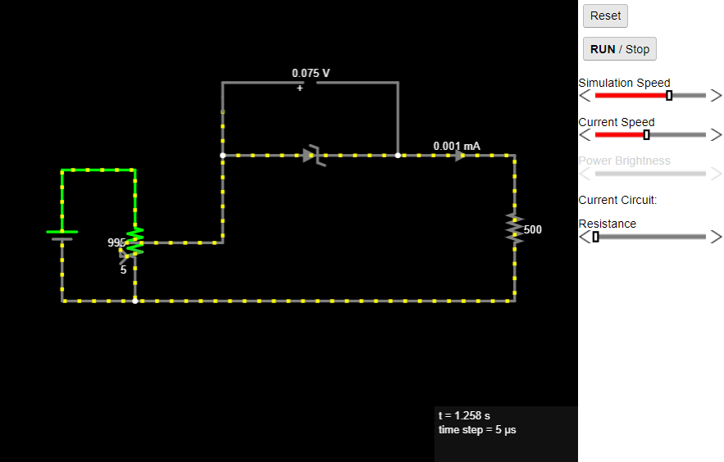

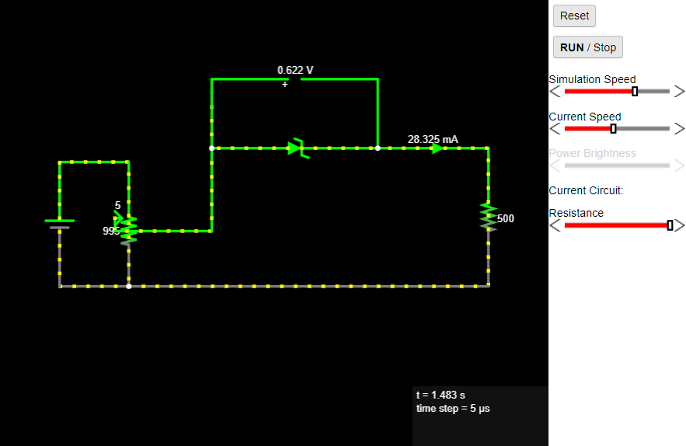

Data: Zener diode in Forward Bias

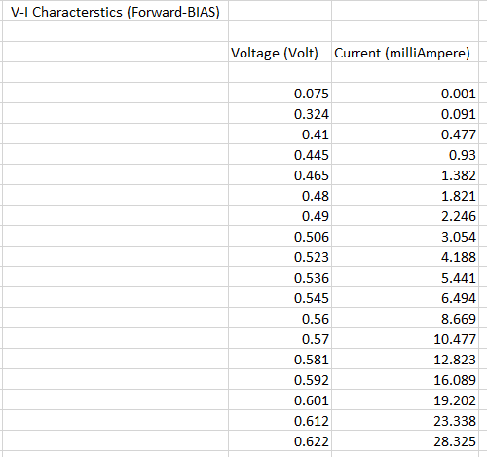

Graph: Forward Bias

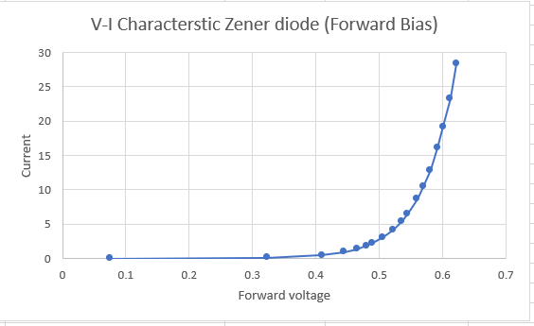

Simulator Circuit for Zener diode in reverse bias

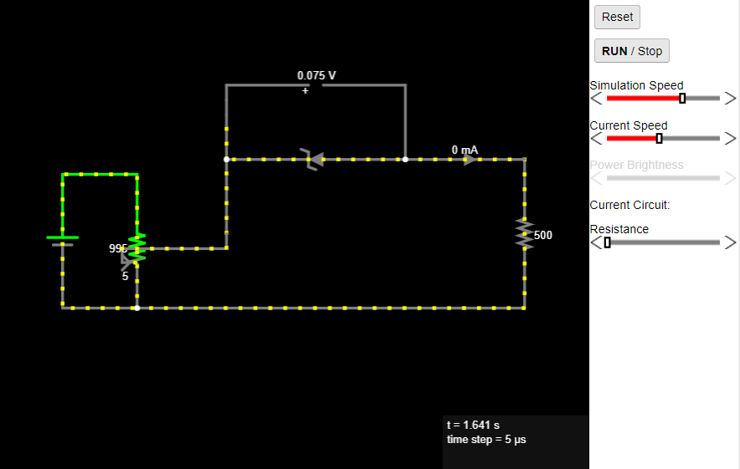

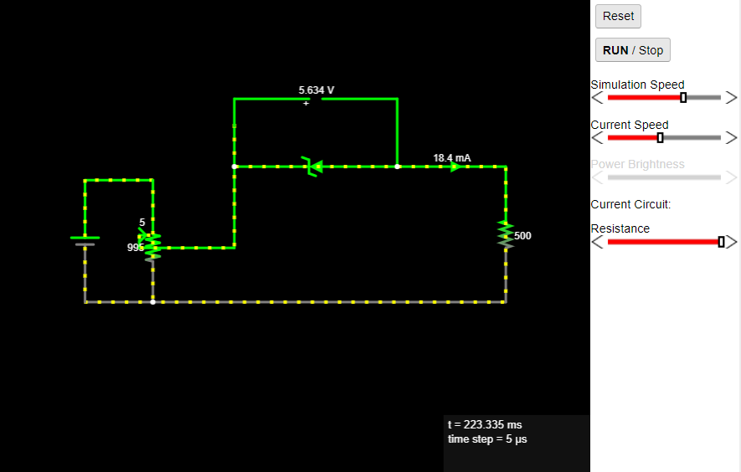

Data: Zener diode in Forward Bias

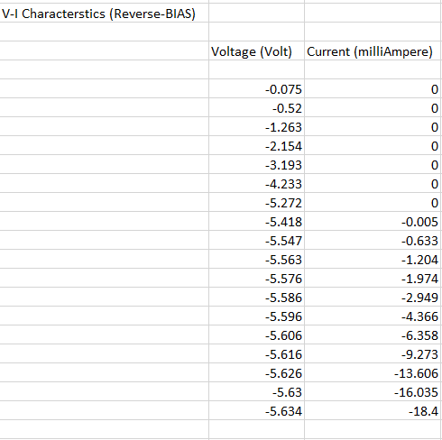

Graph: Reverse Bias

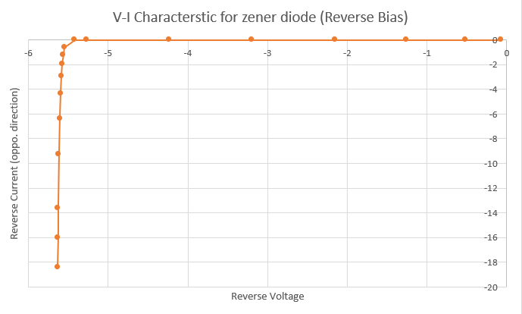

**Note:   
Negative sign indicates that current is flowing in reverse direction and voltage is reverse biased.**

d) Mark the breakdown voltage of zener diode, and calculate the static and dynamic resistance in the case of reverse bias (show the calculation of values graphically). Write down the inference from the VI characteristics.

**ANS.**

Breakdown Voltage (Knee Voltage):   
Breakdown voltage is a parameter of a diode that defines the largest reverse voltage that can be applied without causing an exponential increase in the leakage current in the diode.  
  
According to graph of reverse bias,   
**Breakdown voltage is -5.547 V**

**(Where -ve sign denotes reverse voltage).**

Static Resistance:

The resistance offered by a diode when it is connected to a DC circuit is called static resistance. Static resistance is also defined as the ratio of DC voltage applied across diode to the DC current or direct current flowing through the diode taken at a particular point.

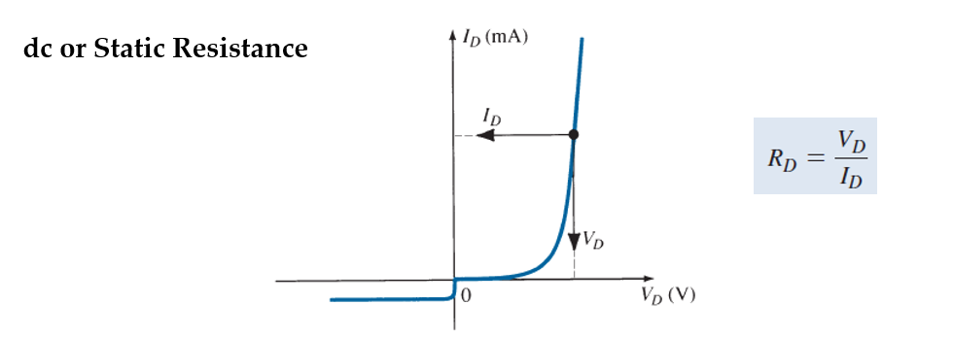

Static resistance of Reverse Bias:

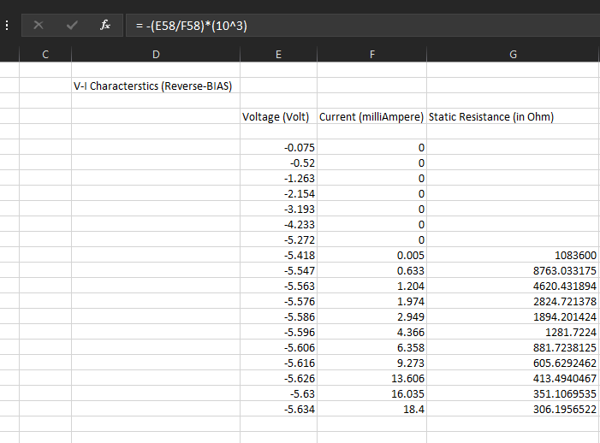

Graph:

**In general, the higher the current through a diode, the lower is the dc resistance level.**

Dynamic Resistance:

Dynamic resistance is **used to quantify the resistance of non-ohmic materials**. It is defined as the ratio of differential change in voltage to a differential change in current.

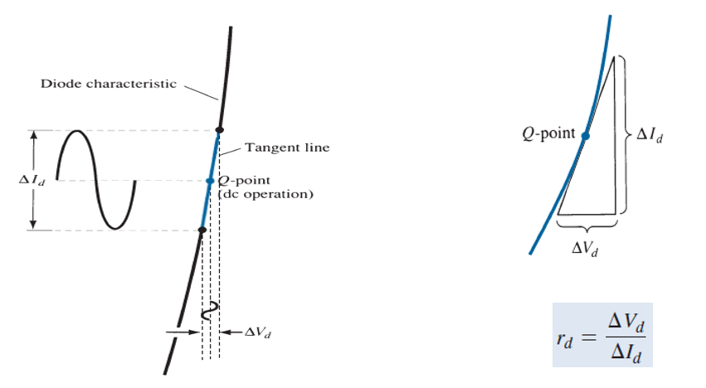

Dynamic resistance of Reverse Bias:

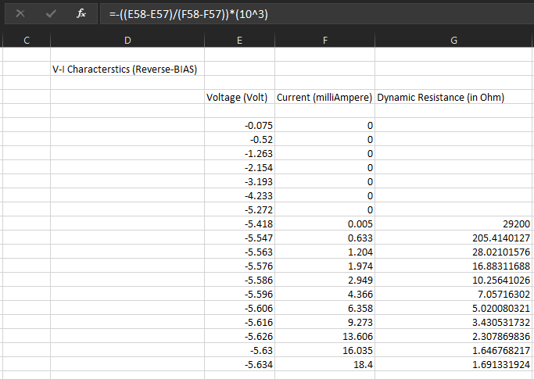

Graph:

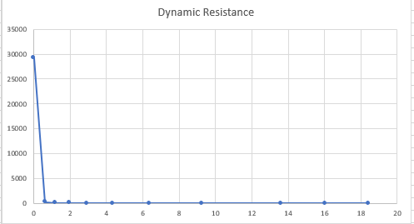

**Inference from V-I Characteristics**

* From the graph drawn of V-I characteristic of forward bias for Zener diode, it can be seen that current is increasing rapidly with small amount of change in voltage just like of normal p-n junction diode.
* From the graph drawn of V-I characteristic of reverse bias for Zener diode, it can be seen that there was no reverse current flow till the reverse voltage becomes 5V then after increase of some millivolt there was sudden flow of current in reverse direction, which was increasing in abrupt manner with small amount of change in volts. This kind of change can destroy or harm normal diodes but Zener diodes are used keeping this kind of behavior in mind as Zener diode can withstand can this kind of abrupt change.

QUESTION-2

**Write a MATLAB program to estimate the operating point of the following circuit. Assume resistance of 1 k ohms, and E=10 V, Is=10pA and n=1. Plot the forward and load-line and mark the operating point on the forward characteristics. Write down the inference from the experiment.**

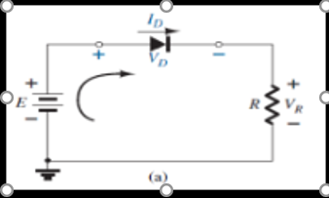

**SOLUTION:**

**CODE TO ESTIMATES THE OPERATING POINT[Q]: -**

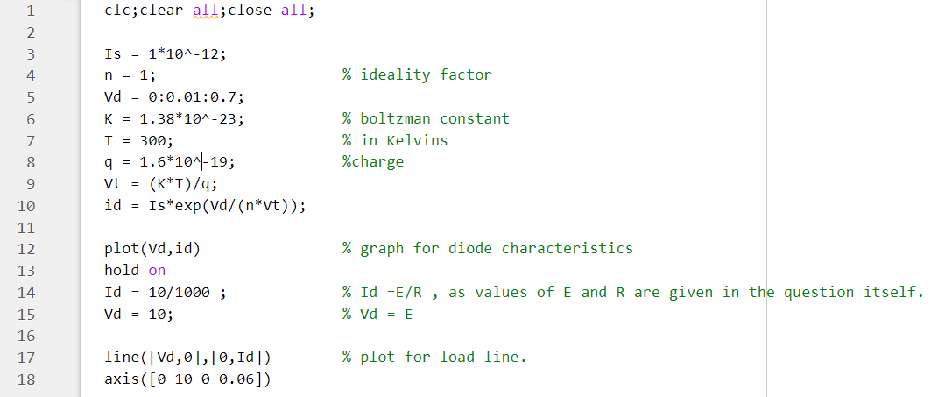

**GRAPH: -**

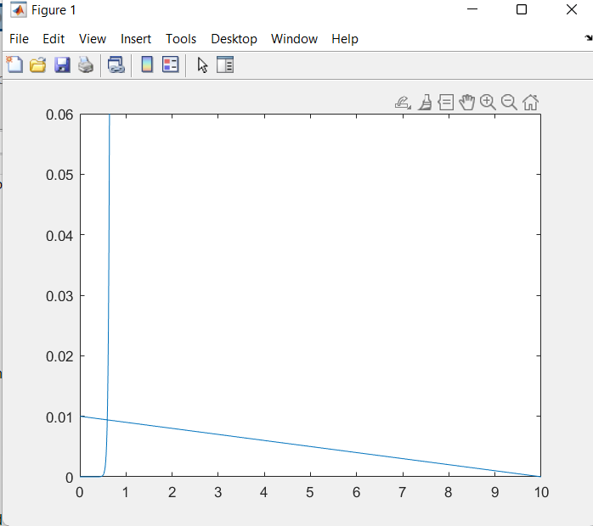

* The Vertical line represents “Diode characteristics”.
* The merging point is “Operating Point”.
* The cross line is “Load Line”

**INFERENCE:**

From the plot the point of intersection of perpendicular line from Q-Point and X-Axis gives the value of

 VDq and point of intersection of perpendicular line from Q-Point and Y-Axis gives the value of IDq.

From the plot the value of

VDq = 0.6V (approximately)

IDq = 9 mA

**The value of VR is**

VR = E – VD = 10 – 0.6 = 9.4 V

**Dc resistance:**

RD = VDq/IDq = 0.6/0.009 = 66.67 ohms

Once the DC Q-point is determined the diode can be replaced by its DC resistance equivalent.

QUESTION-3

Perform the experiment for demonstrating the application of a diode as a Half-wave rectifier in Falstad circuit simulator

a) Explain the theory behind the experiment.

b) Draw the circuit diagrams, Mention the components used, and state the procedure of the experiment.

c)Plot the input and output waveforms.

d)Compute/obtain the value of Vm, Vrms, Vdc, and ripple factor.

e) Redo the experiment using a capacitive filter and plot the input and output waveforms

f) Compute/obtain the value of Vm,Vrpp, V r,rms, Vdc, and ripple factor.

g) Write down the inference from the experiment

**A) Theory**: - A half-wave rectifier is the simplest form of the rectifier and requires only one diode for the construction of a halfwave rectifier circuit.

A halfwave rectifier circuit consists of three main components as follows:

* A diode
* A transformer
* A resistive load

1. A high AC voltage is applied to the primary side of the step-down transformer. The obtained secondary low voltage is applied to the diode.
2. The diode is forward biased during the positive half cycle of the AC voltage and reverse biased during the negative half cycle.
3. The final output voltage waveform is as shown in the figure below:

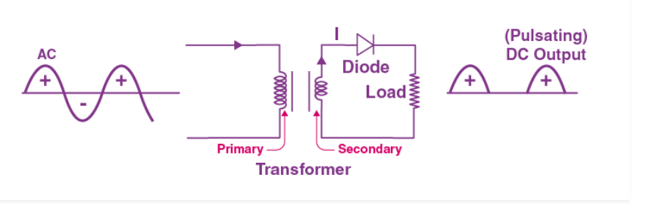

When a diode is reverse biased, it acts as an open switch. Since no current can flow to the load, the output voltage is equal to zero

Halfwave rectifier waveform: -

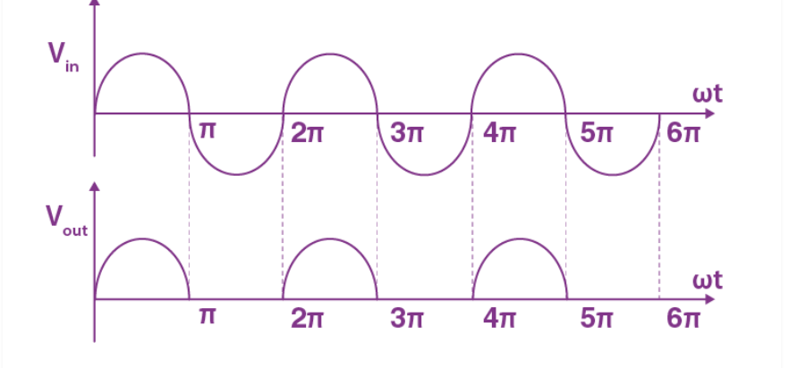

**B) Circuit diagram in Falstad: -**

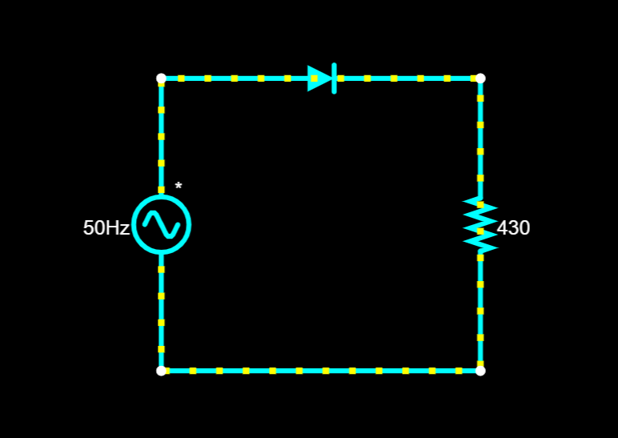

Components used: - Ac voltage source, Diode, Resistor, wire

Procedure: - Draw an Ac voltage source and connect a diode to it after that draw a resistor parallel to the Ac voltage source and connect them with wire and click on run button. Considering it as silicon diode and applying kvl 50-0.7 = 43 is the value for resistance.

**C)Input and output waveforms:** -

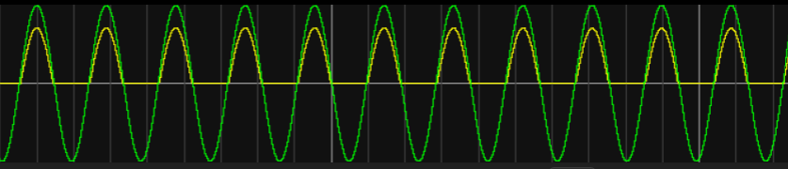

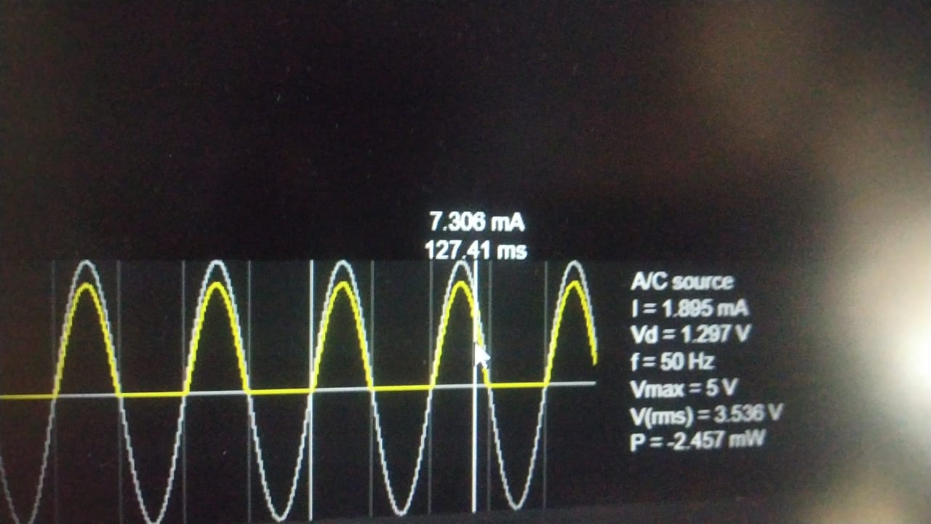

Output waveform: -

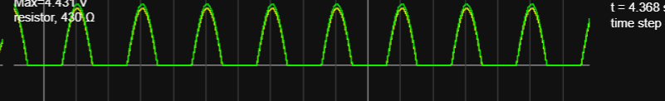

**D)**Here in viewing scope itself we can know the values of Vrms and Vmax

We know that Vrms=Vm/sqrt(2) that is 5/sqrt(2)=3.536

So, the Vmax value is 5v and Vrms value is 3.536.

Next is Vdc so the formula to obtain it is 0.318(Vm)

=0.318*5 =1.59 is the required Vdc

Ripple factor:- ratio of the AC component’s RMS value and the DC component’s RMS value within the output of the rectifier

Ripple factor for half wave rectifier is r=0.386*Vm/Vm*pi

=0.386*5/5*pi

=1.93/1.59 =1.21 is the ripple factor for halfwave rectifier

**Note: - Here we have calculated these taking input Vm=5v as reference**

**E) Next is redoing the same using capacitive filter -**

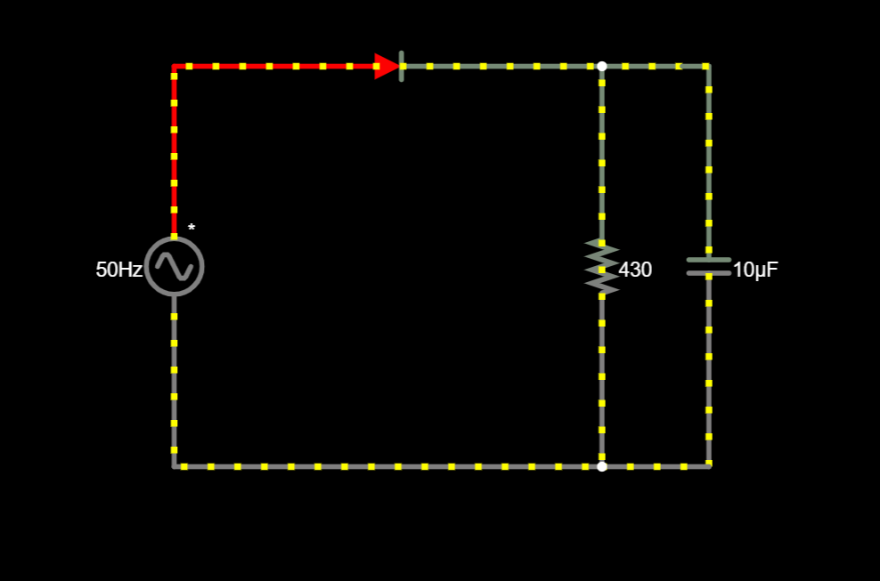

Components used: - Ac voltage source, Diode, Resistor, wire, capacitor

Procedure: - Draw an Ac voltage source and connect a diode to it after that draw a resistor parallel to the Ac voltage source and connect them with wire and after that connect a capacitor parallel to resistor and connect them with wires click on run button. Considering it as silicon diode and applying kvl 50-0.7 = 43 is the value for resistance.

Why we use capacitive filter: - Half Wave and Full Wave Rectifier with Capacitor Filter The filter is one type of electronic device mainly used to perform signal processing. The main function of this filter is to allow the ac components and blocks the dc components of the load. The filter circuit output will be a stable dc voltage. To avoid ripple also we use capacitor filter

Input and output wave form: -

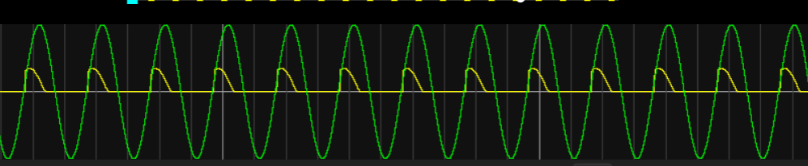

Output wave form: -

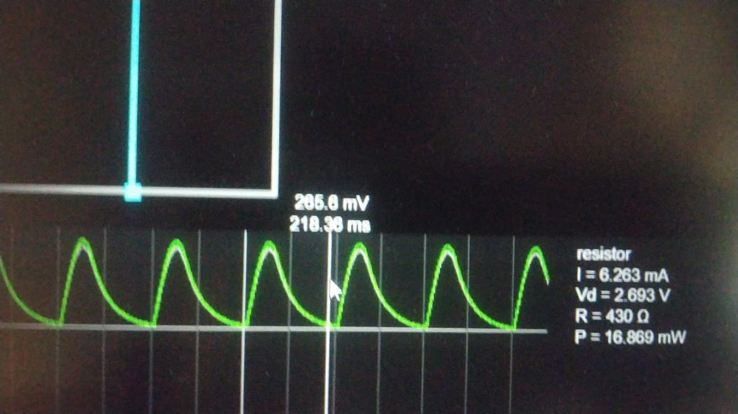

**F)**we have to find Vrpp =Vmax-Vmin =5- 0.321 =4.679

Next is Vr,rms =Vpp/2 sqrt(3)

=4.679/2sqrt(3)=4.052

Peak voltage is 5V

Vdc=Vm-Vrpp/2

=5-4.679/2

=5-2.33 =2.67

Next the ripple factor for capacitive filter is r=1/2*sqrt(3)f *RL*C

½*sqrt(3)*50*430*10^-6 =0.018

**Note: - Here we have calculated these taking input Vm=5v as reference**

**G)Inference:** -

1)We can observe different output waveforms by changing the values of resistance and voltage values

2)We can calculate vrms, vdc, peak voltage and ripple factor from wave forms

3)We can observe AC converting into DC

4) Even though we have connected a capacitor filter values wont change like vrms peak voltage and all...

THANK YOU