INTRODUCTION   
TO   
ELECTRICAL ENGINEERING

GROUP ASSIGNMENT-3

Professor:-Dr.Neethu Mohan

PRESENTATION BY:-

|  |  |
| --- | --- |
| **BATCH-A** | **TEAM-7** |
| GAJULA SRI VATSANKA | CB.EN.U4AIE.21010 |
| GUNNAM HIMAMSH | CB.EN.U4AIE.21014 |
| M.PRASANNA TEJA | CB.EN.U4AIE.21035 |
| VIKHYAT BANSAL | CB.EN.U4AIE.21076 |

Question-1 [done by Gunnam Himamsh]

**1.Perform the experiment for demonstrating the application of a diode as a Full-wave rectifier in Falstad circuit simulator**

**a) Explain the theory behind the experiment.**

**b) Draw the circuit diagrams, Mention the components used, and state the procedure of the experiment**

**c)Plot the input and output waveforms.**

**d)Compute/obtain the value of Vm, Vrms, Vdc, and ripple factor.**

**e) Redo the experiment using a capacitive filter and plot the input and output waveforms**

**f)Compute/obtain the value of Vm,Vrpp, V r,rms, Vd**

A) Theory of Full wave rectifier: -

A full wave rectifier is defined as a type of rectifier that converts both halves of each cycle of an alternating wave (AC signal) into a pulsating DC signal. Full-wave rectifiers are used to convert AC voltage to DC voltage, requiring multiple diodes to construct. Full wave rectification is the process of converting an AC signal to a DC signal.

Circuits that convert alternating current (AC) into direct current (DC) are known as rectifiers. If such rectifiers rectify both the positive and negative half cycles of an input alternating waveform, the rectifiers are full-wave rectifiers.

In a full-wave rectifier, the two cycles of the supply input are rectified. To implement this technique basic full-wave rectifier requires two diodes. Each diode is utilized during each cycle. When the positive cycle is applied one diode conducts and during a negative cycle, the other tends to conduct.

A full wave bridge rectifier is a rectifier that will use four diodes or more than that in a bridge formation. A full wave bridge rectifier system consists of

1. Four Diodes
2. 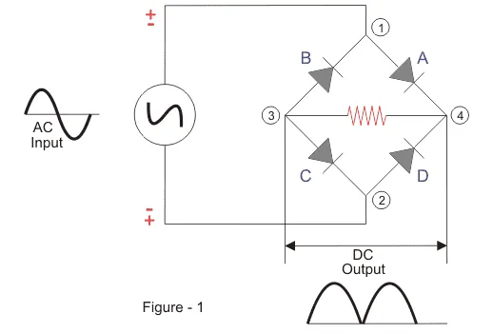Resistive Load

We use the diodes, namely A, B, C and D, which form a bridge circuit. The circuit diagram is as follows.

### **Principle of Full Wave Bridge Rectifier**

We apply an AC across the bridge. During the positive half-cycle, terminal 1 becomes positive, and terminal 2 becomes negative.

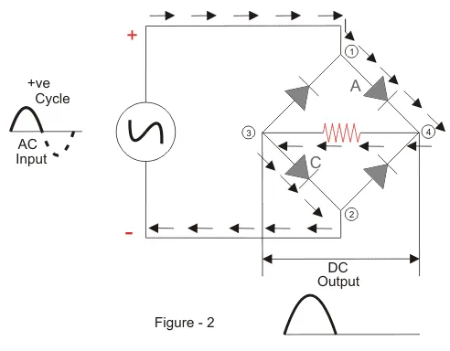

This will cause the diodes A and C to become forward-biased, and the current will flow through it. Meanwhile, diodes B and D will become reverse-biased and block current through them. The current will flow from 1 to 4 to 3 to 2.

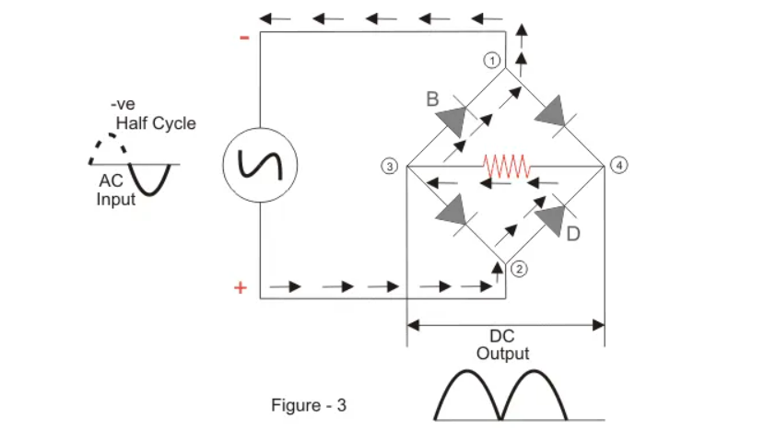

During the negative half-cycle, terminal 1 will become negative, and terminal 2 will become positive.

This will cause the diodes B and D to become forward-biased and will allow current through them. At the same time, diodes A and C will be reverse-biased and will block the current through them. The current will flow from 2 to 4 to 3 to 1.  
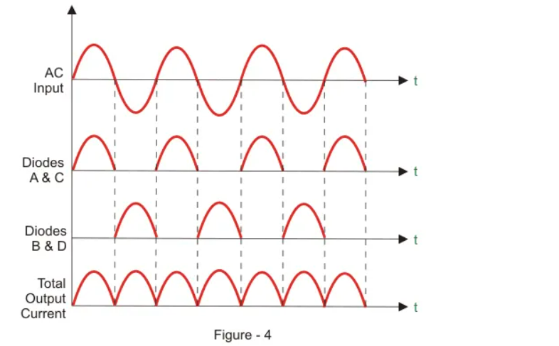

## Advantages of Full Wave Rectifiers

The advantages of full wave rectifiers include:

* Full wave rectifiers have higher rectifying efficiency than half-wave rectifiers This means that they convert AC to DC more efficiently.
* They have low power loss because no voltage signal is wasted in the rectification process.
* The output voltage of a centre-tapped full wave rectifier has lower ripples than a halfwave rectifiers.

## Disadvantages of Full Wave Rectifiers

The disadvantages of full wave rectifiers include:

* The centre-tapped rectifier is more expensive than a half-wave rectifier and tends to occupy a lot of space.

**B)** Circuit diagram: -

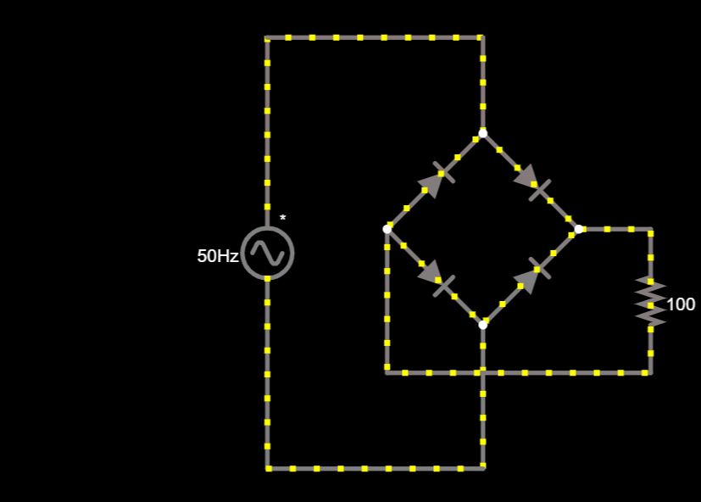

Components used: - Ac voltage source, 4diodes, resistor, Wires

Procedure: -

Draw an Ac voltage source as input and connect 4 diodes and connect them with help of wires as shown in the figure in those 4 diodes.

When voltage is in forward bias 2 diodes are in on position and when diode is in reverse bias 2 diodes are in off position that can be seen in above figure.

Input wave form: -

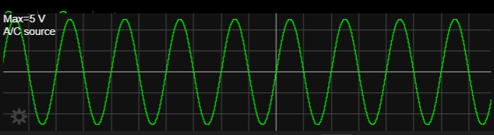

Output wave form: -



D)Input peak voltage(Vm)=3.728V

We know that for full wave rectifier Vrms=Vm/sqrt(2)

=3.728/1.414

=2.636V

Next is Vdc=0.636*Vm =0.636*3.728= 2.371

Ripple factor =0.482 (For Full wave rectifier).

#### E) -**Filter Circuit**

We get a pulsating DC voltage with many ripples as the output of the full wave bridge rectifier. We cannot use this voltage for practical applications.

So, to convert the pulsating DC voltage to pure DC voltage, we use a filter circuit as shown above. Here we place a capacitor across the load. The working of the capacitive filter circuit is to short the ripples and block the DC component so that it flows through another path, and that is through the load.

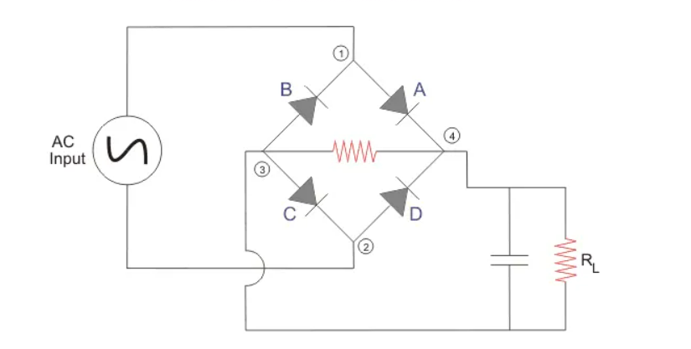

After redoing the experiment using capacitive filter the picture is

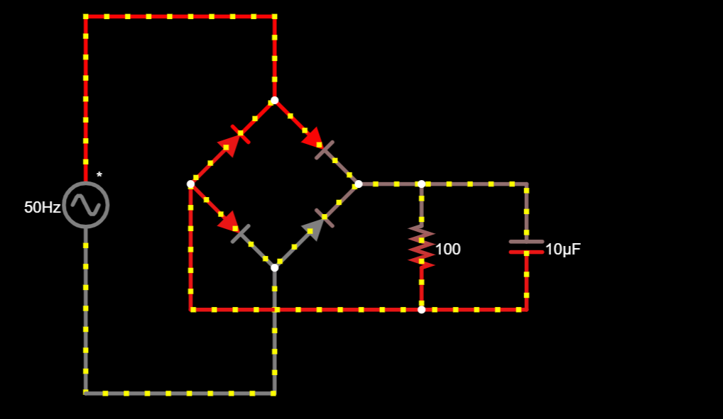

The input waveform is:-



The output waveform is as below: -

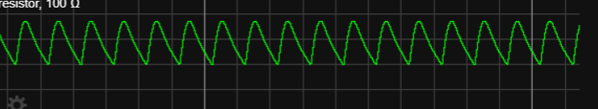

F) Here the peak voltage (Vm)=3.728V

Next is peak to peak voltage Vrpp=3.716-2.135=1.581

Next is Vr,rms=Vrpp/2*Sqrt(3)

=1.581/2*1.732

=0.4477

Next is Vdc=Vm-Vrpp/2

=3.728-1.581/2

=2.9375

Next is ripple factor r=¼/*sqrt(3)*RL*C

=1/0.433*50*100*10*10^-6µF

=0.28

G) Repeat (a) to (f) for centre-tapped Full wave rectifier

A centre tapped full wave rectifier is a type of rectifier which uses a centre tapped transformer and two diodes to convert the complete AC signal into DC signal. The centre tapped full wave rectifier is made up of an AC source, a centre tapped transformer, two diodes, and a load resistor.

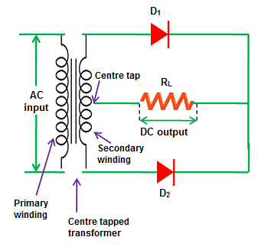

Components used: -

Centre tapped transformer, 2diodes, Load resistor, Ac voltage source,

Procedure: - The AC source is connected to the primary winding of the centre tapped transformer. A centre tap (additional wire) connected at the exact middle of the secondary winding divides the input voltage into two parts.

The upper part of the secondary winding is connected to the diode D1 and the lower part of the secondary winding is connected to the diode D2. Both diode D1 and diode D2 are connected to a common load RL with the help of a centre tap transformer. The centre tap is generally considered as the ground point or the zero-voltage reference point.

The centre tapped full wave rectifier uses a centre tapped transformer to convert the input AC voltage into output DC voltage.

When input AC voltage is applied, the secondary winding of the centre tapped transformer divides this input AC voltage into two parts: positive and negative.

During the positive half cycle of the input AC signal, terminal A become positive, terminal B become negative and centre tap is grounded (zero volts). The positive terminal A is connected to the p-side of the diode D1 and the negative terminal B is connected to the n-side of the diode D1. So, the diode D1 is forward biased during the positive half cycle and allows electric current through it.

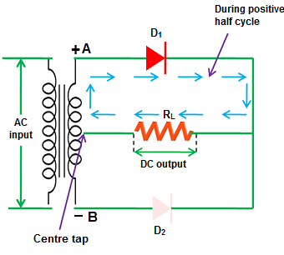

On the other hand, the negative terminal B is connected to the p-side of the diode D2 and the positive terminal A is connected to the n-side of the diode D2. So, the diode D2 is reverse biased during the positive half cycle and does not allow electric current through it.

The diode D1 supplies DC current to the load RL. The DC current produced at the load RL will return to the secondary winding through a centre tap.

Falstad Simulator Circuit:

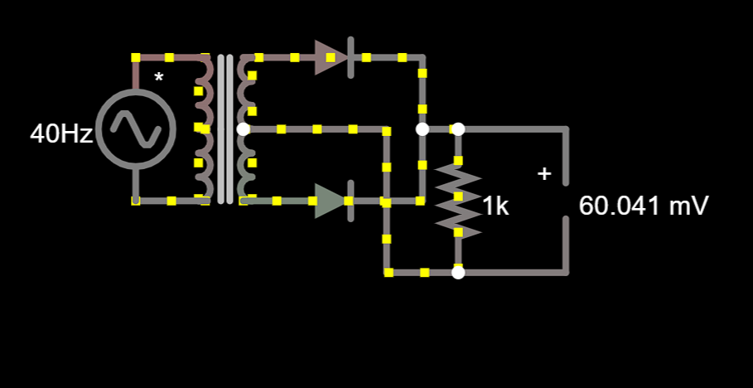

Input waveform: -

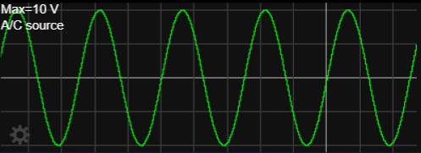

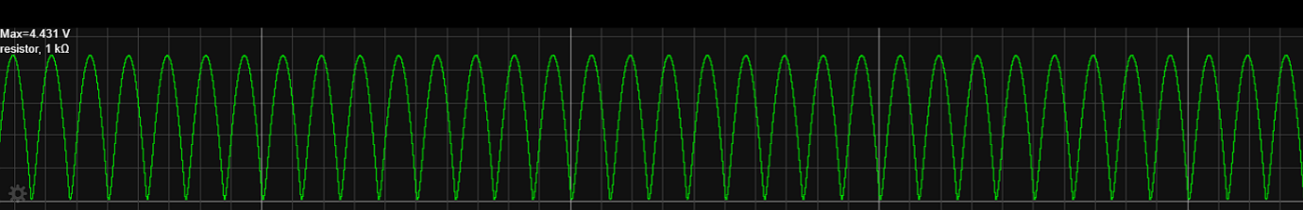Output Waveform: -

Now the value of Vm =4.431

Vrms=Vm/sqrt (2)

=4.431/1.414

=3.13336

Value of Vdc=2Vm/π

=2*3.728/ π

= 2.3733

Value of ripple factor is π/2*sqrt(2)

=1.11

Centre tapped Transformer with filter: -

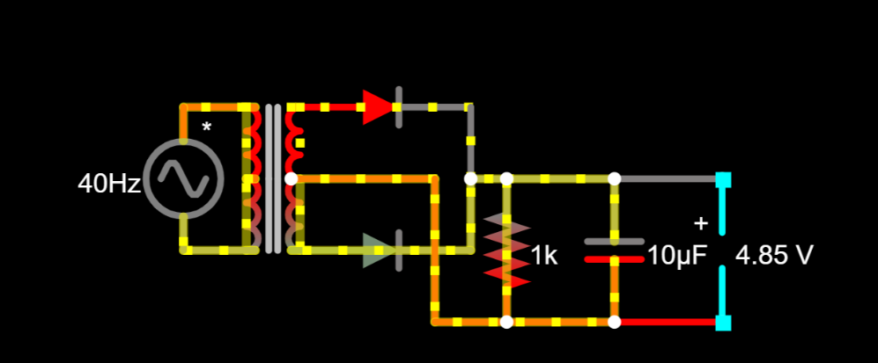

Value of Vm is= 4.857V

Next is Vrpp=(1/fRLC)(Vm/2-0.7)

=(1/40*1000*10*10^-6)(4.857/2-0.7)

=4.321

Next is Vdc =(1-(1/2fRLC)) * (Vm/2-0.7)

=(1-0.2)(4.857/2-0.7)

=(0.8)(1.7285)

=1.3828

Next Vr,rms=Vrpp/2*sqrt(3)

=4.321/3.464

=1.247  
Next ripple factor r=¼*sqrt(3)*40*10*10^-6*1000  
 = ½ * 0.77 = 0.385

**QUESTION-2 [Done by Vikhyat Bansal]**

**Design a circuit to obtain the following transfer characteristic. Plot the input and output waveforms using Falstad circuit simulator.**

**[Hint: Half-wave rectifier and DC source].**

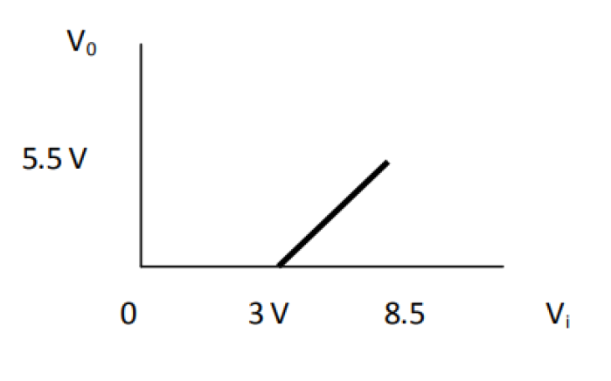

**Ans.**   
Voltage Transfer characteristic:

* Graphical representation of the behavior of a circuit in form of voltage.
* A plot of output voltage versus input voltage.

We are going for a half wave rectifier and VTC of an ideal half wave looks something like this,

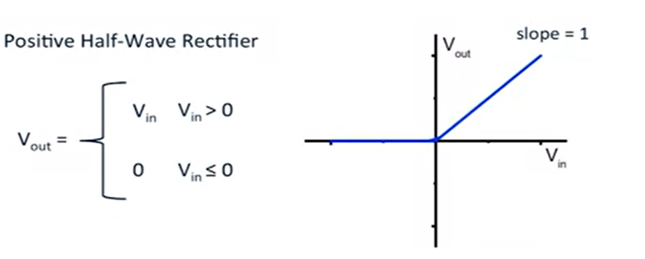

Voltage Characteristic of a non-ideal half wave rectifier:

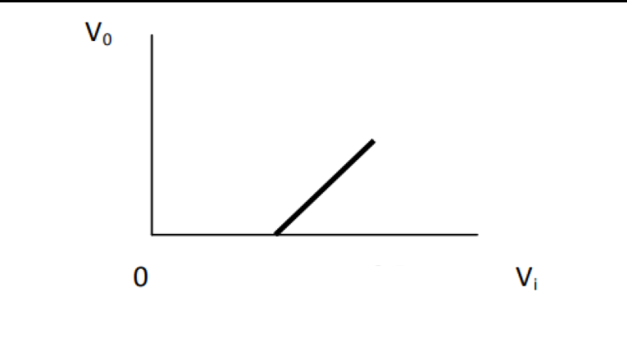

* From above figure, it can be understood that there is some unknown component which must be added in series with diode [as default diode is no more than 0.7V which is not sufficient to create a cut in voltage of 3V] or resistor.
* The unknown component can be figured out using KVL which will lead us to the conclusion that an external DC source must be added in series with diode or resistor to produce a cut in voltage as high as 3V.
* Using the concept of Series Diode Configuration and KVL, we can figure **out the direction of terminal of External DC source** that should be added in series with diode.

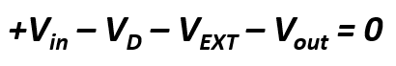

Components Used with Values:

* Wires
* General Diode (Silicon Diode)
* External DC Source:

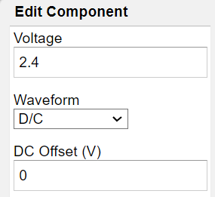

* Resistor (500Ohm)
* Voltmeter (or Analog voltage)
* A/C Input Source:

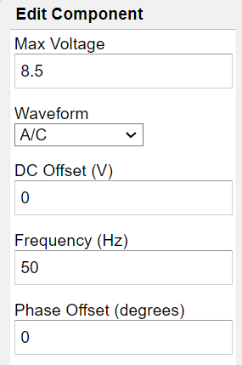

FALSTAD Simulator Circuit [COMPLETE]

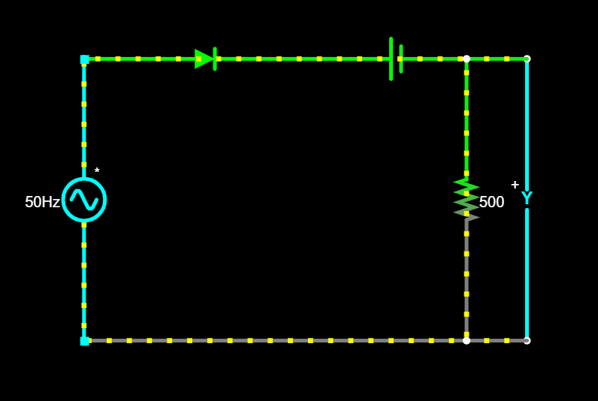

CALCULATION:





Where,

+Vin: A/C Input Source

-VD: Voltage due to diode

-VEXT: External DC Source

-Vout: DC output

Input and Output Waveforms

Input Waveform:

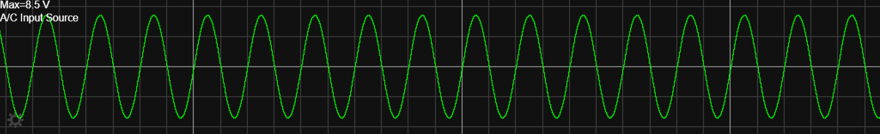

Output Waveform:

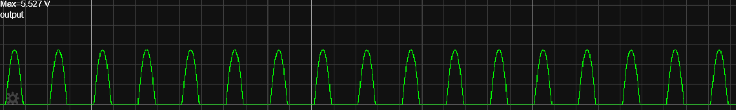

Combined Waveform:

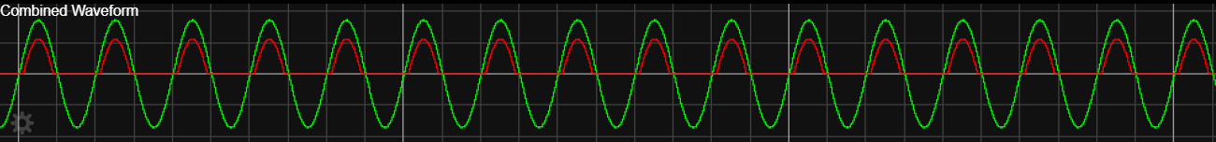

Transfer Characteristic using FALSTAD Simulator:



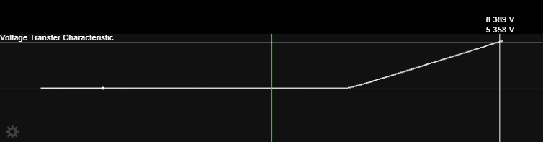

NOTE: To zoom into the document to look closer towards the image:  
Press: CTRL + Scroll UP{Mouse}  
[LINK TO THE CIRCUIT OF QUESTION 2](https://tinyurl.com/yyyyfzpy)

**QUESTION-3[Done by Gajula Sri Vatsanka]**

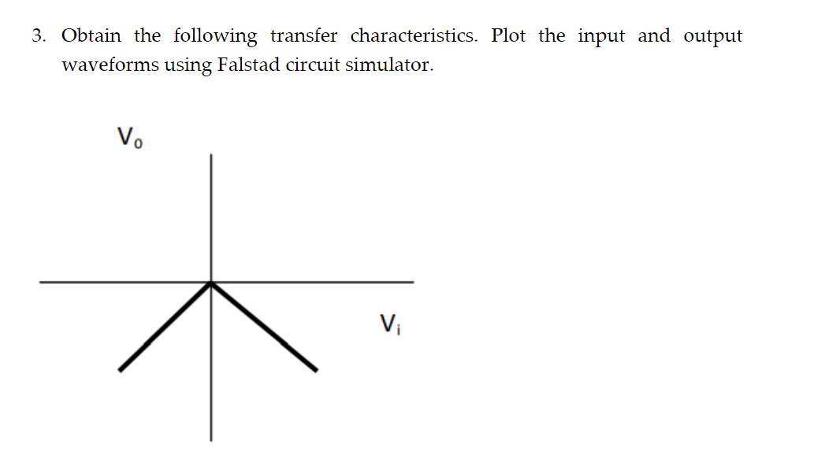

during -ve half cycle, the graph is y = x . ----->Vi = Vo

during +ve half cycle, the graph is y = -x --------> Vi = -Vo

so it is a full wave rectifier, but the output is negative instead of positive

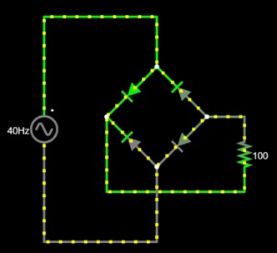

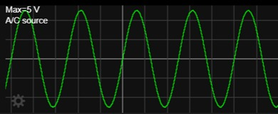

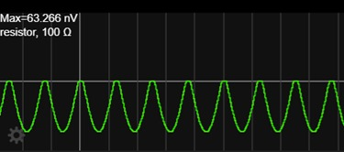

**QUESTION-4[Done by M.prasanna teja]**

**Design and study the following shunt clippers using diodes in the Falstad circuit simulator. Explain the working of the circuit diagram and plot the input and output waveforms.**

**a)Positive clipper clipping at +3V**

**b)Negative clipper clipping at -3 V**

**c)Slicer slicing at -3 V and -5 V**

**d)Double clipper clipping at +3V and –5V**

**ANSWER:-**

**a)Positive clipper clipping at +3V**

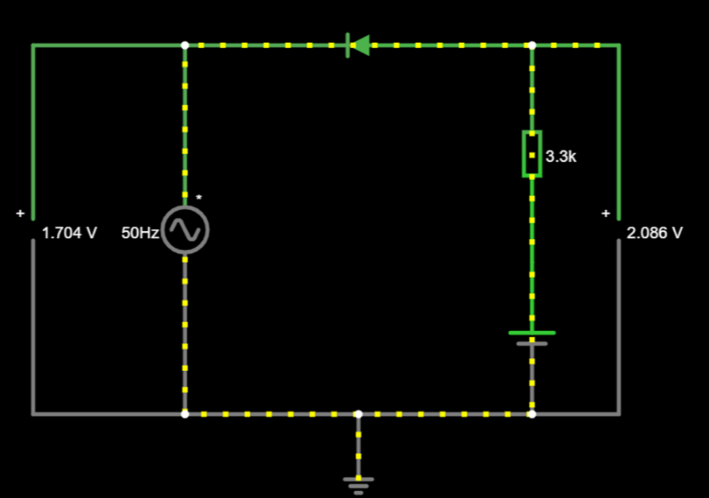

Components in the Circuit :

* An AC source of frequency 50hz and max voltage of 10V.
* A resistor of 3.3K ohm and DC voltage connected of 3V which is grounded.
* An ideal diode connected with the resistor and AC input voltage.
* 2 voltmeters are used to measure the voltage output & input.

Plot of both input & output voltage

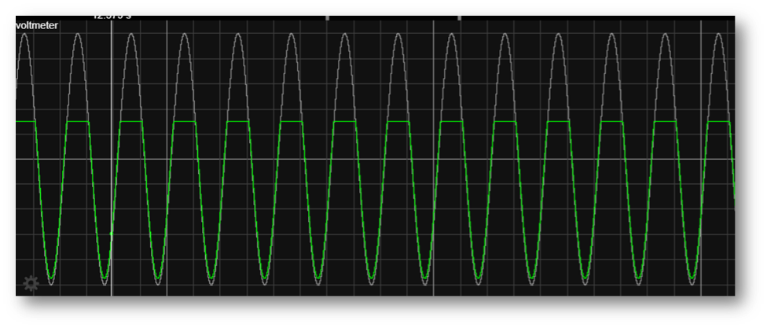

Plot between input and output voltage characteristics.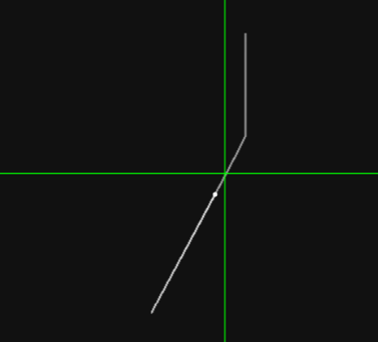 White – in volt X axis – V out  
 green – out volt Y axis – V in

**WORKING OF THE CIRCUIT: -**

* During the positive part of the half cycle the diode doesn't conducts the current to flow inside and the respective voltage will be the DC voltage(3v).( diode is in reverse bias)
* Similarly during the negative part of the input voltage the diode allows the current in the circuit and the voltage across the points will be same as input voltage.( diode is in forward bias)
* As for the + part of the wave it gets clamped at 3v , it is called clamping circuit.
* Like this the mechanism goes in the circuit.

+ part ----> reverse bias

- part ----> forward bias

**b) Negative clipper clipping at -3 V**

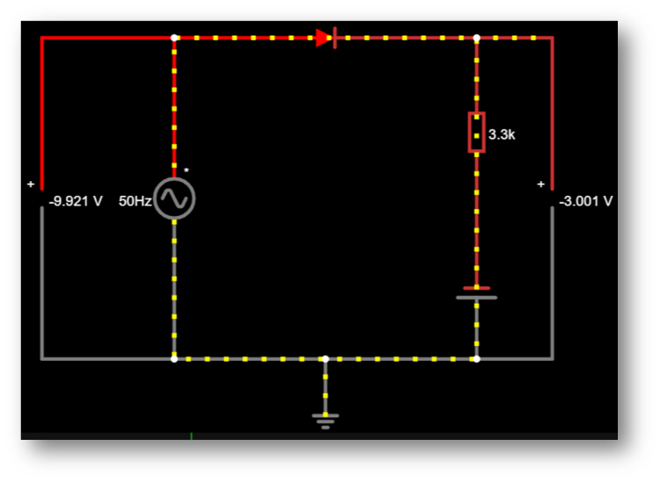

**COMPONENTS USED IN CIRCUIT**

* An AC source of frequency 50hz and max voltage of 10V.
* A resistor of 3.3K ohm and DC voltage connected of ' -3V 'which is grounded.
* An ideal diode connected with the resistor and AC input voltage.
* 2 voltmeters are used to measure the voltage output & input.

Plot between input & output voltage: -

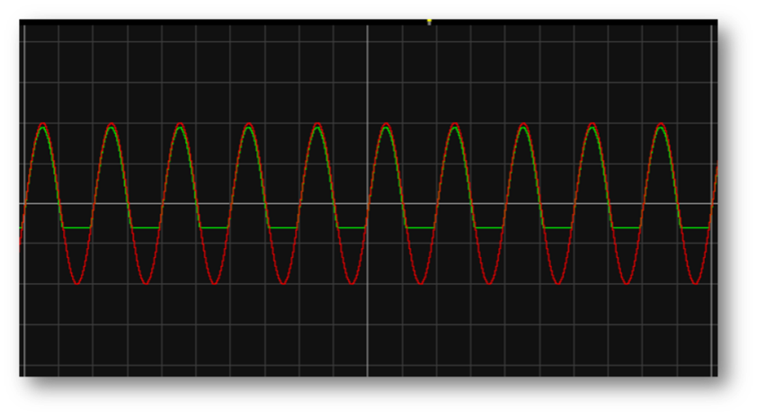red – in volt  
 green – out volt

Plot between input and output voltage characterstics:-

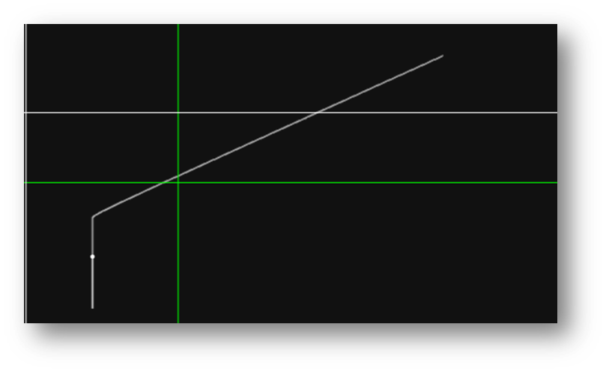  
X axis – V out

Y axis – V in

MECHANISM IN THE CIRCUIT: -

* During the positive part of the half cycle the diode conducts the current to flow inside and the respective voltage gets noted( diode is in forward bias)
* Similarly during the negative part of the input voltage the diode breaks the current in the circuit and the voltage across the points will be the DC voltage we supplied i.e 3V.( diode is in reverse bias)
* As for the - part of the wave it gets clamped at 3v , it is called clamping circuit.
* Like this the mechanism goes in the circuit.

+ part ----> forward bias

- part -----> reverse bias

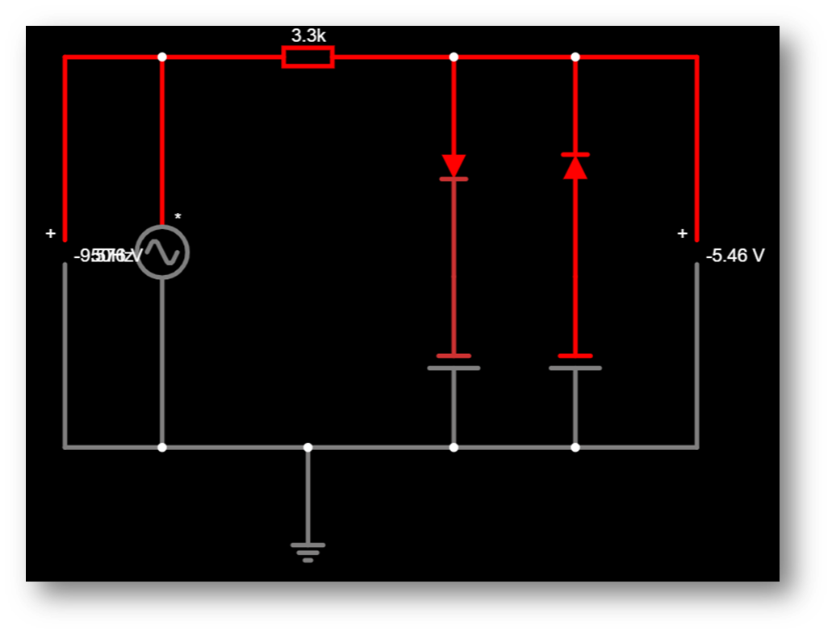

* A AC source of frequency 50hz and max voltage of 10V.
* A resistor of 3.3K ohm and DC voltage connected of ' -3V &-5V' which are grounded.
* 2 ideal diodes are connected oppositely with the resistor and AC input voltage.
* 2 voltmeters are used to measure the voltage output & input.

**Plot between input & output voltage**

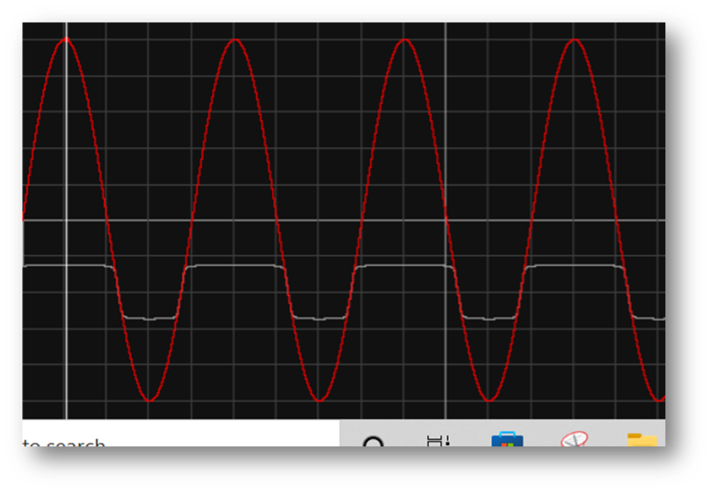

**Plot between input and output voltage characterstics**

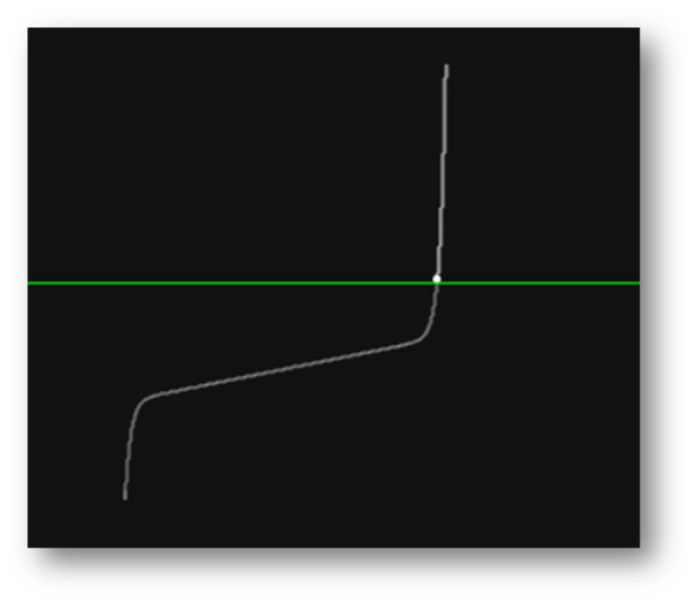 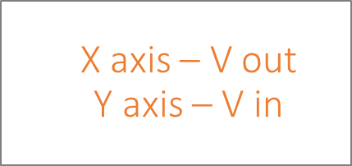

**Working of the circuit....**

§In this circuit we are having 2 diodes connected in opposite direction , so only one diode conducts the current at a time & other doesn't.

§So, during the positive part of the half cycle the 1'st diode conducts the current to flow and 2 nd doesn't, by anlysing the circuit, the output voltage for + cycle will be the DC voltage supplied to the 2 diode (3v).

§Similarly during the negative part of the input voltage the 2'nd diode allows the current in the circuit and 1'st doesn't, by anlysing the circuit ,the voltage across the points will be voltage across 1'st diode(5v).

§Like this the mechanism goes in the circuit.

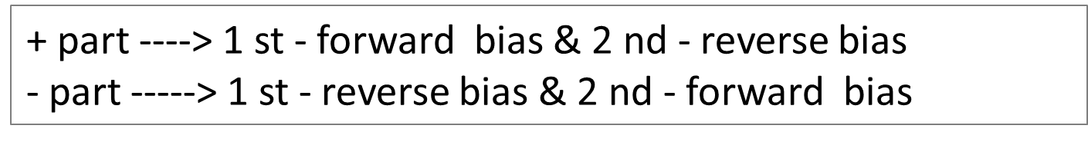

**d)Double clipper clipping at +3V and -5V**

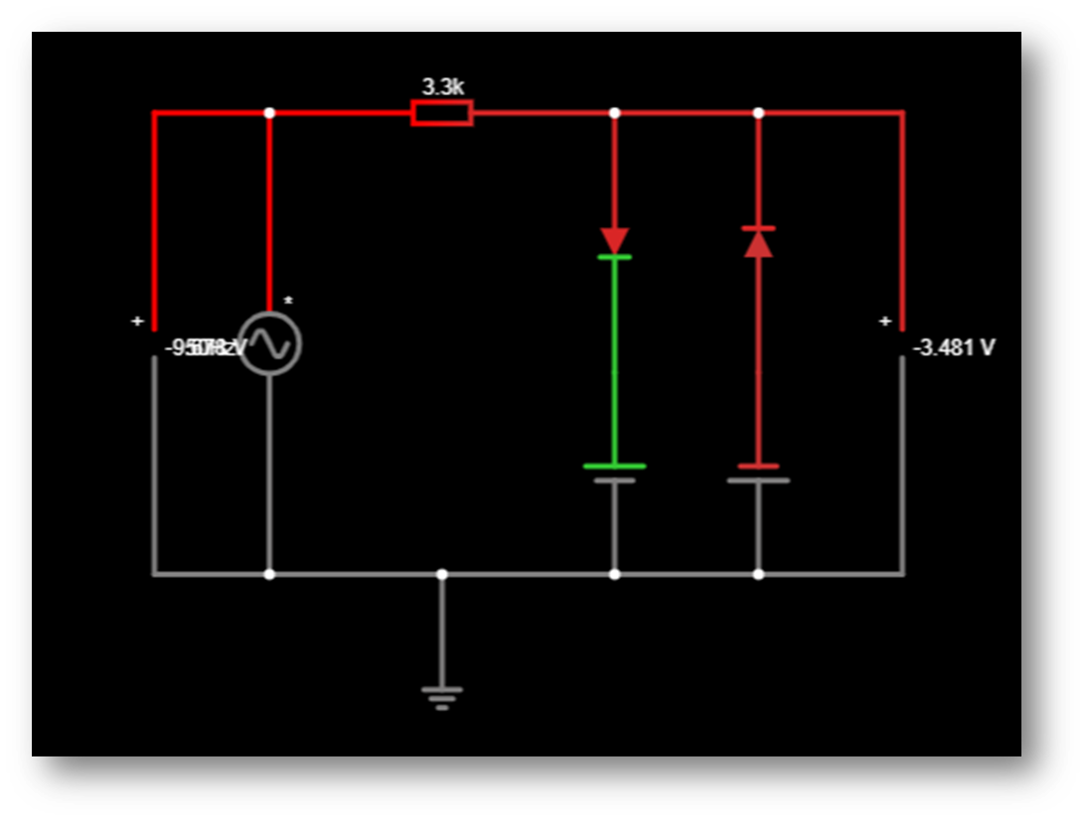

**Components used in the circuit:**

* An AC source of frequency 50hz and max voltage of 10V.
* A resistor of 3.3K ohm and 2 DC voltage's connected of ' +3v ' & '-5v' which is grounded.
* 2 ideal diodes are connected oppositely with the resistor and AC input voltage.
* 2 voltmeters are used to measure the voltage output & input.

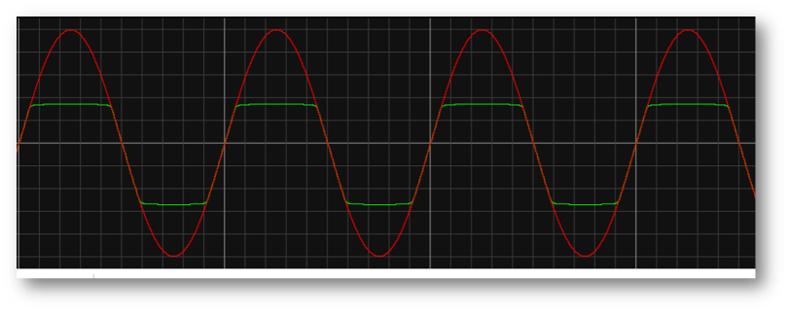

Plot between input & output voltage

**red – inp volt**  
 **green – out volt**

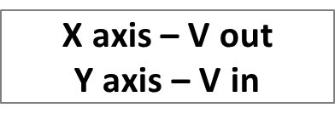

Plot between input and output voltage characterstics

**Working of the circuit:-**

* In this circuit we are having 2 diodes connected in opposite direction, so only one diode conducts the current at a time & other doesn't. The dc voltages are also connected in opposite direction which are grounded.
* So, during the positive part of the half cycle the 1'st diode conducts the current to flow and 2 nd doesn't, by analysing the circuit, the output voltage for + cycle will be the DC voltage supplied to the 2 diode (3v).
* Similarly. during the negative part of the input voltage, the 2'nd diode allows the current in the circuit and 1'st doesn't, by anlysing the circuit, the voltage across the points will be the DC voltage supplied to 1'st diode(-5v).
* Like this the mechanism goes in the circuit.

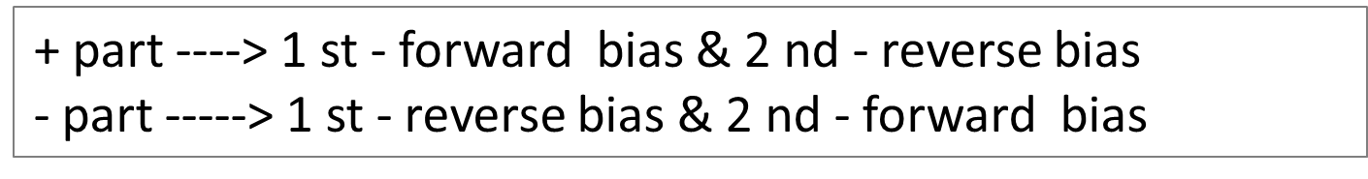

THANK YOU