Assignment 1

21AIE303

Signal and Image Processing – SEM-V

Professor – Dr. Sachin Kumar

Submitted By: Vikhyat Bansal CB.EN.U4AIE21076



Idea of Implementation: Question

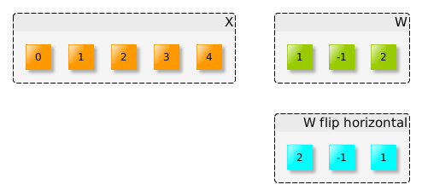

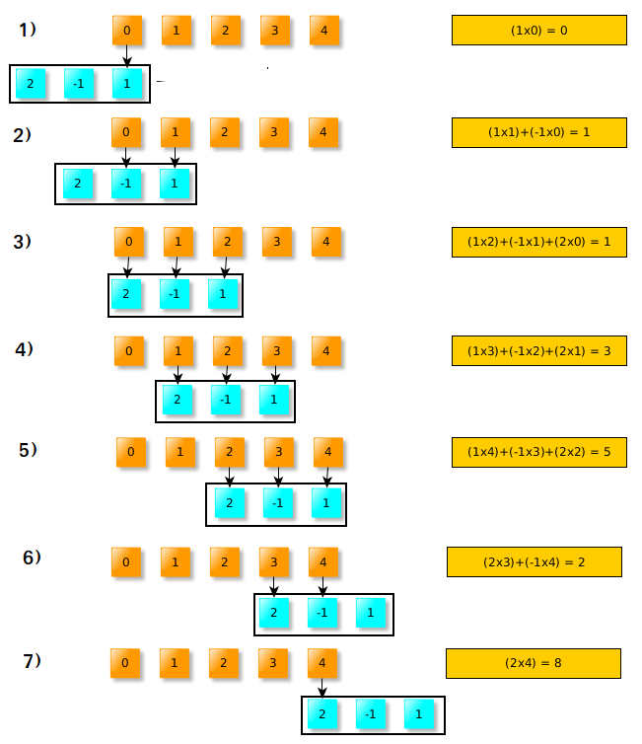Answer:

1. CODE: {Verfication using In-Built – Python}

*import* numpy *as* np

np.convolve(list1,list2)

CODE: {Verfication using In-Built – MATLAB}

conv(list1,list2)

**Verify the workout examples using InBuilt Function:**

**a.) List 1 = [1 2 3 4]  
 List 2 = [1 1]**

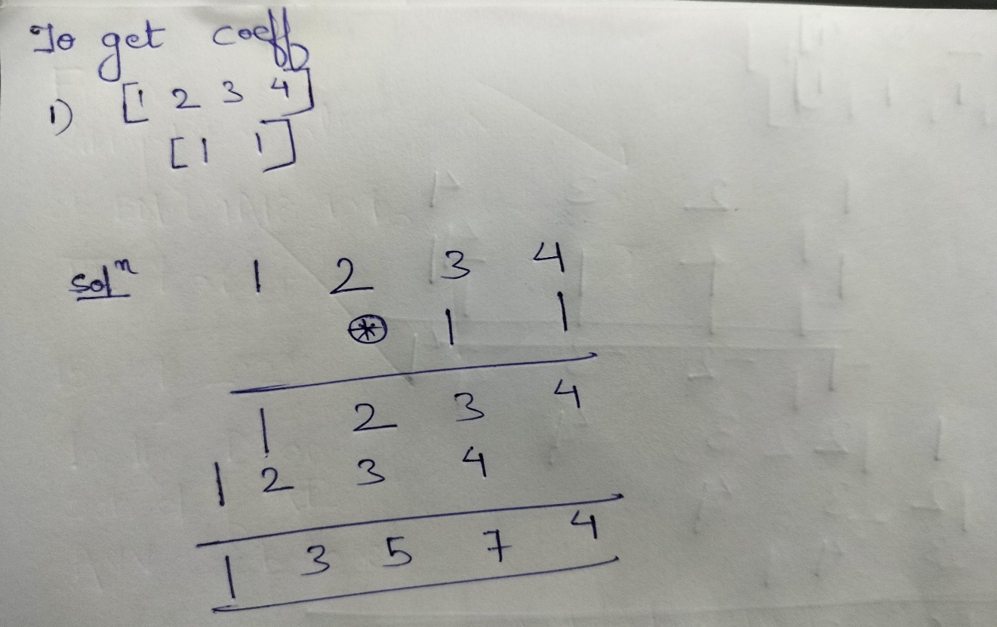**Handwritten:**

Python:

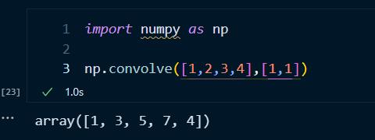

MATLAB:



**b.) List 1 = [1 2 3 4]  
 List 2 = [1 -1]**

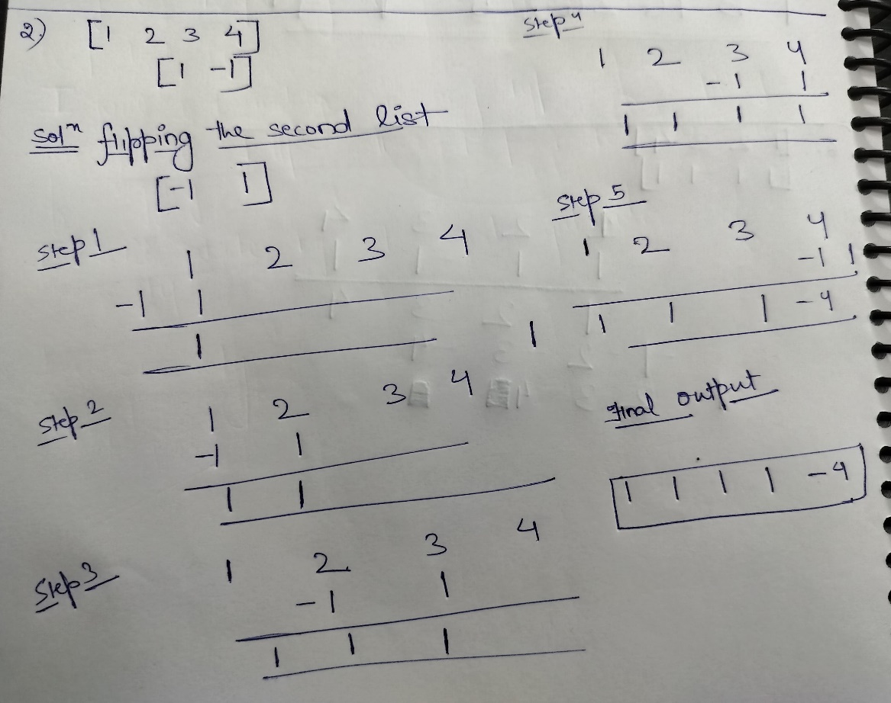**Handwritten:**

Python:

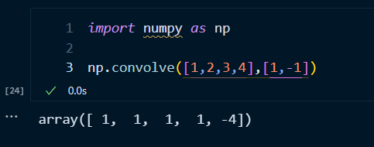

MATLAB:



**c.) List 1 = [1 2 3 4]  
 List 2 = [-1 -1]**

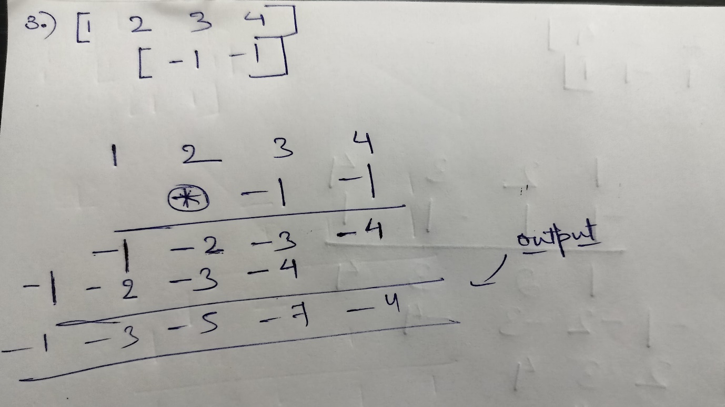**Handwritten:**

Python:

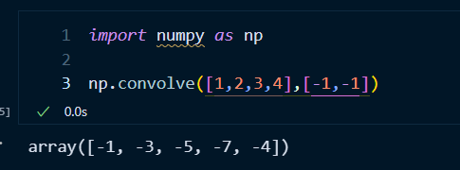

MATLAB:



**d.) List 1 = [1 2 3 4]  
 List 2 = [-1 1]**

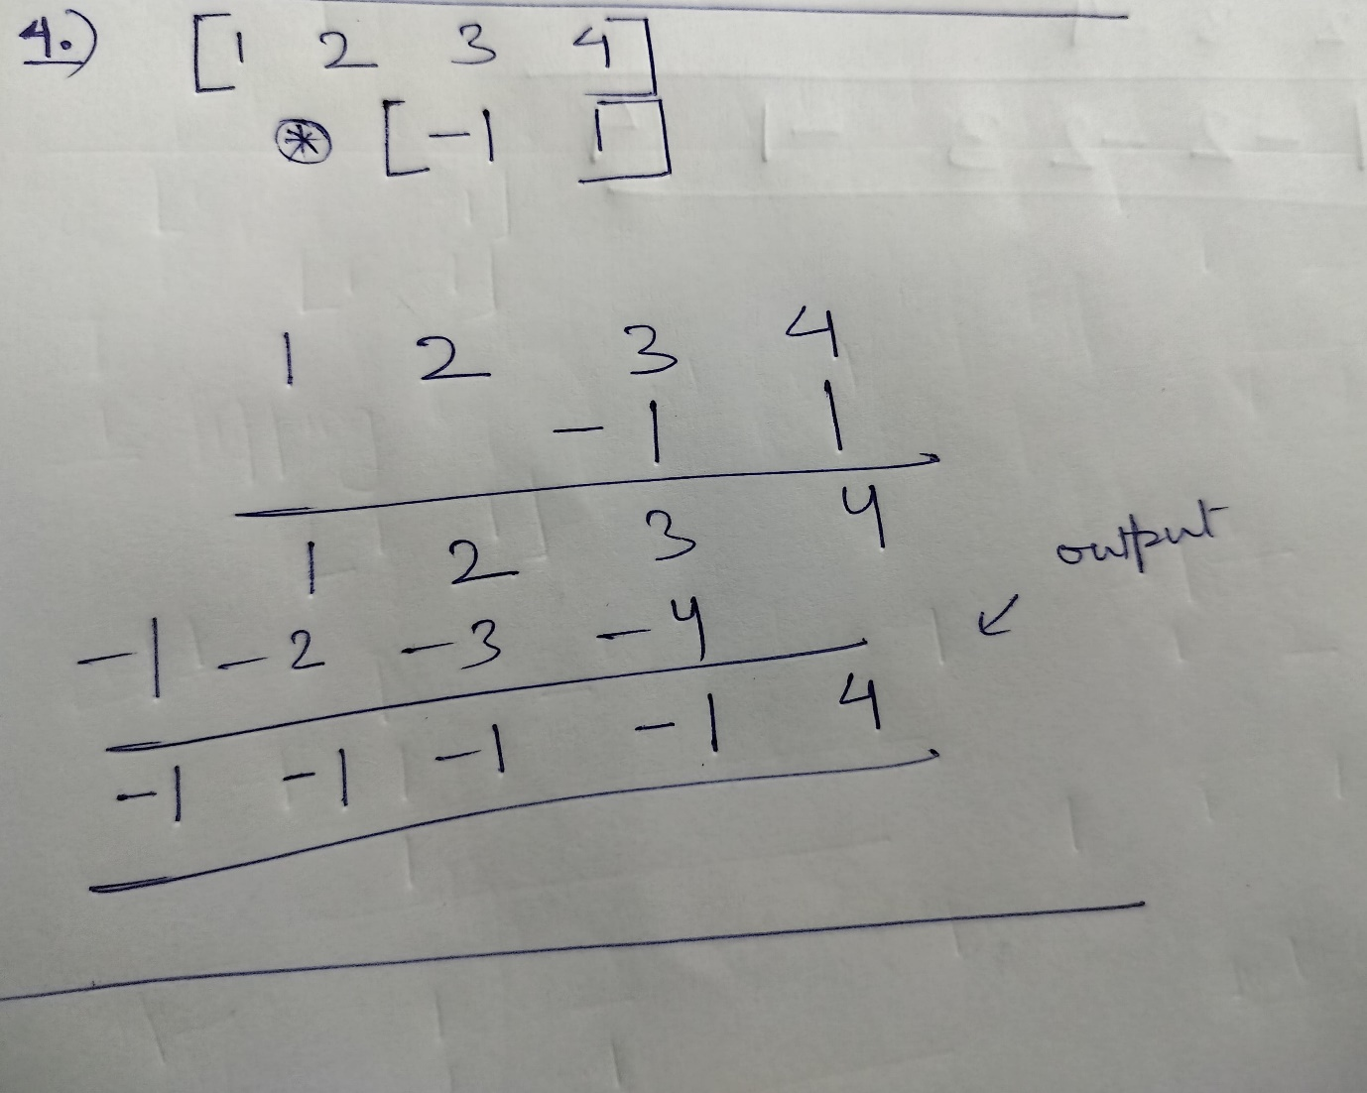**Handwritten:**

Python:

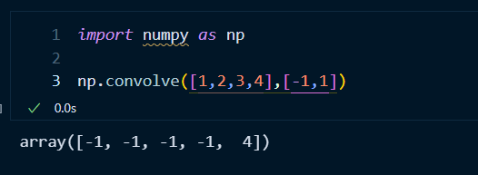

MATLAB:



**e.) List 1 = [1 2 3 4]  
 List 2 = [1 1 1 -1]**

**Handwritten:**

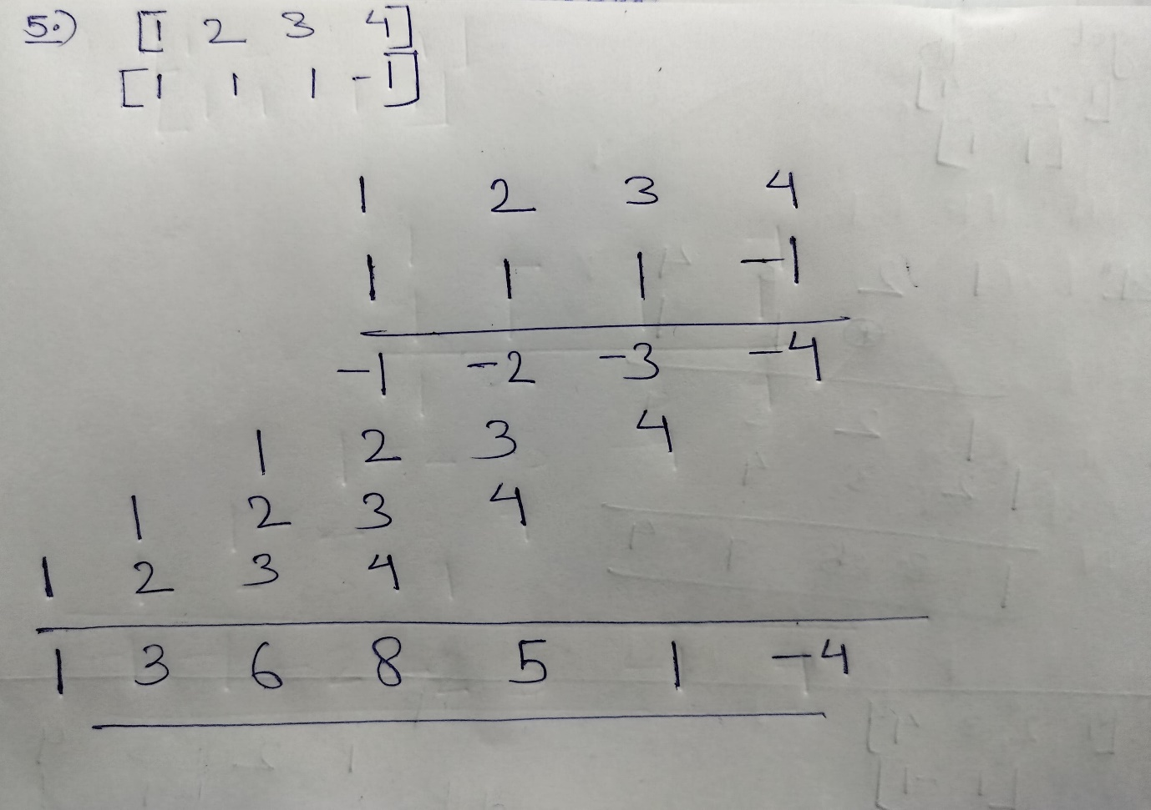

Python:

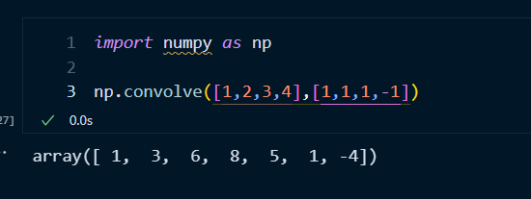

MATLAB:



**f.) List 1 = [1 2 3 4]  
 List 2 = [-1 1 -1 1]**

**Handwritten:**

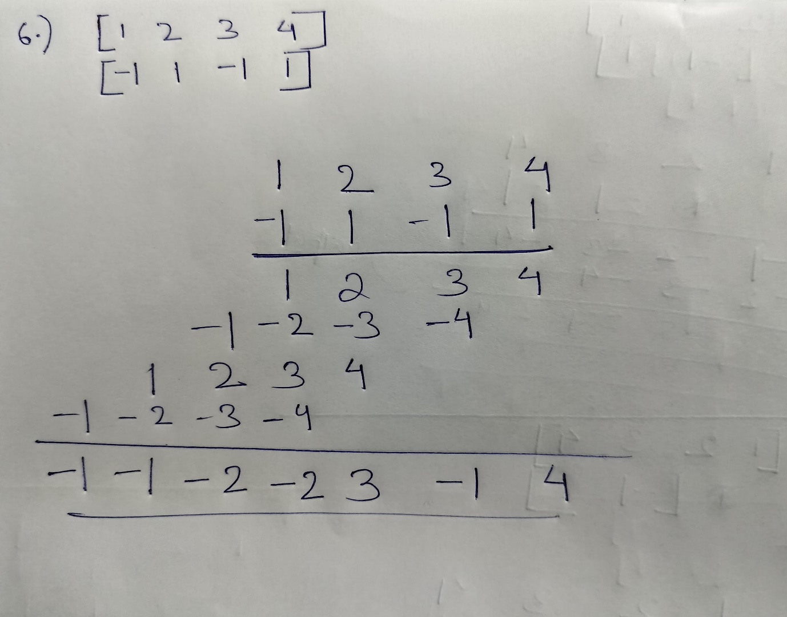

Python:

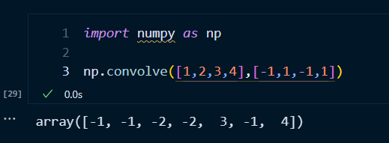

MATLAB:



2. Implement code for convolution and verify using examples given.

CODE: {Self Implemented – Python}

def *convolution*(list1,list2):

    # *Getiing the length of the resultant list an flipping the second list*

    n = len(list1) + len(list2) -1

    coeffs = [0]*n

    list2 = list2[::-1]

    # *Creating a new list with entries as zero of length(list2)-1*

    newlist1 = [0]*(len(list2)-1)

# Adding the initial input list1 to the newlist1 just to get the correct entries.

*for* i *in* range(len(list1)):

        newlist1.append(list1[i])

    # *Adding more zeroes to newlist just to deal with protruding*

*#part of list2 when flipped.*

*for* j *in* range(len(list2)-1):

        newlist1.append(0)

    # *Using Flipping Convolution*

*for* i *in* range(n):

*for* j *in* range(len(list2)):

            coeffs[i] += newlist1[i+j]*list2[j]

*return* coeffs

Code {Self Implemented – MATLAB}

function coefs = convolution(l1,l2)

n = length(l1) + length(l2) - 1; %% Length of final list %%

coefs = zeros(1,n); %% Padding of zeros on empty list %%

l2 = flip(l2); %% Flipping second list %%

newlist1 = zeros(1,length(l2)-1); %% Same as python code%%

for i=1:length(l1)

newlist1(length(l2)-1+i) = l1(i);

end

for j=1:length(l2)-1

newlist1(length(newlist1)+j) = 0;

end

for i=1:n %% Traversing list1 using list2 and updating final coefs list

for j=1:length(l2)

coefs(i) = coefs(i) + newlist1(i+j-1)*l2(j);

end

end

end

**Verify the implemented code using Examples:**

**a.) List 1 = [1 2 3 4]  
 List 2 = [1 1]**

Python:

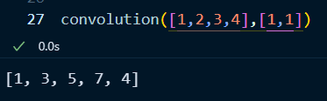

MATLAB:

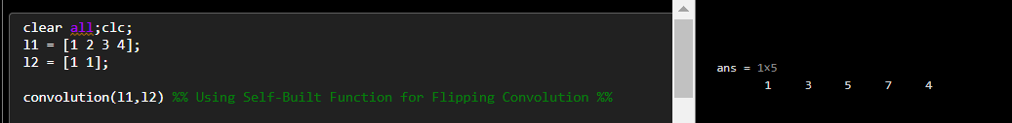

**b.) List 1 = [1 2 3 4]  
 List 2 = [1 -1]**

Python:

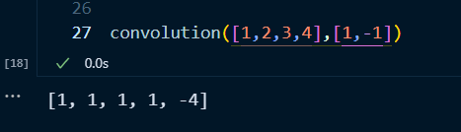

MATLAB:

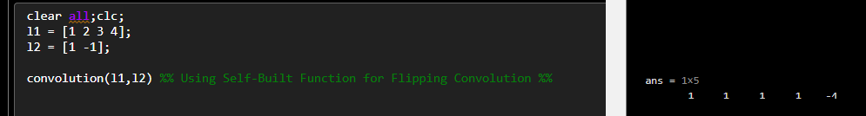

**c.) List 1 = [1 2 3 4]  
 List 2 = [-1 -1]**

Python:

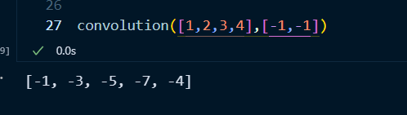

MATLAB:

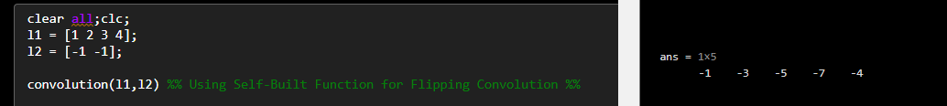

**d.) List 1 = [1 2 3 4]  
 List 2 = [-1 1]**

Python:

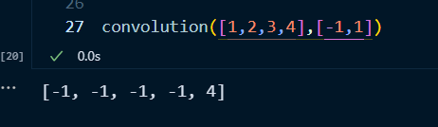

MATLAB:

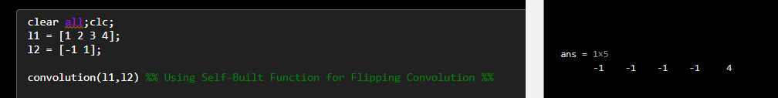

**e.) List 1 = [1 2 3 4]  
 List 2 = [1 1 1 -1]**

Python:

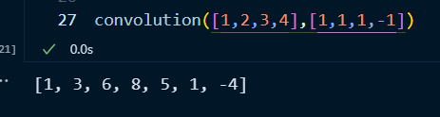

MATLAB:

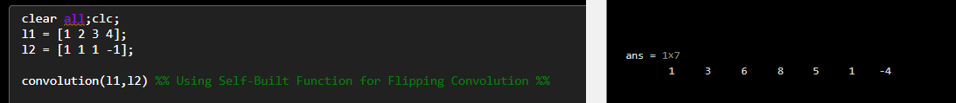

**f.) List 1 = [1 2 3 4]  
 List 2 = [-1 1 -1 1]**

Python:

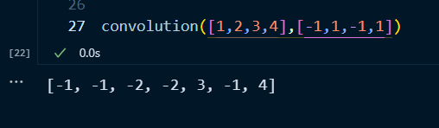

MATLAB:

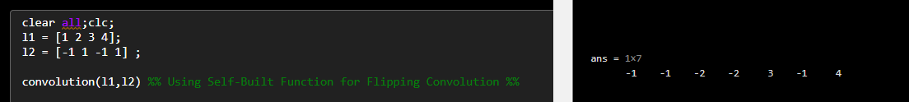

THANK YOU