UserCase Diagram

Sequential Diagram For User

Sequential Diagram For Admin

Collaboration Diagram For User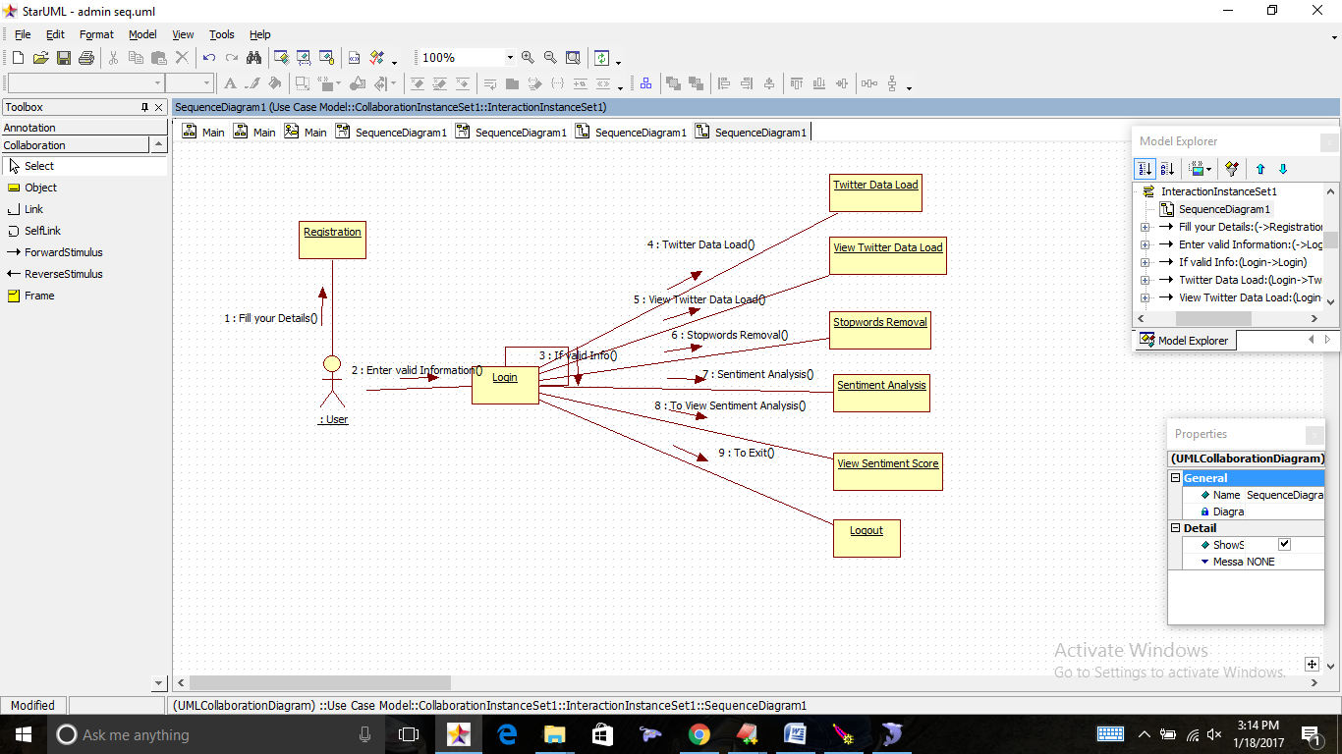

Collaboration Diagram For Admin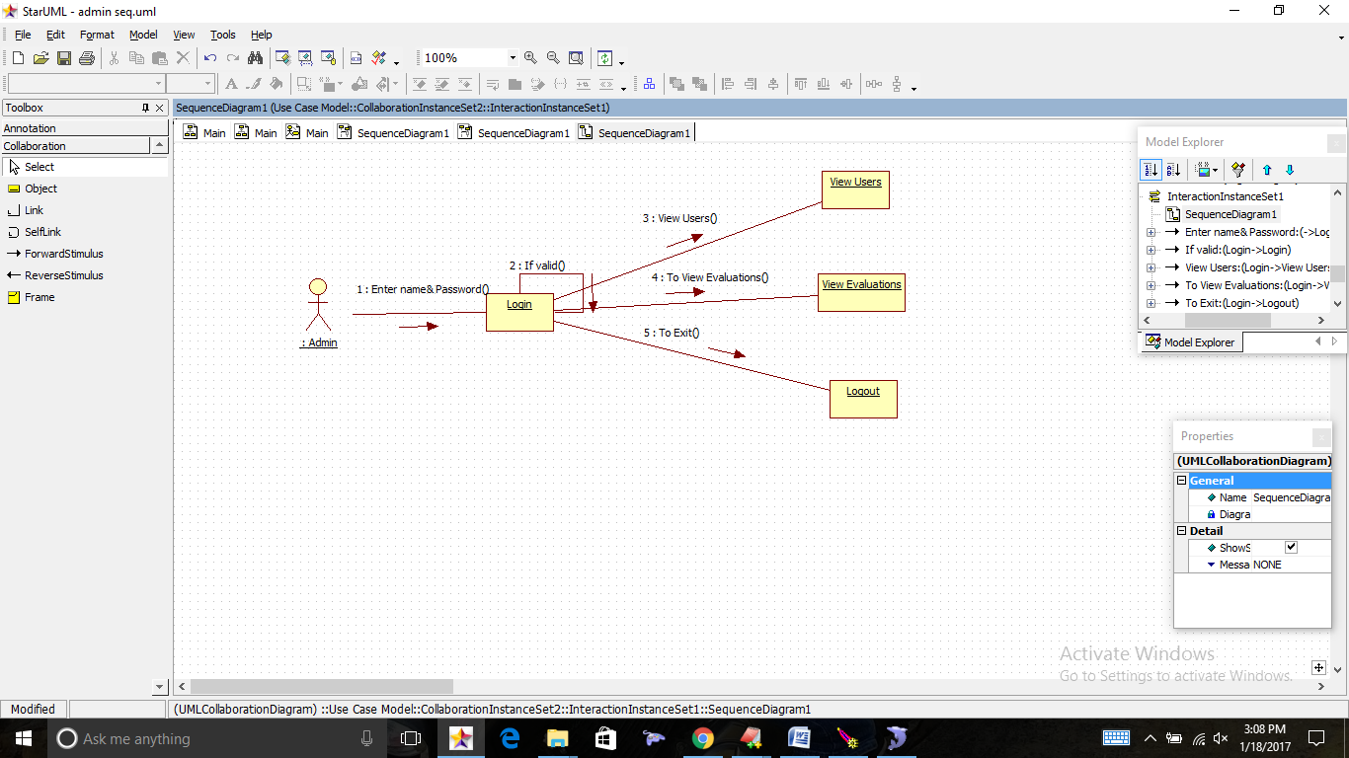

StateChart Diagram

Activity Diagram

Deployment Diagram:

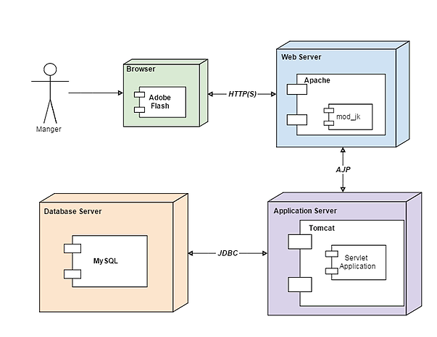

Component Diagram

Class



ER

