AI-Powered Marketing Budget Allocation Agent
Final Project Report — MGMT 590-037 · AI-Enhanced Optimization
Daniels School of Business, Purdue University · Summer 2026
Ana Valderrama · Gregory Sapp · Meghna Advani · Piyush Sandhikar · Vikhyat Koppal
June 2026

Executive Summary
We built an AI agent that converts five years of real eCommerce marketing data into a weekly, dollar-level budget recommendation across five paid advertising channels — and explains, defends, and stress-tests that recommendation in plain language. The agent follows the course's Data → Prediction → Optimization → Decision pipeline end-to-end: it cleans and validates 132,759 rows of daily channel data, fits saturating response curves per channel, tunes the model's hyperparameters with Bayesian Optimization, and solves a constrained nonlinear allocation problem with verified optimality conditions.
The headline result: at a demonstration budget of $50,000 per week, the optimized allocation predicts 15,640.8 conversions versus 5,957.1 for the proportional-to-history status quo — a +162.6% lift from reallocation alone, with no additional spend. The agent also reports the budget's shadow price (0.30 conversions per marginal dollar), a budget-sensitivity grid showing diminishing returns, and honest diagnostics about which channel estimates are well-identified and which are not. Under the instructor's stakeholder modification — minimum activation thresholds and advertising carryover — the problem becomes non-convex; the agent restores a provably global optimum by enumerating all 32 channel ON/OFF patterns and solving a convex subproblem within each.
Our recommendation to a marketing executive is direct: reallocate before you spend more. The marginal dollar belongs to the channel with the highest marginal response until marginal returns equalize — and the agent computes exactly where that point is, every week, in milliseconds.

1. Problem Description and Motivation

1.1 The decision problem
A mid-market direct-to-consumer (DTC) eCommerce brand spends roughly $831,000 per week on paid media across five channels: Google Paid Search, Google Shopping, Google Performance Max (PMax), Meta Facebook, and Meta Instagram. Every week, someone must decide how to split that budget. The decision recurs 52 times a year and individual channels consume tens of thousands of dollars weekly, yet in most organizations it is made by proportional rollover of last quarter's ROAS, platform-reported attribution, or managerial intuition.

1.2 Why current practice fails
Three structural features of paid digital advertising defeat these heuristics:
- Saturating response. Channel response is concave: the first dollar buys far more conversions than the millionth. ROAS-ranked allocation funds “winning” channels straight into their saturation zone while starving channels with high marginal returns.
- Carryover (adstock). Impressions served this week continue converting in later weeks. Single-period attribution under-credits channels with long decay.
- Activation thresholds. Platforms have minimum effective spends κ_c below which campaigns never reach audience frequency. The real decision is not only how much per channel but whether to run a channel at all — a disjunctive, non-convex structure no spreadsheet heuristic handles.

1.3 From prediction to prescription
A standard analytics pipeline would stop at prediction: “Google Shopping converts well.” That is a forecast, not a decision. The gap between the two is exactly what this project closes. Prediction gives us each channel's response curve — conversions as a function of spend. Prescription requires embedding those curves in an optimization model with a budget, bounds, and activation logic, then solving for the spend vector that maximizes total predicted conversions. The agent automates the full chain and returns dollar amounts, not sentiments.

2. Problem Formulation
Following the backward-thinking discipline used throughout the course, we state the decision problem formally before touching any data.

2.1 Decision variables
s = (s₁, …, s₅), s_c ≥ 0 (weekly USD spend on channel c)
One variable per modeled channel: Google Paid Search, Google Shopping, Google PMax, Meta Facebook, Meta Instagram. The decision cadence is weekly.

2.2 Objective function
Maximize total predicted weekly conversions, where each channel contributes through a concave saturation curve:
max Z(s) = Σ_c a_c (1 − exp(−b_c · s_c))
a_c is the channel's conversion ceiling and b_c its saturation rate. The functional form encodes three business facts: zero spend yields zero incremental conversions, the marginal return a_c·b_c·exp(−b_c·s_c) is highest at low spend, and returns approach a finite ceiling. Both parameters are uncertain and must be estimated from data — this is the prediction task.

2.3 Constraints
Constraint | Form | Business meaning
Budget | Σ_c s_c ≤ B | Total weekly spend cannot exceed the budget
Ceilings | s_c ≤ u_c | No channel exceeds 1.5× its historical weekly max
Non-negativity | s_c ≥ 0 | Spend cannot be negative
Activation (Models B, C) | s_c ∈ {0} ∪ [κ_c, u_c] | Run a channel at minimum effective scale, or not at all

The activation constraint is the instructor's stakeholder modification. It makes the feasible set a disjoint union — the problem is non-convex and cannot be handled by a single local solve (Section 5).

2.4 Backward mapping: Decision → Parameters → Data → Prediction → Optimization
Layer | Content
Decision | Allocate budget B across five channels, weekly, in dollars
Parameters needed | (a_c, b_c) response curves; adstock decays λ_c; thresholds κ_c; ceilings u_c; budget B
Data to estimate them | Five years of daily per-channel spend, impressions, clicks, and purchases
Prediction layer | Weekly Marketing Mix Model (MMM) on adstocked spend, hyperparameters tuned by BO
Optimization layer | Constrained nonlinear maximization; activation-pattern enumeration when non-convex

Each layer exists because the layer above it demands something: the decision demands curve parameters, the parameters demand historical spend–response data, the data demands a principled estimator, and the estimates demand an optimizer that respects the constraints a marketer actually faces.

3. Data Sources and Preparation

3.1 Dataset and structure
We use the Multi-Region Marketing Mix Modeling Dataset published by Conjura (figshare ID 25314841) — real, public, and fully disclosed, per the course's no-synthetic-data requirement. Coverage: 132,759 daily rows × 50 columns, 93 anonymized eCommerce brands across 15 verticals and 14 currencies, spanning 21 July 2019 to 2 June 2024.
The 50 columns fall into four groups:
- Identifiers: anonymized company, country, vertical, and date — each (company, country) pair is one daily timeseries.
- Channel activity: spend, impressions, and clicks per channel for Google (Paid Search, Shopping, PMax, Display, Video), Meta (Facebook, Instagram, Other), and TikTok.
- Outcomes: transactions and revenue — total and new-customer — from which we build the conversion target y.
- Commercial context: currency, average order values, and related descriptors used for normalization and audit.

3.2 Channel selection: which channels we kept, and why
Modeling a channel requires enough non-null spend history to fit a response curve. An explicit null-rate audit drove the keep/drop decision, and the agent surfaces this reasoning to the user in its live data-quality stage rather than burying it in preprocessing:
Channel | Decision | Spend null rate | Rationale
Google Paid Search | Kept | low | Dense history; core search demand capture
Google Shopping | Kept | low | Dense history; strongest identified response
Google PMax | Kept | moderate | Sufficient signal after null policy
Meta Facebook | Kept | low | Dense history; largest social channel
Meta Instagram | Kept | moderate | Sufficient signal after null policy
Google Display | Dropped | 85.9% | Too sparse to fit a curve
Google Video | Dropped | 94.3% | Too sparse to fit a curve
Meta Other | Dropped | 82.3% | Heterogeneous catch-all; too sparse
TikTok | Dropped | 97.4% | Effectively absent from the panel

Dropping a channel means it is excluded from the decision vector — the agent cannot recommend spend on a channel whose response it cannot estimate, and it says so explicitly.

3.3 Preprocessing pipeline
The pipeline is fully automated, deterministic, and unit-tested; it runs identically from the command line and inside the app. In order: schema mapping and validation → currency normalization to USD → duplicate detection → null policy (spend nulls on modeled channels are true zeros → 0; outcome nulls audited) → winsorization at the 99th percentile per timeseries (caps data-entry spikes without deleting rows) → daily calendar completion per timeseries → channel aggregation to the five modeled channels → geometric adstock transformation S_eff(t) = s(t) + λ·S_eff(t−1) → target construction → per-timeseries last-3-months holdout split → weekly aggregation. Outputs: a training set of 119,562 daily rows and a holdout of 13,197.

3.4 Weekly portfolio statistics
Because the decision is weekly, daily data is aggregated to portfolio-level weeks before modeling:
Statistic | Value
Mean weekly portfolio paid spend B_portfolio | $831,142 / week
Training weeks / holdout weeks | 242 / 157
Weekly mean of target y (purchases) | 68,058

Per-channel ceilings u_c = 1.5× the maximum historical weekly spend all comfortably exceed their activation thresholds (u_c/κ_c ranges from 20.9× to 122.1×), so no channel is forced permanently OFF at portfolio scale — verified before building the activation model, not discovered after.

3.5 Train/test discipline
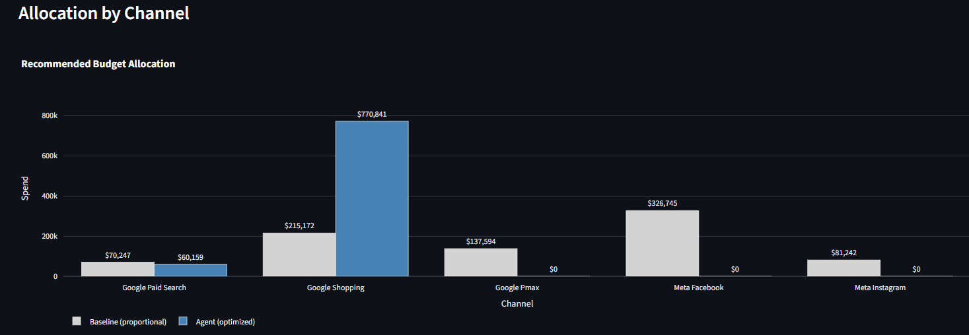
Figure 2: EDA — total daily spend by channel (adstock), July 2019–June 2024.

The holdout serves exactly two purposes: selecting adstock decays and BO hyperparameters, and evaluating allocations against the baseline. It is never seen during curve fitting. This is the boundary that keeps the validation honest.
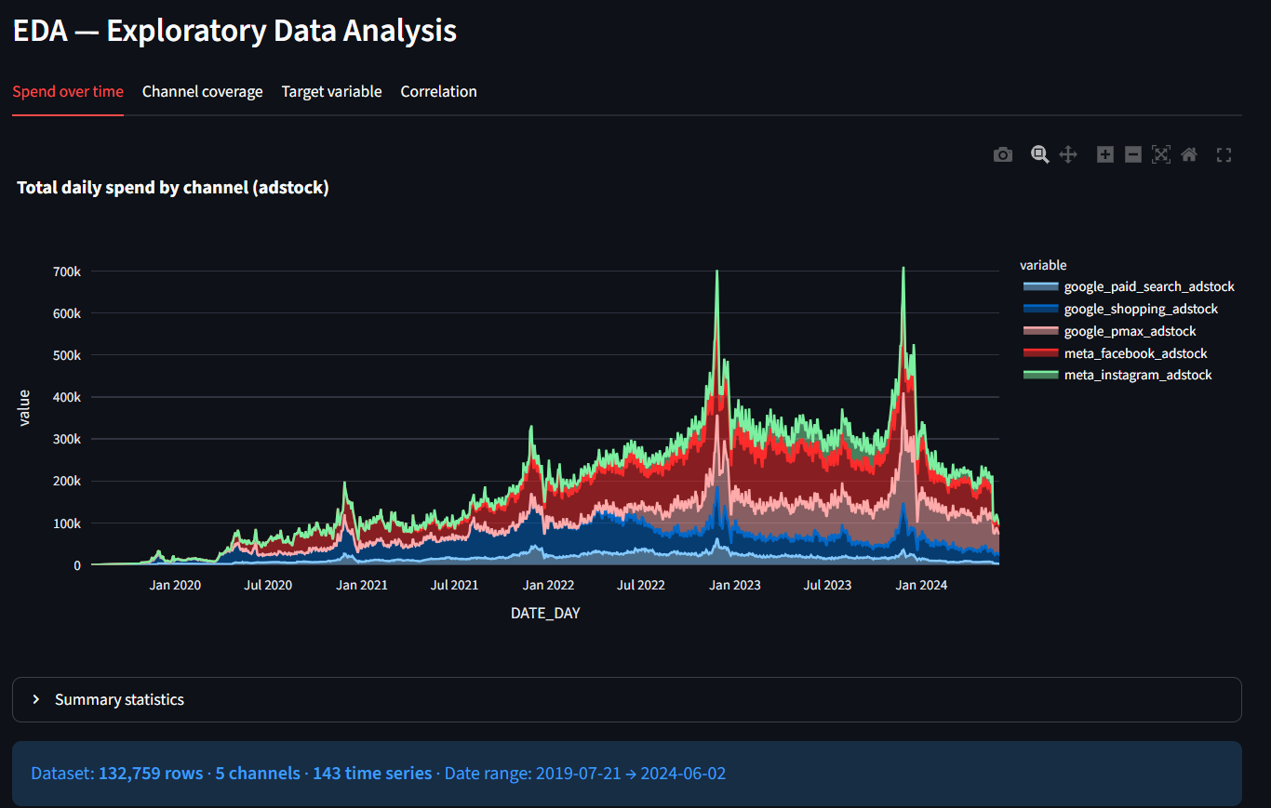

4. Prediction Methodology and Results

4.1 Model form
Each channel's contribution to weekly conversions is the saturation curve f_c(s_c) = a_c (1 − exp(−b_c·s_c)) introduced in Section 2.2. Concavity is a deliberate design choice for the optimizer: it guarantees every optimization subproblem downstream is convex, so the prediction layer and optimization engine are co-designed rather than bolted together.

4.2 Estimation
Curve parameters (a_c, b_c) are fit by nonlinear least squares on weekly-aggregated training data. For the adstock model (Model C), curves are re-fit on steady-state effective spend at the holdout-selected decay rates, so the optimizer's input parameters are always consistent with the temporal assumption being modeled.

4.3 Hyperparameter tuning via Bayesian Optimization
The regularization weight and per-channel adstock decays cannot be chosen in-sample — they are not separately identifiable, and each candidate configuration requires a full MMM refit plus holdout scoring, making the tuning objective an expensive black box. We therefore tune them with Gaussian-Process Bayesian Optimization using Expected Improvement over a 30-evaluation budget (5 random initial points + 25 EI-guided), scored on holdout R². The division of labor mirrors the course material: BO (Lecture 7) optimizes how the agent predicts; gradient-based SLSQP optimizes how it allocates, where the objective is cheap, smooth, and has an analytic gradient. Each algorithm is matched to the problem regime it was designed for.

4.4 Fitted parameters and identification diagnostics
Channel | a_c | b_c | Identification
google_paid_search | 9.01 | 3e-6 | Weak — collinear with PMax
google_shopping | 292,111.66 | 1e-6 | Strong
google_pmax | 656,836.83 | ~0 | Near-linear — extrapolation risk
meta_facebook | 767,739.98 | ~0 | Near-linear — extrapolation risk
meta_instagram | 0.07 | 3e-6 | Weak — collinear with Facebook

Two structural findings are flagged by the agent rather than hidden. First, within-platform multicollinearity: brands scale Paid Search and PMax together, and Facebook and Instagram together, so the weaker member of each pair is not separately identifiable — the regression assigns the shared effect to one channel. Second, the two strongest channels fit near-linearly within the observed spend range, meaning their fitted ceilings are extrapolations. Both caveats propagate into the recommendation language: the agent presents near-zero allocations on collinear channels as identification artifacts, not verdicts.

4.5 Validation

Figure 3: Channel saturation curves — predicted conversions vs. channel spend.

Holdout R² from the BO tuning run: [insert final holdout R², with the in-sample vs. holdout comparison from the BO logs]. The fitting path carries 11 dedicated unit tests; the curve fits shown above reproduce live in the app.
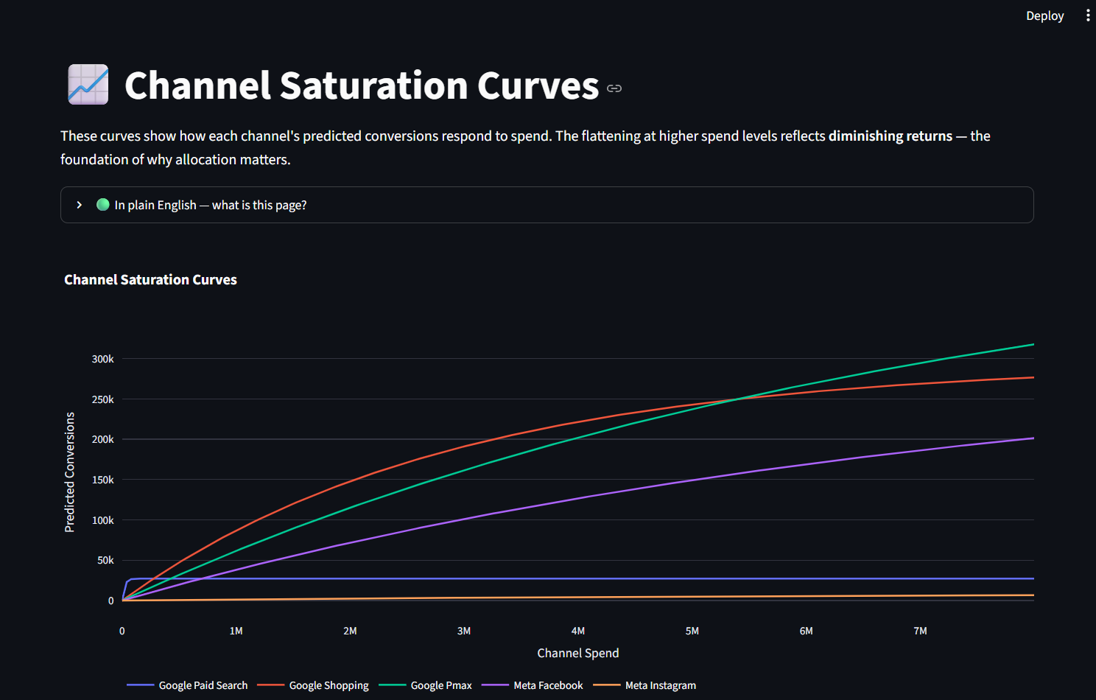

5. Optimization Model Formulation and Solution

5.1 Model A — convex base
max Σ_c a_c (1 − exp(−b_c·s_c)) s.t. Σ_c s_c ≤ B, 0 ≤ s_c ≤ u_c
A concave objective over a polytope: every local optimum is global. We solve with multistart SLSQP (50 random starts), supplying the analytic gradient ∂f_c/∂s_c = a_c·b_c·exp(−b_c·s_c), and verify the KKT conditions explicitly on every solve:
- Primal feasibility — the allocation respects budget and bounds.
- Stationarity — marginal returns are equalized across all channels spending strictly between their bounds; no profitable dollar transfer exists.
- Dual feasibility — constraint multipliers are non-negative.
- Complementary slackness — only binding constraints carry positive multipliers.
The budget multiplier is reported to the user as the shadow price λ_budget: the predicted conversions gained per additional dollar of budget — the single most decision-relevant number the optimizer produces.

5.2 Model B — activation thresholds (non-convex)
The stakeholder modification makes each channel's feasible set s_c ∈ {0} ∪ [κ_c, u_c], a disjoint union; mixed-integer programming is disallowed by the assignment. A single local solve can converge on the wrong ON/OFF configuration. We restore a provable global optimum by exhaustive enumeration: all 2⁵ = 32 activation patterns are generated, patterns whose minimum commitment Σ κ_c (over ON channels) exceeds B are screened out, and a convex, KKT-verified SLSQP subproblem is solved within each surviving pattern. The best pattern wins. As a cross-check, a 50-start SLSQP attack on the unrestricted non-convex problem never beats the enumerated winner.

5.3 Model C — adstock carryover plus activation
At steady state, geometric carryover implies effective spend S_eff = s_c / (1 − λ_c). Model C maximizes Σ_c a_c (1 − exp(−b_c·s_c/(1−λ_c))) over Model B's feasible set, with curves re-fit at the holdout-selected decays. Carryover effectively discounts each channel's saturation rate, rewarding channels with long memory; the enumeration machinery runs unchanged.

5.4 Solver configuration
SciPy SLSQP; 50 multistarts; convergence tolerance 1e-9; max 1,000 iterations. Every solve returns a single structured result object — allocation, predicted conversions, KKT status, shadow price, baseline comparison, lift — which is the integration contract consumed by every downstream page and by the explanation layer.

6. Agent Architecture Description

6.1 The five components
The agent implements the five components required by the project guidelines as one integrated pipeline:
Required component | Our implementation
1. Problem formulation | Guided 7-stage backward analysis + structured-brief parser (JSON schema)
2. Data collection & preparation | Automated cleaning pipeline + weekly statistics layer (Section 3)
3. Prediction layer | Weekly MMM with BO-tuned hyperparameters (Section 4)
4. Optimization engine | Multistart SLSQP + activation-pattern enumeration, KKT-verified (Section 5)
5. Explanation & validation | Plain-language rationale, sensitivity grids, diagnostics, benchmark comparison

[Figure 5: Component map — pipeline boxes with arrows from data preparation through prediction, optimization, and explanation.]

6.2 End-to-end flow
(1) The user uploads data and confirms the detected schema. (2) A seven-stage backward analysis walks from outcome identification through data quality, channel selection, response-curve logic, and constraint definition to an explicit optimization problem statement — and the optimizer cannot run until the user confirms that statement. This makes the backward mapping a living part of the product, not just a section of this report. (3) The pipeline fits curves and solves. (4–6) Results pages present the allocation against the baseline, the fitted curves, budget scenarios, and the Model A/B/C comparison, each with diagnostics.

6.3 Configuration and runtime parameters
Defaults (activation thresholds, decay rates, solver settings) live in a single configuration file; runtime truth lives in the app's session state. Every compute function in the stack — ceiling computation, scale decisions, and the solvers themselves — accepts runtime overrides for κ, u_c, and B, so when a stakeholder changes a threshold mid-conversation the entire chain re-evaluates consistently. Nothing is hard-coded twice.

6.4 Guardrails: testable safety
Chat input passes through a guardrail layer before any LLM sees it: scope enforcement (the agent answers only about this dataset and this decision), PII redaction (emails, phone numbers), and refusal of external-data requests and benchmark fabrication. Output is audited symmetrically: no unsourced statistics, no external-knowledge claims, mandatory data-source grounding. Every rule has a dedicated unit test covering block, redirect, pass-through, and redaction cases.

6.5 LLM layer and graceful degradation
The conversational agent runs on Anthropic Claude with a structured system prompt (identity, cognitive protocol, per-phase workflow instructions); the explanation layer's rationale generator uses Google Gemini. Critically, no natural language ever reaches the solver — briefs are parsed into a strict JSON schema first, and all numbers shown to the user come from the deterministic pipeline, never from the LLM. Both LLM integrations degrade gracefully: with no API key, deterministic template output preserves full functionality, so the demo cannot break and the test suite runs key-free.

6.6 Testing
The full suite — 197 passed, 2 intentionally skipped integration stubs — runs with pytest tests/ and no API key. Coverage spans the data pipeline, weekly statistics, archive handling, backward analysis, guardrails, MMM fitting, the optimizer, the baseline, BO tuning, and the explainer.

7. Sensitivity and Scenario Analysis

7.1 Purpose and approach
The project guidelines require the agent to report how the recommendation changes when key parameters shift. Our primary sensitivity module lives on the app's Sensitivity & Scenario Analysis page and answers: what if my total budget were cut or increased? We hold the fitted response curves (a_c, b_c) and per-channel ceilings fixed and re-solve the optimizer at each budget level. This is a one-factor-at-a-time sensitivity on the total budget B — the same tornado-style logic used in the FreshChoice and airline case notebooks, applied to the constraint that binds most often in practice.
For each scenario: (1) compute B′ = m × B_base; (2) call the same SLSQP solver (Model A, KKT-verified) with unchanged curves and ceilings; (3) record predicted conversions, allocation, lift vs. base, and conversions per $1k. Each sub-solve is globally optimal because the objective is concave. Marginal efficiency falls as budget rises — the diminishing-returns signature of concave saturation.

7.2 Scenario Settings: what each dial controls
Three sidebar controls define the grid. None change the underlying model.
Control | Example | Meaning
Min budget multiplier | 0.50 | Lower bound as fraction of base. 0.50 = 50% budget cut. Range: 0.25–1.0.
Max budget multiplier | 2.00 | Upper bound. 2.00 = double the budget. Range: 1.0–3.0.
Number of scenarios | 7 | Evenly spaced levels between min and max. Example grid: 0.50×, 0.75×, 1.00× (base), 1.25×, 1.50×, 1.75×, 2.00×. Base is inserted if linspace misses 1.00.

Typical output. Headline metrics at portfolio scale:
Scenario | Predicted conversions
Base (1.00×) | 94,831.5
Best (2.00×) | 152,346.7 (+57,515 vs. base, +60.6%)
Worst (0.50×) | 59,767.6 (−35,064 vs. base, −37.0%)

7.3 Outputs and how to read them
Tornado chart. Percent change in predicted conversions vs. base. Green = increases; red = cuts. Each bar reflects a full re-optimization, not a static curve evaluation.

Figure 8: Budget sensitivity tornado (min 0.50×, max 2.00×, 7 scenarios).
Allocation flow chart. Shows how optimal mix shifts as budget scales — which channels absorb incremental dollars.
Scenario summary table. Budget $, conversions, lift %, and conv/$1k. Marginal efficiency identifies when the next tranche of budget is no longer worth funding.

7.4 Connection to course material
Implements Component 5 (Explanation and Validation). Re-optimization at each budget reflects Lecture 2 (Prediction to Prescription) and Lecture 3 (KKT — marginal returns re-equalize when B moves). Tornado format follows FreshChoice/airline notebooks, applied to budget B.

7.5 Activation-threshold sensitivity (companion)
Budget sensitivity holds κ fixed. Model A/B/C page re-runs Model B at κ ± 20% to test robustness of the ON/OFF channel set to platform minimum assumptions.

7. Benchmark Test Results and Comparison

7.1 Benchmark design
The instructor's stakeholder modification serves as the benchmark: the team's own problem plus two frictions — activation thresholds (Model B) and adstock carryover (Model C) — with results compared on holdout weeks against the base Model A and a proportional-to-historical baseline.

7.2 Model A headline
Demonstration configuration, B = $50,000 (chosen so activation effects are visible at demo scale):
Metric | Value
Predicted conversions (optimized) | 15,640.8
Baseline conversions (proportional-to-historical) | 5,957.1
Lift vs. baseline | +162.6%
KKT status | pass
Budget shadow price λ_budget | 0.3043 conv/$
Marginal efficiency | 312.8 conv/$1k

The lift is a reallocation gain — same budget, different distribution. The optimizer concentrates spend on Google Shopping, the channel whose curve identifies a strong concave response, while the baseline spreads dollars across collinear channels whose fitted incremental contribution is near zero.

7.3 Budget sensitivity
Predicted conversions rise monotonically with budget while marginal efficiency falls monotonically (317.1 conv/$1k at $25k → 304.4 at $100k): the diminishing-returns signature, presented as a grid a marketing director can act on directly.

7.4 Model A / B / C comparison

Figure 6: Model A/B/C comparison at portfolio scale ($831,000/week).

At portfolio scale (B = $831k) no activation threshold binds and Model B coincides with Model A; at a $90k stress scenario the activation mechanism switches channels off entirely rather than underfunding them — the qualitative behavior the modification was designed to expose. A κ ± 20% sweep tests whether the winning ON-set is robust to the assumed thresholds: [insert sweep outcome — ON-set invariant, or which channels flip].

7.5 Interpreting discrepancies

Figure 7: Recommended allocation vs. proportional-to-historical baseline.

Where our agent's answer differs from a human baseline, the difference traces to identification, not optimization: the solver provably finds the global optimum of the fitted curves, so any disagreement is a statement about the prediction layer (collinearity, extrapolated ceilings) — exactly the diagnostic the agent reports alongside its recommendation.
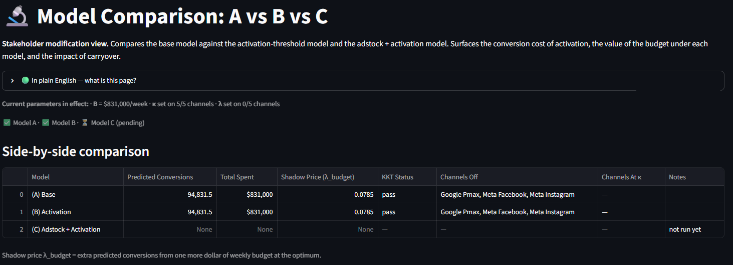


8. Managerial Recommendations
- Reallocate before spending more. At the same budget, redistributing dollars toward the highest marginal returns yields +162.6% predicted conversions versus the proportional status quo. Concentrate the marginal dollar on Google Shopping until its marginal return falls to the shadow price or its ceiling binds.
- Set the budget with the marginal-efficiency column. If unit economics require at least 308 conversions per $1k, the sensitivity grid caps the recommended budget near $75k in the demo configuration; the same logic scales to the full portfolio.
- Treat the collinear pairs as one decision each until disambiguating evidence exists. Run geo-holdouts or platform lift studies on Paid Search vs. PMax and Facebook vs. Instagram; until then, near-zero allocations on the weaker members are identification artifacts, not verdicts.
- Cap the near-linear channels managerially (e.g., 1.2× historical max) rather than trusting extrapolated ceilings.
- Re-solve weekly. The solver runs in milliseconds; refresh the recommendation every Monday as new data lands.
- Platform minimums matter under cuts, not at scale. At $831k/week every channel clears its activation threshold; under a cut to $90k the agent shows exactly which channels to switch off rather than underfund — the kind of structural answer a heuristic cannot give.

9. Limitations and Future Improvements
Limitations (acknowledged in-product, not just here): Within-platform multicollinearity is structural to the dataset; near-linear fits make two channel ceilings extrapolations; the optimizer is single-period and the adstock bridge is the steady-state identity (transient dynamics unmodeled); curves are fit by squared-error loss rather than a decision-aware criterion; activation thresholds are stakeholder-supplied rather than estimated; modeling is at portfolio level rather than per-brand; narrative quality depends on LLM availability, though deterministic fallbacks preserve all function.
Future improvements, Ordered by expected value: decision-aware curve fitting evaluated on holdout allocation regret; Bayesian MMM giving posterior distributions over (a_c, b_c) and quantitative risk bands on the recommendation; posterior-based adstock estimation propagated through sample re-solves; designed experiments to disambiguate the collinear pairs; per-brand curves with a brand selector; multi-period optimization over a rolling horizon; contextual-bandit re-allocation in production; and mixed-integer formulation of the activation structure if the channel count grows beyond enumeration range (2^n is trivial at n=5, untenable at n=20).

AI Usage Disclosure
Generative AI tools were used in two distinct roles, disclosed per course policy. As a development tool: Cursor (Claude-based) assisted with code scaffolding, test generation, and documentation drafting; all model formulations, data decisions, and business interpretations were specified, reviewed, and validated by the team, and every component is covered by team-written acceptance criteria and tests. As a product component: the deployed agent uses Anthropic Claude for conversation and Google Gemini for rationale generation, with guardrails and deterministic fallbacks as described in Section 6. No LLM output enters any numerical computation.

Team Contributions
All members are jointly responsible for the full system; primary contribution areas were:
Member | Primary contributions
Ana Valderrama | Data pipeline, weekly statistics layer, backward-analysis flow
Gregory Sapp | MMM prediction layer, weekly frequency support, curve-fit validation
Meghna Advani | Optimization engine (Models A/B/C), KKT verification, BO tuning, baseline
Piyush Sandhikar | Agent orchestration, problem-formulation module, LLM integration
Vikhyat Koppal | Explanation layer, results and scenario pages, sensitivity visualizations

