ECEN 428/722 - Lab Report

Lab Number: 1
Lab Title: CORDIC circuit design using VITIS HLS
Section Number: 602
Student’s Name: Sai Vikhyat Pattar
Student’s UIN: 936001854
Date: 9/11/2025

TA: Cristhian Roman Vicharra

Note: all sections listed below are mandatory in your post lab reports.

Objectives:
This lab introduces the Coordinate Rotation Digital Computer (CORDIC) algorithm and demonstrates its hardware implementation. CORDIC is an iterative approach designed to evaluate trigonometric, hyperbolic, and other mathematical functions like multiplication and division without using multipliers. It accomplishes this through repeated shift-and-add operations, making it highly suitable for hardware where multipliers are costly.
By systematically rotating vectors through predefined angles, the algorithm approximates the target function. To compute sine and cosine, the initial vector values are chosen as x0=1/Gx_0 = 1/Gx0​=1/G, y0=0y_0 = 0y0​=0, and z0z_0z0​ as the input angle. After multiple iterations, the values converge to cos⁡(z0)\cos(z_0)cos(z0​) and sin⁡(z0)\sin(z_0)sin(z0​). This lab highlights the efficiency of CORDIC in real-world applications such as DSP, robotics, and embedded systems requiring fast and resource-conscious computations.
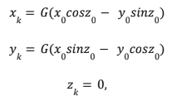

Design:
The workflow for this lab consists of the following steps:
- Setup: Download the provided CORDIC source code package and extract its contents.
- Project Creation: Launch Vitis HLS, start a new project, and add the files (basic_cordic.cpp, basic_cordic.h, basic_cordic_tb.cpp).
- Board Selection: Configure the target device as xc7z020clg400-1.
- Code Validation: Resolve any syntax errors before proceeding.
- C Simulation: Run a C simulation (Project → Run C Simulation). The included testbench validates the correctness of sine and cosine results against reference values, flagging discrepancies beyond 1%.
- C Synthesis: Perform synthesis (Solution → Run C Synthesis → Active Solution), which translates the C implementation into RTL.
- C/RTL Co-Simulation: Use the testbench to validate the RTL implementation. If successful, waveform verification confirms correctness
Results:
Figure 1: C Simulation output for sine and cosine calculations.

Figure 2: RTL/C co-simulation results.
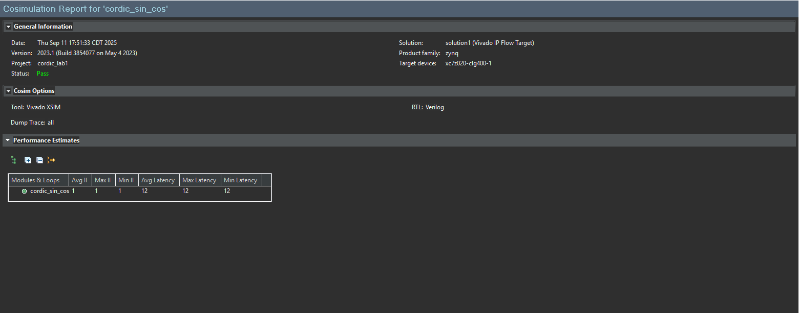

Figures 3.1, 3.2, and 3.3: Behavioral simulation outputs verifying CORDIC functionality.

Figure 3.1
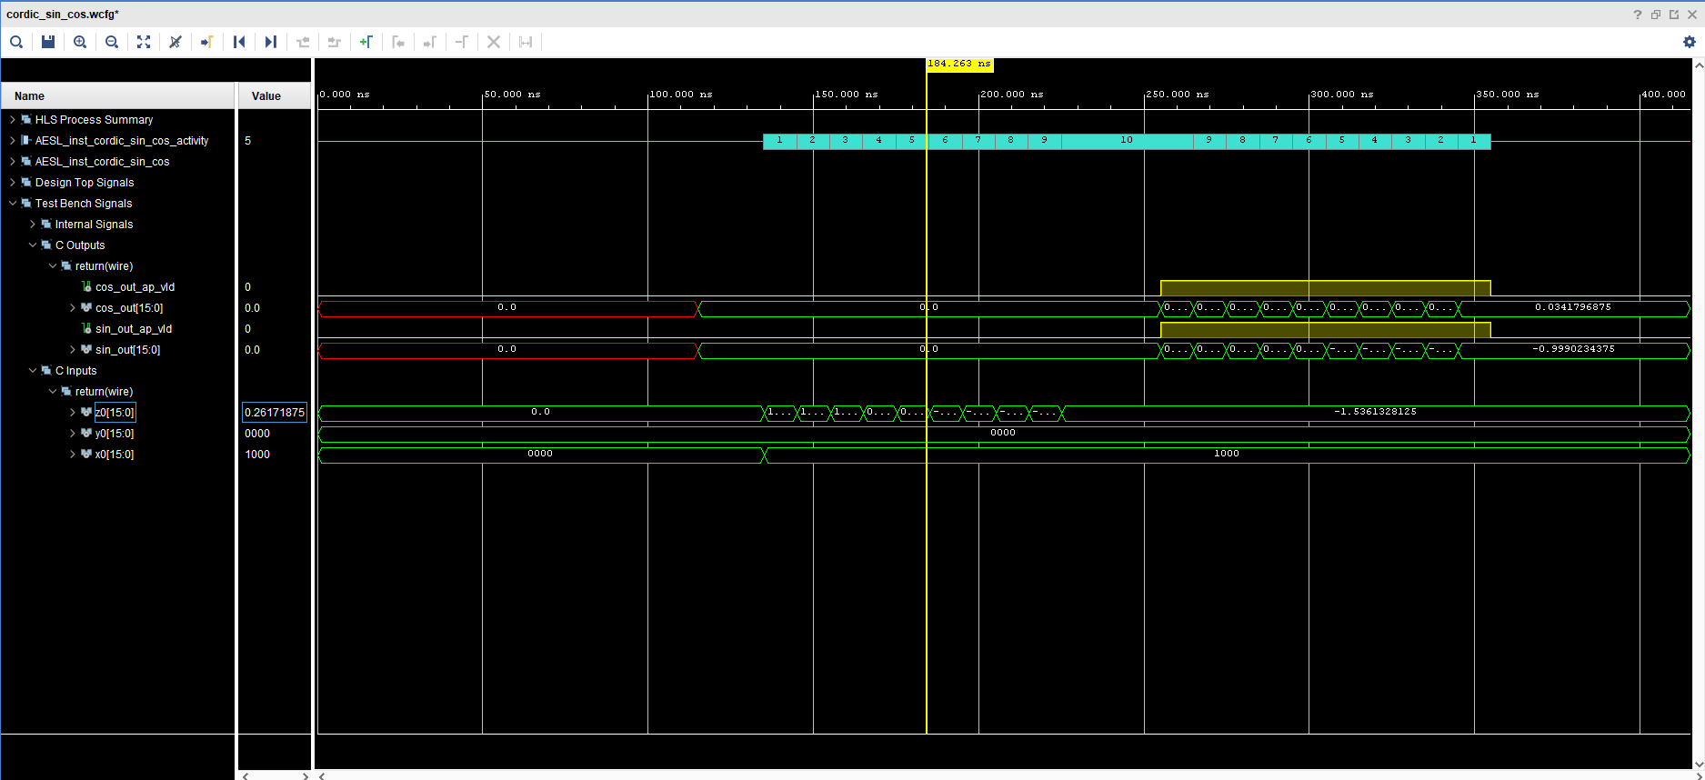

Figure 3.2
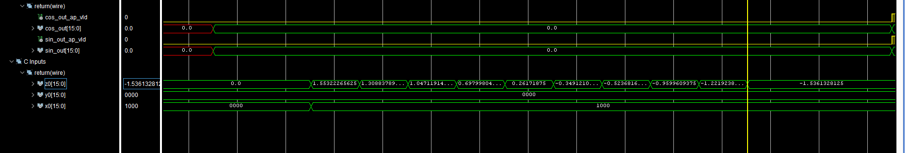

Figure 3.3
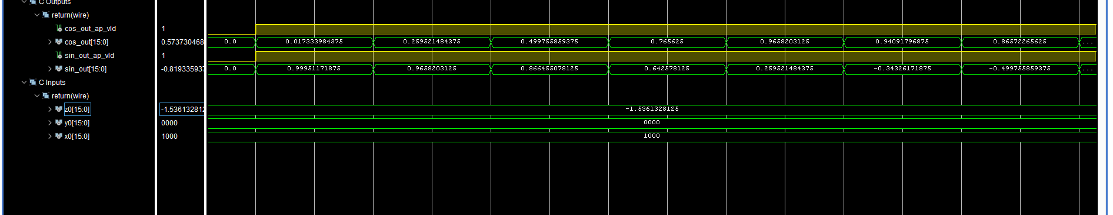

Conclusion:
In this lab, we explored how the CORDIC algorithm simplifies complex mathematical operations—such as trigonometric and hyperbolic functions—into iterative addition and shift operations. By tuning the number of iterations, a balance between accuracy and execution speed can be achieved, offering flexibility for different applications.
We demonstrated how initial conditions can be adjusted to compute sine, cosine, and inverse tangent values. Furthermore, slight modifications extend the algorithm to support hyperbolic functions. These features establish CORDIC as a highly effective and adaptable choice for digital hardware implementations in fields like DSP and embedded systems.

