Predicting Market Volatility Risk Using Liquidity Indicators and Machine Learning
CED6150 | Module 7 Applied Case Study | Yang Liu

1. Problem brief: objective, user and cost
This study asks whether daily ETF liquidity proxies and the VIX can help predict large next-day price movements in the US equity market. The end user is a portfolio risk analyst who needs a simple early-warning signal after the market close. The possible action is extra monitoring or a review of exposure, not automatic trading.
A high-risk day means the absolute SPY return on the following trading day is above 1.5%. This cutoff was fixed before looking at test results. For an illustrative decision exercise, one missed high-risk day costs five units and one false alarm costs one unit. These units express a preference for avoiding misses, not actual investment losses.

2. Data and preparation
The data cover January 2018 through December 2025, using daily SPY and QQQ open, high, low, close and volume, plus VIX observations obtained from Yahoo Finance via yfinance. SPY and QQQ provide liquidity and realized-volatility signals; VIX adds a broader market-risk stream. Data are organized by ETF and date. The modeling table contains 2,000 observations before the train/test split.
Two liquidity measures are constructed: Amihud illiquidity (absolute daily return divided by dollar volume, rescaled by 10⁹) and the Corwin–Schultz high-low spread estimator. Five-day rolling averages enter the models. These are proxies, not observed quoted or effective spreads; negative estimated spreads were set to zero. Additional predictors include ten-day return volatility, current returns, VIX change and lagged VIX. The codebook and tidy panel are supplied separately.

3. Market regimes
K-means was fitted on training-period features only and then assigned labels to 2025 observations. The clusters correspond to lower, moderate and higher stress, with training-period high-risk frequencies of about 6.8%, 27.3% and 72.0%, respectively. They describe historical differences in stress; they are not calibrated probabilities for future days.
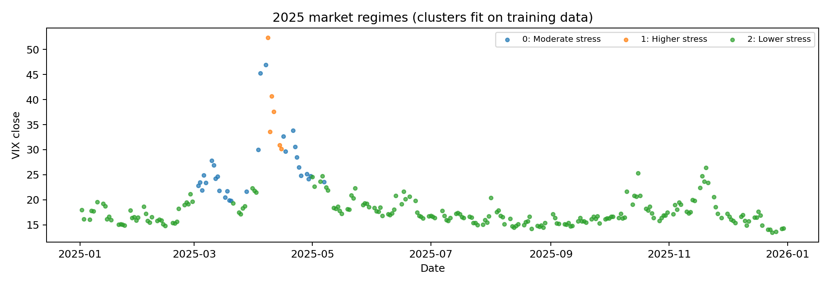
Figure 1. Market-stress clusters assigned to 2025; clusters fit on training years.

4. Liquidity patterns
QQQ typically has a higher Amihud proxy than SPY. Both instruments show sharp temporary increases in estimated spreads around early 2020, while later spikes also occur. These movements are consistent with changing trading conditions, but a visual association does not by itself demonstrate an ability to predict tomorrow’s volatility.
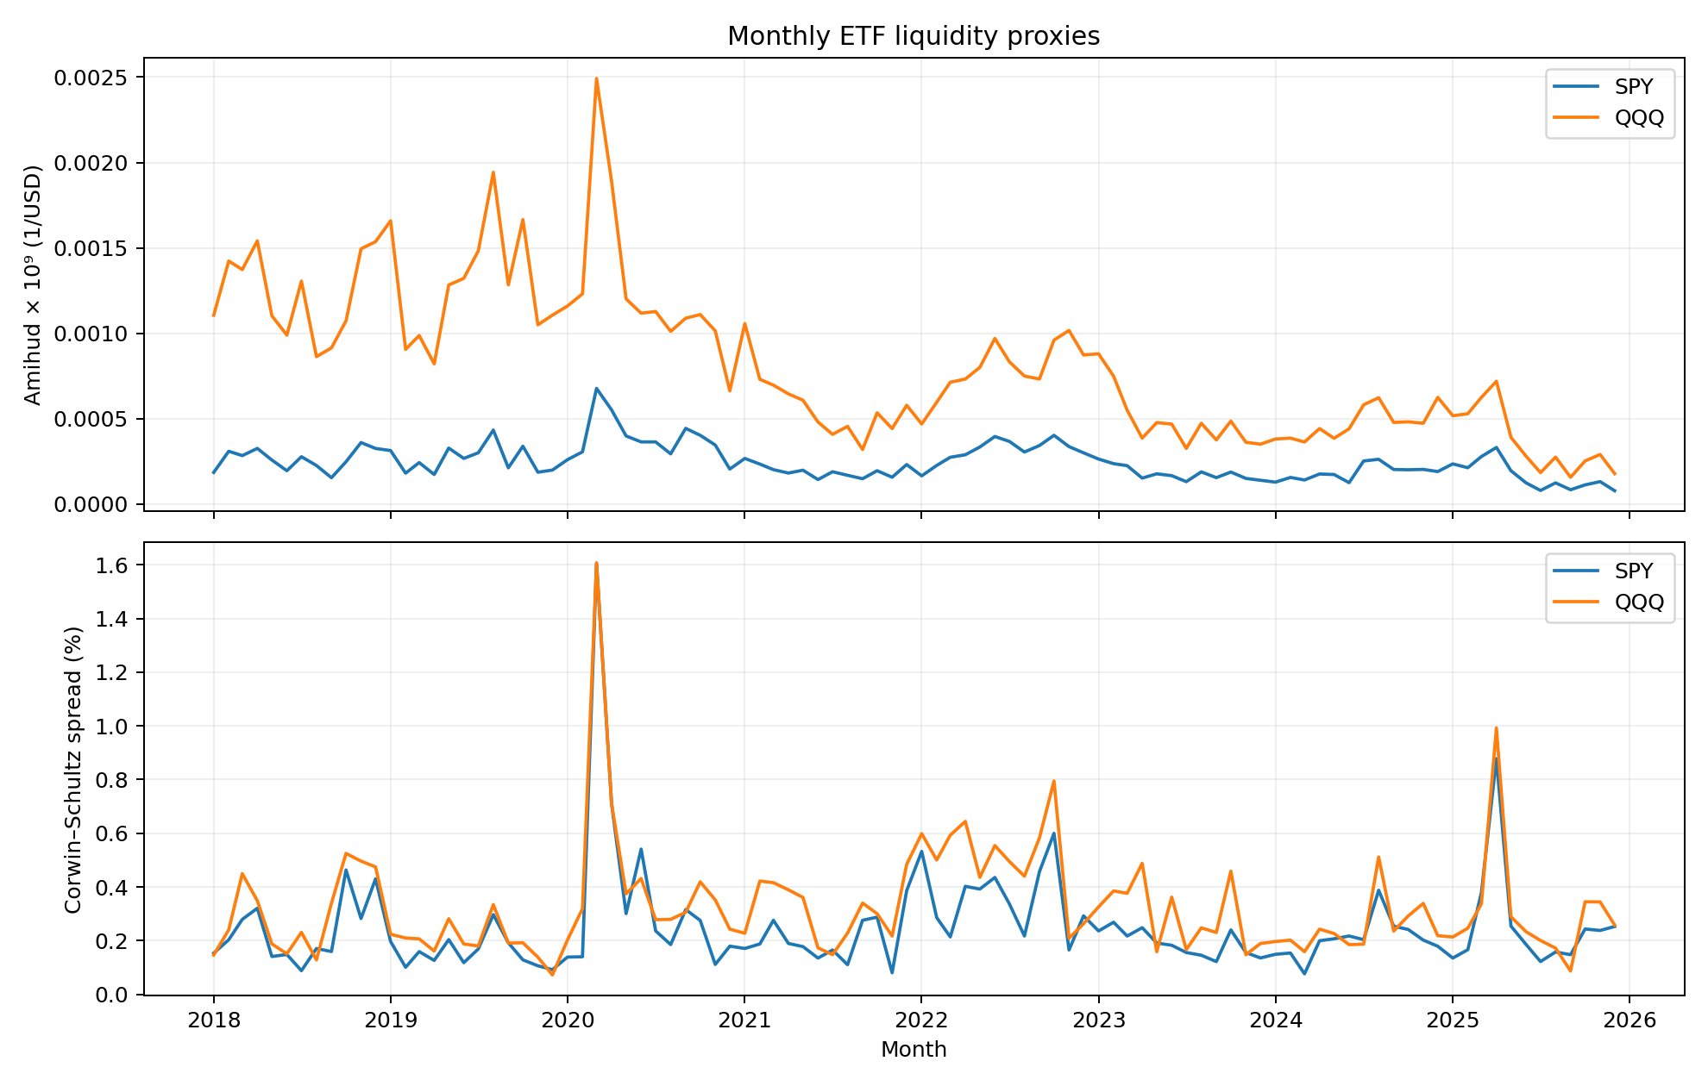
Figure 2. Monthly liquidity proxies for SPY and QQQ from 2018 to 2025.

5. Validation and leakage controls
The classification models are a regularized logistic GLM and a random forest. Five expanding chronological validation windows run through 2024, with a one-row gap because the outcome concerns the next trading day. Imputation and scaling are fit within each training fold. The final training-to-test boundary also excludes the last eligible training row, and all of 2025 remains the independent evaluation period.
ROC-AUC is used to compare ranking quality, while PR-AUC gives additional context for the relatively rare high-risk class. The original models were specified with fixed parameters; a supplemental grid search also tunes logistic C and random-forest tree depth using training-only chronological folds.

6. Model comparison
Model | CV ROC-AUC (mean ± SD) | CV PR-AUC (mean)
Regularized logistic GLM | 0.7720 ± 0.0711 | 0.3845
Random forest | 0.7580 ± 0.0697 | 0.3687

The fixed-parameter logistic GLM performed slightly better across the five validation windows and is easier to interpret. The difference is small, so it is not evidence that linear models always outperform ensembles. The supplemental chronological search selected C = 0.03 for logistic regression (CV ROC-AUC 0.7782), versus depth 4 and minimum leaf size 12 for random forest (CV ROC-AUC 0.7584). These tuning results are an additional check, not replacements for the original threshold analysis.
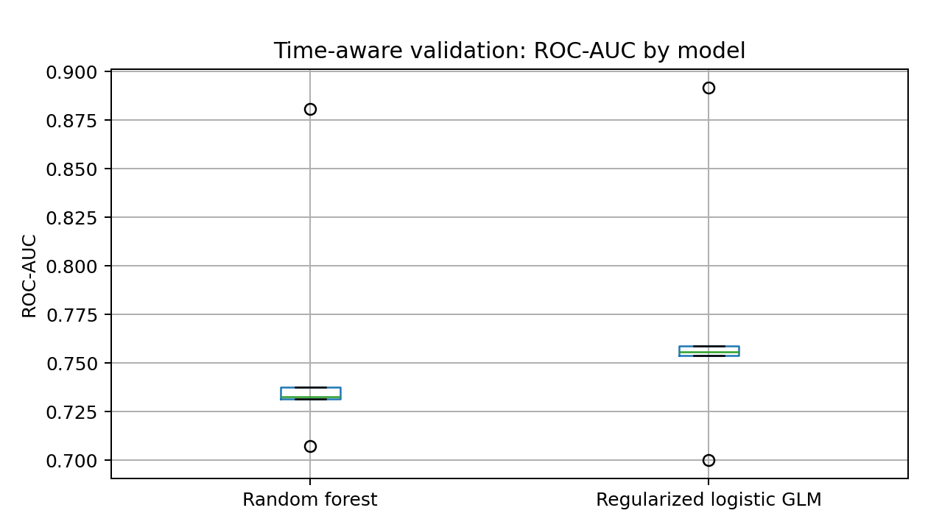
Figure 3. Fixed-parameter model ROC-AUC results over chronological validation folds.

7. Independent 2025 test and operating threshold
The baseline logistic GLM achieved ROC-AUC 0.8037 and PR-AUC 0.4319 on 249 test observations. A probability threshold of 0.26 was chosen from out-of-fold training predictions with false negatives weighted five times as heavily as false positives. The test contained 33 high-risk days and 216 normal days.
 | Predicted normal | Predicted high risk
Actually normal | 207 | 9
Actually high risk | 24 | 9

Precision is 50.0%, and high-risk recall is only 27.3%. Despite overall accuracy near 86.7%, the rule misses 24 of 33 high-risk days. Under the illustrative costs, loss is 9 false alarms × 1 + 24 misses × 5 = 129 units. Test probabilities should not be used to reselect the threshold. The additionally tuned logistic model scored 0.8004 test ROC-AUC; this is an exploratory stability comparison, with no new threshold or confusion matrix claimed.

8. Robustness and sensitivity
The independent 2025 test is an out-of-time check. A feature-ablation test, using the same chronological folds, removes the Amihud and spread inputs. Average ROC-AUC changes from 0.7720 with all features to 0.7772 without liquidity variables. In this dataset, the selected daily liquidity proxies do not improve classification once the other inputs are included. This does not mean liquidity is unimportant in general.
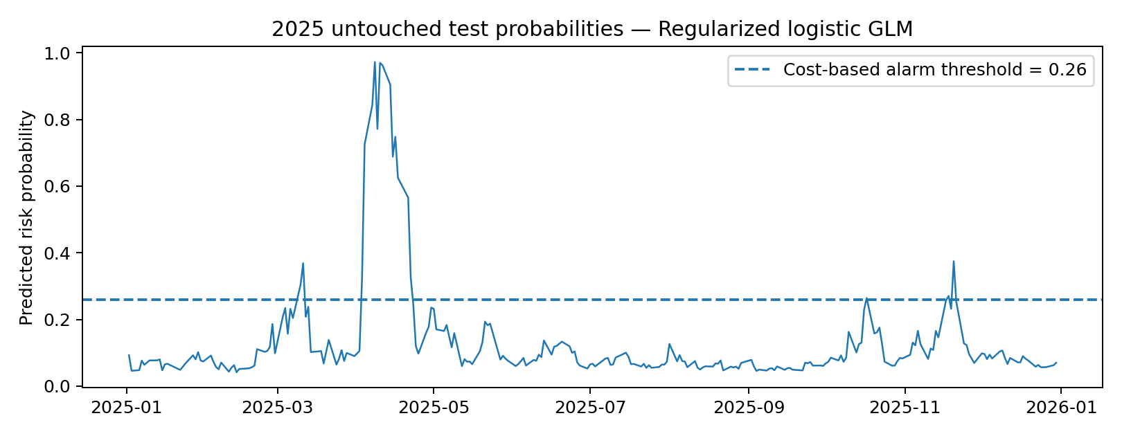
Figure 4. Baseline model predicted risk in 2025 with the training-selected 0.26 alert cutoff.

9. Recommendation and limits
I would use the signal only as supporting information for risk monitoring. Ranking performance is useful, but low recall means it is not a reliable stand-alone alarm. The next step would be to test alternative cost assumptions and thresholds within historical validation, then evaluate performance on newer untouched data before deployment.
This case has limitations: daily proxies are not transaction-level spreads; ETF unadjusted-close returns omit distributions; stress is defined using a 1.5% SPY move rather than an externally validated loss measure; VIX represents market risk, not liquidity; and assumed loss units are illustrative. Market conditions can also change between years.

References
Amihud, Y. (2002). Illiquidity and stock returns: Cross-section and time-series effects. Journal of Financial Markets, 5(1), 31–56. https://doi.org/10.1016/S1386-4181(01)00024-6
Chicago Board Options Exchange. (n.d.). VIX volatility products. Cboe Global Markets. https://www.cboe.com/tradable_products/vix/
Corwin, S. A., & Schultz, P. (2012). A simple way to estimate bid-ask spreads from daily high and low prices. The Journal of Finance, 67(2), 719–760. https://doi.org/10.1111/j.1540-6261.2012.01729.x
Yahoo Finance. (n.d.). Historical market data for SPY, QQQ, and VIX. https://finance.yahoo.com/

Reproducibility and Contribution
The project was completed independently. The accompanying notebook, dataset, codebook, model configuration, and figures provide the materials needed to reproduce the analysis. All results were reviewed using the model outputs.
ChatGPT was used to assist with code debugging, and code development. The analysis is based on the downloaded market data and the results generated in Python.

