-- Your name and cohort here

Yurii Maisuradze, C402

/*

Join Queries

REQUIREMENT - Use a multi-line comment to paste the first 5 or fewer results under your query

             Also include the total records returned.

*/

USE orderbook_activity_db;

-- #1: Display the dateJoined and username for admin users.

**SELECT User.dateJoined, User.uname FROM User JOIN UserRoles ON User.userid = UserRoles.userid JOIN Role ON UserRoles.roleid = Role.roleid WHERE Role.name = 'admin';**

-- #2: Display each absolute order net (share*price), status, symbol, trade date, and username.

-- Sort the results with largest the absolute order net (share*price) at the top.

-- Include only orders that were not canceled or partially canceled.

**SELECT ABS(Order.shares * Order.price), Order.status, Order.symbol, Order.orderTime, User.uname FROM `Order` JOIN User ON Order.userid = User.userid WHERE Order.status NOT IN ('canceled', 'canceled_partial_fill') ORDER BY ABS(Order.shares * Order.price) DESC;**  
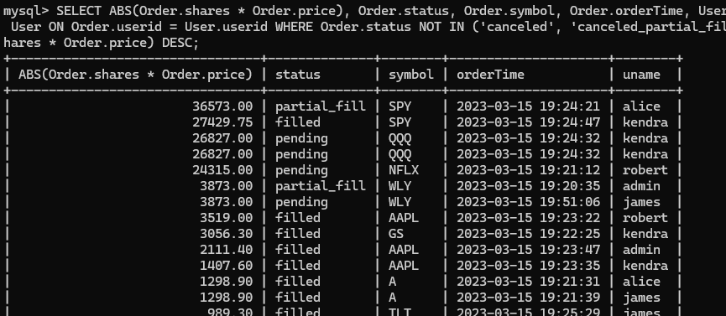

-- #3: Display the orderid, symbol, status, order shares, filled shares, and price for orders with fills.

-- Note that filledShares are the opposite sign (+-) because they subtract from ordershares!

**SELECT Order.orderid, Order.symbol, Order.status, Order.shares, Fill.share, Fill.price FROM `Order` JOIN Fill ON Order.orderid = Fill.orderid;**

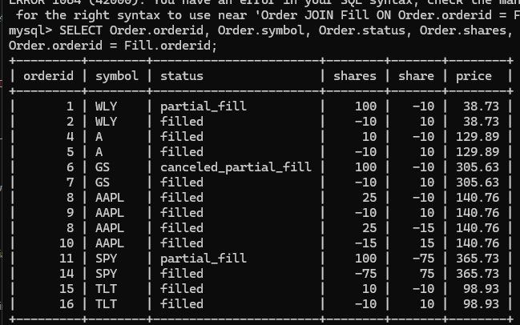

-- #4: Display all partial_fill orders and how many outstanding shares are left.

-- Also include the username, symbol, and orderid.

**SELECT Order.orderid, User.uname, Order.symbol, (Order.shares - SUM(Fill.share)) FROM `Order` JOIN User ON Order.userid = User.userid LEFT JOIN Fill ON Order.orderid = Fill.orderid WHERE Order.status = 'partial_fill' GROUP BY Order.orderid;**

-- #5: Display the orderid, symbol, status, order shares, filled shares, and price for orders with fills.

-- Also include the username, role, absolute net amount of shares filled, and absolute net order.

-- Sort by the absolute net order with the largest value at the top.

**SELECT Order.orderid, Order.symbol, Order.status, Order.shares, Fill.share, Fill.price, User.uname, Role.name, ABS(Fill.share), ABS(Order.shares * Order.price) FROM `Order` JOIN Fill ON Order.orderid = Fill.orderid JOIN User ON Order.userid = User.userid JOIN UserRoles ON User.userid = UserRoles.userid JOIN Role ON UserRoles.roleid = Role.roleid ORDER BY ABS(Order.shares * Order.price) DESC;**

-- #6: Display the username and user role for users who have not placed an order.

**SELECT User.uname, Role.name FROM User LEFT JOIN `Order` ON User.userid = Order.userid JOIN UserRoles ON User.userid = UserRoles.userid JOIN Role ON UserRoles.roleid = Role.roleid WHERE Order.userid IS NULL;**

-- #7: Display orderid, username, role, symbol, price, and number of shares for orders with no fills.

**SELECT Order.orderid, User.uname, Role.name, Order.symbol, Order.price, Order.shares FROM `Order` JOIN User ON Order.userid = User.userid JOIN UserRoles ON User.userid = UserRoles.userid JOIN Role ON UserRoles.roleid = Role.roleid WHERE Order.orderid NOT IN (SELECT orderid FROM Fill);**

-- #8: Display the symbol, username, role, and number of filled shares where the order symbol is WLY.

-- Include all orders, even if the order has no fills.

**SELECT Order.symbol, User.uname, Role.name, SUM(Fill.share) FROM `Order` JOIN User ON Order.userid = User.userid JOIN UserRoles ON User.userid = UserRoles.userid JOIN Role ON UserRoles.roleid = Role.roleid LEFT JOIN Fill ON Order.orderid = Fill.orderid WHERE Order.symbol = 'WLY' GROUP BY Order.symbol, User.uname, Role.name;**

