**Hospital**

**Management Project**

Spring Semester 2017

CSC 4350, 5:30-7:15

24 April 2017

**Big Hero 5**

Gautam Ravichandran

Victoria Green

Ashwin Nair

Karankumar Parikh

Young Jun Son

Table of Contents:

Introduction………………………………………………………………………………..………3

Required Tractability Matrix…………………………………………………………………..4 - 7

System Analysis & Design…………………………………………………………………...8 - 13

Use Case…………………………………………………………………………………………. 8

Sequence Diagram…………………………………………………………………………….9 -13

Object Design & Rationale………………………………………………………………… 14 -15

Test Cases………………………………………………………………………………...…16 - 19

Rational………………………………………………………………………………………… 20

Constructive Cost Model………………………………………………………………………...21

Project Legacy………………………………………………………………………………….. 22

Work Structure Document……………………………………………………………..…….......22

Gantt Chart.…………………………………………………………………………………….. 23

Dictionary………………………………………………………………………………….…… 24

Resumes…………………………………………………………………………………………………………..……..……………………..25 -33

User Guide…………………………………………………………………………………………………………………………………………….34

Introduction:

The Hospital Management System, created by Big Hero 5, is a Java program which allows the user to assist with essential tasks which occur at a hospital. Functions include the login screen, entering patient information, controlling inventory, scheduling appointments, and invoicing. The team utilized SQLite to manage its database and integrated it into the Java program. Using Github, Big Hero 5 was able to upload deliverables, code, and general project materials for easy access. The primary source of communication was through Google Hangouts. Video calls, text messages, and image-sharing led to clearly-illustrated ideas as to which direction the project was headed. After approximately four months of the development process, Big Hero 5 is able to present a working model of the Hospital Management System.

**Hospital Management System (HMS)**

**HMS- 1.0 INTRODUCTION**

A Hospital Management System (HMS) is designed to automate and organize various day-to-day activities taking place in a hospital. It also stores patient and staff database for quick future access.

**HMS- 2.0 APPOINTMENTS**

**2.0.1** The System shall help in setting up patient appointments by considering each individual case and the schedule of assigned doctor.

**2.0.2** The System shall also give doctors an option to set up or cancel an appointment.

**HMS- 2.1 APPOINTMENT DATA REQUIRED**

**2.1.1** For each patient making an appointment, the system shall request the following information:

* Patient First and Last name
* Patient ID
* Patient Age
* Doctor
* Date
* Time
* Contact Number
* Reason for Visit

**HMS- 3.0 PATIENT RECORDS**

**3.0.1** The System shall maintain patient records efficiently. This information will be manually recorded and inputted into the system after the patient’s visit to the doctor.

**3.0.2** Such records shall be accessed by assigned doctors in the future.

**HMS- 4.0 STAFF RECORDS**

**4.0.1** The System shall maintain a record of doctor appointments, prescriptions given by the doctor and details of the doctor.

**4.0.2** The System shall also maintain relevant information about the nurses and other hospital staff.

**HMS- 4.1 STAFF STATIC DATA REQUIRED**

**4.1.1** For each hospital employee, the system shall request the following information:

* First and Last Name
* Staff Type
* Date of Birth
* Age
* Contact Number
* Gender

**4.1.2** This static data shall be obtained and documented when the staff member is hired.

**HMS- 4.2 STAFF ACTIVE DATA REQUIRED**

**4.2.1** For each hospital employee, the system shall request the following information:

* List of appointments

**4.2.2** This active data shall be consistently updated when changes are made.

**HMS- 5.0 PHARMACY**

**5.0.1** The System shall efficiently maintain medicine inventory and notify when a new order needs to be placed. It keeps track of Medicine ID, medicine name, quantity, and supplier.

**HMS- 5.1 REORDER SUPPLY**

For each item in 6.0, the system immediately reacts to the following situation:

* **5.1.1** When the count of an item reaches <=300, the system shall send a notification to the user with the name of the item and the number on hand.

**HMS- 6.0 INVOICE MANAGEMENT**

**6.0.1** The System shall manage patient invoices and transaction details. It keeps track of patient ID, patient name, contact number, doctor assigned, and total cost.

**HMS- 6.1 INVOICE CREATION**

For each invoice created, the system immediately reacts to the following situation:

* **6.1.1** When the doctor finishes recording procedures and medicine administered to the patient into the system, an invoice shall be generated.
* **6.1.2** The generated invoice shall add up the cost of everything administered at the appointment.

|  |  |  |  |  |
| --- | --- | --- | --- | --- |
| **Entry #** | **Paragraph #** | **System Specification Text** | **Type** | **Build** |
| 2.0.1 | 2.0 | The System shall help in setting up patient appointments by considering each individual case and the schedule of assigned doctor. | SW | B1 |
| 2.0.2 | 2.0 | The System shall give doctors an option to set up or cancel an appointment. | SW | B1 |
| 2.1.1 | 2.1 | For each patient making an appointment, the system shall request the following information: Patient First and Last name, age, patient ID, doctor, date, time, contact number, reason for visit. | SW | B1 |
| 3.0.1 | 3.0 | The System shall maintain patient records efficiently. | SW | B2 |
| 3.0.2 | 3.0 | Such records shall be accessed by assigned doctors in the future. | SW | B2 |
| 4.0.1 | 4.0 | The System shall maintain a record of doctor appointments, prescriptions given by the doctor and details of the doctor. | SW | B2 |
| 4.0.2 | 4.0 | The System shall maintain relevant information about the nurses and other hospital staff. | SW | B2 |
| 4.1.1 | 4.1 | For each hospital employee, the system shall request the following information: first and last name, gender, date of birth, age, contact number, staff type. | SW | B2 |
| 4.1.2 | 4.1 | This static data shall be obtained and documented when the staff member is hired. | SW | B2 |
| 4.2.1 | 4.2 | For each hospital employee, the system shall request the following information: list of appointments. | SW | B2 |
| 4.2.2 | 4.2 | This active data shall be consistently updated when changes are made. | SW | B2 |
| 5.0.1 | 5.0 | The System shall efficiently maintain medicine inventory and notify when a new order needs to be placed. It keeps track of Medicine ID, medicine name, quantity, and supplier. | SW | B3 |
| 5.1.1 | 5.1 | When the count of an item reaches <=300, the system shall send a notification to the user with the name of the item and the number on hand. | SW | B3 |
| 6.0.1 | 6.0 | The System shall manage patient invoices and transaction details. It keeps track of patient ID, patient name, contact number, doctor assigned, and total cost. | SW | B4 |
| 6.1.1 | 6.1 | When the doctor finishes recording procedures and medicine administered to the patient into the system, an invoice shall be generated. | SW | B4 |
| 6.1.2 | 6.1 | The generated invoice shall add up the cost of everything administered at the appointment. | SW | B4 |

System Analysis & Design:

Hospital Management System Use Case Diagram:



Login Sequence Diagram:

C:\Users\Gautam\Documents\GitHub\HospitalManagement\Presentation\PresImage\LoginSeqDia.png

New User Registration Sequence Diagram:

C:\Users\Gautam\Documents\GitHub\HospitalManagement\Presentation\PresImage\NewUseRegSeqDia.png

Schedule Appointment Sequence Diagram:

C:\Users\Gautam\Documents\GitHub\HospitalManagement\Presentation\PresImage\SchedAptSeqDia.png

Doctor Appointment Sequence Diagram:

C:\Users\Gautam\Documents\GitHub\HospitalManagement\Presentation\PresImage\DocAptSeqDia.png

Pharmacy Sequence Diagram:

C:\Users\Gautam\Documents\GitHub\HospitalManagement\Presentation\PresImage\Pharmacy1.png

C:\Users\Gautam\Documents\GitHub\HospitalManagement\Presentation\PresImage\Pharmacy2.png

C:\Users\Gautam\Documents\GitHub\HospitalManagement\Presentation\PresImage\Pharmacy3.png

Invoice Sequence Diagram:

C:\Users\Gautam\Documents\GitHub\HospitalManagement\Presentation\PresImage\InvSeqDia.png

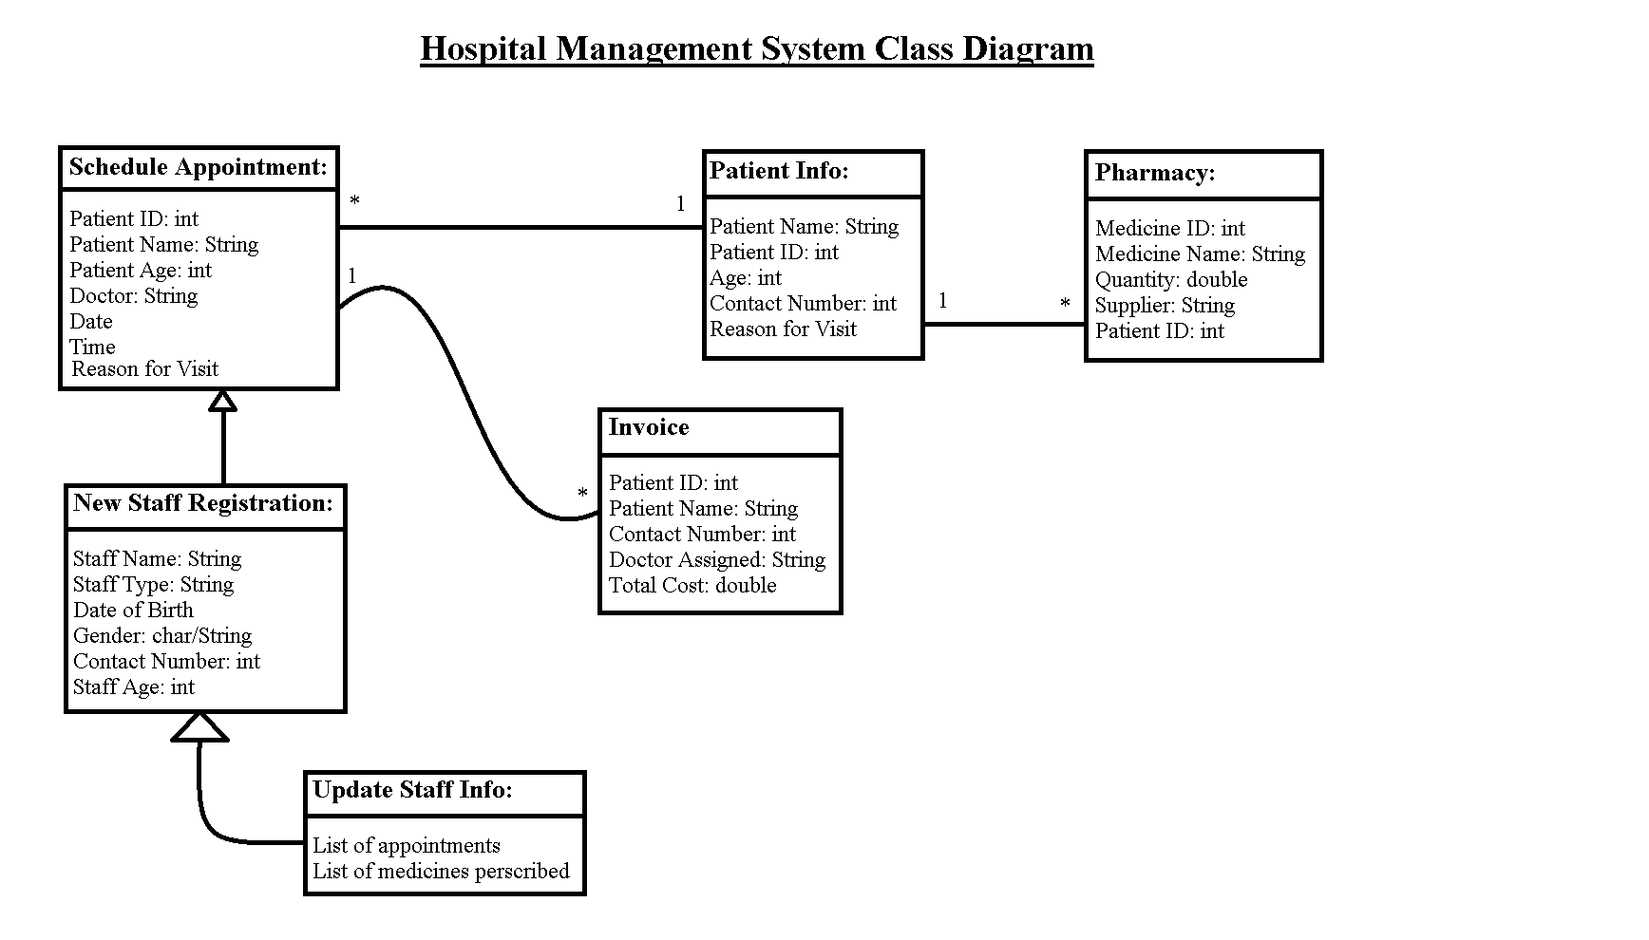

**Application Objects Rationale:**

**Schedule Appointment**

* *Patient ID:* Required for identification of each patient in the database
* *Patient Name:* Required information for scheduling and documentation purposes
* *Doctor:* Required information so patient gets the doctor they want
* *Date:* Required information for patient and doctor for scheduling purposes
* *Time:* Required information for patient and doctor for scheduling purposes
* *Reason for Visit:* Useful information for the doctor to know before appointment

**New Staff Info**

* *Staff ID:* Required for identification of staff member in the database
* *Staff Name:* Required information for documentation purposes
* *Staff Type:* Whether the staff is a doctor or other member, useful for update staff info
* *Date of Birth:* Useful information for patients to have when choosing a doctor
* *Age:* Useful information for patients to have when choosing a doctor
* *Gender:* Useful information for patients to have when choosing a doctor
* *Contact Number:* For other staff members to reach this staff member

**Update Staff Info**

* *List of Appointments:* Required so there is no overlap in scheduling appointments
* *List of Medicines Prescribed:* Useful information to have, some patients like to know

**Patient Info**

* *Patient Name:* Required information for scheduling and documentation purposes
* *Patient ID:* Required for identification of each patient in the database
* *Age:* Useful information for doctors to know when treating patients
* *Contact Number:* Required in case staff members need to reach the patient
* *Reason for Visit:* Useful information for the doctor to know before appointment

**Pharmacy**

* *Medicine ID:* Required information for identification of medicine in the database
* *Medicine Name:* Required information for documentation purposes
* *Quantity:* Required information in order to maintain supply
* *Supplier:* Required information for documentation purposes
* *Patient ID:* Required for identification of each patient taking medicine

**Invoice**

* *Patient ID:* Required for identification of each patient with an invoice
* *Patient Name:* Required information for invoice documentation purposes
* *Contact Number:* Required in case staff members need to reach the patient
* *Doctor:* Required for invoice documentation purposes
* *Total Cost:* Required value on the invoice for the patient

**Software Architecture Rationale**

The intent of the hospital management system is to obtain and update information for staff, as well as maintain several services for multiple patients at any given time. As a result, it has been determined that a client-server model is the best software architecture for this project.

**Test Cases**

**TEST 1**

|  |  |
| --- | --- |
| **Attribute** | **Description** |
| Attribute Name | User Login |
| Tester | Ashwin Nair |
| Input | User enters the login credentials – username and login. |
| Action | If the login credentials are accurate, and if the username and password match, then the user will be deemed logged in and will have access to the user interface of the Hospital Management System. |
| Test Type | Acceptance Test, System Test |

**TEST 2**

|  |  |
| --- | --- |
| **Attribute** | **Description** |
| Attribute Name | Scheduling an Appointment |
| Tester | Ashwin Nair |
| Input | The user must provide:   * Patient Name (First and Last) * Patient ID * Doctor * Date * Time * Contact (Phone) * Visit Reason |
| Action | The system will process the information and schedule the appointment time according to staff availability. |
| Test Type | Acceptance Test, System Test |

**TEST 3**

|  |  |
| --- | --- |
| **Attribute** | **Description** |
| Attribute Name | Medicine Information |
| Tester | Ashwin Nair |
| Input | User selects medicine ID from the dropdown selection. |
| Action | The system returns the medicine’s Name, Supplier, and Quantity |
| Test Type | Acceptance Test, System Test |

**TEST 4**

|  |  |
| --- | --- |
| **Attribute** | **Description** |
| Attribute Name | Medicine Low Quantity Alert |
| Tester | Ashwin Nair |
| Input | User selects medicine, |
| Action | Medicine ID selection is rendered, and if the medicine quantity drops below the minimum of 300, the alert box notifies the user that the item is low in quantity |
| Test Type | Acceptance Test, System Test |

**TEST 5**

|  |  |
| --- | --- |
| **Attribute** | **Description** |
| Attribute Name | Medicine Reorder |
| Tester | Ashwin Nair |
| Input | User enters the quantity of the medicine needed to be reordered. |
| Action | Medicine Totals are updated in the database upon entering the quantity. |
| Test Type | Acceptance Test, System Test |

**TEST 6**

|  |  |
| --- | --- |
| **Attribute** | **Description** |
| Attribute Name | Creating New Staff Information |
| Tester | Ashwin Nair |
| Input | User fills out information for the following criteria:   * First and Last Name * Staff Type * Age * Contact (Phone) * Gender |
| Action | This staff member’s information is added in the database and rendered on log as a new staff member. |
| Test Type | Acceptance Test, System Test |

**TEST 7**

|  |  |
| --- | --- |
| **Attribute** | **Description** |
| Attribute Name | Updating Staff Information |
| Tester | Ashwin Nair |
| Input | User updates necessary information from the following criteria:   * First and Last Name * Staff Type * Age * Contact (Phone) * Gender |
| Action | This staff member’s information is updated in the database and rendered on log. |
| Test Type | Acceptance Test, System Test |

**TEST 8**

|  |  |
| --- | --- |
| **Attribute** | **Description** |
| Attribute Name | Creating New Patient Information |
| Tester | Ashwin Nair |
| Input | User fills out information for the following criteria regarding the patient:   * First and Last Name * Age * Contact (Phone) * Address * Gender |
| Action | This patient’s information is added in the database and rendered on log as a new patient in the server. |
| Test Type | Acceptance Test, System Test |

**TEST 9**

|  |  |
| --- | --- |
| **Attribute** | **Description** |
| Attribute Name | Updating Patient Information |
| Tester | Ashwin Nair |
| Input | User fills out information for the following criteria regarding the patient:   * First and Last Name * Age * Contact (Phone) * Address * Gender |
| Action | This patient’s information is updated in the database and rendered on log. |
| Test Type | Acceptance Test, System Test |

Rationale:

Baymax Hospital is a rising medical center located in the center of Atlanta, Georgia. In order to help deliver the most advanced and compassionate care, our management system must be able to efficiently obtain, update, and maintain large amounts of information for the hospital’s staff and patients. It will allow quick scheduling of appointments, maintain a healthy supply of pharmaceuticals, and create pharmacy invoices for our patients.

The Hospital Management System will be linked to a database and must comply with all of Baymax Hospital’s requirements. The system will be loaded onto the desktop of both the hospital front desk for check-in purposes, as well as the front desk of the pharmacy. This software is strictly for use by hospital staff in order to better serve our patients.

When the software is loaded and the receptionist logs in, they will first be greeted with the option to schedule an appointment for patients that are already in the database. The patient and the doctor that is being requested are selected, as well as a date, time, and reason for visit. When the appointment is scheduled, it is entered into the database to be accessed later. Patient history shows each patient’s name, age, contact number, and the information for the upcoming appointment is shown. There is also functionality to view all scheduled appointments for each doctor in the hospital.

The system also maintains the hospital’s pharmacy. If a specific medication’s quantity drops below 300, the front desk of the pharmacy is prompted to resupply the medicine. The quantity is immediately checked upon entering the pharmacy module, as well as every time a medication is purchased. When the receptionist sells medication to a patient, an invoice is generated that obtains all purchased medications and calculates the total price. All information is stored and updated in real-time.

The information provided above is in line with all of Baymax Hospital’s requirements specified by Big Hero 5, before the system was produced.

1. The login page allows the receptionist to log into the system using a correct username and password.
2. The Schedule Appointment module allows the receptionist to book an appointment during an available time slot.
3. The Doctor Appointments module displays all appointments made for a specified doctor.
4. Patient Information maintains each patient’s name, age, contact number, and upcoming appointments.
5. The pharmacy maintains the medicine inventory, notifies the receptionist when a quantity drops under 300, and distributes prescribed medications to patients.
6. An invoice is generated when a medication is sold to the patient.

Constructive Cost Model:

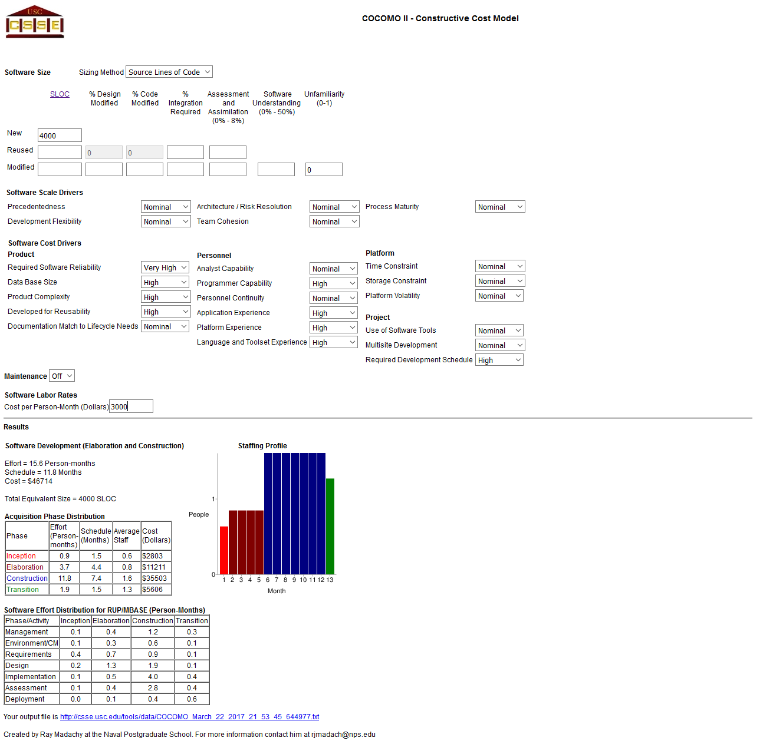

Project Legacy:

This Hospital management system can be used to help make receptionist jobs easier to handle. With just one single input, they are able to get all the information they would need with just a simple ID input along with security measures. This will help the efficiency of hospitals as well as help patients get better service from the hospital. The hospital database system will also allow for better management of doctors so that each patient gets the best service possible in the optimal amount of time. The Pharmacy application will also help patients keep track of their prescriptions as well as help the hospital keep proper stock of their medicine so that every patient will always get what they need immediately.

The challenging part of building the management project was making the database since all of the members within our group had never set up a database before. Once we had that set up, programming the UI was pretty straightforward.

Final Work Structure Document:

|  |  |
| --- | --- |
| Gautam Ravichandran | **Team Coordinator**  Final Document Handler  Java Coder  Front-end Developer |
| Victoria Green | GUI Coder/tester  Front end tester  RTM Update Manager |
| Ashwin Nair | Java Coder  Front-end Developer  GUI Coder  Final Product Double Checker |
| Karankumar Parikh | Front-end Developer  Database Manager  Setting up Database Backend |
| Young Jun Son | Java Coder  User Guide  Application Tester |

Gantt chart:

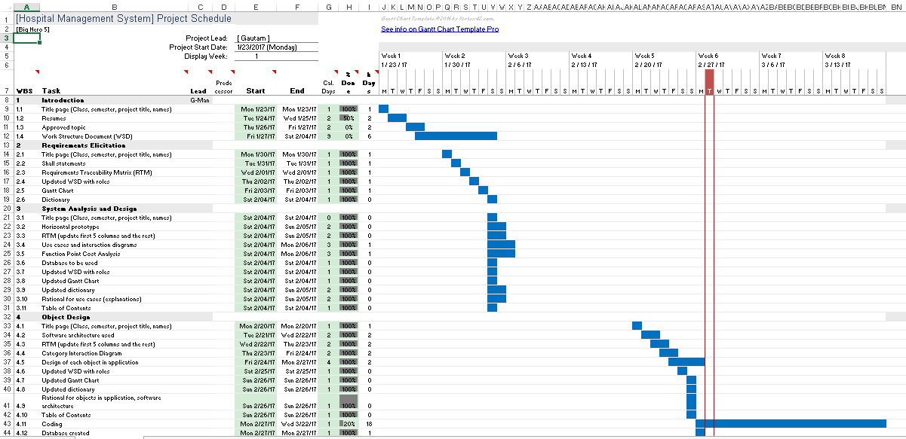

Dictionary:

Static:​ This term defines fixed values. These are values that are set to equal a certain value throughout its iteration. This includes the relevant hospital employee information, such as: name, gender, etc. are static as they are fixed values depending on the individual employee information. This also pertains to the same relevant descriptive details of the patients.

Database: ​This is a data storing system which will allow the software to access content of the system later by those including: doctors, nurses, and front desk employees.

GUI:​ (Graphic User Interface) This is the interface in which users will be able to access the content of the Hospital Management System. The GUI contains the UX/UI aspects of the program such as the window, buttons, search bars, tabs, etc.

Java:​ The programming language which is used for the software’s implementation and design. This programming language will address the contents of the Hospital

Management System and the layout of the system methodologies.

Active Data:​ The data that is dynamic or interchangeable within the system. This is the system information pertaining to the employees and the general hospital supply/accommodation and the changes in their data (scheduling/inventory/room availability)

SQLite:​ Database structuring/management tool which stores content related to the user. This user information includes but is not limited to: employee information, patient information, inventory/supply count, general hospital facilities.

UX/UI:​ (User Experience/User Interface) This relates to the content on the front-end side of the software and its accessibility/use or general functionality of the content when used by people for testing purposes or public use.

Use Case Diagram:​ Shows an overview of the system and functions.

Methods:​ These are functions which can be called throughout the program. Sometimes the code for how methods work is hidden from view in order to make code easier to read. These functions complete specific tasks, such as sorting, calculating, and adding/deleting.

Class:​ A class is a blueprint for objects created in a program. These classes will be made to contain organized code to control things like patient data, inventory, and patient accounts.

Object:​ An object is what a class controls. There can be a patient object, which will have states and behaviors such as name, date of birth, and wellness levels.

Horizontal Prototype:​ Shows the broad relationships between a system and maps out its range of abilities.

**Gautam Ravichandran**

5404 Spring Creek Ln. Atlanta, GA 30350

[gautam_ravichandran@yahoo.com](mailto:gautam_ravichandran@yahoo.com)

770-265-0551

**OBJECTIVE:** To obtain an internship within the field of information technology and computer science.

**EDUCATION:**

Georgia State University - Atlanta, GA Expected Graduation: May 2018

Bachelor of Science, Computer Science, GPA: 3.96

Enrolled in the Honors College

**TECHNICAL SKILLS:**

* Knowledge on all Microsoft and Apple programs
* Knowledge of Java programming, C++, SQL
* Knowledge of UNITY, and Blender
* Knowledge of Windows 8, Windows Vista, IOS, and Android OS
* Able to work with VR programs through Oculus Rift and VIVE
* Leadership experience with groups and teams
* Library work knowledge
* Strong visual organizational skill

**STUDENT ORGANIZATIONS:**

Robotics Club, President

* Participated in the National Robotic Competition 2014
* Participated in Zero Robotics Competition 2014
* Participated in First Tech Challenge 2015

Computer Science Club, Active member

* Program and Implement different challenges based on guidelines
* Gather, sort, and analyze data through the use of computer programs, Java, Microsoft word, Microsoft Excel, and HTML
* Work with a team of 4 to 8 people to simulate real life work environments

Second Place Winner at GSU Hackathon Fall 2016

* Created Virtual Reality Pacman game
* Used Blender to design models and textures
* Used Unity as the platform to run game through the Oculus Rift headset

**WORK EXPERIENCE:**

*Computer Science Undergraduate TA – Georgia State University*  August 2016 – Present

* Work at the tutoring center helping students with any computer science questions.
* Grade homework and post results to the website
* Grade quizzes and post results to the website

*Norfolk Southern - Atlanta GA*  May 2016 – August 2016

IT App Dev - ENAA

* Use SQL on the SSRS platform to help make/update templates for the Norfolk Southern Police Department.
* Helped Norfolk Southern Police Department update their website format and their report locations.
* Assist and take notes at meeting with the team.
* Use Java and JavaScript to go through programs, identify the logic problems within the code and fix the code while adding comments while necessary.
* Promote/deploy developed applications to Test
* Filled out forms to apply for QA deployment as well as Production deployment.

*Physics Tutor – Georgia State University*  January 2016 – May 2016

* Taught 1 hour physics lab three times a week.
* Graded homework assignments and posted grades
* Recorded/posted attendance for three classes

*Math Tutor – Sandy Springs, GA*  August 2013 – December 2015

* Teach students Statistics, Calculus 1 Variable, Algebra I, Algebra II, Geometry and Integrated Geometry II.
* Provided individual and group instructions to students to improve academic performance, improve occupational skills, or prepare for academic and occupational tests.
* Assess and reflect upon students’ progress throughout tutoring sessions.
* Provide feedback to students using motivational reinforcement techniques to create a positive learning experience.

*Roswell Regional Library - Roswell, GA* June 2011 – May 2015

Library Volunteer

* Maintain records of books received, stored, issued, and returned.
* Instruct patrons on how to use reference sources, catalogs, and automated information systems.
* Answer routine enquiries, and help patrons in need of assistance.
* Locate library materials, including books, periodicals, cassettes, and online sources.

*Woodland Elementary School – Sandy Sprints, GA* June 2011 – May 2015

Mentor

* Instruct groups of students, using various teaching methods such as lectures discussions, and demonstrations.
* Taught students from 3rd to 5th grade about robotics, computer science, and the practical uses of technology.

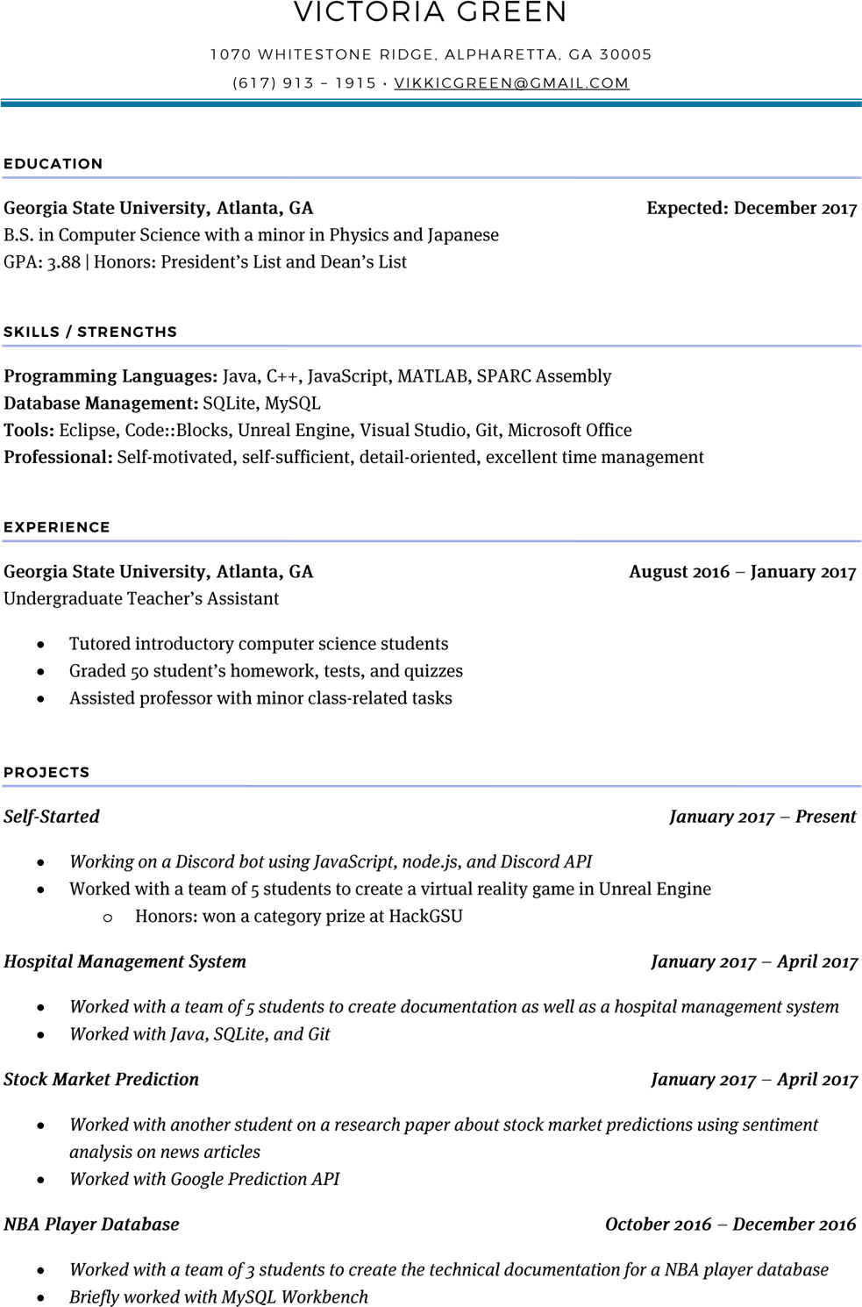

**Young Jun Son (Tony)**

5925 Barrington Ln, Alpharetta, GA 30005

Email: ogonga1201@hotmail.com

Phone: 678-315-3758

|  |
| --- |
| Background |

I've been a floor staff at Regal Northpoint for two years, then moved onto the part time management position at Medlock. Since then, I've been given the opportunity to progress my work at Regal and gain general theatre management experience. I would like a fresh start in a new environment and work to positively influence my peers along the way.

Volunteer work:

Employment History

Concessions stand at Chattahoochee High School football game 2012

Theater experience:

* Regal North Point 8 (1283) (Floor Staff) 2012 – 2014
* Experience: Usher, Box Office, and Concessions.
* Regal Medlock Crossing 18 (0354) (PT Associate Manager) 2014-current
* Experience: High-volume cash handling (~$7500); projector troubleshoot (Manual start, bulb changes, formatting conflicts, etc.; daily employee schedules; ELI reports; light maintenance (repairing cabinet locks, adjusting equipment, computer/register maintenance); recliner & reserved seating; beer & wine; customer service

Graduated from Chattahoochee High School

Education

GPA: 3.79

Achievements:

* Honor Roll for all four years.
* Chamber choir for two years.

Currently enrolled in Georgia State University as a junior.

* Studying Computer Science.
* Boxing club (2015)
* Brazilian Jiu Jitsu club (2017)

|  |
| --- |
| Miscellaneous |

Interests:

* Automotives, martial arts, rock climbing, coding, technology, arts, and of course, film.

Currently:

* Learning Java, C, and assembly language programming

**Ashwin M. Nair**

697 Trillium Lane [anair7@student.gsu.edu](mailto:anair7@student.gsu.edu)

Lilburn, GA 30047 [www.linkedin.com/in/ashwin-nair](http://www.linkedin.com/in/ashwin-nair)

(678) 510-9884 <http://codepen.io/AshNair/>

**OBJECTIVE**

Seeking an entry level full time position in the technical and analytical field wherein I would be able contribute my knowledge and gain expertise through collaborating with individuals to develop the company’s next groundbreaking technical services for developing company growth.

**EDUCATION**

**Georgia State University**, Atlanta, GA **Projected Graduation: May 2017**

Bachelor of Science in Computer Sciences

Computer Software Systems Concentration

Dean’s List, HOPE Scholarship Recipient

**RELEVANT COURSEWORK**

* Computer Architecture - Computer Networks - Design & Analysis: Algorithms - System-Level Programming
* Data Mining - Web Programming - Data Structures - Software Engineering

**CERTIFICATIONS**

* Front-End Web Development Certification Program, **Free Code Camp March 2016-Present**

**SKILLS**

* **Programming Languages:** Java, Python, HTML/HTML5, JavaScript, JQuery, JSON, CSS, Bootstrap Programming, Familiar with: C, PHP, MySQL
* **Developmental Software Platforms:** Familiar with: Visual Studio, Eclipse IDE, NetBeans IDE, Notepad++, Python IDLE, GitHub
* **Supplementary Software Skills:** Microsoft Office 2010/2013/2016 Suites, LibreOffice
* **Operating Systems:** Windows, iOS, Linux, Android
* **Languages:** Hindi, Malayalam, Spanish, Tamil

**PROJECTWORK**

* Work Management System, **Python October-December 2014**
  + Created a program entitled “SpeedSpot Employee Management System” using the Tkinter GUI to create an employee database for a fictional company. Self-taught in usage of the Tkinter GUI from various coding platforms.
* Book Rental System, **HTML/JavaScript/CSS December 2016**
  + Developed a fictional company entitled CORE, in which users would be able to request books to read.
* Sentimental Analysis and Customer Segmentation in Housing Markets, **HTML/JavaScript/CSS September -December 2016**
  + Developed a prototype company platform which implements customer segmentation tactics based on user zip code and family/relationship status.
  + Implemented software that incorporates sentimental analysis of the customer base and their queries posted and immediately return best fit options for customer success and retention.
* Hospital Management System, **Java January 2017-Present**
  + Collaborating with a team to create a Hospital Management System.
  + **Responsibilities:** **QA Analyst/Documentation/Java Coding**- Testing and Developing Software.

**EMPLOYMENT**

**UserIQ – Atlanta, GA**

*Regionally recognized innovative B2B SaaS company focusing on developing software for Web-Application Assistance for B2B SaaS establishments.*

**Quality Assurance Analyst**  **February 2017-Present**

* Unit Testing/Debugging of Application JavaScript functionality.
* Acceptance Testing of the User Interface and web application functions.

**Software Engineer Development Team Member (Intern) January 2017-Present**

* Collaborating with the Software Engineering team in development of the UserIQ Application.
  + Partaking in JavaScript/Front-End Development of the Application Controllers
  + Developing the functionality of the UserIQ interface.
  + Collaborating in conversion of JavaScript Controllers from ECMAScript5 to ECMAScript6.

**Sales Prospector (Business Development) Intern August 2016-Present**

* Discovering prime candidates and optimal prospective connections who would be interested in partnering with UserIQ software.
* Accumulating contacts of prospective buyers through various professional/networking platforms.
* Communicating with prospective buyers and operating the prospective buyers UserIQ databases.
  + **Recognition: *Best Performer***- Received acknowledgement for attracting most prospective clients in initial stages of the internship and was recognized for the best quality and quantity of work. Commended for the high volume of leads provided for optimal company growth.
  + **Participation: *“The A-Team”***- Collaborating with a group of employees in a competition to come up with a cost-effective option to optimize clients and demo counts through incentivized methods of client acquisition. As an intern, I assisted in brainstorming possible software implementation strategies and cost-effective campaigns to achieve the target.

**Kumon Learning Center – Norcross, GA / Lilburn, GA**

*Internationally acclaimed and leading tutoring service for student excellence and guidance through after-school learning enrichment initiatives.*

**Grader/Tutor/Data Entrant/Supervisor** **June 2013-June 2016**

* Tutored children of grades Kindergarden-12th Grade and assisted students in comprehension of core Mathematics and Reading concepts.
* Executed the grading of students’ papers and perform data entry by allotting students’ scores onto Kumon servers.
* Supervised of the overall center operation in absence of superiors and trained new incoming employees on Kumon center protocols.
  + **Recognition:** Longest-tenured employee at the Norcross Location and held multiple positions with promotions throughout time at the center.

**INVOLVEMENTS**

* Member, **GSU Student Alumni Association August** **2013-May 2014**
* Volunteer, **Atlanta Habitat for Humanity June-August 2011**
* Member, **GSU Indian Student Association** **May 2016-Present**
* Member, **GSU Computer Science Club** **May 2016-Present**
* Member, **GSU** **Collegiate Entrepreneurs Organization September 2016-Present**

|  |  |
| --- | --- |
| **Karan M. Parikh** | 408 Waterford Landing,  Mcdonough, GA 30253  **(678)834-3304** |

**kparikh30@gmail.com**

**linkedin.com/in/parikhkp**

To find a full-time opportunity that will use my technical knowledge, strong communication skills, organizational abilities and business experience

**EXPERIENCE**

**Apple Inc.,** Atlanta, GA—

***AppleCare At Home Advisor***

AUGUST 2016 - Present

* Technical Tier 1 Advisor assisting customers with iOS device issue troubleshooting over the phone
* Educating customers about various iOS functionalities thereby enriching their support experience.

**PROJECTS**

**One Stop Cricket Shop**

Summer 2016

-**URL**[:http://codd.cs.gsu.edu/~kparikh2/Final%20Project/Final%20Project/test.html](http://codd.cs.gsu.edu/~kparikh2/Final%20Project/Final%20Project/test.html)

- Worked as a team leader in a group of 4 students developing a sporting goods website for cricket with extensive use of HTML, CSS, JavaScript, PHP, MySQL and Ajax

**Supermarket Application**

Spring 2015

- Worked as a Team Member developing a Supermarket Application using Java as Front-End and Oracle 10g Database as the backend (JDBC)

**Text Editor** (Notepad++)

Fall 2016

-Designed a WPF(C#) Text Editor Application using Microsoft Visual Studio as a platform having features similar to Notepad++

**EDUCATION**

**Georgia State University,** Atlanta, GA — ***Computer Science***

Bachelors in Computer Science

Expected Graduation Date: May 2017

GPA: 4.1/ 4.3 Honors:

* President’s List- Spring 2016
* Dean’s List- Fall 2016

**SKILLS**

* **Programming Languages:** C,

C++, C#, Java, HTML, CSS,

JavaScript, PHP, MySQL, Oracle

10g

* **Operating Systems**: Windows,

Mac, Linux - Knowledge of Software Development Methodologies:

Agile(Scrum & XP), Waterfall

-Android App Development Experience

* Time Management and

Schedule Management, Solid Interpersonal Skills, Independent and Solid Team Player, Advance Computer Skills

* **Communication**: Public

Speaking (Speech, Presentation,

Letters, Proposal, Teamwork,

Interpersonal), Article Writer

Technical Document Writing

(Project Proposal, Technical Reports)

RELATED EXPERIENCE

**HackGT 2016, HackGSU 2016,**

**HackGSU 2015**

Active Participant

**TCS(Tata Consultancy Services)**

**CODEVITA 2015**

Selected in Top 750 teams (Round 3) **LANGUAGES**

English, Gujarati, Hindi

User Guide:

1.1: Login Screen: Enter username (admin) and password (admin).

1.2: Alternatively, create a user and fill in information (name, date of birth, address, gender, phone number, and type of staff.

2.0: Schedule appointment: Allows user to schedule an appointment by selecting patient and doctor.

2.1: Patient id will allow user to choose patient.

2.2: Patient name and age is displayed.

2.3: Doctor can be chosen.

2.4: Date can be selected, along with time.

2.5: Select reason for visit.

2.6: Click “Schedule” button to confirm.

3.0: Patient info tab.

3.1: Select patient id to bring up information from the database.

3.2: Displays patient name, age, contact number, and upcoming appointments from the database.

4.0: Doctor’s appointments tab shows appointments scheduled for a specified doctor

4.1: Select doctor’s name.

4.2: Appointment schedule is displayed in blue box.

4.3: Contact number for doctor and today’s date is shown.

5.0: Pharmacy tab.

5.1: Low quantity window shows up, warning user. User can now type in a number and order medication. The window will disappear when threshold supply is reached or when the window is manually closed.

5.2: Medicine ID brings up information of medicines.

5.3: Patient ID must be chosen in order to deliver the medicines.

5.4: Quantity to be charged to patient. It will also subtract the quantity from supply.

6.0: Invoice tab shows how much the patient is to be billed.

6.1: Select patient id to show a total amount in dollars, as well as how many medicines were billed.