📄 Cybersecurity Threat Intelligence Dashboard – Executive Insights Report
Prepared By: Vikku Kumar
Role: Data Analyst | Power BI Developer
Tool Used: Power BI, Power Query, DAX, Excel
Analysis Period: 2015–2024

EXECUTIVE SUMMARY
Project Overview
The Cybersecurity Threat Intelligence Dashboard was developed to analyze global cyber incidents between 2015 and 2024. The dashboard transforms raw cybersecurity data into actionable business insights through interactive visualizations and KPI monitoring.
The primary objective is to identify attack patterns, assess financial impact, understand industry vulnerabilities, and evaluate defense mechanisms used to combat cyber threats.

Business Objective
Organizations face increasing cybersecurity challenges that result in financial losses, operational disruptions, and reputational risks.
This dashboard enables decision-makers to:
- Monitor cyber attack trends over time.
- Identify high-risk industries.
- Evaluate cybersecurity vulnerabilities.
- Understand financial impact.
- Support data-driven security strategies.

Executive KPIs
KPI | Value
Total Cyber Attacks | 3,000
Total Affected Users | 1.53 Billion
Total Financial Loss | $412.51K Million
Average Resolution Time | 36.68 Hours

Dashboard Snapshot
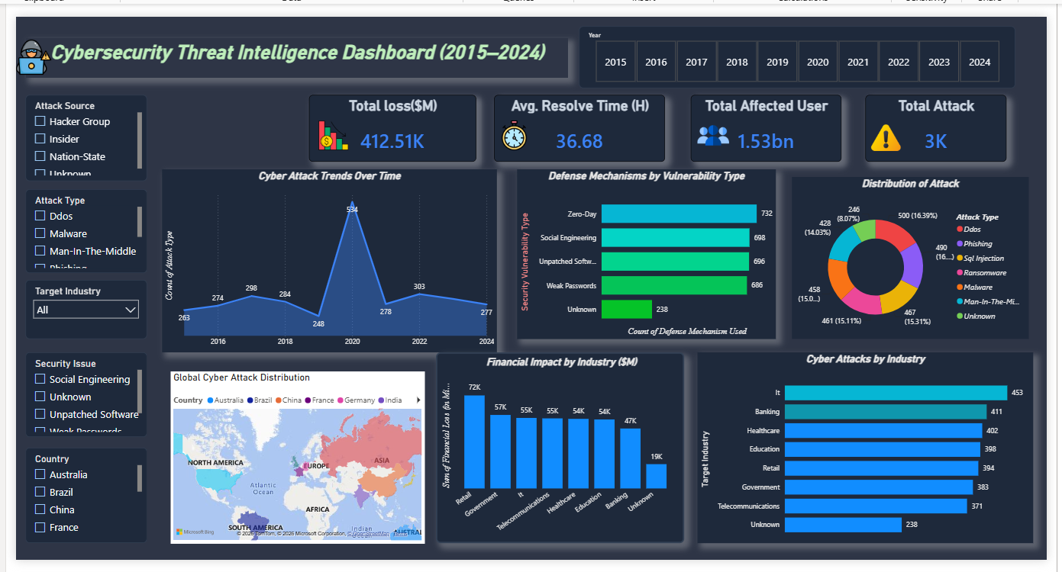
KEY BUSINESS INSIGHTS
Insight 1: Cyber Attacks Reached Their Peak in 2020
The analysis shows that cyber attacks increased significantly over the years, reaching a peak of 534 incidents in 2020.
Business Interpretation
The rapid increase in attacks highlights the growing sophistication of cyber threats and the need for stronger cybersecurity frameworks.
Recommendation
Organizations should continuously monitor emerging threats and invest in advanced detection systems.

Insight 2: IT Industry Is the Most Targeted Sector
The IT industry experienced the highest number of cyber attacks.
Top Targeted Industries
Industry | Attacks
IT | 453
Banking | 411
Healthcare | 402
Education | 398
Retail | 394
Business Interpretation
Industries handling sensitive data remain attractive targets for cybercriminals.
Recommendation
High-risk industries should prioritize cybersecurity investments and continuous security monitoring.

Insight 3: Retail Industry Suffered the Highest Financial Loss
Financial impact analysis reveals that the Retail sector experienced the highest monetary loss.
Top Industries by Financial Loss
Industry | Loss ($M)
Retail | 72
Government | 57
IT | 55
Telecommunications | 55
Healthcare | 54
Business Interpretation
Cybersecurity incidents can directly affect organizational profitability and business continuity.
Recommendation
Organizations should implement stronger risk management and incident response plans.

CYBERSECURITY RISK ANALYSIS
Insight 4: Zero-Day Vulnerabilities Are the Biggest Threat
The dashboard indicates that Zero-Day vulnerabilities were the most exploited security weakness.
Top Vulnerabilities
Vulnerability | Incidents
Zero-Day | 732
Social Engineering | 698
Unpatched Software | 696
Weak Passwords | 686
Business Interpretation
Attackers continue to exploit unknown or unpatched system vulnerabilities.
Recommendation
Organizations should:
- Conduct regular vulnerability assessments.
- Maintain proactive patch management.
- Deploy endpoint protection solutions.

Insight 5: Human Factors Continue to Drive Cyber Risk
Social Engineering attacks remain among the most exploited attack vectors.
Business Interpretation
Technology alone cannot eliminate cyber risks. Employee awareness remains critical.
Recommendation
- Conduct cybersecurity awareness training.
- Run phishing simulation campaigns.
- Establish security best practices.

Insight 6: Multi-Layer Security Controls Are Essential
Organizations most frequently deployed:
- Firewalls
- VPNs
- Antivirus
- Encryption
- AI-Based Detection
Business Interpretation
No single security control can fully protect against modern cyber threats.
Recommendation
Implement a layered cybersecurity strategy combining preventive, detective, and corrective controls.

GEOGRAPHIC & ATTACK ANALYSIS
Global Threat Distribution
Cyber attacks were reported across multiple countries and regions.
Key Findings
- North America experienced a significant concentration of incidents.
- Europe and Asia also showed elevated attack activity.
- Cyber threats remain a global challenge affecting organizations of all sizes.
Recommendation
Organizations operating internationally should maintain consistent cybersecurity policies across all regions.

Most Common Attack Types
The dashboard identified several recurring attack categories:
- DDoS
- Malware
- Phishing
- SQL Injection
- Ransomware
- Man-in-the-Middle
Business Interpretation
Cybercriminals use both technical exploits and human manipulation techniques to compromise systems.
Recommendation
Organizations should implement:
- Network monitoring
- Email security controls
- Endpoint protection
- Threat intelligence solutions

TECHNICAL IMPLEMENTATION
Data Preparation
The dataset was processed using Power Query to:
- Remove inconsistencies
- Handle missing values
- Standardize data formats
- Improve data quality

Data Modeling
The Power BI data model was designed to support:
- Fast reporting performance
- Efficient filtering
- Cross-visual analysis

DAX Measures Created
KPI Calculations
- Total Financial Loss
- Total Cyber Attacks
- Total Affected Users
- Average Resolution Time
Analytical Measures
- Industry Attack Count
- Vulnerability Metrics
- Financial Impact Analysis
- Trend Analysis

Power BI Features Used
- KPI Cards
- Bar Charts
- Column Charts
- Donut Charts
- Geographic Maps
- Interactive Slicers
- Custom Themes
- Drill-Down Analysis

BUSINESS RECOMMENDATIONS & CONCLUSION
Strategic Recommendations
Strengthen Vulnerability Management
Prioritize Zero-Day vulnerability detection and remediation.
Improve Employee Security Awareness
Reduce phishing and social engineering risks through continuous training.
Adopt AI-Powered Threat Detection
Leverage advanced analytics for proactive threat identification.
Enhance Incident Response
Reduce resolution times through automation and predefined response plans.
Implement Multi-Factor Authentication
Strengthen identity and access management controls.

Conclusion
The Cybersecurity Threat Intelligence Dashboard successfully provides a comprehensive view of global cybersecurity incidents between 2015 and 2024.
The analysis reveals that:
✅ Cyber attacks continue to increase in sophistication and frequency.
✅ IT, Banking, Healthcare, and Retail sectors remain primary targets.
✅ Zero-Day vulnerabilities and social engineering attacks represent major security risks.
✅ Financial losses from cyber incidents can significantly impact organizational performance.
✅ A proactive, multi-layered cybersecurity strategy is essential for reducing cyber risk.
This dashboard demonstrates the practical application of Power BI, Data Modeling, DAX, Power Query, Data Visualization, and Business Intelligence Reporting to solve real-world cybersecurity analytics challenges.

👨‍💻 Author
Vikku Kumar
BCA Graduate (2025)
Data Analyst | Power BI | SQL | Python | Excel
GitHub: https://github.com/Vikku018
LinkedIn: https://www.linkedin.com/in/vikku-kumar/
⭐ Thank you for reviewing this project.

