**Project 1 - Basic E-Commerce Website**

* ABSTRACT

Project is to develop a Single Page E-commerce Website. The theme used in this project is of a food selling site which sells variety of food through e-commerce site. This is a single page site so page can be divided into 3- section namely,

1. The navigation bar
2. The middle section
3. Address section

The navigation bar includes options for user to navigate through the site and use the services available.

The middle section tells to the users about seller.

The address section provides address/contacts details of the outlets of the seller, social links, etc.

* OBJECTIVE

To develop an E-commerce site which is suitable for making food business for seller with the users.

With the help of web development languages like HTML, CSS and Javascript, a single E-commerce page is to be developed.

It serves as a online food ordering site which can take orders from the users and delivers the food within given period of time.

Primary objectives includes user friendly experience must be served to the user and the site must delivers attractive view to the user as well.

* INTRODUCTION

This project is about development of an E-commerce website through which users can sell the food online through site. The development languages used in the projects are as follows:

**Web development** refers to the creating, building, and maintaining of websites. It includes aspects such as web design, web publishing, web programming, and database management. It is the creation of an application that works over the internet i.e. websites.

The word Web Development is made up of two words, that is:

Web: It refers to websites, web pages or anything that works over the internet.

Development: It refers to building the application from scratch.

HTML: HTML stands for Hyper Text Markup Language. It is used to design the front end portion of web pages using markup language. It acts as a skeleton for a website since it is used to make the structure of a website.

[CSS](https://www.geeksforgeeks.org/css-tutorials/): Cascading Style Sheets fondly referred to as CSS is a simply designed language intended to simplify the process of making web pages presentable. It is used to style our website.

[JavaScript](https://www.geeksforgeeks.org/javascript-tutorial/): JavaScript is a scripting language used to provide a dynamic behavior to our website.

* METHODOLOGY

The Project is developed by using general model which is normally used in development projects.

The sequential phases in model are −

**Requirement Gathering and analysis** − All possible requirements of the system to be developed are captured in this phase and documented in a requirement specification document.

**System Design** − The requirement specifications from first phase are studied in this phase and the system design is prepared. This system design helps in specifying hardware and system requirements and helps in defining the overall system architecture.

**Implementation** − With inputs from the system design, the system is first developed in small programs called units, which are integrated in the next phase. Each unit is developed and tested for its functionality, which is referred to as Unit Testing.

**Integration and Testing** − All the units developed in the implementation phase are integrated into a system after testing of each unit. Post integration the entire system is tested for any faults and failures

**Deployment of system** − Once the functional and non-functional testing is done; the product is deployed in the customer environment or released into the market.

**Maintenance** − There are some issues which come up in the client environment. To fix those issues, patches are released. Also to enhance the product some better versions are released. Maintenance is done to deliver these changes in the customer environment

* CODE

<!DOCTYPE html>

<html lang="en">

<head>

  <meta charset="UTF-8">

  <meta http-equiv="X-UA-Compatible" content="IE=edge">

  <meta name="viewport" content="width=device-width, initial-scale=1.0">

  <link rel="stylesheet" href="https://cdnjs.cloudflare.com/ajax/libs/OwlCarousel2/2.2.1/assets/owl.carousel.min.css.">

  <!-- Bootstrap CSS -->

  <link href="https://cdn.jsdelivr.net/npm/bootstrap@5.1.3/dist/css/bootstrap.min.css" rel="stylesheet"

    integrity="sha384-1BmE4kWBq78iYhFldvKuhfTAU6auU8tT94WrHftjDbrCEXSU1oBoqyl2QvZ6jIW3" crossorigin="anonymous">

  <!-- Font Awesome -->

  <link rel="stylesheet" href="https://cdnjs.cloudflare.com/ajax/libs/font-awesome/4.7.0/css/font-awesome.min.css">

  <!-- Custom CSS -->

  <link rel="stylesheet" href="./Sass/styles.css">

  <!-- Owl Carousel -->

  <link rel="stylesheet" href="https://cdnjs.cloudflare.com/ajax/libs/owl-carousel/1.3.3/owl.carousel.min.css"

    integrity="sha512-X/RSQYxFb/tvuz6aNRTfKXDnQzmnzoawgEQ4X8nZNftzs8KFFH23p/BA6D2k0QCM4R0sY1DEy9MIY9b3fwi+bg=="

    crossorigin="anonymous" referrerpolicy="no-referrer" />

  <!-- AOS CSS -->

  <link href="https://unpkg.com/aos@2.3.1/dist/aos.css" rel="stylesheet">

  <title>Food-Crow</title>

</head>

<body>

  <!-- Navigation Bar -->

  <section class="Navigation">

    <nav class="navbar navbar-expand-lg  ">

      <div class="container">

        <a class="navbar-brand" href="#">Food-Crow</a>

        <div class="emptydiv"></div>

        <button class="navbar-toggler navbar-dark" type="button" data-bs-toggle="collapse"

          data-bs-target="#navbarSupportedContent" aria-controls="navbarSupportedContent" aria-expanded="false"

          aria-label="Toggle navigation">

          <span class="navbar-toggler-icon"></span>

        </button>

        <div class="collapse navbar-collapse navbar-dark" id="navbarSupportedContent">

          <ul class="navbar-nav me-auto mb-2 mb-lg-0">

            <li class="nav-item">

              <a class="nav-link active" aria-current="page" href="#"><svg xmlns="http://www.w3.org/2000/svg" width="16"

                  height="16" fill="currentColor" class="bi bi-house-fill" viewBox="0 0 16 16">

                </svg><span>Home</span></a>

            </li>

            <li class="nav-item">

              <a class="nav-link active" aria-current="page" href="#About"><svg xmlns="http://www.w3.org/2000/svg"

                  width="16" height="16" fill="currentColor" class="bi bi-question-circle-fill" viewBox="0 0 16 16">

                </svg> <span> About us</span> </a>

            </li>

            <li class="nav-item">

              <a class="nav-link active" aria-current="page" href="#"><svg xmlns="http://www.w3.org/2000/svg" width="16"

                  height="16" fill="currentColor" class="bi bi-bookmark-fill" viewBox="0 0 16 16">

                </svg> <span> Our Chefs</span></a>

            </li>

            <li class="nav-item">

              <a class="nav-link active" aria-current="page" href="#"><svg xmlns="http://www.w3.org/2000/svg" width="16"

                  height="16" fill="currentColor" class="bi bi-person-lines-fill" viewBox="0 0 16 16">

                </svg> <span>Contact us</span></a>

            </li>

        </div>

      </div>

    </nav>

  </section>

  <section class="AboutUS container " id="About" data-aos="zoom-in">

    <div class="aboutus_title">

      <h2>About Us</h2>

      <p class="str">Lorem ipsum dolor sit amet consectetur.</p>

      <p>Lorem ipsum dolor sit amet consectetur adipisicing elit. Doloribus laboriosam facilis vel. Similique

        dicta, corrupti repellendus incidunt eum nisi officia magnam perferendis veritatis voluptatem fuga

        delectus, deserunt esse beatae eveniet ipsum id sit. Quidem?</p>

      <p>Lorem ipsum dolor sit amet consectetur adipisicing elit. Odio aliquid dignissimos accusantium, officia

        ducimus animi ad asperiores? Tempore iusto nisi libero deleniti in laborum, quam aperiam eaque

        temporibus officiis aliquam inventore quae error. Provident quas quasi ut? Natus ullam quibusdam, facere

        et iusto iste quidem quod nam quasi eligendi eveniet.</p>

    </div>

    <div class="circleImg">

      <div class="Circle"></div>

      <div class="sCircle"></div>

    </div>

  </section>

  <footer>

    <div class="footwrapper ">

      <div class="title">

        <p class="animated">

          Food-Crow

        </p>

      </div>

      <hr>

      <div class="foot-tab container">

        <div class="links-tab">

          <h6>About Us</h6>

          <p>Lorem ipsum dolor sit amet consectetur adipisicing elit. Dolores veniam laboriosam doloribus at

            reprehenderit recusandae placeat debitis itaque rem autem.</p>

        </div>

        <div class="links-tab">

          <h6>Our Address </h6>

          <p>Lorem ipsum dolor <br> sitLorem ipsum dolor <br> sit.Lorem .

            Lorem ipsum -222222.</p>

        </div>

        <div class="links-tab">

          <h6>Our Social links </h6>

          <p>Lorem ipsum dolor <br> sitLorem ipsum dolor <br> sit.Lorem .

            Lorem ipsum -222222.</p>

        </div>

        <div class="links-tab">

          <h6>Contact Us </h6>

          <p>Lorem ipsum dolor <br> sitLorem ipsum dolor <br> sit.Lorem .

            Lorem ipsum -222222.</p>

        </div>

      </div>

      <div class="socialButtons">

        <a class="btn btn-block btn-social btn-twitter">

          <span class="fa fa-twitter"></span>

        </a>

        <a class="btn btn-block btn-social btn-linkedin">

          <span class="fa fa-linkedin"></span>

        </a>

        <a class="btn btn-block btn-social btn-github">

          <span class="fa fa-github"></span>

        </a>

      </div>

      <div class="copyrights">Copyright © 2021-2022 Rajat Bijekar. All Rights Reserved. All other trademarks and

        copyrights are the property of their respective holders.</div>

    </div>

  </footer>

  <script src="https://unpkg.com/aos@2.3.1/dist/aos.js"></script>

  <script>

    AOS.init();

  </script>

  <script src="https://cdnjs.cloudflare.com/ajax/libs/jquery/3.4.1/jquery.min.js"></script>

  <script src="https://cdnjs.cloudflare.com/ajax/libs/OwlCarousel2/2.2.1/owl.carousel.min.js"></script>

  <script src="https://use.fontawesome.com/826a7e3dce.js"></script>

  <script>// Permet de mettre à jour le plugin Owl Carousel pour utiliser jQuery 3.4.1

    $.fn.andSelf = function () {

      return this.addBack.apply(this, arguments);

    }

    //  EXPERTISE CAROUSEL HOOK

    $('.owl-carousel').owlCarousel({

      loop: true,

      margin: 10,

      autoplayTimeout: 1500,

      nav: true,

      navText: [

        "<i class='fa fa-caret-left'></i>",

        "<i class='fa fa-caret-right'></i>"

      ],

      autoplay: true,

      autoplayHoverPause: true,

      responsive: {

        0: {

          items: 1

        },

        450: {

          items: 2

        },

        770: {

          items: 3

        },

      }

    })</script>

  <!-- Bootstrap Scripts -->

  <script src="https://cdn.jsdelivr.net/npm/@popperjs/core@2.10.2/dist/umd/popper.min.js"

    integrity="sha384-7+zCNj/IqJ95wo16oMtfsKbZ9ccEh31eOz1HGyDuCQ6wgnyJNSYdrPa03rtR1zdB"

    crossorigin="anonymous"></script>

  <script src="https://cdn.jsdelivr.net/npm/bootstrap@5.1.3/dist/js/bootstrap.min.js"

    integrity="sha384-QJHtvGhmr9XOIpI6YVutG+2QOK9T+ZnN4kzFN1RtK3zEFEIsxhlmWl5/YESvpZ13"

    crossorigin="anonymous"></script>

  <!-- Custom Scripts -->

  <script src="JS/index.js"></script>

</body>

</html>

<!DOCTYPE html>

<html lang="en">

<head>

  <meta charset="UTF-8">

  <meta http-equiv="X-UA-Compatible" content="IE=edge">

  <meta name="viewport" content="width=device-width, initial-scale=1.0">

  <link rel="stylesheet" href="https://cdnjs.cloudflare.com/ajax/libs/OwlCarousel2/2.2.1/assets/owl.carousel.min.css.">

*<!-- Bootstrap CSS -->*

  <link href="https://cdn.jsdelivr.net/npm/bootstrap@5.1.3/dist/css/bootstrap.min.css" rel="stylesheet"

    integrity="sha384-1BmE4kWBq78iYhFldvKuhfTAU6auU8tT94WrHftjDbrCEXSU1oBoqyl2QvZ6jIW3" crossorigin="anonymous">

*<!-- Font Awesome -->*

  <link rel="stylesheet" href="https://cdnjs.cloudflare.com/ajax/libs/font-awesome/4.7.0/css/font-awesome.min.css">

*<!-- Custom CSS -->*

  <link rel="stylesheet" href="./Sass/styles.css">

*<!-- Owl Carousel -->*

  <link rel="stylesheet" href="https://cdnjs.cloudflare.com/ajax/libs/owl-carousel/1.3.3/owl.carousel.min.css"

    integrity="sha512-X/RSQYxFb/tvuz6aNRTfKXDnQzmnzoawgEQ4X8nZNftzs8KFFH23p/BA6D2k0QCM4R0sY1DEy9MIY9b3fwi+bg=="

    crossorigin="anonymous" referrerpolicy="no-referrer" />

*<!-- AOS CSS -->*

  <link href="https://unpkg.com/aos@2.3.1/dist/aos.css" rel="stylesheet">

  <title>Food-Crow</title>

</head>

<body>

*<!-- Navigation Bar -->*

  <section class="Navigation">

    <nav class="navbar navbar-expand-lg  ">

      <div class="container">

        <a class="navbar-brand" href="#">Food-Crow</a>

        <div class="emptydiv"></div>

        <button class="navbar-toggler navbar-dark" type="button" data-bs-toggle="collapse"

          data-bs-target="#navbarSupportedContent" aria-controls="navbarSupportedContent" aria-expanded="false"

          aria-label="Toggle navigation">

          <span class="navbar-toggler-icon"></span>

        </button>

        <div class="collapse navbar-collapse navbar-dark" id="navbarSupportedContent">

          <ul class="navbar-nav me-auto mb-2 mb-lg-0">

            <li class="nav-item">

              <a class="nav-link active" aria-current="page" href="#"><svg xmlns="http://www.w3.org/2000/svg" width="16"

                  height="16" fill="currentColor" class="bi bi-house-fill" viewBox="0 0 16 16">

                </svg><span>Home</span></a>

            </li>

            <li class="nav-item">

              <a class="nav-link active" aria-current="page" href="#About"><svg xmlns="http://www.w3.org/2000/svg"

                  width="16" height="16" fill="currentColor" class="bi bi-question-circle-fill" viewBox="0 0 16 16">

                </svg> <span> About us</span> </a>

            </li>

            <li class="nav-item">

              <a class="nav-link active" aria-current="page" href="#"><svg xmlns="http://www.w3.org/2000/svg" width="16"

                  height="16" fill="currentColor" class="bi bi-bookmark-fill" viewBox="0 0 16 16">

                </svg> <span> Our Chefs</span></a>

            </li>

            <li class="nav-item">

              <a class="nav-link active" aria-current="page" href="#"><svg xmlns="http://www.w3.org/2000/svg" width="16"

                  height="16" fill="currentColor" class="bi bi-person-lines-fill" viewBox="0 0 16 16">

                </svg> <span>Contact us</span></a>

            </li>

        </div>

      </div>

    </nav>

  </section>

  <section class="AboutUS container " id="About" data-aos="zoom-in">

    <div class="aboutus_title">

      <h2>About Us</h2>

      <p class="str">Lorem ipsum dolor sit amet consectetur.</p>

      <p>Lorem ipsum dolor sit amet consectetur adipisicing elit. Doloribus laboriosam facilis vel. Similique

        dicta, corrupti repellendus incidunt eum nisi officia magnam perferendis veritatis voluptatem fuga

        delectus, deserunt esse beatae eveniet ipsum id sit. Quidem?</p>

      <p>Lorem ipsum dolor sit amet consectetur adipisicing elit. Odio aliquid dignissimos accusantium, officia

        ducimus animi ad asperiores? Tempore iusto nisi libero deleniti in laborum, quam aperiam eaque

        temporibus officiis aliquam inventore quae error. Provident quas quasi ut? Natus ullam quibusdam, facere

        et iusto iste quidem quod nam quasi eligendi eveniet.</p>

    </div>

    <div class="circleImg">

      <div class="Circle"></div>

      <div class="sCircle"></div>

    </div>

  </section>

  <footer>

    <div class="footwrapper ">

      <div class="title">

        <p class="animated">

          Food-Crow

        </p>

      </div>

      <hr>

      <div class="foot-tab container">

        <div class="links-tab">

          <h6>About Us</h6>

          <p>Lorem ipsum dolor sit amet consectetur adipisicing elit. Dolores veniam laboriosam doloribus at

            reprehenderit recusandae placeat debitis itaque rem autem.</p>

        </div>

        <div class="links-tab">

          <h6>Our Address </h6>

          <p>Lorem ipsum dolor <br> sitLorem ipsum dolor <br> sit.Lorem .

            Lorem ipsum -222222.</p>

        </div>

        <div class="links-tab">

          <h6>Our Social links </h6>

          <p>Lorem ipsum dolor <br> sitLorem ipsum dolor <br> sit.Lorem .

            Lorem ipsum -222222.</p>

        </div>

        <div class="links-tab">

          <h6>Contact Us </h6>

          <p>Lorem ipsum dolor <br> sitLorem ipsum dolor <br> sit.Lorem .

            Lorem ipsum -222222.</p>

        </div>

      </div>

      <div class="socialButtons">

        <a class="btn btn-block btn-social btn-twitter">

          <span class="fa fa-twitter"></span>

        </a>

        <a class="btn btn-block btn-social btn-linkedin">

          <span class="fa fa-linkedin"></span>

        </a>

        <a class="btn btn-block btn-social btn-github">

          <span class="fa fa-github"></span>

        </a>

      </div>

      <div class="copyrights">Copyright © 2021-2022 Rajat Bijekar. All Rights Reserved. All other trademarks and

        copyrights are the property of their respective holders.</div>

    </div>

  </footer>

  <script src="https://unpkg.com/aos@2.3.1/dist/aos.js"></script>

  <script>

    AOS.init();

  </script>

  <script src="https://cdnjs.cloudflare.com/ajax/libs/jquery/3.4.1/jquery.min.js"></script>

  <script src="https://cdnjs.cloudflare.com/ajax/libs/OwlCarousel2/2.2.1/owl.carousel.min.js"></script>

  <script src="https://use.fontawesome.com/826a7e3dce.js"></script>

  <script>*// Permet de mettre à jour le plugin Owl Carousel pour utiliser jQuery 3.4.1*

    $.fn.andSelf = function () {

      return this.addBack.apply(this, arguments);

    }

*//  EXPERTISE CAROUSEL HOOK*

    $('.owl-carousel').owlCarousel({

      loop: true,

      margin: 10,

      autoplayTimeout: 1500,

      nav: true,

      navText: [

        "<i class='fa fa-caret-left'></i>",

        "<i class='fa fa-caret-right'></i>"

      ],

      autoplay: true,

      autoplayHoverPause: true,

      responsive: {

        0: {

          items: 1

        },

        450: {

          items: 2

        },

        770: {

          items: 3

        },

      }

    })</script>

*<!-- Bootstrap Scripts -->*

  <script src="https://cdn.jsdelivr.net/npm/@popperjs/core@2.10.2/dist/umd/popper.min.js"

    integrity="sha384-7+zCNj/IqJ95wo16oMtfsKbZ9ccEh31eOz1HGyDuCQ6wgnyJNSYdrPa03rtR1zdB"

    crossorigin="anonymous"></script>

  <script src="https://cdn.jsdelivr.net/npm/bootstrap@5.1.3/dist/js/bootstrap.min.js"

    integrity="sha384-QJHtvGhmr9XOIpI6YVutG+2QOK9T+ZnN4kzFN1RtK3zEFEIsxhlmWl5/YESvpZ13"

    crossorigin="anonymous"></script>

*<!-- Custom Scripts -->*

  <script src="JS/index.js"></script>

</body>

</html>

***Note: Refer to index.html file for code and output***

***Outputs:***

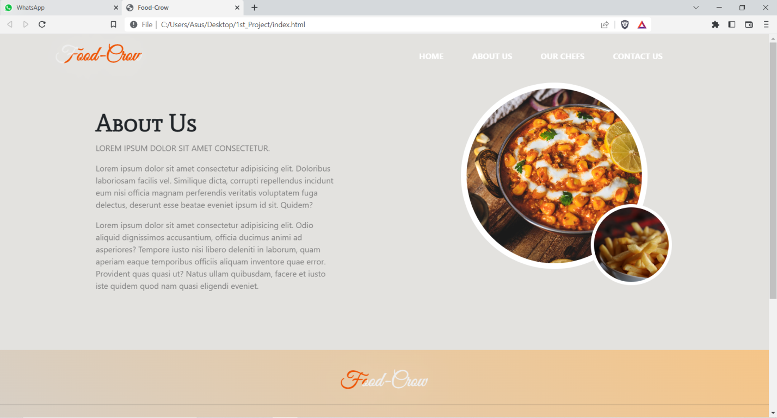

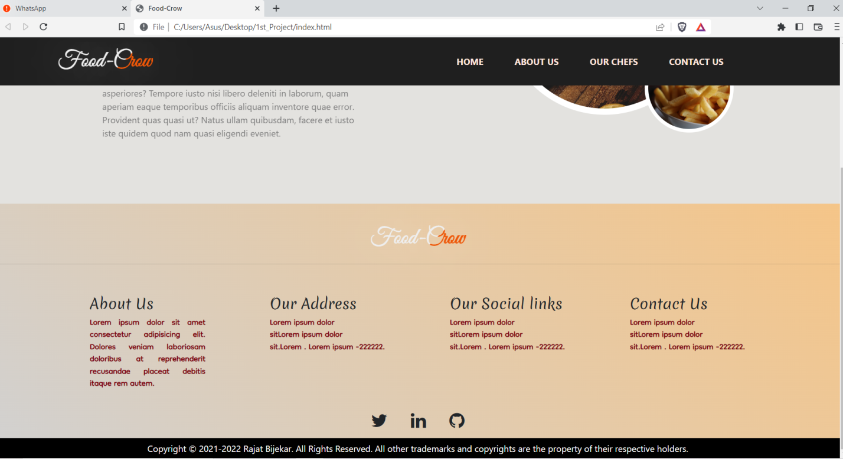

* CONCLUSION

With the help of Web development languages: HTML| CSS| Javascript, a Single page E-commerce web site has been developed successfully.