Ex. No.:3 | Intelligent Email Assistant | REG NO: URK23CS1033
DATE: 10/10/2026 | Intelligent Email Assistant | REG NO: URK23CS1033

Aim:
To develop an Intelligent Email Assistant using Ollama that generates context-aware customer replies by analyzing previous email interactions.
Problem Statement:
Develop an AI-powered Email Assistant capable of understanding customer queries, retrieving similar historical conversations, generating professional responses, improving tone, summarizing conversations, and storing generated replies.
Software Requirements:
Software | Version
Python | 3.11.15
Ollama | 0.23.1
Llama 3.2 (local LLM) | llama3.2:latest
Pandas | 3.0.5
Sentence Transformers | 6.0.1
Cursor (VS Code based editor) | 3.15.19
Input Parameters
Parameters | Description
Customer Name | Name of the customer who sent the email. Cannot be empty.
Subject | Subject line of the customer email. Defaults to General Inquiry.
Email | Body of the customer email, used for intent detection, retrieval and reply generation.
System Architecture
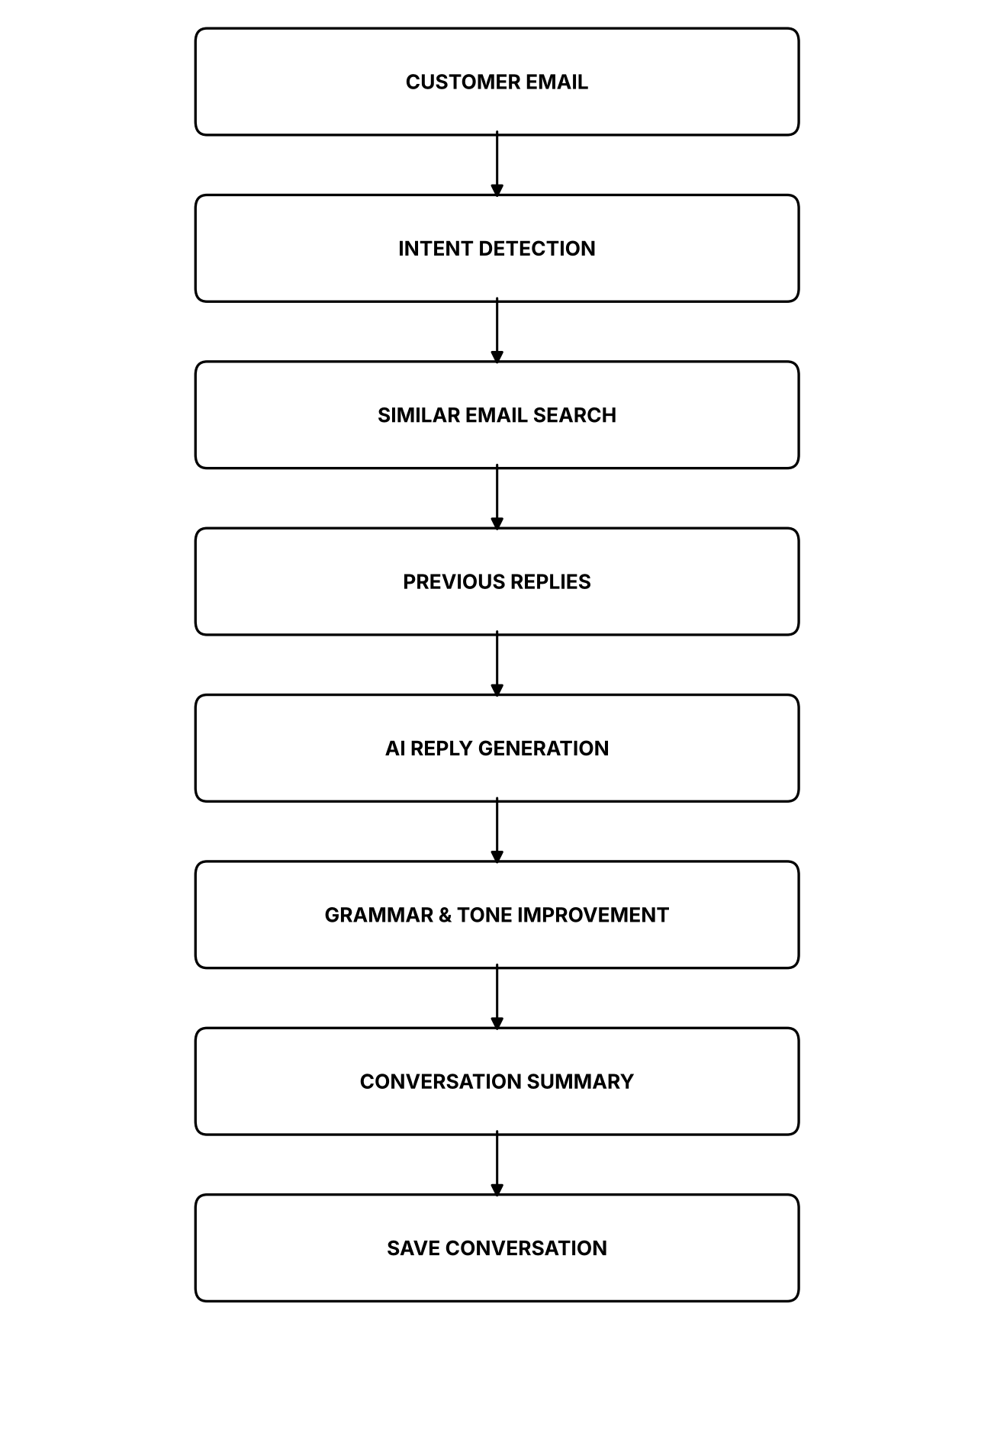
System Architecture of the Intelligent Email Assistant
Module Design
Module | Responsibility
Input Module | Collects the customer name, email subject and email body, validates them and displays the entered details.
Intent Module | Uses Ollama to classify the customer email into one of the categories present in the dataset.
Retrieval Module | Embeds the dataset with Sentence Transformers and retrieves the most similar previous email and its reply using cosine similarity.
Reply Module | Generates a professional email reply from the customer email, the detected intent and the retrieved previous reply.
Tone Module | Rewrites the generated reply in friendly, formal and empathetic tones.
Summary Module | Generates a summary of the customer issue in about 50 words.
Save Module | Saves the customer email, generated reply, intent and date to outputs/generated_reply.txt (implemented in utils.py).

Implementation
Intent detection (intent_module.py)
def detect_intent(email, verbose=True):
"""Q3 - identify the customer intent with the local model."""
raw = utils.ask(SYSTEM, "Email: {}\nCategory:".format(email), temperature=0.0)
text = raw.lower()

intent = None
for candidate in INTENTS:
if candidate.lower() in text:
intent = candidate
break
if intent is None:
keywords = [("deliver", "Delivery Issue"), ("refund", "Refund Request"),
("cancel", "Order Cancellation"), ("warrant", "Warranty"),
("exchange", "Exchange Request"), ("payment", "Payment Issue"),
("account", "Account Issue"), ("login", "Account Issue"),
("technical", "Technical Support"), ("complaint", "Product Complaint")]
for key, value in keywords:
if key in text:
intent = value
break
intent = intent or "General Inquiry"

utils.update_state(intent=intent)

if verbose:
print("Detected Intent")
print(utils.DASH)
print(intent)
print(utils.DASH)
return intent
Similar email retrieval (retrieval_module.py)
def retrieve_similar(email, verbose=True):
"""Q5 - retrieve the most similar previous email and its reply."""
emails, model, embeddings = _build()
query = model.encode(email, normalize_embeddings=True)
scores = util.cos_sim(query, embeddings)[0]
best = int(scores.argmax())
row = emails.iloc[best]
score = float(scores[best])

utils.update_state(previous_email=row["Customer_Email"],
previous_reply=row["Previous_Reply"])

if verbose:
print("Similar Email Retrieval")
print(utils.DASH)
print("Dataset records : {}".format(len(emails)))
print("Matched Email ID : {}".format(row["Email_ID"]))
print("Category : {}".format(row["Category"]))
print("Similarity Score : {}".format(round(score, 4)))
print()
print("Previous Email")
print(row["Customer_Email"])
print()
print("Previous Reply")
print(row["Previous_Reply"])
print(utils.DASH)
return {"email": row["Customer_Email"], "reply": row["Previous_Reply"],
"score": score, "category": row["Category"]}
AI reply generation (reply_module.py)
def generate_reply(verbose=True):
"""Q6 - generate a professional reply from the email and the previous reply."""
state = utils.load_state()

prompt = ("Customer Email:\n{}\n\n"
"Detected Intent: {}\n\n"
"A previous reply used for a similar case:\n{}\n\n"
"Write a professional reply to this customer."
).format(state.get("email", ""), state.get("intent", ""),
state.get("previous_reply", ""))

reply = utils.ask(SYSTEM, prompt)
utils.update_state(reply=reply)

if verbose:
print("AI Generated Reply")
print(utils.DASH)
print(reply)
print(utils.DASH)
print("Words : {}".format(len(reply.split())))
return reply
Tone improvement (tone_module.py)
def rewrite(reply, tone, verbose=True):
"""Rewrite one reply in the requested tone."""
text = utils.ask(SYSTEM, "Rewrite this reply in a {} tone:\n\n{}".format(tone, reply))
if verbose:
print("{} Tone".format(tone))
print(utils.DASH)
print(text)
print(utils.DASH)
print()
return text

def improve_all(reply, verbose=True):
"""Q7 - rewrite the reply in friendly, formal and empathetic tones."""
results = {}
for tone in TONES:
results[tone] = rewrite(reply, tone, verbose)
utils.update_state(tones=results)
return results
Saving the reply (utils.py)
def save_reply(state, verbose=True):
"""Q9 - save the email, generated reply, intent and date to a text file."""
lines = [
"INTELLIGENT EMAIL ASSISTANT - GENERATED REPLY",
"=" * 55,
"Date : {}".format(datetime.datetime.now().strftime("%d/%m/%Y %H:%M")),
"Customer Name : {}".format(state.get("name", "")),
"Subject : {}".format(state.get("subject", "")),
"Detected Intent: {}".format(state.get("intent", "")),
"=" * 55,
"",
"CUSTOMER EMAIL",
"-" * 55,
state.get("email", ""),
"",
"GENERATED REPLY",
"-" * 55,
state.get("reply", ""),
"",
]
if state.get("summary"):
lines += ["CONVERSATION SUMMARY", "-" * 55, state["summary"], ""]

try:
os.makedirs(OUTPUT_DIR, exist_ok=True)
with open(REPLY_FILE, "w") as f:
f.write("\n".join(lines))
except OSError as exc:
raise ModelError("Could not save the reply: {}".format(exc))

GitHub Link: https://github.com/ViknanS/Intelligent-Email-Assistant-exp3.git
LinkedIn Post Link: https://www.linkedin.com/in/viknan/

Output Screenshots:
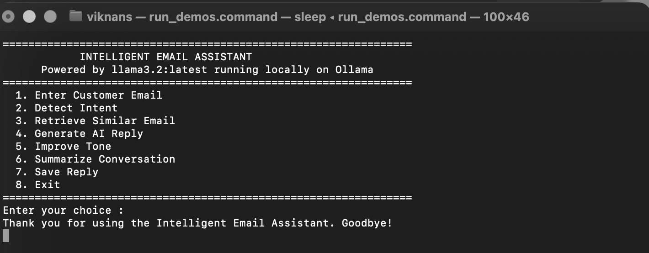
Home Screen
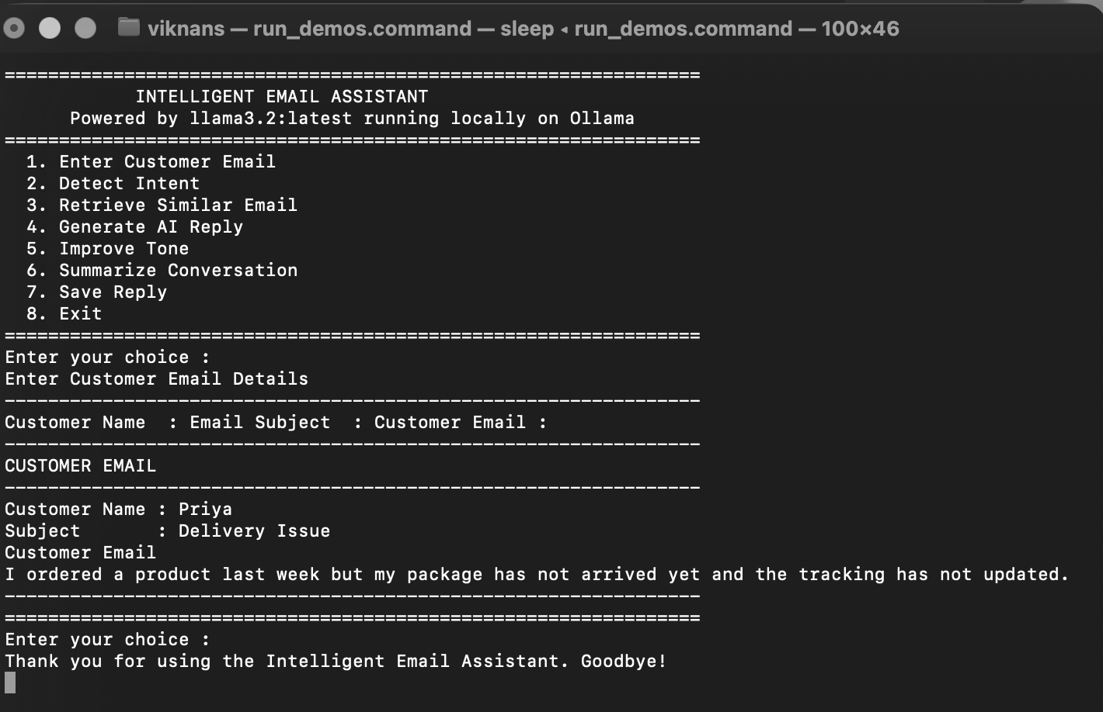
Customer Email
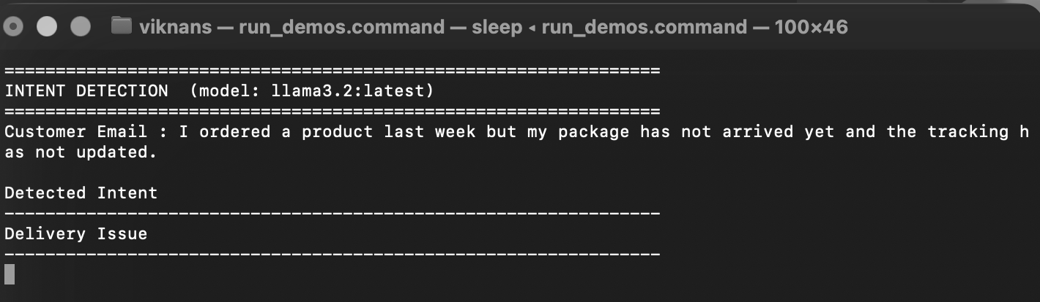
Intent Detection
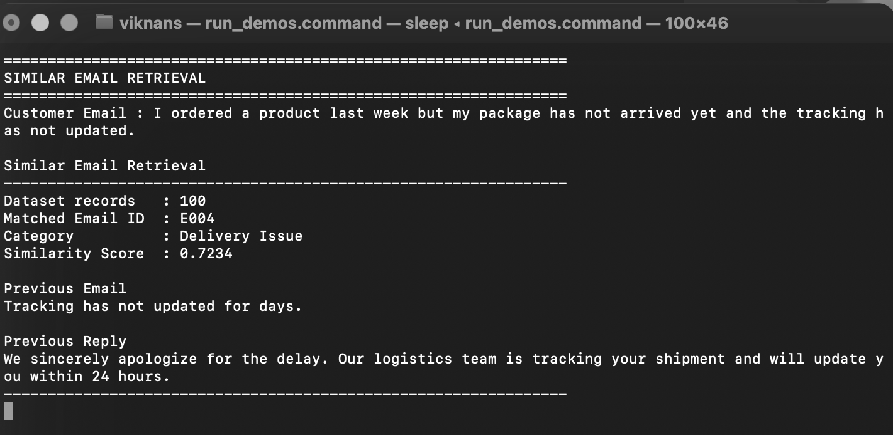
Similar Email Retrieval
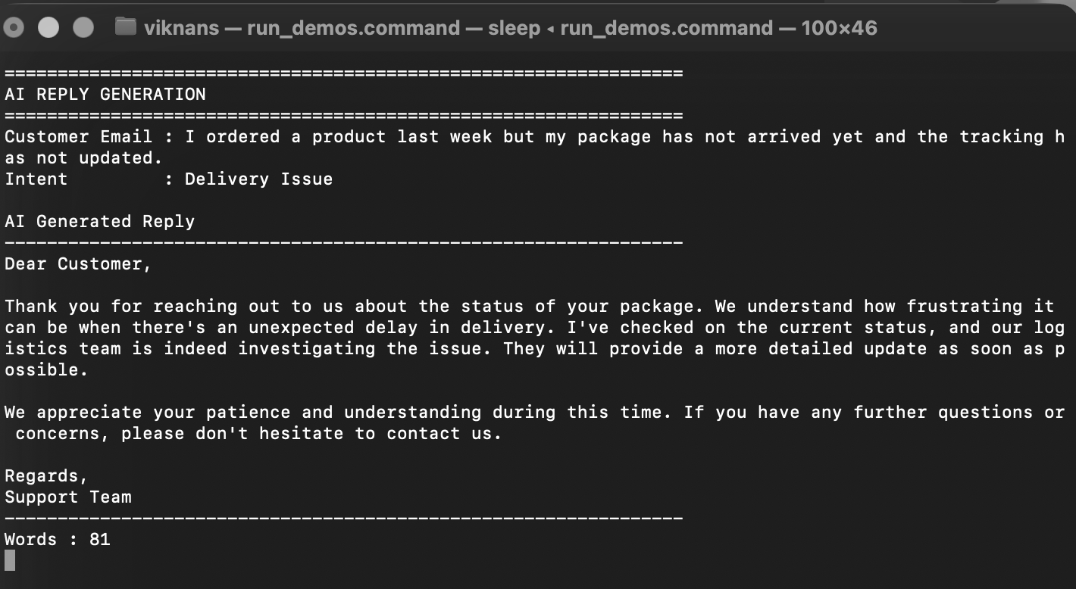
AI Reply
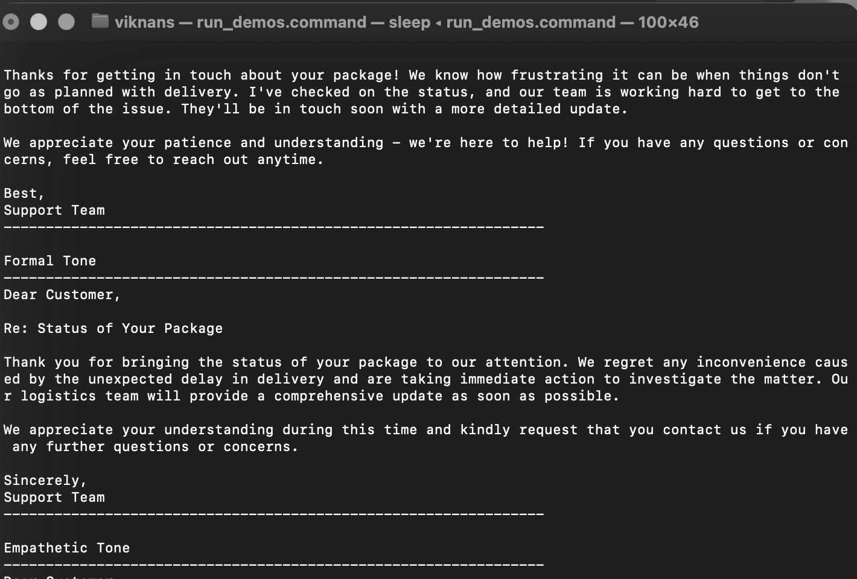
Tone Improvement
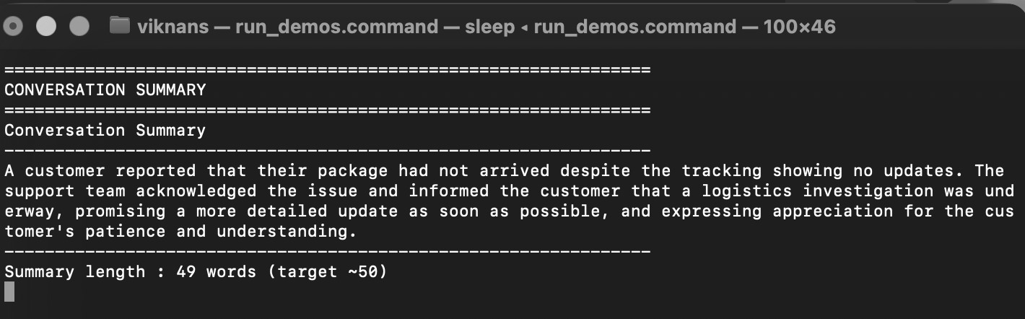
Conversation Summary
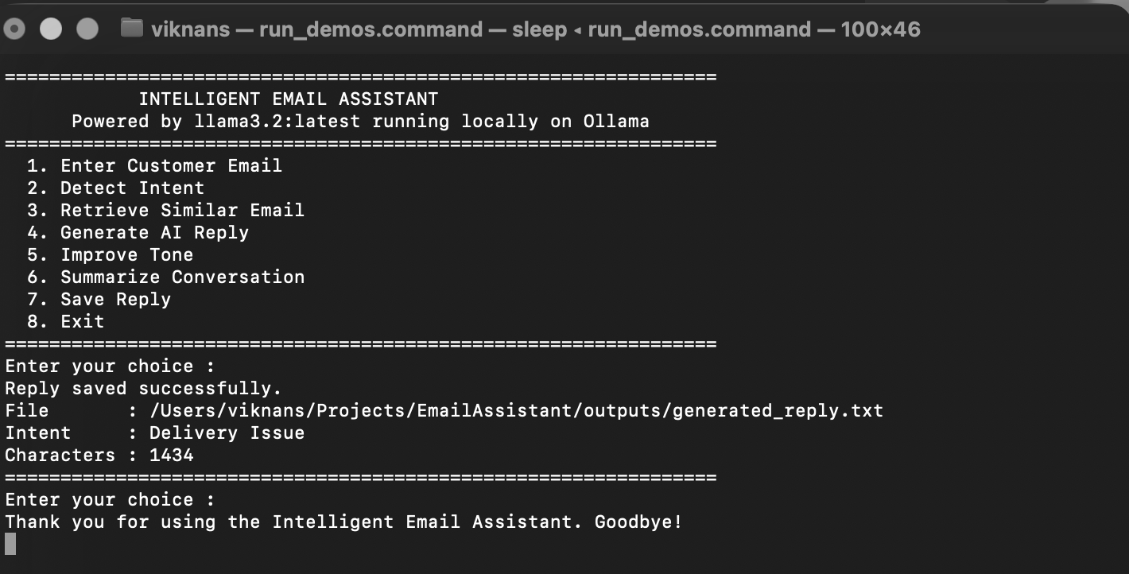
Saved Reply
Result:
Thus, an Intelligent Email Assistant was successfully developed using Ollama. The application understands customer emails, retrieves similar historical conversations, generates professional responses, rewrites replies in different tones, summarizes conversations, and saves generated replies locally without requiring cloud-based APIs.

