Ex. No.:4 | PERSONALIZED RECOMMENDATION SYSTEM | REG NO: URK23CS1033
DATE: 10/10/2026 | PERSONALIZED RECOMMENDATION SYSTEM | REG NO: URK23CS1033

Aim:
To develop a personalized recommendation system using GPT-4 that analyzes user preferences and generates, ranks and explains suitable recommendations based on the user's profile, interests, skill level and goals.
Problem Statement:
Design and develop an intelligent personalized recommendation system using GPT-4. The application should collect user information and preferences, analyze the user's requirements, generate personalized recommendations, rank them according to suitability, provide explanations for the recommendations and refine the results based on user feedback.
Software Requirements:
Software | Version
Python | 3.11.15
Ollama | 0.23.1
Llama 3.2 (local LLM) | llama3.2:latest
ollama (Python client) | 0.6.2
Cursor (VS Code based editor) | 3.15.19
Input Parameters
Parameters | Description
Name | Name of the user. Cannot be empty.
Age | Age of the user.
Background | Educational or professional background, for example Computer Science.
Interests | Comma separated list of interests, for example Artificial Intelligence, Python.
Skill Level | Current level of the user, for example Beginner.
Preferred Category | Type of resource preferred, for example Online Courses.
Goal | What the user wants to achieve, for example Learn AI.
Preferences | Derived from the profile and used as constraints during generation.
Number of items | How many recommendations to generate. Accepts 1 to 10; default 5.
System Architecture
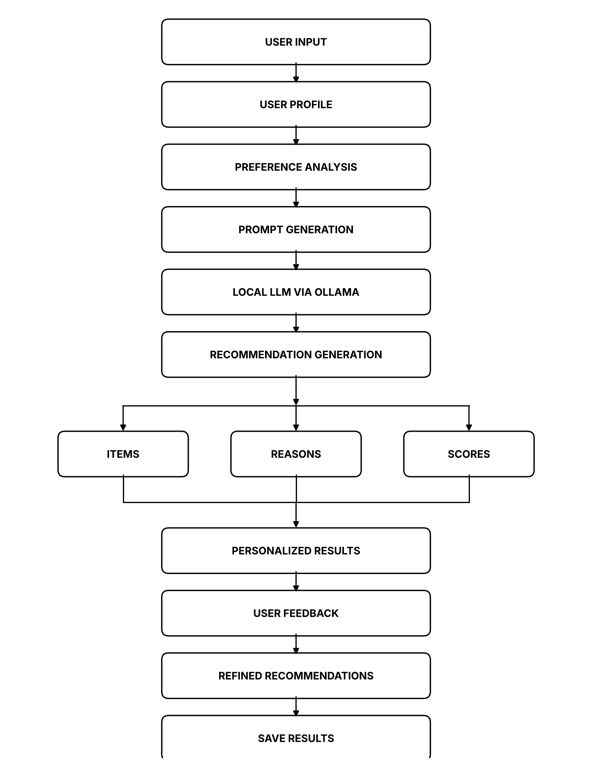
System Architecture of the Personalized Recommendation System
Module Design
Module | Responsibility
Input Module | Collects the name, age, background, interests, skill level, preferred category, goal and number of items, and displays them.
Profile Module | Stores and displays the user profile used by every other module.
Preference Module | Analyzes the profile to identify primary and secondary interests, skill level, goal, preference and constraints.
Prompt Module | Constructs the prompt from the profile and the preference analysis.
Recommendation Module | Generates the personalized recommendations with a name, suitability score and reason for each item.
Ranking Module | Ranks the generated recommendations by suitability score and displays the ranked table.
Explanation Module | Generates an explanation describing why each recommendation suits the user.
Feedback Module | Takes the user feedback and regenerates a refined recommendation list.
Intent Module | Detects the intent as GENERATE, REFINE, SHOW_PROFILE, EXPLAIN, SAVE or EXIT.
Save Module | Writes the ranked recommendations to outputs/recommendations.txt.
Main Module | Integrates all modules and runs continuous interaction until the user exits.

Implementation
Preference analysis (profile_module.py)
def analyse_preferences(profile, verbose=True):
"""Q3 - identify major interests, skill level, goal, preferred type and constraints."""
interests = [i.strip() for i in profile["interests"].split(",") if i.strip()]
analysis = {
"primary_interest": interests[0] if interests else profile["interests"],
"secondary_interest": interests[1] if len(interests) > 1 else "-",
"skill_level": profile["skill_level"],
"goal": profile["goal"],
"preference": profile["category"],
"constraints": "Content must suit a {} learner aiming to {}".format(
profile["skill_level"].lower(), profile["goal"].lower()),
}

if verbose:
print("Preference Analysis")
print(utils.DASH)
print("Primary Interest : {}".format(analysis["primary_interest"]))
print("Secondary Interest : {}".format(analysis["secondary_interest"]))
print("Skill Level : {}".format(analysis["skill_level"]))
print("Goal : {}".format(analysis["goal"]))
print("Preference : {}".format(analysis["preference"]))
print("Constraints : {}".format(analysis["constraints"]))
print(utils.DASH)
return analysis
Prompt construction (prompt_module.py)
def build_prompt(profile, analysis):
"""Q4 - construct the prompt from the collected user information."""
return (
"User:\n"
"Name: {name}\n"
"Background: {background}\n"
"Interests: {interests}\n"
"Skill Level: {skill_level}\n"
"Goal: {goal}\n"
"Preference: {category}\n\n"
"Primary Interest: {primary}\n"
"Constraints: {constraints}\n\n"
"Recommend {count} suitable learning resources.\n"
"For each recommendation provide the name, a suitability score out of 100, "
"and a one sentence reason."
).format(primary=analysis["primary_interest"],
constraints=analysis["constraints"], **profile)
Recommendation generation and parsing (recommendation_module.py)
def parse_items(reply, limit):
"""Turn the model reply into a list of {name, score, reason}."""
items = []
for raw in reply.splitlines():
line = utils.clean_item(raw)
if "|" not in line:
continue
parts = [p.strip() for p in line.split("|")]
if len(parts) < 3:
continue
name, score_raw, reason = parts[0], parts[1], " | ".join(parts[2:])
digits = re.findall(r"\d+", score_raw)
if not name or not digits:
continue
items.append({"name": name, "score": min(int(digits[0]), 100), "reason": reason})
if len(items) == limit:
break
return items

def generate(profile, analysis, verbose=True, extra=""):
"""Q5 - generate personalized recommendations using the model."""
prompt = prompt_module.build_prompt(profile, analysis)
if extra:
prompt += "\n\n" + extra

reply = utils.ask(prompt_module.SYSTEM_PROMPT, prompt)
items = parse_items(reply, profile["count"])

if not items:
raise utils.ModelError("Could not parse any recommendation from the model reply.")

result = {"items": items, "profile_name": profile["name"]}
utils.save_result(result)

if verbose:
display(items)
return result
Ranking (ranking_module.py)
def rank(items, verbose=True):
"""Q6 - rank the recommendations by suitability score."""
ranked = sorted(items, key=lambda i: i["score"], reverse=True)

if verbose:
width = max([len(i["name"]) for i in ranked] + [14])
print("RECOMMENDATION RANKING")
print(utils.DASH)
print("{:<5} | {:<{w}} | {}".format("Rank", "Recommendation", "Score", w=width))
print("-" * (width + 20))
for rank_no, item in enumerate(ranked, 1):
print("{:<5} | {:<{w}} | {}%".format(rank_no, item["name"], item["score"], w=width))
print("-" * (width + 20))
return ranked
Intent detection (intent_module.py)
def detect_intent(query):
"""Q9 - classify the request into exactly one of the six allowed intents."""
raw = utils.ask(SYSTEM, "User: {}\nLabel:".format(query), temperature=0.0)
text = raw.upper().replace("-", "_").replace(" ", "_")

for intent in INTENTS:
if intent in text:
return intent
if "REFINE" in text or "BEGINNER" in text:
return "REFINE_RECOMMENDATION"
if "EXPLAIN" in text or "WHY" in text:
return "EXPLAIN_RECOMMENDATION"
if "PROFILE" in text:
return "SHOW_PROFILE"
if "SAVE" in text:
return "SAVE_RECOMMENDATION"
if "EXIT" in text or "QUIT" in text:
return "EXIT"
return "GENERATE_RECOMMENDATION"

GitHub Link: https://github.com/ViknanS/PERSONALIZED-RECOMMENDATION-SYSTEM-Exp4.git
LinkedIn Post Link: https://www.linkedin.com/in/viknan/

Output Screenshots:
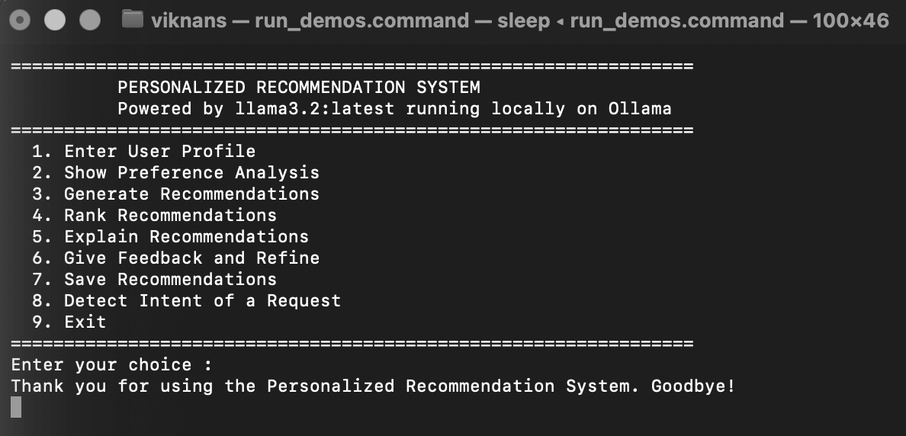
Home Screen
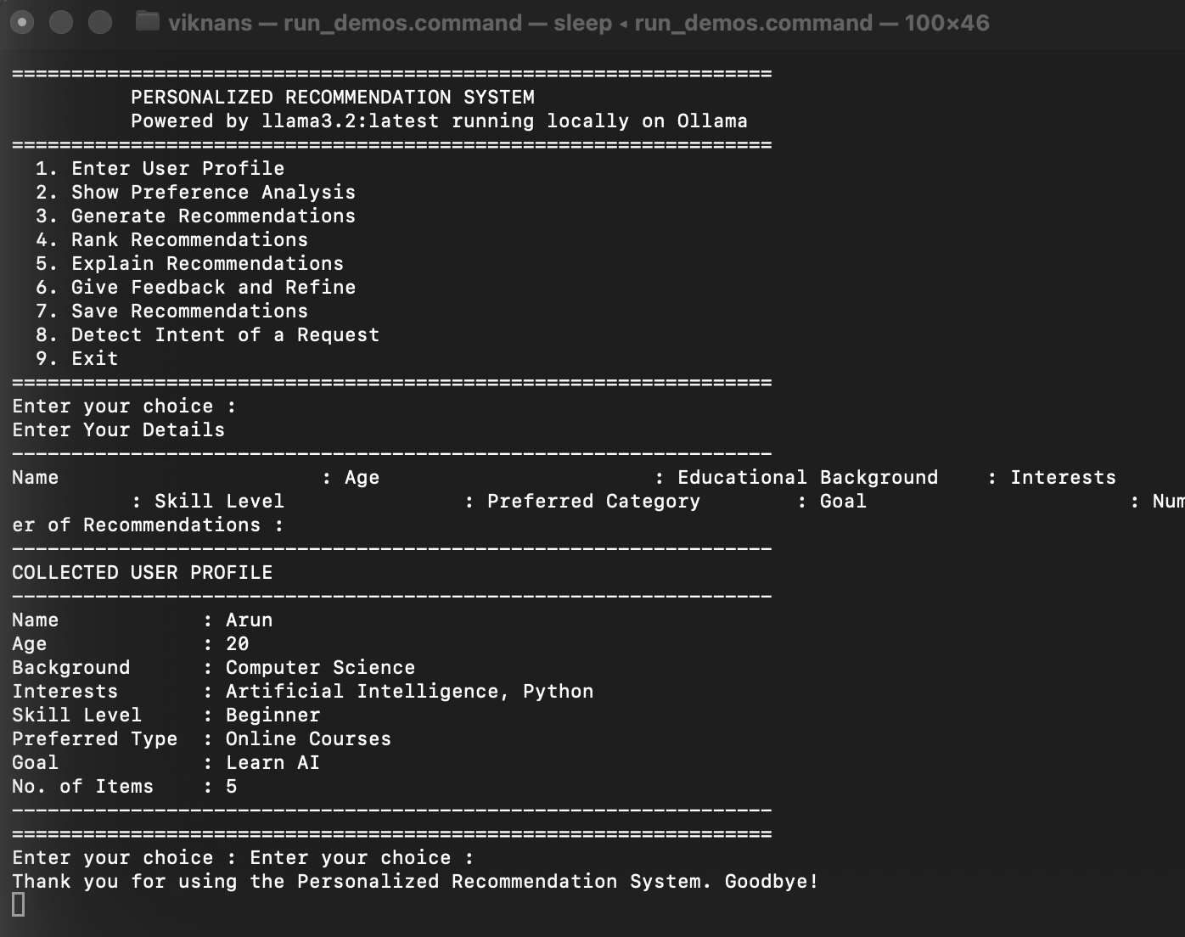
User Profile Input
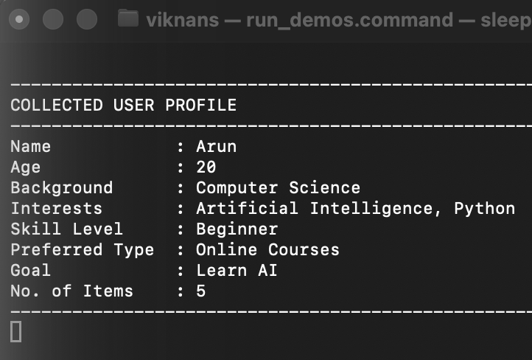
Collected User Profile
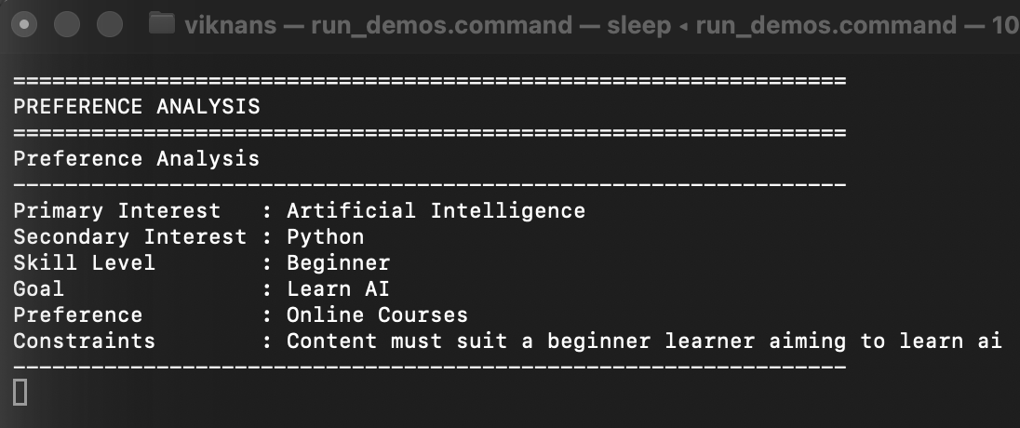
Preference Analysis
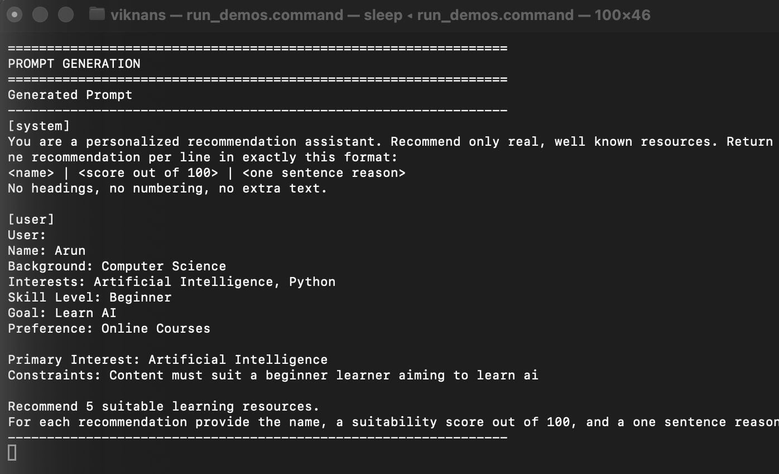
Prompt Generation
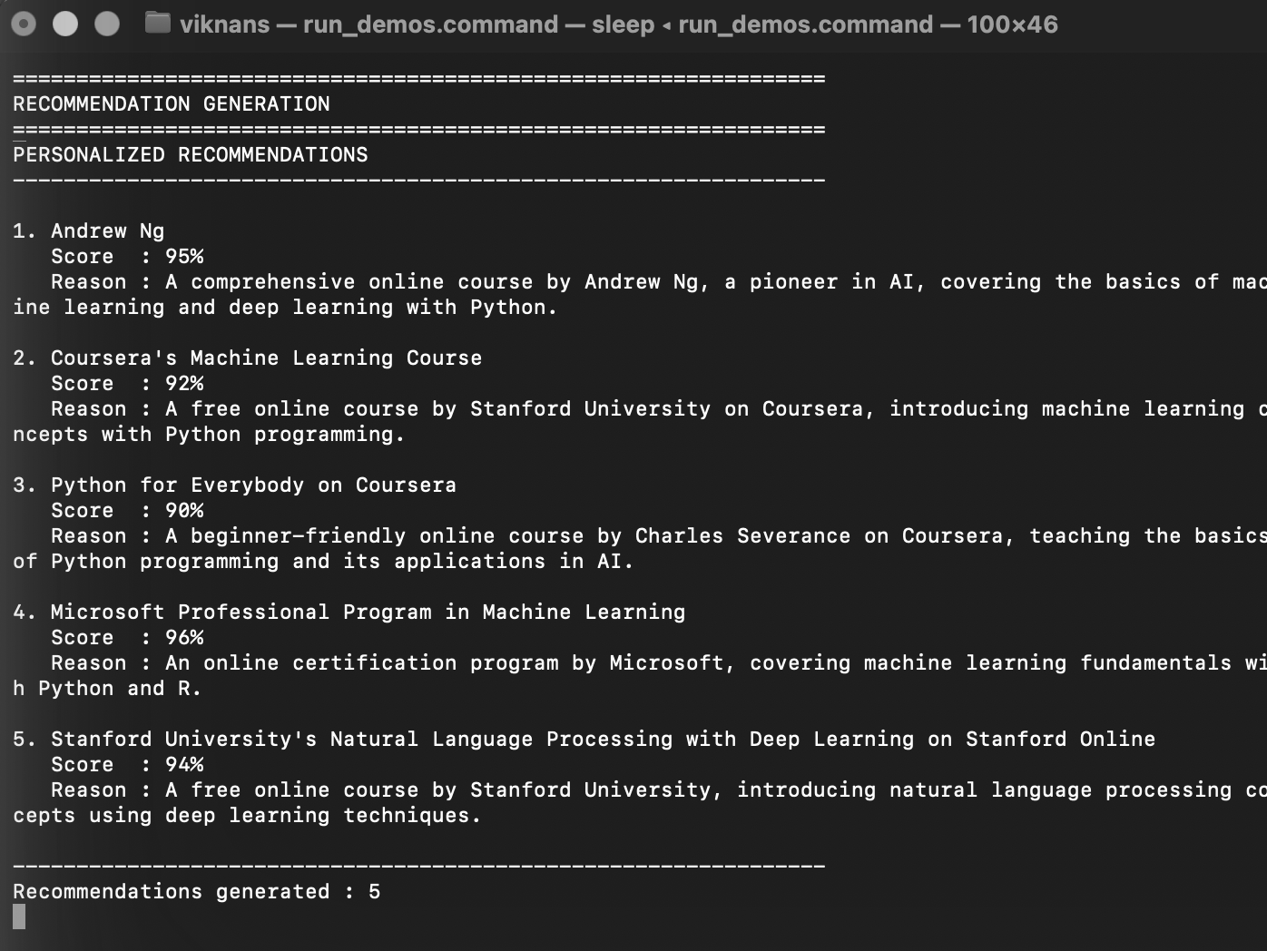
GPT-4 Recommendation
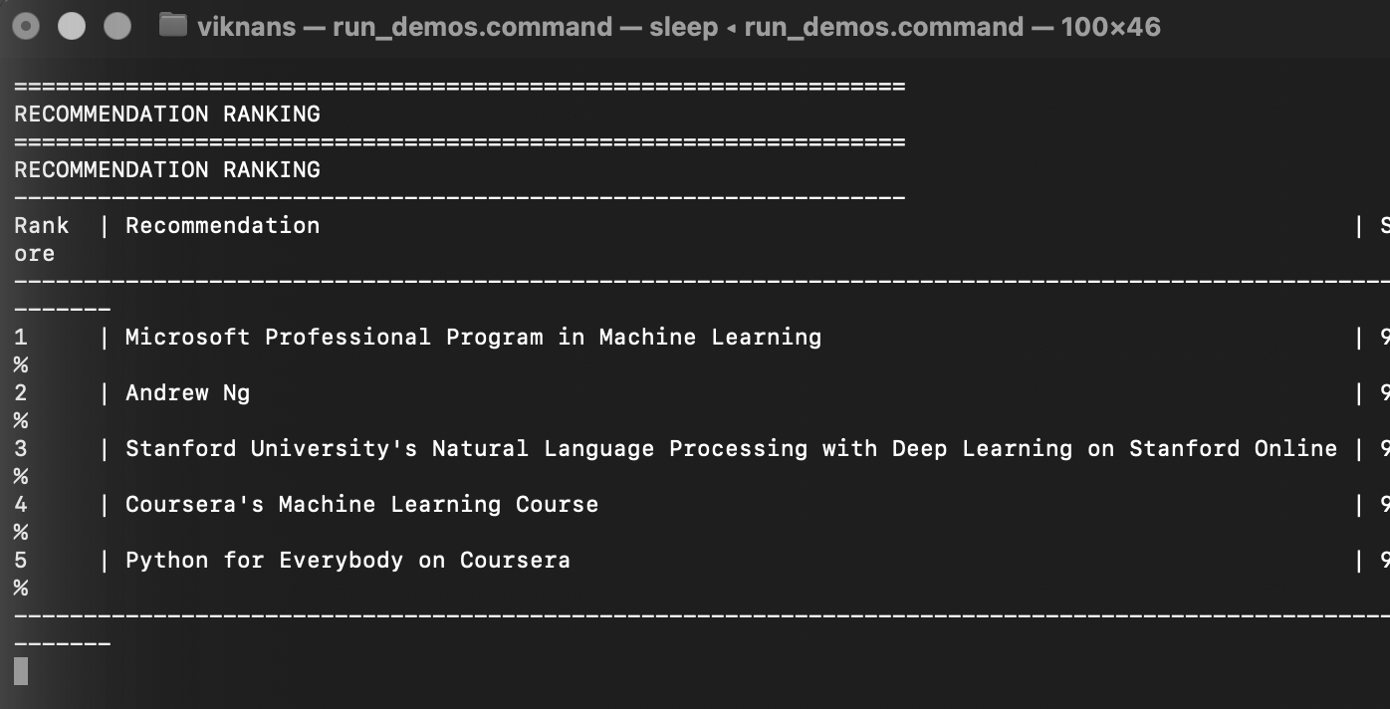
Recommendation Ranking
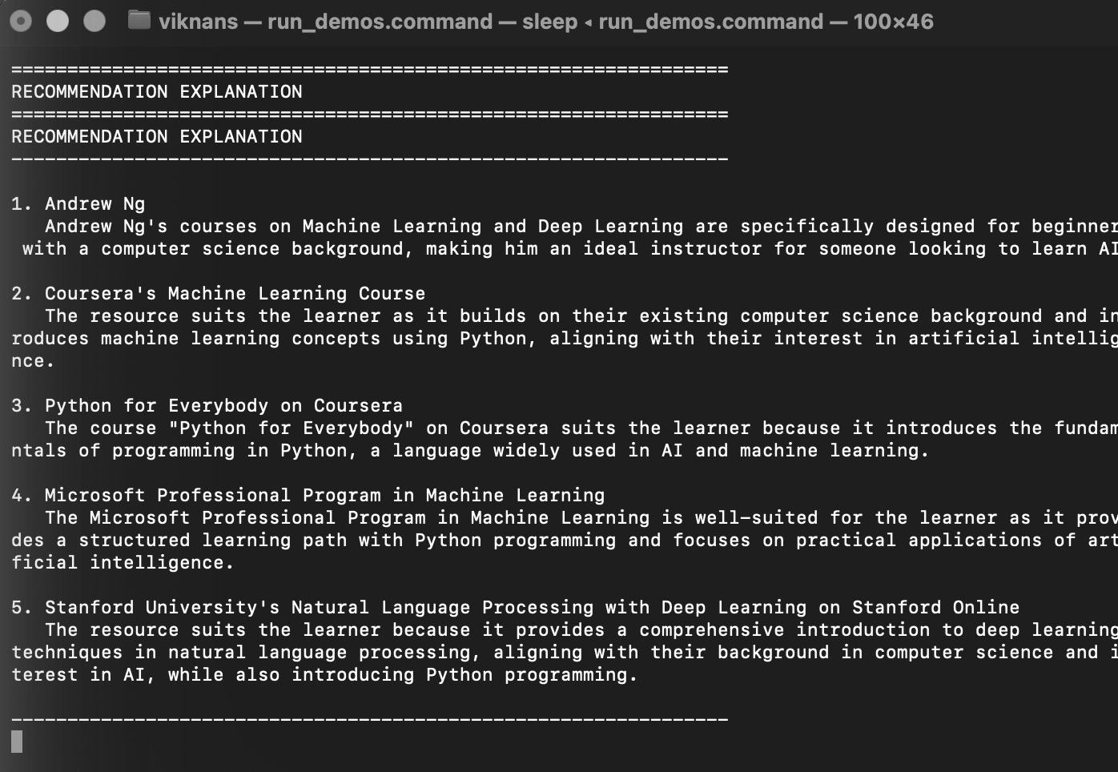
Recommendation Explanation
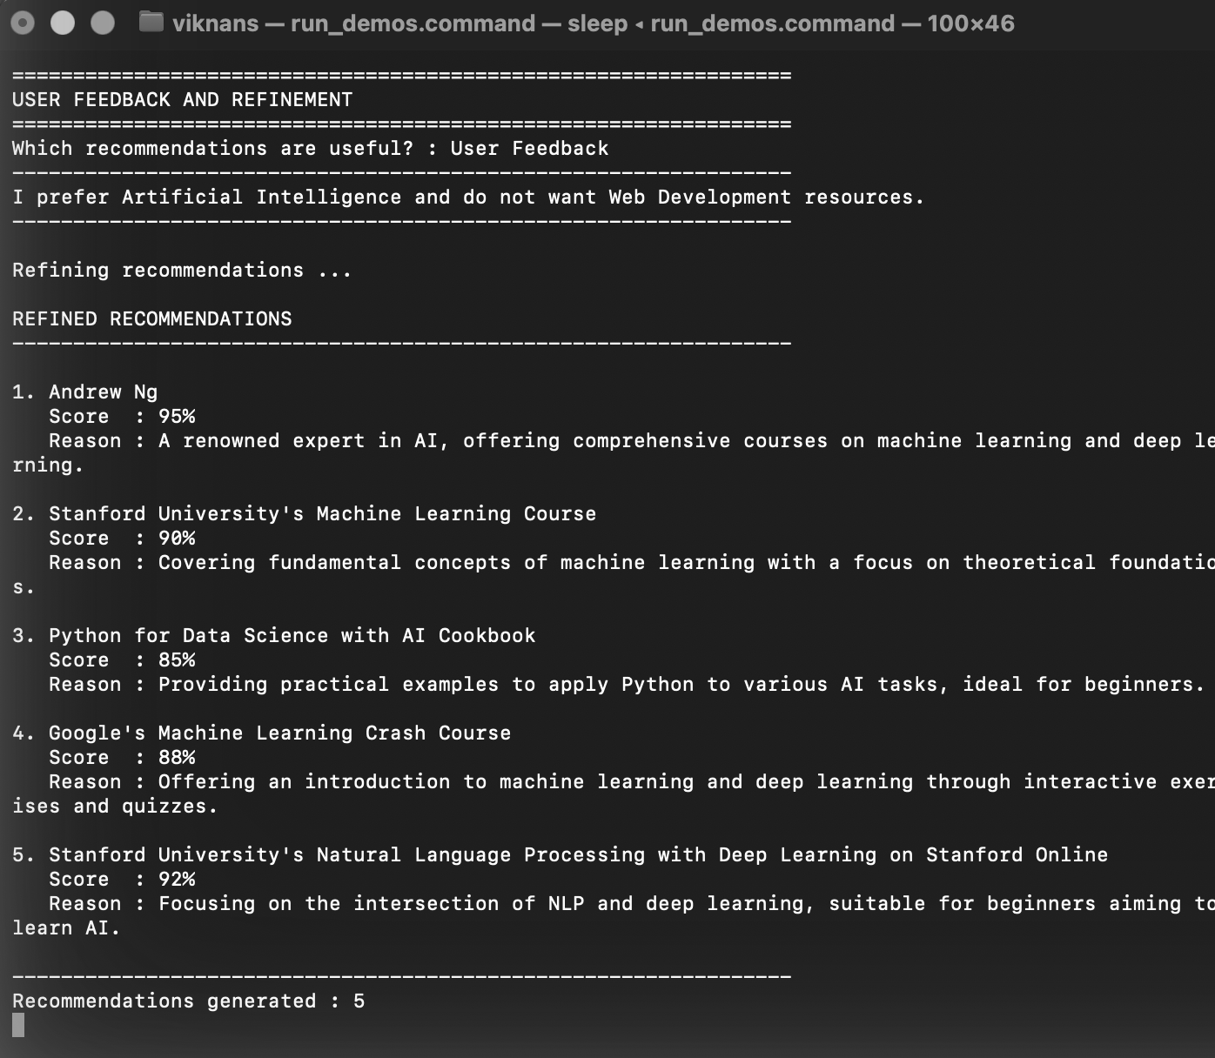
User Feedback
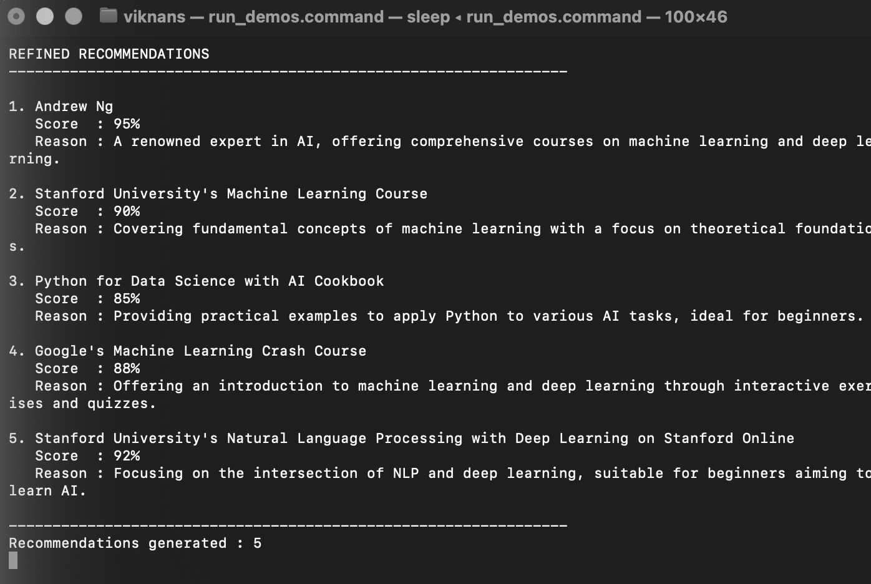
Refined Recommendations
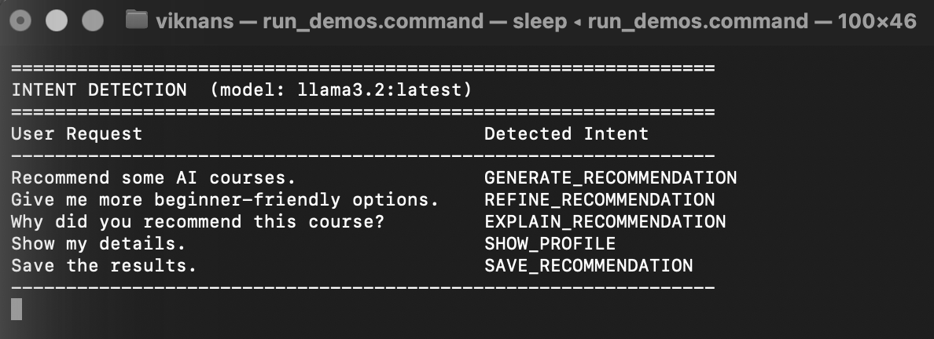
Intent Detection
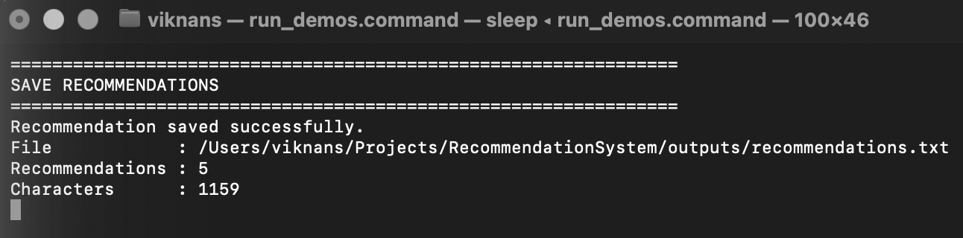
Recommendation Saved Successfully
Result:
Thus, a personalized recommendation system using GPT-4 was successfully developed. The system collects user information, analyzes preferences, generates personalized recommendations, ranks and explains the recommendations, accepts user feedback and produces refined recommendations.

