Ex. No.:6 | AI-POWERED MEDICAL SYMPTOM ASSISTANT USING GPT-4 | REG NO: URK23CS1033
DATE: 04/11/2026 | AI-POWERED MEDICAL SYMPTOM ASSISTANT USING GPT-4 | REG NO: URK23CS1033

Aim:
To develop an AI-powered medical symptom assistant using GPT-4 that analyzes user-reported symptoms, identifies possible associated conditions, generates relevant follow-up questions and provides general guidance regarding professional medical attention.
Problem Statement:
Design and develop an AI-powered medical symptom assistant using GPT-4. The application should collect basic user information and symptoms, analyze the reported symptoms, identify possible conditions, generate follow-up questions and present the results in a structured format. The system should include appropriate safety instructions and clearly state that the generated output is not a medical diagnosis.
Software Requirements:
Software | Version
Python | 3.11.15
Ollama | 0.23.1
Llama 3.2 (local LLM used in place of GPT-4) | llama3.2:latest
Pandas | 3.0.5
Sentence Transformers | 6.0.1
Cursor (VS Code based editor) | 3.15.19
Input Parameters
Parameters | Description
Age | Age of the person reporting the symptoms. Checked for a numeric value under 120.
Sex | Sex, where relevant to the reported symptoms.
Symptoms | Free natural-language description of the symptoms, entered in the user's own words.
Duration | How long the symptoms have been present.
Severity | Mild, Moderate or Severe, as reported by the user.
Medical History | Previously known relevant conditions.
Medication | Medications currently being taken, if relevant.
Allergies | Known allergies, if relevant.
Additional Information | Any other detail the user wishes to add.
System Architecture
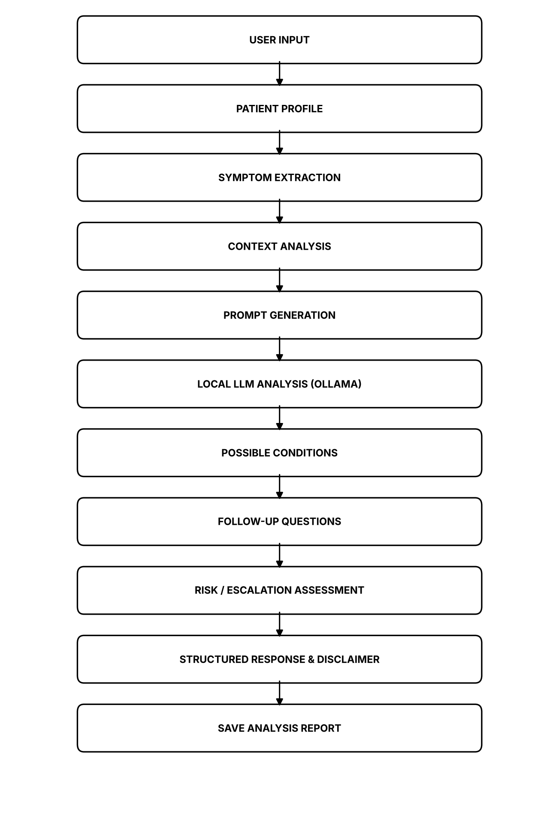
System Architecture of the AI-Powered Medical Symptom Assistant
Module Design
Module | Responsibility
Input Module | Collects the age, sex, duration, severity, medical history, medication, allergies and additional information, together with the natural-language symptom description, and displays the symptom input.
Profile Module | Normalises the collected fields into a patient profile, checks the age and severity values and displays the patient information.
Symptom Module | Uses the local model to extract the individual symptoms from the natural-language description and cleans the extracted list.
Context Module | Lists the contextual fields the user did not provide and uses Sentence Transformers to find the closest reference cases, reporting the details usually relevant for symptoms of that kind.
Prompt Module | Builds the analysis prompt with the patient information, the extracted symptoms and the missing information, and states the safety rules the model must follow.
Analysis Module | Sends the prompt to the local model, splits the response into its four sections, displays the possible conditions and assembles the complete structured response.
Question Module | Generates five short follow-up questions from the symptoms, the missing information and the details usually checked for similar cases.
Safety Module | Produces the medical attention guidance, flags wording that is generally treated as urgent and displays the required disclaimer.
Save Module | Writes the structured analysis and the raw model response to outputs/medical_analysis.txt.
Main Module | Provides the nine-option menu and connects all the modules into a single application.

Implementation
Patient information input (input_module.py)
def collect():
"""Q1 - collect the patient information and the symptom description."""
print("Enter the patient information. Press Enter to skip a field.")
print(utils.DASH)

record = {}
for key, label, default in FIELDS:
value = input(label).strip()
record[key] = value or default

print(utils.DASH)
print("Describe the symptoms in your own words.")
record["symptom_text"] = input("Symptoms : ").strip()

if not record["symptom_text"]:
print("A symptom description is required.")
return None

utils.update_state(**record)
return record
Symptom extraction (symptom_module.py)
def extract(verbose=True):
"""Q2 - extract the symptoms from the natural-language input."""
text = utils.require("symptom_text", "Please enter the symptoms first (option 1).")
if not text:
return None

raw = utils.ask(SYSTEM, "Patient description:\n{}\n\nList the symptoms.".format(text),
temperature=0.1)
symptoms = clean_list(raw)
utils.update_state(symptoms=symptoms, symptom_count=len(symptoms))

if verbose:
print("Extracted Symptoms")
print(utils.DASH)
print("Patient description:")
for line in utils.wrap(text, 58):
print(" {}".format(line))
print(utils.DASH)
print("Symptoms identified by the model:")
for item in symptoms:
print(" * {}".format(item))
print(utils.DASH)
print("Model : {}".format(utils.OLLAMA_MODEL))
print("Symptoms found : {}".format(len(symptoms)))
print(utils.DASH)
return symptoms
Context analysis (context_module.py)
def missing_fields(state):
"""List the contextual fields the user has not supplied."""
return [label for key, label in CONTEXT_FIELDS
if str(state.get(key, "")).strip().lower() in EMPTY]

def similar_cases(symptom_text, top=3):
"""Find the reference cases whose symptoms are closest to the description."""
from sentence_transformers import util

frame = utils.load_cases()
model = _embedder()
query = model.encode(symptom_text, convert_to_tensor=True)
corpus = model.encode(frame["symptoms"].tolist(), convert_to_tensor=True)
scores = util.cos_sim(query, corpus)[0]

order = scores.argsort(descending=True)[:top]
rows = []
for idx in order:
i = int(idx)
rows.append({"Case": frame.at[i, "case_id"],
"Category": frame.at[i, "category"],
"Usual Duration": frame.at[i, "typical_duration"],
"Score": round(float(scores[i]), 4)})
checks = []
for idx in order:
for item in str(frame.at[int(idx), "commonly_checked"]).split(","):
item = item.strip()
if item and item not in checks:
checks.append(item)
return rows, checks
Prompt generation (prompt_module.py)
def build_prompt(verbose=True):
"""Q4 - construct the analysis prompt for the model."""
state = utils.load_state()
if not state.get("symptom_text"):
print("Please enter the symptoms first (option 1).")
return None

prompt = TEMPLATE.format(
age=state.get("age", "Not provided"),
sex=state.get("sex", "Not provided"),
duration=state.get("duration", "Not provided"),
severity=state.get("severity", "Not provided"),
history=state.get("history", "None reported"),
medication=state.get("medication", "None reported"),
allergies=state.get("allergies", "None reported"),
additional=state.get("additional", "None reported"),
symptom_text=state.get("symptom_text", ""),
symptoms="\n".join("- {}".format(s) for s in state.get("symptoms", [])) or "- not extracted",
missing="\n".join("- {}".format(m) for m in state.get("missing", [])) or "- none",
)

utils.update_state(prompt=prompt, prompt_chars=len(prompt))

if verbose:
print("Prompt Generation")
print(utils.DASH)
print("System role : informational medical symptom assistant")
print("Headings asked : Possible Conditions, Explanation,")
print(" Additional Information Needed, Medical Attention")
print("Safety rules : 6 (no diagnosis, no invented information)")
print("Prompt chars : {}".format(len(prompt)))
print("Prompt words : {}".format(len(prompt.split())))
print(utils.DASH)
print("Generated prompt (first lines)")
print(utils.DASH)
utils.preview(prompt, lines=22)
print(utils.DASH)
return prompt
Symptom analysis (analysis_module.py)
def analyze(verbose=True):
"""Q5 - generate the preliminary symptom analysis with the local model."""
prompt = utils.load_state().get("prompt") or prompt_module.build_prompt(verbose=False)
if not prompt:
return None

response = utils.ask(prompt_module.SYSTEM, prompt, temperature=0.2)
sections = split_sections(response)
utils.update_state(response=response, sections=sections,
response_words=len(response.split()))

if verbose:
print("Model Response")
print(utils.DASH)
print("Model : {}".format(utils.OLLAMA_MODEL))
print("Response words : {}".format(len(response.split())))
print("Sections found : {} of {}".format(len(sections), len(HEADINGS)))
print(utils.DASH)
print(response)
print(utils.DASH)
return response
Follow-up questions (question_module.py)
def generate(verbose=True):
"""Q6 - generate follow-up questions for the reported symptoms."""
state = utils.load_state()
if not state.get("symptom_text"):
print("Please enter the symptoms first (option 1).")
return None

prompt = ("Reported symptoms:\n{}\n\nInformation not provided:\n{}\n\n"
"Details usually relevant for symptoms of this kind:\n{}\n\n"
"Write five follow-up questions.").format(
"\n".join("- {}".format(s) for s in state.get("symptoms", [])) or state["symptom_text"],
"\n".join("- {}".format(m) for m in state.get("missing", [])) or "- none",
"\n".join("- {}".format(c) for c in state.get("usually_checked", [])[:6]) or "- none")

questions = clean(utils.ask(SYSTEM, prompt, temperature=0.3))
utils.update_state(questions=questions)

if verbose:
print("FOLLOW-UP QUESTIONS")
print(utils.DASH)
for n, q in enumerate(questions, 1):
for i, line in enumerate(utils.wrap(q, 56)):
print("{:>3}. {}".format(n, line) if i == 0 else " {}".format(line))
print(utils.DASH)
print("Questions generated : {}".format(len(questions)))
print("Model : {}".format(utils.OLLAMA_MODEL))
print(utils.DASH)
return questions
Medical attention guidance and disclaimer (safety_module.py)
def guidance_lines():
"""The medical-attention wording for the current case."""
lines = utils.wrap(GENERAL, 56)
if flagged_terms():
lines += [""] + utils.wrap(ESCALATION, 56)
state = utils.load_state()
severity = str(state.get("severity", "Not provided"))
lines += ["",
"Severity reported by the user : {}".format(severity),
"This system does not make a clinical triage decision."]
return lines

def guidance(verbose=True):
"""Q7 - display the medical attention guidance."""
if not utils.require("symptom_text", "Please enter the symptoms first (option 1)."):
return None
lines = guidance_lines()
utils.update_state(guidance=lines, urgent_terms=flagged_terms())

if verbose:
print("MEDICAL ATTENTION")
print(utils.DASH)
for line in lines:
print(line)
print(utils.DASH)
terms = flagged_terms()
print("Urgent terms detected in the description : {}".format(
", ".join(terms) if terms else "none"))
print(utils.DASH)
return lines
Saving the report (save_module.py)
def save(verbose=True):
"""Q10 - save the generated analysis to outputs/medical_analysis.txt."""
state = utils.load_state()
if not state.get("sections"):
print("Please analyze the symptoms first (option 3).")
return None

report = state.get("structured") or analysis_module.structured(verbose=False)

lines = [
"AI-POWERED MEDICAL SYMPTOM ASSISTANT - ANALYSIS REPORT",
"=" * 55,
"Date : {}".format(datetime.datetime.now().strftime("%d/%m/%Y %H:%M")),
"Model : {}".format(utils.OLLAMA_MODEL),
"=" * 55,
"",
report,
"",
"RAW MODEL RESPONSE",
"-" * 55,
state.get("response", ""),
"",
]

try:
os.makedirs(utils.OUTPUT_DIR, exist_ok=True)
with open(utils.ANALYSIS_FILE, "w") as f:
f.write("\n".join(lines))
except OSError as exc:
raise utils.ModelError("Could not save the analysis: {}".format(exc))

GitHub Link: https://github.com/ViknanS/exp6-AI-Powered-Medical-Symptom-Assistant.git
LinkedIn Post Link: https://www.linkedin.com/in/viknan/

Output Screenshots:
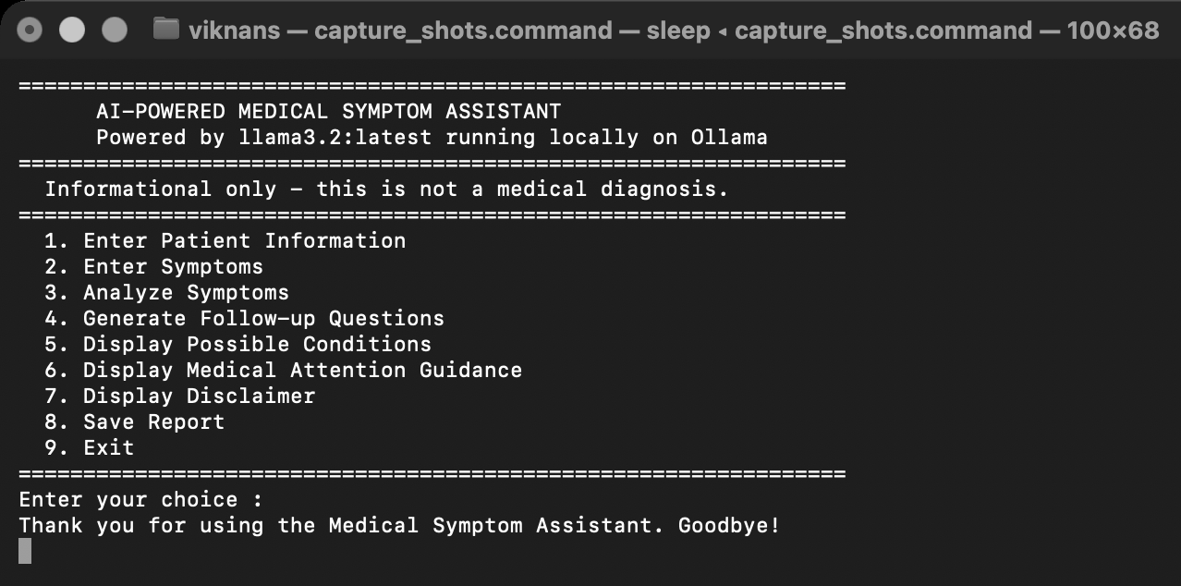
Home Screen
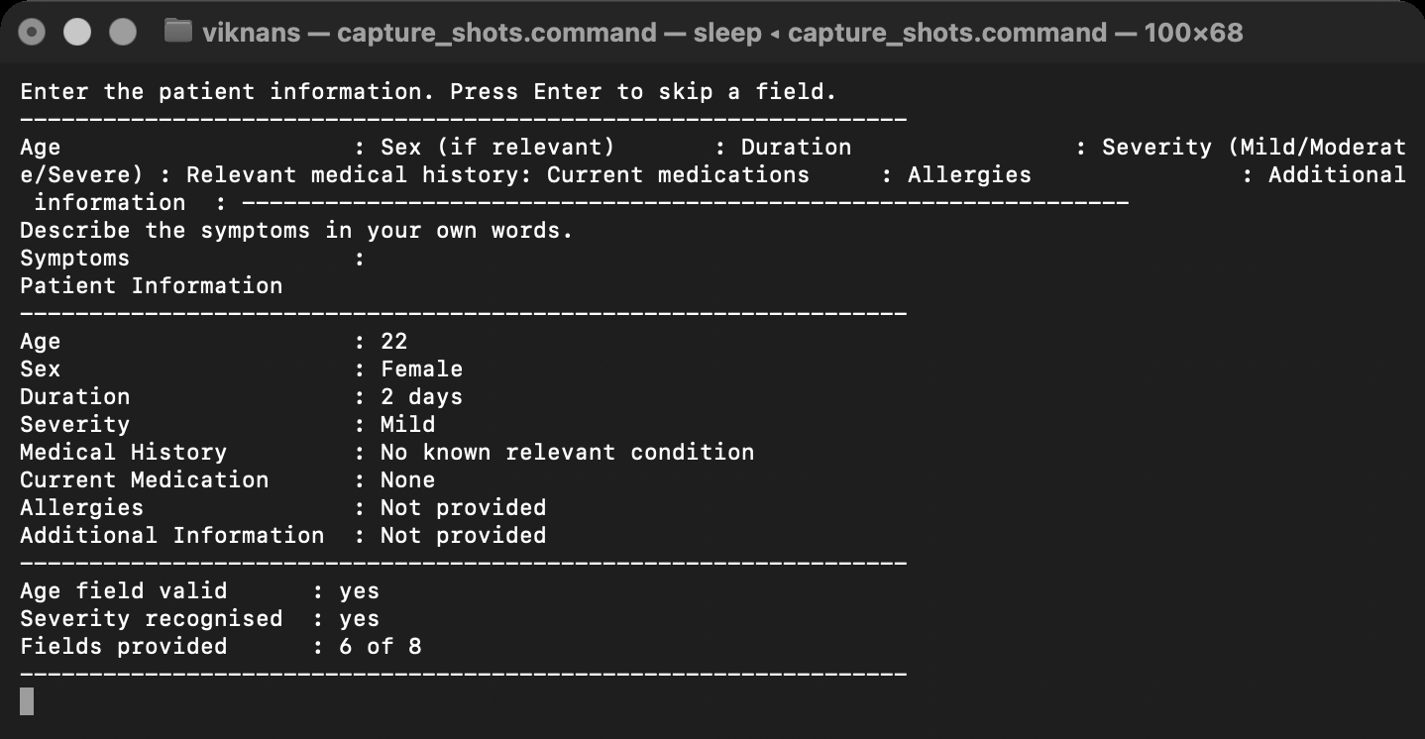
Patient Information Input
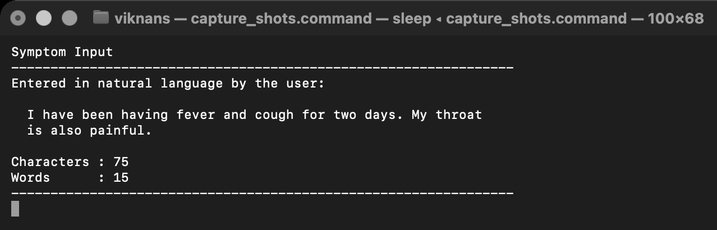
Symptom Input
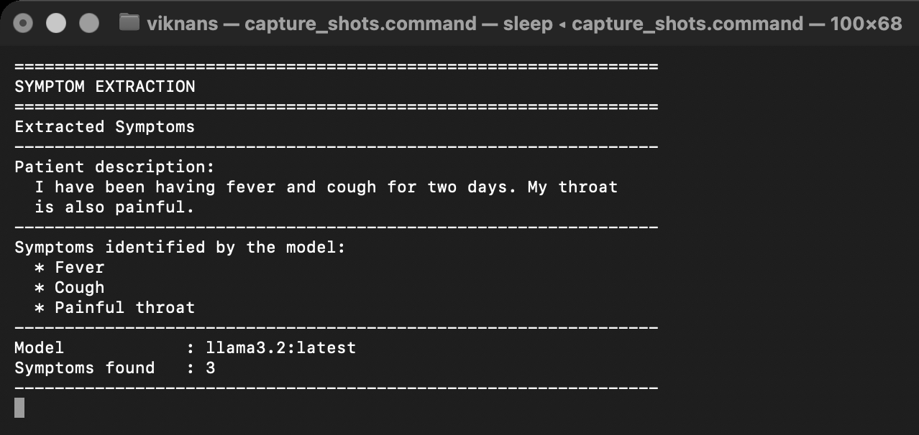
Extracted Symptoms
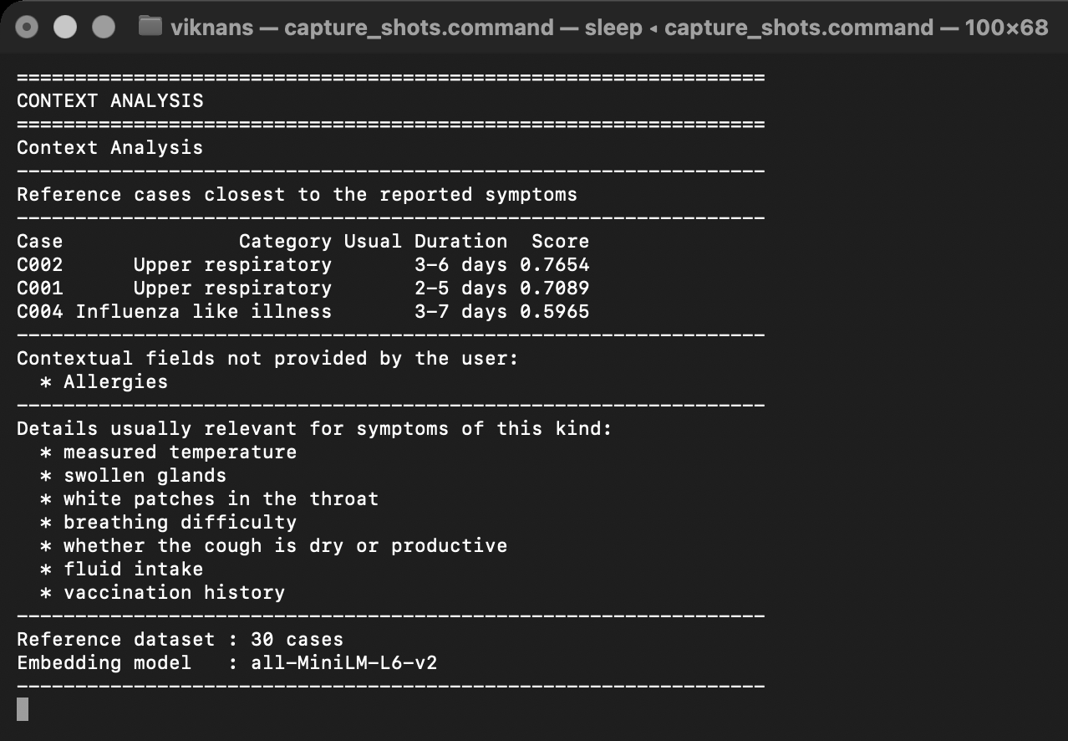
Context Analysis
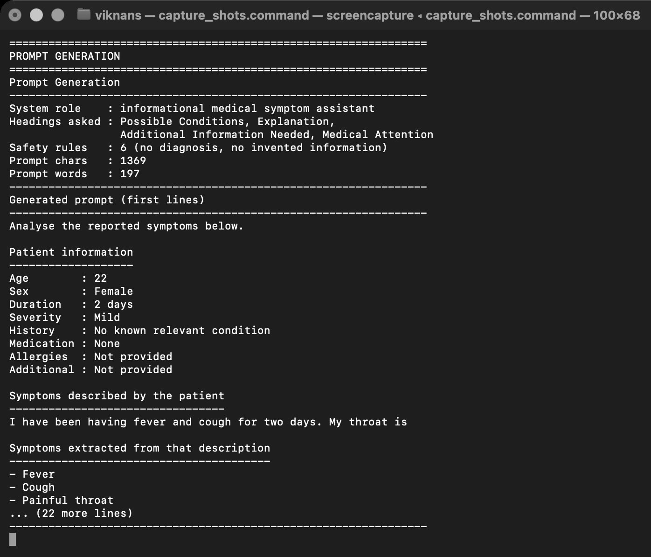
Prompt Generation
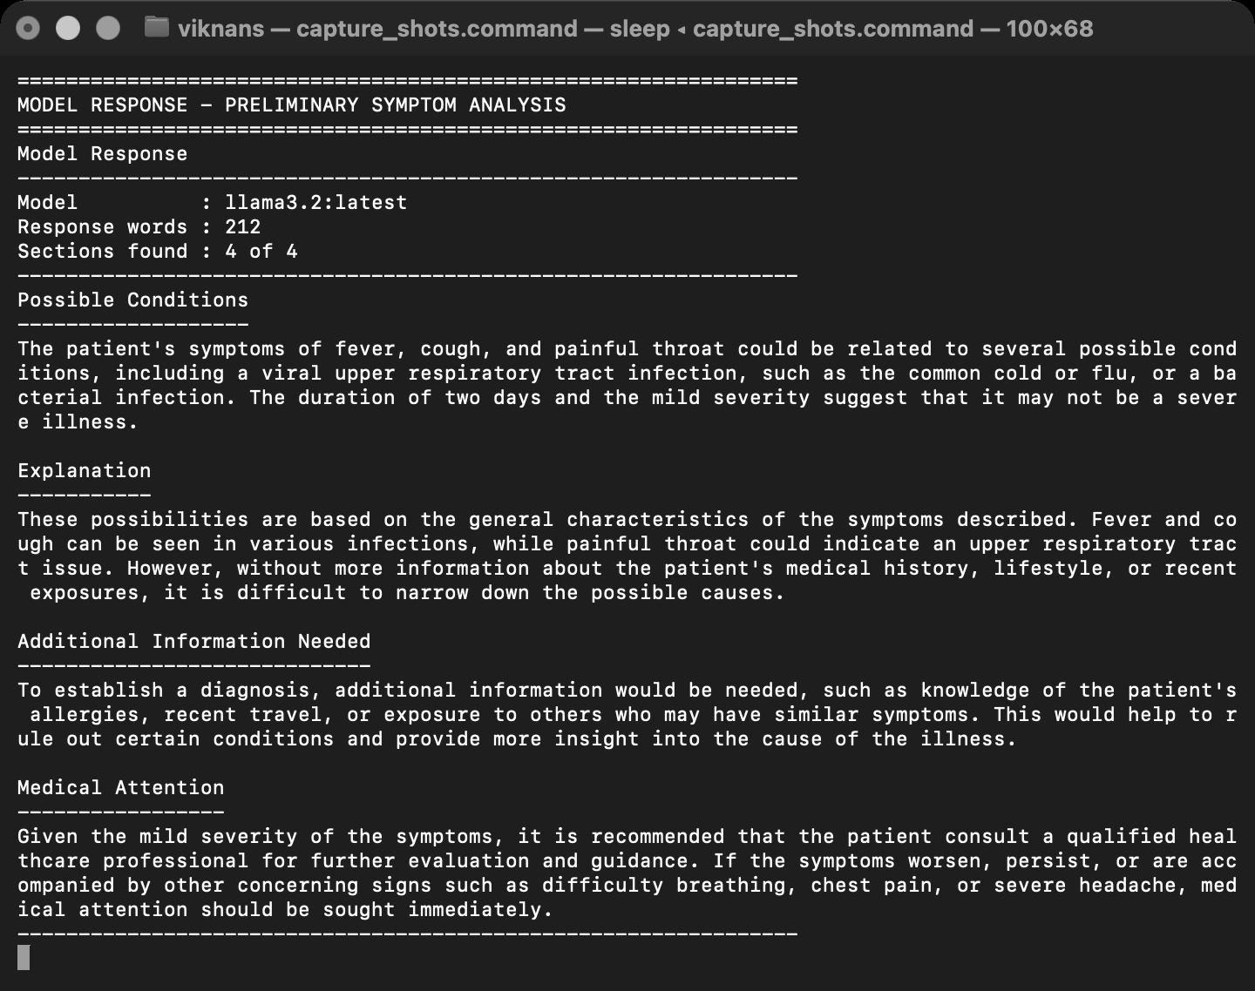
GPT-4 Response
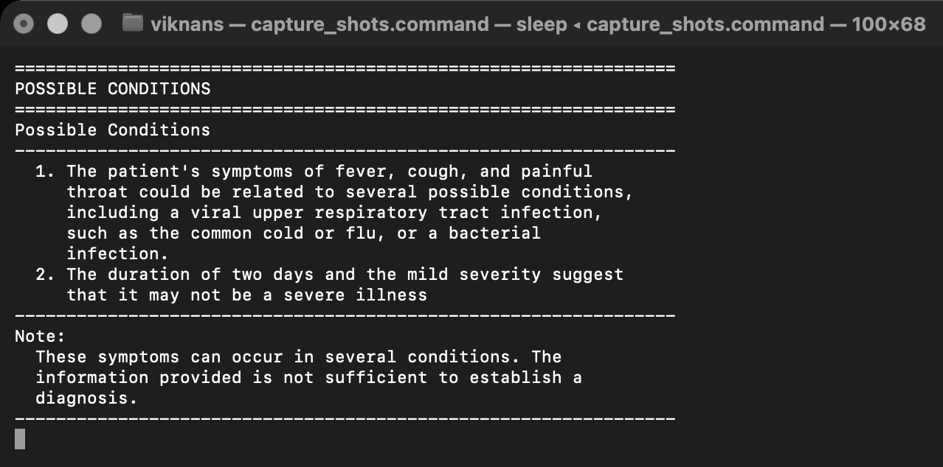
Possible Conditions
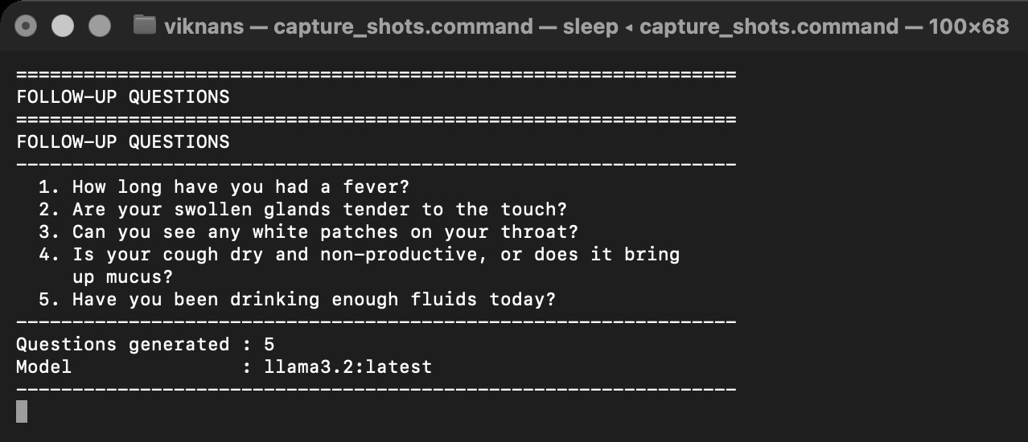
Follow-up Questions
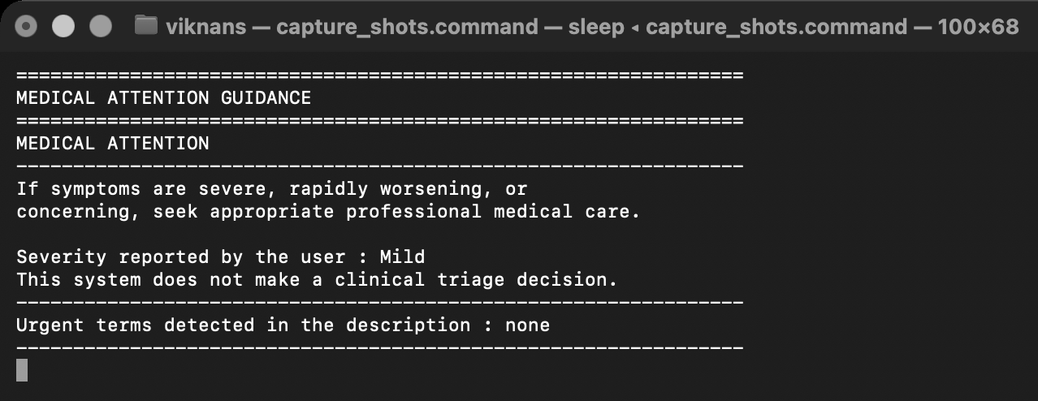
Medical Attention Guidance
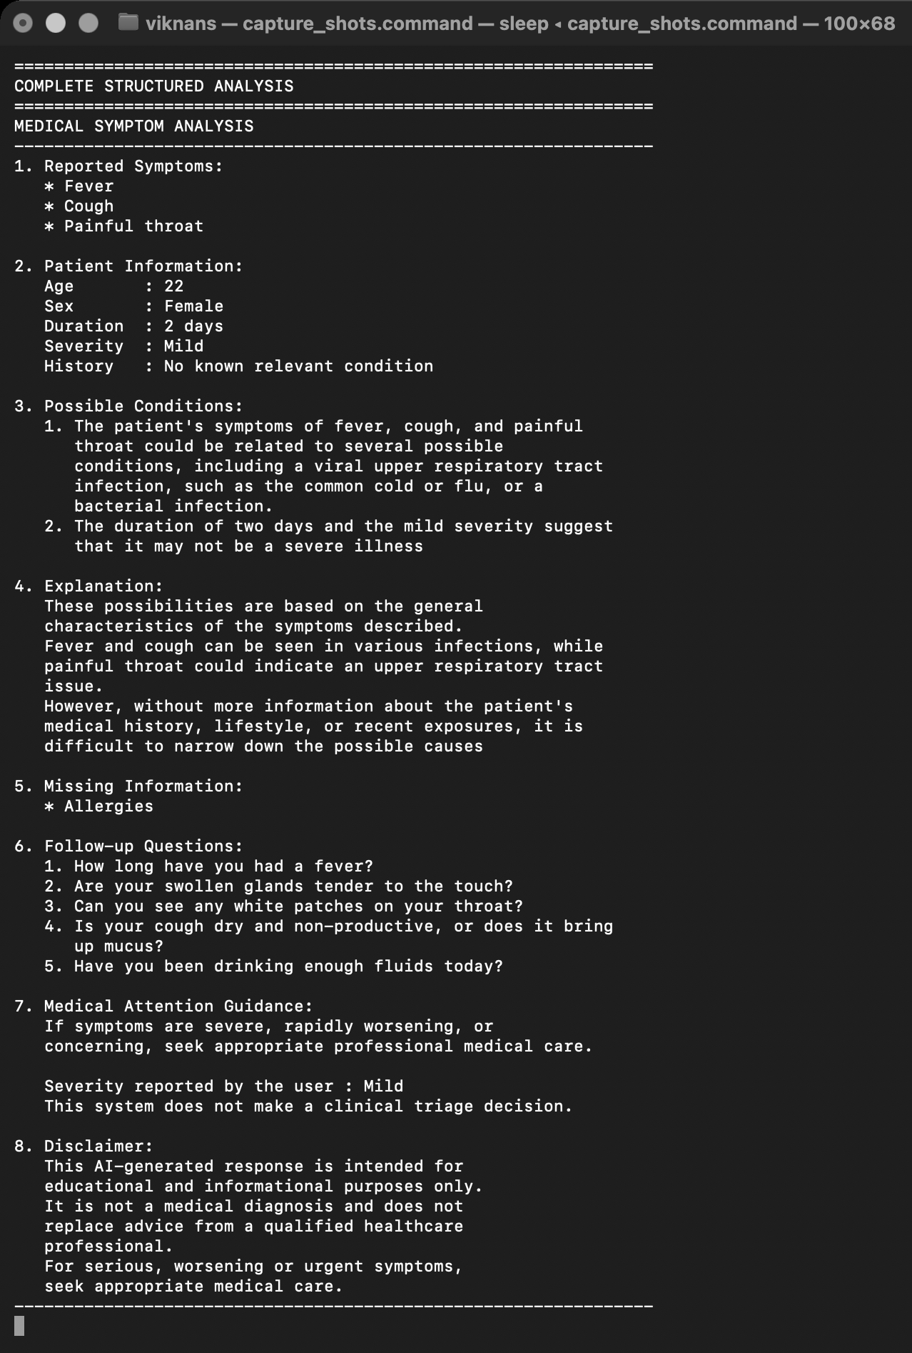
Complete Structured Analysis
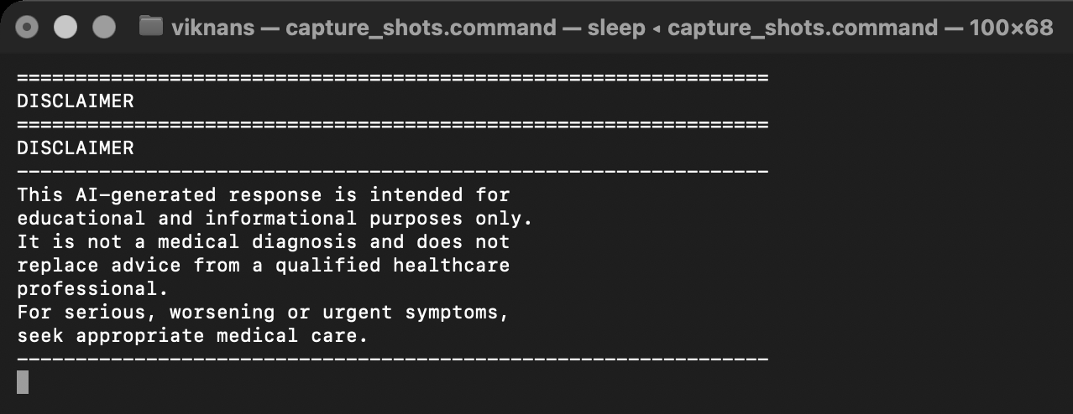
Disclaimer
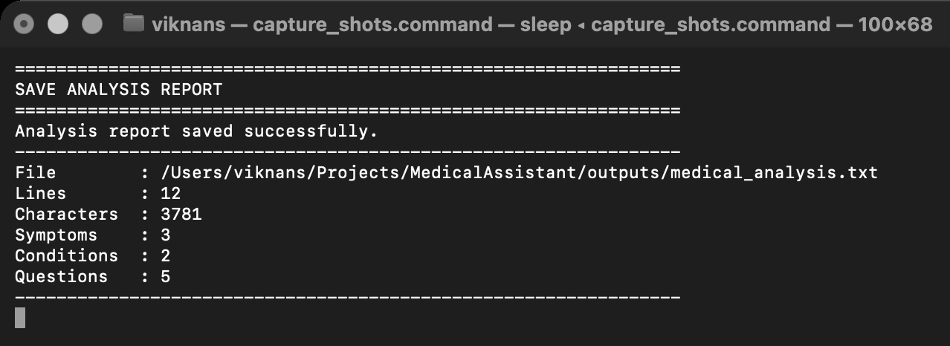
Saved Report
Result:
Thus, an AI-powered medical symptom assistant using GPT-4 was successfully developed. The system accepts user-reported symptoms and relevant contextual information, performs preliminary symptom analysis, generates possible conditions and follow-up questions, provides appropriate medical-attention guidance and produces a structured informational response with a safety disclaimer.

