

Executive summary

Monolithic applications are a single code based applications that primarily have one build and deployment unit. Here, the scaling is limited as running a copy of the whole system is resource-intensive. No wonder, the monolithic applications have been successful in the past and will continue to be used in coming days, but as cloud is acquiring dominance in decision making, monolithic needs to be revisited as they will stop serving the picture. The change cycle brings in a lot of challenges, as the changes are tied together – even if a small part of the application is changed, then the entire monolith application is required to be rebuilt and deployed. Evolution of SOA did not change the way monolithic applications were designed or run as a modular structure, making it further difficult to keep changes that ought to affect only one module within that module. While scaling an application means scaling the entire application and not the individual components which in turn require greater resource.

What is Microservice?

An architectural style of developing a single application as a suite of small services, each running in its own process and communicating with lightweight mechanisms, often an HTTP resource API.

- By Martin Fowler

However, there has been a lot of progression in areas of Cloud, DevOps, and Continuous Delivery leading it to the next evolutionary concept in SOA (service-oriented architecture) realm i.e., Microservices1. In the below whitepaper, success mantra is the focus. Tools, frameworks, patterns, techniques etc. are the focus. Nagarro’s own experience has been discussed in detail.

Introduction

Microservices tend to accommodate some of the challenges associated with large monolithic applications that are developed using SOA. The following image shows few challenges that are faced by monolithic applications:

Challenges faced by monolithic applications
Scaling Issues
Technology Evolution
Continuous Delivery
Difficult to scale the application as it has to run multiple instances behind a load balancer. Individual component scaling is not possible. Additionally, the dependencies of ESB make choices difficult.
Not able to support fast technological changes and the lesser time to market. Additionally, the various integration patterns and principles like SOA adds to complexity.
It is quite challenging to follow a continuous delivery practice where there is a single large code base as each component/module needs to be built, tested and deployed for change.

Figure 1: Challenges faced by Monolithic Applications

Solution to this?

Microservices: These are functional system decomposition, decomposed into manageable and independently deployable components.

Here, the term micro refers to the small team size of developers. Each Microservice is complete with Resource representation and Data Management.
SOA and Microservices, both are service based architectures, meaning they place importance to services as a primary architecture component. However, both of them are quite different in characteristics and usage.

Characteristics and Usage Comparison of SOA and Microservice based Architecture (MSA)

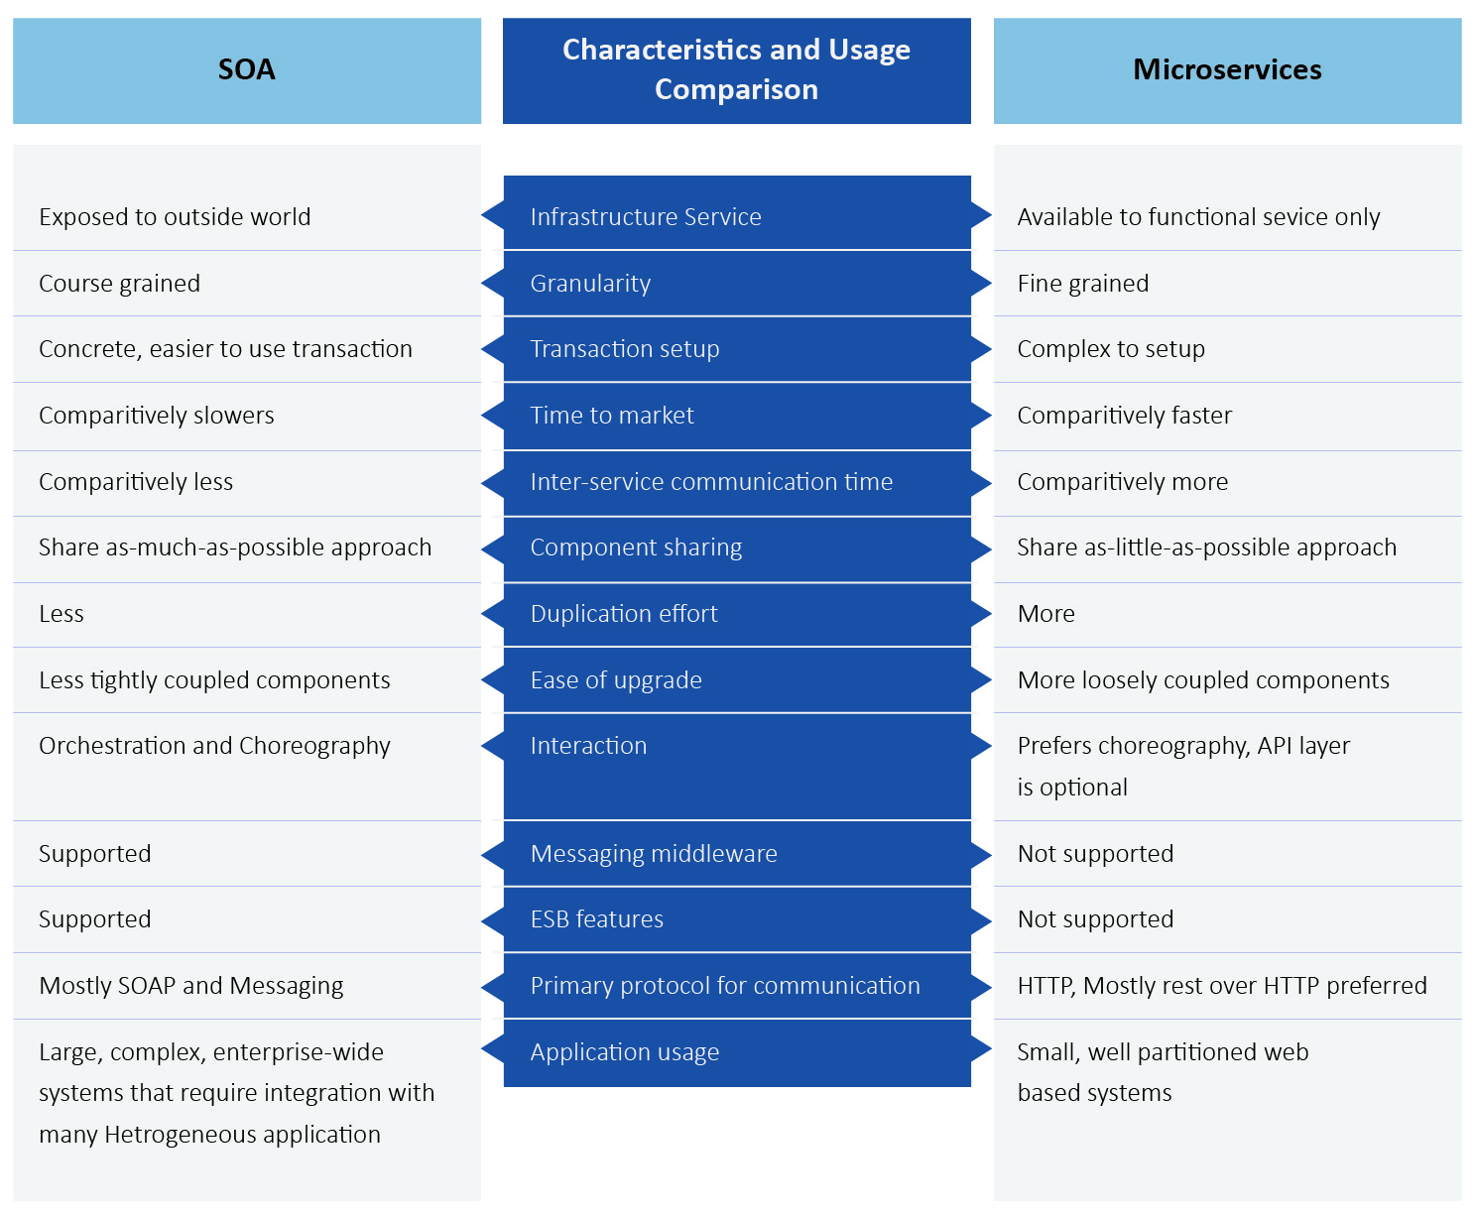

Figure 2: Characteristics and usage comparison

Microservices can be summarised as an evolution from SOA, in which finer grained services are created which are independently scalable and rapidly deployable. The above figure discusses the difference between SOA and Microservices.

Microservice architecture (MSA)
MSA is a software architectural style in which the problem statement (requirement) is functionally decomposable and each part of the proposed solution is developed and deployed separately as a Microservice. These Microservices may interact among each other using HTTP protocol or via Messages.

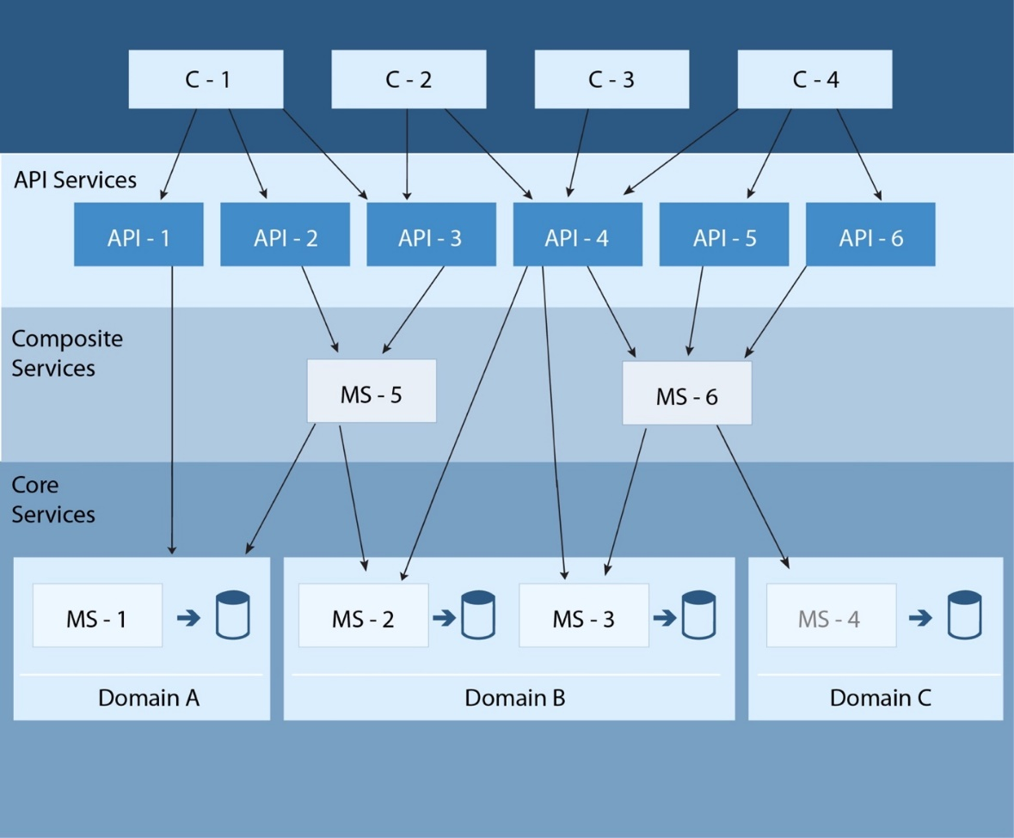

Figure 3: Microservices logical architecture

MSA Characteristics

Microservice itself being an application contains state and/or logic to meet business requirement. Microservice based architecture has some key identifying characteristics which are:
- Autonomous: Microservices are developed, deployed, and governed independently. Full stack teams of small size implement the requirement in programming language and database of their choice.
- Decentralized data management: Functional decomposition can be easily achieved using domain driven design. This results in decentralized data management for services.
- Single Responsibility focus: Each Microservice has a single responsibility scope and should strive towards loose coupling and high cohesion.
- Owning build and deployment: A Microservice build and deployment task is independent from other Microservice build and deployment task.
- Discoverable nature of services: Services can be registered and discovered over the network.
- Infrastructure automation: To support auto-scaling nature, Microservices can be deployed on containers or on Cloud platforms.

MSA and Design Considerations

The following design considerations are taken care while moving towards MSA:

- Inter-services Communication: For communication between Microservices, REST over HTTP is a recommended approach for lightweight communication.
- Testing: Distributed transaction and Integration tests are quite complex to set up in Microservices due to the large number of fine grained services.
- Deployment: Each Microservice should be independently deployable where a single repository for each service should be given preference. Selection of cloud, container technologies like Docker help in managing deployment across environments.
- Failure Isolation: In case of MSA, chances of failures increase multi-fold, as number of the services increase. To mitigate the risk of failure/disruption in service to users, design patterns such as Timeouts, Circuit Breaker etc. are employed.
- Monitoring: To monitor data from various Microservices, tools (like Logstash or Splunk⁷ to query and aggregate logs from various Microservices) aid in understanding the system behaviour and diagnose performance issues.
- Documentation: Tools like Swagger⁶ or Postman Collections are used to document numerous Microservices (RESTful APIs).
- API Gateway: API Gateway provides a way to handle cross cutting concerns such as authentication, rate limiting, quota management, analytics, etc. Various open source and commercial solutions are available for implementing API gateway.
- DevOps Automation: It’s an approach to better manage frequent iterations of code deployment through automation of change, configuration, and release processes. It understands the dependence of software development on IT operations. This has far greater importance, since the application is deployed on the cloud and infrastructure services being part of the code now.

When and where MSA makes sense

In applications where changes are smaller and frequent, it makes sense to have MSA implemented. Here, the overall system is never unavailable as the newer version releases of Microservice are mostly deployed independently of execution of another Microservices. MSA supports both Web apps and Mobile apps.

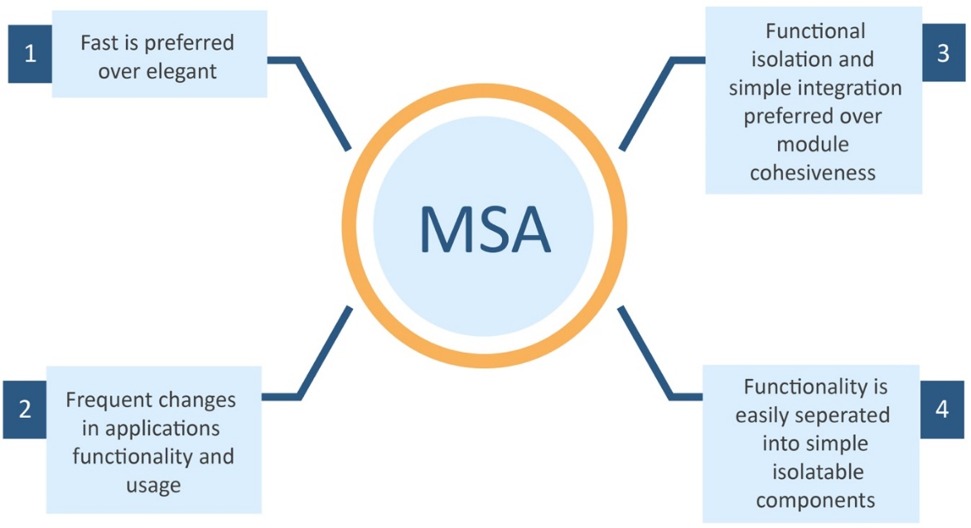

Figure 4: Preferred key attributes for MSA

For example, an app that extracts data from various sources can use MSA, to develop Microservice for extracting information from each provider. Also as services evolve, the app can support several versions concurrently.
Microservices can be used to build solutions across various verticals. MSA can be implemented in either Greenfield project or Brownfield project.

It’s comparatively easier to implement MSA for Greenfield projects as there is no dependency of older complex architecture and one is free to implement MSA using the best practices. Irrespective of the project type, the first task is to define the boundaries of the new components.

Greenfield MSA Project

The key points to take care for fast development and easy integration of Microservices are listed below:
- Single responsibility of each Microservice.
- Each Microservice may implement UI and manages data associated with its single responsibility function.
- Small size full stack team independently produces a Microservice.
- Independent build and deployment management for each Microservice.
- Mostly stateless communication.
- Version management is supported for Microservices.

Brownfield MSA Project
However, in Brownfield projects implementation on MSA, migration might not be straightforward due to:
- Complex nature of integration
- Design issues (such as tightly coupled systems)
- Use of legacy technologies such as AS400
- Unified data storage for transaction, reporting and master data.

An example could be a payment component in Monolithic application which could be refactored in a Microservice. Here the application may have its own UI, followed by a middle tier which interacts with other services (using Messaging Systems and Queues) like Order details, Customer details and may store data in its own database. Refer below illustration for migration of Monolithic components to Microservice.

Migration of Monolithic components to Microservices

Another examples could be Product catalogue Microservice (for adding/updating/retrieving/deleting products), Shipping Microservice, which handles the shipping of the products to the customer.

MSA & Containerization

A discussion on cloud computing cannot be held without talking about containers. Organizations across all segments, from insurance, e-commerce, banks, and major financial service firms want to leverage containers for specific development and IT operations scenarios. So what are containers? Containers are complete eco systems which are given a restricted amount of CPU, a limited amount of memory and a network setup that runs independently of the other containers. Hence containers are associated with extremely fast startup, standardized application packaging and isolation model which is best suited models for Microservices. The term ‘containerization’ refers to the basics of containers; the way containers work and the widely used scenarios where the containers fit in.
Microservices are packaged as containers and many usually fit within a single server or virtual machine with fast deployment. With this model, Microservice scale-out can be nearly instantaneous, allowing an application to adapt to changing loads. The loose coupling containers also mean that Microservices can scale independently.

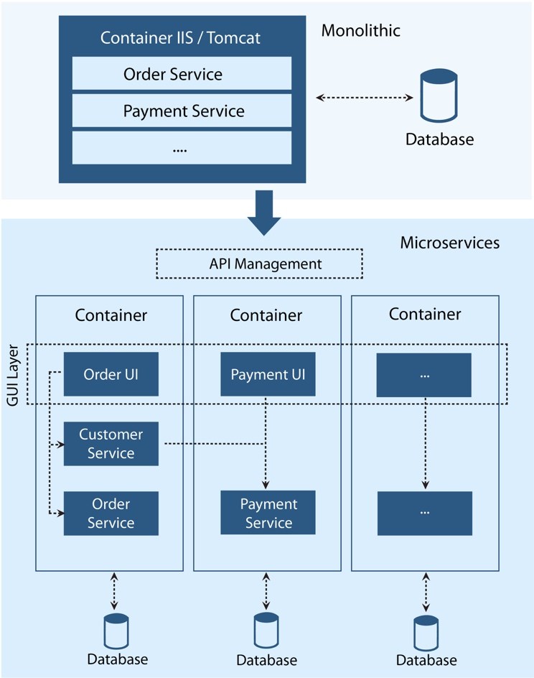

Figure 5: Migration of Payment component to Microservices

Importance of Dockers
Docker is basically an open source project that largely automates the deployment of applications inside software containers by providing an additional layer of abstraction and automation of OS level virtualization on OS. Docker uses the resource isolation features of the OS kernel such as cgroups and kernel namespaces and filesystem such as aufs to allow independent "containers" to run within a single OS instance. Dockers provide good options for deployment of Microservices,
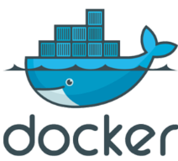
as it isolates containers per service. This makes it easy to manage/update the services. Lot of open source frameworks around Dockers have come up. One such framework is Kubernetes⁸ for easy deployment and management of multiple Docker containers of the same type. Another implementation is Hyper-V Containers in Windows Server 2016. Hyper-V containers enhance the isolation provided by windows server containers by running each container in a highly optimized virtual machine in which kernel of the container host is not shared.

Microservices Design Patterns

Implementation of Microservices involve various key design patterns such as aggregator (higher level composite Microservice), proxy (to delegate), shared database, event sourcing, CQRS, circuit breakers, asynchronous communication and some advanced patterns such as transaction complexity. There is an overlap between cloud patterns and Microservices patterns.
Below are some of the key patterns which Nagarro has used for successful implementations of the projects.

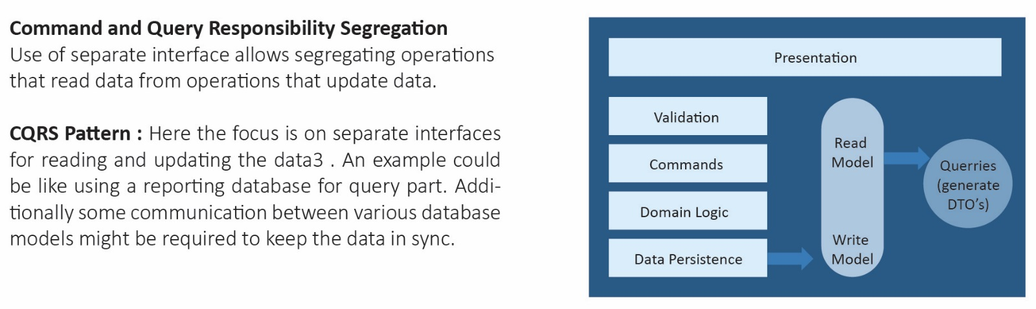

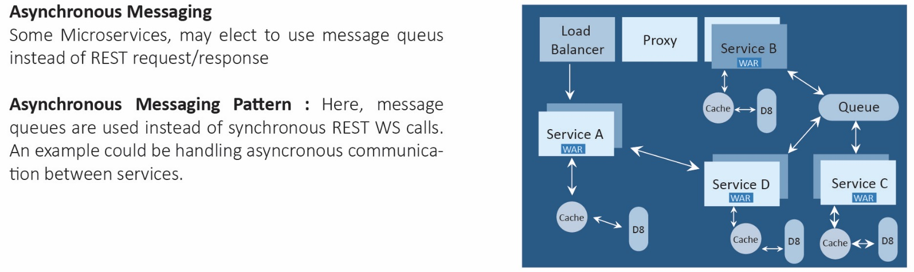

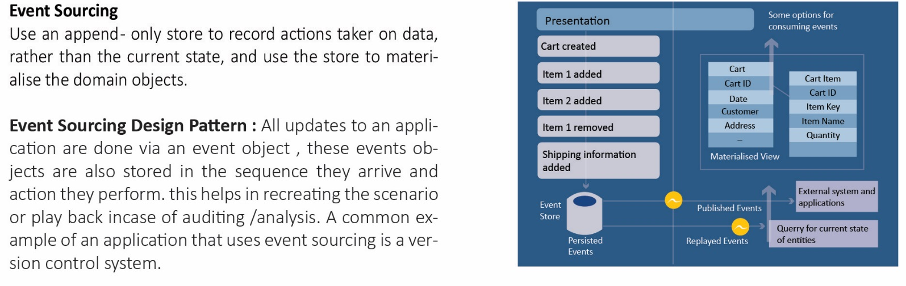

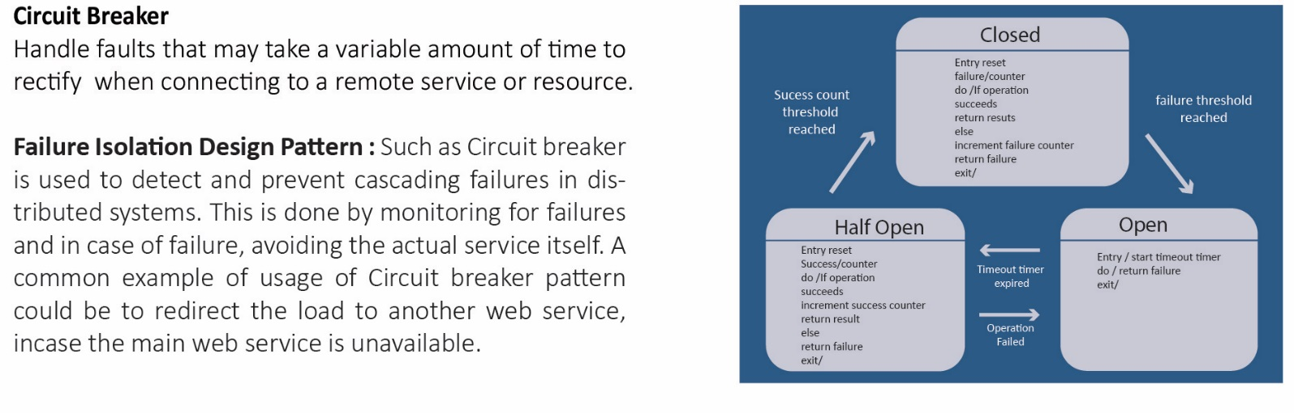

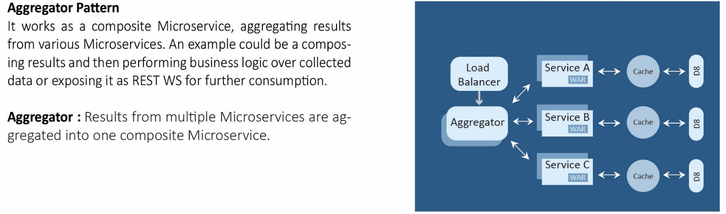

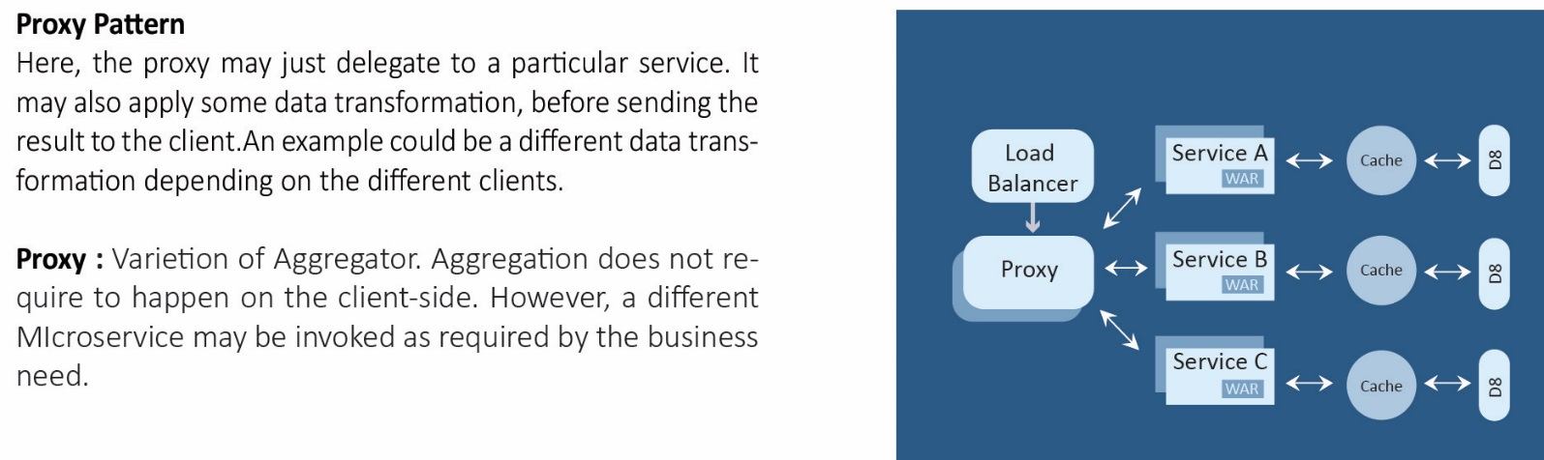

Microservices Frameworks across various Platforms

Microservices can be implemented across various technologies such as Java, .NET, Python etc. and across various platforms such as Windows, UNIX etc. These can be hosted locally or on Cloud platforms such as AWS, Azure etc. These platforms provide a formal structure to jump the bandwagon. Here is a brief summary for various frameworks available in open source and commercial world.

Open Source frameworks/platforms

- Spring Boot/Cloud: These are projects which are built on top of spring framework. They provide additional features such as embedded server, service registration & discovery, routing, load balancing, circuit breakers and more for implementing Microservices.
- OSGI: Open Service Gateway Initiative defines architecture for developing modular applications and managing cross dependencies between them. Popular open source OSGI containers are Equinox, Knopflerfish and Apache Felix.
- OpenShift: It is an open source PAAS by Red Hat that leverages Docker container based packaging for deploying container orchestration and compute management capabilities for Kubernetes, enabling users to run containerized JBoss Middleware, other programming languages, databases and other application runtimes. OpenShift Enterprise 3 also offers a complete DevOps experience for developers/architects to automate their applications builds and deployment process.
- Netflix OSS: Netflix¹³ open-source software ecosystem. This platform provides service discovery through Eureka, distributed configuration through Archaius, resilient intelligent inter-process service communication through Ribbon and provide reliability beyond single service calls using Hystrix¹³.
- AKKA.IO framework: Is an open source, actor based system which provides toolkit and runtime for development of distributed applications. Some of the features which help us in Microservice development are clustering support, loose coupling, high resilience, performance and scalability.
- Orleans framework: Is an open source, actor (synonym is Grains) based framework from Microsoft for developing distributed, scalable applications. These applications are meant to be deployed in cloud.
- Express for Node JS: Express.js is a Node.js web application server framework, designed for building web applications.
- Dropwizard: Is an open source framework from Yammer for developing high-performance RESTful services. Dropwizard has out-of-the-box support for sophisticated configuration, application metrics, logging, and operational tools.
- Spark: Is an open source Java framework for developing REST API's, but it also supports template engines.
- Sinatra: Is an open source software web application library and domain-specific language written in Ruby which does not follow the MVC pattern.
There are technology libraries from different providers which can be used for defined operation such as Service discovery server is provided by Netflix Eureka, Dynamic Routing and Load Balancing is provided by Netflix Ribbon, Circuit breaker implementation, Monitoring is provided by Netflix Hystrix. Additionally, there are other open source frameworks which are (both open source and commercial) supported by Microsoft Azure. The following section discusses various frameworks that are supported by Microsoft Azure.

Microsoft Azure supported

The most of open source containers /platform will run on Azure. However, there are some services available for Microservices in Azure which will have huge impact. Some of them are:
- Service Fabric: Microsoft evolution of Microservices is in the form of service fabric. Service Fabric powers many hyper scale cloud services including DocDB, Cortana, Intune and Skype for Business as well as many internal Azure infrastructure services. Service Fabric runs on Windows with any .NET language whereas Linux and Java support are under development. Service Fabric offers:
  - Extensible lifecycle management
  - Hybrid deployments
  - Health models for both the infrastructure and Microservices.

This simplifies DevOps as it enables automated health based upgrades and automatic rollback mechanisms. Both stateless and stateful Microservices are offered in Service Fabric with data consistency support.
- Mesosphere DCOS with Apache Mesos and Marathon: Cluster management capabilities of Apache Mesos are expanded with Mesosphere by additional components to manage large server infrastructures. Microsoft and Mesosphere have partnered to bring these components of the Mesosphere Datacentre Operating System (DCOS), Marathon and Swarm/Compose and to Azure. Mesos integrate with the Mesosphere DCOS, which is built atop Mesos. The Mesosphere DCOS provides Microservices platform capabilities including load balancing, service discovery, health checks, and metrics aggregation. Marathon, also available in Azure is a framework for Mesos that is designed to launch long running applications.
- Kubernetes: Kubernetes, originally developed by Google in 2014, is an open source system for automating deployment, operations, and scaling of containerized applications8. It groups containers that make up an application into logical units. With Kubernetes, applications can be quickly deployed, scaled and hardware optimised resulting in decrease time to market.

Available Commercial Products

Apart from the open source frameworks, some commercial products are also available. Few of the commercial products are mentioned below:

- Pivotal Cloud Foundry Pivotal Cloud Foundry is based on open source Cloud Foundry project. It enables MSA by combining workflow and container scheduling from Cloud Foundry with integrations for MSA patterns like service discovery, client side load balancing, circuit breakers and distributed tracing. It utilizes Spring Cloud and NetflixOSS. It supports Microservices operations using deployment and service management capabilities such as auto scaling, health monitoring, application metrics, streaming logs etc.
- TIBCO Business Works product suite: TIBCO products such as ActiveMatrixTM, TIBCO Enterprise Administrator (for administration and monitoring), Silver Fabric (for Continuous Integration and Continuous Delivery) and API Exchange (Service gateway) are some of the products which are used to create and manage Microservices.

Nagarro, has adopted MSA by successfully implementing it in various projects.
- Jolie Enterprise: It is the suite from italianaSoftware which allows for an easy and rapid service deployment. All the deployed services are continuously monitored and checked. More information available at http://www.italianasoftware.com/products.html
- IAM.Dockables: IAM.Dockables™ are based on the open source IAM Microservices community (www.iamdockables.org) that is building Microservices for social, mobile, and classic identity and access management functions. More information available at http://www.gooddoglabs.com/
- Nginx Plus: It is a commercial product from Nginx Inc. Some of the features provided by it are activity monitoring, advanced load balancing, high availability and more. More information available at
http://www.infoworld.com/article/2612108/open-source-software/nginx-takes-the-slippery-road-away-from-open-source.html

Microservices Ecosystem

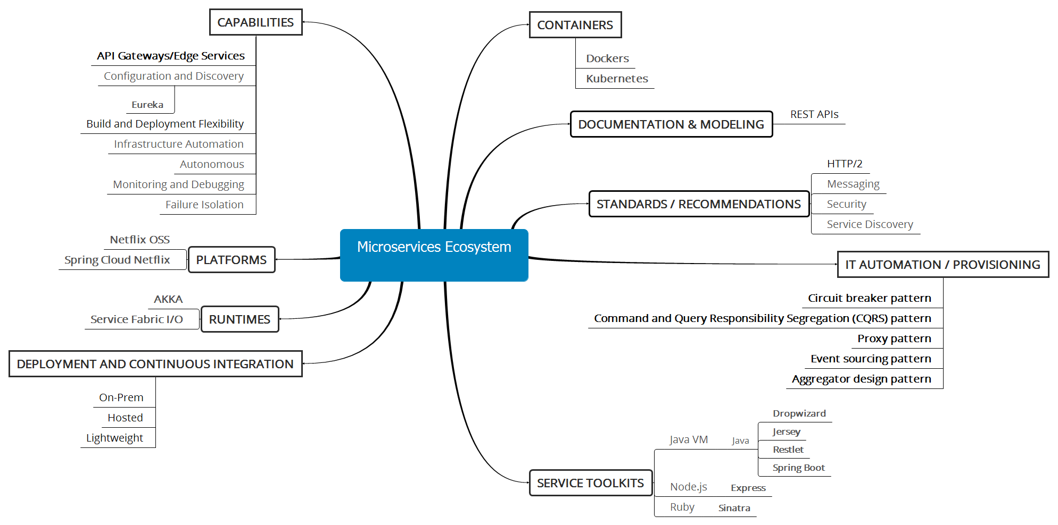

Figure 6: Microservices Ecosystem

The above diagram depicts the Microservices ecosystem¹³ that covers the capabilities, patterns, various standards (including modelling) and technologies involved across platforms, runtimes, deployment (including containers), and service toolkits. Note: The frameworks highlighted in bold font in

Framework Recommendation

Open source

Within open source frameworks, Spring Cloud with Netflix libraries⁹ offers easy and scalable architectures. The same can be clubbed with other available containers or platforms like Dockers, Kubernetes, Azure etc. to make a scalable solution. A reason for selecting such a combination is that the:
- Spring Ecosystem has benefit of underlying spring modules, such as IOC, AOP. Spring Cloud provides APIs for discovering and connecting to services.
- Netflix libraries provide a robust, enterprise product such as Eureka, Ribbon and Hystrix.
- Microservices can be deployed to Cloud infrastructure and Docker/Mesos containers.
- Service Fabric in Microsoft world enables developers to build and manage scalable and reliable applications composed of microservices running at very high density on a Service Fabric cluster. It provides an extremely sophisticated runtime for building distributed, scalable stateless and stateful microservices.
Other important open source frameworks are Cloud Foundry, Apache Mesos, Dockers etc. which are heavily used in industry and both AWS and Azure are supporting the same.

Commercial

Among commercial solution, Pivotal Cloud Foundry and NGINX Plus (instead of open source NGINX) finds good traction in industry. They both support AWS and Azure. From frameworks perspective, Using Spring Boot based frameworks with Netflix is still preferred.

MSA at Nagarro

Nagarro capability in MSA

Nagarro’s capability in Microservices involves the following areas:
- Consulting: To provide expert advice to clients on building application with Microservices or migrating existing application to Microservices architecture.
- Implementation: To implement the solution according to Microservices Architecture keeping in mind the best practices and design principles (like Circuit breaker).
- Monitoring & Alerting: To monitor numerous Microservices on dashboard and generate metrics, alerts depending on certain conditions.
- DevOps automation: DevOps infrastructure automation approaches will help you achieve this by facilitating auto scaling, golden images, automatic deployments and dynamic service registration at runtime. This is facilitated using cloud services.
- Complex test automation: Testing becomes much more complex in a distributed Microservices based application.

Challenges in Adoption

Microservices comes with its own share of challenges. Some of them are:
- Increased redundancy of data, due to database isolation.
- Rapid provisioning of new infrastructure.
- Increased operational complexity: The right tools should be in place for visualizing and coordinating the deployment and also ensuring that the complex interactions between these systems are being monitored and audited.
- Slower debugging/maintenance among different technical stack application: Using multiple language and technology stacks to build services accompanied by lack of standardization slows down the development.
- Increased effort for backward compatibility and versioning: Due to higher number of fine grained services, more effort is required for backward compatibility and versioning.
- Testing the whole system/Integration testing: Since a system is composed of many Microservices, integration testing becomes a complex exercise.
- Distributed transactions are even more complex to setup. Lack of standardization among all the MSA providers, causes inter-operability issues.

Nagarro success stories in MSA

Nagarro has implemented large scale solutions involving both migration and development from ground zero. One of the major projects was for major airline, where MSA was successfully followed. Here, the legacy monolithic application was migrated to Microservices to derive benefits such as technology heterogeneity, resilience, scaling, and composability and it was optimized for replace ability.

Success Mantra

Modern applications require services to be proficient, highly scalable, robust, independently managed, and build using the best suited technology.
Microservices offer solution taking care of all the above criteria. Here the services can be developed, deployed, and scaled independently of one another. This gives a greatest amount of flexibility and control. There are mechanisms and processes which have been pioneered and made available by high-profile companies like Netflix who give an approach for successfully supporting the Microservices architecture.
Nagarro recommends the following changes across processes, mind-set, technology, design etc. to achieve successful Microservices project. This is summarized in following diagram Following are some of the focus areas to successfully implement MSA within the organization:
- Full stack teams: Projects must have full stack teams for development of Microservices.
- Mind-set Change: MSA and DevOps require mind-set change. This is not easy when there has been huge legacy which needs to be unlearned to relearn the fast track development cycles.
- Use proper patterns for Microservices: Patterns such as circuit breakers are generally used to provide stability and prevent cascading failures in distributed enterprise systems. This help in redirecting the requests to another system in case the primary service is unavailable. Design patterns such as timeouts with circuit breaker patterns, helps in overall system quality.
- 12 Factor Apps⁴: The 12 factor is a good set of advice and an approach to build apps that will increase agility through process, tools, and culture. It may refactor the monolithic EAR into Microservices living in JARs.
- API Gateway: Implement API gateway using a high scalable concurrent framework such as AKKA.IO and Spring Cloud.
- Optimum utilization of PaaS Services: Utilize cloud PAAS/SAAS for application needs like database, caching etc.
- Fast provisioning: Project teams must achieve automated mechanisms for machine provisioning. This is achieved by technologies such as containerization (for example: Dockers), Cloud services, and DevOps approach.
- Basic monitoring: Due to large number of single responsibility services, monitoring the system requires more attention. Focus on use of monitoring tools is suggested.

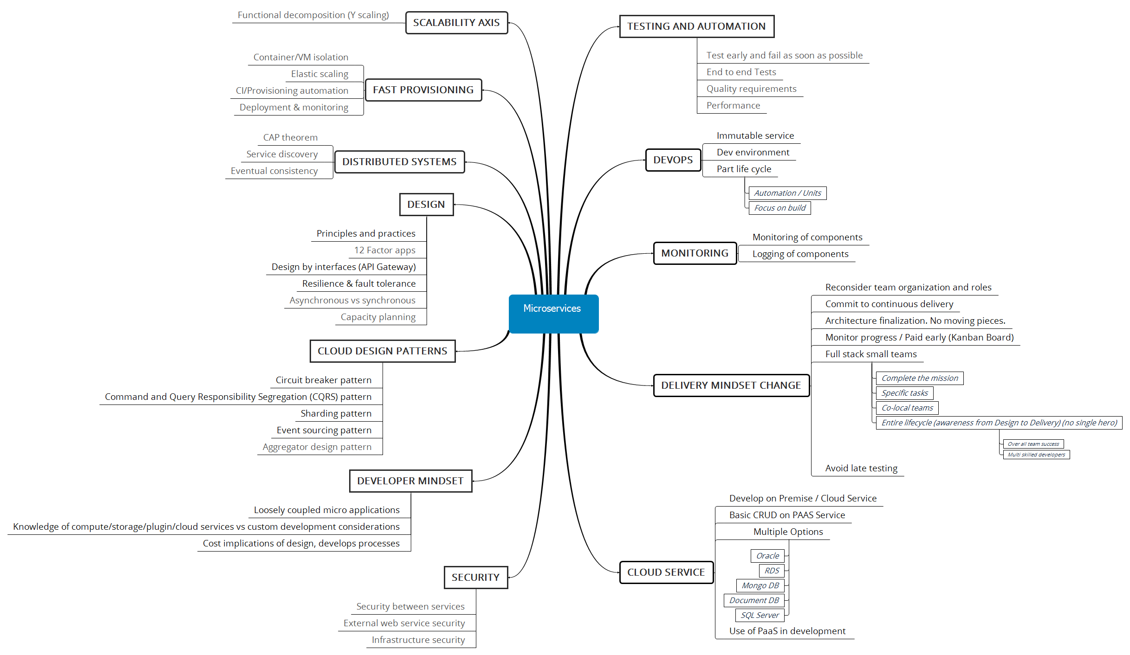

Figure 7: Success Mantra

Conclusion
Business needs to keep improving and evolving in terms of technologies, frameworks, better and efficient processes, newer methodologies and ways to accomplish objectives.
Companies are automating continuously to keep abreast with rapidly evolving challenges. The troika of IOT, Big Data, and Cloud is bringing a rapid evolution of technology. This whitepaper highlights Microservices as a solution which can expedite the software development process and can help to build systems that are more flexible, loosely-coupled and scalable. This makes them (systems) easier to develop and adapt to change. They are definitely more tolerant of failure and in case of failure; they meet it with elegance rather than disaster. It is not necessary for a 100% movement to MSA. This can be partial also. Architects can move only 1-2 services to MSA and keep rest of them as is. The best use case fitment is very essential.
- There is no short cut to this nirvana. Frameworks build using MSA are there but more than that mind-set change is required along with change processes like DevOps. All this combined is a part of the disruption. This change is not easy given the fact that this change is at times painful but it should be remembered that “change is good”. It's also often hard. But to succeed in business, it must be adopted.

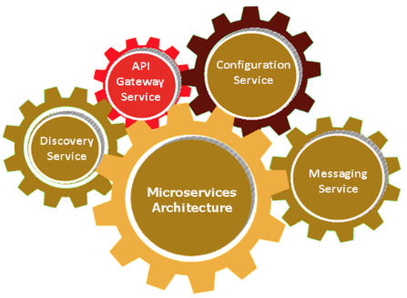

Footnotes

- James Lewis, “Microservices,” Martin Fowler, March 25, 2014, http://martinfowler.com/articles/microservices.html.
- DevOps website, http://devops.com/; Freek van Gool, GOTO Amsterdam 2015: The Microservices Track,” Trifork Blog, April 29, 2015, http://blog.trifork.com/2015/04/29/goto-amsterdam-2015-the-microservicestrack/; “Monoliths to Microservices,” Qcon New York, https://qconnewyork.com/ny2015/track/monolithsmicroservices
- “Building microservices with event sourcing and CQRS,” Plain Old Objects, Jan. 4, 2015, http://plainoldobjects.com/2015/01/04/example-application-for-my-qconsf-presentation-about-building-microserviceswith-event-sourcing-and-cqrs/
- “The Twelve Factor App,” 12factor.net, http://12factor.net/
- Martin Fowler, “Circuit Breaker,” Martin Fowler, March 6, 2014, http://martinfowler.com/bliki/CircuitBreaker.html.
- “Swagger Restful API Documentation Specification,” Swagger, http://swagger.io/specification/.
- Splunk website, http://www.splunk.com/
- An Introduction to Kubernetes https://www.digitalocean.com/community/tutorials/an-introduction-to-kubernetes
- Netflix OSS https://netflix.github.io/
- Dropwizard http://www.dropwizard.io/0.9.2/docs/#
- Jersey http://www.gajotres.net/best-available-java-restful-micro-frameworks/
- Play http://www.gajotres.net/best-available-java-restful-micro-frameworks/2/
- Awesome Microservices https://github.com/mfornos/awesome-microservices

About the Authors

Vikas Gandhi
Associate Director | Technology
Vikas has about 18+ years of experience in IT industry. He has experience in large scale enterprise solutions with extensive experience across all aspects of software engineering in Government, commercial, healthcare and educational environments.
He is an avid reader and an evangelist by heart. He loves to explore technical world and deeply inspired by the role technology plays in curing malice present in modern society. vikas.gandhi@nagarro.com

Ashish Balhara
Architect | Technology
Having overall technical experience of 10+ years, Ashish’s core skills involves envisioning, designing and developing medium to large scale enterprise applications from scratch involving JEE technologies (Spring, Hibernate, JPA, Caching, Restful WS), Database technologies (Oracle, MySQL), LogAnalyzer, Elastic Search.
Having strong analytical skills Ashish helps delivering solutions (application architecture and design), estimates, technical reviews, training and mentoring. He is also involved in design and development of Java modernization tool (jMod) at Nagarro. ashish.balhara@nagarro.com

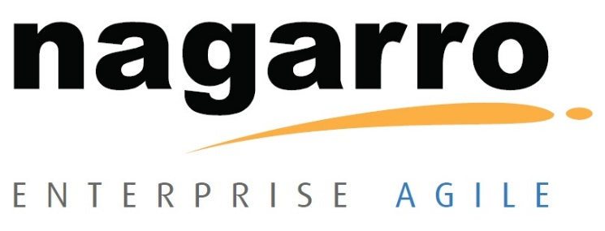
Nagarro specializes in building complex, business-critical software and IT projects for leading companies across multiple industries. Headquartered in Silicon Valley and a member of the Allgeier Group in Germany, Nagarro is recognized worldwide for its technical expertise, agile deployment, and bedrock commitment to customer service.
Nagarro is a Microsoft Gold Certified Partner for application development, collaboration and content. Nagarro has also been named to the Global Outsourcing 100® List by the IAOP® (International Association of Outsourcing Professionals®), earning the highest possible scores in three categories – Customer References, Employee Management and Executive Leadership. Identifying Nagarro among the 25 “Rising Stars”, this ranking reinforces Nagarro’s reputation as a top global provider of business-critical outsourced IT services.

Follow us on:
sales@nagarro.com www.nagarro.com /company/nagarro /nagarro /nagarroinc
© Copyright 2013 - 2016. Nagarro In. All rights reserved. No part of this document may be reproduced, stored in a retrieval system, transmitted in any form or by any means, electronic, mechanical, photocopying, recording, or otherwise, without express written permission from Nagarro Inc. Specifications subject to change without notice. All other trademarks mentioned herein are the property of their respective owners. Specifications subject to change without notice.

