MOBILE DATA ANALYSIS

CODE

**Mobile Data Analysis using hive and visualisation using R-programming and PowerBi**

* Starting Hive



* Checking databases

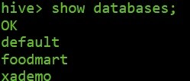

* Creating database



* Using database



* Creating mobile_data table

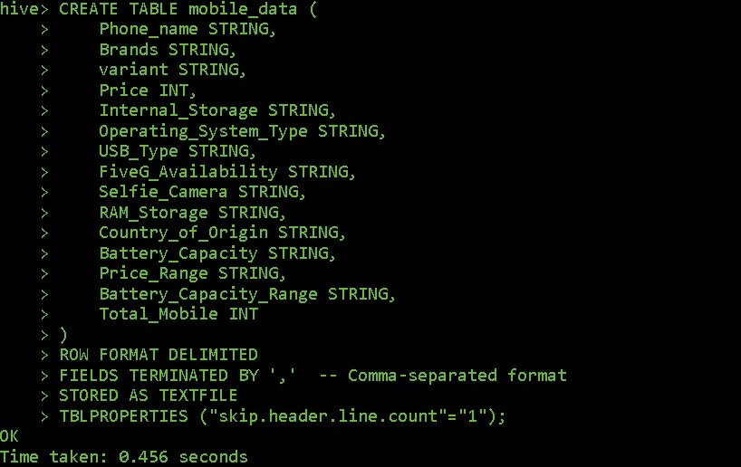

* Loading dataset into mobile_data table

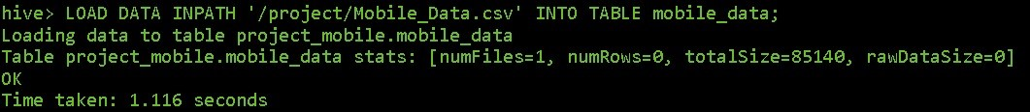

* Checking mobile_data table

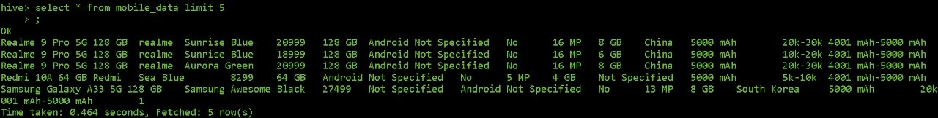

* Average Price of Android vs IOS Phones

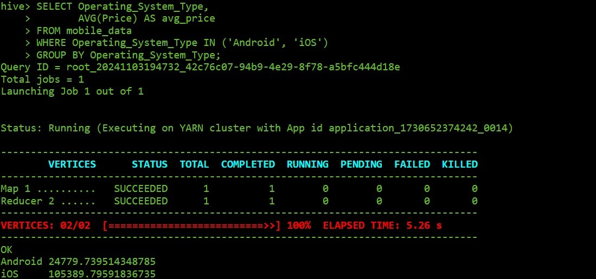

**Query**: *"SELECT Operating_System_Type, AVG(Price) AS avg_price FROM mobile_data WHERE Operating_System_Type IN ('Android', 'iOS') GROUP BY Operating_System_Type;"*

**Purpose**: This query calculates the average price of smartphones for each operating system type, specifically focusing on Android and iOS devices. By grouping the data by Operating_System_Type, it allows for a comparison of average prices between these two popular platforms, providing insight into general pricing trends across operating systems.

**Output**: The query outputs two rows, showing the average price for Android and iOS phones. For example, it might display:

Android 24779.73951

iOS 105389.7959

This comparison highlights the difference in price points between Android and iOS devices.

**Insight**: The results reveal a clear price distinction between Android and iOS phones, with iOS devices typically priced higher. This suggests that iOS targets a more premium market segment, while Android devices offer a wider price range, catering to various consumer budgets.

* Top 3 Brands by Total Sales Value

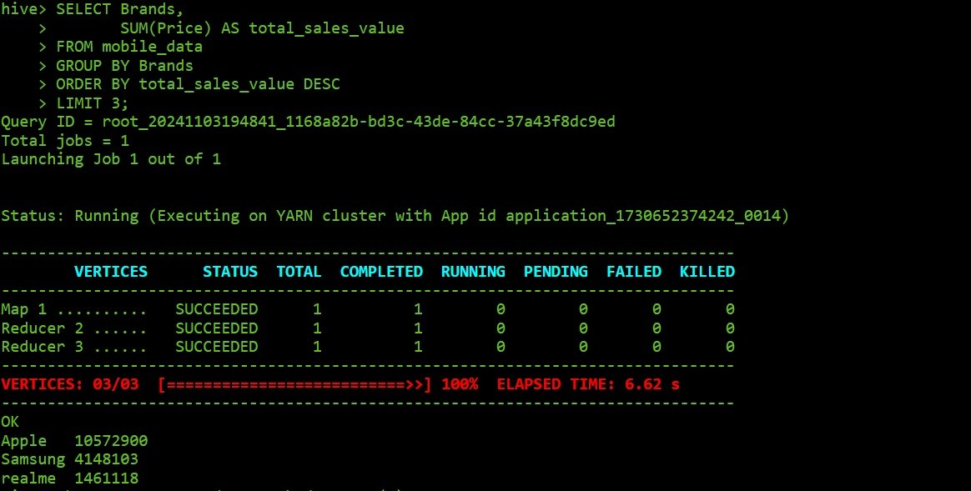

**Query**: *"SELECT Brands, SUM(Price) AS total_sales_value FROM mobile_data GROUP BY Brands ORDER BY total_sales_value DESC LIMIT 3;"*

**Purpose**: This query calculates the total sales value for each smartphone brand by summing the prices of all models within each brand. By ordering the results in descending order, it identifies the top three brands with the highest total sales value, offering insights into which brands generate the most revenue based on their product pricing.

**Output**: The query provides the top three brands along with their total sales values.

For instance:

Apple: ₹10572900

Samsung: ₹4148103

Realme: ₹1461118

This output showcases the leading brands in terms of sales value, reflecting their market performance.

**Insight**: Identifying the top brands by total sales value helps understand which brands dominate the market in terms of revenue generation. High sales value for a brand often correlates with brand reputation, customer loyalty, and effective pricing strategy. Such data is valuable for competitors aiming to assess market leaders and strategize accordingly, and for brands themselves to reinforce their market position.

* Top 5 phones with the largest battery capacity

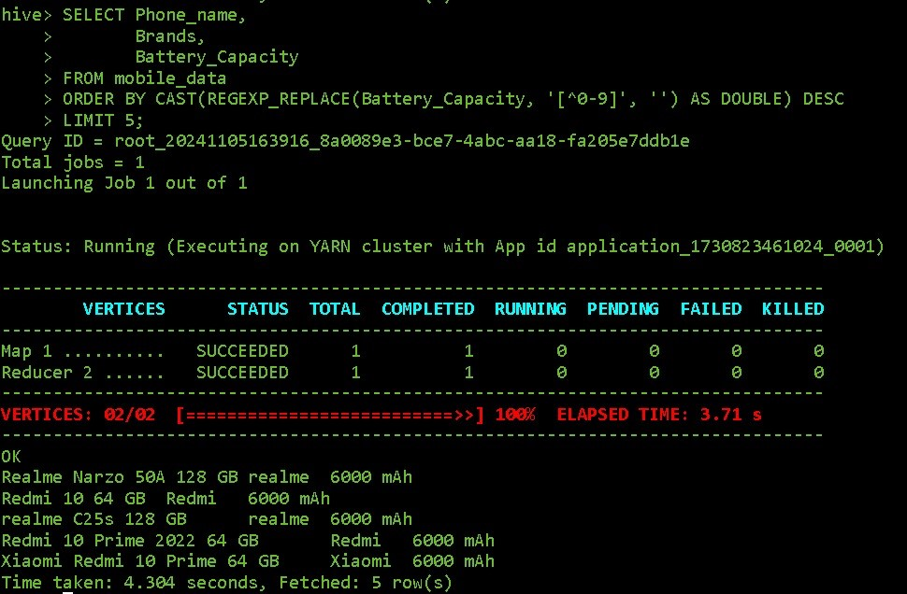

**Query**: *"SELECT Phone_name, Brands, Battery_Capacity FROM mobile_data ORDER BY CAST(REGEXP_REPLACE(Battery_Capacity, ‘[^0-9]’,’’)  AS DOUBLE) DESC LIMIT 5;"*

**Purpose**: This query retrieves the top five smartphones with the highest battery capacity, organized in descending order. By casting Battery_Capacity as a double, it ensures accurate sorting for numeric values, showcasing which models offer the longest potential battery life.

**Output**: The output lists the top five phones, including their names, brands, and battery capacities. For example:

Realme Narzo 50A ,

Redmi 10,realme c25s ,

Redmi 10 Prime …

**Insight**: This data highlights the smartphones designed with high battery capacities lets say 6000mAh, appealing to consumers who prioritize extended usage time. Brands can leverage this information to target battery-conscious customers, while competitors can analyze which brands lead in this aspect and adjust their offerings accordingly.

* Prices of the Mobiles based on the Operating System types: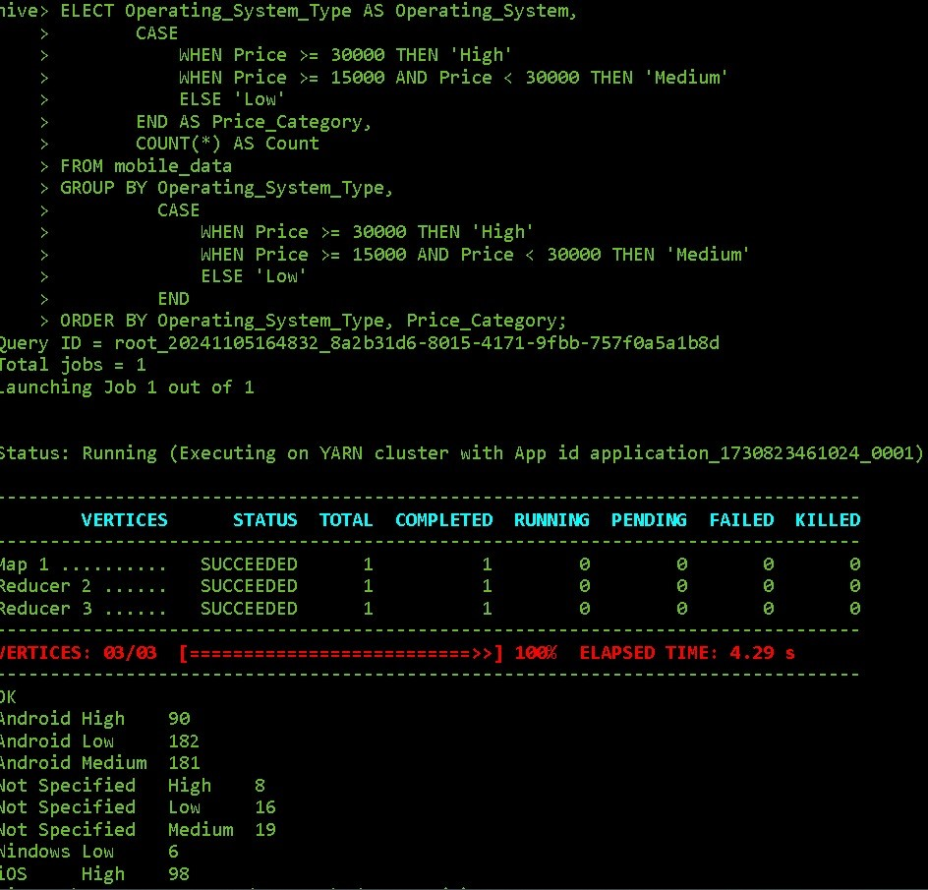

**Query***:  “SELECT Operating_System_Type AS Operating_System,*

*CASE   WHEN Price >= 30000 THEN 'High'*

*WHEN Price >= 15000 AND Price < 30000 THEN 'Medium'*

*ELSE 'Low'*

*END AS Price_Category,   COUNT(*) AS Count*

*FROM mobile_data*

*GROUP BY Operating_System_Type,*

*CASE   WHEN Price >= 30000 THEN 'High'*

*WHEN Price >= 15000 AND Price < 30000 THEN 'Medium'*

*ELSE 'Low'*

*END  ORDER BY Operating_System_Type, Price_Category;”*

***Purpose****:* This query categorizes the prices of mobile devices in the mobile_data table by their Operating_System_Type and groups them into three price categories:

***High****: Price >= 30,000*

***Medium****: 15,000 <= Price < 30,000*

**Low**: Price < 15,000

**Output**:The query output provides counts of devices in each price category for various operating systems.

**Android:**

**High**: 90 devices

**Medium**: 181 devices

**Low**: 124 devices

**Insight**:   **Price Distribution**: Android devices are available across all price categories, with the highest concentration in the "Medium" price range, indicating a variety of options catering to different budgets.**Premium Segmentation**: Windows has a high count in the "High" category, showing that most Windows devices in the dataset are on the pricier side. **Unspecified OS**: Devices with unspecified OS show a low distribution across categories, possibly reflecting generic or unclassified devices.

* Average Price of the Mobiles phones in India:

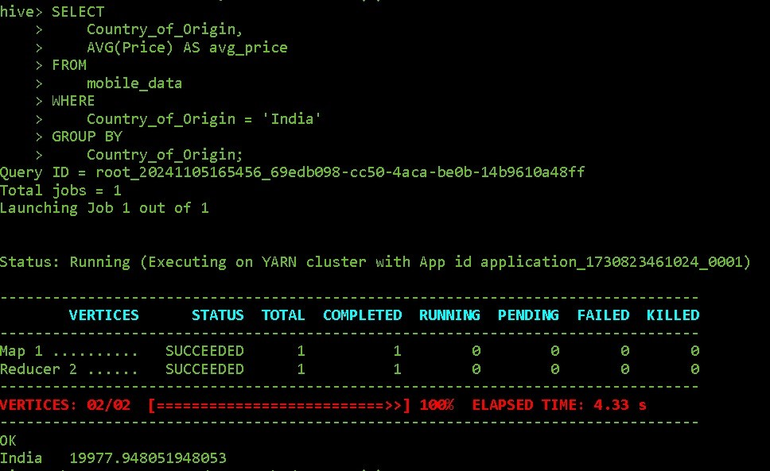

Query: “*SELECT Country_of_Origin, AVG(Price) AS avg_price FROM mobile_data WHERE Country_of_Origin = 'India' GROUP BY Country_of_Origin;”*

**Purpose of the Query:** The query is designed to calculate the average price of mobile phones in India. This helps in understanding the general price point of mobile phones originating from or sold in India.

**Output:** From the screenshot, the output displays:

* **Country_of_Origin:** India
* **avg_price:** 19977.948051948053

This indicates that the average price of mobile phones in India is approximately **₹19,978**.

**Insights:** The average mobile phone price in India, around ₹20,000, suggests a strong consumer preference for mid-range devices, indicating that brands can capture a larger market by focusing on budget-friendly options. This price point serves as a strategic benchmark for brands aiming to align with local purchasing power.

* Count Mobiles phones based on the ram storage:

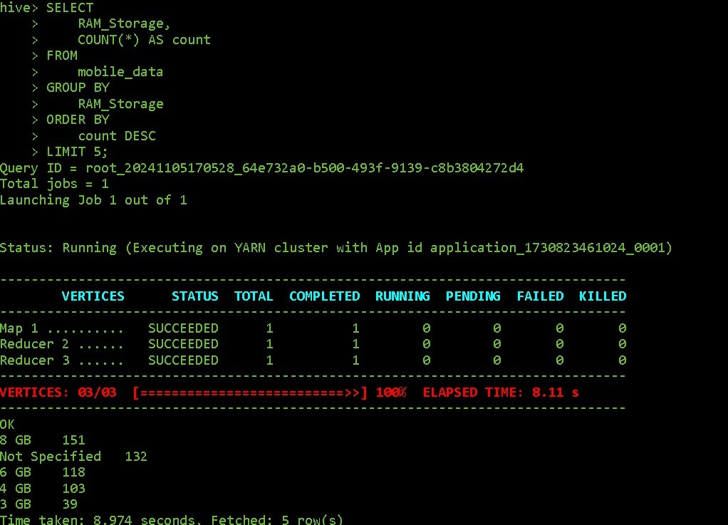

**Query:***” SELECT RAM_Storage, COUNT(*) AS count FROM mobile_data GROUP BY RAM_Storage ORDER BY count DESC LIMIT 5;”*

**Purpose of the Query**: The query aims to identify the top 5 most common RAM storage configurations in mobile devices, along with their respective counts, ordered by the highest count.

**Output**: The result shows the top 5 RAM storage options and their popularity.For example:

* 8 GB: 151 devices
* Not Specified: 132 devices
* 6 GB: 118 devices
* 4 GB: 103 devices
* 3 GB: 39 devices

**Insights:** The majority of mobile devices have 8 GB of RAM, making it the most popular configuration, while a significant number do not specify RAM size. This indicates a preference for higher RAM among listed devices, but also that not all devices report detailed RAM specifications.

1. **Data Visualization**

* Average Price of Android vs IOS phone

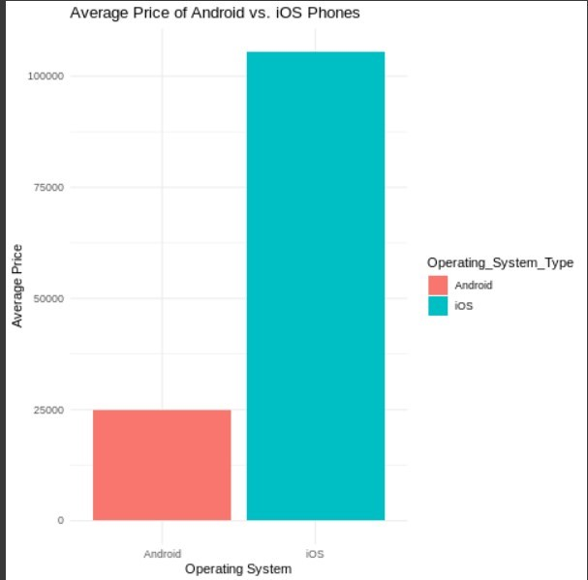

**Description:** A horizontal bar chart illustrating the average price of Android and iOS phones.

**Business Implications:** The analysis indicates that iOS's premium pricing strategy aligns with targeting affluent consumers, while Android's diversity allows it to capture a larger share of the budget market. Companies in the mobile industry should consider these pricing dynamics when developing marketing strategies and product offerings, particularly focusing on the growing demand for affordable Android devices while maintaining a premium image for iOS products.

* Top 3 brands by total sales value

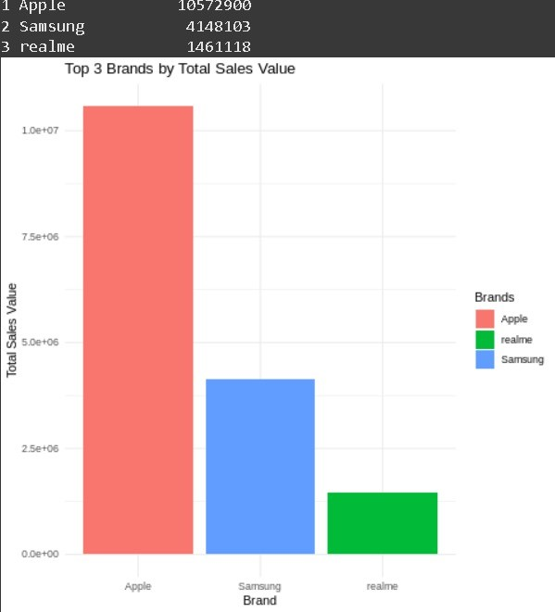

**Description**: A bar chart displaying the top three brands with the highest total sales value to identify leading brands in revenue.

**Business Implications**: The identification of top-performing brands underscores the importance of brand equity and market strategy. Other companies can analyze these leaders’ marketing techniques, product offerings, and customer engagement strategies to improve their own performance. Additionally, insights from these top brands can guide investment decisions, product development, and marketing campaigns targeting specific consumer segments.

* Average Battery Capacity by Operating System

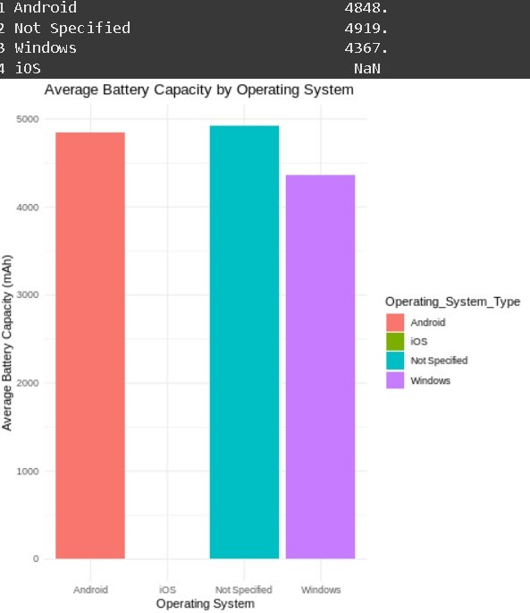

**Description:** A bar chart displaying the average battery capacity of mobile devices categorized by operating system, allowing for a comparison of battery performance across different platforms.

**Business Implications:** Understanding the average battery capacity by operating system can guide manufacturers in product development, particularly in optimizing battery life to meet consumer demands. Companies may leverage these insights to enhance marketing strategies, emphasizing battery performance as a key selling point. Furthermore, knowledge of battery capacity trends can inform competitive analysis, helping brands to position themselves effectively in the market.

* Top 5 Phones with Largest Batteries
* 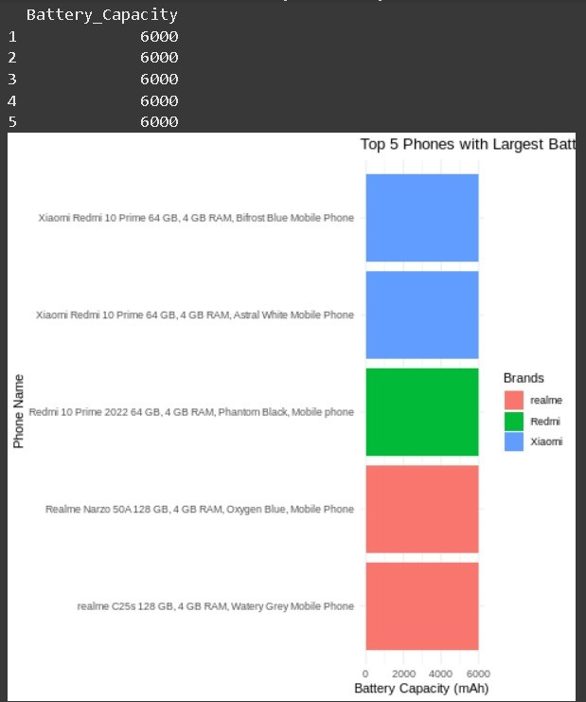

**Description:** A bar chart illustrating the top five phone models with the highest battery capacities, highlighting devices that prioritize power efficiency and longevity.

**Business Implications:** Identifying the phones with the largest battery capacities can inform consumers’ purchasing decisions, particularly for those prioritizing battery life. Manufacturers can use these insights to guide product development and marketing strategies, emphasizing battery performance as a key feature. Additionally, understanding trends in battery capacity among leading models can help brands position themselves competitively and highlight innovations in power efficiency.

* Proportion of 5G and Non-5G Phones:
* 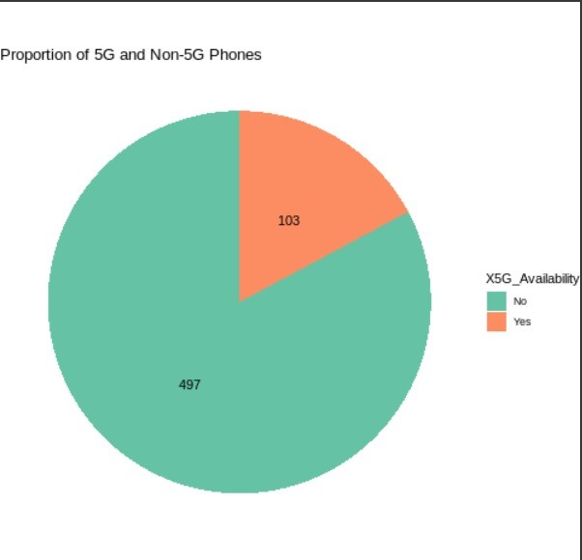

**Description:** A pie chart displaying the proportion of 5G phones compared to Non-5G phones, providing a visual representation of the market share of each category.

**Business Implications:** The proportion of 5G to Non-5G phones can inform manufacturers and retailers about consumer preferences and market trends. Companies should consider investing in the development of 5G devices, as demand is likely to increase. Additionally, marketing strategies may need to highlight the advantages of 5G technology to attract tech-savvy consumers, while still providing options for those who prioritize affordability over the latest features.

* Box Plot of Phone Pries by 5G Availability

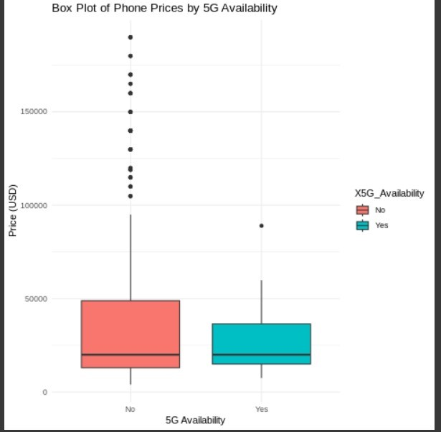

**Description**: A box plot visualizing the price distribution of phones based on whether they support 5G, helping to identify any pricing differences between 5G and Non-5G models.

**Business Implications:** This analysis helps manufacturers and retailers understand the pricing landscape of 5G versus Non-5G phones. If 5G phones consistently show a higher price range, businesses can target tech-savvy consumers with premium marketing, while maintaining a more affordable Non-5G lineup for budget-conscious customers. Insights from the price distribution can inform pricing strategies, enabling companies to competitively position their 5G devices to maximize market reach.

* Density Plot of Phone Prices

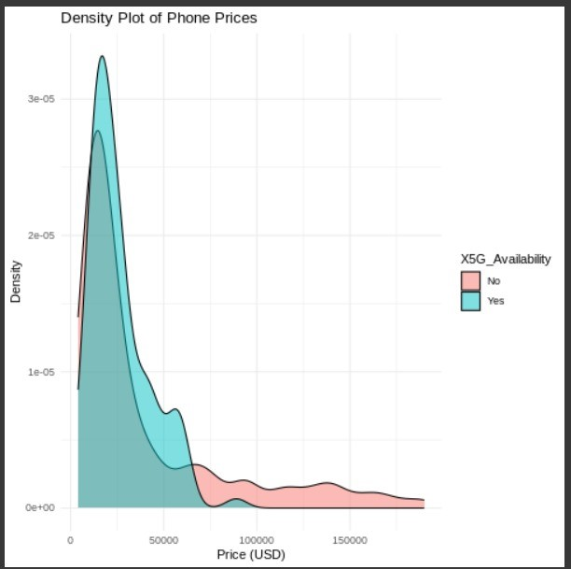

**Description:** A density plot showing smartphone price distribution by 5G availability, providing insights into pricing trends in the market.

**Key Findings:**

**Distinct Price Clusters**: 5G phones generally fall into higher price ranges, while non-5G phones spread across a broader range, covering budget and mid-tier markets.

**Premium for 5G**: Higher price densities for 5G phones suggest added value for advanced technology.

**Diverse Market for Non-5G**: Non-5G phones cater to a wider consumer base, with varied pricing to meet different budgets.

**Consumer Segmentation**: Pricing reflects the divergence in demand between 5G and non-5G buyers.

PowerBI visualisation :

