C32 | ROADMAP AND DIVISION OF WORK
Delivery Roadmap
Four-track plan with Track 1 carrying the heaviest load
Case C32 | Fynd x NMIMS Hyderabad | Product and business simulation
Stack: React, Node.js, Express, TypeScript, AWS (serverless)
Status: v1.0 master document | Date: 17 October 2026
Honesty note: all data in this case is synthetic. This document makes no claim of live revenue, market demand or production readiness. Items marked HYPOTHESIS or ASSUMPTION must be tested before being treated as fact.
Document map
Section | What it covers
1. Plan at a glance | Assumptions, load split (40 / 22 / 20 / 18), timeline chart, why Track 1 is heaviest
2. Track charters | Skills, ownership, handoffs and accountability per track
3. Track 1: Core Engine and API | 14 work packages, 240 hours, weekly intent
4. Track 2: Frontend | 9 work packages, 132 hours
5. Track 3: AWS and DevOps | 11 work packages, 120 hours
6. Track 4: Business and Evidence | 9 work packages, 108 hours
7. Handoffs, dependencies, relief valves | Interface contracts, Track 1 relief valves, descope ladder
8. Master week-by-week plan | Ten weeks across four tracks, pairing slots
9. Milestones and gates | M0 to M5 with exit criteria
10. Team operating rhythm | Cadence, working agreements, status template
11. Responsibility matrix | R, A, C, I by activity
12. Plan risks and contingencies | Signals and responses
13. Viva readiness and final checklist | Who explains what, submission checklist

1. Plan at a glance
This roadmap turns the master blueprint into a ten-week delivery plan for four tracks. Track 1 (Core Engine and API) carries the heaviest load, 40% of total effort, because the rules engine, atomic inventory holds and the API are the heart of the rubric and of the viva.
Planning assumptions (change them, keep the ratios)
Team: 4 people, one track owner each. Duration: 10 weeks. Capacity: about 15 focused hours per person per week, so about 600 hours in total.
If your calendar is shorter or longer, keep the percentages and scale the weeks. If your team has a different size, Track 1 still gets roughly 40%; split Track 1 into 1A (core and rules) and 1B (API and data) and share the owner role.

1.1 Load split
Track | Mission | Share | Hours (of 600)
Track 1: Core Engine and API | Pure rules package, decision engine, DynamoDB holds, Express API, approvals, amendments, import and export services. | 40% | 240
Track 2: Frontend (React) | Design system, quote builder, review queue, calendar, evidence pages, UI and E2E tests. | 22% | 132
Track 3: AWS and DevOps | CDK infrastructure, CI/CD, Cognito, scheduler and worker, observability, security, cost, release. | 20% | 120
Track 4: Business and Evidence | Discovery, pricing, unit economics, acceptance scenarios, growth experiment, evidence ledger, final report and viva pack. | 18% | 108

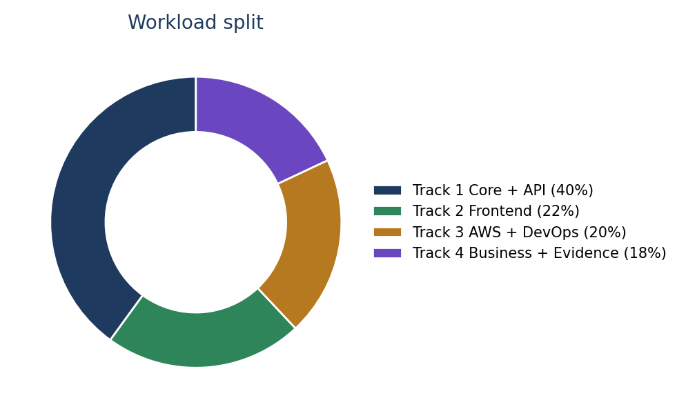
Figure 1: workload split across the four tracks

1.2 Timeline
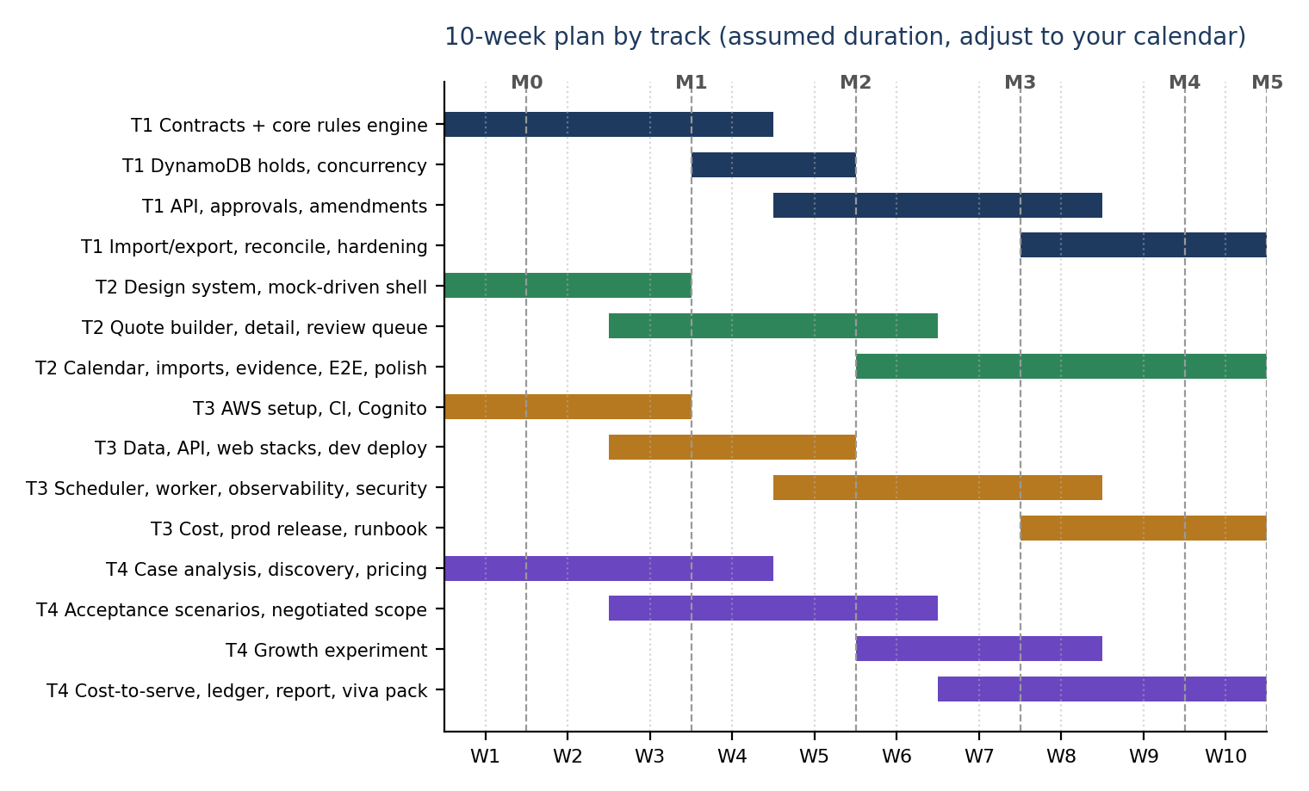
Figure 2: ten-week plan by track with milestones M0 to M5

1.3 Why Track 1 is heaviest, and how we keep it from becoming the bottleneck
- It owns the hardest problems: exact money rules, null handling, atomic holds, idempotency, approvals, amendments, explainable decisions.
- Contract freeze in week 1. Zod schemas, error codes and an OpenAPI draft are published first so Tracks 2, 3 and 4 never wait for the engine.
- Mock-driven UI. Track 2 builds against MSW mocks generated from the contract and swaps to the real API in week 5.
- Infrastructure with a hello-world Lambda. Track 3 proves the pipeline and Cognito before the real API exists.
- Fixtures from Track 4. Track 4 writes acceptance scenarios and expected outputs early, which doubles as Track 1's test oracle.
- Relief valves (Section 7.2) pre-agreed so the team can shift work without a debate when Track 1 slips.

2. Track charters
 | Track 1: Core and API | Track 2: Frontend | Track 3: AWS and DevOps | Track 4: Business and Evidence
Best-fit skills | Node, TypeScript, testing, data modelling | React, UX, accessibility | AWS, CDK, CI/CD, security | Research, finance, writing, presenting
Owns | @c32/core, apps/api, data model, API contract | apps/web, design system, UI tests | infra/, workflows, observability, cost | evidence/, ledger, experiment, report
Hands off to others | Schemas and OpenAPI (wk 1); core releases (wk 3, 4); API on dev (wk 5) | UI screenshots for evidence; E2E reports | Dev URL, Cognito config (wk 3); deploys (wk 5+) | Acceptance scenarios (wk 3); scope record (wk 5); ledger
Depends on | T4 scenarios; T3 DynamoDB Local in CI | T1 contract; T3 Cognito; T1 API (wk 5) | T1 bundle outputs; T2 build output | T1 and T3 metrics for cost; T2 UI for demos
Final accountable for | Correctness and consistency | Usability and accessibility | Deployability, security, cost | Evidence honesty and business story

Cross-track rule
Each track owner is the reviewer for one other track so knowledge spreads: T1 reviews T3 data code; T3 reviews T1 infra-touching code; T2 reviews T4 UI-facing evidence; T4 reviews T2 copy and flows. Any change to @c32/core needs a reviewer from a different track.

3. Track 1: Core Engine and API (240 hours, 40%)
Track 1 is split into fourteen work packages. The core package is built first and independently of AWS, so progress is visible and testable from week 1.
ID | Work package | Hours | Weeks | Depends on | Done when
T1-01 | Monorepo, tooling, lint, test setup; contract freeze (Zod schemas, error codes, OpenAPI draft). | 14 | 1 | none | Repo builds; contract v0.1 published; Tracks 2 to 4 unblocked.
T1-02 | Core pricing engine: revenue, cost, contribution, margin, floor check, minimum safe rate; golden tests. | 26 | 1 to 2 | T1-01 | T01, T03, T04, T05, T18 pass.
T1-03 | Null and unknown policy, validation, calendar semantics, expiry maths, injected clock. | 18 | 2 to 3 | T1-02 | T06 to T08, T25 pass.
T1-04 | Availability, sellable rooms, partial offer, decline, decision engine, reason codes. | 22 | 2 to 3 | T1-02 | T02, T09 to T11 pass; core v0.1 tagged (M1).
T1-05 | Inclusions model and counter-offer generator. | 18 | 3 to 4 | T1-04 | T14, T19 pass; counter-offers re-evaluated by the engine.
T1-06 | Property-based tests P1 to P6. | 10 | 3 to 4 | T1-04 | P1 to P6 green; coverage gate met.
T1-07 | DynamoDB repositories: single-table design, transactional holds, release, confirm. | 30 | 4 to 5 | T1-04; T3 data stack | Holds acquired and released via transactions in DynamoDB Local.
T1-08 | Concurrency and idempotency tests. | 14 | 5 | T1-07 | T12, T13, T24 pass; invariant checker green.
T1-09 | Express API: routes, RBAC, services, problem+json, adapter for Lambda. | 26 | 5 to 7 | T1-07; T3 API stack | Thin slice live on dev (M2); full route set by week 7.
T1-10 | Approvals, four-eyes rule, terms hash, audit events. | 12 | 6 | T1-09 | T16, T17 pass.
T1-11 | Amendments (partial cancellation), extend, cancel. | 12 | 7 | T1-09 | T15, T20 pass.
T1-12 | CSV and JSON import and export services; evidence bundle generator. | 14 | 7 to 8 | T1-09 | T21 to T23 pass.
T1-13 | Expiry worker logic and nightly reconciliation job. | 10 | 8 | T1-07; T3 scheduler | Worker releases holds exactly once; drift report is zero.
T1-14 | Hardening: performance checks, optional mutation testing, bug bash, final reviews. | 14 | 9 to 10 | all | No open critical bugs; release candidate tagged (M4).

Track 1 weekly intent
Week | Focus | Exit evidence
1 | Repo, tooling, contract freeze; start pricing engine. | Contract v0.1 published; T01 passes.
2 | Complete pricing; null policy; start availability. | T03 to T05, T06 pass.
3 | Decision engine; expiry maths; start inclusions. | Core v0.1 passes T01 to T11 (M1).
4 | Counter-offers; property tests; repositories begin. | P1 to P6 green.
5 | Atomic holds; concurrency tests; first API slice. | Create-and-view quote live on dev (M2).
6 | Routes; approvals and audit. | T16, T17 pass on dev.
7 | Amendments; extend; import and export start; scope freeze. | Feature complete for MUST and SHOULD (M3).
8 | Evidence bundle; worker; reconciliation. | Bundle downloads from dev.
9 | Hardening and bug bash. | Release candidate (M4).
10 | Freeze; fixes only; viva support. | Final submission (M5).

4. Track 2: Frontend, React (132 hours, 22%)
ID | Work package | Hours | Weeks | Depends on | Done when
T2-01 | Design system, tokens, accessible components, app shell, routing. | 16 | 1 to 2 | none | Storybook-style gallery or page of components; keyboard and contrast checked.
T2-02 | Typed API client, MSW mocks from the contract, auth flow (mock first, Cognito when ready). | 14 | 2 to 3 | T1-01; T3-03 | UI runs fully against mocks; sign-in works on dev.
T2-03 | Quote Builder wizard with live contribution meter (uses @c32/core). | 26 | 3 to 5 | T1-02; T1-04 | Fixture, shortage and below-floor flows work live.
T2-04 | Quote Detail: result, arithmetic trail, countdown, audit timeline, actions. | 16 | 5 to 6 | T1-09 | Confirm, extend, cancel wired with idempotency.
T2-05 | Review queue and approval dialog; self-approval blocked. | 12 | 6 | T1-10 | T16, T17 flows pass in E2E.
T2-06 | Availability calendar heatmap and Policy screen. | 14 | 6 to 7 | T1-07; T1-09 | Held vs confirmed visible; version-checked policy save.
T2-07 | Import and export UI with row-level report tables. | 10 | 7 to 8 | T1-12 | Null shows as Unknown; errors list row numbers.
T2-08 | Evidence page and Experiment Log. | 10 | 8 | T1-12; T4-08 | Three-stage view; bundle download.
T2-09 | Component tests, Playwright E2E, axe accessibility, polish. | 14 | 7 to 9 | all UI | Rubric flows green against dev; no critical a11y findings.

Track 2 guardrails: never render unknown as zero; use text plus colour for status; confirmation is never optimistic; every mutation carries an Idempotency-Key.

5. Track 3: AWS and DevOps (120 hours, 20%)
ID | Work package | Hours | Weeks | Depends on | Done when
T3-01 | AWS account hygiene, Budgets alert, CDK bootstrap, infra skeleton, GitHub OIDC role. | 14 | 1 to 2 | none | Budget alert active; cdk deploy of an empty stack works from CI.
T3-02 | CI pipeline: verify, integrate (DynamoDB Local), build. | 14 | 2 to 3 | T1-01 | PR checks block merges when red.
T3-03 | AuthStack: Cognito user pool, groups, app client, hosted UI, seed users. | 10 | 2 to 3 | T3-01 | Sales, Owner, Viewer users can sign in; groups in JWT.
T3-04 | DataStack: table, GSI, PITR, S3 buckets, lifecycle, idempotency table. | 10 | 3 to 4 | T3-01 | Table and buckets deployed to dev.
T3-05 | ApiStack: esbuild packaging, Lambda with serverless-express, HTTP API, JWT authorizer, throttling. | 16 | 4 to 5 | T1-09 skeleton | Hello route and real thin slice reachable with JWT.
T3-06 | WebStack: S3 and CloudFront with OAC, headers policy, deploy step. | 10 | 4 to 5 | T2-01 | SPA served over HTTPS on dev.
T3-07 | EventBridge Scheduler, expiry worker, sweeper, DLQ, SES verified identity. | 12 | 5 to 6 | T1-13 | Expiry releases rooms on schedule; DLQ alarm tested.
T3-08 | Observability: EMF metrics, alarms, dashboard, tracing, SNS. | 12 | 6 to 7 | T3-05 | Dashboard shows quotes by decision; test alarm fires.
T3-09 | Security: CDK assertion tests, IAM review, dependency and secret scans. | 10 | 7 to 8 | T3-04 to T3-07 | Public bucket or wildcard IAM fails the build.
T3-10 | Cost measurement, destroy script, cost table with Track 4. | 6 | 8 to 9 | T3-08 | Cost drivers filled with measured numbers.
T3-11 | Prod release, smoke tests, runbook, restore drill. | 6 | 9 to 10 | all | Prod stack from tag; runbook committed.

Track 3 guardrails: no VPC or NAT; least-privilege IAM per function; no long-lived AWS keys in GitHub; keep log retention short; document every cost-bearing optional service before enabling it.

6. Track 4: Business and Evidence (108 hours, 18%)
ID | Work package | Hours | Weeks | Depends on | Done when
T4-01 | Case analysis, open questions to case owners, baseline-v0 evidence. | 10 | 1 | none | Questions sent; baseline folder and tag exist.
T4-02 | Discovery plan: interview guide, shadow plan, hotel or persona shortlist. | 14 | 1 to 3 | T4-01 | 3 to 5 sessions scheduled.
T4-03 | Value and pricing hypotheses, price probes, unit-economics model. | 14 | 2 to 4 | T4-02 | Model with formulas; probes ready.
T4-04 | Acceptance scenarios and extra fixture files with expected outputs. | 14 | 3 to 6 | T4-01 | 10 or more scenarios consumed by Track 1 tests.
T4-05 | Negotiated scope record: stakeholder sessions, decisions, deferrals. | 8 | 4 to 5 | T4-02 | Scope record committed; tag scope-negotiated.
T4-06 | Growth experiment: design, run, log, tier results. | 16 | 6 to 8 | T2-03; T3-05 | Log complete with who, response, outcome tier.
T4-07 | Cost-to-serve measurement with Track 3; update unit economics. | 8 | 8 to 9 | T3-10 | Measured values replace placeholders.
T4-08 | Evidence ledger, traceability matrix, bundle review. | 14 | 6 to 10 | T1-12 | Every claim tagged Observed, Derived or Assumption.
T4-09 | Final report, demo script, rehearsals, viva Q and A pack. | 10 | 9 to 10 | all | Two timed rehearsals completed.

Track 4 guardrails: never present synthetic or role-play data as live revenue or market demand; record negative results; get consent for anyone contacted.

7. Handoffs, dependencies and relief valves

7.1 Interface contracts between tracks
ID | Handoff | From to | Due | Format
C1 | Zod schemas, error codes, OpenAPI draft (contract v0.1) | T1 to T2, T3, T4 | End of week 1 | packages/core, docs/openapi.json
C2 | Acceptance scenarios and expected outputs | T4 to T1, T2 | Week 3 (then rolling) | data/fixtures/*.json and CSV
C3 | Hello-world pipeline: PR checks and dev deploy | T3 to all | Week 3 | GitHub Actions and CDK
C4 | Cognito pool, groups, seed users, hosted UI URL | T3 to T2 | Week 3 | SSM parameters and README
C5 | Core v0.1 released as workspace package | T1 to T2 | End of week 3 (M1) | Tagged version and changelog
C6 | API thin slice on dev (create, get quote) | T1 and T3 to T2 | End of week 5 (M2) | Dev URL and OpenAPI
C7 | Evidence bundle generator | T1 to T4 | Week 8 | JSON, CSV, checksums
C8 | Measured cost drivers | T3 to T4 | Week 8 to 9 | Spreadsheet or table

7.2 Relief valves for Track 1
Track 1 carries 40% of effort. To protect the plan, the team pre-agrees these moves. Any can be triggered by the Track 1 owner without debate at a weekly planning session.
ID | Valve | Moves to | Approx. hours | Condition
RV1 | Expiry worker logic and reconciliation job (T1-13) | Track 3 owner, reviewed by Track 1 | 10 | Track 1 behind by more than 10% at end of week 6
RV2 | CSV and JSON import and export services (T1-12) | Track 3 owner, reviewed by Track 1 | 14 | Track 1 behind by more than 15% at end of week 6
RV3 | OpenAPI generation and schema maintenance | Track 2 owner | 6 | Any time after week 2
RV4 | Bug bash coordination and test-case triage (part of T1-14) | Track 4 owner | 6 | Week 9

7.3 Descope ladder (never cut MUST items)
If the plan slips, cut from the top of this list downward. Each cut is recorded in the decision log and the evidence ledger so the final report is honest about what was not built.
Order | Cut | Effect
1 | Alternate-date suggestions (ALT_DATES) and PDF or email quotes | Lose COULD polish; no rubric impact.
2 | Mutation testing and load tests | Weaker quality evidence; property tests remain.
3 | Multi-room-type quotes | Single room type remains, as in the fixture.
4 | Athena analytics on exports | No analytics beyond the evidence bundle.
5 | Experiment Log screen (keep the log as a file) | Same evidence, less UI.
6 | Amendments UI (keep the API and tests) | Challenge case shown via API and test evidence.

8. Master week-by-week plan
Week | Track 1 | Track 2 | Track 3 | Track 4 | Milestone
1 | Repo and tooling; contract freeze; start pricing | Design system; app shell | AWS setup; budget; OIDC | Case analysis; questions; baseline-v0 | M0 Contracts and repo ready
2 | Pricing complete; null policy | API client and mocks | CI pipeline; Cognito | Interview guide; pricing hypotheses
3 | Availability and decisions; expiry maths | Quote builder starts | CI integration tests; data stack starts | Acceptance scenarios; interviews begin | M1 Core v0.1 passes T01 to T11; pipeline live
4 | Inclusions; counter-offers; property tests; repositories begin | Builder with live meter | Data, API and web stacks | Pricing probes; negotiated-scope sessions
5 | Atomic holds; concurrency; API slice | Builder done; detail page | Dev deploy; scheduler starts | Scope record; tag scope-negotiated | M2 Thin slice live on dev
6 | Routes; approvals; audit | Review queue; calendar | Worker, SES, observability | Growth experiment starts
7 | Amendments; imports; scope freeze | Policy; imports UI; E2E starts | Dashboards; alarms; security tests | Experiment continues; ledger grows | M3 Feature complete; scope freeze
8 | Evidence bundle; worker; reconcile | Evidence page; E2E | Cost measurement; assertions | Cost-to-serve; ledger; traceability
9 | Hardening; bug bash | Polish; accessibility fixes | Prod release candidate; runbook | Final report draft; rehearsal 1 | M4 Release candidate and evidence bundle
10 | Fixes only; viva support | Fixes only | Prod release; restore drill | Final report; rehearsal 2 | M5 Final submission

8.1 Pairing slots
Week | Pair | Purpose (90 minutes each)
3 | Track 1 with Track 2 | Integrate core into the quote builder; agree error display.
4 to 5 | Track 1 with Track 3 | DynamoDB transactions and IAM; Lambda packaging.
6 | Track 1 with Track 4 | Walk through acceptance scenarios against the engine.
8 | Track 3 with Track 4 | Cost drivers and unit economics.
9 | All four | Bug bash and demo rehearsal.

9. Milestones and gates
Milestone | When | Exit criteria | Gate owner
M0 Foundations | End of week 1 | Monorepo builds; contract v0.1 published; open questions sent to case owners; AWS budget alert active. | Track 1
M1 Core v0.1 | End of week 3 | T01 to T11 pass; core coverage tracking started; CI green on PRs; Cognito available. | Track 1 and Track 3
M2 Thin slice | End of week 5 | Create-and-view quote works through deployed UI, API and DynamoDB; holds atomic; T12 and T13 pass. | Track 3
M3 Feature complete | End of week 7 | All MUST and agreed SHOULD items implemented on dev; scope frozen; negotiated scope tagged. | Whole team
M4 Release candidate | End of week 9 | T01 to T25 and P1 to P6 green; E2E and axe green; evidence bundle generated from dev; ledger complete. | Track 4 and Track 3
M5 Final submission | End of week 10 | Prod release from tag; report, demo and viva pack rehearsed twice; repository tidy. | Whole team

10. Team operating rhythm

10.1 Cadence
Ritual | When | Duration | Purpose
Planning | Monday | 30 min | Confirm the week per track; check dependencies; trigger relief valves.
Mid-week sync | Wednesday | 15 min | Unblock; adjust.
Demo and retro | Friday | 45 min | Show working software; update the plan and risk list.
Async update | Daily | 2 min | Written status in the team thread: done, next, blocked.

10.2 Working agreements
- Work in progress limit: at most two work packages in progress per person.
- Definition of ready: a work package has inputs, owner, estimate and a done-when line before it starts.
- Definition of done: merged to main, tests pass in CI, documented, and demonstrated or evidenced.
- Pull requests: small, linked to a work package ID, one reviewer from another track for core changes.
- Decision log: every scope or design decision recorded in docs/decisions.md with date and reason.
- Blocked for more than 24 hours: raise it in the team thread and at the next sync; do not wait for the weekly meeting.
- Honesty rule: if a number or claim has no source, it goes in the ledger as an Assumption.

10.3 Weekly status template
Field | Content
Week and milestone | W5, heading to M2
Hours used vs plan (per track) | T1 52 of 48 planned
Done this week | Work package IDs completed
Next week | Work package IDs planned
Blocked | What and who can unblock
Risks changed | New, rising, closed
Decisions made | Link to decision log

11. Responsibility matrix
R = responsible (does the work), A = accountable (final say), C = consulted, I = informed.
Activity | T1 | T2 | T3 | T4
Contract, schemas, OpenAPI | A, R | C | C | C
Core rules engine and tests | A, R | I | I | C
DynamoDB holds and API | A, R | C | C | I
Web application | C | A, R | I | C
AWS infrastructure and CI/CD | C | I | A, R | I
Security review | C | C | A, R | I
Acceptance scenarios and fixtures | C | C | I | A, R
Growth experiment and pricing | I | C | I | A, R
Evidence ledger and bundle | R | C | C | A, R
Final report | C | C | C | A, R
Demo and viva | R | R | R | R

12. Plan risks and contingencies
Risk | Signal | Contingency
Track 1 overload | Hours used more than 15% above plan at any milestone | Trigger relief valves RV1 to RV4; apply descope ladder.
Late contract changes | More than two breaking changes after week 2 | Freeze contract; changes need team agreement and a version bump.
Cognito or AWS setup delays | No sign-in by end of week 3 | Use local mock auth in dev; continue; finish Cognito in week 4.
Hidden test mismatch | Case owners answer differently from our defaults | Switch floor mode by configuration; add tests; update ledger.
Team availability drops | A member misses two consecutive syncs | Re-balance within track; apply descope ladder; inform mentor early.
Demo risk | Dev environment unstable in week 9 | Local run and recorded demo as fallback; freeze dev deploys during rehearsal.
Evidence gaps | Ledger has claims without sources at M4 | Tag as Assumption or remove; never invent a source.

13. Viva readiness and final checklist

13.1 Who explains what
Track | Be ready to explain
Track 1 | Quote arithmetic, null policy, floor decision, atomic holds, idempotency, approval binding, amendments.
Track 2 | State management, live preview with shared core, accessibility choices, error mapping, why confirm is not optimistic.
Track 3 | Architecture and ADRs, security controls, observability, cost drivers and guardrails, rollback.
Track 4 | Customer and hypotheses, pricing probes, experiment design and results, evidence ledger, what is not proven.
Everyone | The fixture numbers (40000, 16000, 24000, floor 20000, minimum rate 1800), the three rubric flows, and the honest limits of synthetic data.

13.2 Final submission checklist
- Deployed prod URL with seeded scenarios; recorded demo as backup.
- Repository with tags baseline-v0, scope-negotiated, final-v1 and a clear README.
- T01 to T25 and P1 to P6 results, coverage, E2E and accessibility reports attached.
- Evidence bundle exported from the deployed environment; ledger with Observed, Derived and Assumption tags.
- Master blueprint, this roadmap, ADRs, runbook and cost table.
- Final report states plainly: data is synthetic; no live revenue or production readiness is claimed; next 30-day test is defined.

