



LOW-LEVEL DESIGN

# CREDIT CARD DEFAULT PREDICTION



**VIKRAM TAVITI**

## Document Version Control

|  |  |  |  |
| --- | --- | --- | --- |
| **Date Issued** | **Version** | **Description** | **Author** |
| **07.09.2022** | V1.0 | Initial LLD- V1.0 | VIKRAM TAVITI |

Contents

Document Version Control 1

* 1. Introduction 3
  2. What is Low-Level Design Document? 3
  3. Scope 3

2.0 Architecture 4

* 1. Architecture Description 5
  2. Data Description 5
  3. Exploratory Data Analysis 5
  4. Data Pre-processing 5
  5. Model Building 5
  6. Data Validation 6
  7. Deployment 6

4.0 Unit Test Cases 7

# Introduction

## What is Low-Level Design Document?

The goal of LLD or Low-Level design document (LLDD) is to give the internal logical design of the actual program code. Low-Level design is created based on the High-Level design. LLD describes the class diagrams with the methods and relations between classes and program specs. It describes the modules so that the programmer can directly can directly code the program from the document.

## Scope

Low-level design (LLD) is a component-level design process that follows a step-by-step refinement process. This process can be used for designing data structures, required software architecture, source code, and ultimately, performance algorithms. Overall, the data organization may be defined during requirement analysis and then refined during data design work.

# 2.0 Architecture

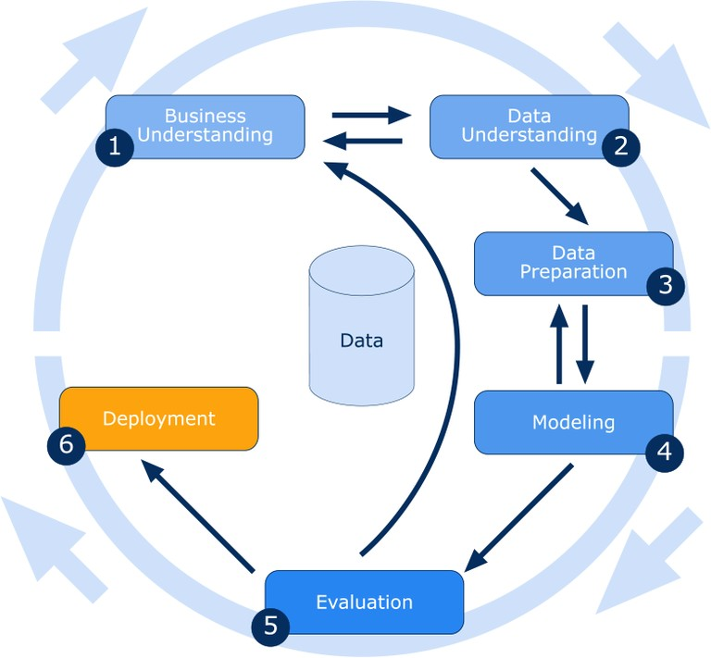

## Architecture Description

## Data Description

The source of data for this project is UCI Machine Learning repository. This dataset contains information on default payments, demographic factors, credit data, history of payment, and bill statements of credit card clients in Taiwan from April 2005 to September 2005.

## Exploratory Data Analysis

Exploring the data by visualizing the distribution of values in some columns of the dataset, and the relationships between target column and other columns. Visualizing the distribution of age, gender, education, payment details.

## Data Pre-processing

If data is not suited to take place directly for the model building, then, cleaning of dataset becomes important for using the data under various classification algorithms.

## Model Building

After data pre-processing is done, we will split the dataset into training set and validation set. Then we will use training set for building the best

model. The model will be trained on several algorithms. We will evaluate the models on various metrics and the one with the best performance overall is considered for deploying.

## Data Validation

Here Data Validation will be done on the test dataset.

## Deployment

We will be deploying the model to Heroku platform.



7 Low-Level Design

# 4.0 Unit Test Cases

|  |  |  |  |
| --- | --- | --- | --- |
| **Test Case Description** |  | **Pre-Requisite** | **Expected Result** |
| Verify whether the Application URL is accessible to the user | 1. | Application URL should be defined | Application URL should be accessible to the user |
| Verify whether the application loads completely for the user when the URL is accessed | 1. Application URL is accessible 2. Application URL is deployed | | Application URL should load completely for the user when URL is accessed |
| Verify whether user can see input field after opening URL | 1. Application is accessible | | User should be able to see input fields after opening URL |
| Verify whether user can edit all the input fields | 1. | Application is accessible | User should be able to edit all the input fields |
| Verify whether user has options to filter the inputs fields | 1. | Application is accessible | User should filter the options of input fields |
| Verify whether user gets submit button to submit the inputs | 1. | Application is accessible | User should get submit button to submit the inputs |
| Verify whether user can see the output after submitting the inputs | 1. Application is accessible | | User should get outputs after submitting the inputs |
|  |  | |  |