

CREDIT CARD DEFAULT PREDICTION

**WIREFRAME DOCUMENT**

***VIKRAM TAVITI***

Homepage

Homepage consists of single page having different input section and submit button. The page designed in such way that user have to enter the details asked for in order to predict whether he/she is going to default There are 23 input sections in the homepage where the user have to enter their six months credit card payment details.

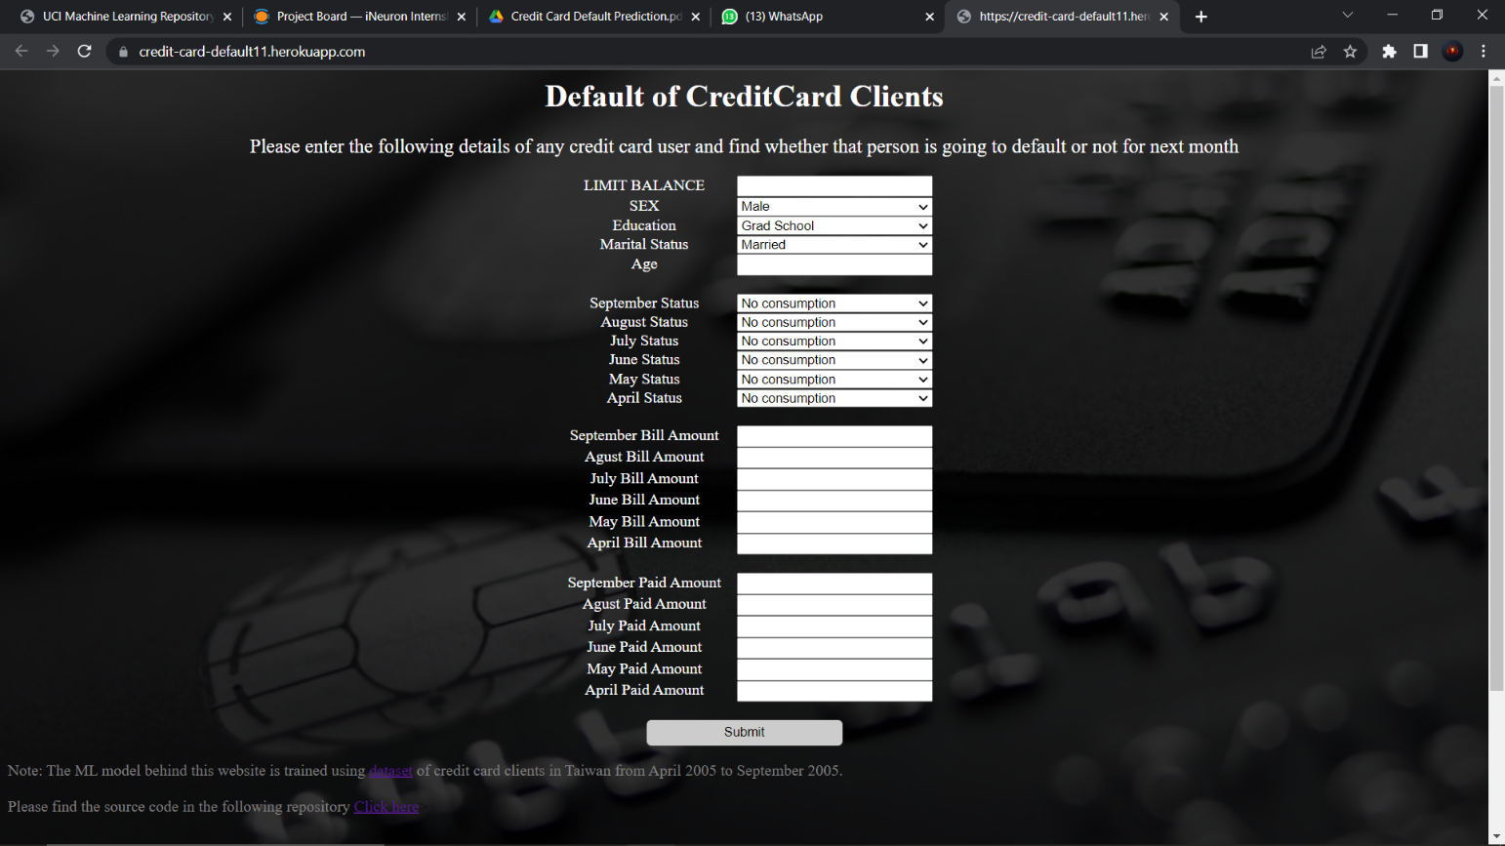

Result page

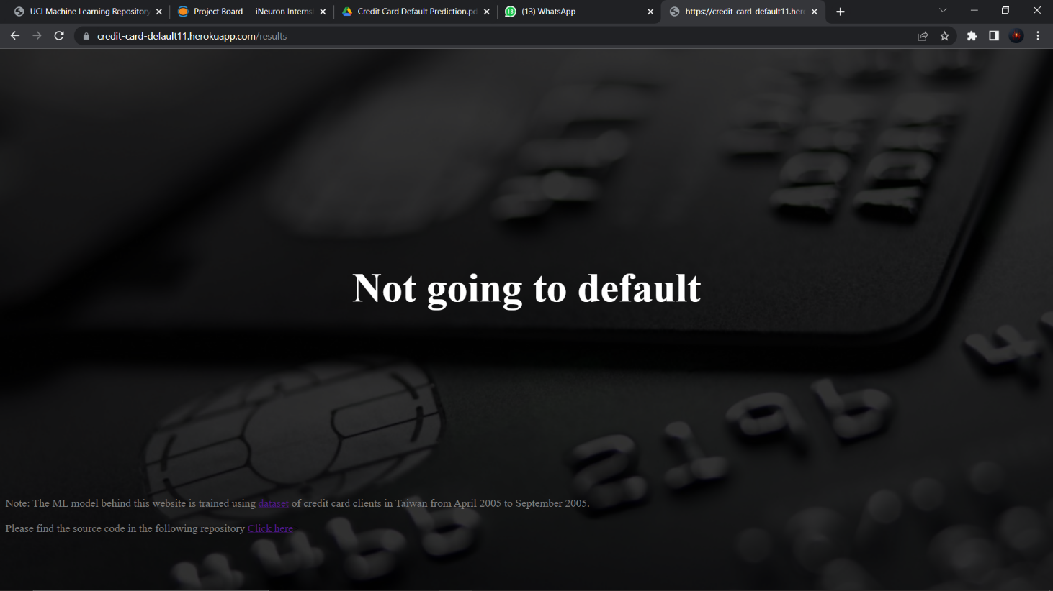Result page shows the prediction based on the details entered in the homepage.