Water Quality Prediction using Statistical, Machine Learning and hybrid models

Shriya B Vikram V Vyshali S

SSN College of Engineering, Chennai

October 26, 2021


Water- Essential to sustain life.
India- only 4 percentage of freshwater resources. Tamilnadu- only 2.5 percent out of the 4
Water contamination is getting alarming- oil spills, industrial wastes, chemical fertilizers, pesticides, etc.

Water quality analysis- done before using ML,DL, Auto-ML, Auto-DL,etc
Our objective- Overcome shortcomings
Statistical models, Machine Learning models and a hybrid model

The proposed system will use a combination of statistical and Machine learning models.
Real-world data is generally incomplete, inconsistent and noisy. The statistical model- pre-processes the data set
Then, the Machine Learning model-predicts the water quality of the water sample.
The results of the conventional statistical, machine learning models and the hybrid model is compared.

ML, DL, Auto-ML and Auto-DL have previously been used to analyse water quality.
Statistical models- not found much
Our approach: Analyse the results of an ML model, a statistical model, and a hybrid of the two.
Hybrid: Data pre-processing done using statistical models like
min-max, Z-score, etc and the prediction to be done using Random Forest.
The exact statistical model is yet to be decided because not much of research is available. Need to test before deciding the best suit for the project

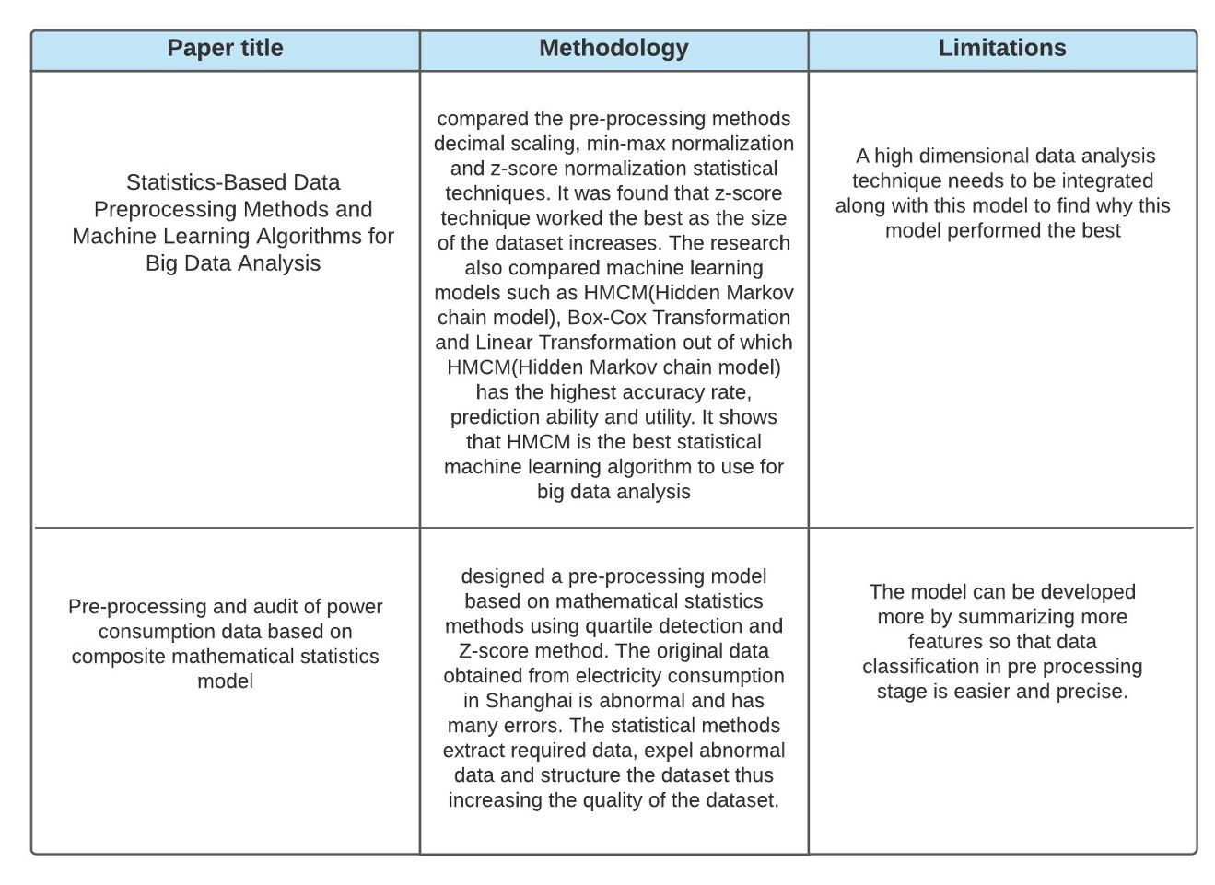

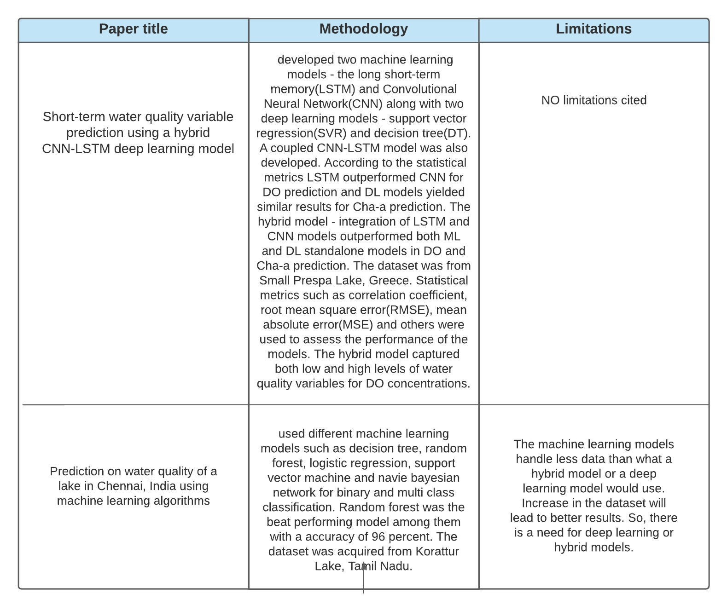

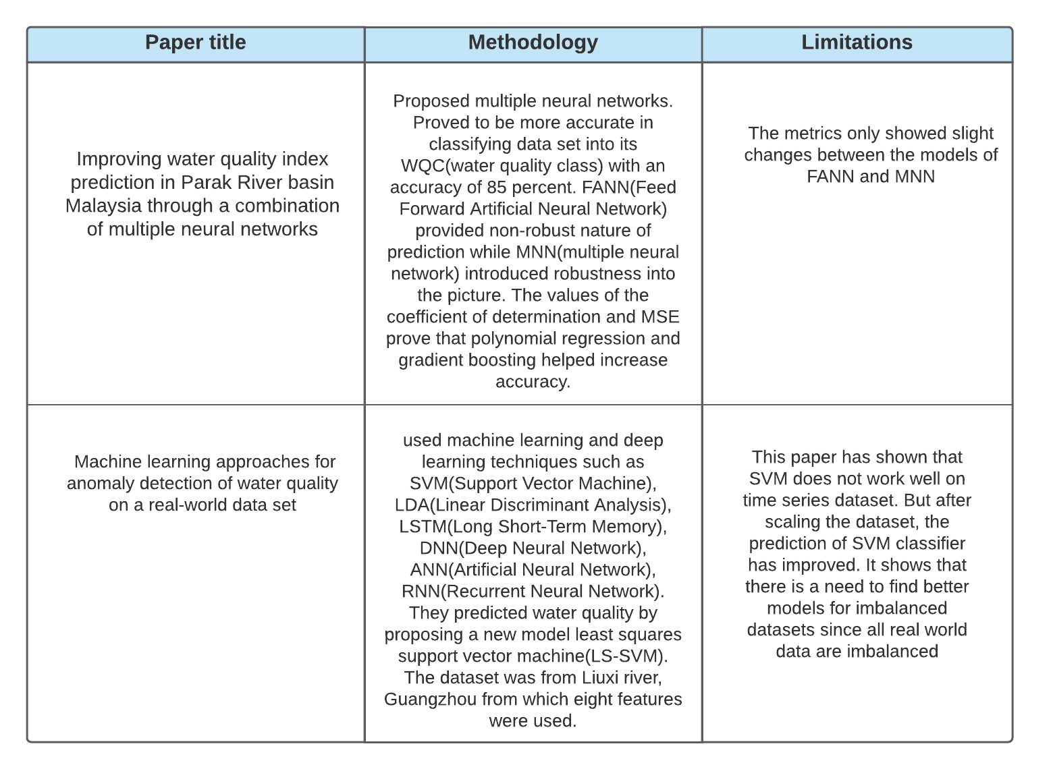

Initially, results obtained from Water quality analysis
Using: machine learning model (Random Forest) and a statistical model (such as PCA, CA, DA etc)
Later, we device a hybrid system combining both the models
Data pre-processing unit processes the data set based on several parameters using a statistical model
Models to be tried: Z-score normalization, min-max normalization, decimal scaling and quartile detection method
Later we use a machine learning model (Random Forest) that would predict the water quality.
Compare the results of all the three and see if the hybrid model has good performance instead of individual models.

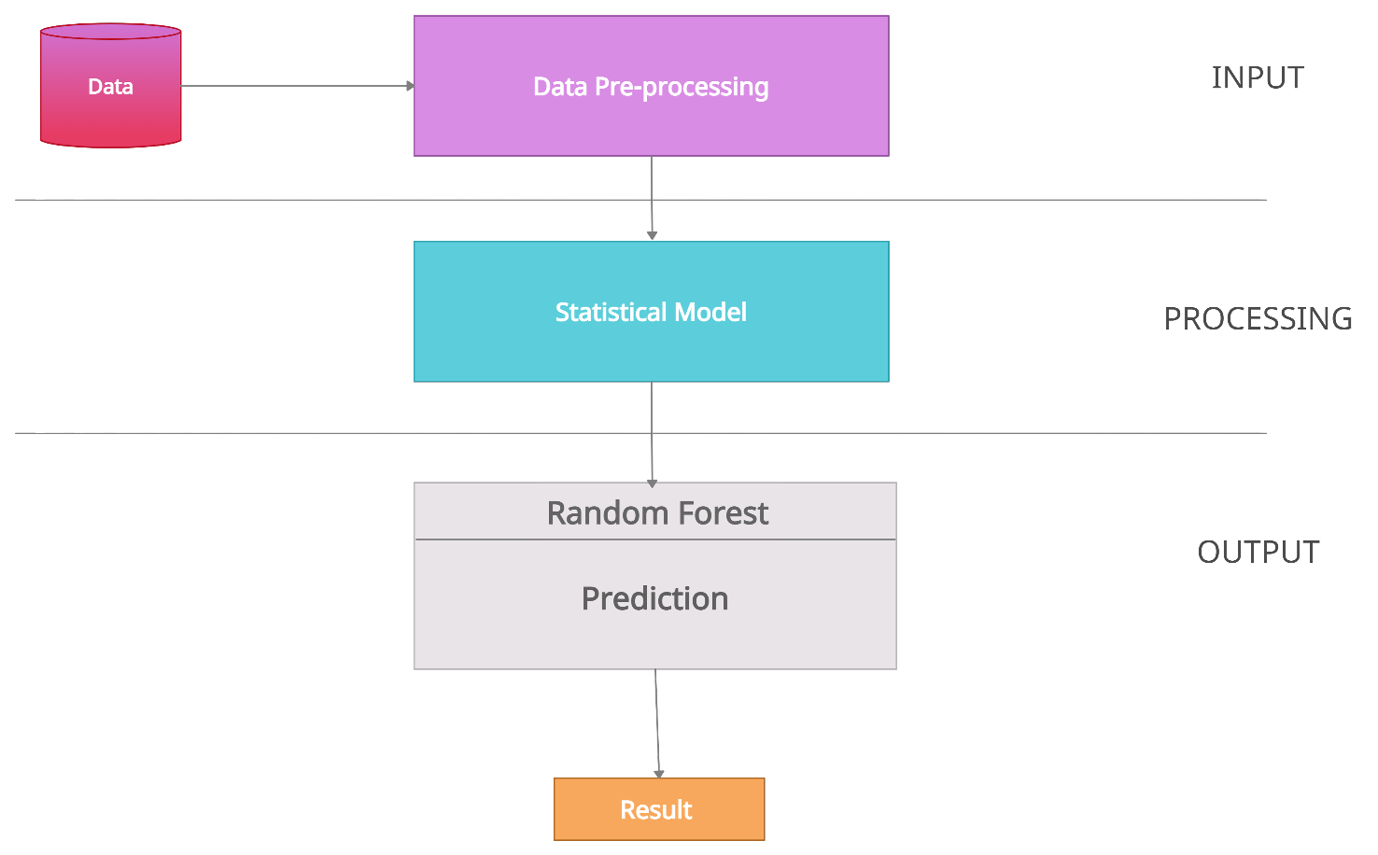

Random Forest - Supervised Machine Learning Algorithm Solving problems on classification and regression
The majority vote after building decision trees on different samples is taken for classification.
can handle categorical values and performs better for classification rather than regression.
example for bagging type of ensemble technique
creates a different training subset from sample training data with replacement the final output is based on majority voting.
Main limitation - large number of trees can make the algorithm too slow - ineffective for real-time predictions.

PCA,CA,DA
Principal component analysis (PCA) - technique for reducing the dimensionality of such datasets, increasing interpretability but at the same time minimizing information loss.
Important use of PCA - represent a multivariate data table as smaller set of variables (summary indices) in order to observe trends, jumps, clusters and outliers.
Cluster analysis (CA) - task of grouping a set of objects in such a way that objects in the same group are more similar to each other than to those in other groups.
classify different objects into groups in such a way that the similarity between two objects is maximal if they belong to the same group and minimal otherwise.
Discriminant analysis (DA) - method used in statistics and other fields, to find a linear combination of features that characterizes or separates two or more classes of objects or events.
Performs a multivariate test of differences between groups

Our project comprise of four major modules:


ML module Statistical module Hybrid module Result analysis
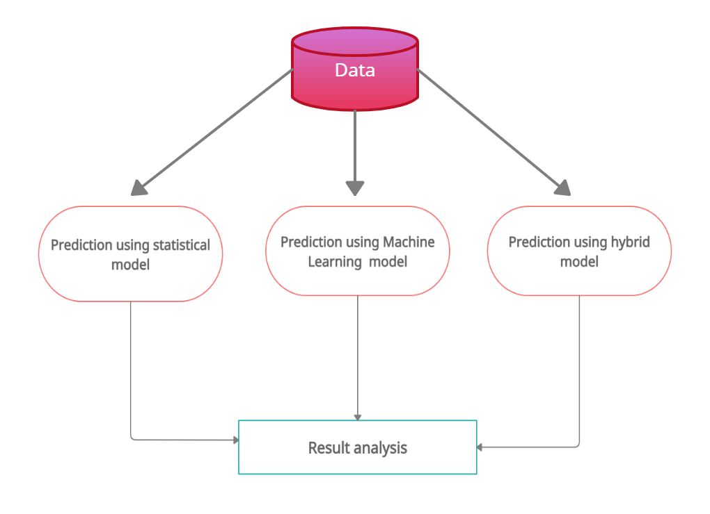

Shriya B Vikram V Vyshali S (SSNCE) October 26, 2021 13 / 15
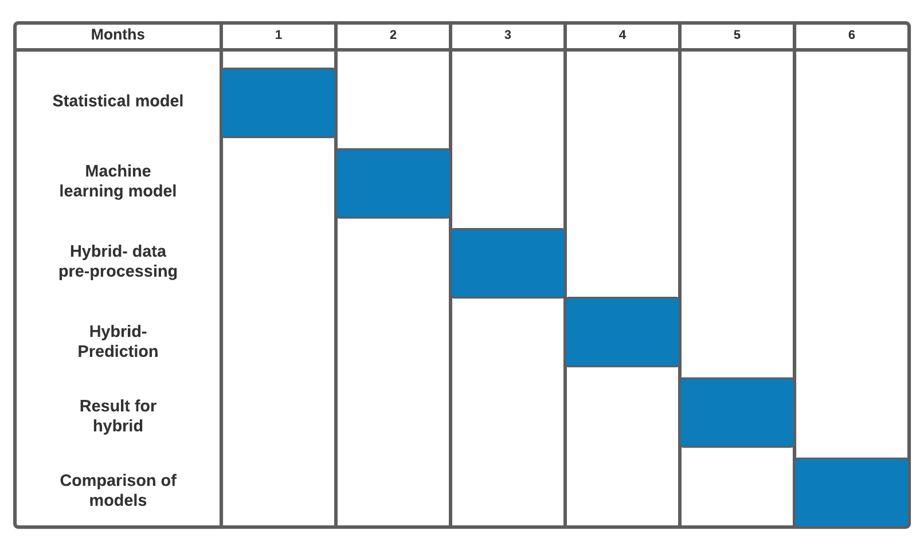

Thank You

