Water Quality Prediction using Statistical,Ensemble and Hybrid models

Vyshali S Vikram V Shriya B

SSN College of Engineering, Chennai

March 31, 2022

System Architecture

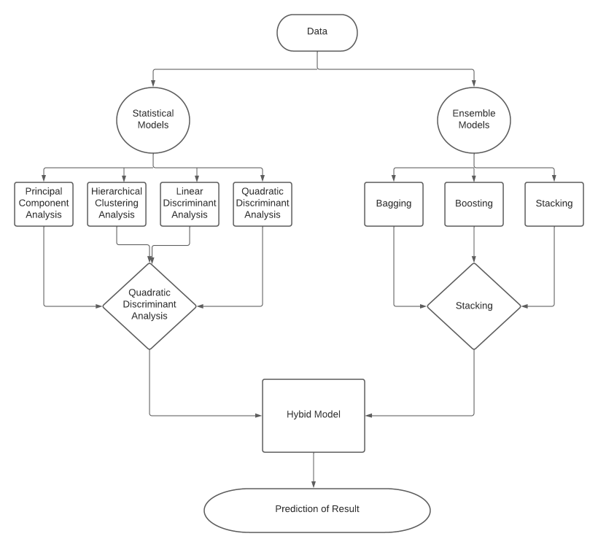
System Design - Statistical Models
Analyse the data set in order to resolve the shortcomings of real world data.

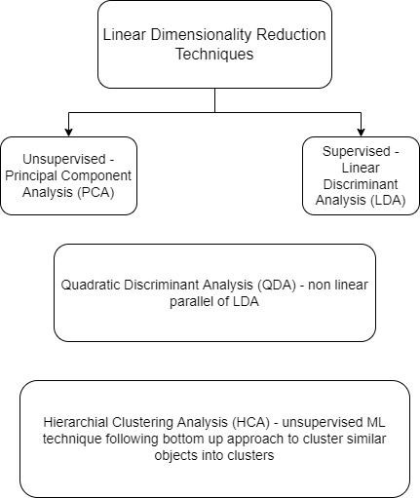

Combine several base models in order to produce one optimal predictive model.

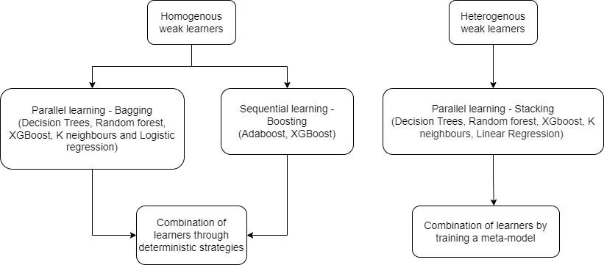

Binary Class Korattur Lake Dataset –> 5000 x 10

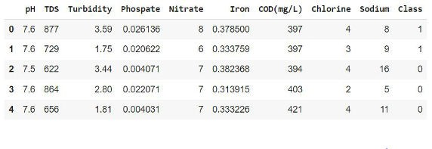
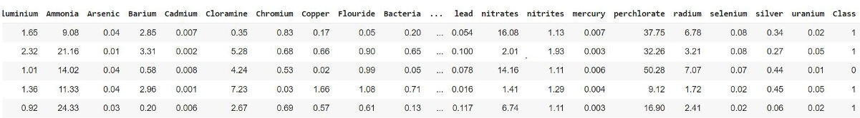
Binary Class Kaggle Dataset : –> 7999 x 21

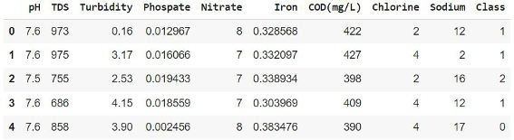
Multi Class Korattur Lake Dataset : –> 10139 x 10
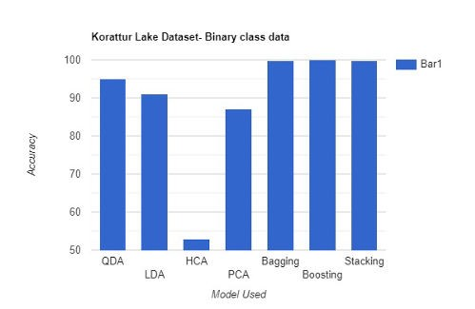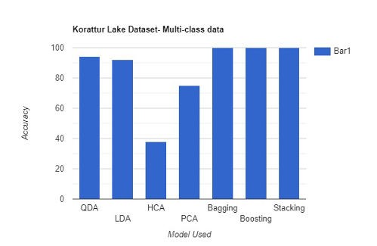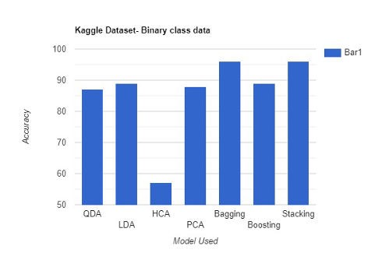


Building a hybrid model using the best statistical and ensemble models, that is Quadratic Discriminant Analysis(QDA) and Stacking.
Try Implementing time series forecasting models such as Moving-Average, Exponential Smoothing and Autoregressive Integrated Moving Average (ARIMA).

Thank You

