**Setup Screenshots**

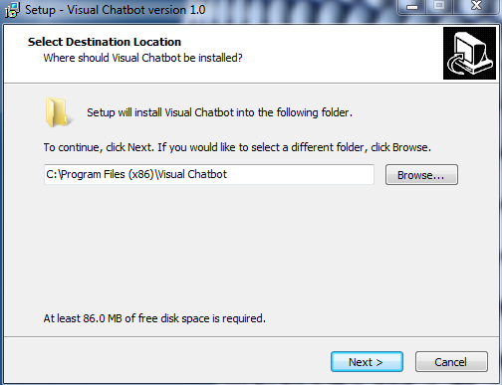

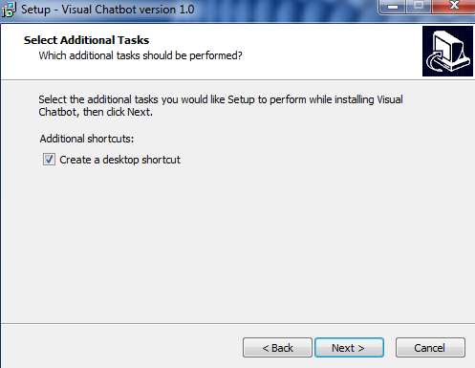

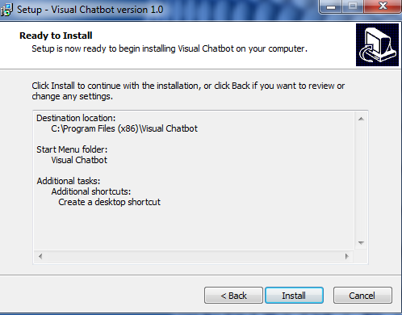

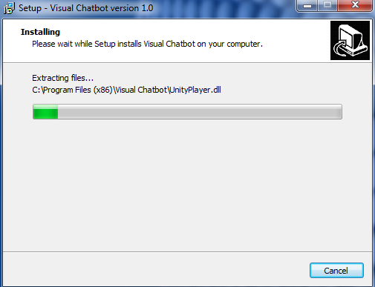

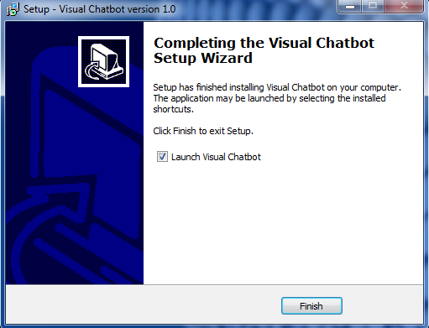

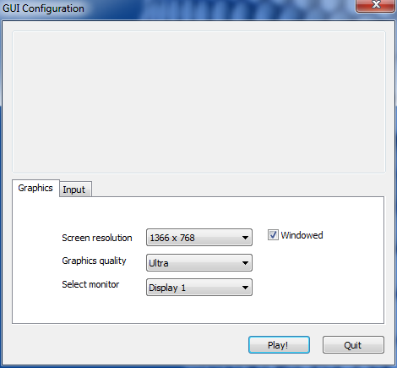

Setup instructions in order of images:

1. Choose install directory
2. Check is desktop shortcut is required
3. If all information provided is to satisfaction, press install to start installation process
4. Installation begins (Typical install time about 30sec-2min)
5. Finish installation.
6. Check required specifications according to available hardware for performance and press Play! To launch