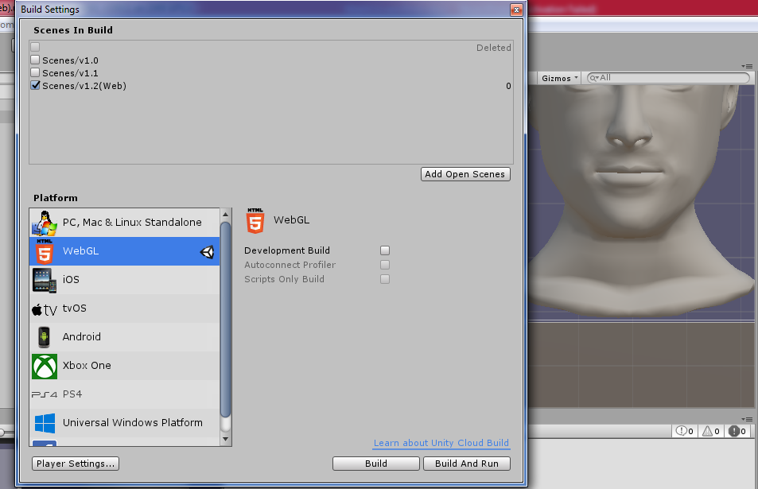

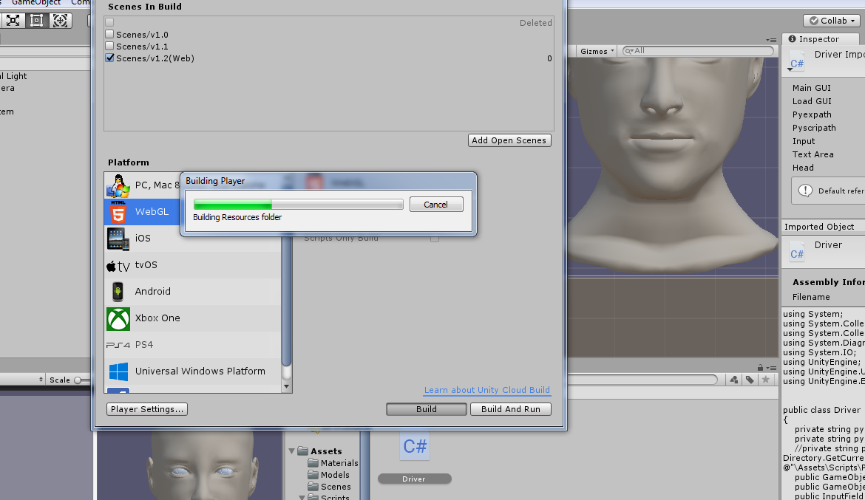

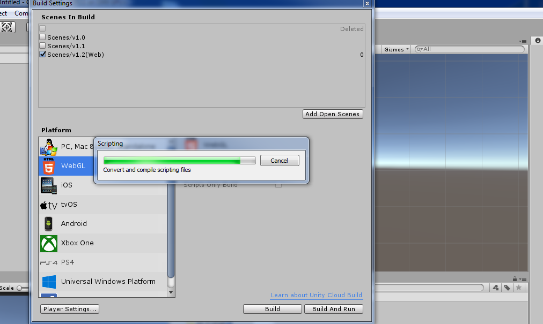

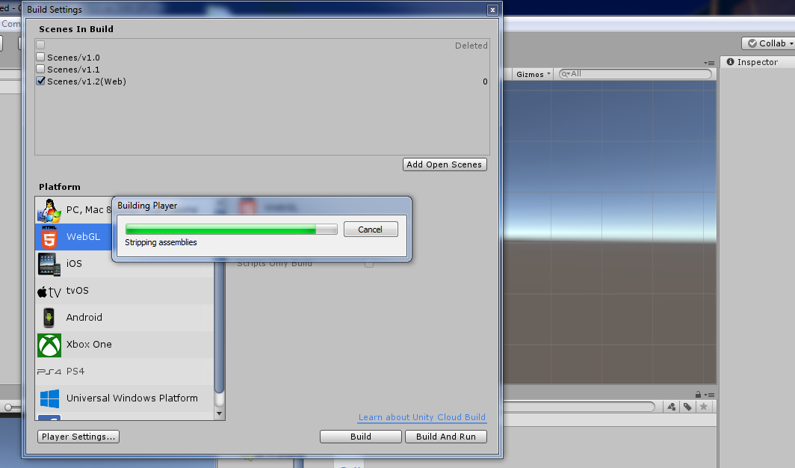

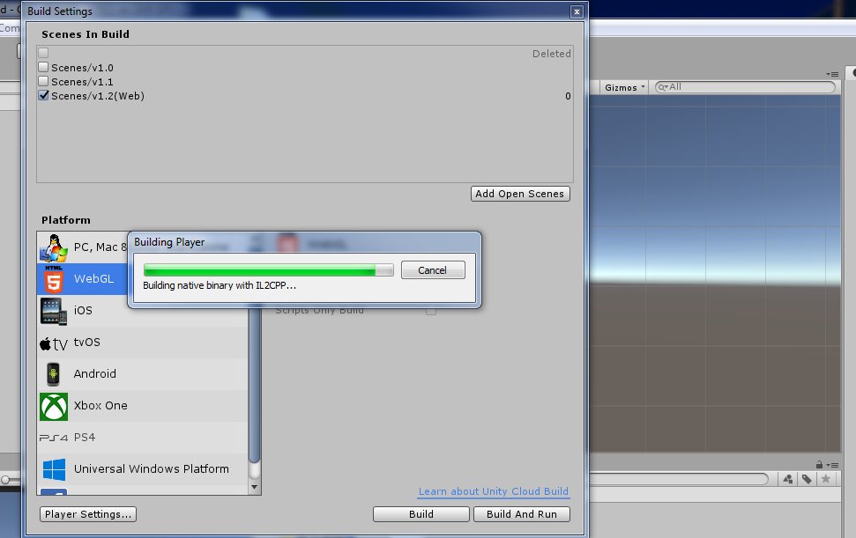

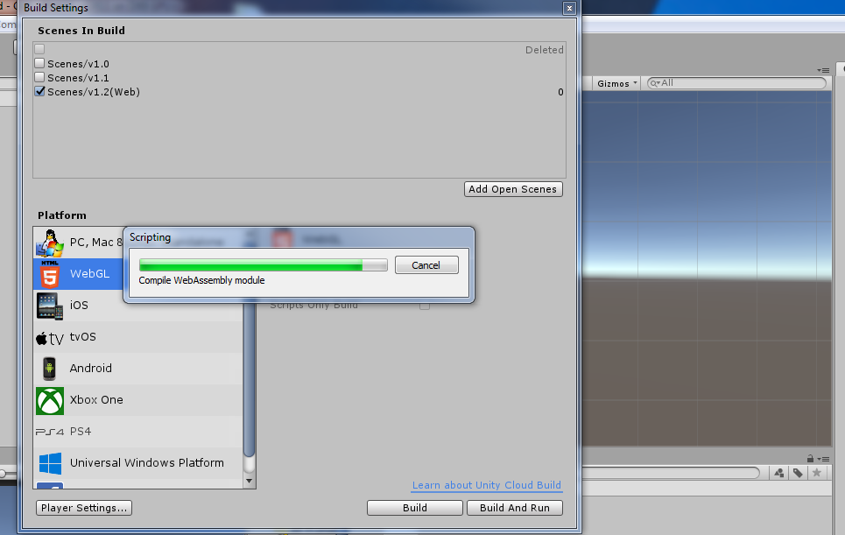

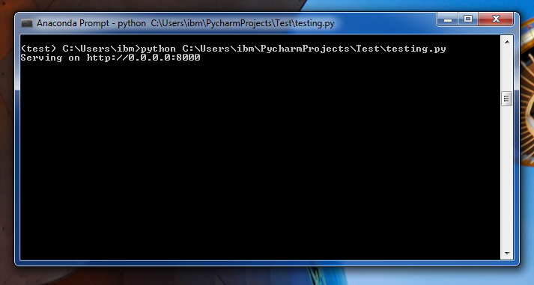

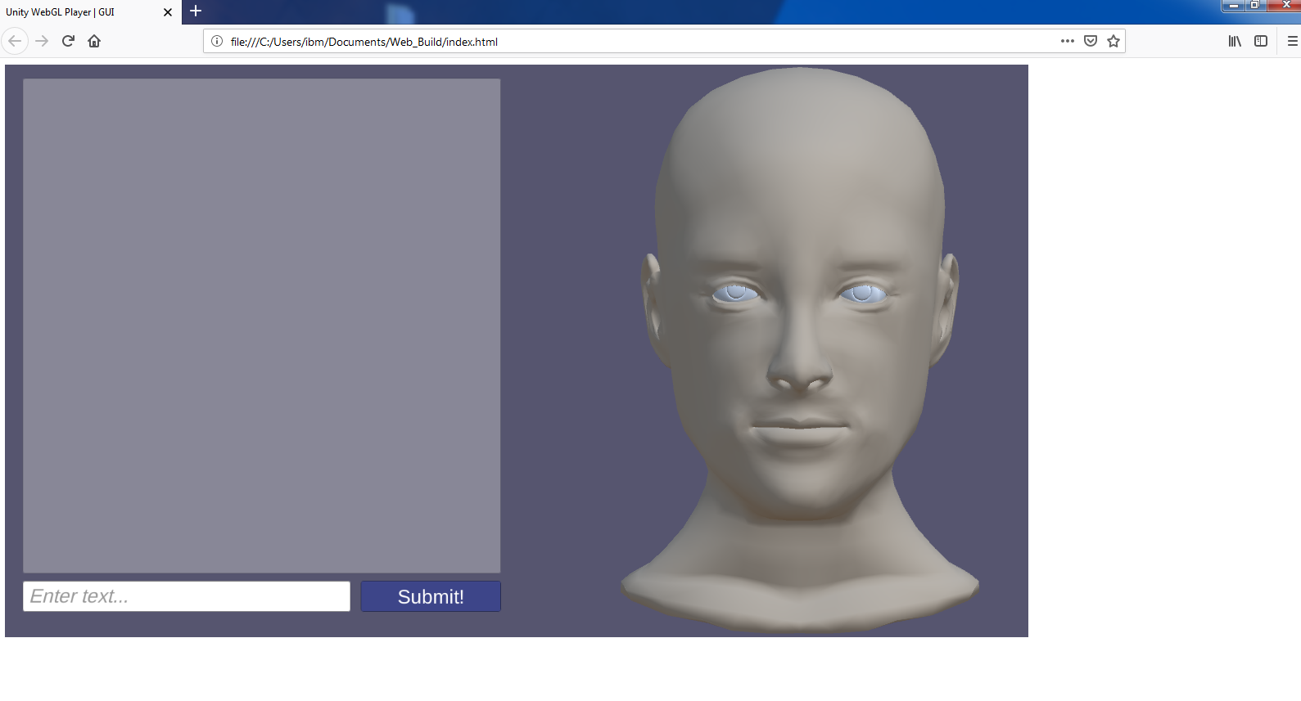

Steps:

1. Run testing.py from cmd as shown above in the screenshot. This will create a localhost server for testing use (testing.py can be uploaded to an online server for production use).

2. Once server is running open the index.html file in the Web_Build folder using Mozilla Firefox or Microsoft Edge (Chrome doesn’t allow WebGL built apps to run from localhosts due to its security mechanism. This build can be uploaded on a server to serve as front end, which can then be accessed using Chrome).

3. Once app has loaded enter query strings and press submit button to start using the app.

**Dependencies**

All carried forward from previous desktop build + Flask and Waitress

**Notes**

* Chatbot.py included in the zip contains model chatbot built using Chatterbot Library. Modify getResponse method if needed to accommodate a customized chatbot framework. **DO NOT CHANGE the getViseme and p2v methods.** Copy the methods to your customized chatbot to use them in the testing.py script.
* The current WebGL build has the server URL: “http:\\localhost:8000\predict_viseme?req=” hardcoded into it, hence this build currently only works on a localhost server. **DO NOT** change the argument req in the predict_viseme method in testing.py